Name: _____________________________ (please print)

Signature: __________________________

ECE 2202 – Final Exam

December 6, 2017

**Keep this exam closed until you are told to begin.**

1. This exam is closed book, closed notes. You may use one 8.5” x 11” crib sheet, or its equivalent.

2. Show all work on these pages. Show all work necessary to complete the problem. A solution without the appropriate work shown will receive no credit. A solution that is not given in a reasonable order will lose credit. Clearly indicate your answer (for example by enclosing it in a box).

3. It is assumed that your work will begin on the same page as the problem statement. If you choose to begin your work on another page, you must indicate this on the page with the problem statement, with a clear indication of where the work can be found. **If your work continues on to another page, indicate clearly where your work can be found. Failure to indicate this clearly will result in a loss of credit.**

4. Show all units in solutions, intermediate results, and figures. Units in the exam will be included between square brackets.

5. Do not use red ink. Do not use red pencil.

6. You will have 170 minutes to work on this exam.

1. ________________/35

2. ________________/30

3. ________________/35

4. ________________/35

5. ________________/30

6. ________________/35

Total = 200

Room for extra work

1. {35 Points} The switch in the circuit shown was open for a long time before it closed at *t* = 0. Find all of the values, if any, of *LX*, so that the time constant for the equation for *iL(t)* valid for *t*  0 will be ** = 2[s]. If there are no values that satisfy this, show why you know that is true.



# Room for extra work

2. {30 Points} In the circuit below, it is given that *vC*(17[ms]) = 10[V].   
Find *vC*(18[ms]).   
A plot of *iC(t)* over a limited range of time is given in the plot below.





# Room for extra work

3. {35 Points} There was no energy stored in inductor *L2* for *t* < 0.

Switch A had been open and Switch B had been closed for a long time before *t* = 0. Then, Switch A closed at *t* = 0, and Switch B opened 1[s] later.

1. Find *vX*(0.5[s]).
2. Find all of the values of time *t* where *vX* = 5[V], during the time period   
   *t* > 1[s]. If there are no such values of time, explain why not.
3. Find *iX*(2[s]).



Room for extra work

Room for extra work

4. {35 Points} The circuit shown below operates in steady-state. Find a numerical expression for *iA(t)*.





Room for extra work

5. {30 Points} The circuit shown below operates in steady-state.

Find all of the possible values of *CX* so that the rms value of *vX(t)* is 25[V].





Room for extra work

6. {35 Points} The circuit shown below operates in steady-state.

Load 1 absorbs (5200 34[VA].

Load 2 absorbs 4700[W] and delivers 3700[VAR].

Load 3 absorbs 6500[W] at a leading power factor of 0.75.

Load 4 absorbs 4200[VA] at a lagging power factor of 0.75.

Load 5 absorbs (4500 - 2100*j*)[VA].

The source *iS(t)* is given by the expression



1. Find *vX(t)*.
2. Find the impedance of Load 3.
3. Find the resistance of Load 3.
4. Find the reactance of Load 3.
5. Find the admittance of Load 3.
6. Find the conductance of Load 3.
7. Find the susceptance of Load 3.



SOLUTION:

1. {35 Points} The switch in the circuit shown was open for a long time before it closed at *t* = 0. Find all of the values, if any, of *LX*, so that the time constant for the equation for *iL(t)* valid for *t*  0 will be ** = 2[s]. If there are no values that satisfy this, show why you know that is true.



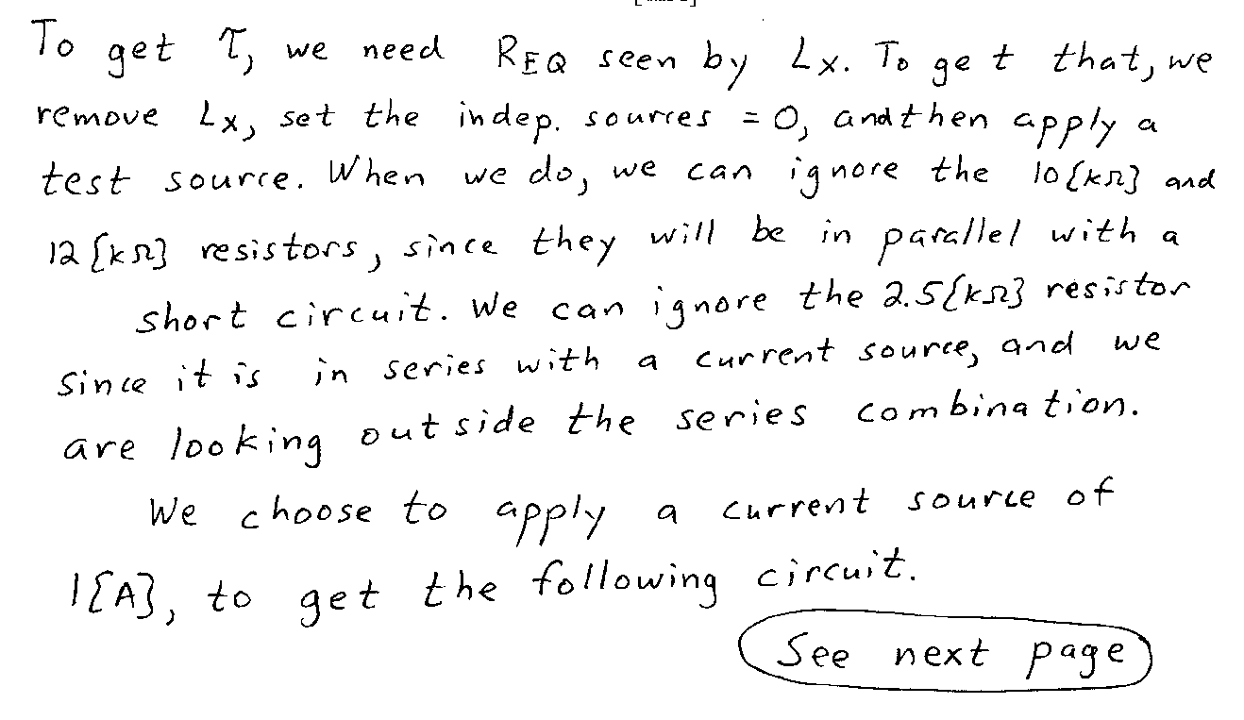

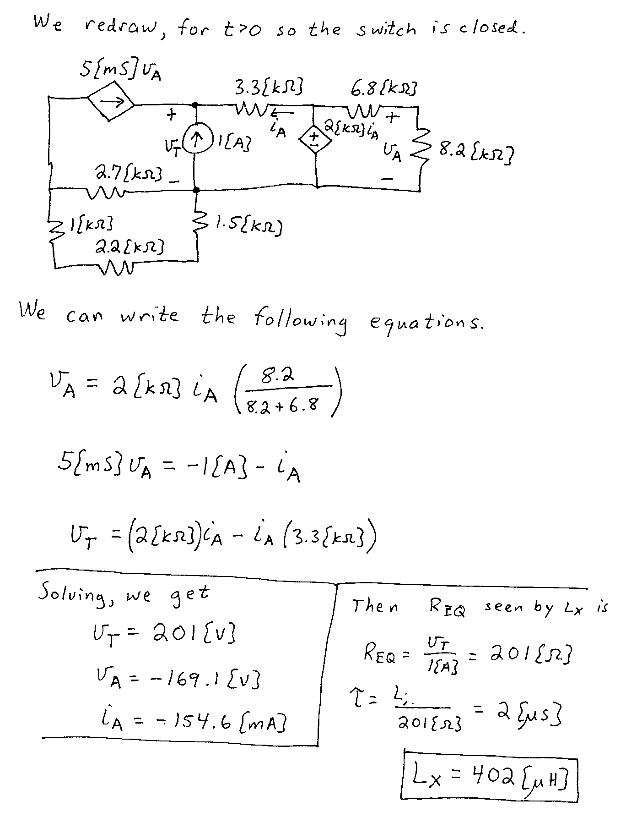

2. {30 Points} In the circuit below, it is given that *vC*(17[ms]) = 10[V].   
Find *vC*(18[ms]).   
A plot of *iC(t)* over a limited range of time is given in the plot below.

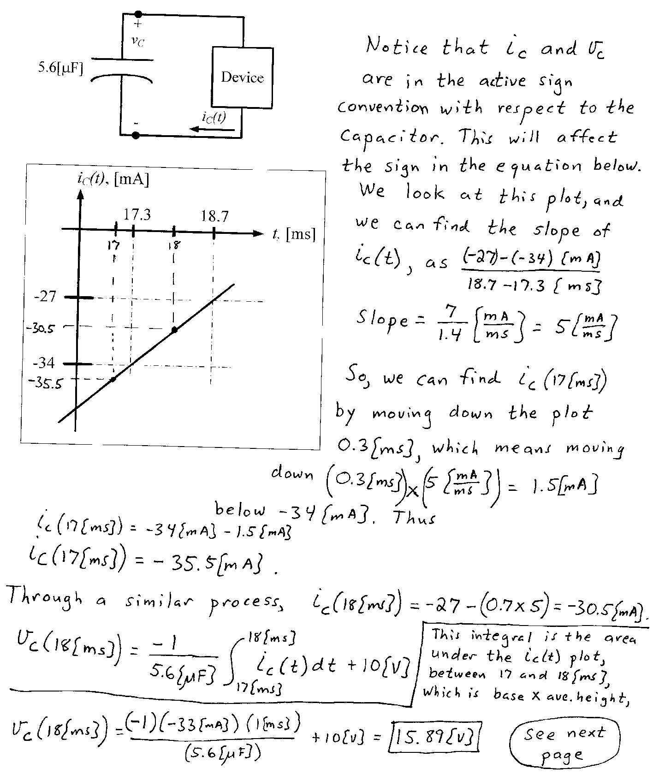

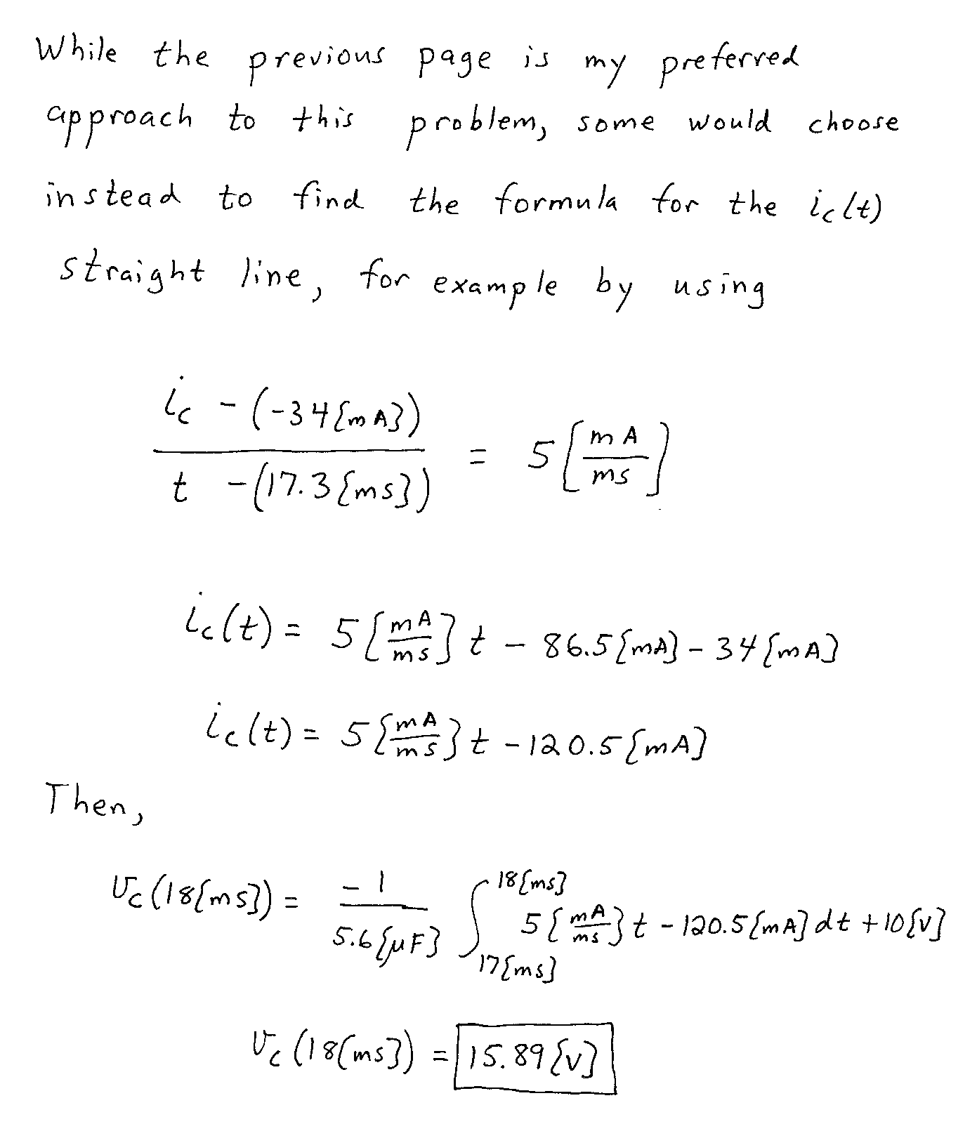

3. {35 Points} There was no energy stored in inductor *L2* for *t* < 0.

Switch A had been open and Switch B had been closed for a long time before *t* = 0. Then, Switch A closed at *t* = 0, and Switch B opened 1[s] later.

1. Find *vX*(0.5[s]).
2. Find all of the values of time *t* where *vX* = 5[V], during the time period   
   *t* > 1[s]. If there are no such values of time, explain why not.
3. Find *iX*(2[s]).

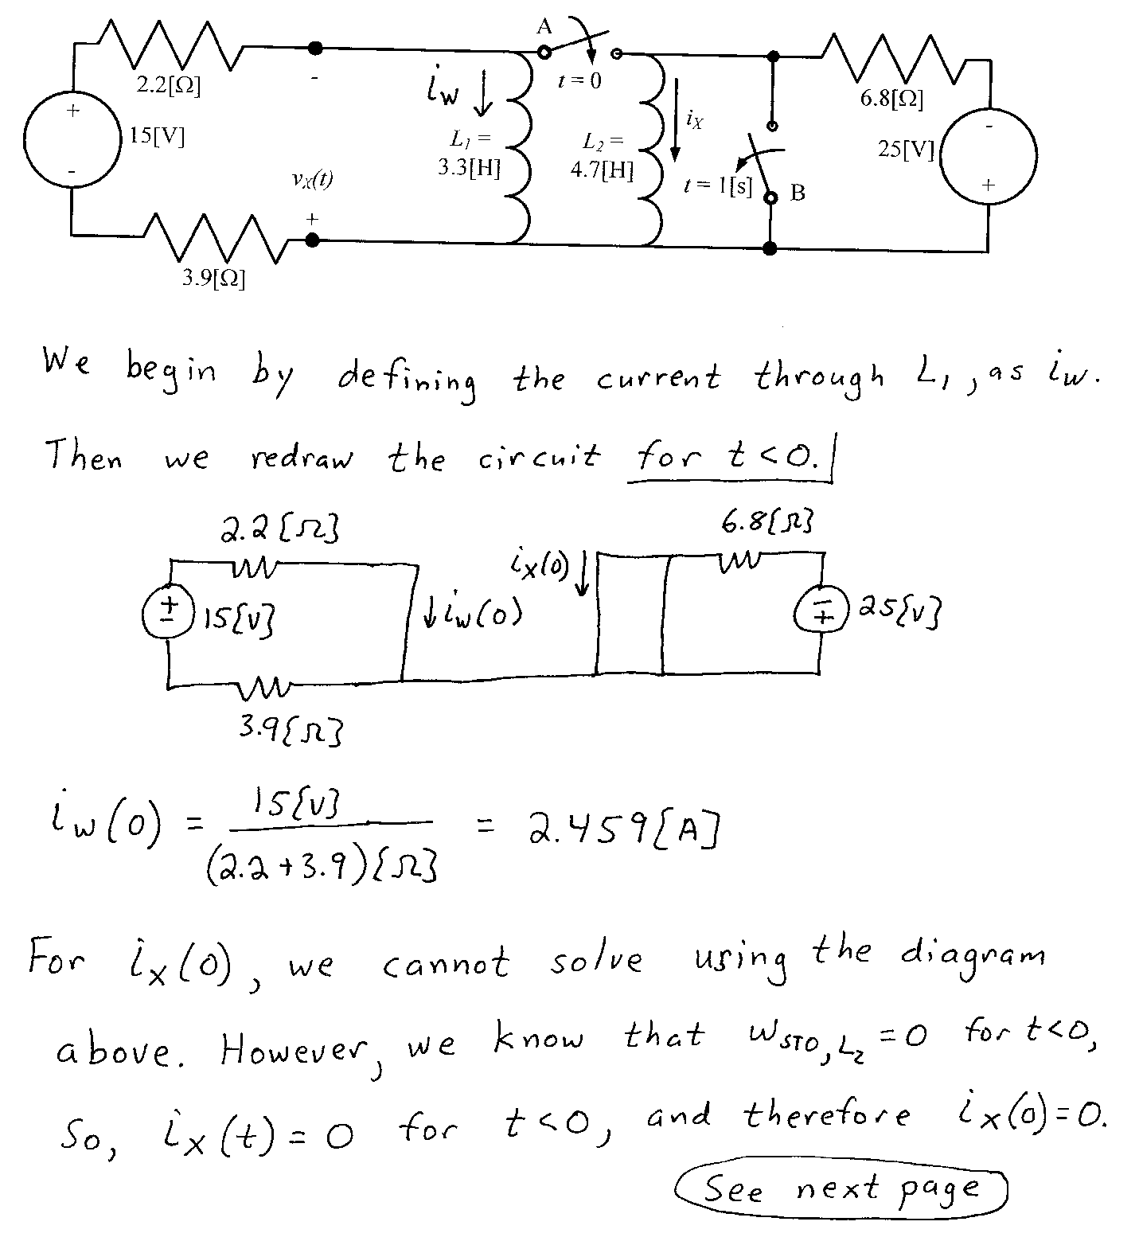

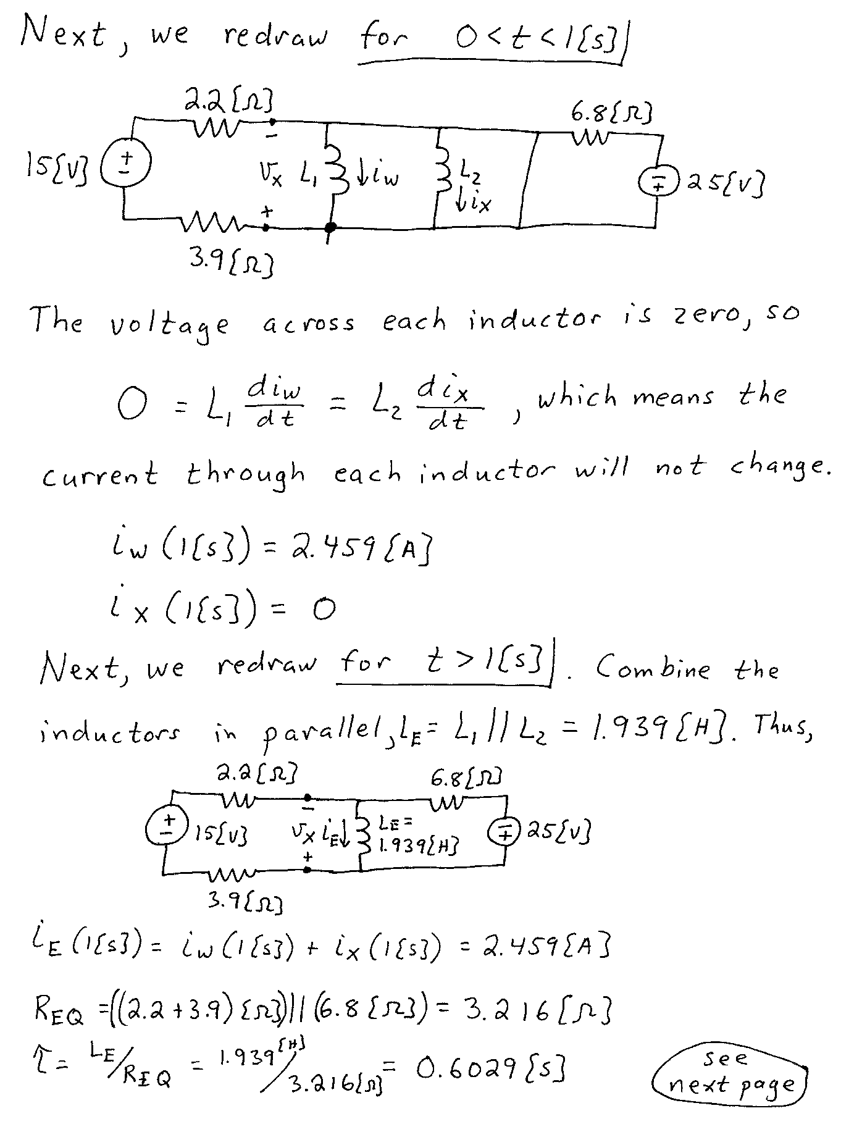

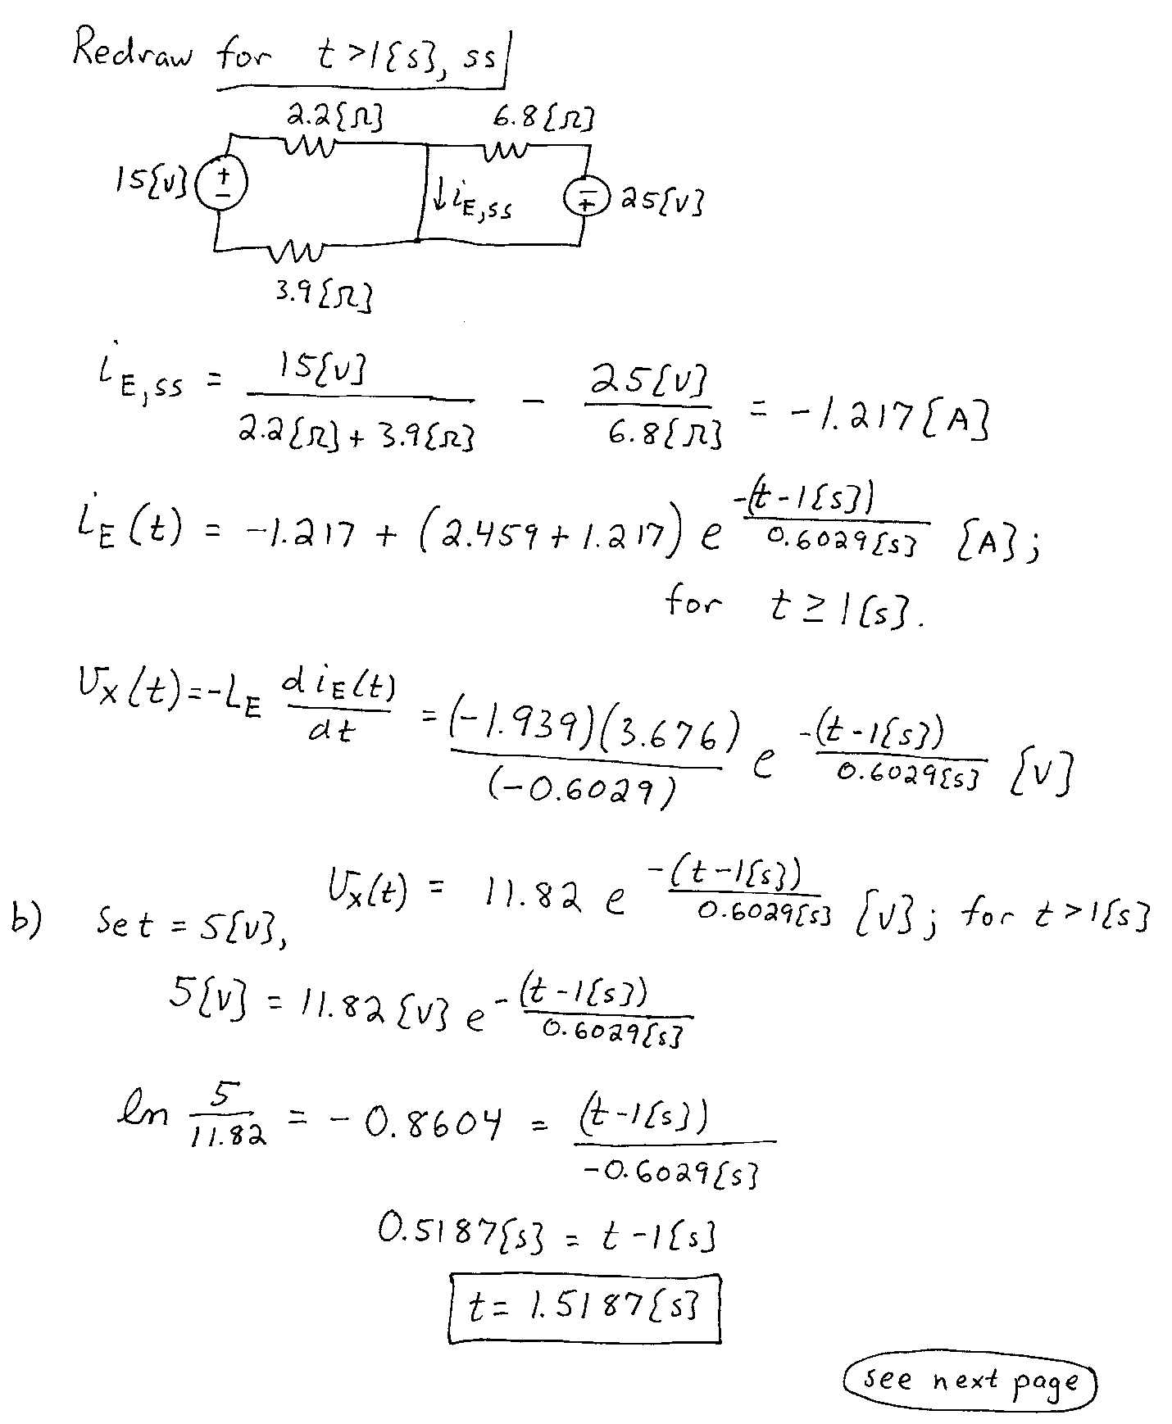

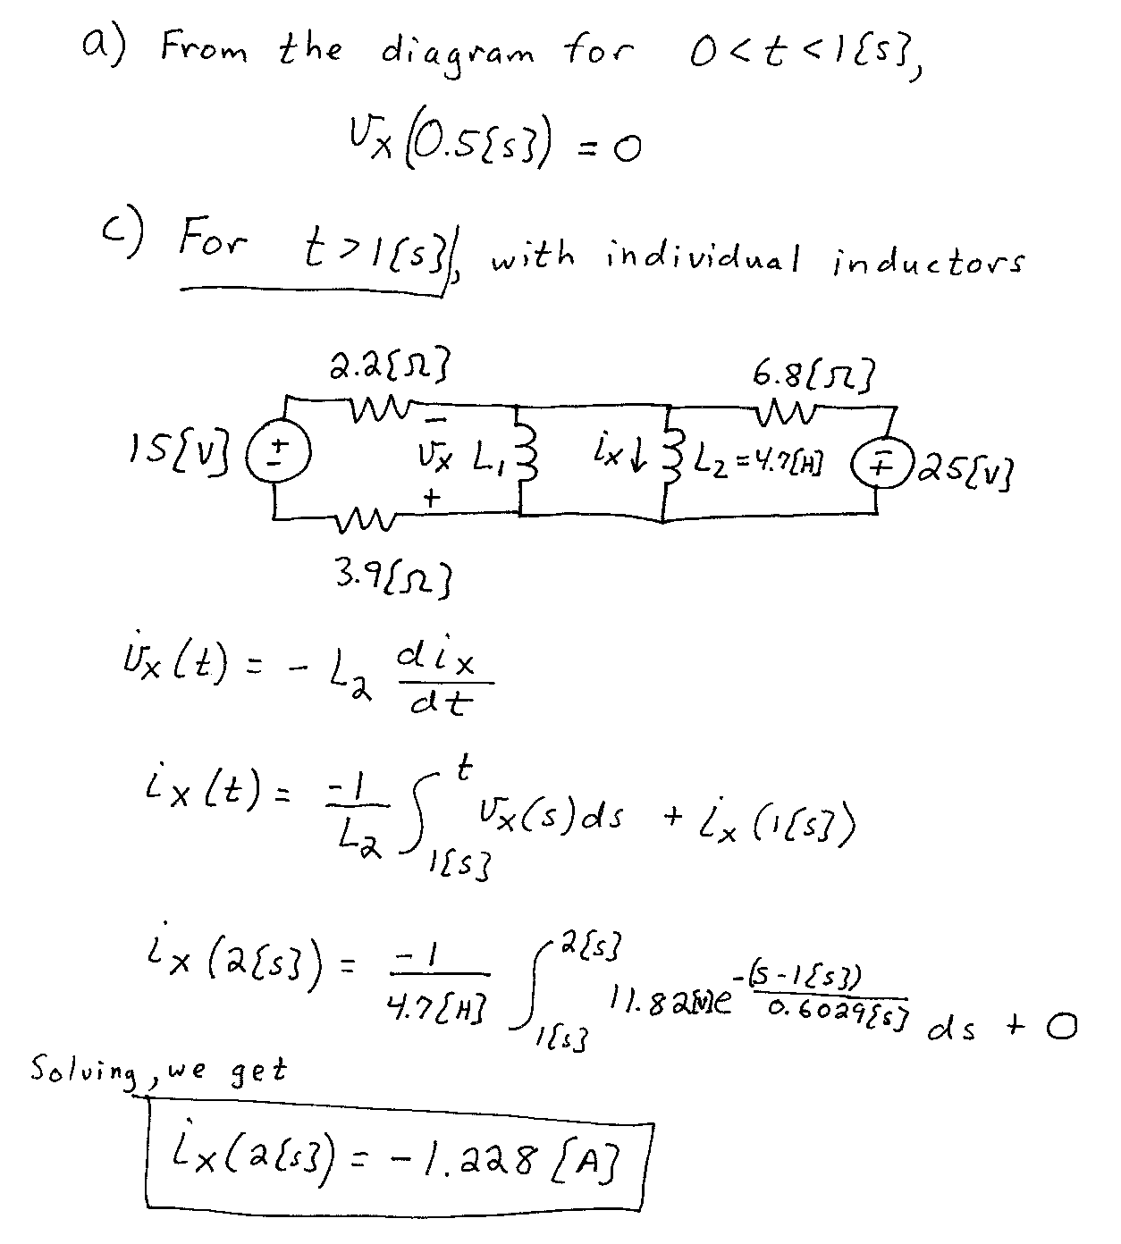

4. {35 Points} The circuit shown below operates in steady-state. Find a numerical expression for *iA(t)*.





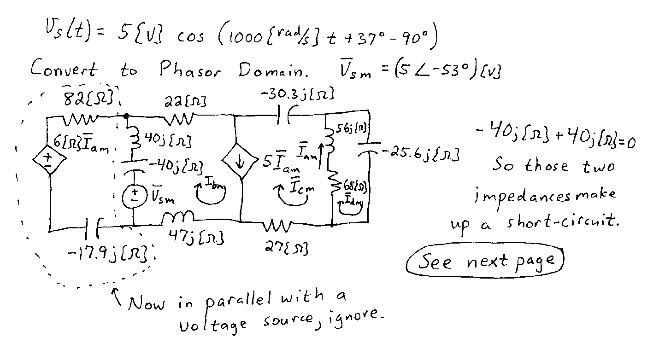

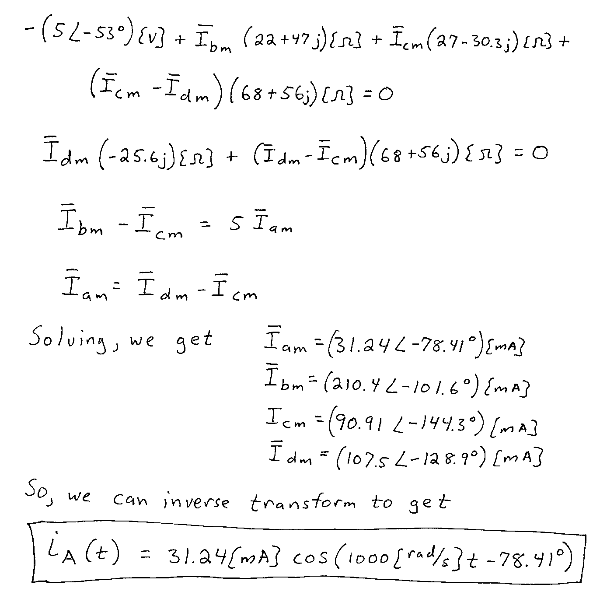

5. {30 Points} The circuit shown below operates in steady-state.

Find all of the possible values of *CX* so that the rms value of *vX(t)* is 25[V].





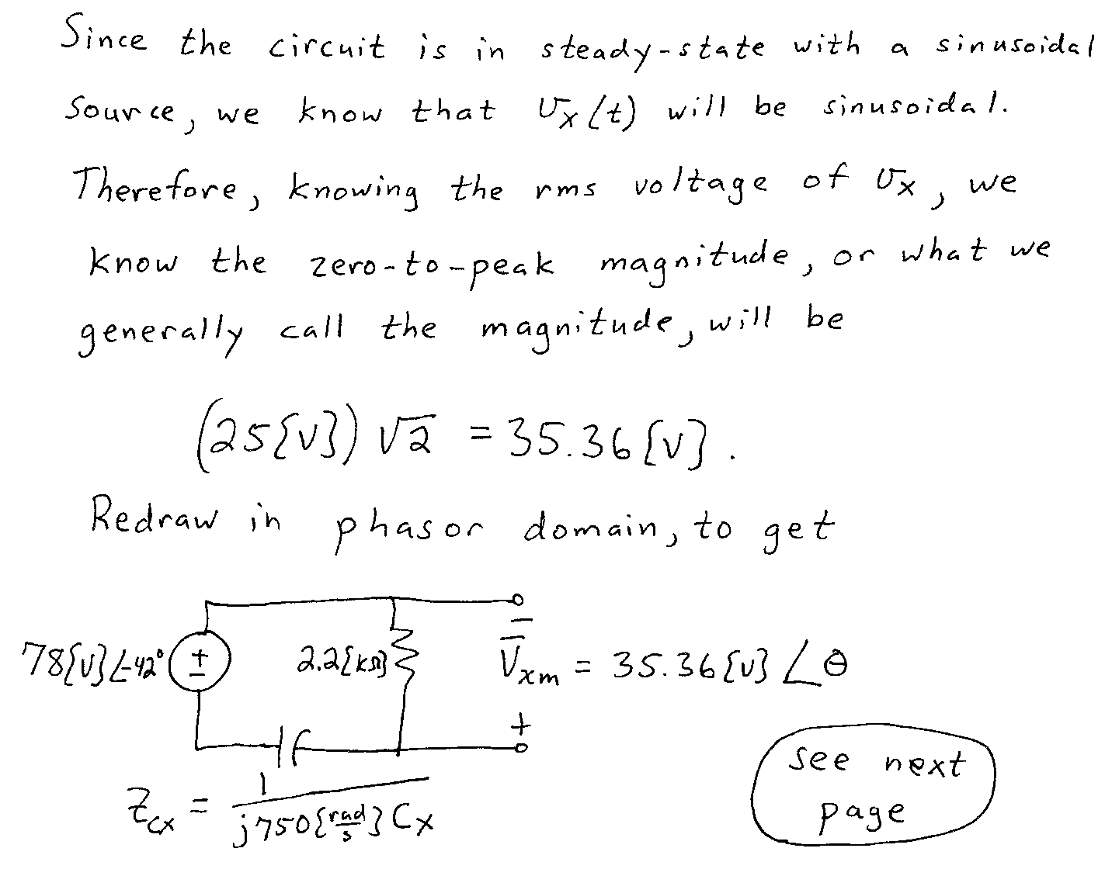

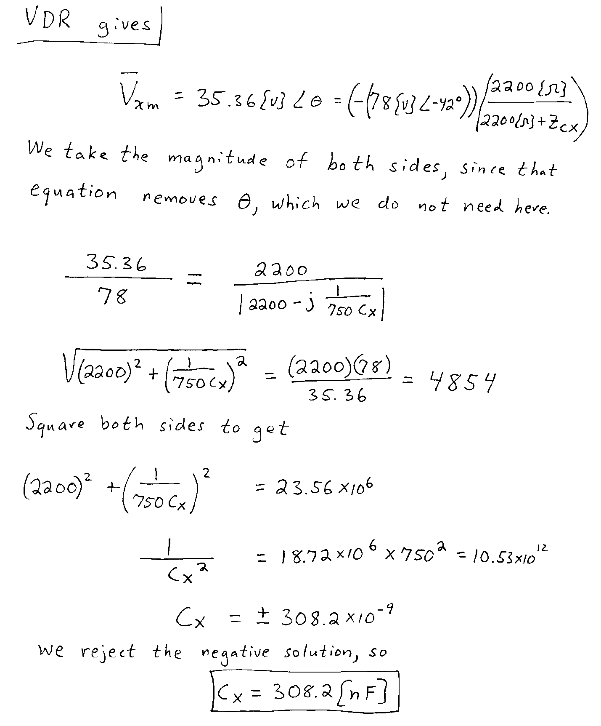

6. {35 Points} The circuit shown below operates in steady-state.

Load 1 absorbs (5200 34[VA].

Load 2 absorbs 4700[W] and delivers 3700[VAR].

Load 3 absorbs 6500[W] at a leading power factor of 0.75.

Load 4 absorbs 4200[VA] at a lagging power factor of 0.75.

Load 5 absorbs (4500 - 2100*j*)[VA].

The source *iS(t)* is given by the expression

