Name: _____________________________ (please print)
Signature: __________________________
Circle your class time: 10-11AM, MWF 1-2:30PM, MW 4-5:30PM TuTh

DO NOT OPEN THIS BOOKLET UNTIL INSTRUCTED TO DO SO

ECE 2300 -- EXAM #2
April 21, 2001

1. This exam is open book, open notes. You may use any calculator or computer. Turn all cell phones or other communications devices off.
2. Show all work on these pages. Show all work necessary to complete the problem. If you go on to another page, indicate clearly where your work can be found. A solution without the appropriate work shown will receive no credit. Clearly indicate your answer (for example, by enclosing it in a box).
3. Show all units in solutions, intermediate results, and figures. Units in the exam will be included between square brackets.
4. Do not use red ink. Do not use red pencil.
5. You will have 90 minutes to work on this exam.

1. ________________/30
2. ________________/25
3. ________________/45
1) {30 Points} For the circuit shown, calculate the Thevenin equivalent resistance with respect to terminals a and b. The given circuit has been in this configuration for a long time.
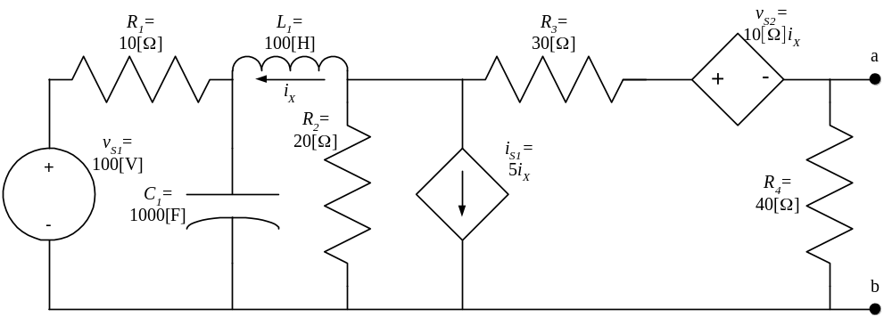
2) {25 Points} In the circuit shown below, the switches SW1 and SW2 were closed for a long time.
At time t = 0, both switches open simultaneously.
For t > 0, calculate the energy trapped in the capacitors.
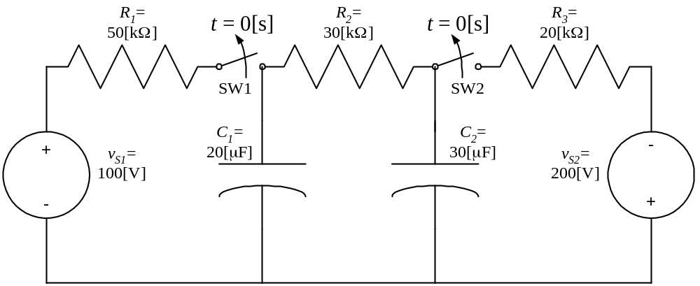
3) {45 Points} In the circuit shown, switch SW1 was in position a and switch SW2 was in position d for a long time.
Then, switch SW1 was moved to position b at t = 0, and stays there.
Then, switch SW2 was moved to position f at t = 10[μs], and stays there.
Find v_{X}(20[μs]).
In your expressions, clearly specify the time interval or moment in time for which your expressions apply.
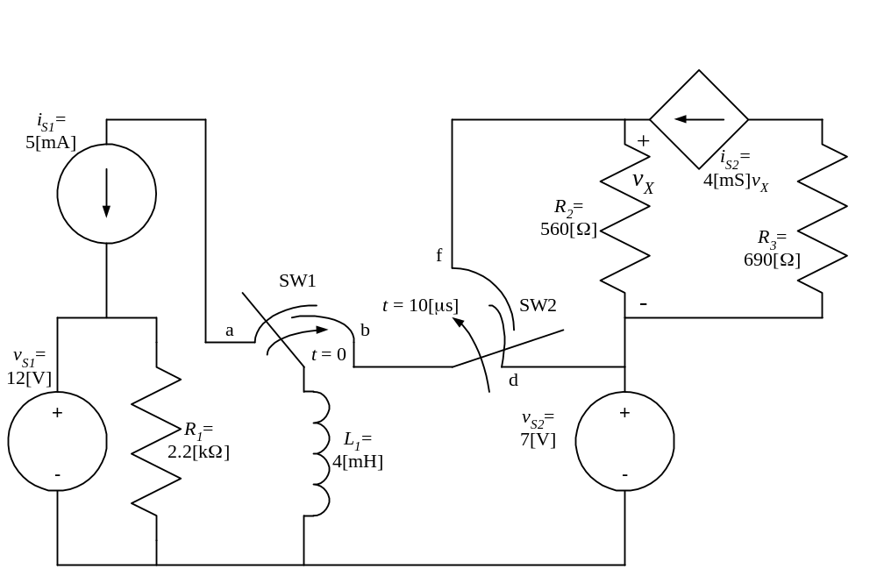
SOLUTION:
1) {30 Points} For the circuit shown, calculate the Thevenin equivalent resistance with respect to terminals a and b. The given circuit has been in this configuration for a long time.
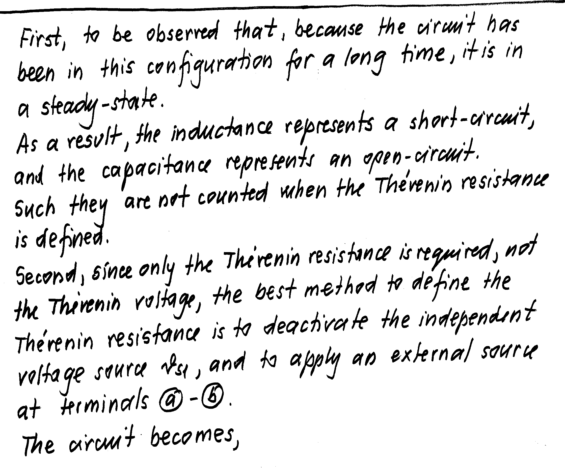
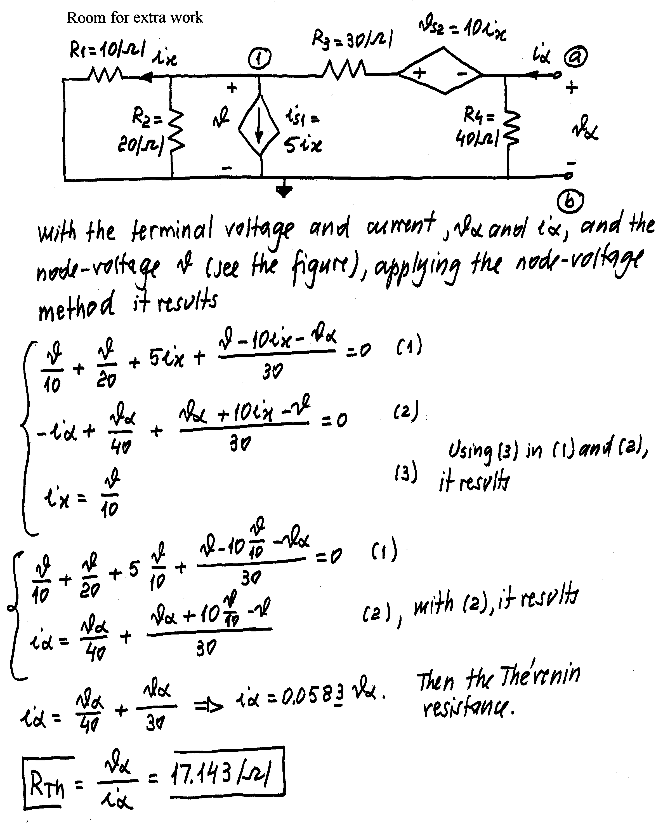
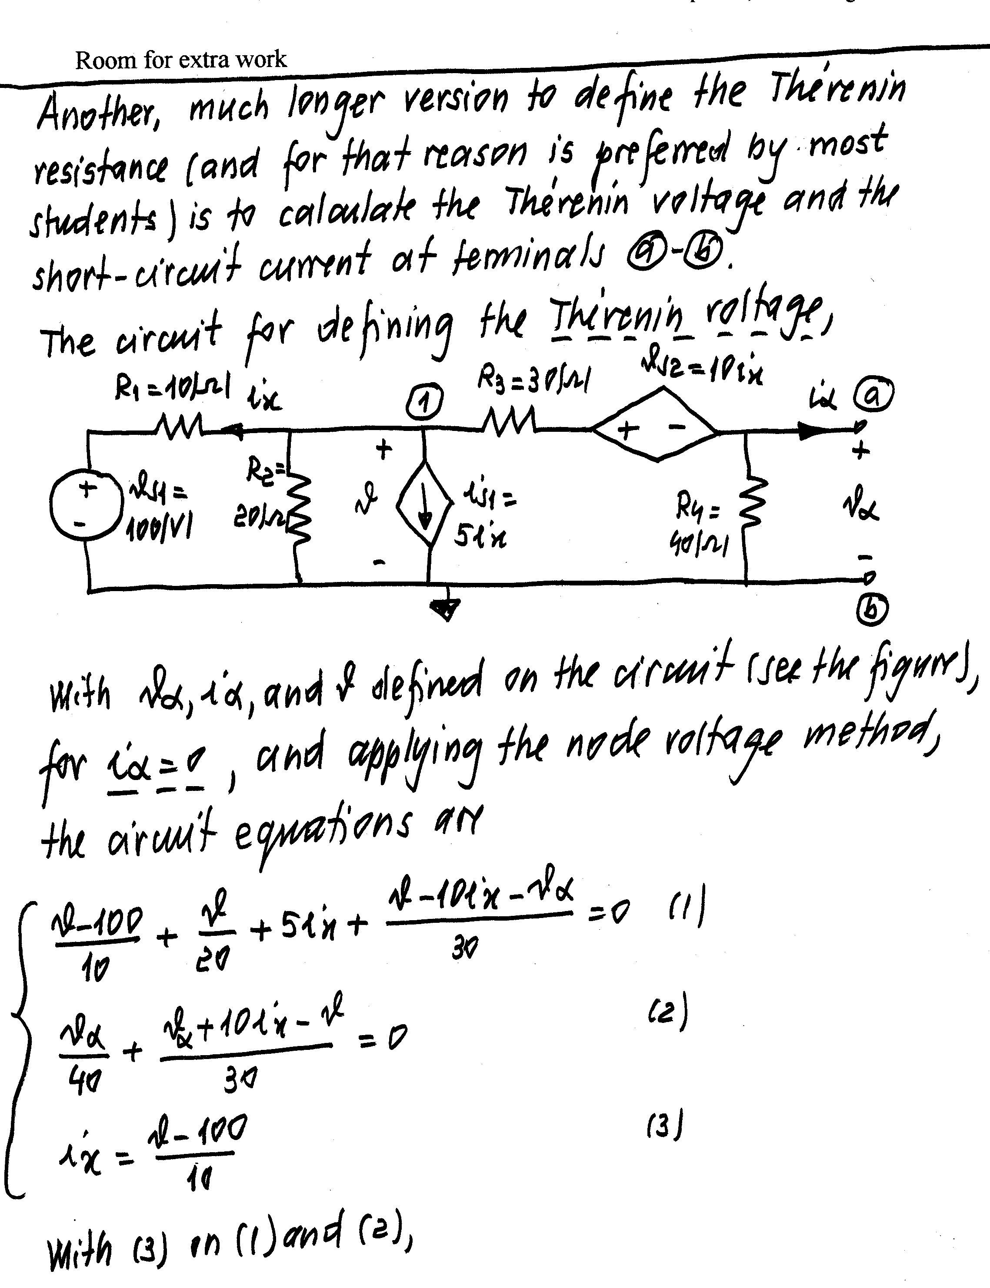
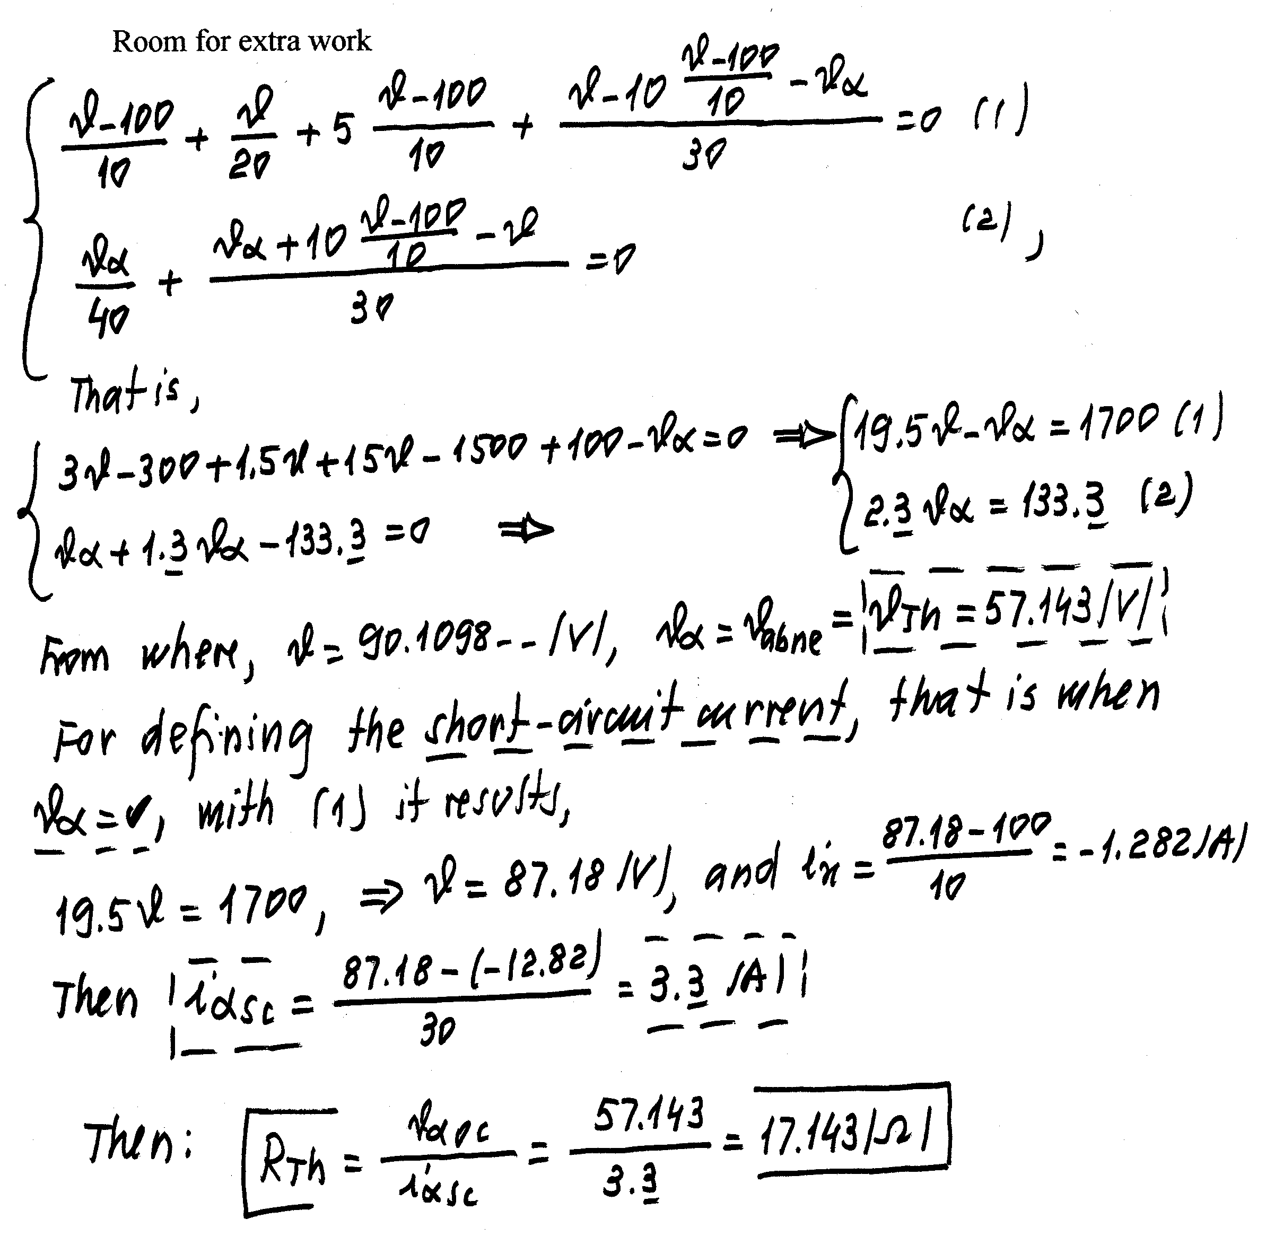

2) {25 Points} In the circuit shown below, the switches SW1 and SW2 were closed for a long time.
At time t = 0, both switches open simultaneously.
For t > 0, calculate the energy trapped in the capacitors.
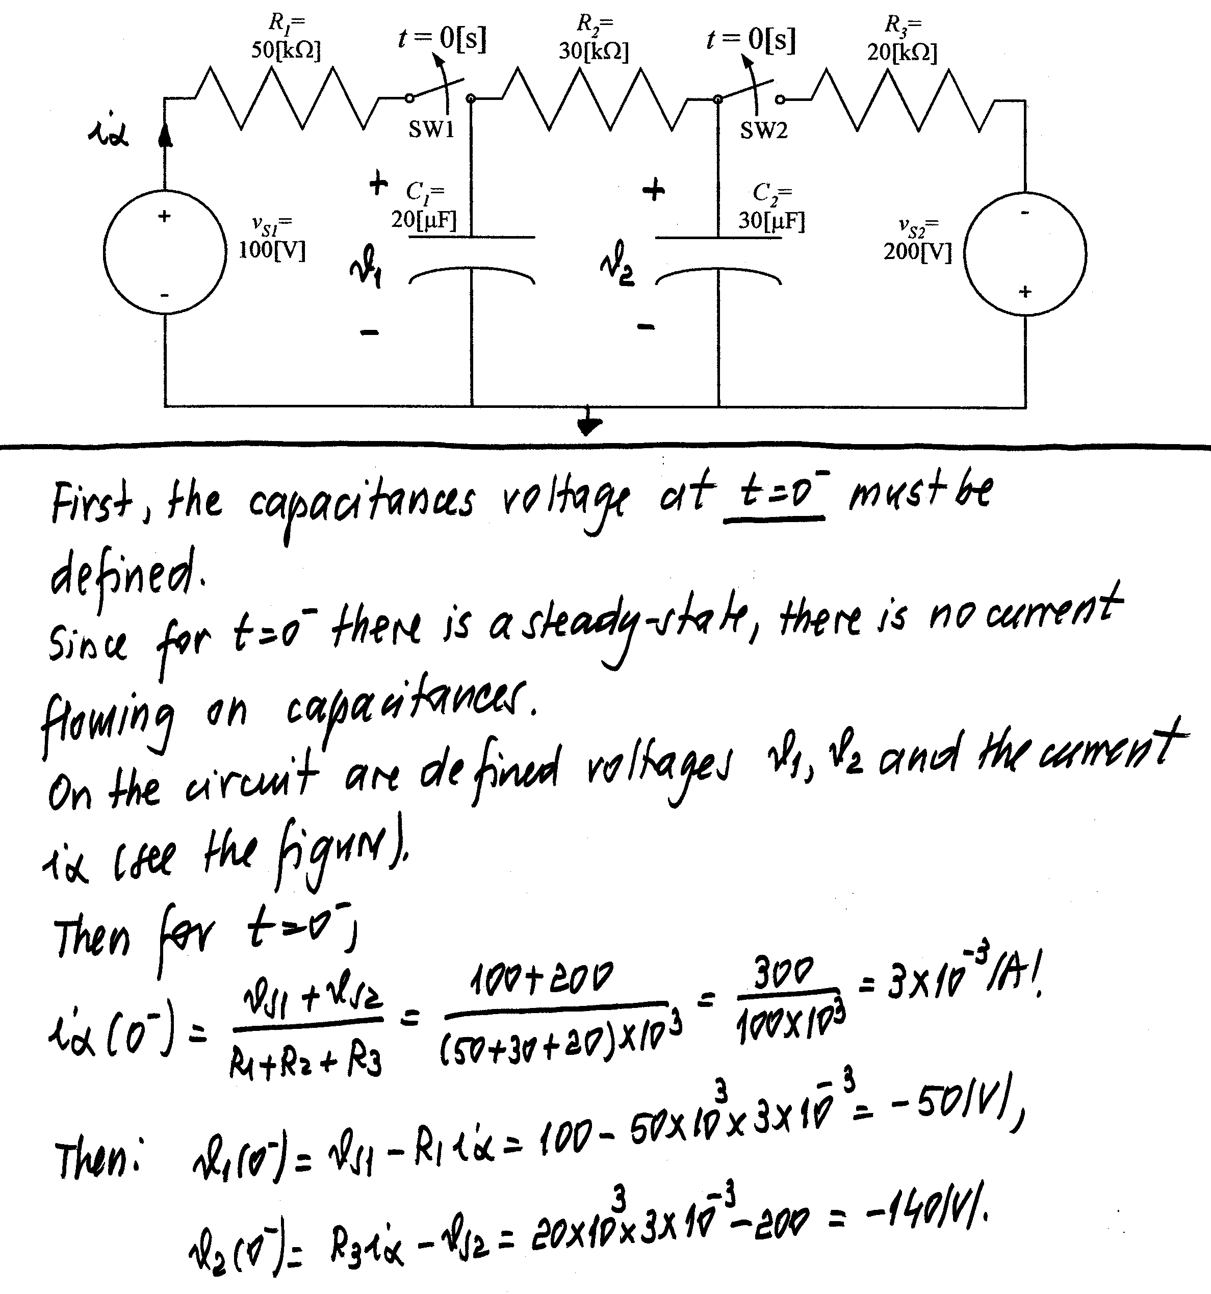
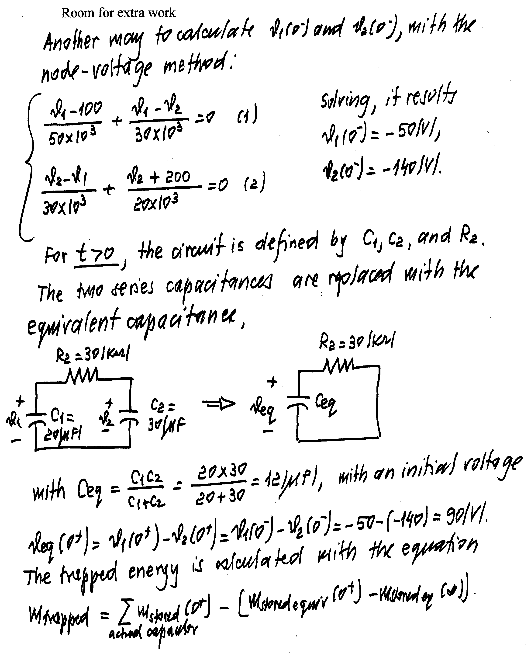
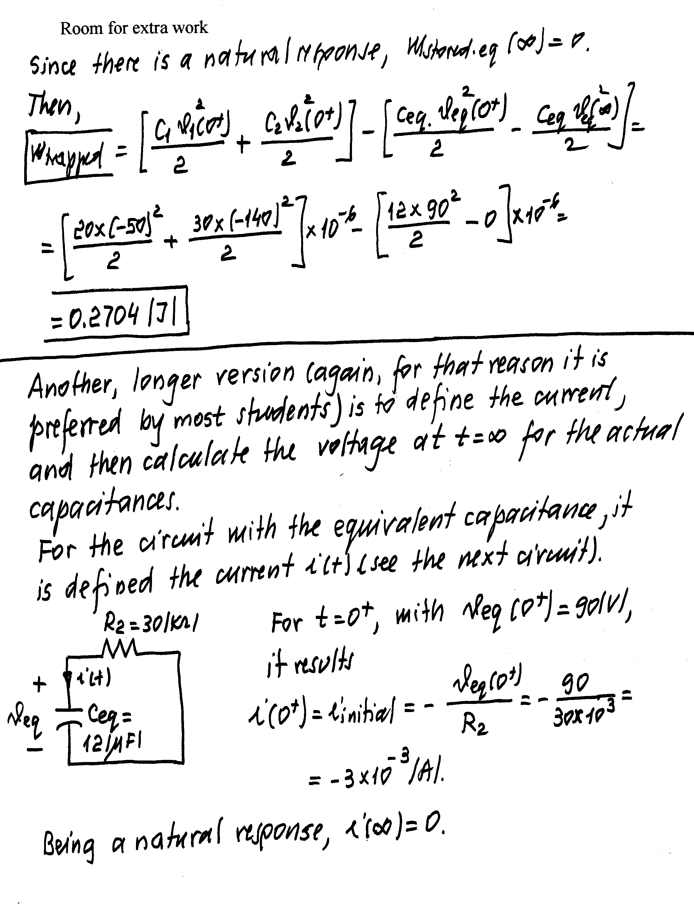
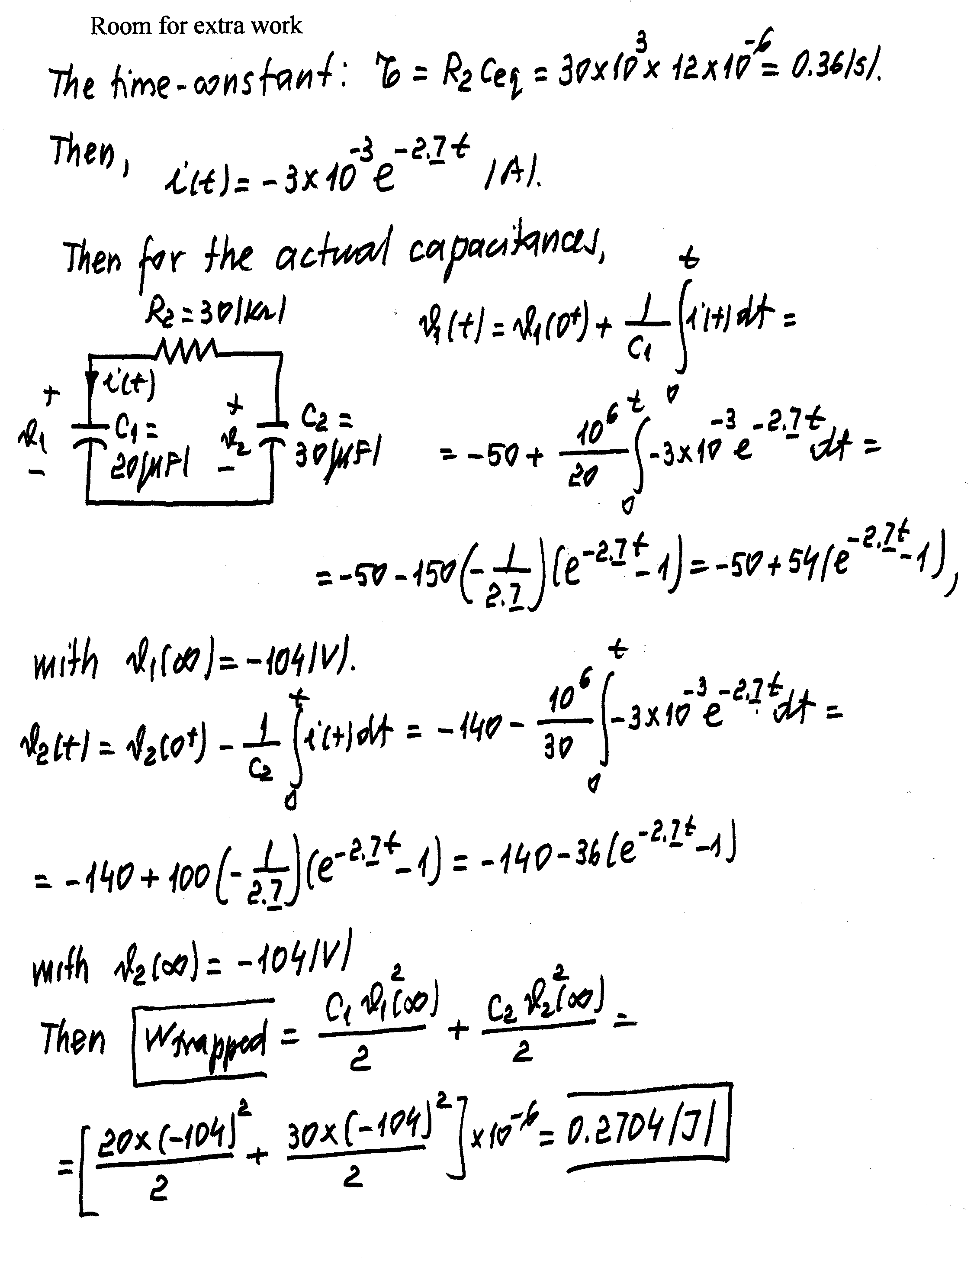

3) {45 Points} In the circuit shown, switch SW1 was in position a and switch SW2 was in position d for a long time.
Then, switch SW1 was moved to position b at t = 0, and stays there.
Then, switch SW2 was moved to position f at t = 10[μs], and stays there.
Find v_{X}(20[μs]).
In your expressions, clearly specify the time interval or moment in time for which your expressions apply.



