Name: _____________________________ (please print)
Signature: __________________________

ECE 2300 -- Quiz #5
Shattuck Section – TuTh 4:00-5:30PM
April 13, 2004

Keep this quiz closed and face up until you are told to begin.

1. This quiz is closed book, closed notes. You may use one 8.5” x 11” crib sheet, or its equivalent.
2. Show all work on these pages. Show all work necessary to complete the problem. A solution without the appropriate work shown will receive no credit. A solution which is not given in a reasonable order will lose credit.
3. It is assumed that your work will begin on the same page as the problem statement. If you choose to begin your work on another page, you must indicate this on the page with the problem statement, with a clear indication of where the work can be found. If your work continues on to another page, indicate clearly where your work can be found. Failure to indicate this clearly will result in a loss of credit.
4. Show all units in solutions, intermediate results, and figures. Units in the quiz will be included between square brackets.
5. Do not use red ink. Do not use red pencil.
6. You will have 45 minutes to work on this quiz.

________________/20
Room for extra work
For the circuit shown, the switches were open for a long time, before both of them closed at t = 0. It is known that
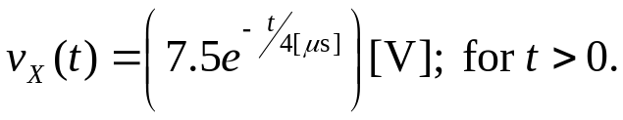
- Find R₁.
- Find the energy stored in inductor L₁ at t = ∞.
- Find R₂.
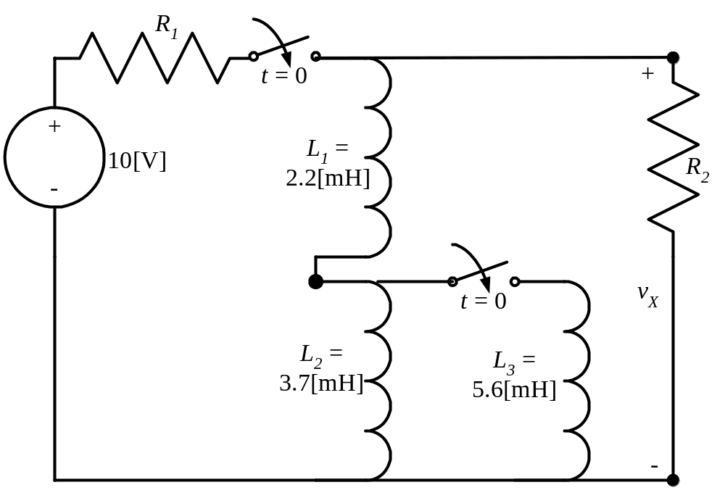

ECE 2300 -- Quiz #5 – April 13, 2004 –4:00 – 5:30PM TuTh Shattuck Section Solution
For the circuit shown, the switches were open for a long time, before both of them closed at t = 0. It is known that
- Find R₁.
- Find the energy stored in inductor L₁ at t = ∞.
- Find R₂.
Solution:


