Name: _____________________________ (please print)
Signature: __________________________

ECE 2300 -- Quiz #4
Shattuck Section – TuTh 4:00PM
March 24, 2005

Keep this quiz closed and face up until you are told to begin.

1. This quiz is closed book, closed notes. You may use one 8.5” x 11” crib sheet, or its equivalent.
2. Show all work on these pages. Show all work necessary to complete the problem. A solution without the appropriate work shown will receive no credit. A solution which is not given in a reasonable order will lose credit.
3. It is assumed that your work will begin on the same page as the problem statement. If you choose to begin your work on another page, you must indicate this on the page with the problem statement, with a clear indication of where the work can be found. If your work continues on to another page, indicate clearly where your work can be found. Failure to indicate this clearly will result in a loss of credit.
4. Show all units in solutions, intermediate results, and figures. Units in the quiz will be included between square brackets.
5. Do not use red ink. Do not use red pencil.
6. You will have 30 minutes to work on this quiz.

________________/20
Room for extra work
- For the circuit given below, find the Norton equivalent as seen by the current source.
- Find the power delivered by the current source in this circuit.

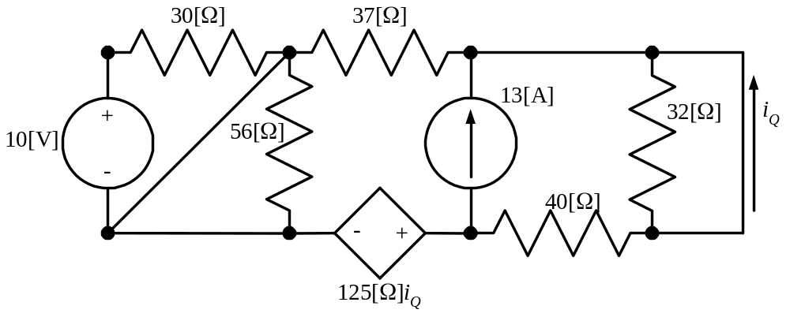

Room for extra work

ECE 2300 -- Quiz #4 – March 24, 2005 –4PM TuTh Shattuck Section Solution

- For the circuit given below, find the Norton equivalent as seen by the current source.
- Find the power delivered by the current source in this circuit.

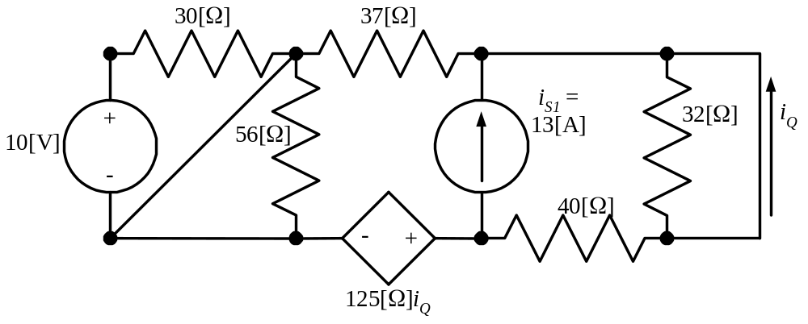

Solution:
a) To get the equivalent seen by the i_{S1} current source, we need to remove the current source. We will name the terminals of the current source A and B, and then remove it. We will choose to find the short-circuit current i_{SC} first.
The new diagram with the current source removed, and the short circuit current defined is given below.
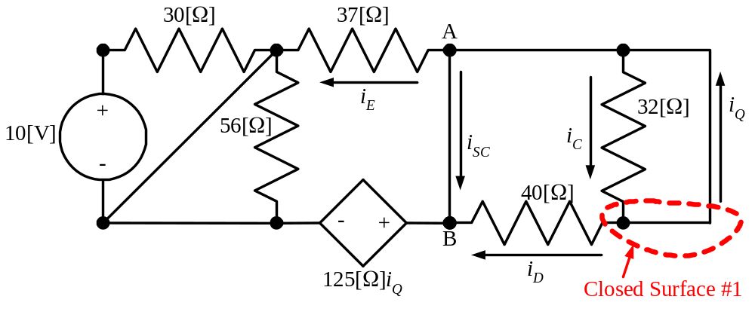
We have named some other currents that will be useful to us. First, we note that the voltage across the 32[Ω] resistor is zero, so
i_{C} = 0.
Similarly, the voltage across the 40[Ω] resistor is zero, so
i_{D} = 0.
Now we can write KCL for Closed Surface #1, and get
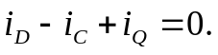
Therefore, we know that
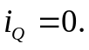

Now, we will write KVL for Closed Loop #1, as shown in the diagram that follows.
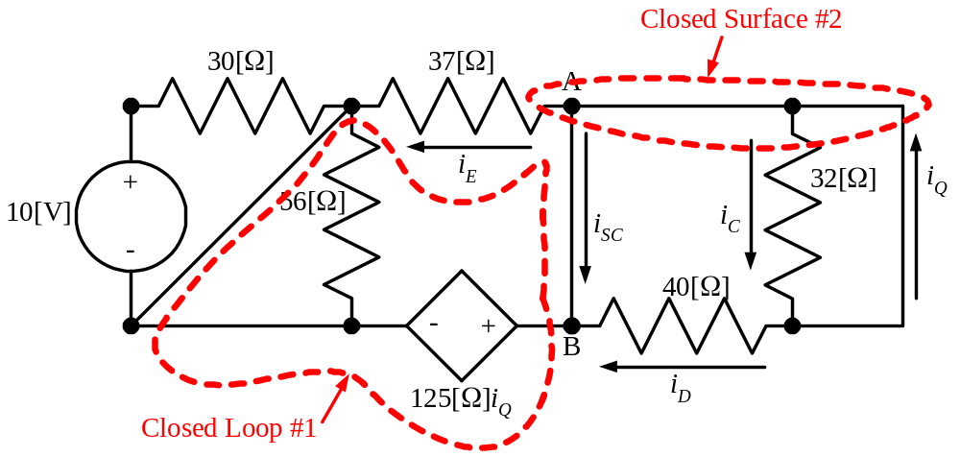
When we write KVL, we get
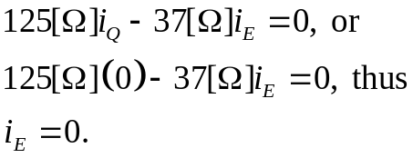
With this, we can write KCL for Closed Surface #2, and get
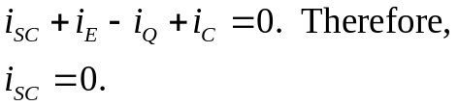
Since the short-circuit current is zero, the open-circuit voltage must also be zero. Thus, we need to find the equivalent resistance. We set the independent sources equal to zero, and apply a test source between terminals A and B. We will choose a 1[V] voltage source. We get the following diagram. The goal is to find the current through the voltage source, which we have named i_{T} in this diagram. Now, we can certainly solve this circuit, but we can make the solution easier to see by simplifying it first. Note that there is no voltage across the 32[Ω], 56[Ω], and 30[Ω} resistors, since there are wires across them. Therefore, they have no current through them, and can be removed.
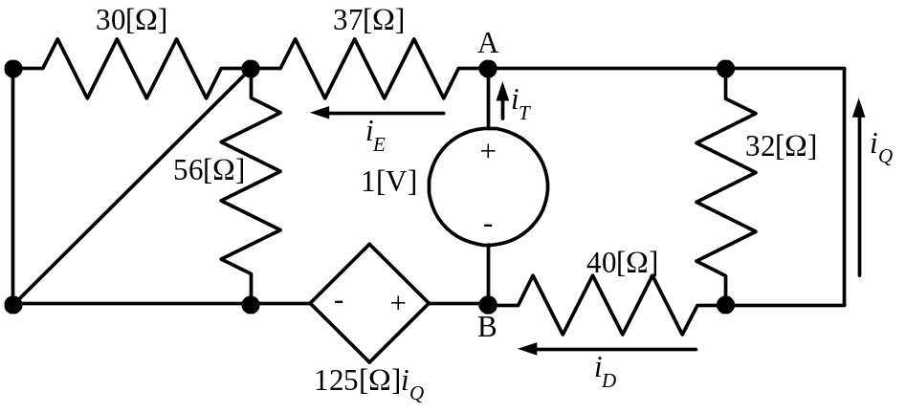
Thus, we remove these resistors, and we get a new diagram, which is equivalent with respect to the 1[V] voltage source.
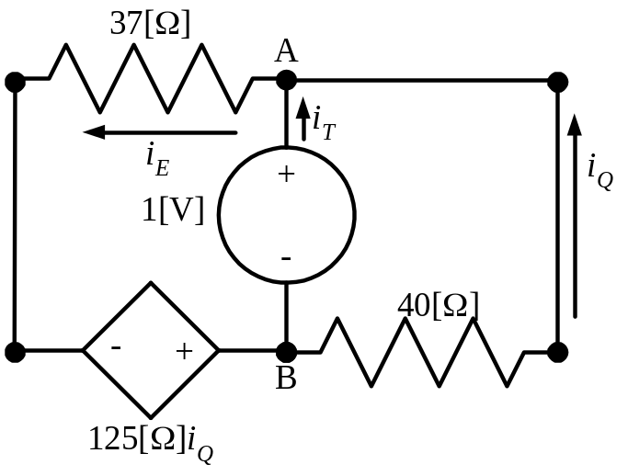
In this diagram, it is clear that
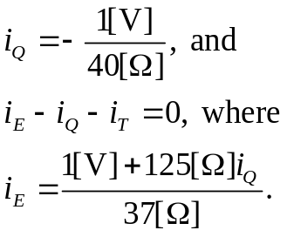
Solving, we get
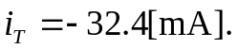
Thus, we can get R_{EQ}, as
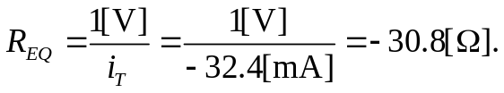
Therefore, the Norton equivalent as seen by the current source in the original circuit, is a zero-valued current source in parallel with a resistance of –30.8[Ω]. This is just the resistance.
b) The power delivered by the current source will be the power absorbed by the resistance, and therefore we can write that
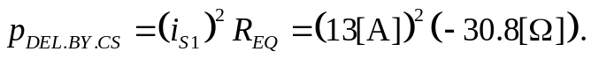
Thus
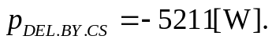

Note: If we had noticed a key point in the original circuit, our solution would have gone much faster. In that original circuit, we had a number of elements or groups of elements that were in parallel with a wire, which means that they were in parallel with a zero-valued voltage source. This means that we can use one of our additional source transformations to solve for things outside the equivalent circuit. Look at the original circuit again, here.
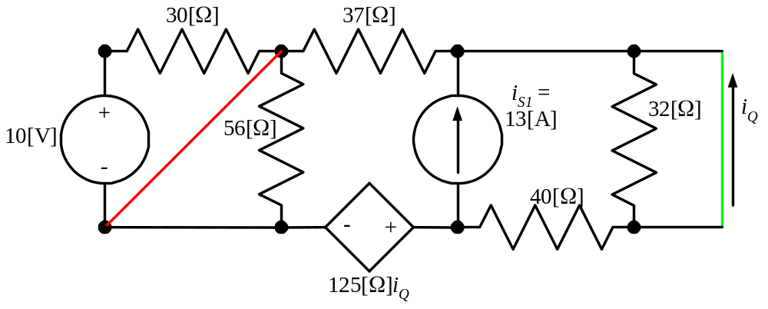
The 10[V] source in series with the 30[Ω] resistor are in parallel with the wire shown here in red. The 56[Ω] resistor is also in parallel with that wire. The 32[Ω] resistor is in parallel with the wire shown here in green. Thus, if we remove these items, using this special source transformation, the current source, which is outside these equivalents, will not be able to tell the difference. Thus, we will have a simpler circuit, which follows.
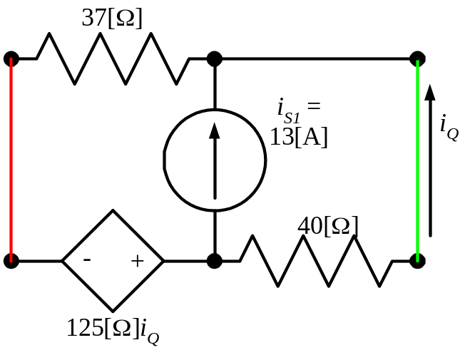
There are no other independent sources outside of the current source, and therefore the Norton current, seen by the current source, will have to be zero. We can solve immediately for the equivalent resistance seen by the current source. If we see this, and know how to use equivalent circuits properly, we can solve this problem much more easily.

