Name: _____________________________ (please print)
Signature: __________________________

ECE 2300 -- Exam #1
March 7, 2009

Keep this exam closed until you are told to begin.

1. This exam is closed book, closed notes. You may use one 8.5” x 11” crib sheet, or its equivalent.
2. Show all work on these pages. Show all work necessary to complete the problem. A solution without the appropriate work shown will receive no credit. A solution that is not given in a reasonable order will lose credit. Clearly indicate your answer (for example by enclosing it in a box).
3. It is assumed that your work will begin on the same page as the problem statement. If you choose to begin your work on another page, you must indicate this on the page with the problem statement, with a clear indication of where the work can be found. If your work continues on to another page, indicate clearly where your work can be found. Failure to indicate this clearly will result in a loss of credit.
4. Show all units in solutions, intermediate results, and figures. Units in the exam will be included between square brackets.
5. Do not use red ink. Do not use red pencil.
6. You will have 90 minutes to work on this exam.

1. ________________/25
2. ________________/25
3. ________________/20
4. ________________/30
Total = 100
Room for extra work
1. {25 Points} Use the circuit below to solve this problem.
a) Find v_{Q}.
b) Find v_{X}.
c) Find the power delivered by the current source.

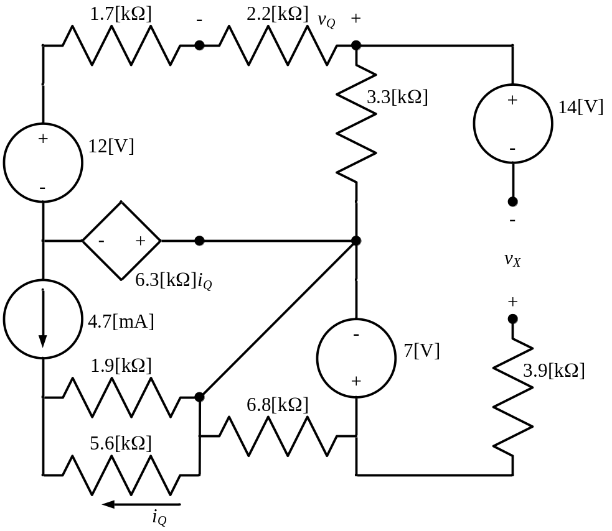

Room for extra work

2. {25 Points} Use the circuit shown below to solve this problem. Show your steps in some clear fashion. You are strongly encouraged to redraw the diagram as needed to make your work more clear.
a) Find the equivalent resistance with respect to terminals F and J.
b) Find the equivalent resistance as seen by terminals A and L.

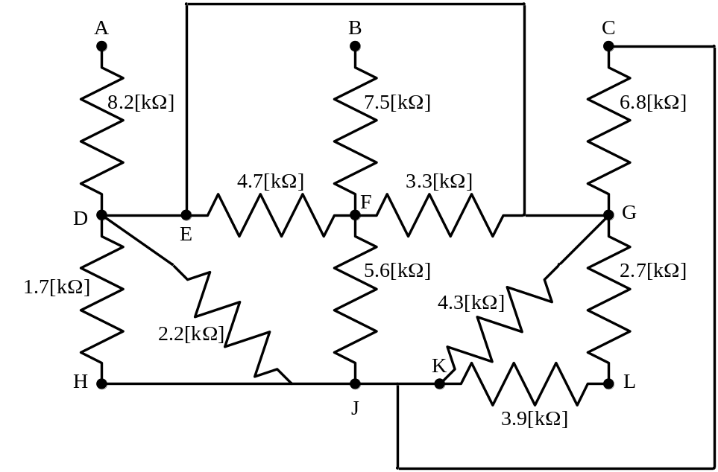

Room for extra work

3. {20 Points} A measurement of the resistance of an unknown resistor R_{X} is attempted by a novice using a voltmeter and an ammeter, as shown in the circuit below. The intention is to simultaneously measure the current through the resistor with the ammeter, and the voltage across the resistor with the voltmeter. The resistance will then be obtained from the ratio of these two readings. For this problem, assume that the meter resistance for the ammeter is 300[Ω], and its full-scale current is 2.5[mA]. For this problem, assume that the meter resistance for the voltmeter is 10[kΩ], and the full-scale voltage is 25[V].
a) If R_{X} is 1.43[kΩ], find the ratio of the voltmeter reading to the ammeter reading in this circuit.
b) What voltmeter and ammeter characteristics would need to change to get a measurement of resistance from this technique to be within 1% of the correct answer, if R_{X} is 1.43[kΩ]?
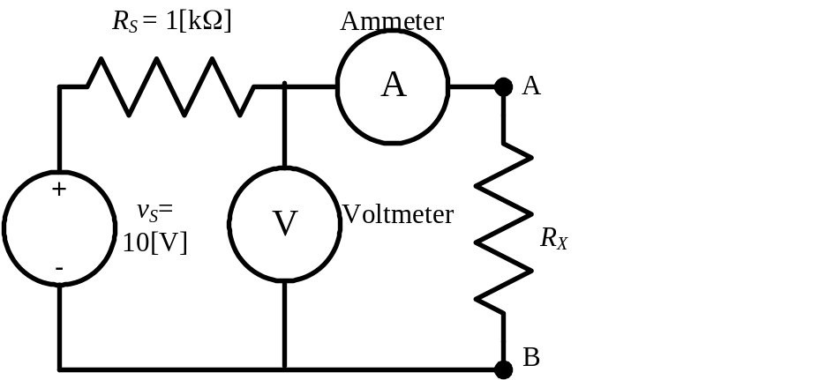

Room for extra work

4. {30 Points} For the given circuit, use the Node-Voltage method to write a complete set of independent equations that could be used to solve this circuit. You only need to write one set of equations. Do not simplify the circuit. Do not attempt to solve or simplify your equations. Define all variables.

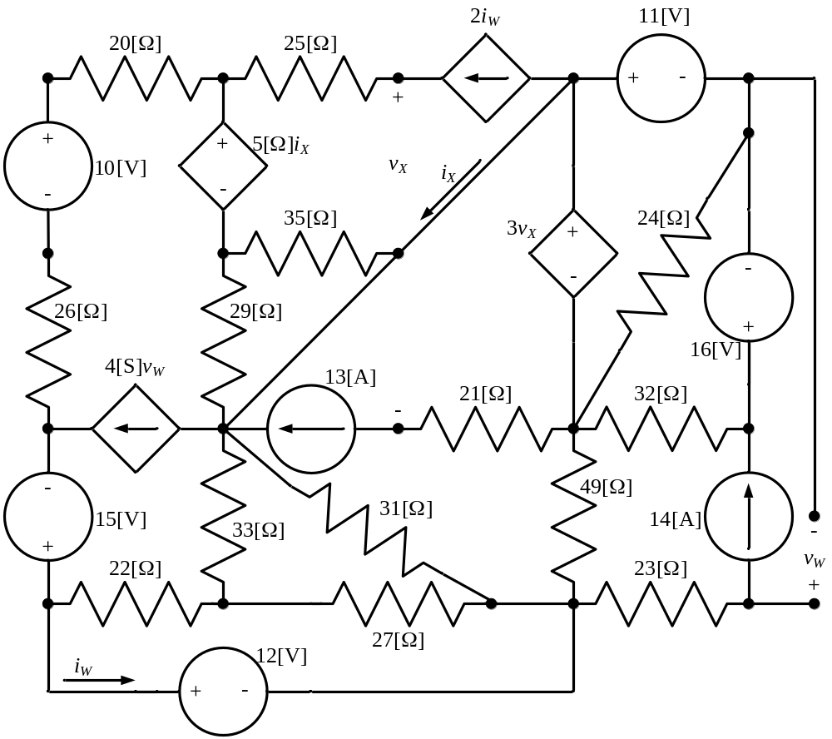

Solutions:
1. {25 Points} Use the circuit below to solve this problem.
a) Find v_{Q}.
b) Find v_{X}.
c) Find the power delivered by the current source.
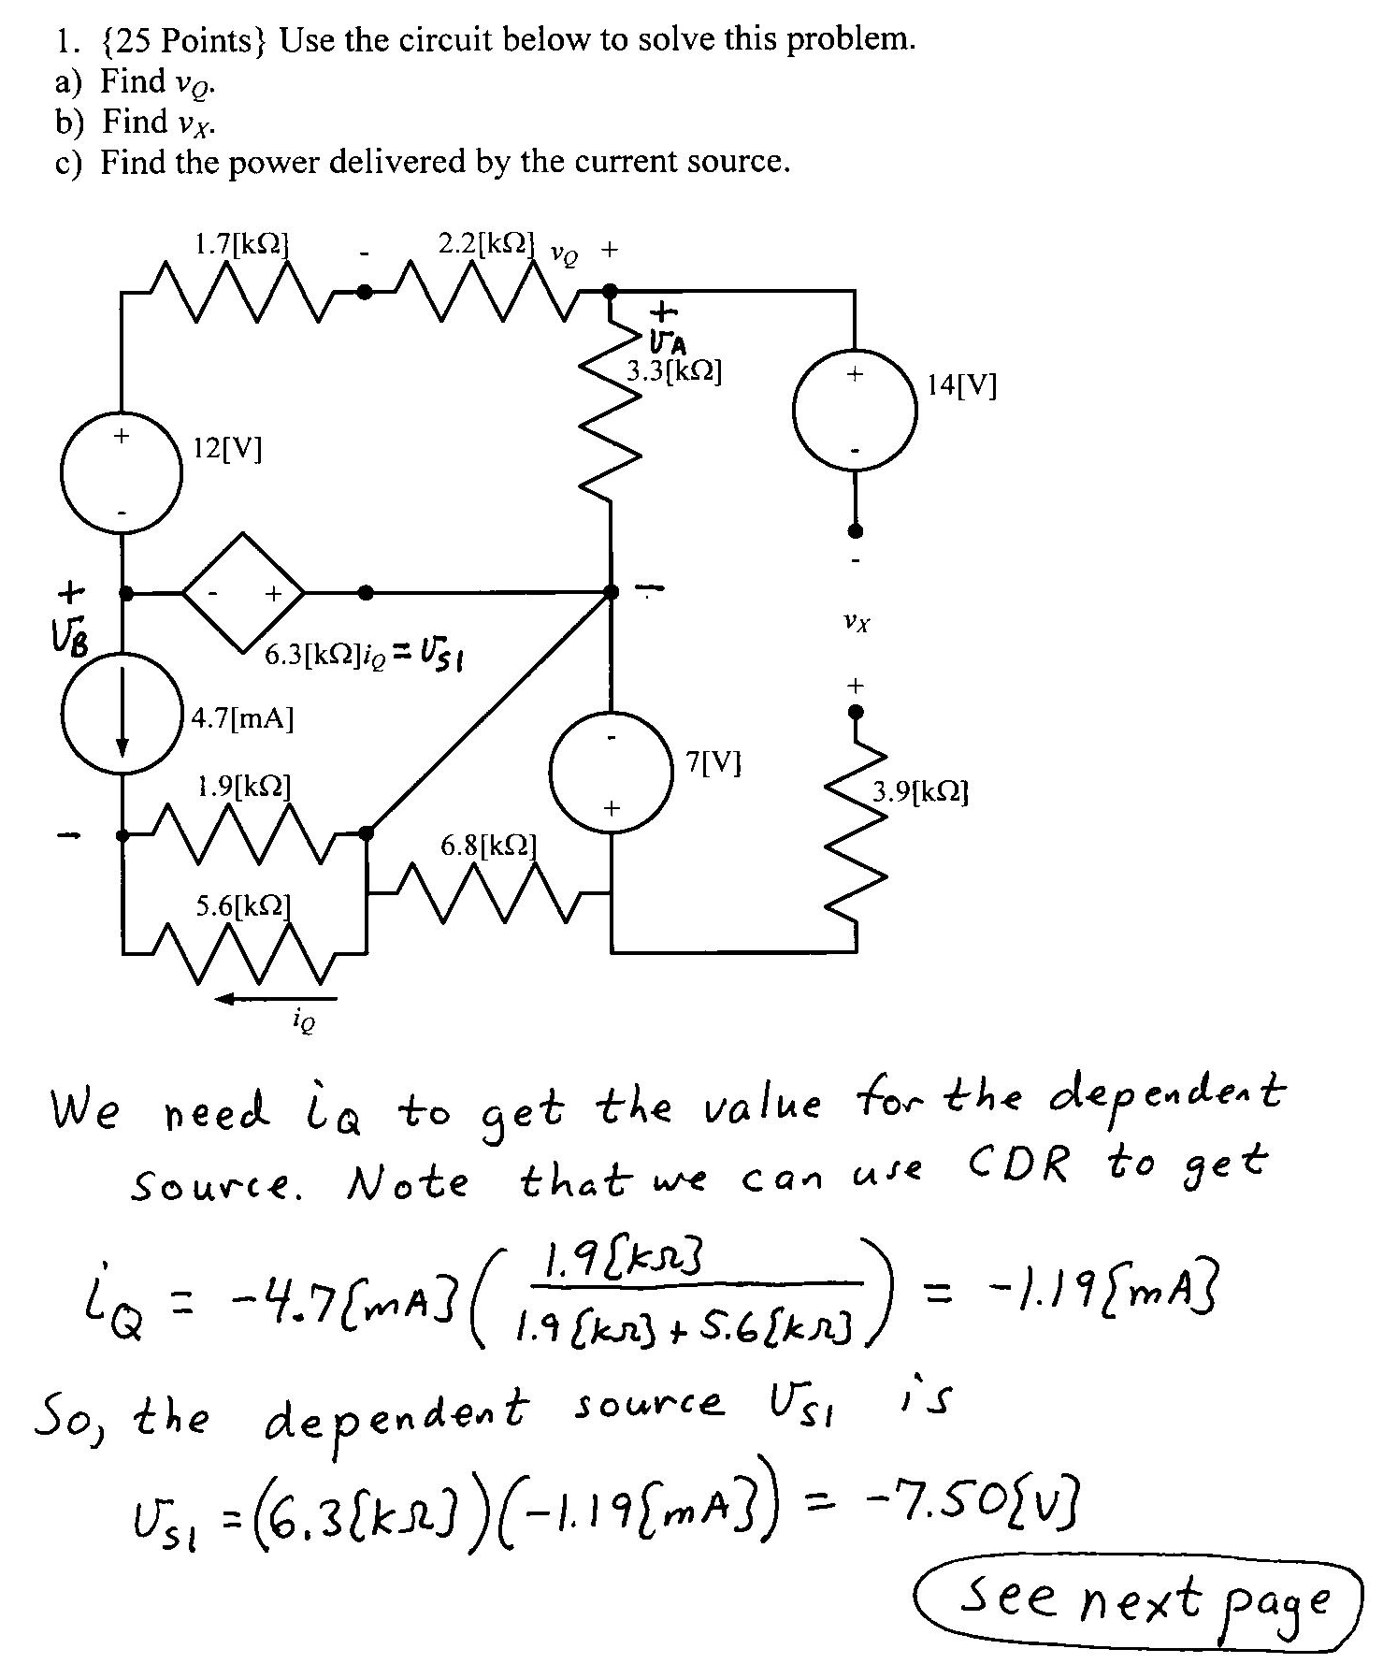
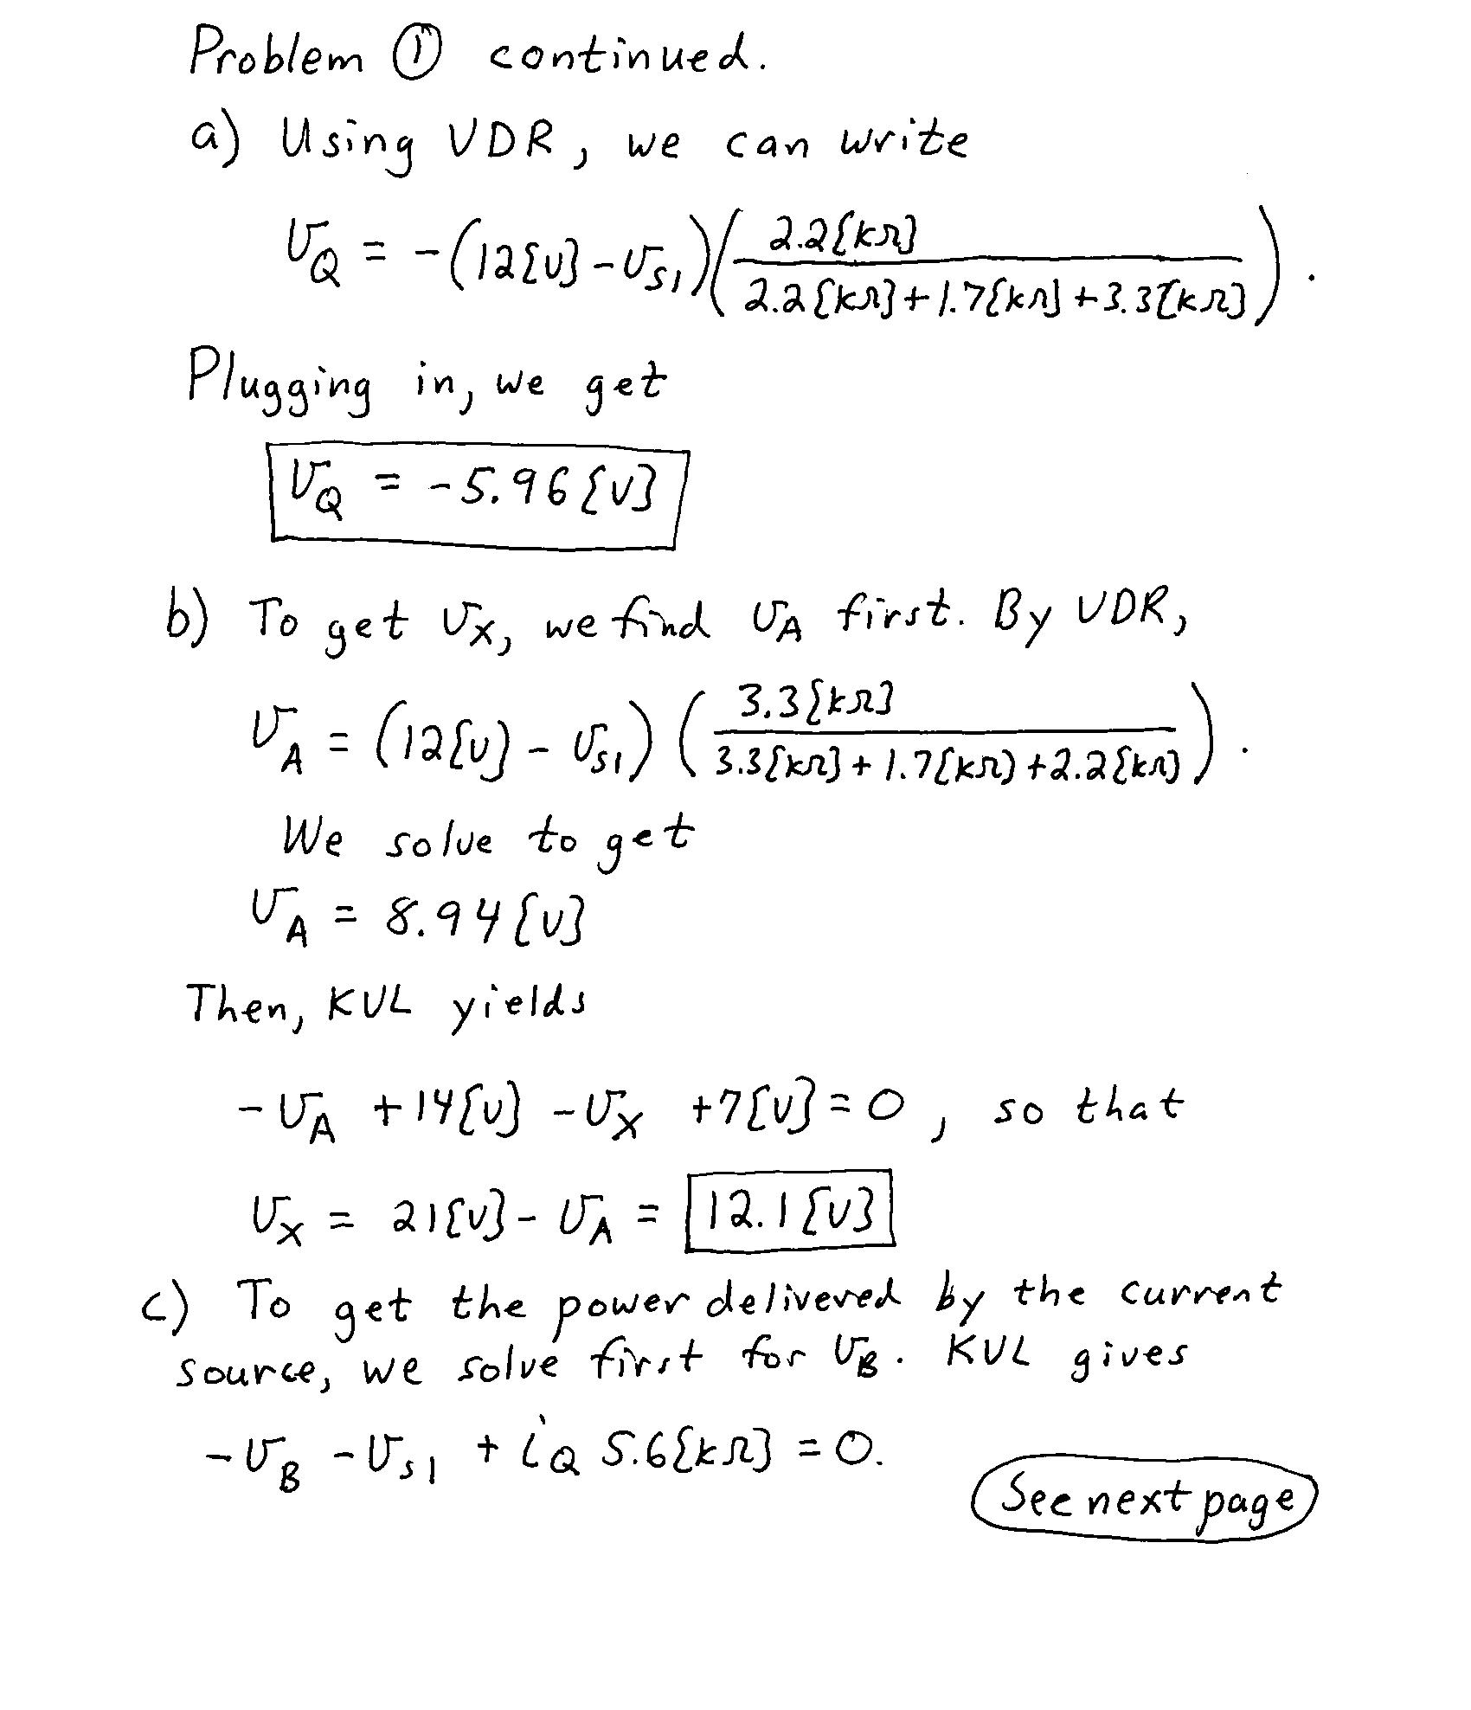
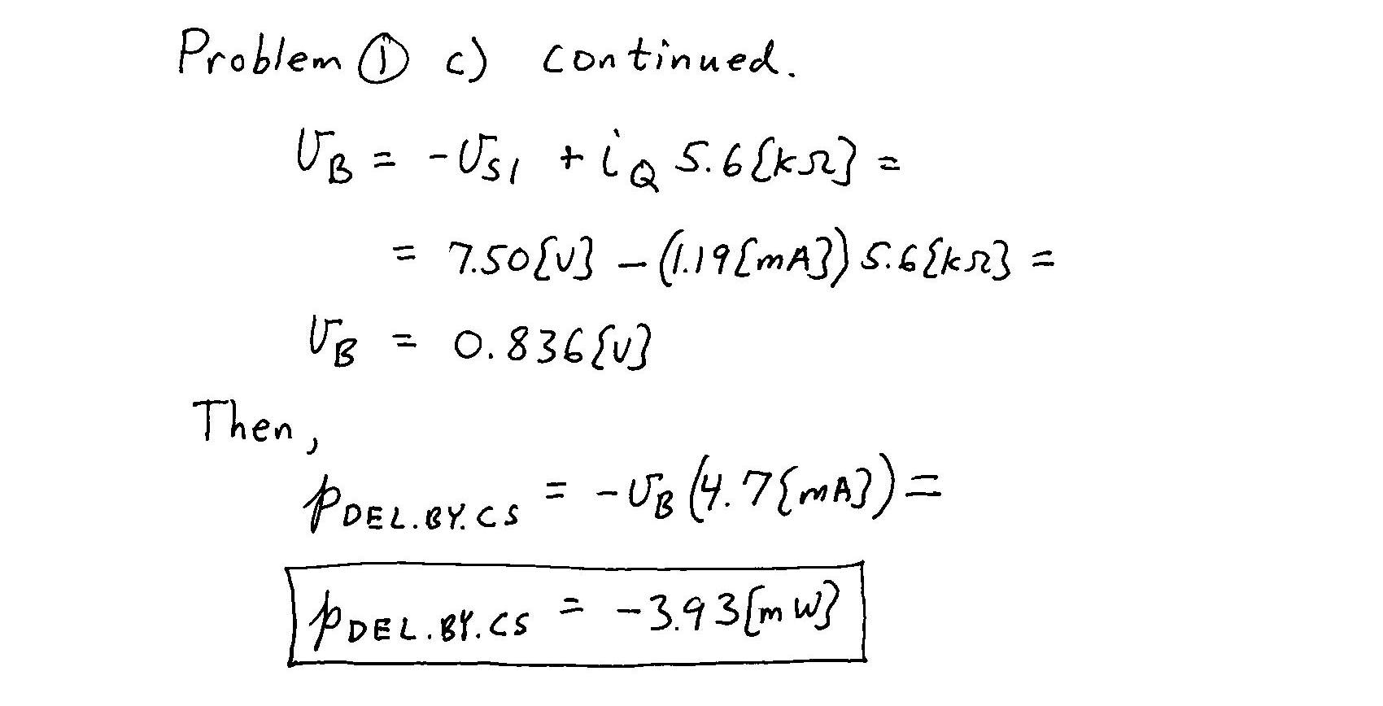

2. {25 Points} Use the circuit shown below to solve this problem. Show your steps in some clear fashion. You are strongly encouraged to redraw the diagram as needed to make your work more clear.
a) Find the equivalent resistance with respect to terminals F and J.
b) Find the equivalent resistance as seen by terminals A and L.
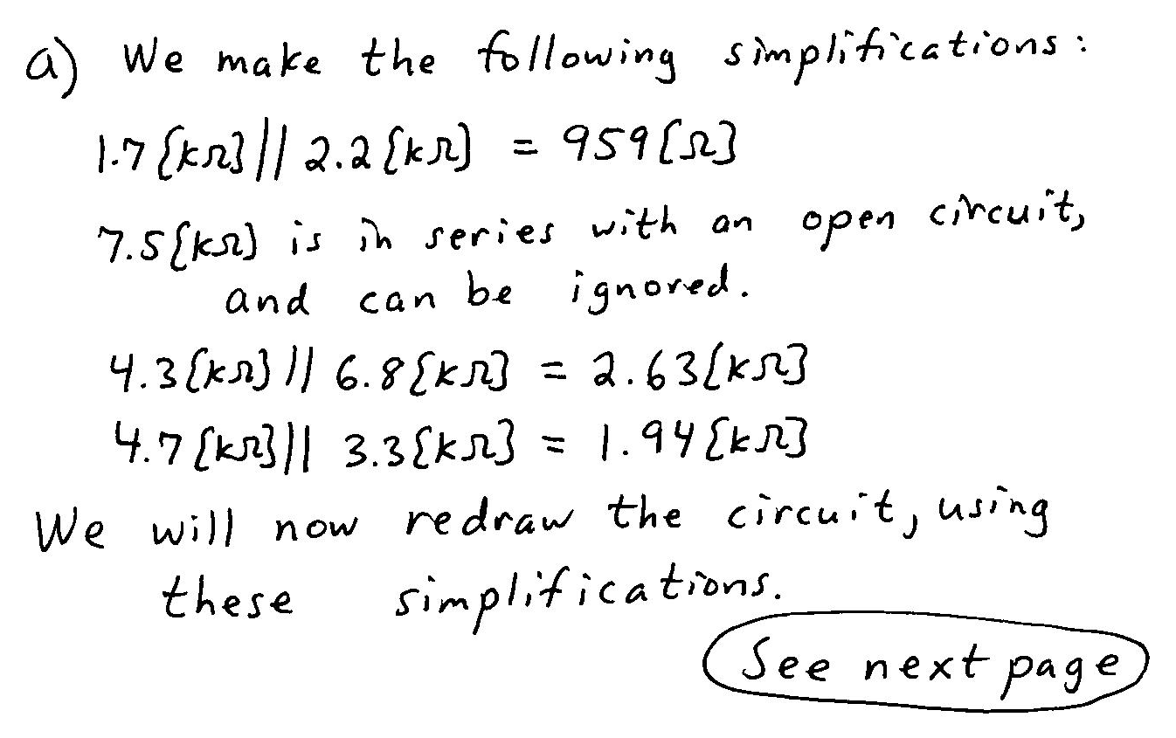
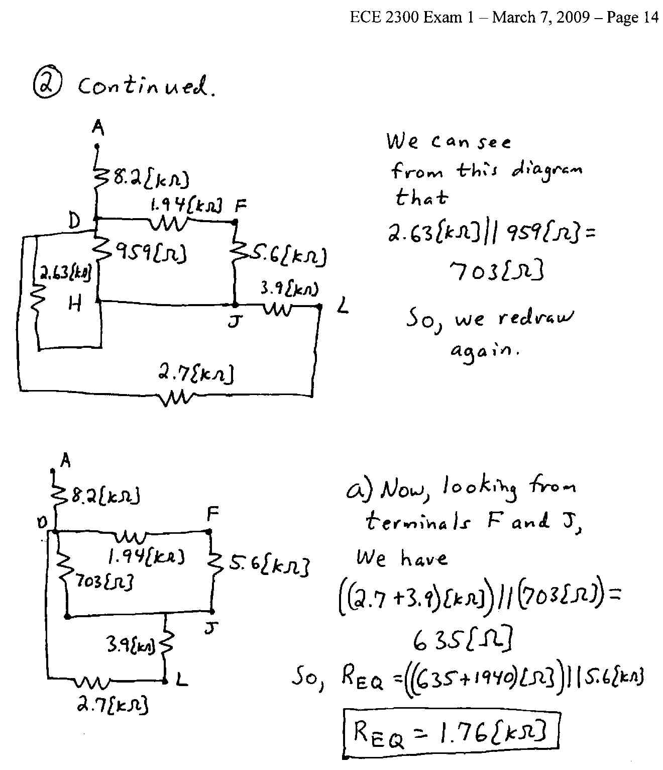
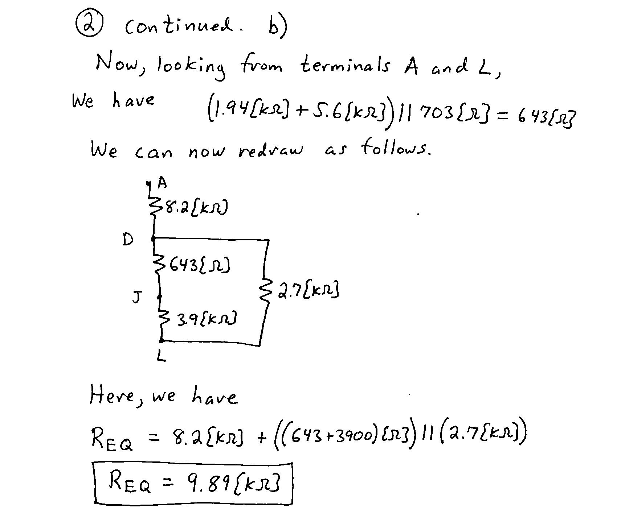
3. {20 Points} A measurement of the resistance of an unknown resistor R_{X} is attempted by a novice using a voltmeter and an ammeter, as shown in the circuit below. The intention is to simultaneously measure the current through the resistor with the ammeter, and the voltage across the resistor with the voltmeter. The resistance will then be obtained from the ratio of these two readings. For this problem, assume that the meter resistance for the ammeter is 300[Ω], and its full-scale current is 2.5[mA]. For this problem, assume that the meter resistance for the voltmeter is 10[kΩ], and the full-scale voltage is 25[V].
a) If R_{X} is 1.43[kΩ], find the ratio of the voltmeter reading to the ammeter reading in this circuit.
b) What voltmeter and ammeter characteristics would need to change to get a measurement of resistance from this technique to be within 1% of the correct answer, if R_{X} is 1.43[kΩ]?

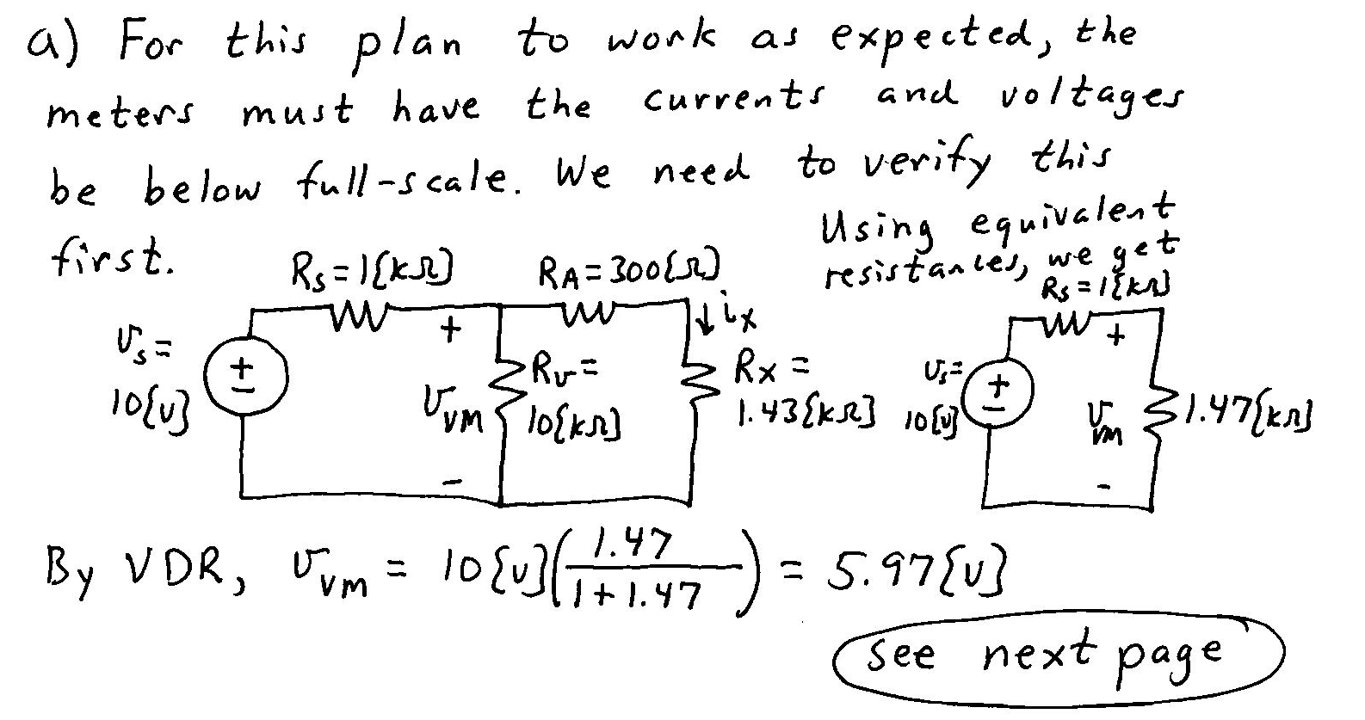
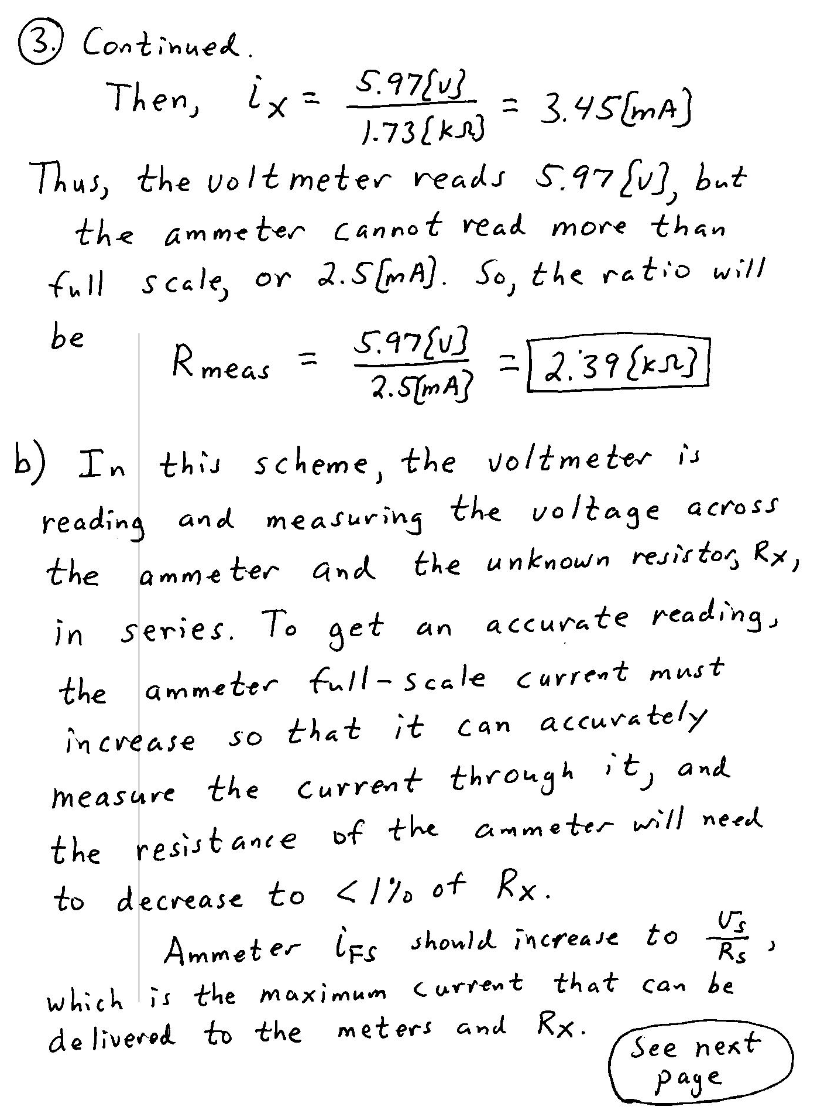
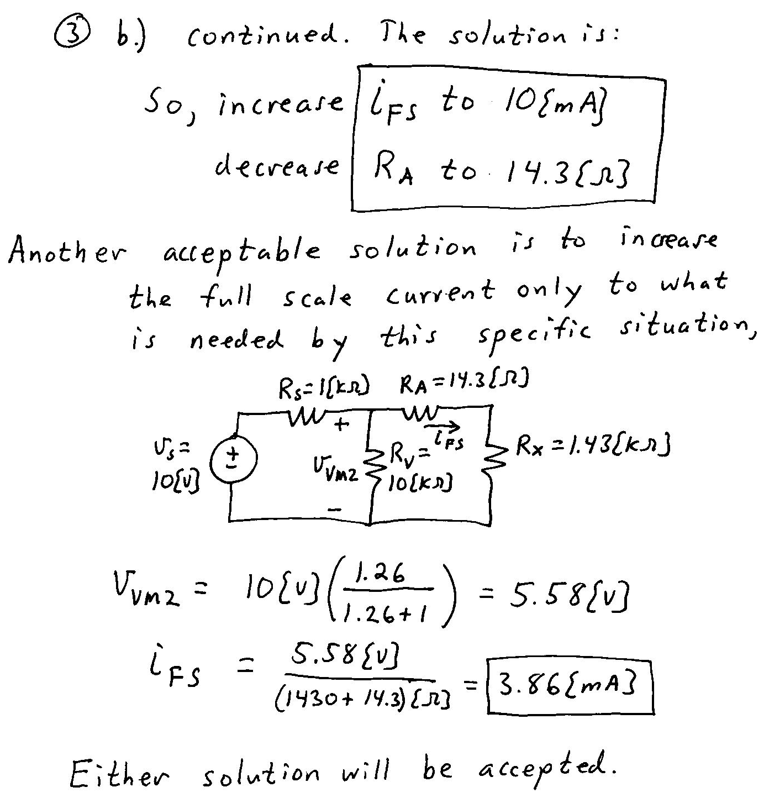
4. {30 Points} For the given circuit, use the Node-Voltage method to write a complete set of independent equations that could be used to solve this circuit. You only need to write one set of equations. Do not simplify the circuit. Do not attempt to solve or simplify your equations. Define all variables.


