Name: _____________________________ (please print)
Signature: __________________________
Section (underline one): Trombetta Shattuck

ECE 2300 – Final Exam
May 4, 2013

Keep this exam closed and face up until you are told to begin.

1. This exam is closed book, closed notes. You may use one 8.5” x 11” crib sheet, or its equivalent.
2. Show all work on these pages. Show all work necessary to complete the problem. A solution without the appropriate work shown will receive no credit. A solution which is not given in a reasonable order will lose credit.
3. It is assumed that your work will begin on the same page as the problem statement. If you choose to begin your work on another page, you must indicate this on the page with the problem statement, with a clear indication of where the work can be found. If your work continues on to another page, indicate clearly where your work can be found. Failure to indicate this clearly will result in a loss of credit.
4. Show all units in solutions, intermediate results, and figures. Units in the exam will be included between square brackets.
5. Do not use red ink. Do not use red pencil.
6. You will have 170 minutes to work on this exam.

1. ________________/30 2. ________________/20

3. ________________/20 4. ________________/20

5. ________________/40 6. ________________/30

7. ________________/40

Total________________/200
Room for extra work

1. (30 points) When a 2[kΩ] resistor is connected to terminals a and b in the circuit in Figure 1, the current i_{O} as defined in Figure 2 is -2.119[A]. When that 2[kΩ] resistor is removed, and a current source of 120[mA] is connected between terminals a and b in its place, the voltage v_{O} as defined in Figure 3 is 750.46[V]. If then a -120[V] voltage source is connected in place of the current source between a and b, what will be the current i_{Z} as defined in Figure 4?

Room for extra work

2. (20 points) In the circuit below, find the power delivered by the dependent current source.

Room for extra work

3. (20 points) There are two separate voltmeters available for use in a laboratory. One voltmeter has a full-scale reading of 200[V], and has an equivalent resistance of 6.8[MΩ]. The second voltmeter has a full-scale reading of 150[V], and has an equivalent resistance of 25[MΩ]. The plan is to increase the range of voltages that can be measured by putting the two voltmeters in series, and placing the series combination across an unknown voltage. Find the largest voltage that can be measured using the two voltmeters in series, assuming that the voltage will be determined by adding the voltages measured on the two voltmeters.

Room for extra work

4. (20 points) Use the mesh-current method to write a complete set of equations that could be used to solve the circuit below. Do not simplify the circuit. Do not attempt to solve the equations. You must define all circuit variables. Do not skip any meshes.
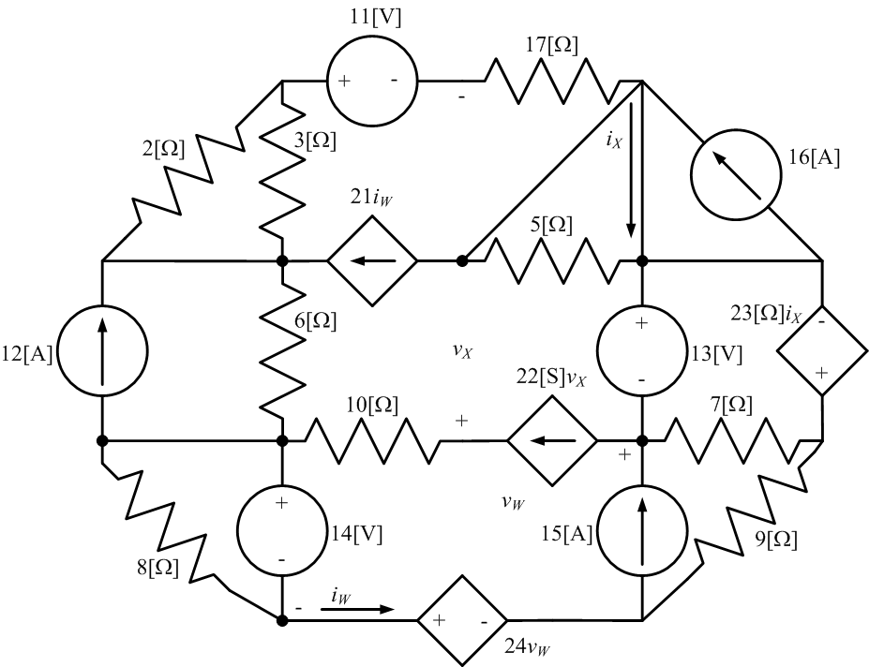

Room for extra work

5. (40 points) In the circuit given below, the switch was in position A for long time before it moved at t = 0 to position B. The switch then moved back to A at
t = 200[μs]. Find i_{L}(t) for t ≥ 200[μs].

Room for extra work

6. (30 points) Find the Thévenin impedance Z_{TH} as seen by the current source, at
ω = 1500[rad/s]. Draw a circuit model for Z_{TH}, modeling it either as a resistance in series with an inductor or as a resistance in series with a capacitor.

Room for extra work

7. (40 points) In the circuit below, the load is enclosed with a dashed line.
a) Find the value of the inductance L₁ that will make the voltage v_{S}(t) be in phase with the current i_{X}(t).
b) Find the value of the power factor angle for the load that results from the value of L₁ found in part a).
c) Find the value of the power factor of the load, if L₁ = 3.9[mH]. Indicate whether this is a leading or a lagging power factor.
d) Find the apparent power absorbed by the load, if L₁ = 3.9[mH].

1. (30 points) When a 2[kΩ] resistor is connected to terminals a and b in the circuit in Figure 1, the current i_{O} as defined in Figure 2 is -2.119[A]. When that 2[kΩ] resistor is removed, and a current source of 120[mA] is connected between terminals a and b in its place, the voltage v_{O} as defined in Figure 3 is 750.46[V]. If then a -120[V] voltage source is connected in place of the current source between a and b, what will be the current i_{Z} as defined in Figure 4?

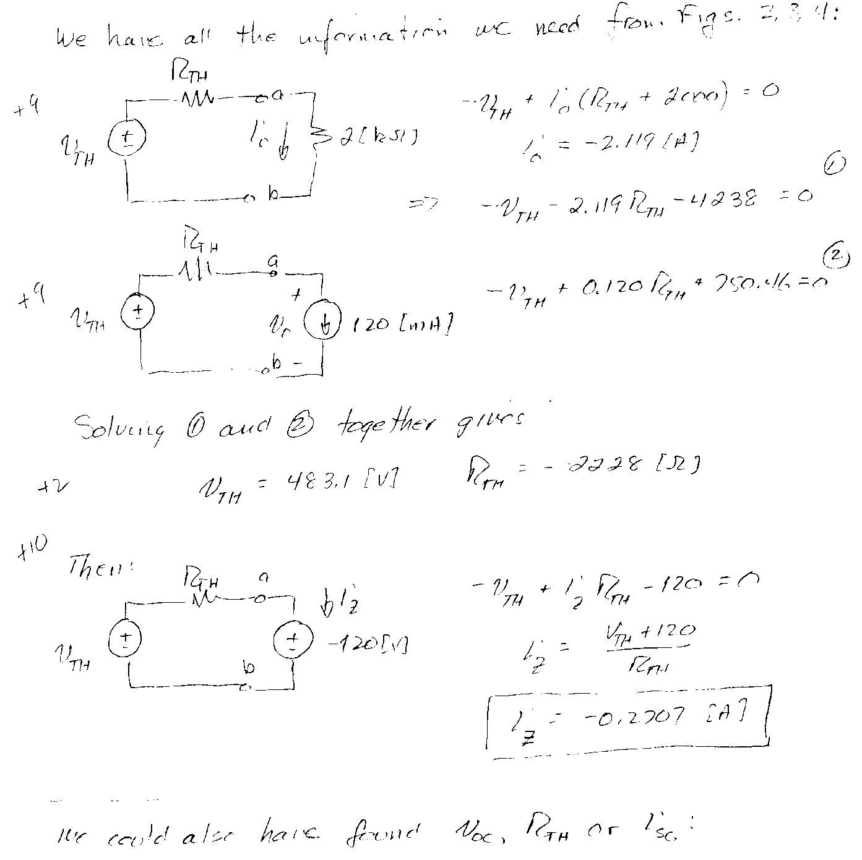
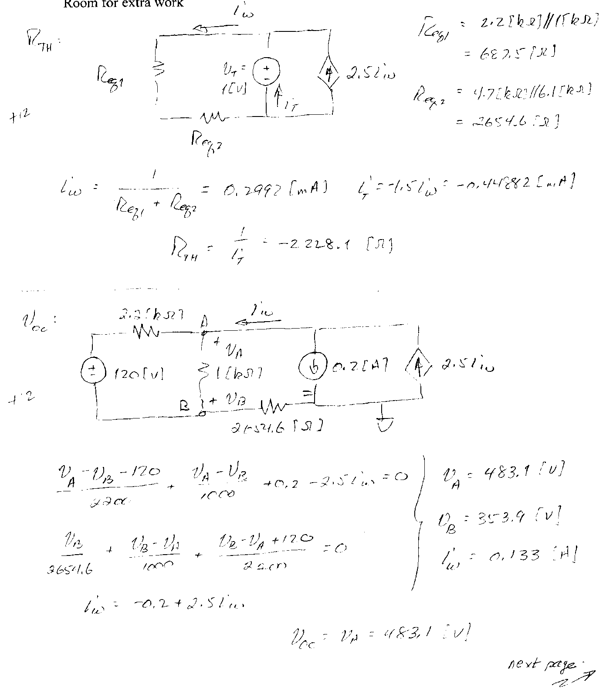
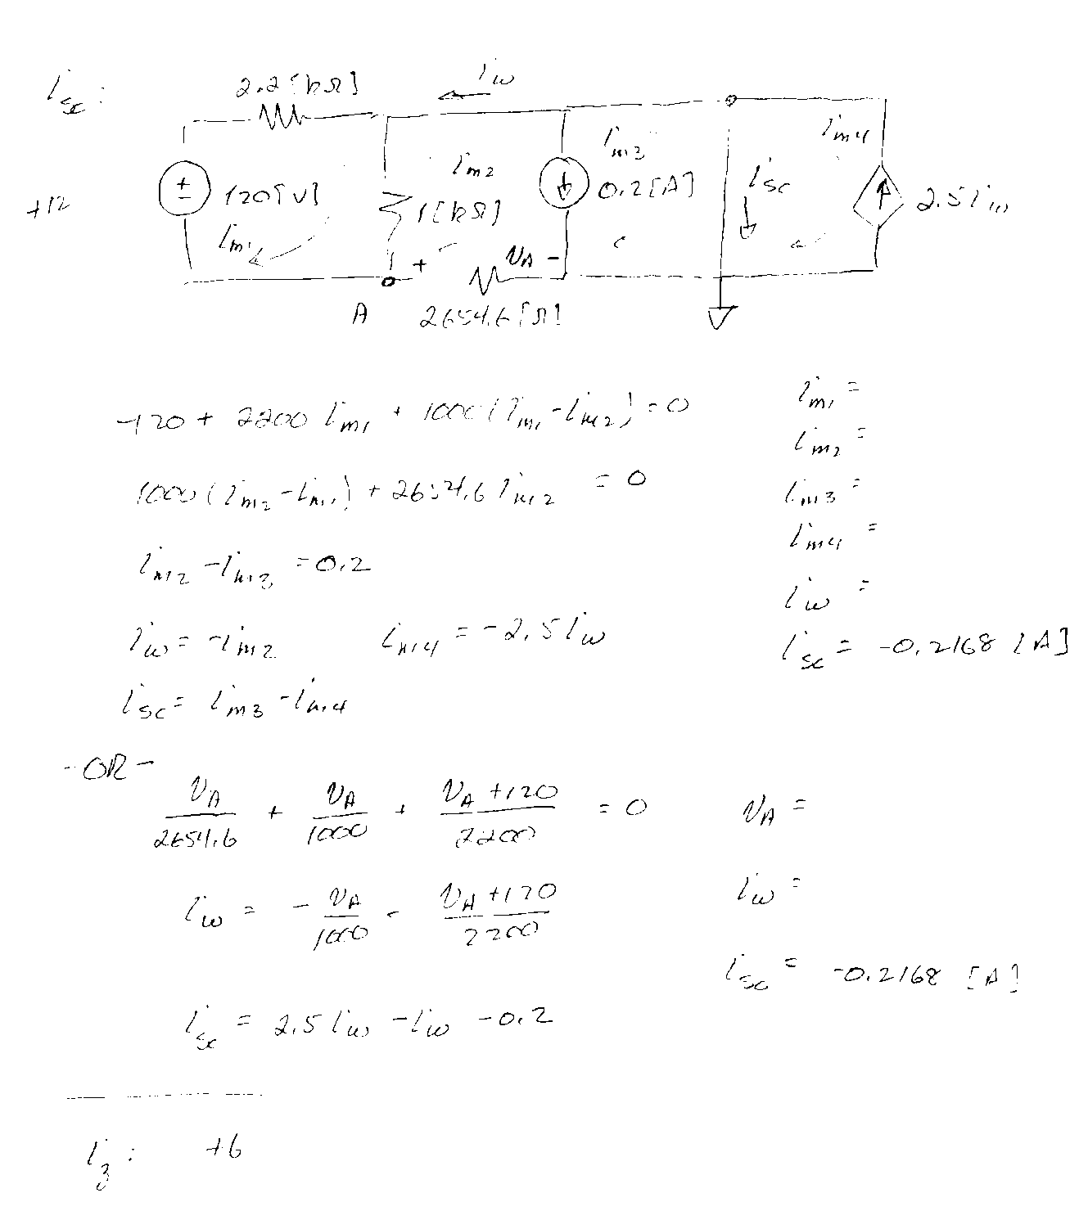
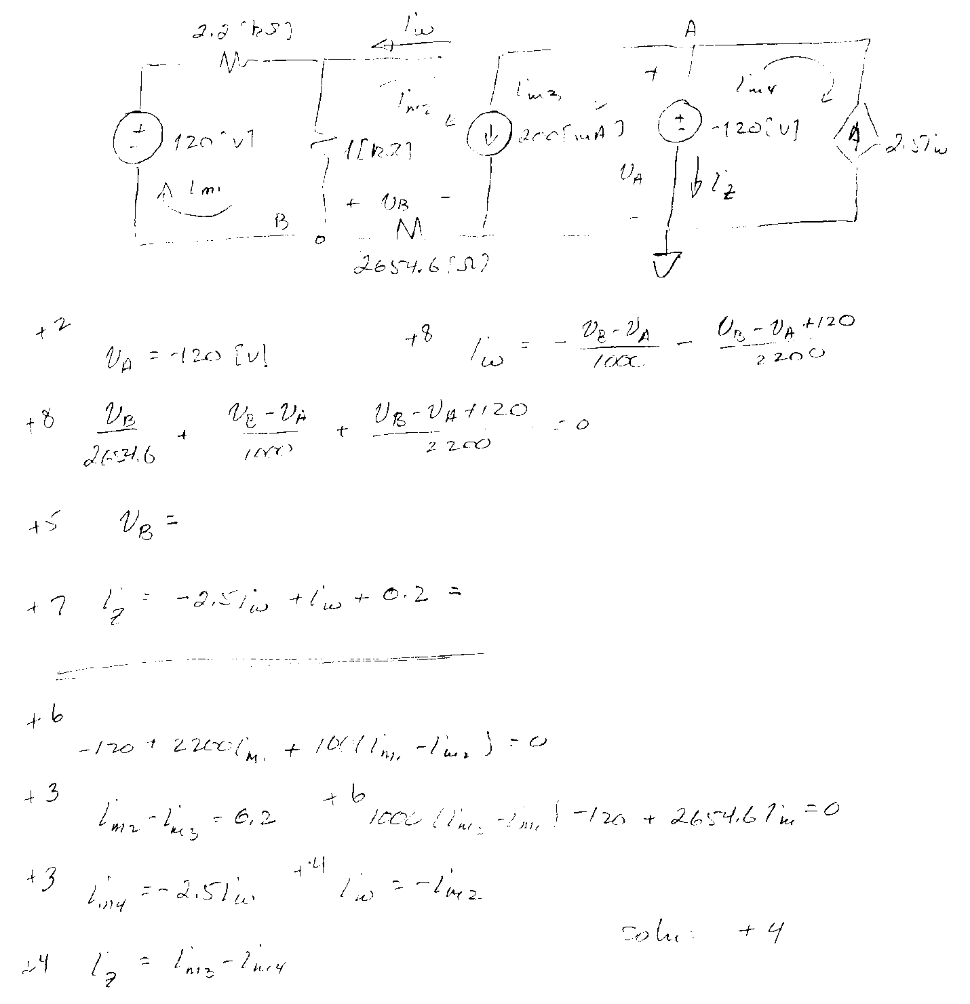

2. (20 points) In the circuit below, find the power delivered by the dependent current source.

3. (20 points) There are two separate voltmeters available for use in a laboratory. One voltmeter has a full-scale reading of 200[V], and has an equivalent resistance of 6.8[MΩ]. The second voltmeter has a full-scale reading of 150[V], and has an equivalent resistance of 25[MΩ]. The plan is to increase the range of voltages that can be measured by putting the two voltmeters in series, and placing the series combination across an unknown voltage. Find the largest voltage that can be measured using the two voltmeters in series, assuming that the voltage will be determined by adding the voltages measured on the two voltmeters.
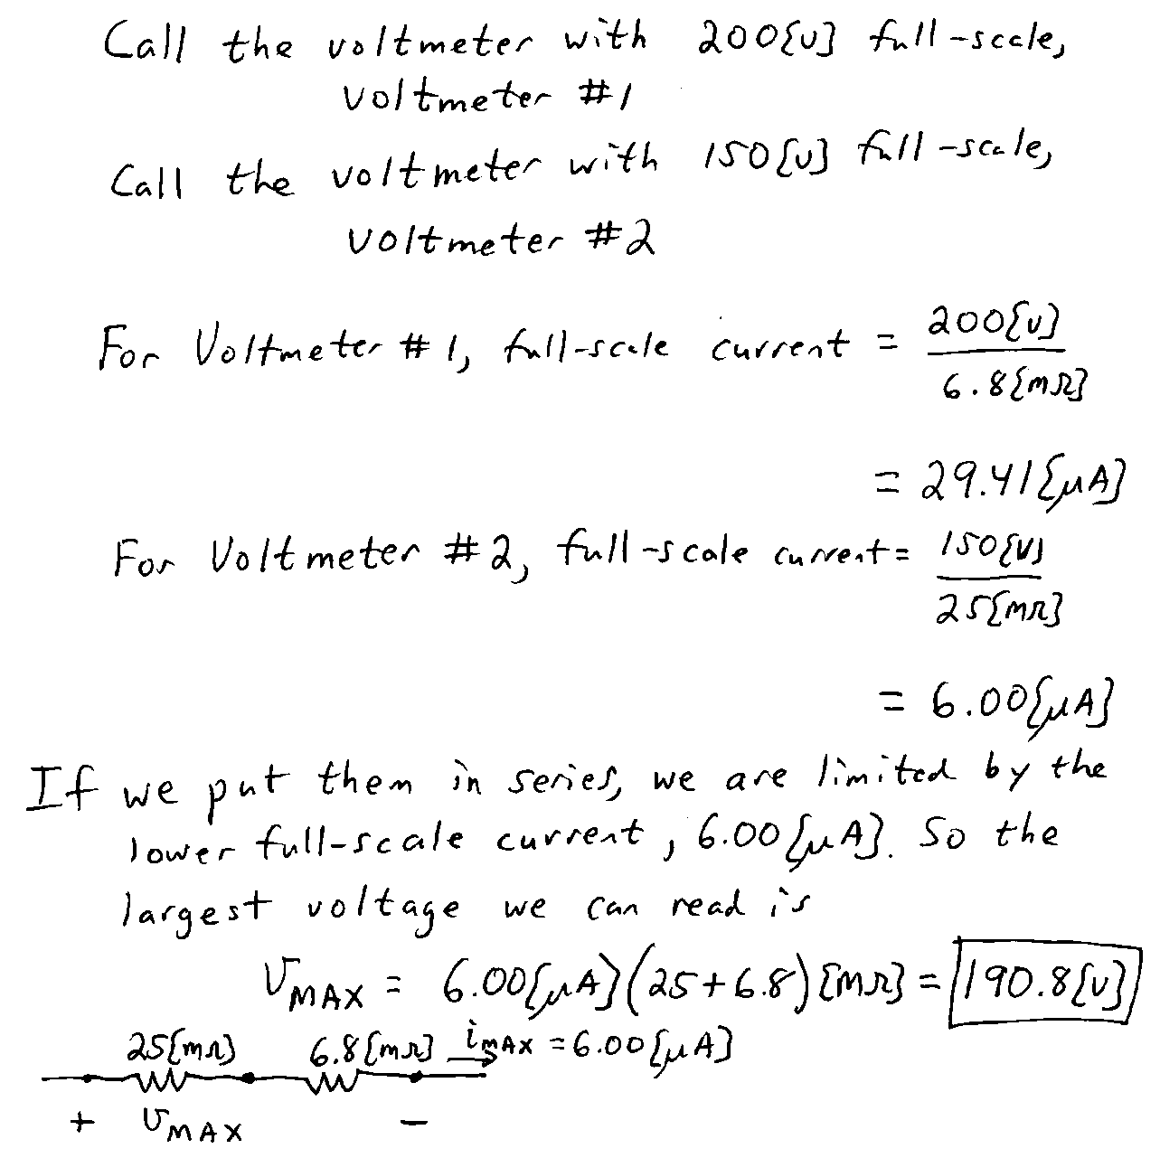

4. (20 points) Use the mesh-current method to write a complete set of equations that could be used to solve the circuit below. Do not simplify the circuit. Do not attempt to solve the equations. You must define all circuit variables. Do not skip any meshes.
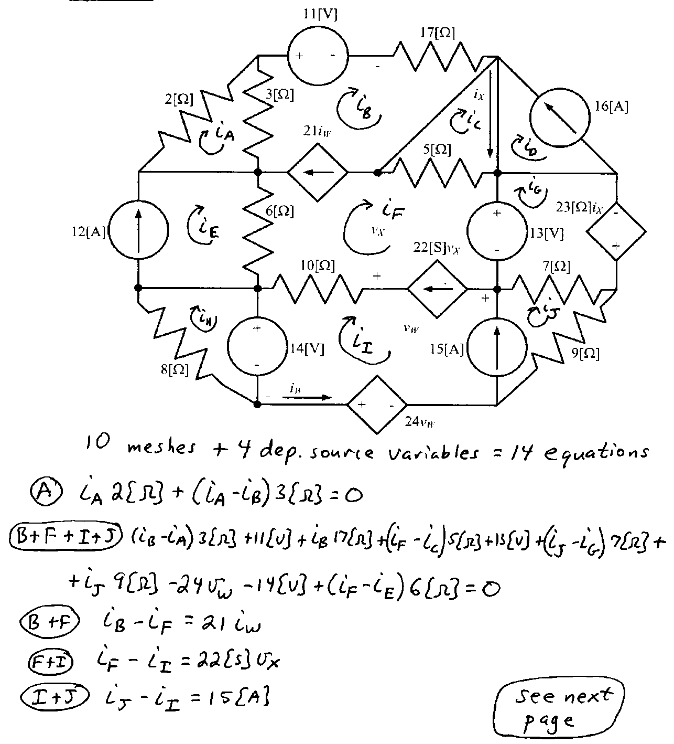

5. (40 points) In the circuit given below, the switch was in position A for long time before it moved at t = 0 to position B. The switch then moved back to A at
t = 200[μs]. Find i_{L}(t) for t ≥ 200[μs].
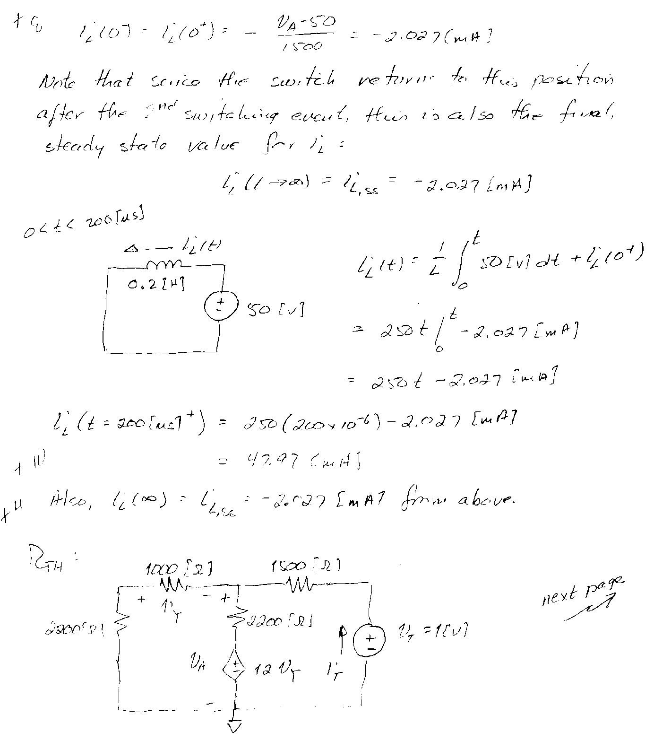
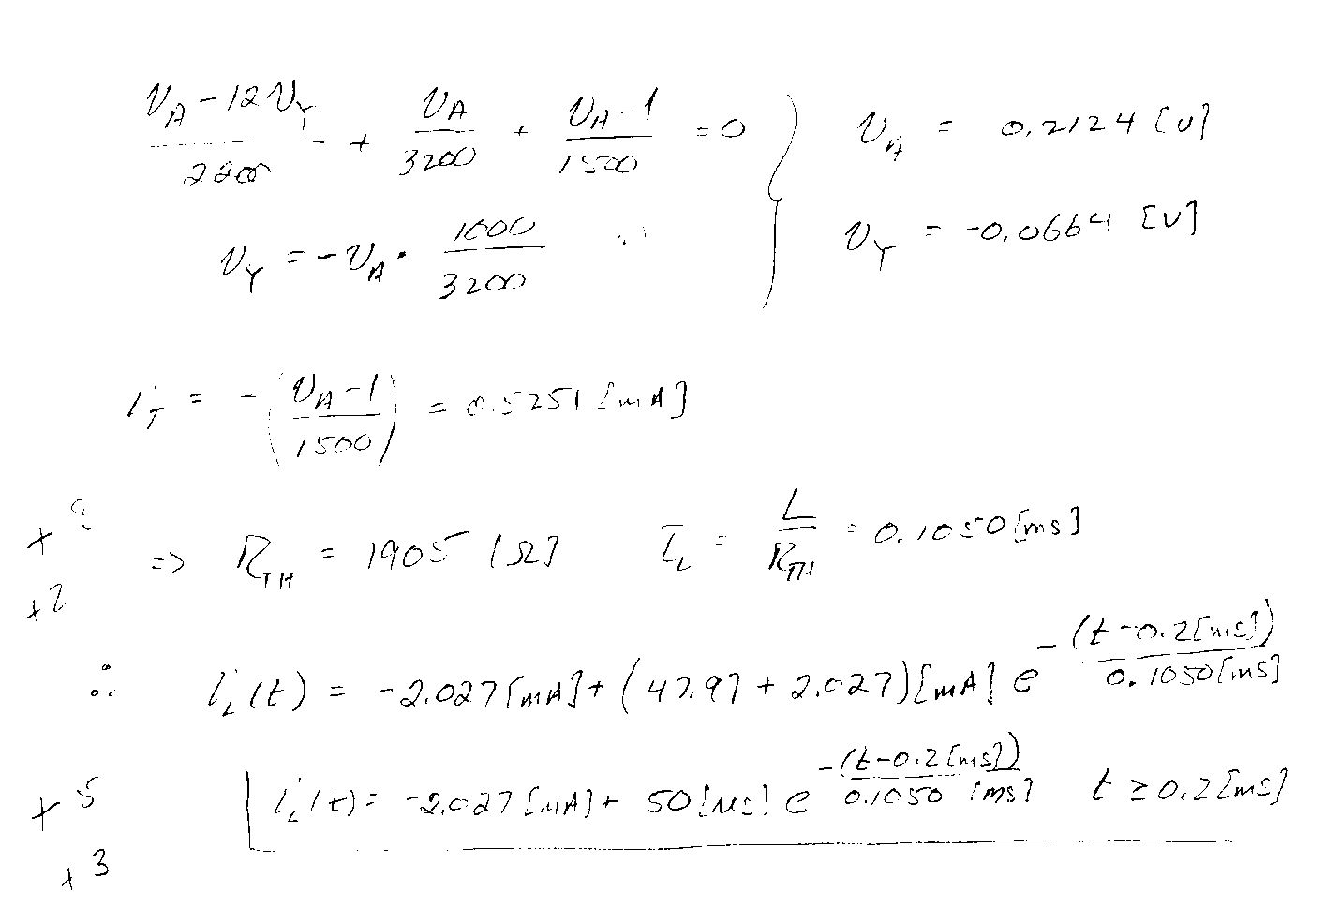

6. (30 points) Find the Thévenin impedance Z_{TH} as seen by the current source, at
ω = 1500[rad/s]. Draw a circuit model for Z_{TH}, modeling it either as a resistance in series with an inductor or as a resistance in series with a capacitor.
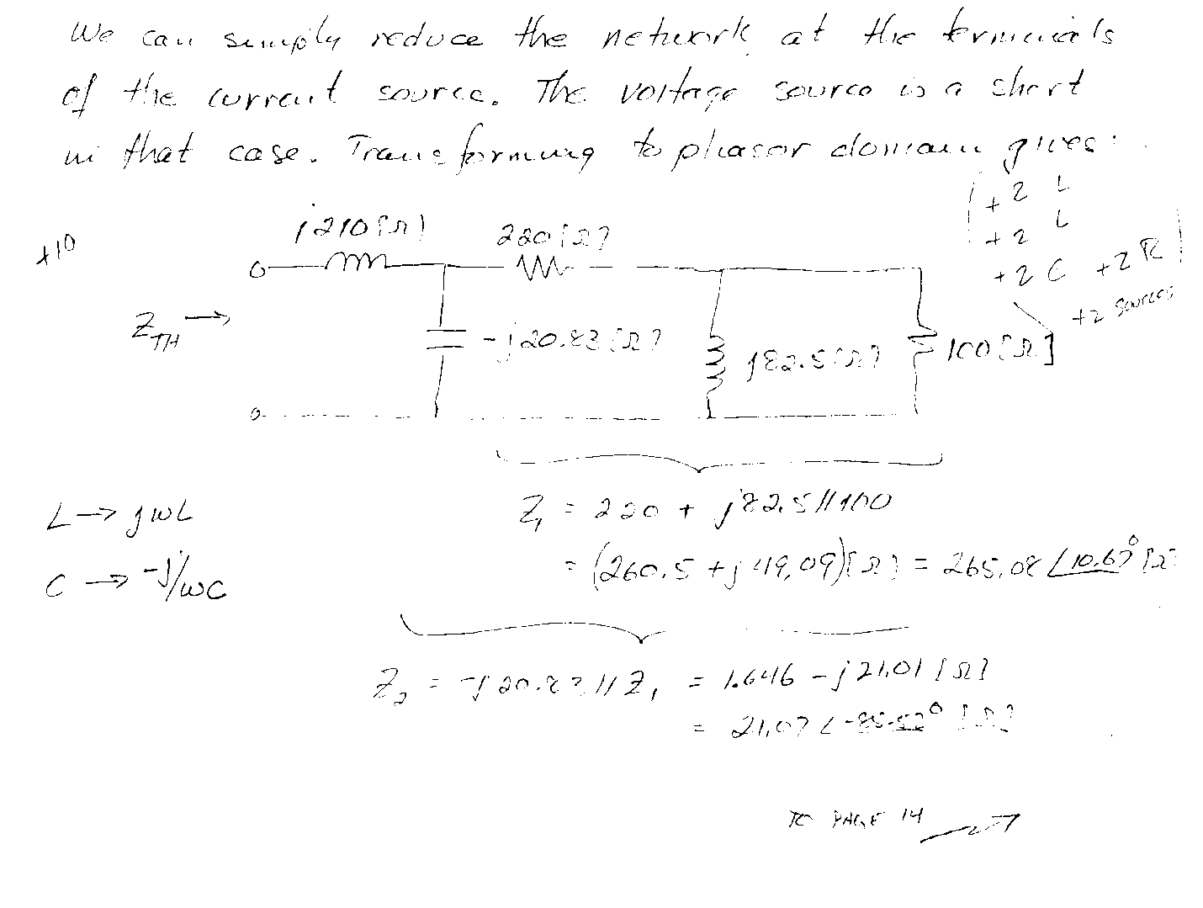

7. (40 points) In the circuit below, the load is enclosed with a dashed line.
a) Find the value of the inductance L₁ that will make the voltage v_{S}(t) be in phase with the current i_{X}(t).
b) Find the value of the power factor angle for the load that results from the value of L₁ found in part a).
c) Find the value of the power factor of the load, if L₁ = 3.9[mH]. Indicate whether this is a leading or a lagging power factor.
d) Find the apparent power absorbed by the load, if L₁ = 3.9[mH].
