Name: _____________________________ (please print)

Signature: __________________________

ECE 2300 -- Exam #1

March 7, 2015

Keep this exam closed until you are told to begin.

1. This exam is closed book, closed notes. You may use one 8.5” x 11” crib sheet, or its equivalent.

2. Show all work on these pages. Show all work necessary to complete the problem. A solution without the appropriate work shown will receive no credit. A solution that is not given in a reasonable order will lose credit. Clearly indicate your answer (for example by enclosing it in a box).

3. It is assumed that your work will begin on the same page as the problem statement. If you choose to begin your work on another page, you must indicate this on the page with the problem statement, with a clear indication of where the work can be found. **If your work continues on to another page, indicate clearly where your work can be found. Failure to indicate this clearly will result in a loss of credit.**

4. Show all units in solutions, intermediate results, and figures. Units in the exam will be included between square brackets.

5. Do not use red ink. Do not use red pencil.

6. You will have 90 minutes to work on this exam.

1. ________________/30

2. ________________/30

3. ________________/40

Total = 100

Room for extra work

1. {30 Points} Use the figure given below to solve this problem. Show your steps in some clear fashion. You are strongly encouraged to redraw the diagram as needed to make your work more clear.

a. Find the equivalent resistance of this circuit as seen by terminals A and B.

b. Find the equivalent resistance of this circuit as seen by terminals A and L.



# Room for extra work

2. {30 Points} A multi-range voltmeter is shown in Figure 1. The meter has full-scale voltages of 50[V], 100[V] and 250[V].

A resistor RX is connected between the 50[V] terminal and the common terminal. The voltmeter is then connected to a circuit as shown in Figure 2. The voltmeter reads 83[V] on the 100[V] scale.

a. Find the values of R1, R2 and R3.

b. Find the value of RX.



Room for extra work 3. {40 Points} A device can be modeled by using a current source *iD* of 3.5[A] in parallel with a resistance, as shown in Figure 1. The terminal labels of the device, a and b, are shown in this figure.

The device is connected to the circuit as shown in Figure 2, by connecting a to c, and connecting b to d. When this connection is made, a voltage *vX* = -4.6[V] resulted.

Find *RD*.





Room for extra work

Solutions:

1. {30 Points} Use the figure given below to solve this problem. Show your steps in some clear fashion. You are strongly encouraged to redraw the diagram as needed to make your work more clear.

a. Find the equivalent resistance of this circuit as seen by terminals A and B.

b. Find the equivalent resistance of this circuit as seen by terminals A and L.

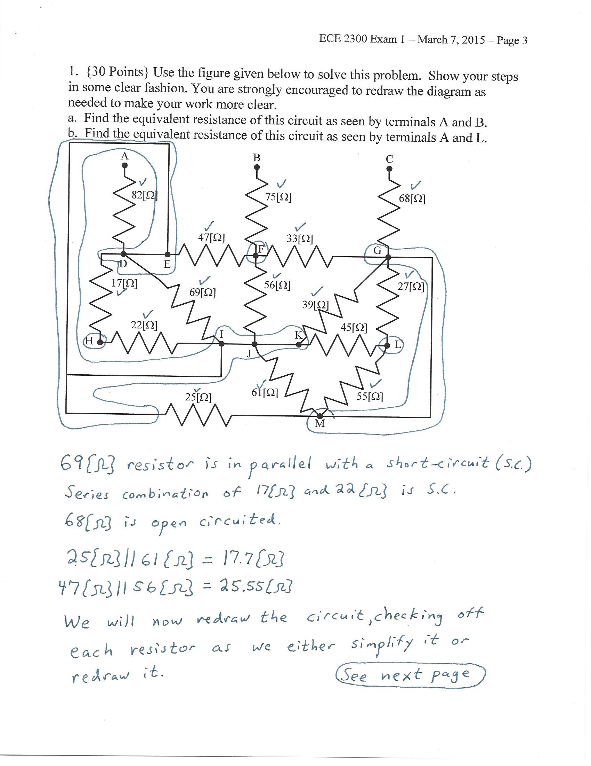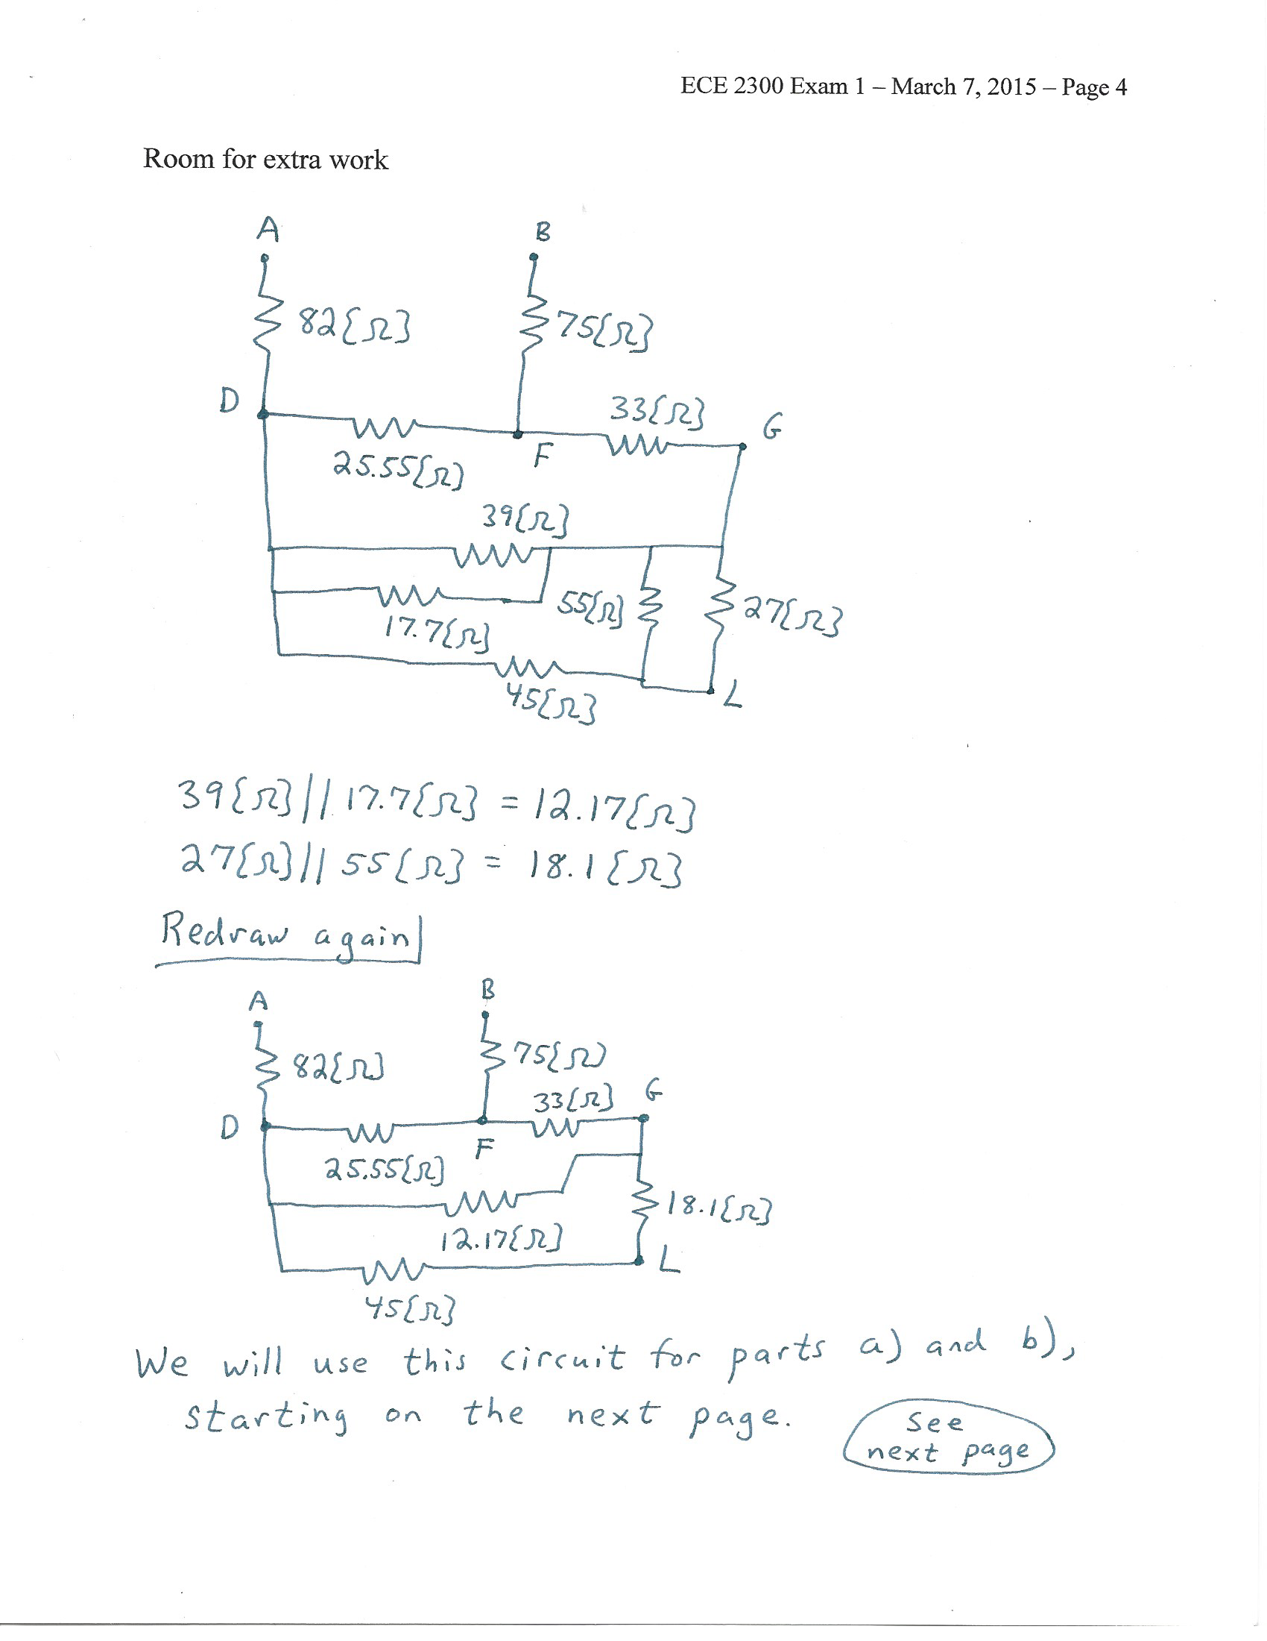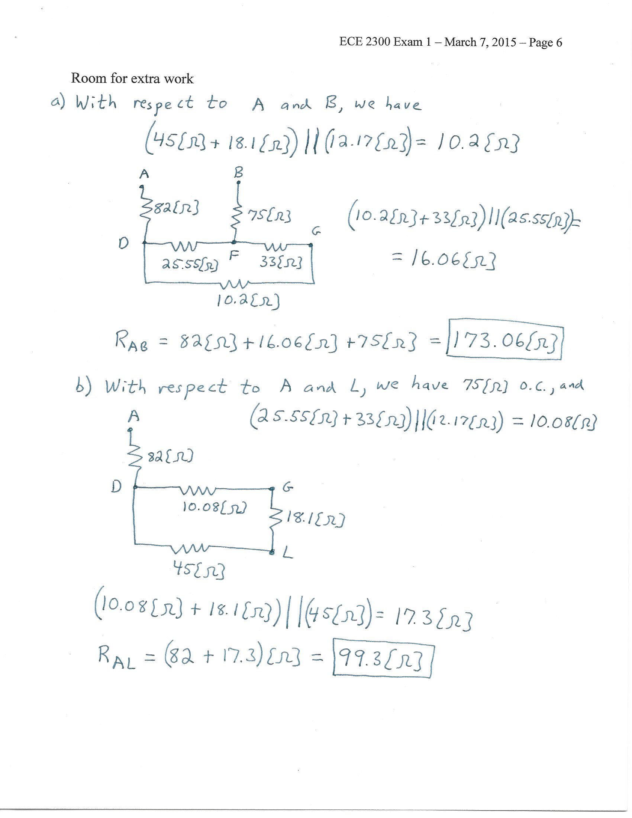

# 2. {30 Points} A multi-range voltmeter is shown in Figure 1. The meter has full-scale voltages of 50[V], 100[V] and 250[V].

A resistor RX is connected between the 50[V] terminal and the common terminal. The voltmeter is then connected to a circuit as shown in Figure 2. The voltmeter reads 83[V] on the 100[V] scale.

a. Find the values of R1, R2 and R3.

b. Find the value of RX.

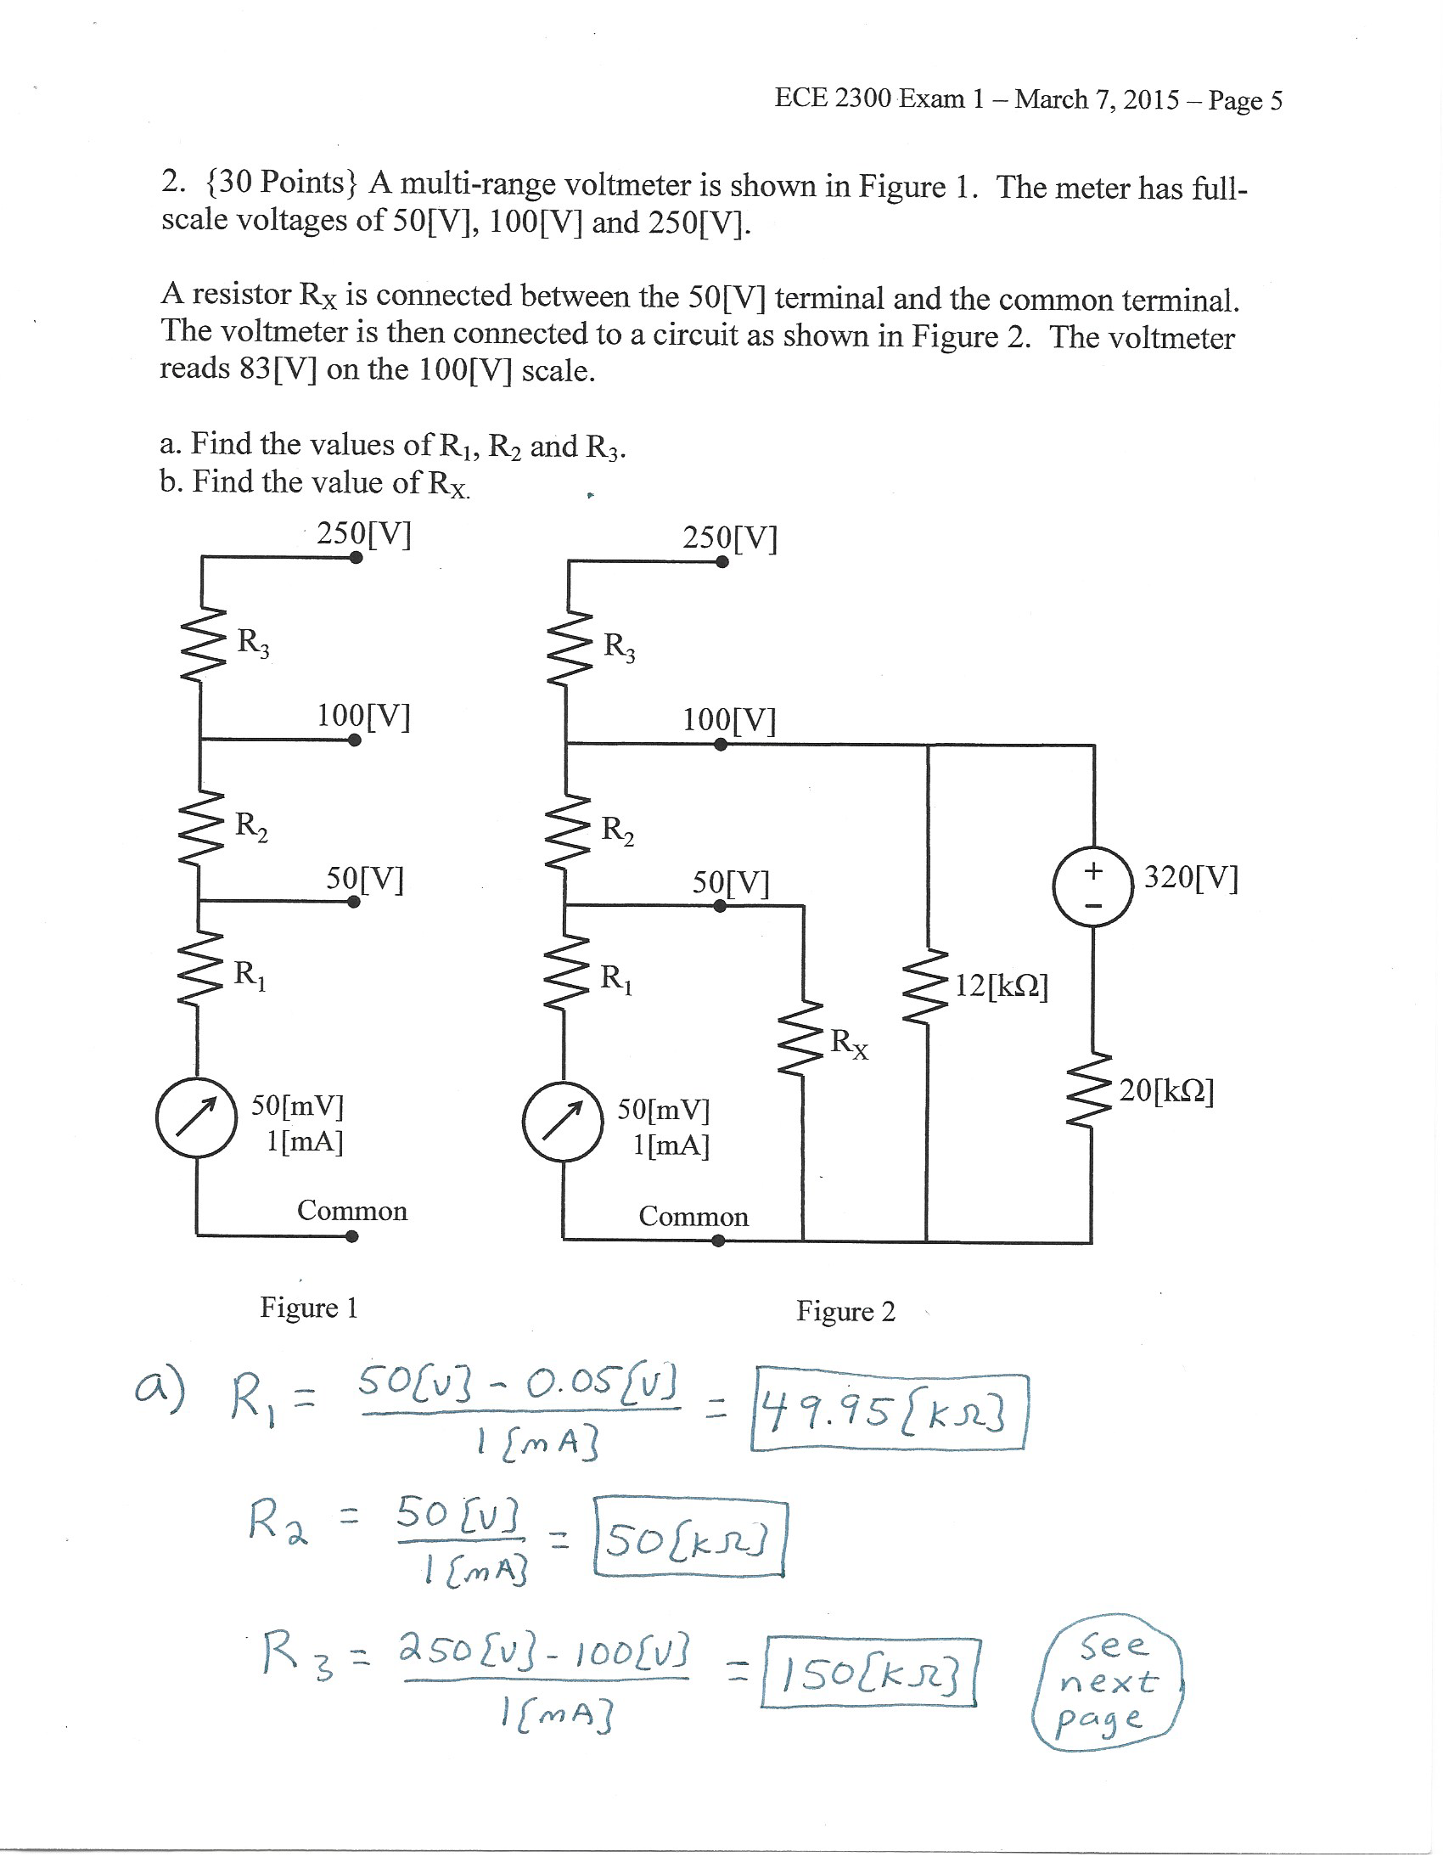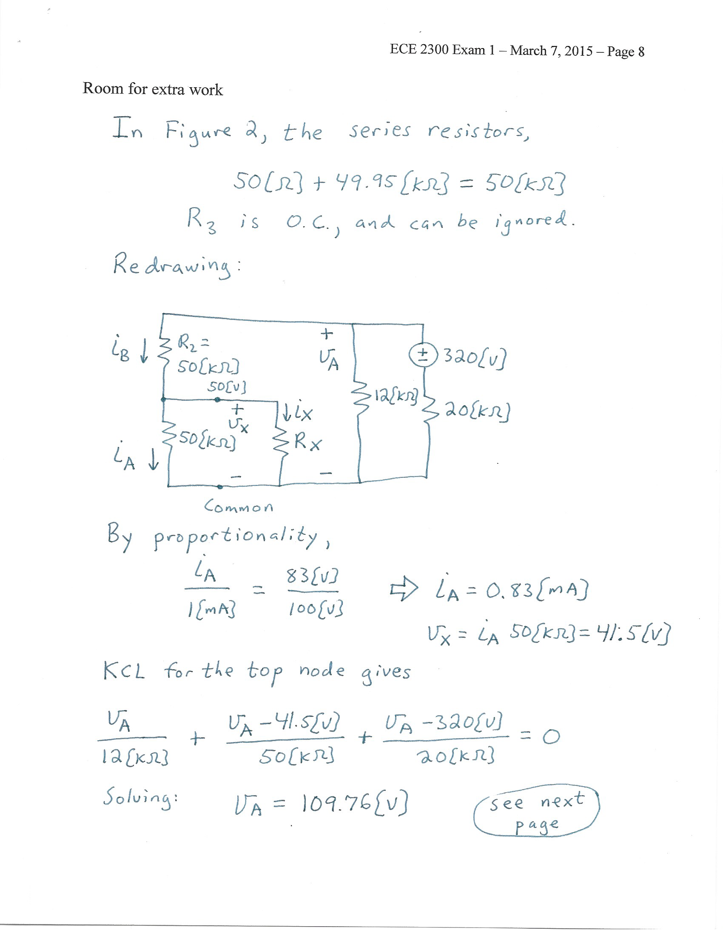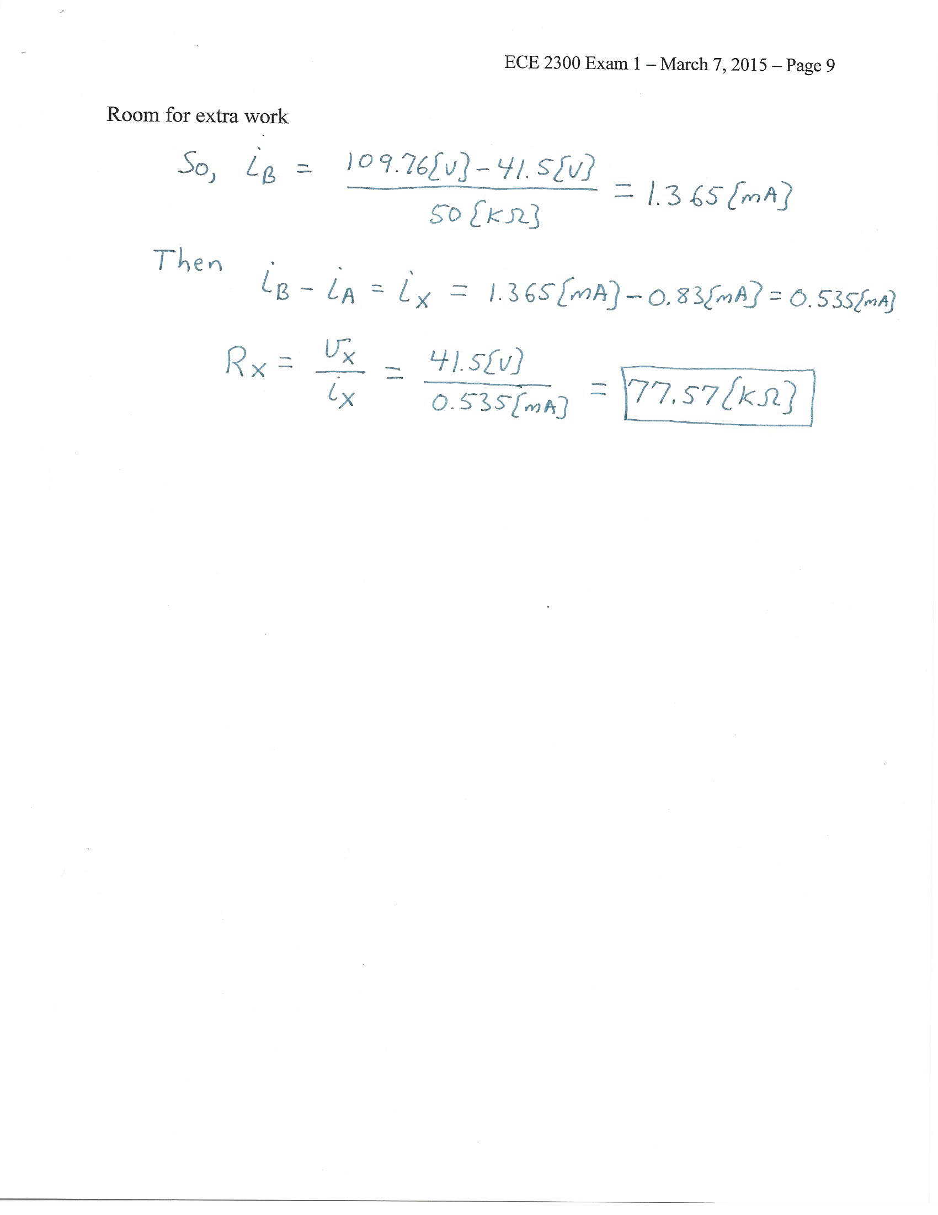

3. {40 Points} A device can be modeled by using a current source *iD* of 3.5[A] in parallel with a resistance, as shown in Figure 1. The terminal labels of the device, a and b, are shown in this figure.

The device is connected to the circuit as shown in Figure 2, by connecting a to c, and connecting b to d. When this connection is made, a voltage *vX* = -4.6[V] resulted.

Find *RD*.





See next page:

