Name: _____________________________ (please print)

Signature: __________________________

ECE 2300 -- Exam # 2

April 16, 2016

Keep this exam closed until you are told to begin.

1. This exam is closed book, closed notes. You may use one 8.5” x 11” crib sheet, or its equivalent.

2. Show all work on these pages. Show all work necessary to complete the problem. A solution without the appropriate work shown will receive no credit. A solution that is not given in a reasonable order will lose credit. Clearly indicate your answer (for example by enclosing it in a box).

3. It is assumed that your work will begin on the same page as the problem statement. If you choose to begin your work on another page, you must indicate this on the page with the problem statement, with a clear indication of where the work can be found. **If your work continues on to another page, indicate clearly where your work can be found. Failure to indicate this clearly will result in a loss of credit.**

4. Show all units in solutions, intermediate results, and figures. Units in the exam will be included between square brackets.

5. Do not use red ink. Do not use red pencil.

6. You will have 90 minutes to work on this exam.

1. ________________/30

2. ________________/30

3. ________________/40

Total = 100

Room for extra work

1. {30 Points} Use the Mesh-current method to write a complete set of equations that could be used to solve the circuit below. Do not attempt to simplify the circuit. Do not attempt to simplify or solve the equations. Define all variables.



# Room for extra work

2. {30 Points} The circuit shown below delivers maximum power to the load resistance *RL* when the value of that load resistance, connected to terminals **a** and **b**, is equal to 2.5[Ω]**.** Find the value of *k* for the *iS1* dependent current source, given that this power condition holds.



Room for extra work 3. {40 Points} In the circuit shown below, the switches SWA and SWC were open for a long time, and switch SWB was closed for a long time, before *t* = 0. Then, at   
*t* = 0, switch SWA closed. At *t* = 1[s], switch SWB opened and switch SWC closed. It is known that *iA* = 0.51[A] for t < 0.

1. Find the power absorbed by *R2* at *t* = 2[s].
2. Find the energy stored in *L2* at *t* = 0+.



Room for extra work

Solution:

1. {30 Points} Use the Mesh-current method to write a complete set of equations that could be used to solve the circuit below. Do not attempt to simplify the circuit. Do not attempt to simplify or solve the equations. Define all variables.

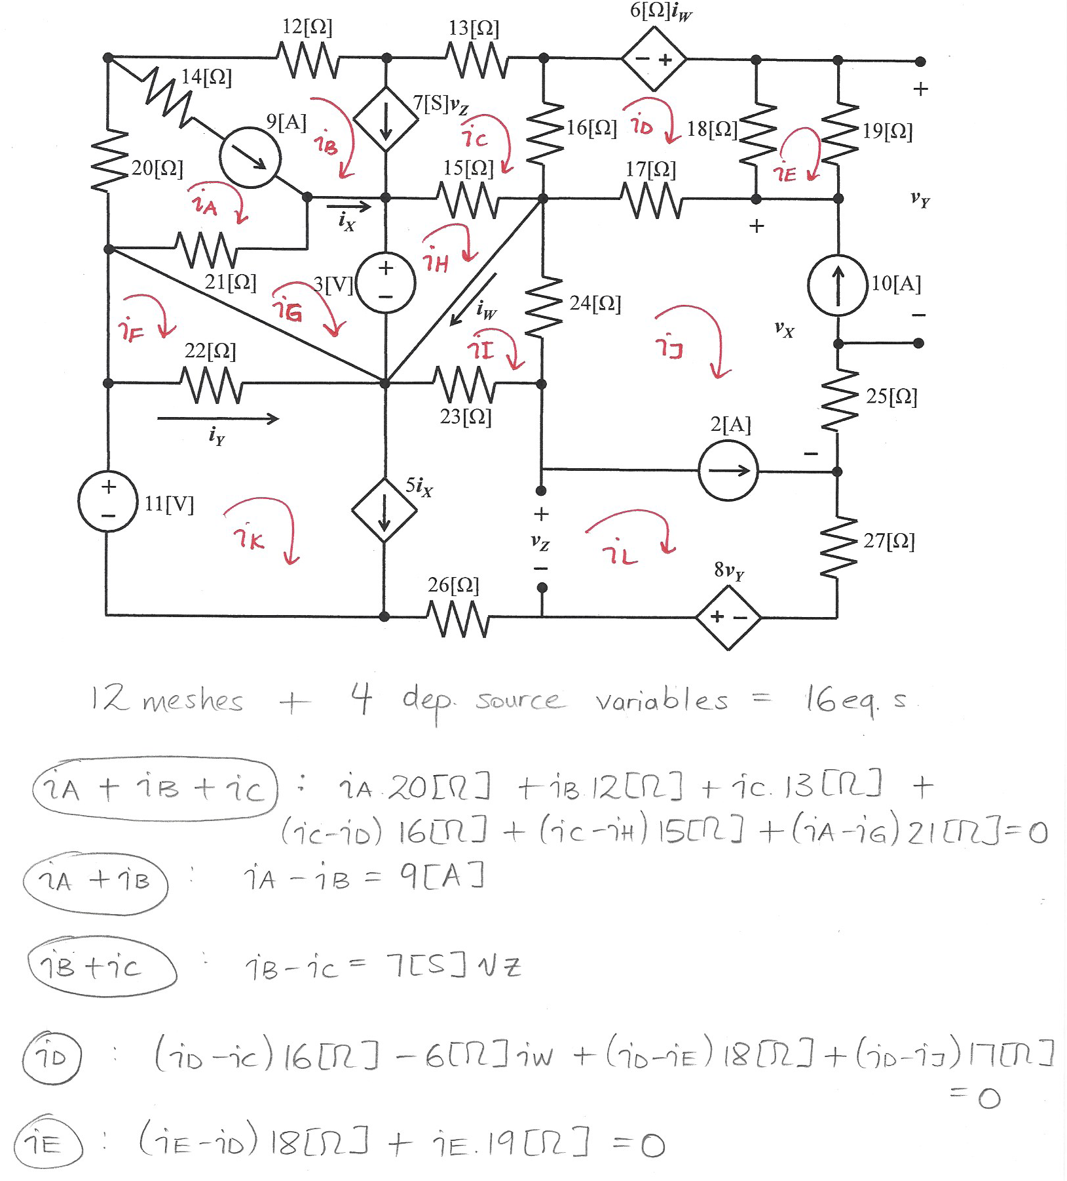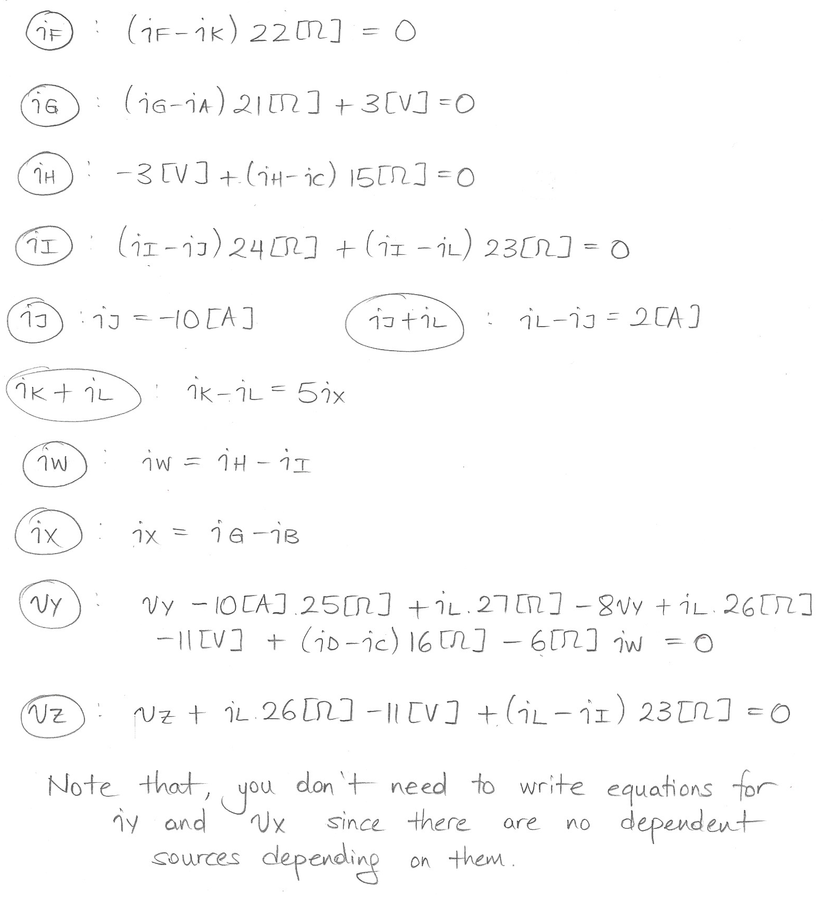

# 2. {30 Points} The circuit shown below delivers maximum power to the load resistance *RL* when the value of that load resistance, connected to terminals **a** and **b**, is equal to 2.5[Ω]**.** Find the value of *k* for the *iS1* dependent current source, given that this power condition holds.

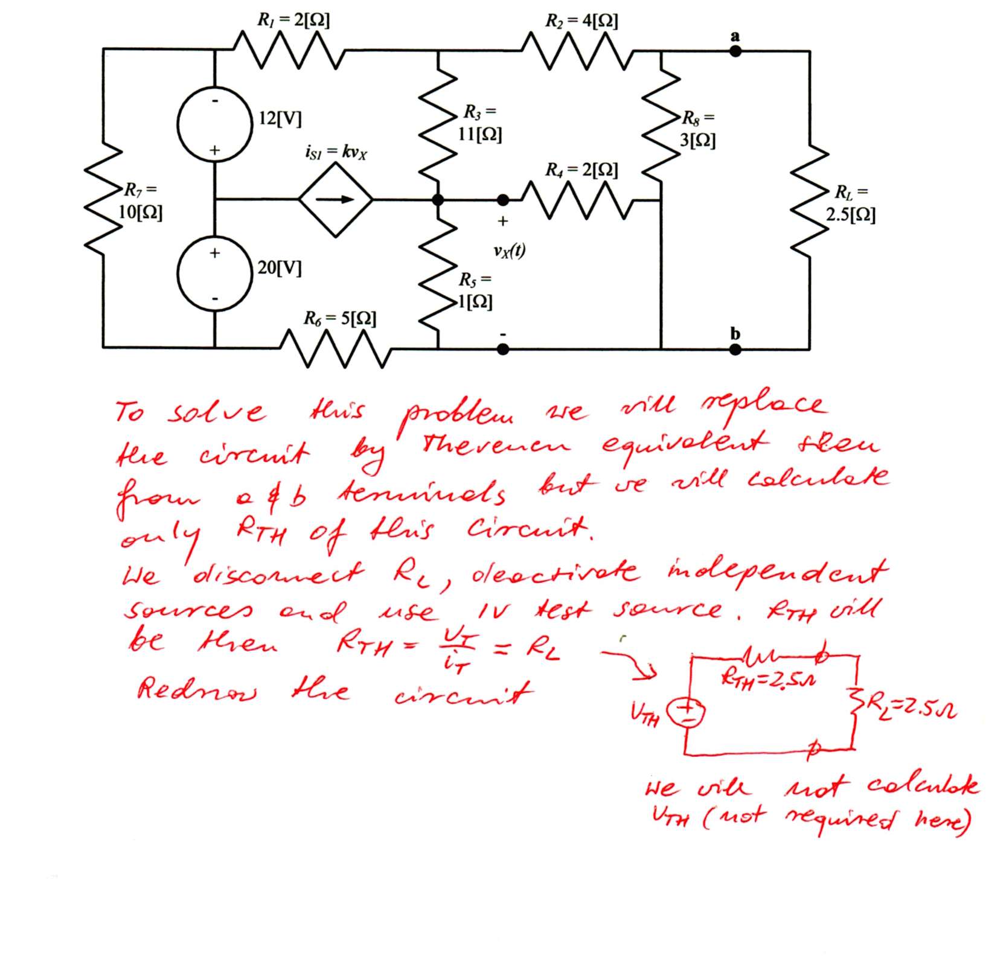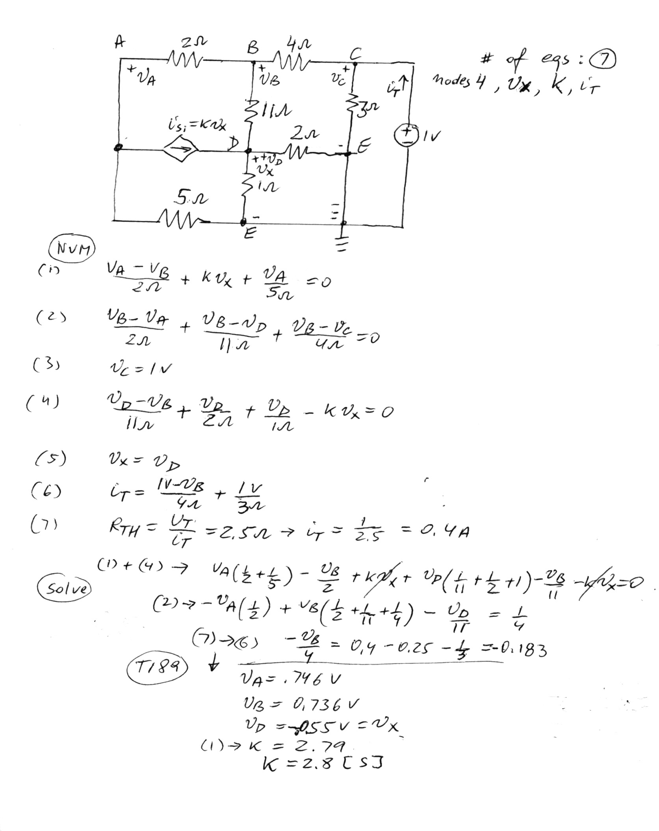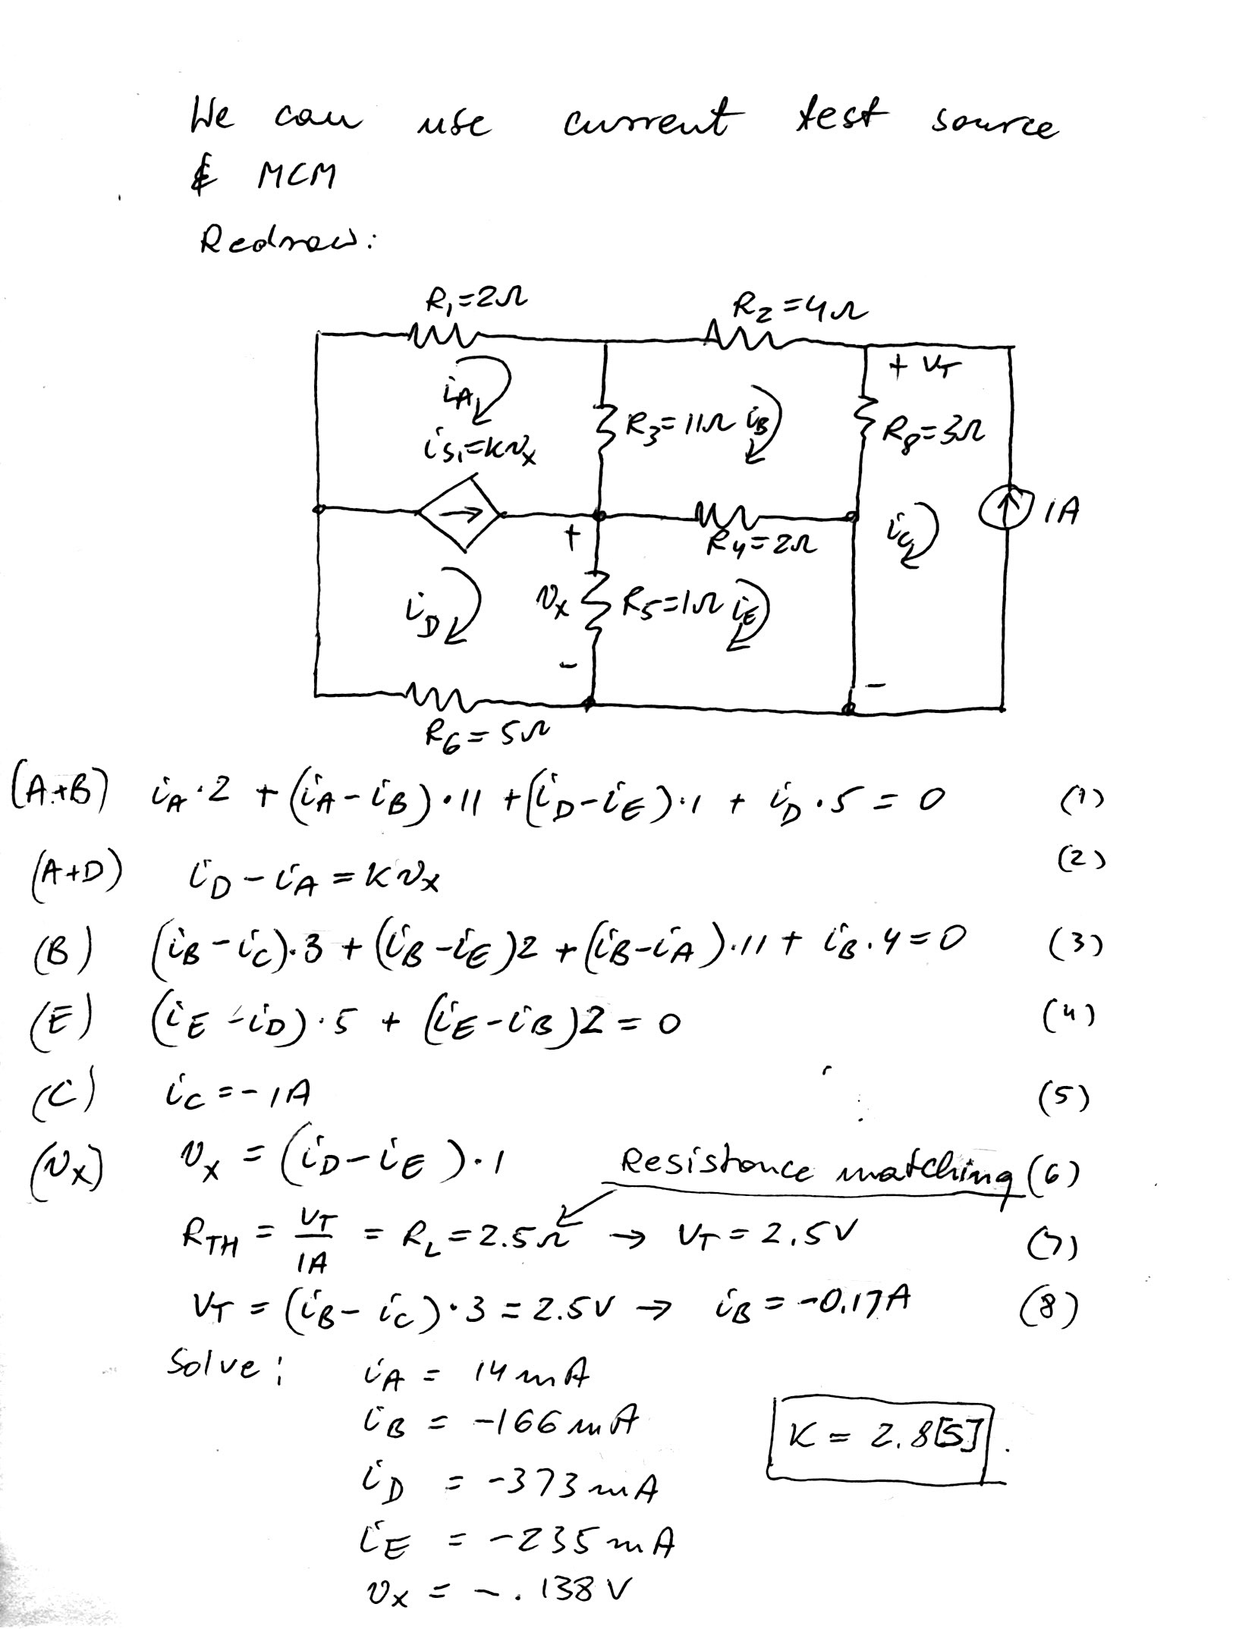

3. {40 Points} In the circuit shown below, the switches SWA and SWC were open for a long time, and switch SWB was closed for a long time, before *t* = 0. Then, at   
*t* = 0, switch SWA closed. At *t* = 1[s], switch SWB opened and switch SWC closed. It is known that *iA* = 0.51[A] for t < 0.

1. Find the power absorbed by *R2* at *t* = 2[s].
2. Find the energy stored in *L2* at *t* = 0+.

