Name: _____________________________ (please print)
Signature: __________________________

ECE 2202 – Exam #1
March 4, 2017

Keep this exam closed until you are told to begin.

1. This exam is closed book, closed notes. You may use one 8.5” x 11” crib sheet, or its equivalent.
2. Show all work on these pages. Show all work necessary to complete the problem. A solution without the appropriate work shown will receive no credit. A solution that is not given in a reasonable order will lose credit. Clearly indicate your answer (for example by enclosing it in a box).
3. It is assumed that your work will begin on the same page as the problem statement. If you choose to begin your work on another page, you must indicate this on the page with the problem statement, with a clear indication of where the work can be found. If your work continues on to another page, indicate clearly where your work can be found. Failure to indicate this clearly will result in a loss of credit.
4. Show all units in solutions, intermediate results, and figures. Units in the exam will be included between square brackets.
5. Do not use red ink. Do not use red pencil.
6. You will have 90 minutes to work on this exam.

1. ________________/30
2. ________________/35
3. ________________/35
Total = 100
Room for extra work
1. {30 Points} Use the circuit shown below to solve this problem.
a) Find the Norton equivalent as seen by the i_{S3} current source.
b) Find the power delivered by the i_{S3} current source in this circuit.

Room for extra work

2. {35 Points} The switch in the circuit below was open for a long time, and then it closed at t = 0.
a) Find i_{X}(0⁻).
b) Find i_{X}(0⁺).
c) Find i_{X}(200[ms]).
d) Find the energy stored in inductor L_{X} at t = 200[ms].

Room for extra work

3. {35 Points} For the circuit shown below, switch 1 (SW1) had been open for a long time, and switch 2 (SW2) had been at position “a” for a long time. At t = 0, switch 1 (SW1) closed, then, at t = 1[s], switch 2 (SW2) switched from position “a” to position “b”. Find the numerical expressions for $i_{L}(t)$ for t ≥ 0.

Room for extra work

1. {30 Points} Use the circuit shown below to solve this problem.
a) Find the Norton equivalent as seen by the i_{S3} current source.
b) Find the power delivered by the i_{S3} current source in this circuit.
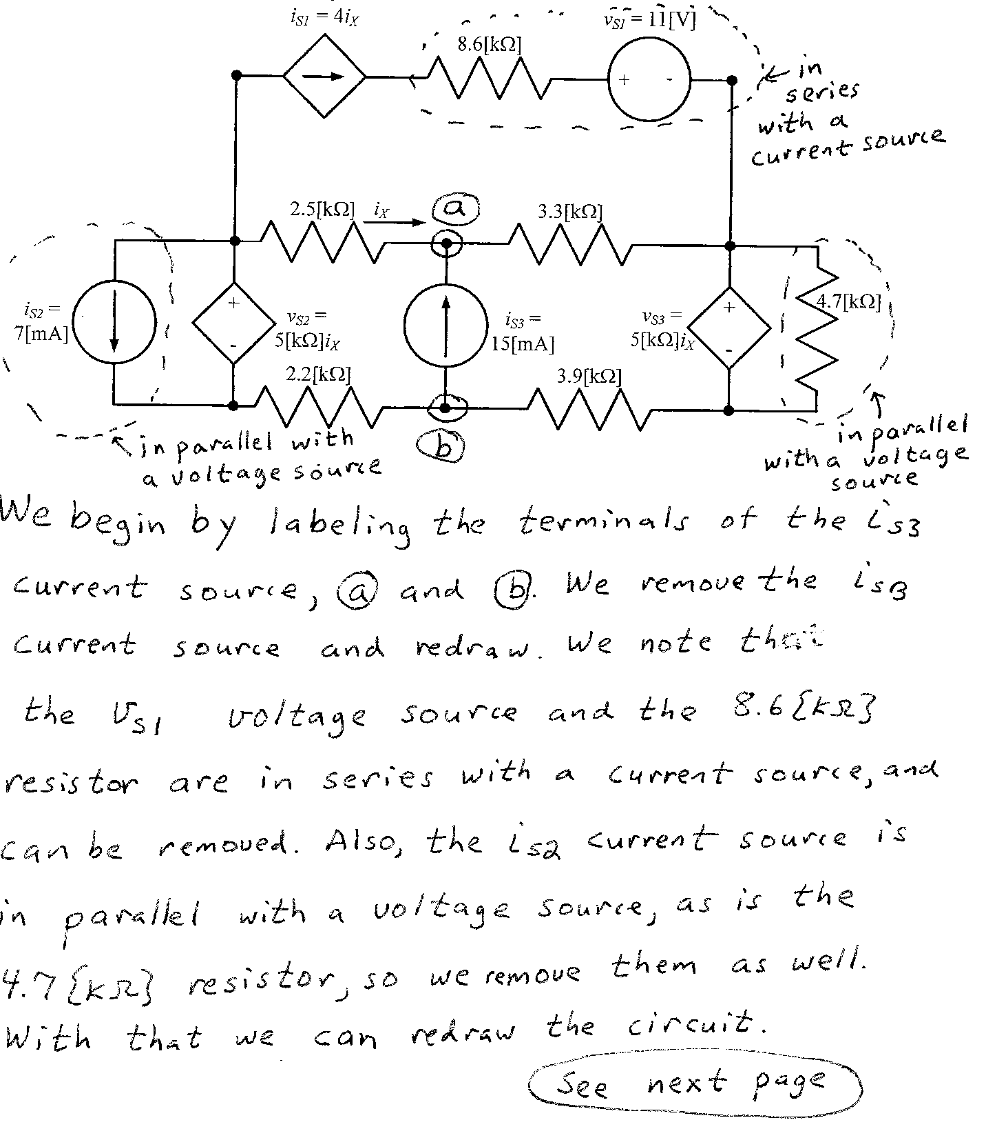
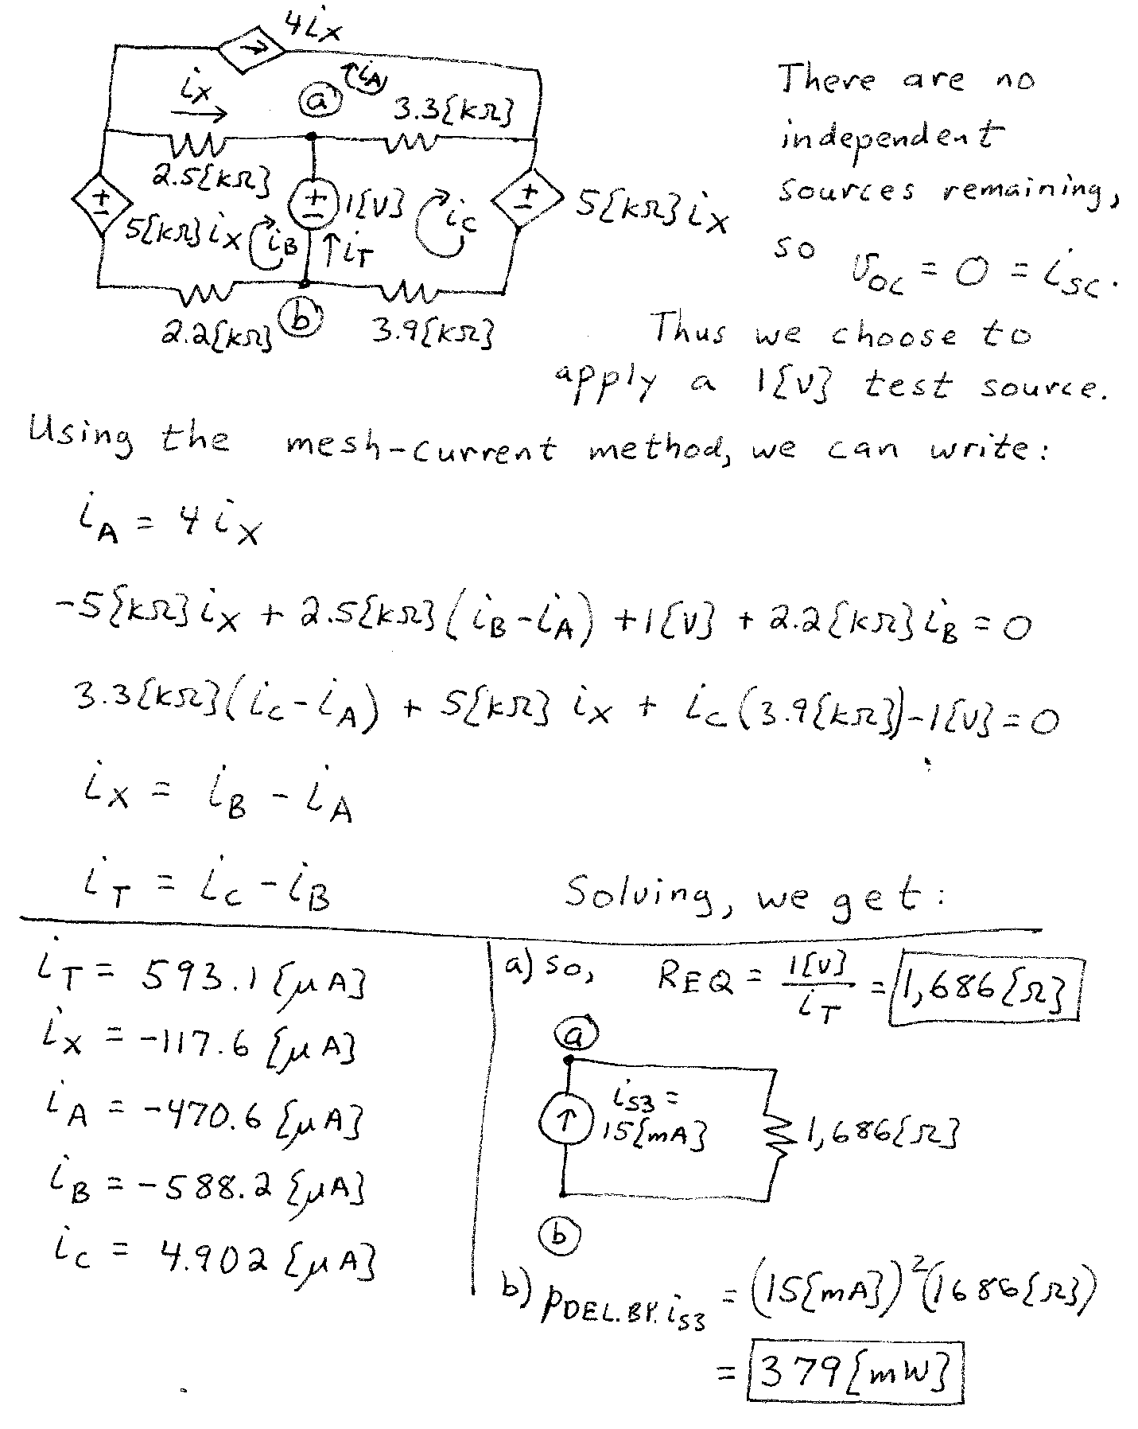

2. {35 Points} The switch in the circuit below was open for a long time, and then it closed at t = 0.
a) Find i_{X}(0⁻).
b) Find i_{X}(0⁺).
c) Find i_{X}(200[ms]).
d) Find the energy stored in inductor L_{X} at t = 200[ms].
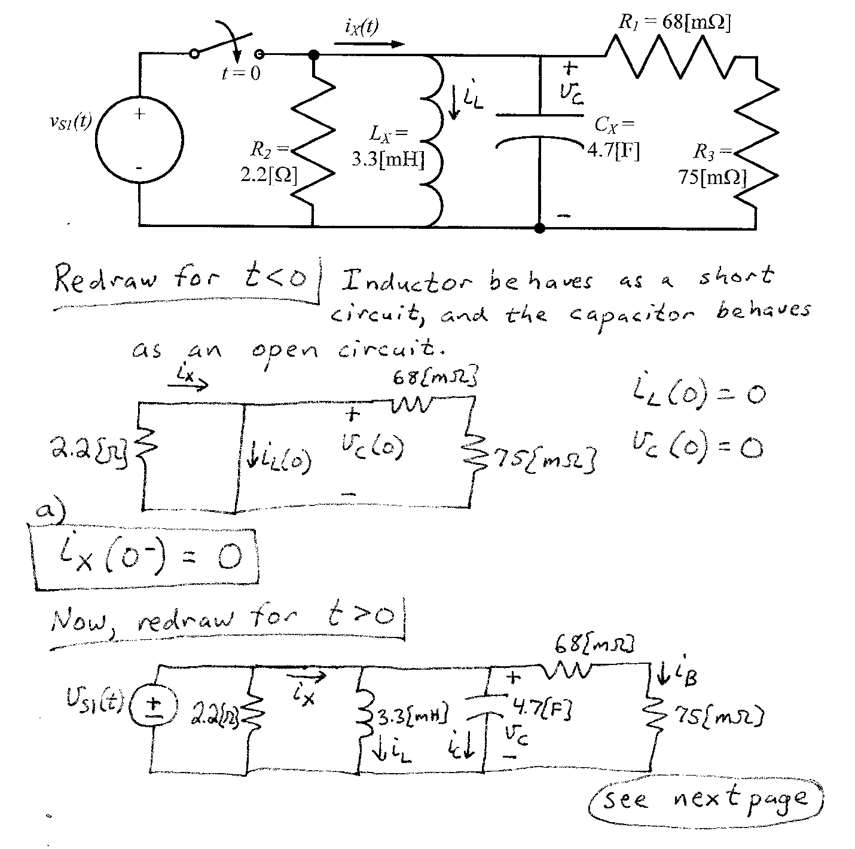
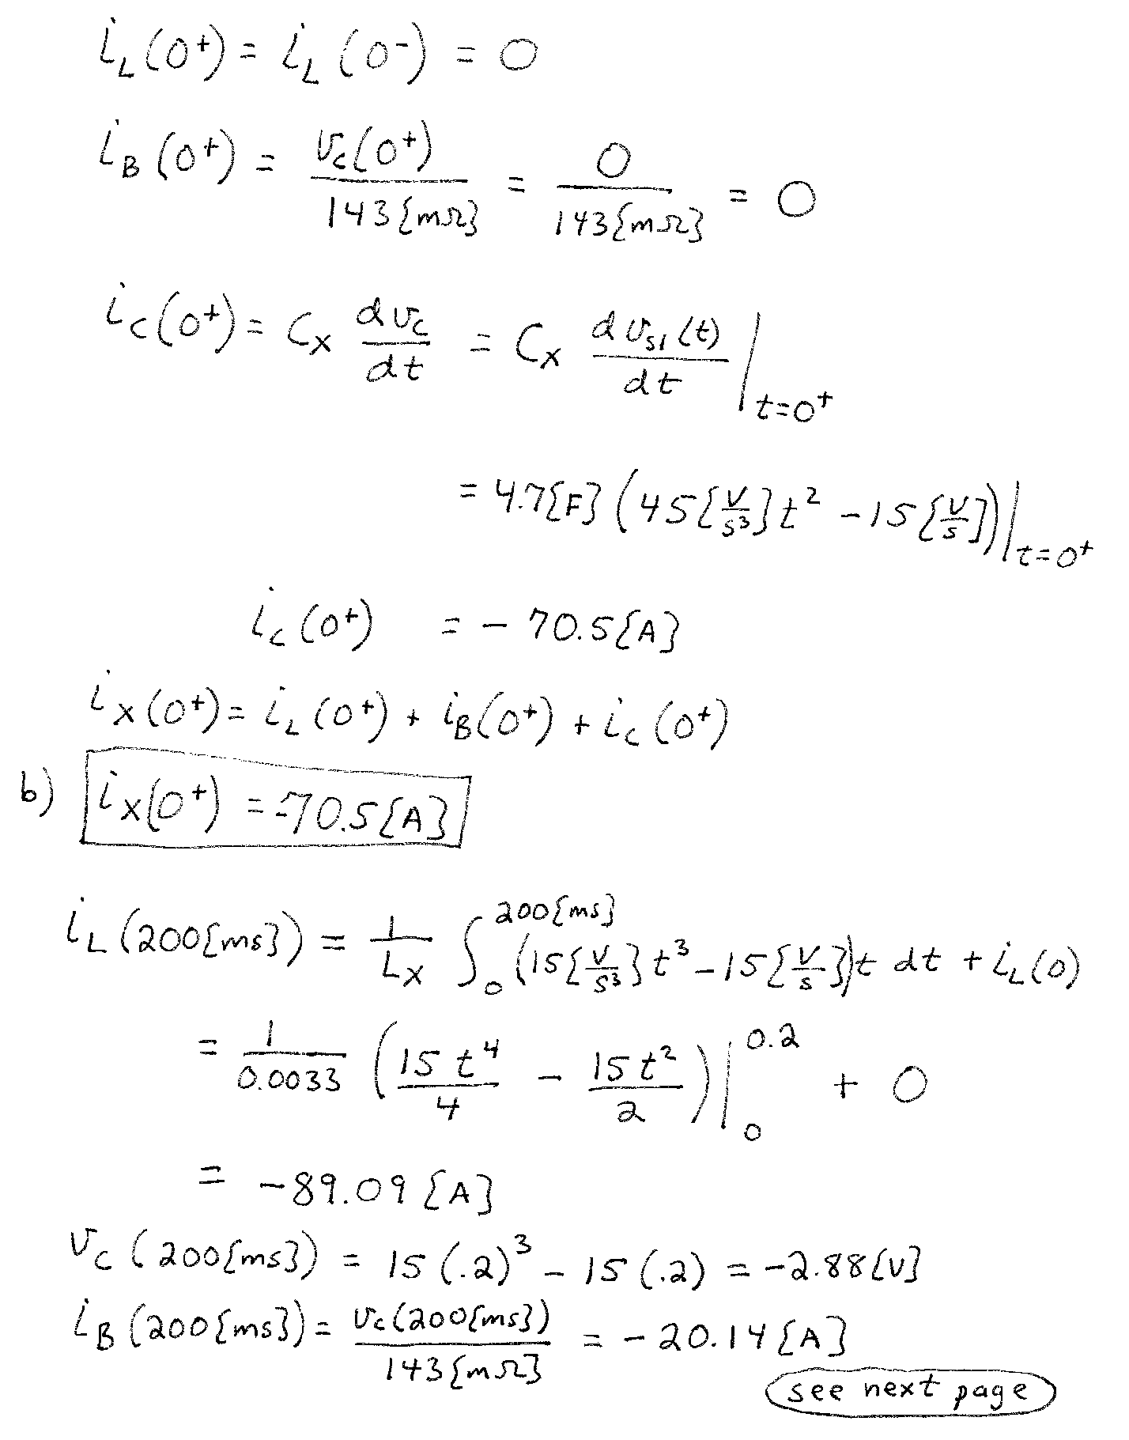
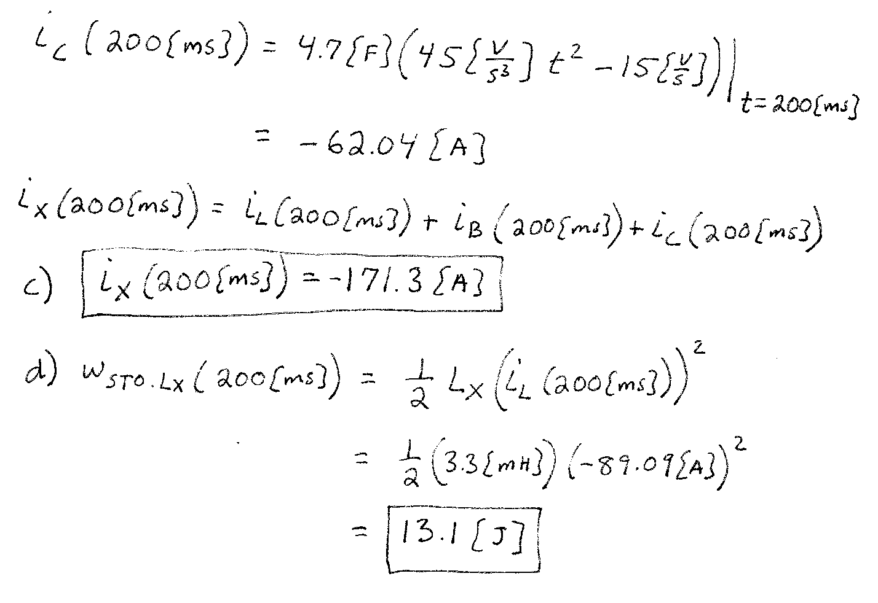

3. {35 Points} For the circuit shown below, switch 1 (SW1) had been open for a long time, and switch 2 (SW2) had been at position “a” for a long time. At t = 0, switch 1 (SW1) closed, then, at t = 1[s], switch 2 (SW2) switched from position “a” to position “b”. Find the numerical expressions for $i_{L}(t)$ for t ≥ 0.
