Name: _____________________________ (please print)
Signature: __________________________

ECE 2202 – Final Exam
May 3, 2017

Keep this exam closed until you are told to begin.
1. This exam is closed book, closed notes. You may use one 8.5” x 11” crib sheet, or its equivalent.
2. Show all work on these pages. Show all work necessary to complete the problem. A solution without the appropriate work shown will receive no credit. A solution that is not given in a reasonable order will lose credit. Clearly indicate your answer (for example by enclosing it in a box).
3. It is assumed that your work will begin on the same page as the problem statement. If you choose to begin your work on another page, you must indicate this on the page with the problem statement, with a clear indication of where the work can be found. If your work continues on to another page, indicate clearly where your work can be found. Failure to indicate this clearly will result in a loss of credit.
4. Show all units in solutions, intermediate results, and figures. Units in the exam will be included between square brackets.
5. Do not use red ink. Do not use red pencil.
6. You will have 170 minutes to work on this exam.

1. ________________/30
2. ________________/40
3. ________________/30
4. ________________/35
5. ________________/30
6. ________________/35
Total = 200
Room for extra work
1. {30 Points} Use the circuit below to solve. The switch SW2 opens at t = 0, and switch SW1 opens at t = 1[s]. The energy stored in inductor L₂ at t = 0 is zero. It is also known that i_{X}(0⁺) = -6.7[A].
a) Find i_{X} (2[s]).
b) Find v_{X} (3[s]).

Room for extra work

2. {40 Points} The circuit has been stable for a long time before t = 0. $v_{x}\left(0\right)=-3 [V]$. The switch SW1 opens at t = 1 [s], and switch SW2 opens at t = 0 and then close at t = 1 [s]. Find
a) $v_{C1}(0^{-})$,$v_{C1}(0^{+})$, $i_{C1}(0^{-})$, and $i_{C1}(0^{+})$.
b) Energy stored in $C_{1}$, $C_{2}$, and $C_{3}$ at $t=0[s]$.
c) Energy stored in $C_{1}$, $C_{2}$, and $C_{3}$ at $t=1[s]$.
d) Energy stored in $C_{1}$, $C_{2}$, and $C_{3}$ at $t=∞$.

Room for extra work

Room for extra work

3. {30 Points}The circuits shown below operate in steady-state. We know the independent current source $i_{s}\left(t\right)=12\sin\left(100\left[\frac{rad}{s}\right]t+50°\right)[A]$.
- Redraw the circuit in phasor domain.
- Find $i_{R}$.
- Find complex power absorbed by $3$ resistor + 0.02[H] inductor branch.

Room for extra work

4. {35 Points} The circuit shown below operates in steady-state. We know that the rms value of v_{X}(t) is 1,547[V_{rms}]. We are given that
- Find L₂.
- Find a numerical expression for v_{X}(t), as a function of time, t.

Room for extra work

5. {30 Points} The circuit shown below operates in steady-state. Find:
a) The average power absorbed by the $8[]$ resistor.
b) Real and reactive power absorbed by the load. Comparing the answer you obtained from question a) with the real power absorbed by the load: do they have the same answers and why?
c) Power factor, power factor angle of the load. Is this a lagging or leading power factor?
d) Complex power delivered by source.

Room for extra work

6. {35 Points} The circuits shown below operate in steady-state. Load 1 and Load 3 each absorb (56∠34°)[kVA]. Load 2 and Load 4 each absorb 47[kW] and deliver 15[kVAR]. The sources v_{S1}(t) and v_{S2}(t) are given by
- Find $i_{A}(t)$.
- Find $i_{B}(t)$.
- Find the impedance of Load 1.
- Find the impedance of Load 3.
- Write an equation that relate $Z_{Load1}$, $Z_{Load2}$, $Z_{Load3}$, and $Z_{Load4}$.

1. {30 Points} Use the circuit below to solve. The switch SW2 opens at t = 0, and switch SW1 opens at t = 1[s]. The energy stored in inductor L₂ at t = 0 is zero. It is also known that i_{X}(0⁺) = -6.7[A].
a) Find i_{X} (2[s]).
b) Find v_{X} (3[s]).
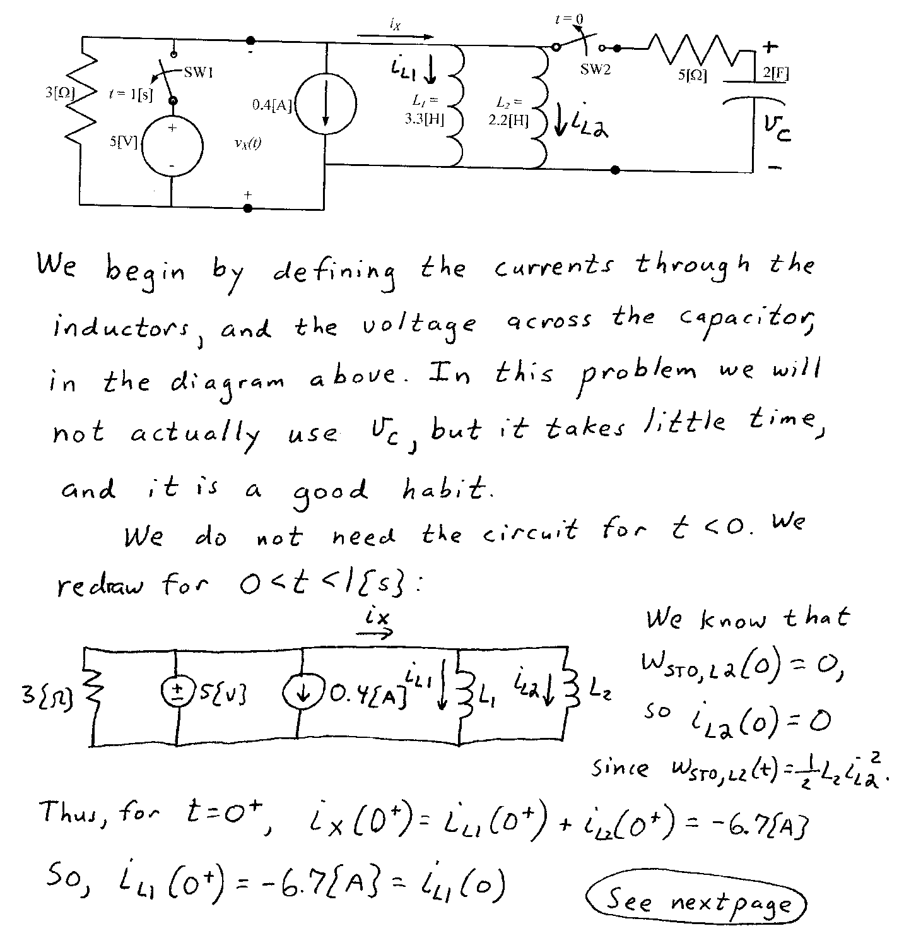
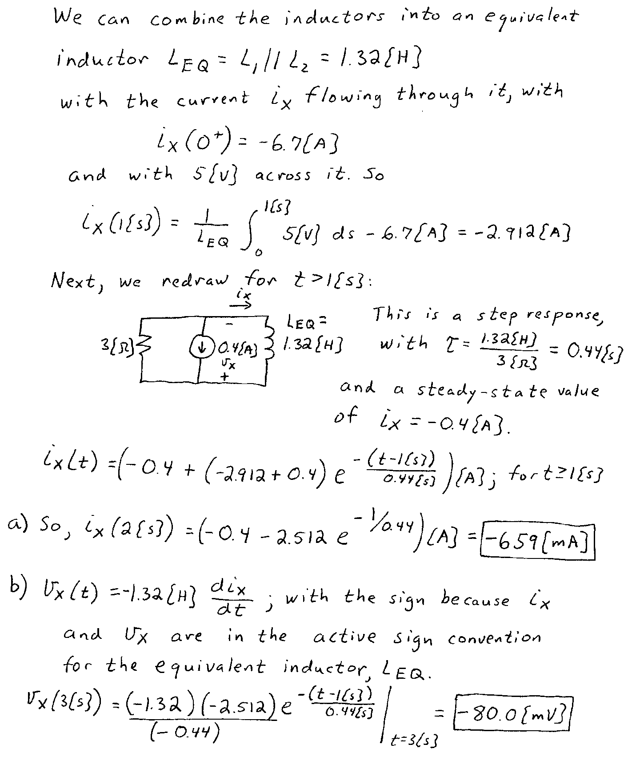

2. {40 Points} The circuit has been stable for a long time before t = 0. $v_{x}\left(0\right)=-3 [V]$. The switch SW1 opens at t = 1 [s], and switch SW2 opens at t = 0 and then close at t = 1 [s]. Find
a) $v_{C1}(0^{-})$,$v_{C1}(0^{+})$, $i_{C1}(0^{-})$, and $i_{C1}(0^{+})$.
b) Energy stored in $C_{1}$, $C_{2}$, and $C_{3}$ at $t=0[s]$.
c) Energy stored in $C_{1}$, $C_{2}$, and $C_{3}$ at $t=1[s]$.
d) Energy stored in $C_{1}$, $C_{2}$, and $C_{3}$ at $t=∞$.

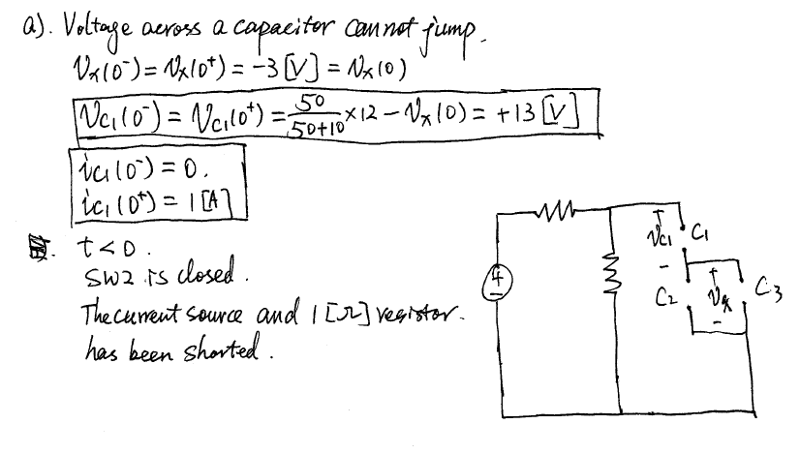
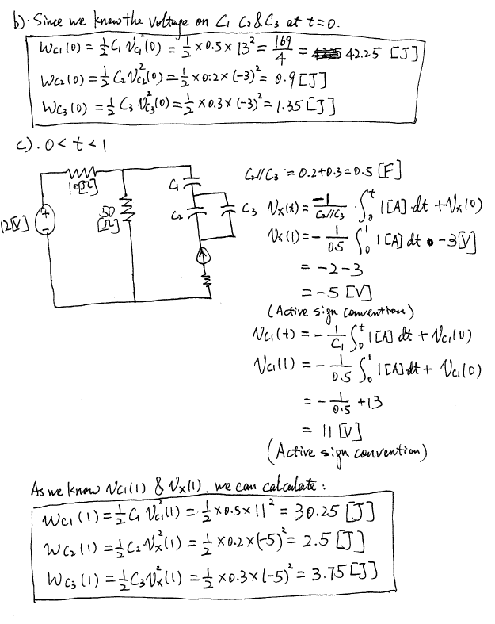
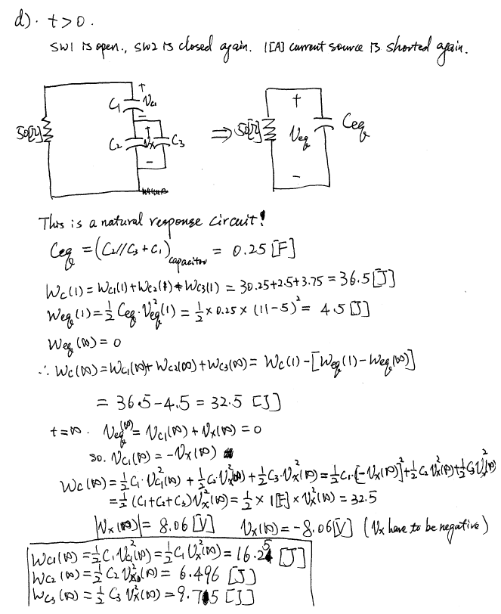

3. {30 Points}The circuits shown below operate in steady-state. We know the independent current source $i_{s}\left(t\right)=12\sin\left(100\left[\frac{rad}{s}\right]t+50°\right)[A]$.
- Redraw the circuit in phasor domain.
- Find $i_{R}$.
- Find complex power absorbed by $3$ resistor + 0.02[H] inductor branch.

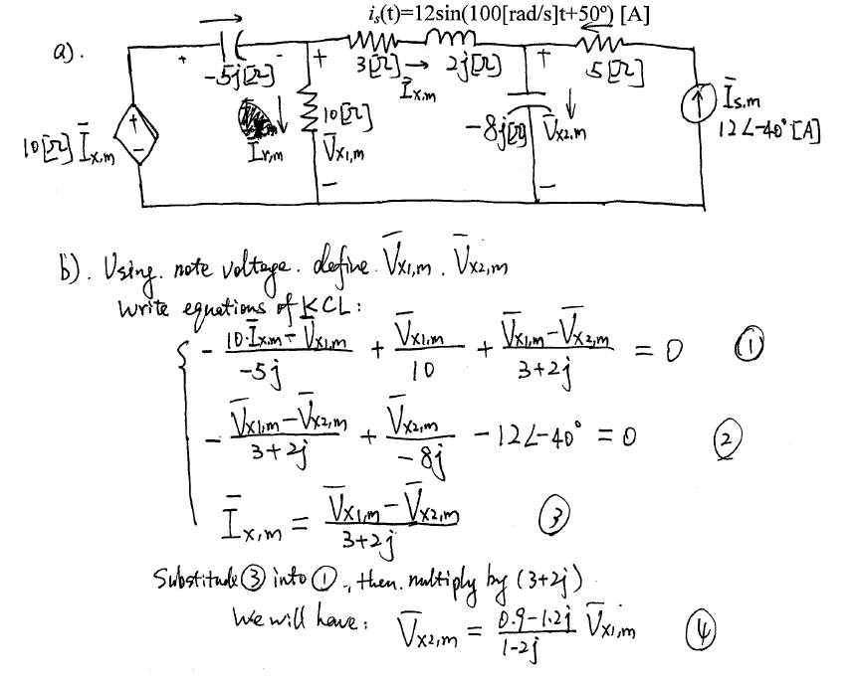
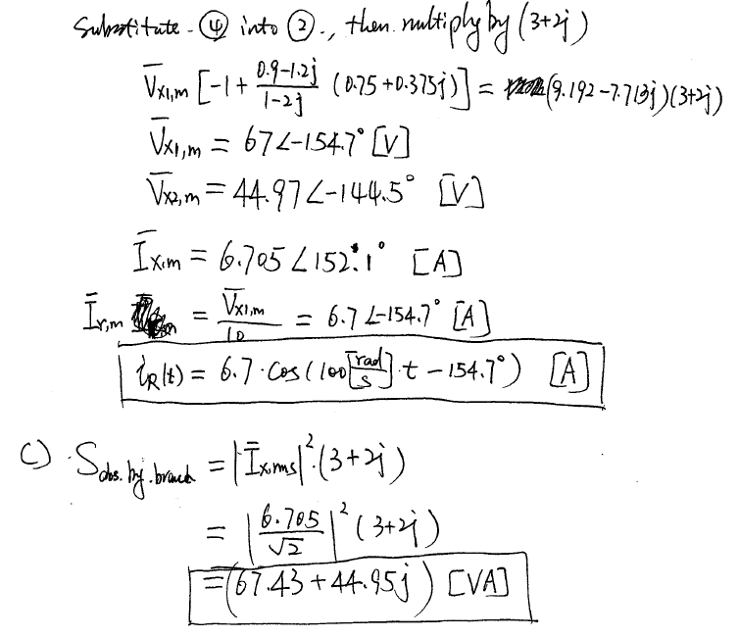

4. {35 Points} The circuit shown below operates in steady-state. We know that the rms value of v_{X}(t) is 1,547[V_{rms}]. We are given that
- Find L₂.
- Find a numerical expression for v_{X}(t), as a function of time, t.
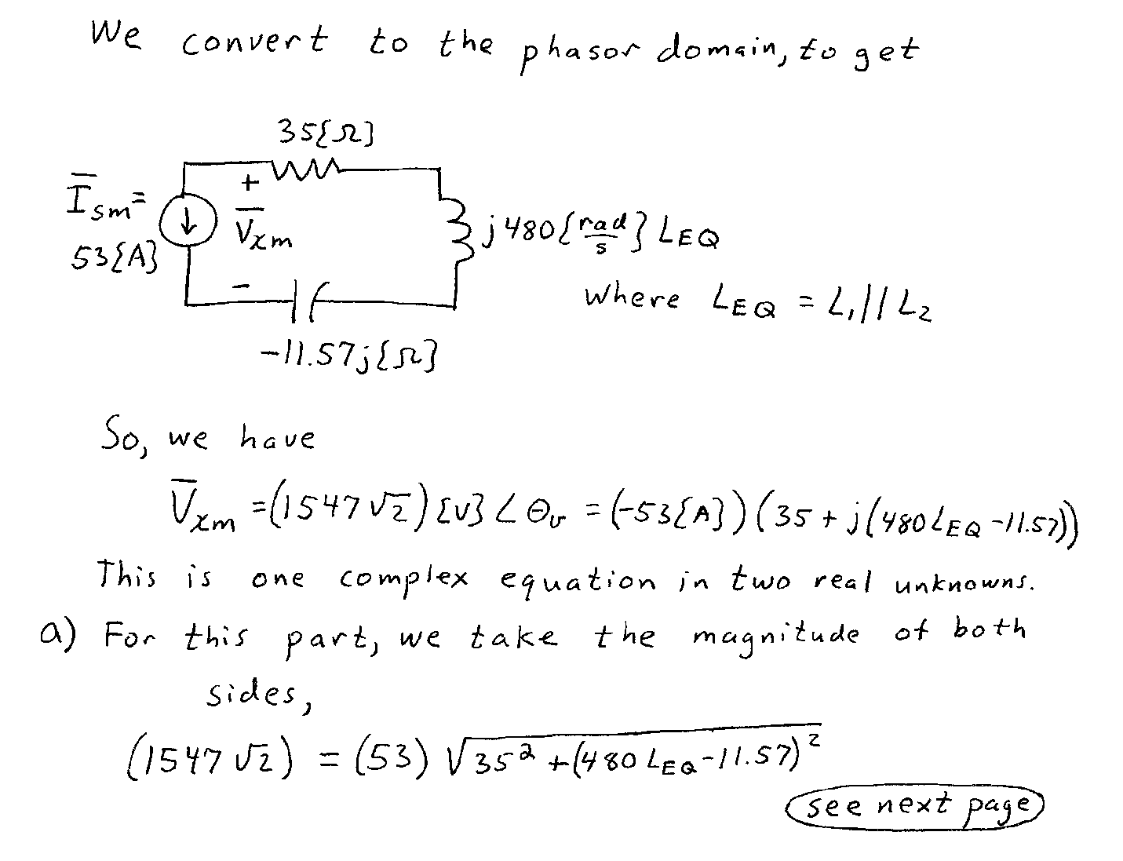
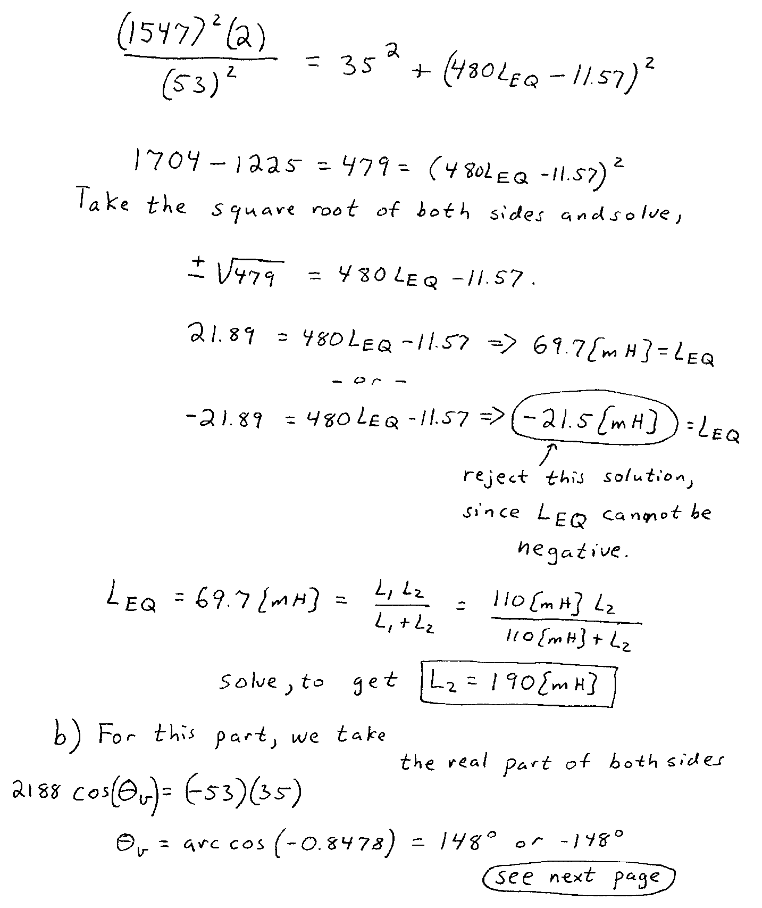
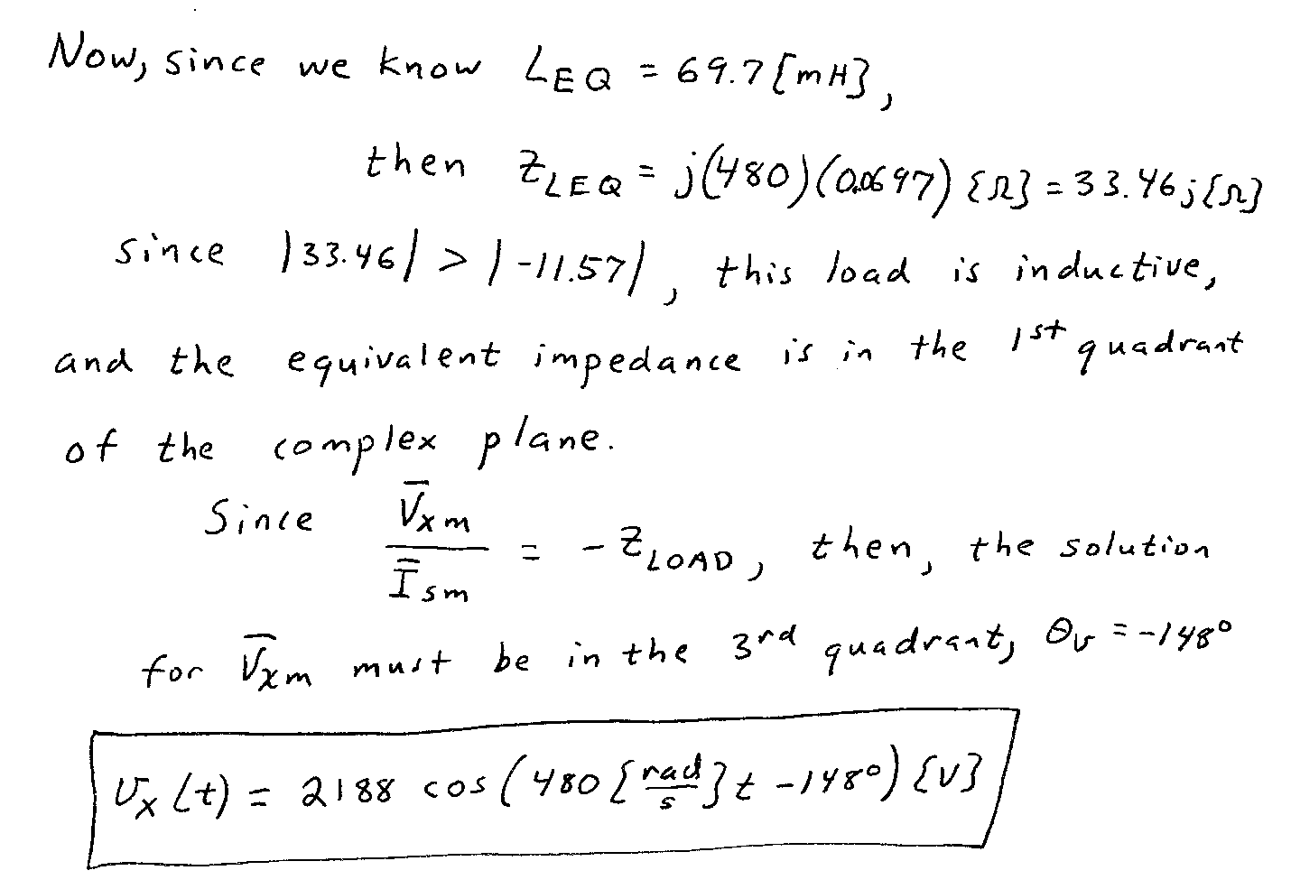

5. {30 Points} The circuit shown below operates in steady-state. Find:
a) The average power absorbed by the $8[]$ resistor.
b) Real and reactive power absorbed by the load. Comparing the answer you obtained from question a) with the real power absorbed by the load: do they have the same answers and why?
c) Power factor, power factor angle of the load. Is this a lagging or leading power factor?
d) Complex power delivered by source.
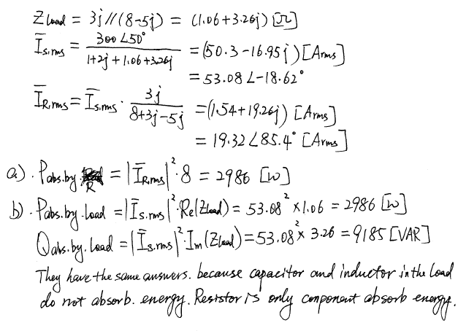
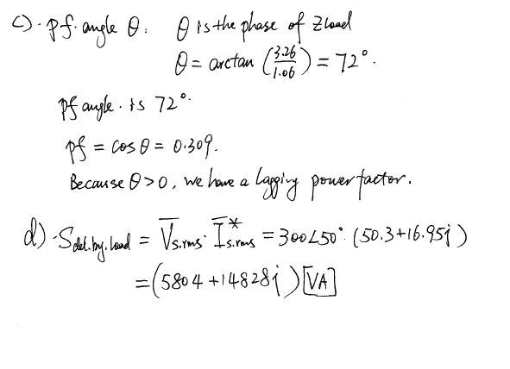

6. {35 Points} The circuits shown below operate in steady-state. Load 1 and Load 3 each absorb (56∠34°)[kVA]. Load 2 and Load 4 each absorb 47[kW] and deliver 15[kVAR]. The sources v_{S1}(t) and v_{S2}(t) are given by
