Name: _____________________________ (please print)
Signature: __________________________

ECE 2202 – Exam #1
March 24, 2018

Keep this exam closed until you are told to begin.

1. This exam is closed book, closed notes. You may use one 8.5” x 11” crib sheet, or its equivalent.
2. Show all work on these pages. Show all work necessary to complete the problem. A solution without the appropriate work shown will receive no credit. A solution that is not given in a reasonable order will lose credit. Clearly indicate your answer (for example by enclosing it in a box).
3. It is assumed that your work will begin on the same page as the problem statement. If you choose to begin your work on another page, you must indicate this on the page with the problem statement, with a clear indication of where the work can be found. If your work continues on to another page, indicate clearly where your work can be found. Failure to indicate this clearly will result in a loss of credit.
4. Show all units in solutions, intermediate results, and figures. Units in the exam will be included between square brackets.
5. Do not use red ink. Do not use red pencil.
6. You will have 90 minutes to work on this exam.

1. ________________/30
2. ________________/30
3. ________________/40
Total = 100
Room for extra work
1. {30 Points} Use the circuit shown below to solve this problem. The Thevenin resistance as seen by the resistance R_{L} is -1.57[Ω]. Find the value of X that makes this Thevenin resistance value correct. Include any appropriate units in your solution.

Room for extra work

2. {30 Points} In the circuit below it is given that
a) Find the energy stored in L₁ at t = 4[s].
b) Find the power delivered by v_{S}(t) at t = 4[s].

Room for extra work

3. {40 Points} The switch SWA has been open for a long time before it closed at
t = 0, and re-opened again at t = 2[µs]. Switch SWB has been closed for a long time before it opened at t = 2[µs]. Find numerical expressions for the current through the inductor, as a function of time, for t$≥$0.

Room for extra work

1. {30 Points} Use the circuit shown below to solve this problem. The Thevenin resistance as seen by the resistance R_{L} is -1.57[Ω]. Find the value of X that makes this Thevenin resistance value correct. Include any appropriate units in your solution.
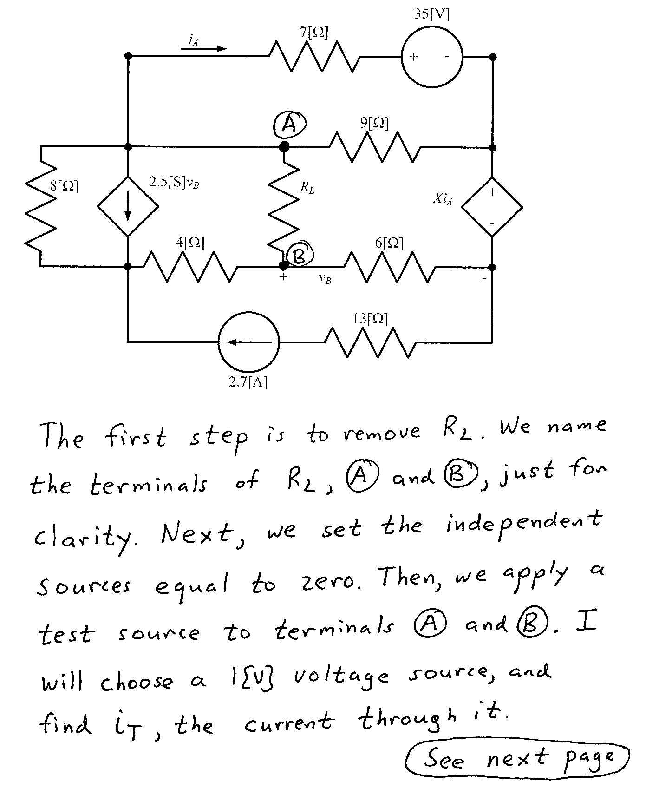
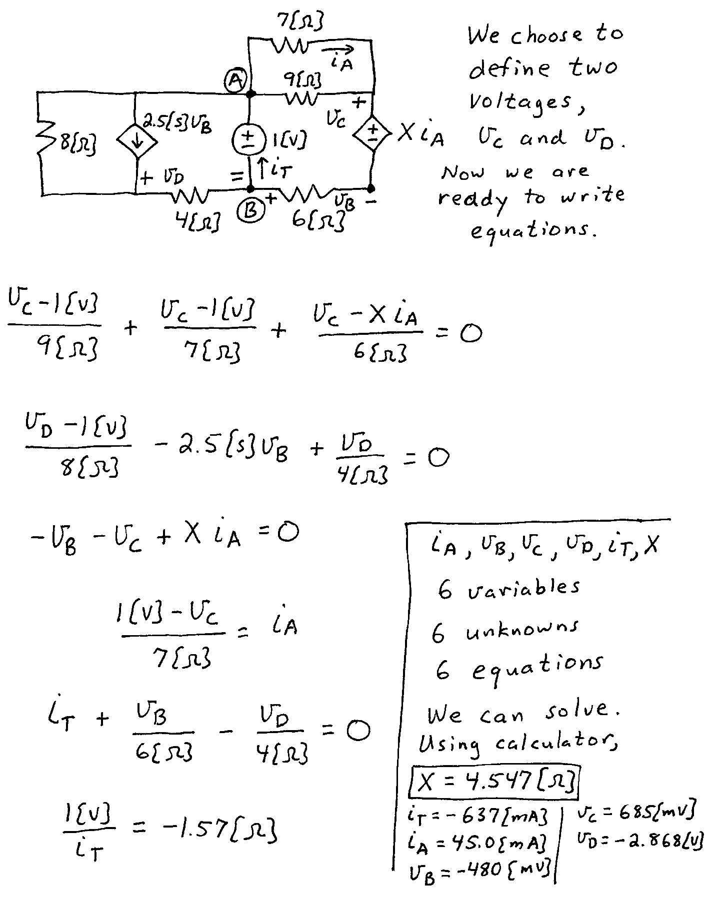

2. {30 Points} In the circuit below it is given that
a) Find the energy stored in L₁ at t = 4[s].
b) Find the power delivered by v_{S}(t) at t = 4[s].
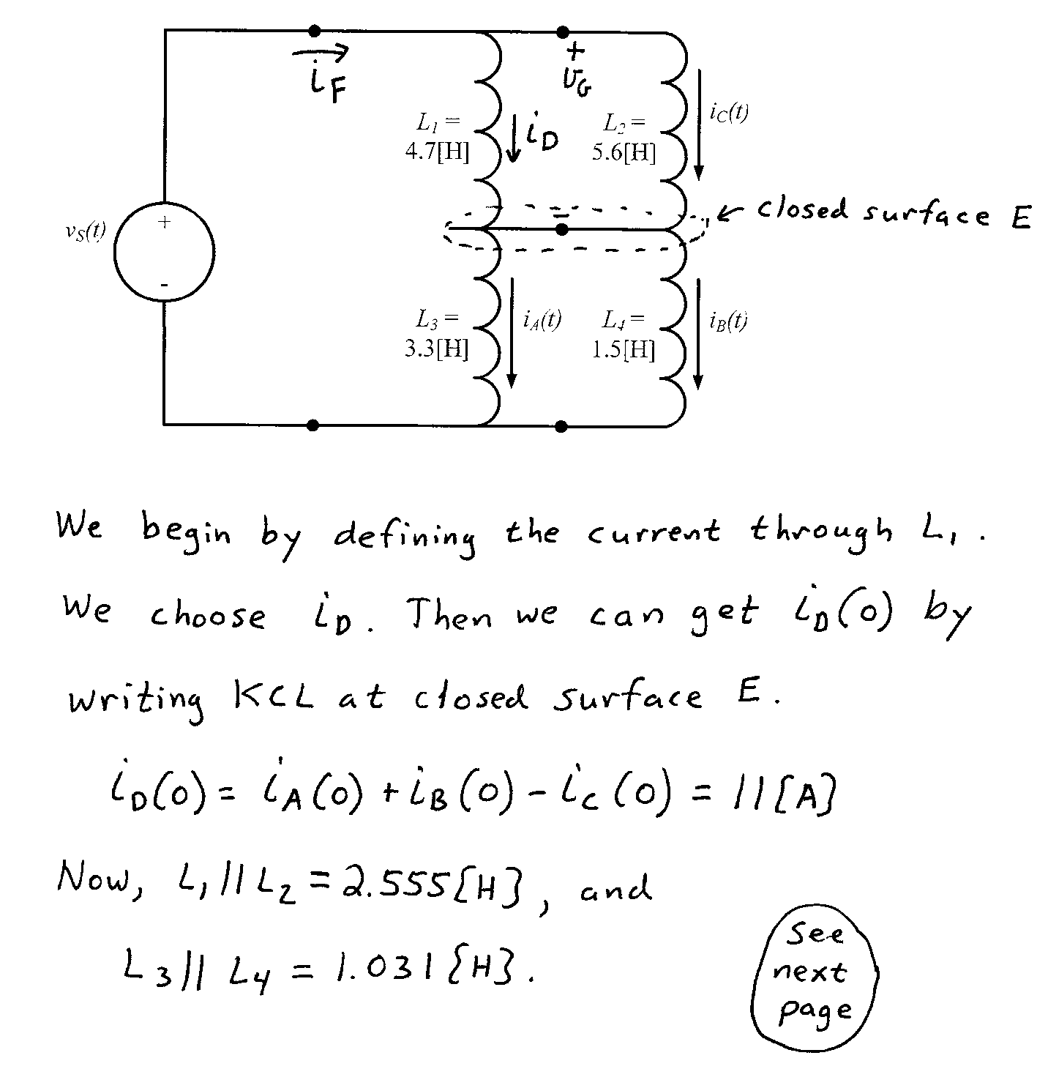
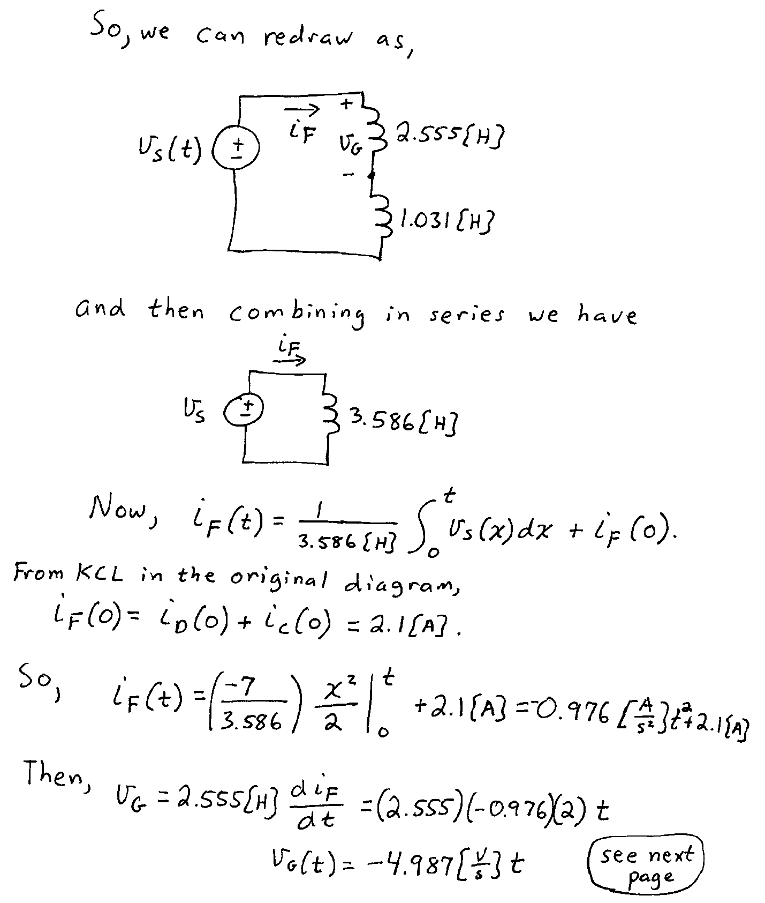
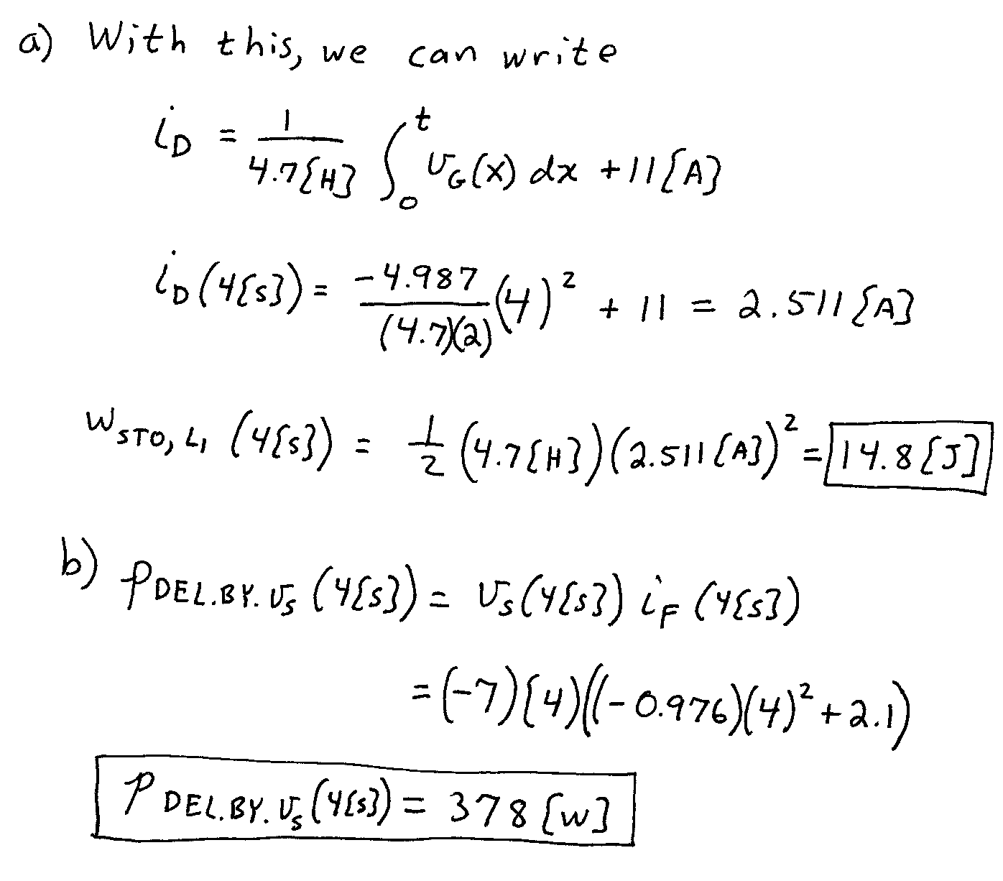

3. {40 Points} The switch SWA has been open for a long time before it closed at
t = 0, and re-opened again at t = 2[µs]. Switch SWB has been closed for a long time before it opened at t = 2[µs]. Find numerical expressions for the current through the inductor, as a function of time, for t$≥$0.
