Name: _____________________________ (please print)
Signature: __________________________

ECE 2202 – Exam 2
April 21, 2018

Keep this exam closed until you are told to begin.

1. This exam is closed book, closed notes. You may use one 8.5” x 11” crib sheet, or its equivalent.
2. Show all work on these pages. Show all work necessary to complete the problem. A solution without the appropriate work shown will receive no credit. A solution that is not given in a reasonable order will lose credit. Clearly indicate your answer (for example by enclosing it in a box).
3. It is assumed that your work will begin on the same page as the problem statement. If you choose to begin your work on another page, you must indicate this on the page with the problem statement, with a clear indication of where the work can be found. If your work continues on to another page, indicate clearly where your work can be found. Failure to indicate this clearly will result in a loss of credit.
4. Show all units in solutions, intermediate results, and figures. Units in the exam will be included between square brackets.
5. Do not use red ink. Do not use red pencil.
6. You will have 90 minutes to work on this exam.

1. ________________/40
2. ________________/30
3. ________________/30
Total = 100
Room for extra work
- {40 Points} Use the circuit shown below to solve. The switch SWA was open and switch SWB was closed for a long time before t = 0. Then, switch SWA closed and switch SWB opened, at the same time, at t = 0.
- Find i_{X}(20[s]).
- Find the energy stored in capacitor C₁ at t = 20[s].
- Find the total energy stored in the three capacitors a long time after t = 0.

Room for extra work

- {30 Points}The circuit given below is operating in steady state. It is given that
$$i_{S}=75\sin\left(55\left[\frac{rad}{s}\right]t+50°\right)[mA]$$

$$v_{S}=10\cos\left(150\left[\frac{rad}{s}\right]t+30°\right)[V]$$

Find the steady state expression for $v_{x}(t)$.
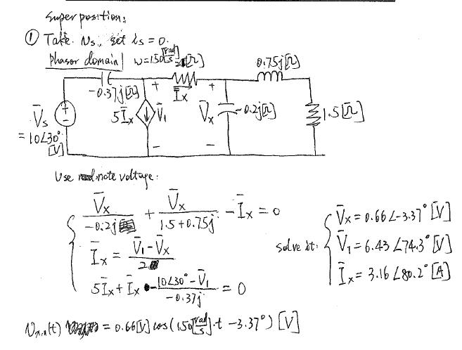
Room for extra work
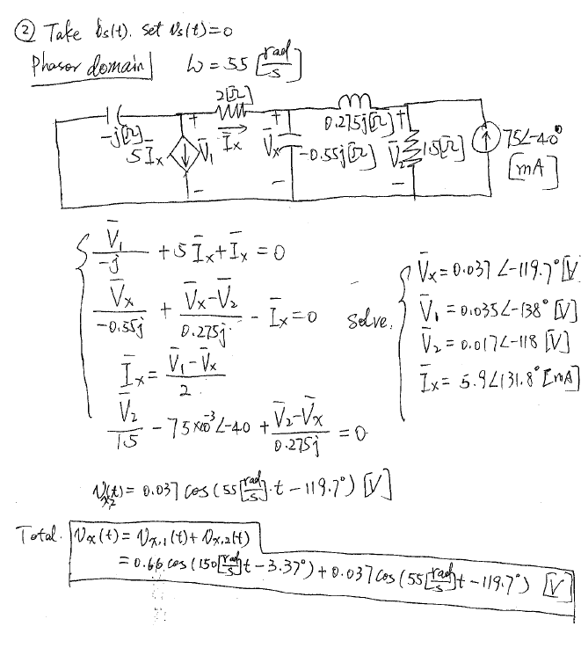
Room for extra work

- {30 Points} The circuit showing below is working in steady state. The angular frequency ($ω$) of the voltage source is $100\left[\frac{rad}{s}\right]$.
- Please find R and L values which will allow the ratio of phasor voltage of $Vi$ to the phasor voltage of $Vo$ to satisfy $\frac{Vi}{Vo}=3.6∠-33.69°$.
- Assume for part b) that $R = 2.3[]$and $L =7.2[mH]$. Please calculate: reactance and susceptance seen by the voltage source ($v_{i}(t)$).

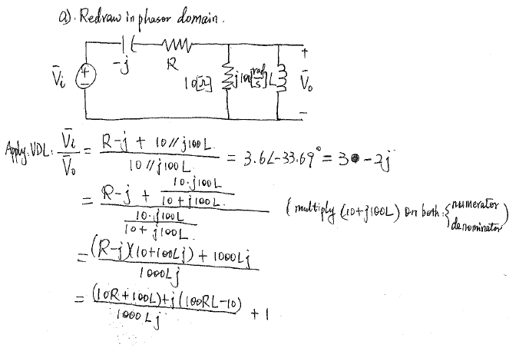
Room for extra work
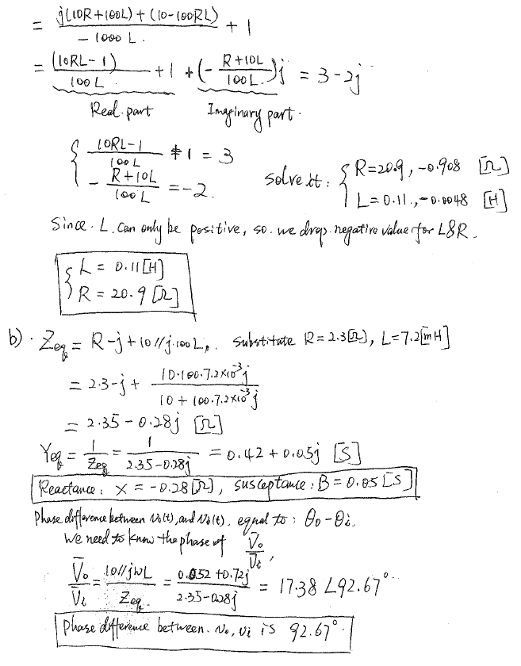
Room for extra work

