Name: _____________________________ (please print)
Signature: __________________________

ECE 2202 – Final Exam
May 3, 2018
Keep this exam closed until you are told to begin.

1. This exam is closed book, closed notes. You may use one 8.5” x 11” crib sheet, or its equivalent.
2. Show all work on these pages. Show all work necessary to complete the problem. A solution without the appropriate work shown will receive no credit. A solution that is not given in a reasonable order will lose credit. Clearly indicate your answer (for example by enclosing it in a box).
3. It is assumed that your work will begin on the same page as the problem statement. If you choose to begin your work on another page, you must indicate this on the page with the problem statement, with a clear indication of where the work can be found. If your work continues on to another page, indicate clearly where your work can be found. Failure to indicate this clearly will result in a loss of credit.
4. Show all units in solutions, intermediate results, and figures. Units in the exam will be included between square brackets.
5. Do not use red ink. Do not use red pencil.
6. You will have 170 minutes to work on this exam.

1. ________________/30
2. ________________/30
3. ________________/30
4. ________________/30
5. ________________/40
6. ________________/40
Total = 200
Room for extra work
- {30 Points} Use the circuit below to solve.
- Find the Thevenin equivalent as seen by the i_{S1} current source. Draw the Thevenin equivalent you found, showing numerical values, and attach the i_{S1} current source to your equivalent.
- Find the power delivered by the i_{S1} current source in the circuit below.

Room for extra work

- {30 Points} The source $v_{i}$ is a zero mean sinusoidal voltage source with frequency of $ω$ and the circuit is operating in steady-state.
- Find the frequency $ω$ for which the current $i_{i}$and the voltage $v_{i}$ are in phase.
- Assume for part b) that $ω=100[{rad}/s]$. Please calculate the reactance and susceptance seen by the voltage source ($v_{i}(t)$).

Room for extra work

- {30 Points}The circuit given below is operating in steady state. It is given that
$$v_{S}=1000\cos\left(100\left[\frac{rad}{s}\right]t\right)[V]$$

- Find the real and reactive power absorbed by the load.
- Find the reactive power absorbed by the 12[mF] capacitor and the 8[H] inductor, and compare your results with reactive power absorbed by load. Do they have same value and why?
- Calculate the phase difference between $v_{line}(t)$ and $i_{x}(t)$.
- Find the power factor and power factor angle of the load. Is it a lagging or leading power factor, and is it an inductive or a capacitive load?

Room for extra work

- {30 Points} It is given that:
$$i_{s}=5e^{- \frac{t}{2.5[s]}}[A]$$
$$v_{A}\left(0\right)=-1.5[V]$$
$$v_{B}\left(0\right)=+3.8[V]$$
- Please find the numerical expression of $v_{B}(t)$ for $t≥0$.
- Please find the numerical expression of $i_{C}(t)$ for $t≥0$.
- Find the energy stored in the equivalent capacitor of the three capacitors at $t=+∞$.
- Find the energy stored in the individual capacitors at$t=+∞$.

Room for extra work

- {40 Points}The switch in the circuit given below had been in position a for long time, and then moved to position b at t = 0.
- Find v_{X}(1[μs]).
- Find the sum of the energies stored in the magnetic fields of the two inductors at t = ∞.

Room for extra work

- {40 Points}The circuit shown operates in steady-state. The current i_{A} is given by
Load 1 absorbs 5.7[kW] and delivers 4.3[kVAR].
Load 2 absorbs (6.7∠-13°)[kVA].
Load 3 absorbs 7.5[kW] at a lagging pf = 0.87.
Load 4 absorbs 8.7[kVA] at a leading pf = 0.72.
- Find v_{B}(t).
- Find the impedance of the combination of the four loads, as seen by the voltage source.
- Find the power factor of the combination of the four loads, as seen by the voltage source.
- Find v_{L2}(t).

- {30 Points} Use the circuit below to solve.
- Find the Thevenin equivalent as seen by the i_{S1} current source. Draw the Thevenin equivalent you found, showing numerical values, and attach the i_{S1} current source to your equivalent.
- Find the power delivered by the i_{S1} current source in the circuit below.
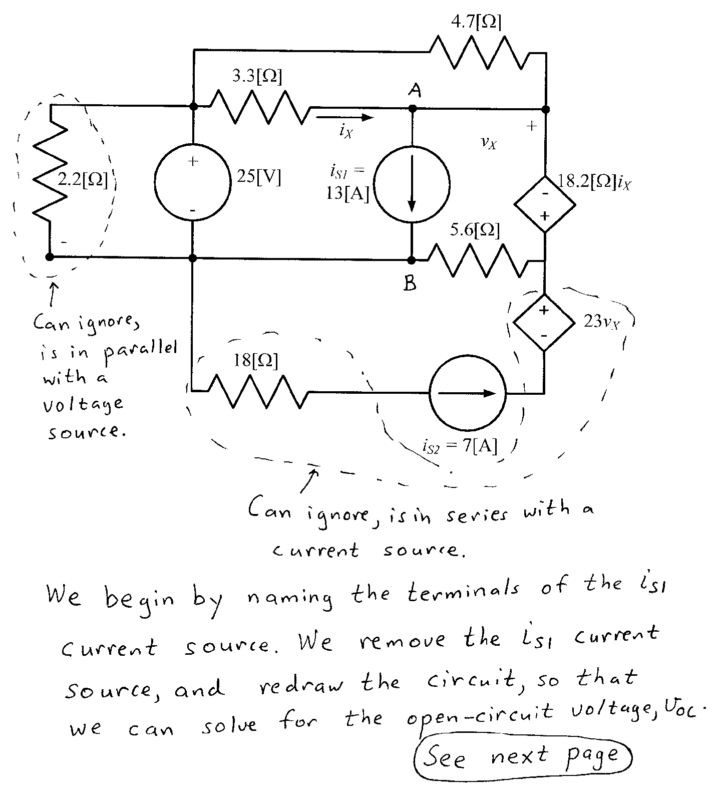
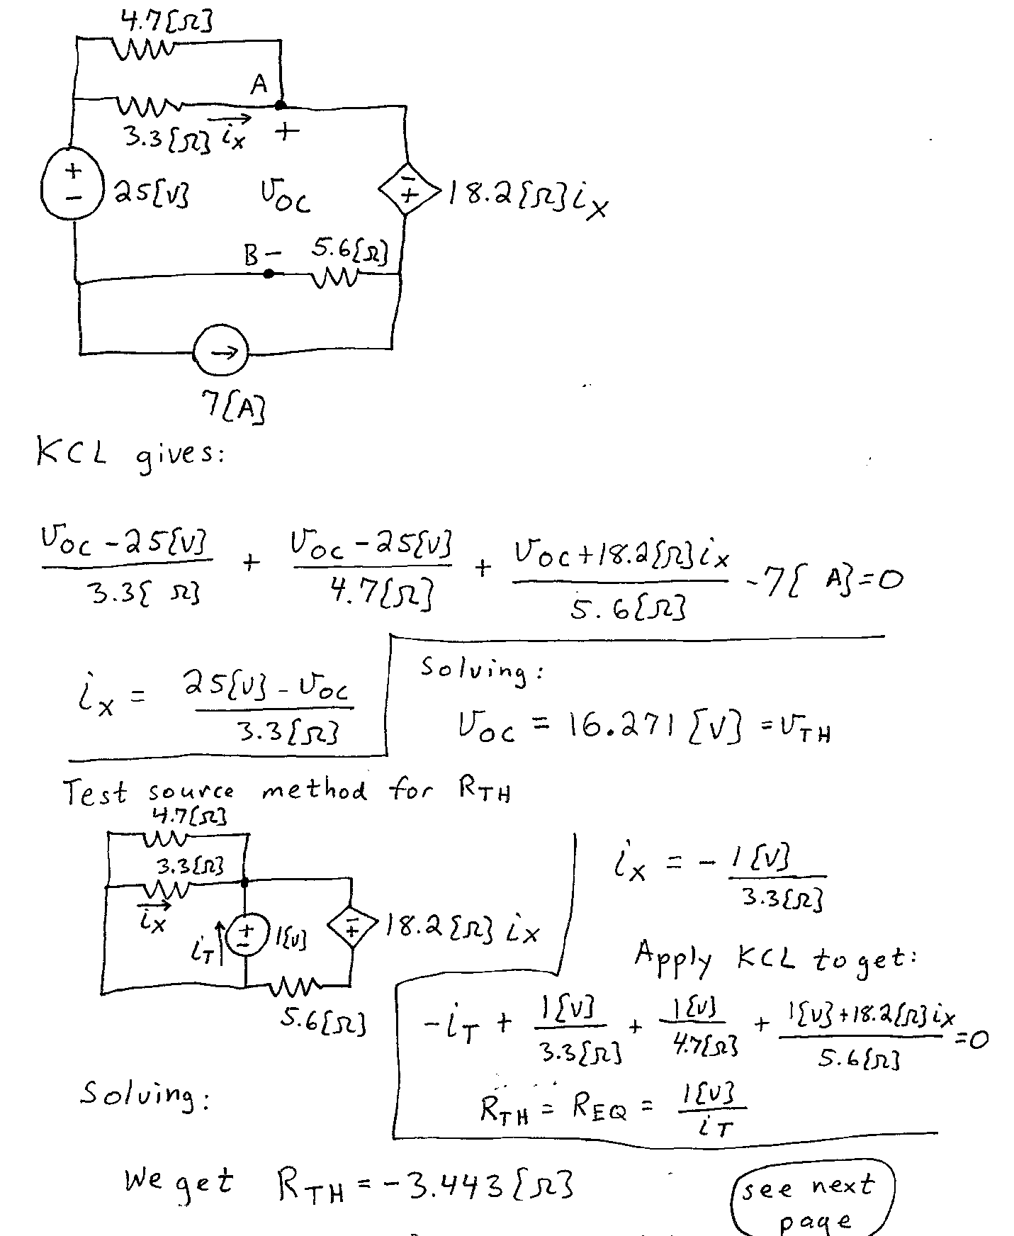
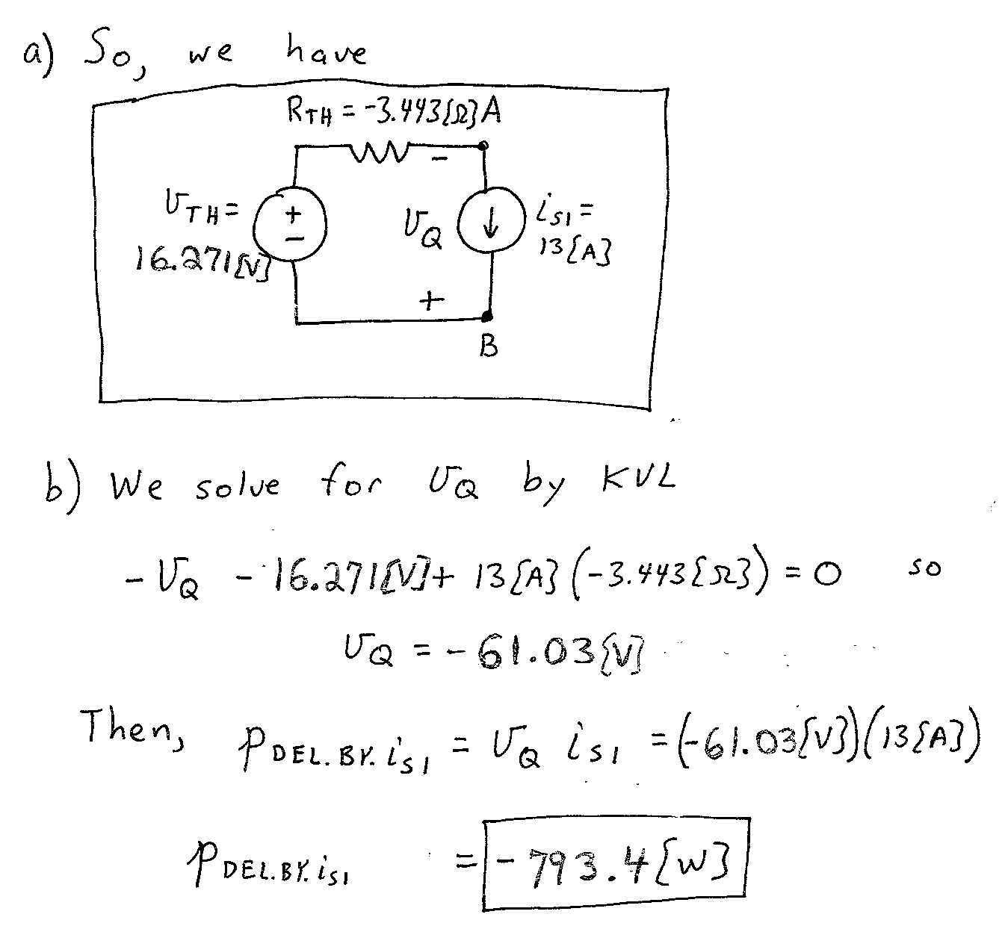

- {30 Points} The source $v_{i}$ is a zero mean sinusoidal voltage source with frequency of $ω$ and the circuit is operating in steady-state.
- Find the frequency $ω$ for which the current $i_{i}$and the voltage $v_{i}$ are in phase.
- Assume for part b) that $ω=100[{rad}/s]$. Please calculate the reactance and susceptance seen by the voltage source ($v_{i}(t)$).

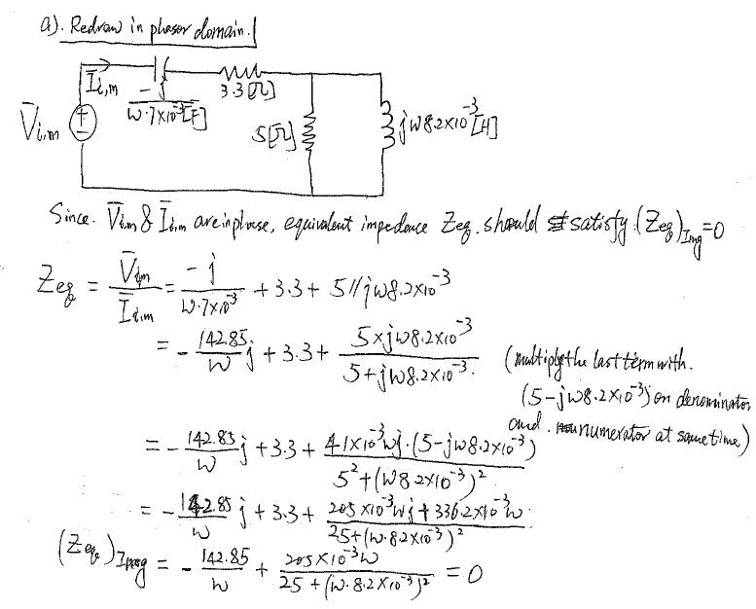
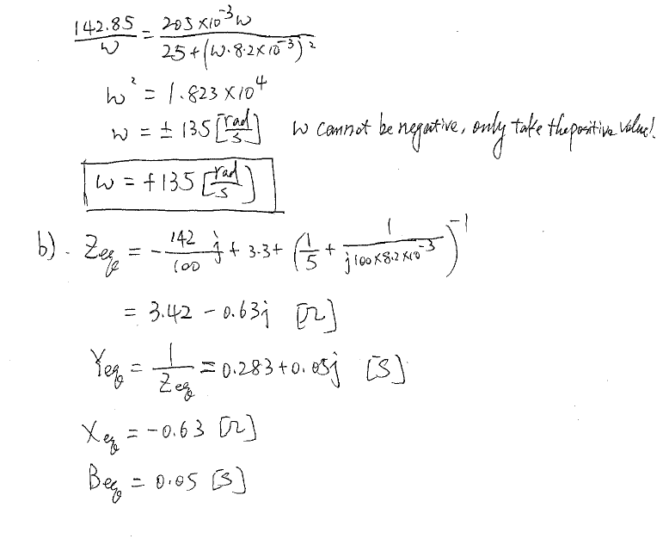
- {30 Points}The circuit given below is operating in steady state. It is given that
$$v_{S}=1000\cos\left(100\left[\frac{rad}{s}\right]t\right)[V]$$

- Find the real and reactive power absorbed by the load.
- Find the reactive power absorbed by the 12[mF] capacitor and the 8[H] inductor, and compare your results with reactive power absorbed by load. Do they have same value and why?
- Calculate the phase difference between $v_{line}(t)$ and $i_{x}(t)$.
- Find the power factor and power factor angle of the load. Is it a lagging or leading power factor, and is it an inductive or a capacitive load?
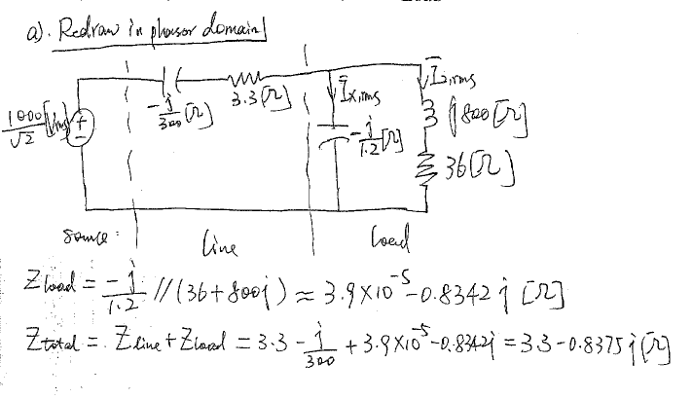
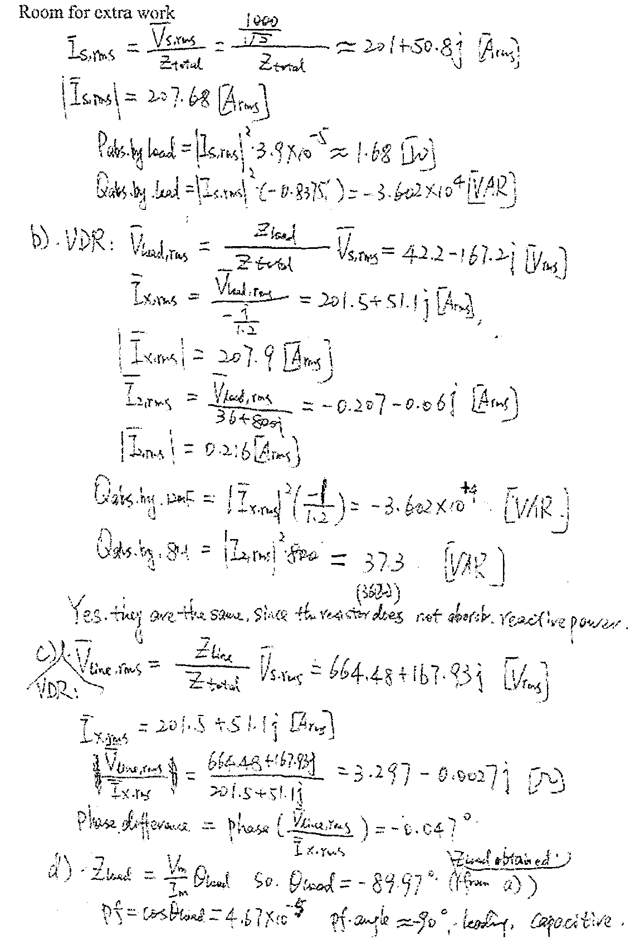
- {30 Points} It is given that:
$$i_{s}=5e^{- \frac{t}{2.5[s]}}[A]$$
$$v_{A}\left(0\right)=-1.5[V]$$
$$v_{B}\left(0\right)=+3.8[V]$$
- Please find the numerical expression of $v_{B}(t)$ for $t≥0$.
- Please find the numerical expression of $i_{C}(t)$ for $t≥0$.
- Find the energy stored in the equivalent capacitor of the three capacitors at $t=+∞$.
- Find the energy stored in the individual capacitors at$t=+∞$.

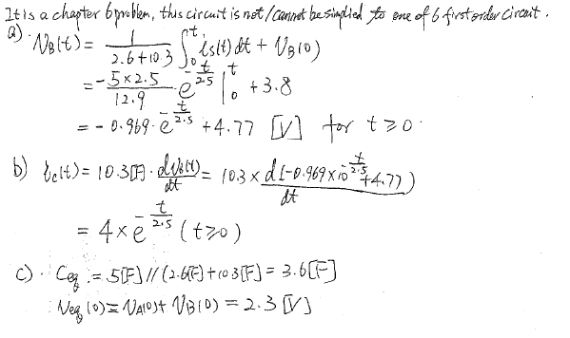
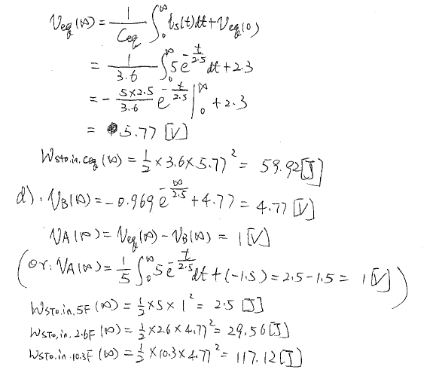
- {40 Points}The switch in the circuit given below had been in position a for long time, and then moved to position b at t = 0.
- Find v_{X}(1[μs]).
- Find the sum of the energies stored in the magnetic fields of the two inductors at t = ∞.
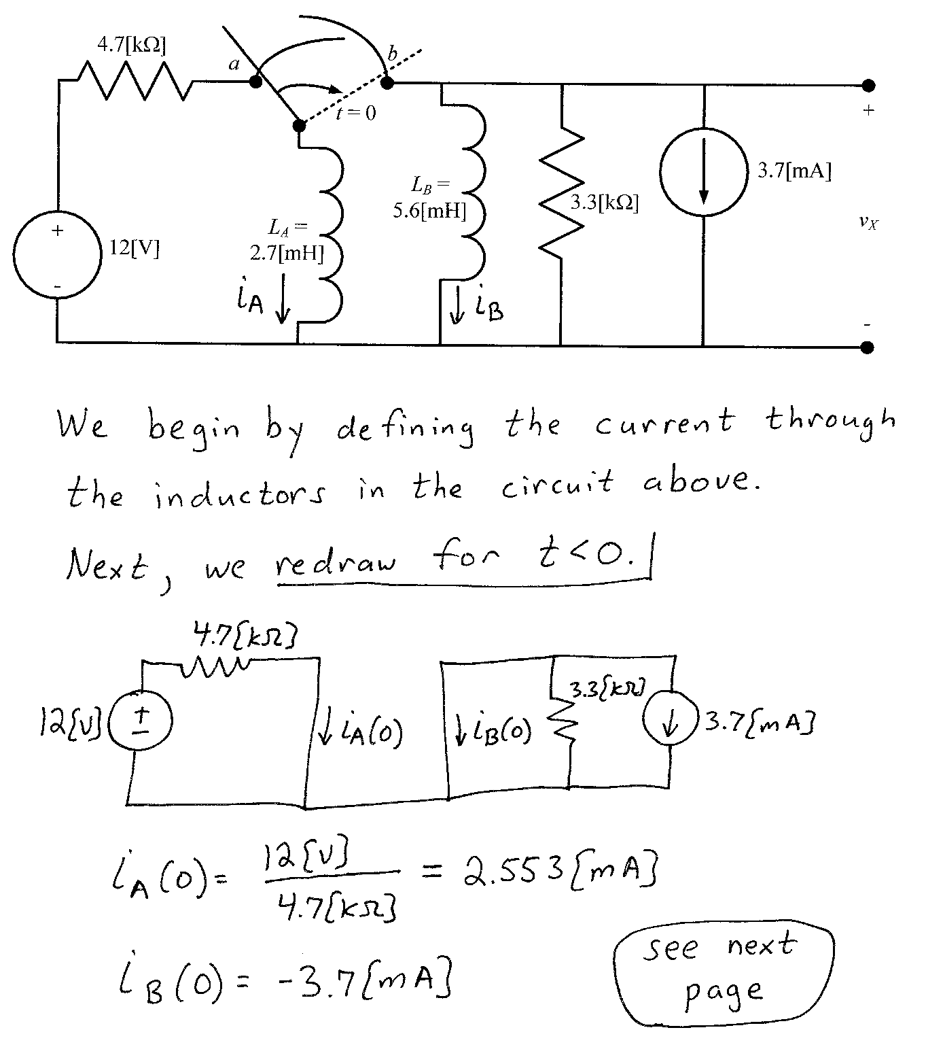
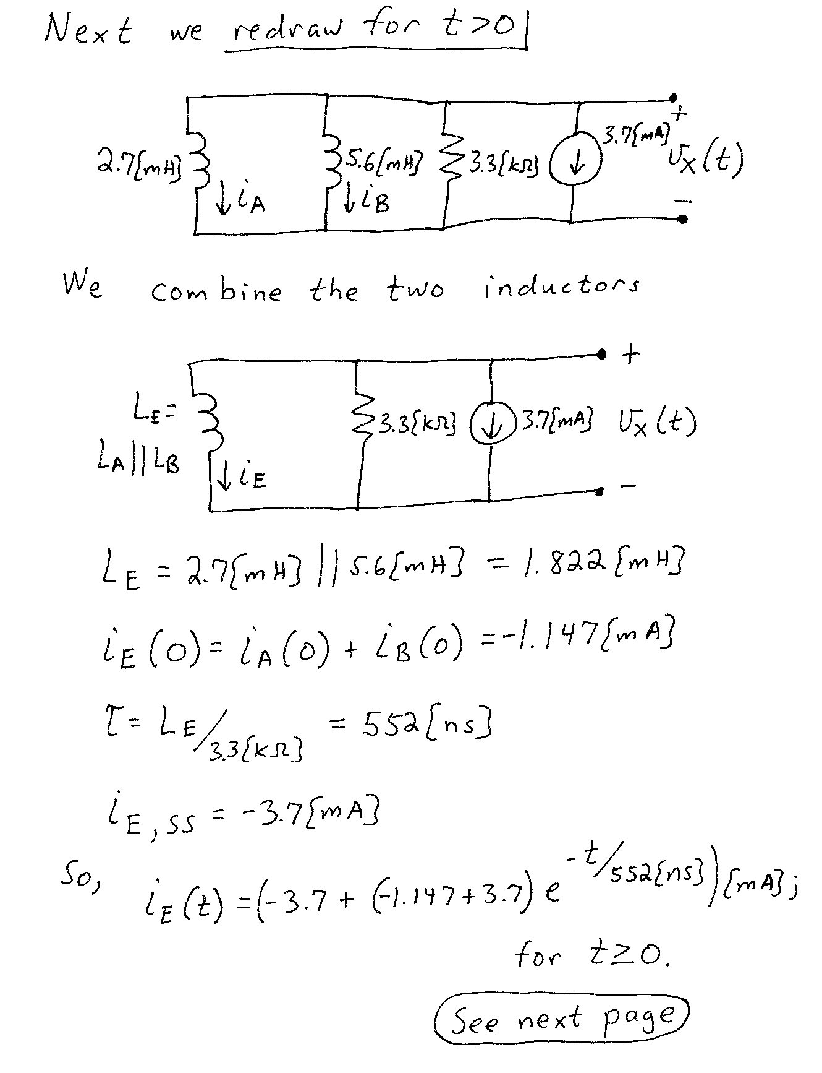
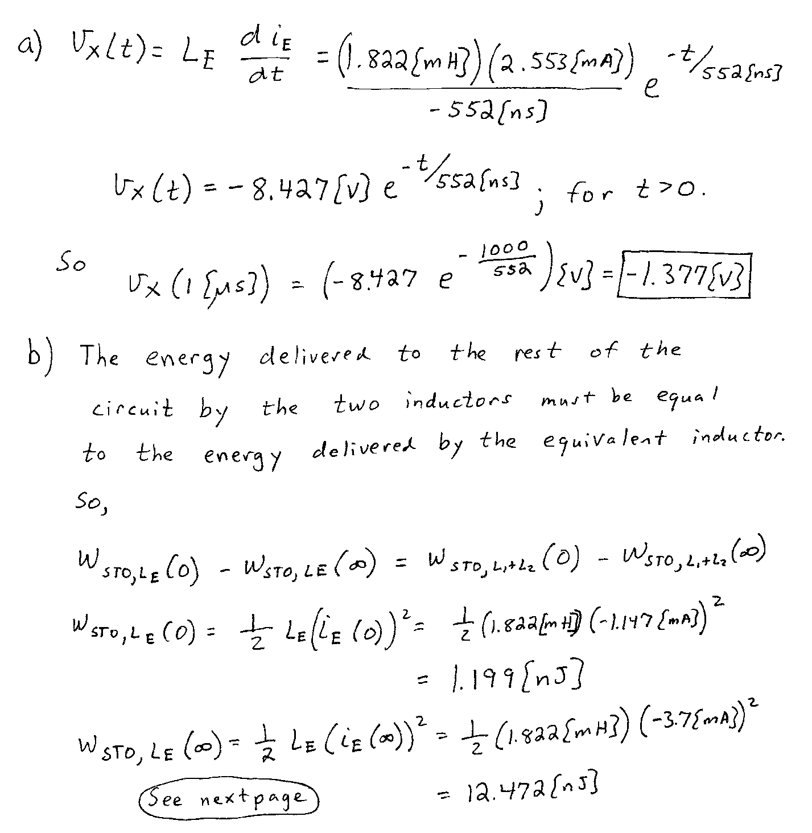
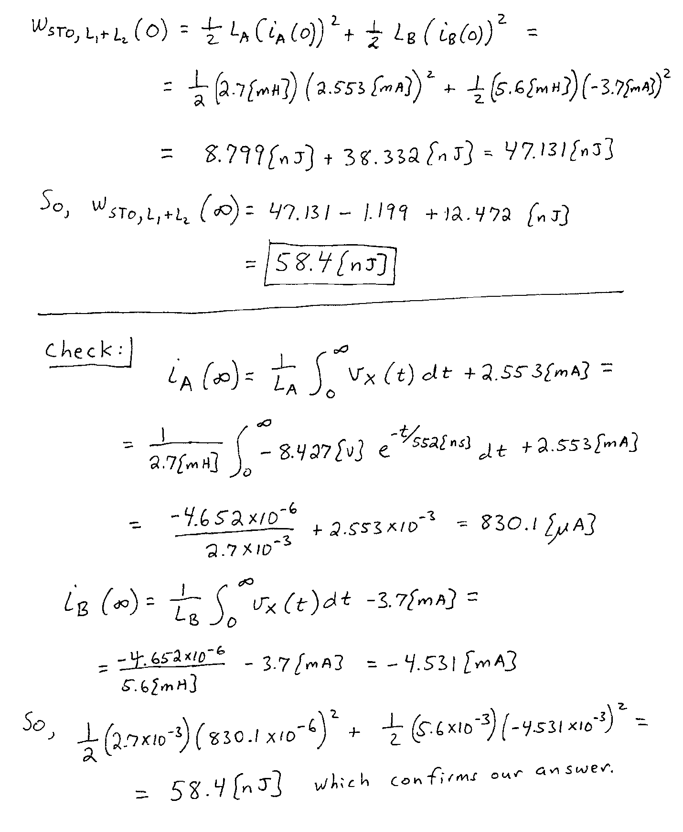

- {40 Points}The circuit shown operates in steady-state. The current i_{A} is given by
Load 1 absorbs 5.7[kW] and delivers 4.3[kVAR].
Load 2 absorbs (6.7∠-13°)[kVA].
Load 3 absorbs 7.5[kW] at a lagging pf = 0.87.
Load 4 absorbs 8.7[kVA] at a leading pf = 0.72.
- Find v_{B}(t).
- Find the impedance of the combination of the four loads, as seen by the voltage source.
- Find the power factor of the combination of the four loads, as seen by the voltage source.
- Find v_{L2}(t).
