Peoplesoft ID Number: _____________________________

ECE 2202 – Exam 1 Problem 2
March 6, 2021

1. You may use one 8.5” x 11” crib sheet, or its equivalent. Do not communicate with anyone except Dr. Shattuck or Dr. Shan while you are taking this quiz.
2. Show all work necessary to complete the problem. Use additional sheets of paper as needed. A solution without the appropriate work shown will receive no credit. A solution which is not given in a reasonable order will lose credit. Include this page with your Peoplesoft ID Number, or include a different, separate page with your Peoplesoft ID Number. Failure to do this will result in points being deducted.
3. Show all units in solutions, intermediate results, and figures. Units in the quiz will be included between square brackets.
4. Do not use red ink. Do not use red pencil.
5. You will have 30 minutes to work on this problem, plus additional time to print, scan and email your work. Use a filename which is your Peoplesoft ID Number, followed by Problem2. Email your completed problem to dshattuc@central.uh.edu and xshan@central.uh.edu. It must be sent by 10:15am, or points will be deducted.

________________/40
In the circuit below, $v_{S}\left(t\right)=-3\left[\frac{V}{s^{2}}\right]t^{2}-2\left[\frac{V}{s}\right]t+5[V]$ for $t≥0$. There are three switches in the circuit: S1, S2 and S3. Before t = 0, S1 has been opened for a long time, S2 has been closed for a long time, and S3 has been at position a for a long time. At t = 0, S1 is closed, S2 is opened, and S3 is moving from position a to b. At t = 1 [s], S1 is opened, S2 is closed, and S3 is moved from position b to a. Please find:
- $v_{L1}(0^{+})$, $i_{L1}(0^{+})$, $v_{L2}(0^{+})$, and $i_{L2}(0^{+})$.
- $v_{L1}(1^{+})$, $i_{L1}(1^{+})$, $v_{L2}(1^{-}),v_{L2}(1^{+})$, and $i_{L2}(1^{+})$.

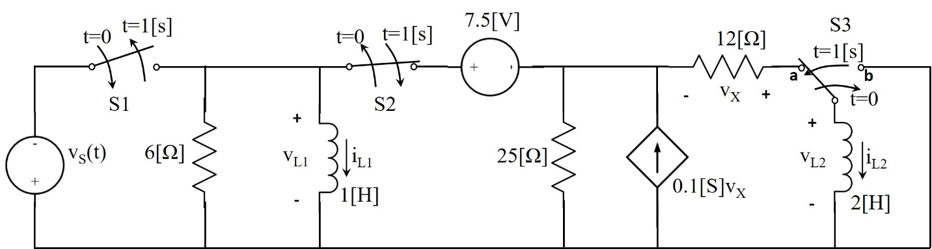

In the circuit below, $v_{S}\left(t\right)=-3\left[\frac{V}{s^{2}}\right]t^{2}-2\left[\frac{V}{s}\right]t+5[V]$ for $t≥0$. There are three switches in the circuit: S1, S2 and S3. Before t = 0, S1 has been opened for a long time, S2 has been closed for a long time, and S3 has been at position a for a long time. At t = 0, S1 is closed, S2 is opened, and S3 is moving from position a to b. At t = 1 [s], S1 is opened, S2 is closed, and S3 is moved from position b to a. Please find:
- $v_{L1}(0^{+})$, $i_{L1}(0^{+})$, $v_{L2}(0^{+})$, and $i_{L2}(0^{+})$.
- $v_{L1}(1^{+})$, $i_{L1}(1^{+})$, $v_{L2}(1^{-}),v_{L2}(1^{+})$, and $i_{L2}(1^{+})$.

