Peoplesoft ID Number: _____________________________

ECE 2202 – Exam 1
March 6, 2021

1. You may use one 8.5” x 11” crib sheet, or its equivalent. Do not communicate with anyone except Dr. Shattuck or Dr. Shan while you are taking this exam.
2. Show all work necessary to complete the problem. Use additional sheets of paper as needed. A solution without the appropriate work shown will receive no credit. A solution which is not given in a reasonable order will lose credit. Include this page with your Peoplesoft ID Number, or include a different, separate page with your Peoplesoft ID Number. Failure to do this will result in points being deducted.
3. Show all units in solutions, intermediate results, and figures. Units in the quiz will be included between square brackets.
4. Do not use red ink. Do not use red pencil.
5. You will have 75 minutes to work on this exam, plus additional time to print, scan and email your work. Email your completed problem to dshattuc@central.uh.edu and xshan@central.uh.edu.

________________/40

________________/40

________________/20

1. {40 Points} Use the circuit below to solve.
- Find the Norton equivalent as seen by the i_{S1} current source. Draw the Norton equivalent circuit, attaching the i_{S1} current source. Include numerical values for all components in your diagram.
- Find the power delivered by the i_{S1} current source in this circuit.

2. {40Points}. In the circuit below, $v_{S}\left(t\right)=-3\left[\frac{V}{s^{2}}\right]t^{2}-2\left[\frac{V}{s}\right]t+5[V]$ for $t≥0$. There are three switches in the circuit: S1, S2 and S3. Before t = 0, S1 has been opened for a long time, S2 has been closed for a long time, and S3 has been at position a for a long time. At t = 0, S1 is closed, S2 is opened, and S3 is moving from position a to b. At t = 1 [s], S1 is opened, S2 is closed, and S3 is moved from position b to a. Please find:
- $v_{L1}(0^{+})$, $i_{L1}(0^{+})$, $v_{L2}(0^{+})$, and $i_{L2}(0^{+})$.
- $v_{L1}(1^{+})$, $i_{L1}(1^{+})$, $v_{L2}(1^{-}),v_{L2}(1^{+})$, and $i_{L2}(1^{+})$.

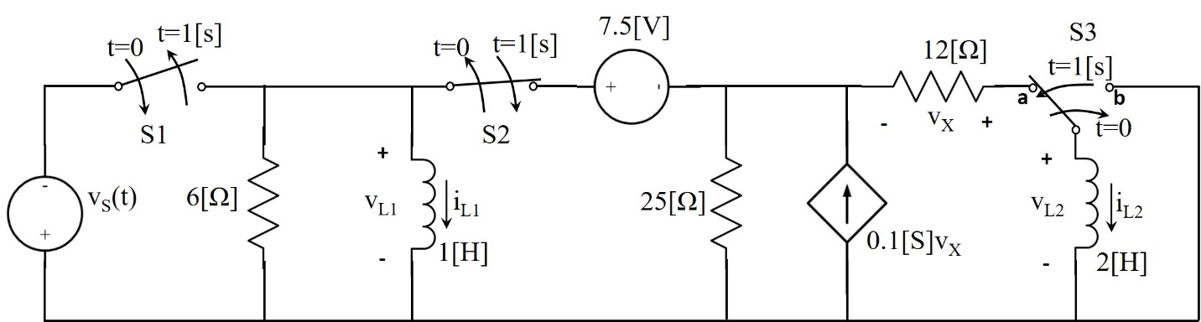

3. {20 Points} The switch in the circuit shown below had been closed for a long time, and then opened at t = 0.
Find v_{X}(0⁺).

Solutions:

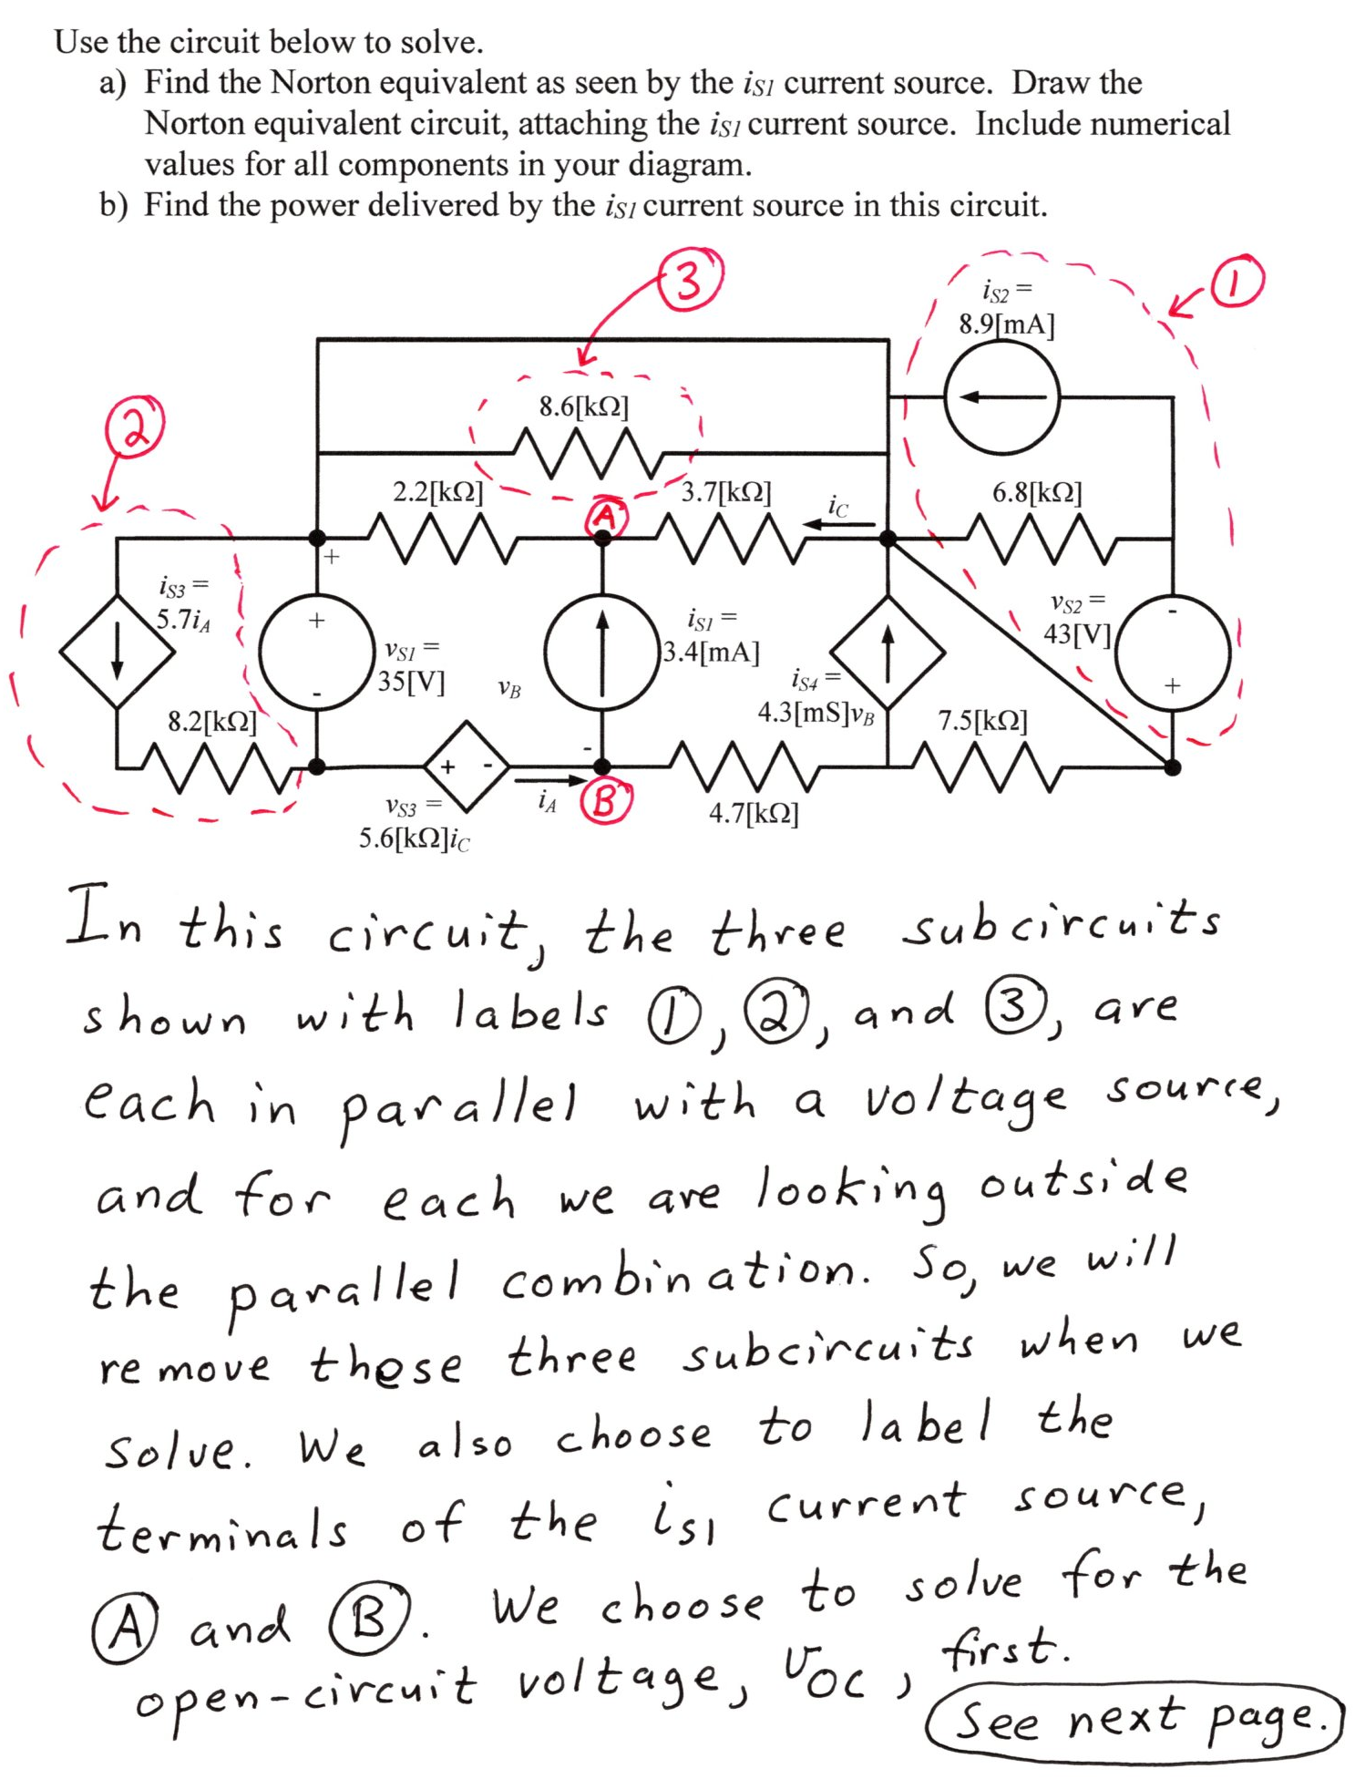
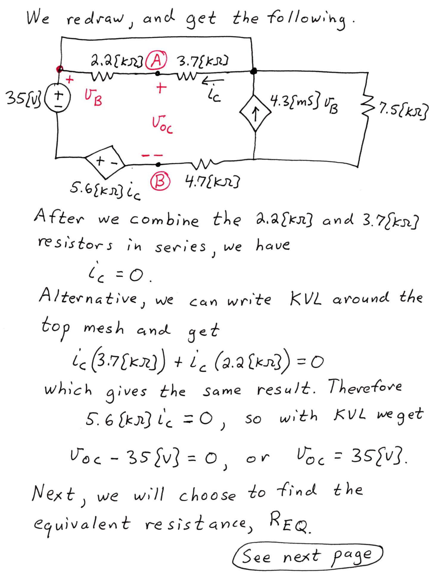
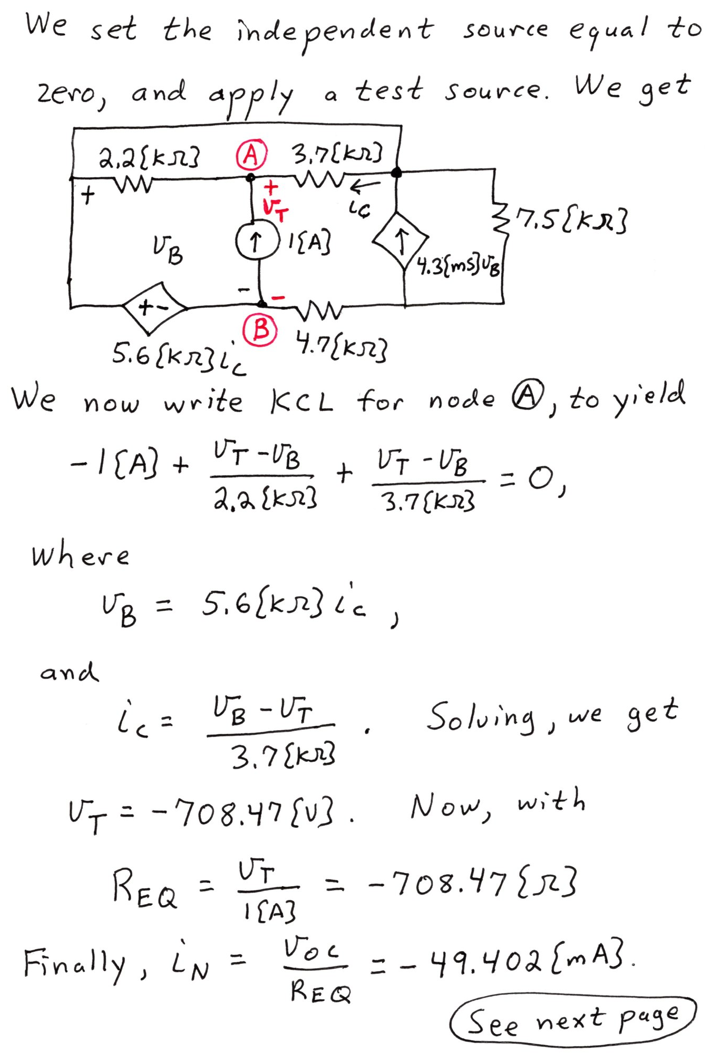
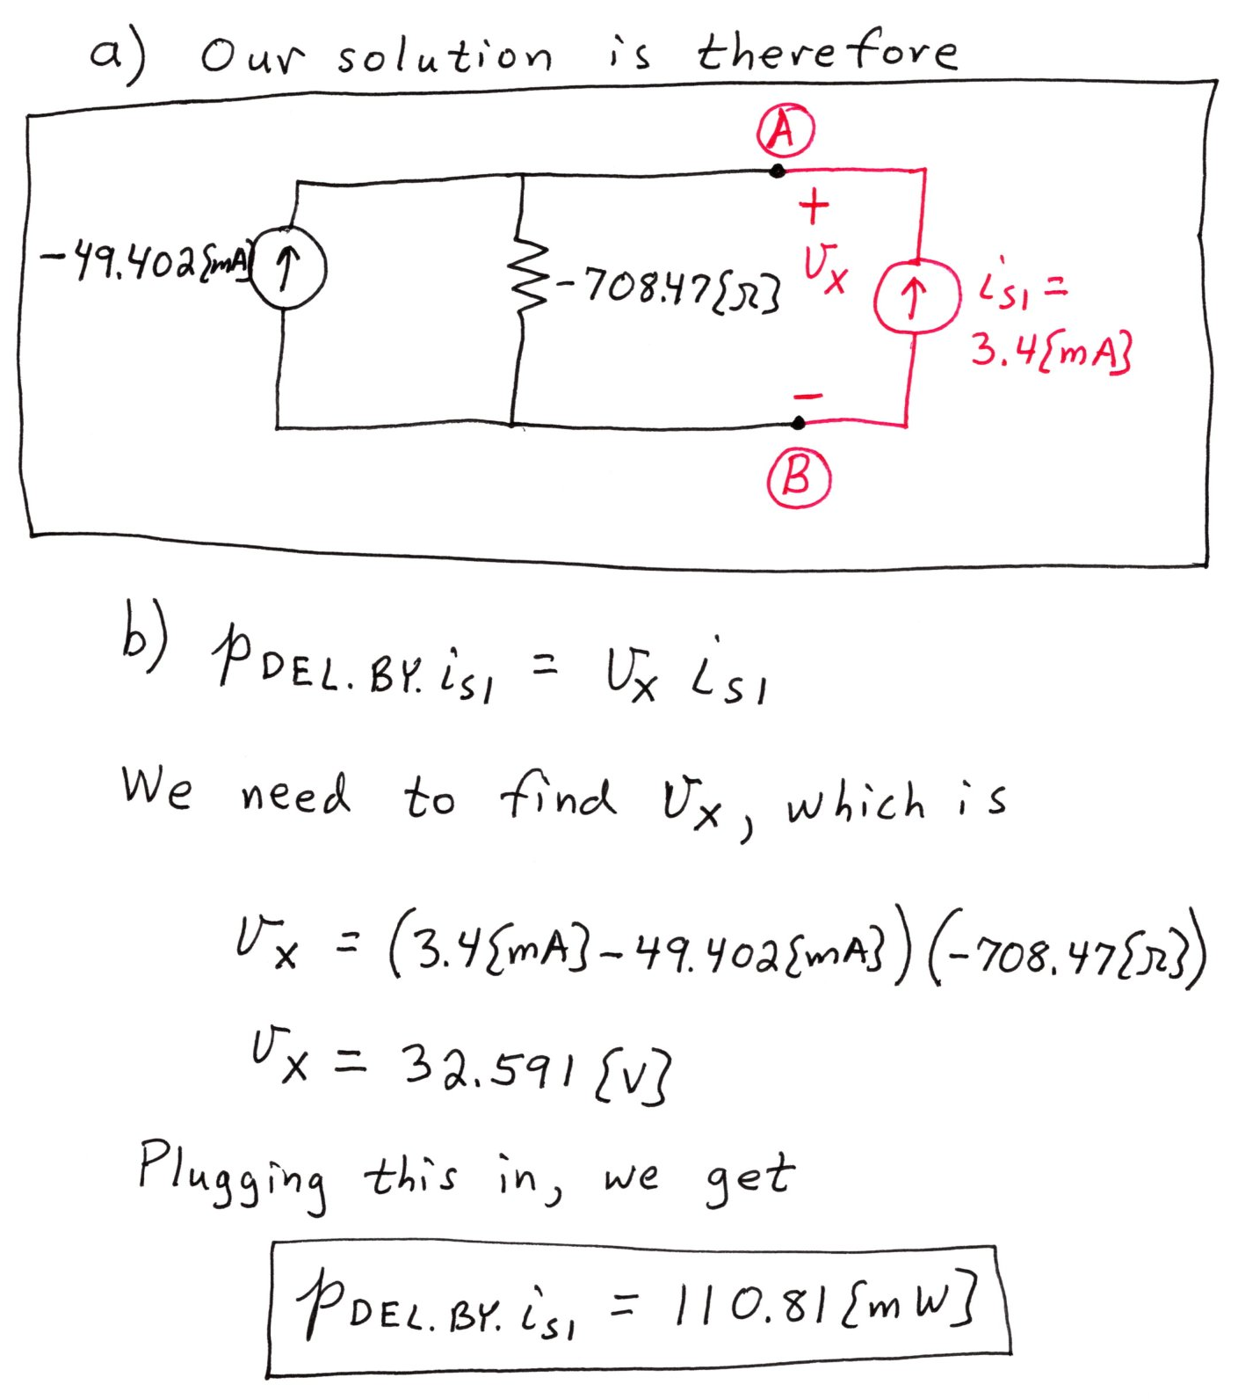

- In the circuit below, $v_{S}\left(t\right)=-3\left[\frac{V}{s^{2}}\right]t^{2}-2\left[\frac{V}{s}\right]t+5[V]$ for $t≥0$. There are three switches in the circuit: S1, S2 and S3. Before t = 0, S1 has been opened for a long time, S2 has been closed for a long time, and S3 has been at position a for a long time. At t = 0, S1 is closed, S2 is opened, and S3 is moving from position a to b. At t = 1 [s], S1 is opened, S2 is closed, and S3 is moved from position b to a. Please find:
- $v_{L1}(0^{+})$, $i_{L1}(0^{+})$, $v_{L2}(0^{+})$, and $i_{L2}(0^{+})$.
- $v_{L1}(1^{+})$, $i_{L1}(1^{+})$, $v_{L2}(1^{-}),v_{L2}(1^{+})$, and $i_{L2}(1^{+})$.

