Name: _____________________________ (please print)
Signature: __________________________

DO NOT OPEN THIS BOOKLET UNTIL INSTRUCTED TO DO SO

ECE 2300 – EXAM #1
June 17, 2003

1. This quiz is closed book, closed notes. You may use one 8.5” x 11” crib sheet, or its equivalent. You may use any calculator. Turn all cell phones or other communications devices off.
2. Show all work on these pages. Show all work necessary to complete the problem. If you go on to another page, indicate clearly where your work can be found. A solution without the appropriate work shown will receive no credit. Clearly indicate your answer (for example, by enclosing it in a box).
3. Show all units in solutions, intermediate results, and figures. Units in the exam will be included between square brackets.
4. Do not use red ink. Do not use red pencil.
5. You will have 90 minutes to work on this exam.

1. ________________/30
2. ________________/35
3. ________________/35

Room for extra work
1) {30 Points} The voltmeter shown in the circuit below has a 100[V] full-scale reading, and a resistance of 10[kΩ].
a) Find the power delivered by the v_{S1} voltage source.
b) Find the power delivered by the v_{S2} voltage source.
c) Find the magnitude of the reading on 100[V] scale for the voltmeter.
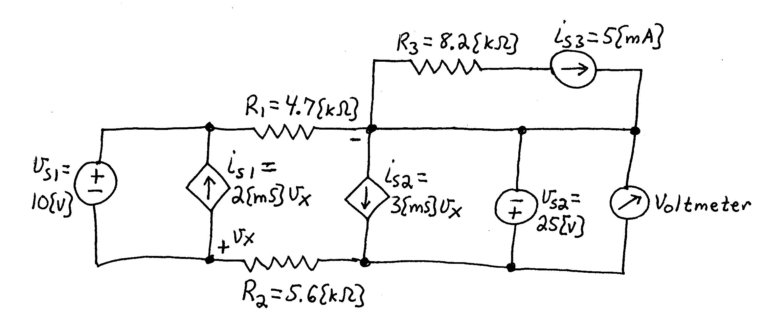

Room for extra work
2) {35 Points} The device shown in the figures below can be modeled by a voltage source in series with a resistance. The device was connected to the circuit shown in Figure 1, and a voltage v_{X} of 23[V] resulted. The same device was then connected to the circuit shown in Figure 2, and a current i_{X} of -430[mA] resulted.
Find the power delivered to a 10[Ω] resistor that is connected to the same device, as shown in Figure 3.
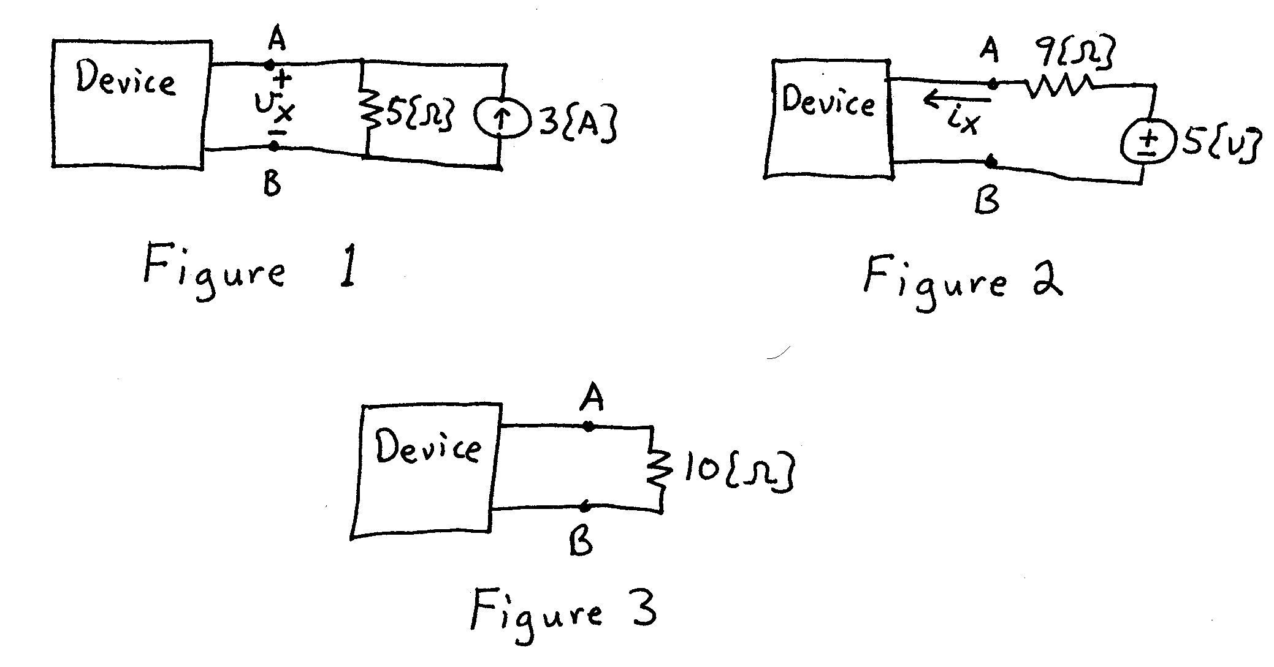
Room for extra work
3) {35 Points} For the circuit shown, use the node-voltage method to write a complete set of independent equations that could be used to solve this circuit. Do not attempt to solve the equations. Do not attempt to simplify the circuit.
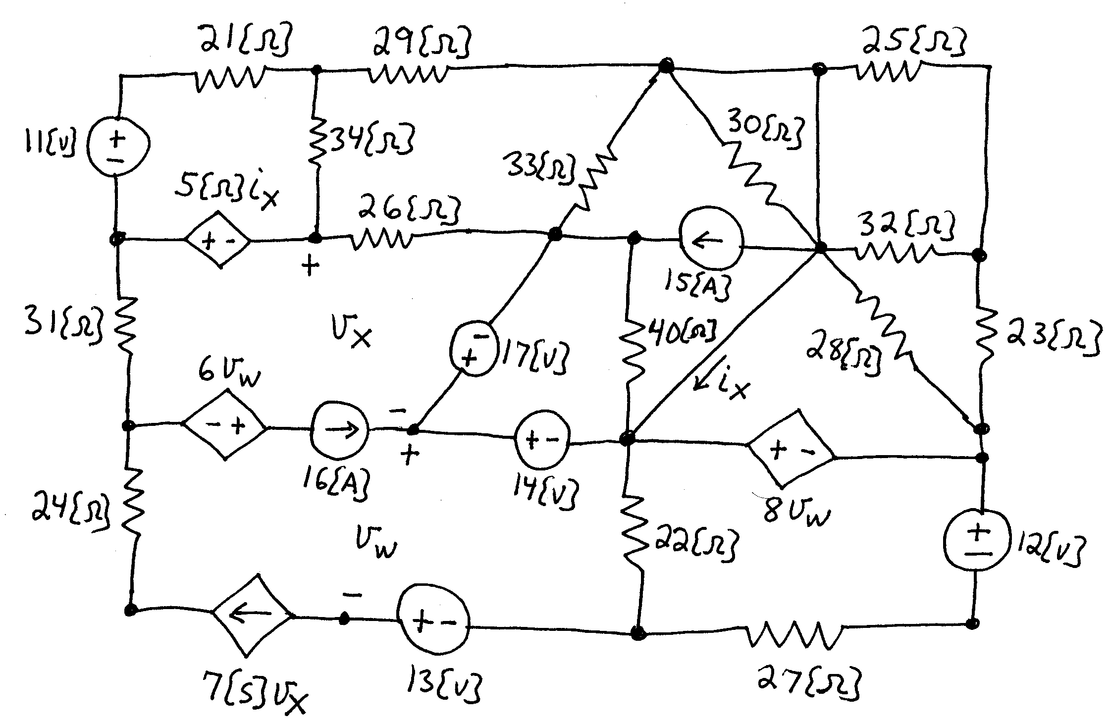

Solution:
1) {30 Points} The voltmeter shown in the circuit below has a 100[V] full-scale reading, and a resistance of 10[kΩ].
a) Find the power delivered by the v_{S1} voltage source.
b) Find the power delivered by the v_{S2} voltage source.
c) Find the magnitude of the reading on 100[V] scale for the voltmeter.
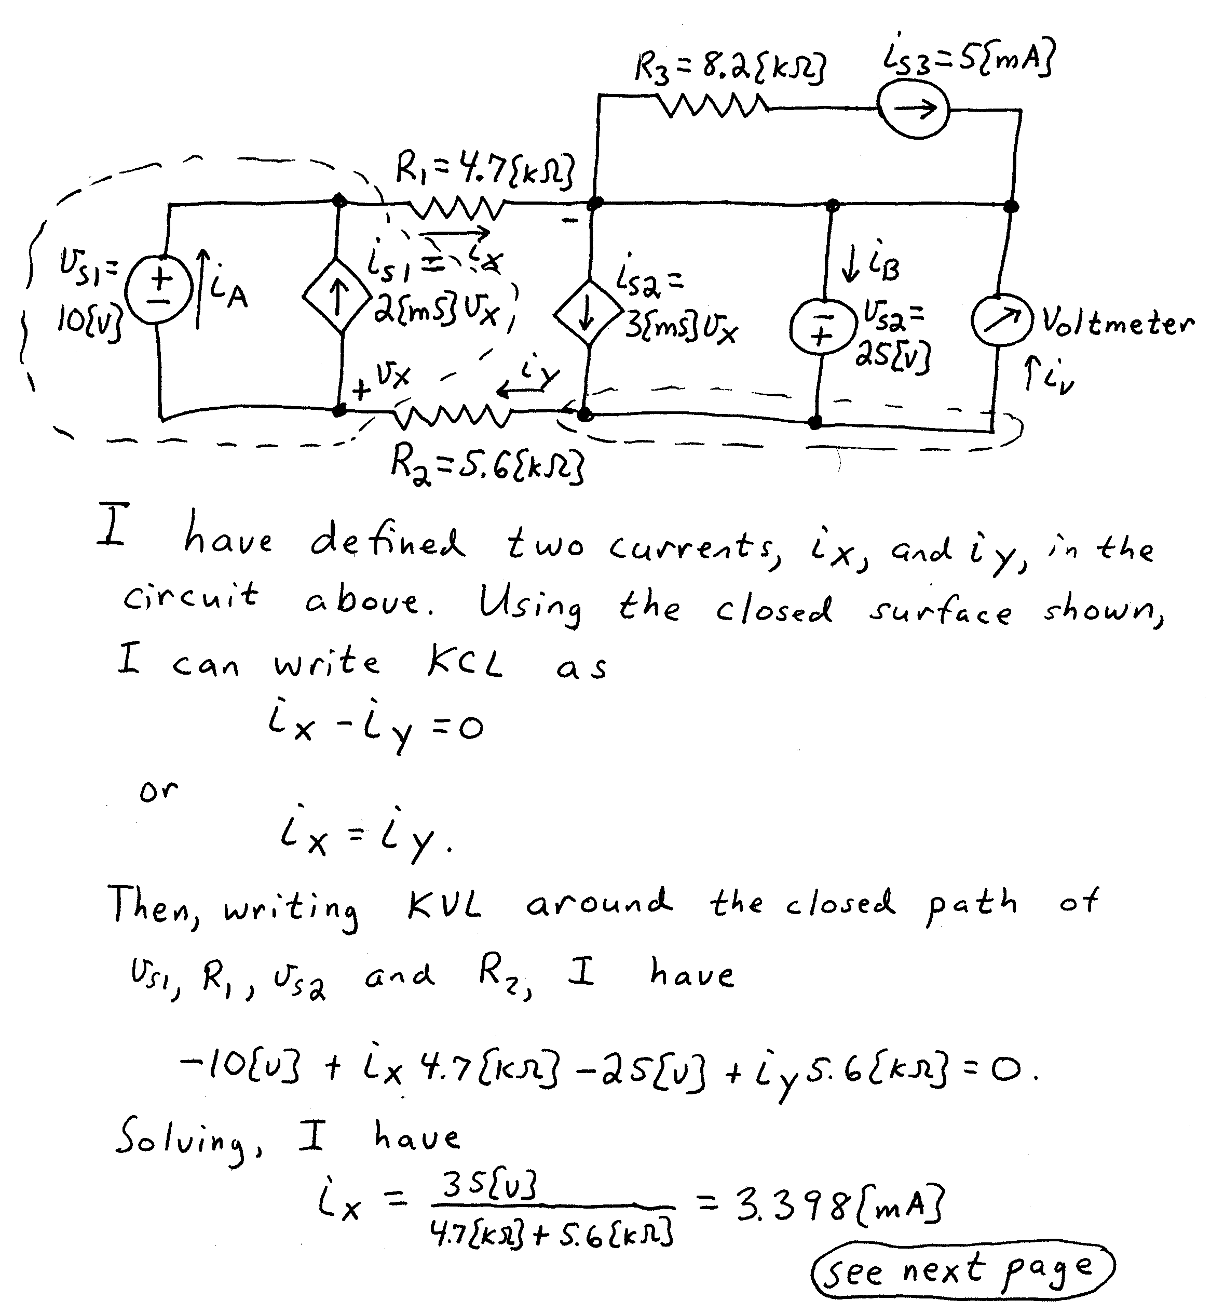
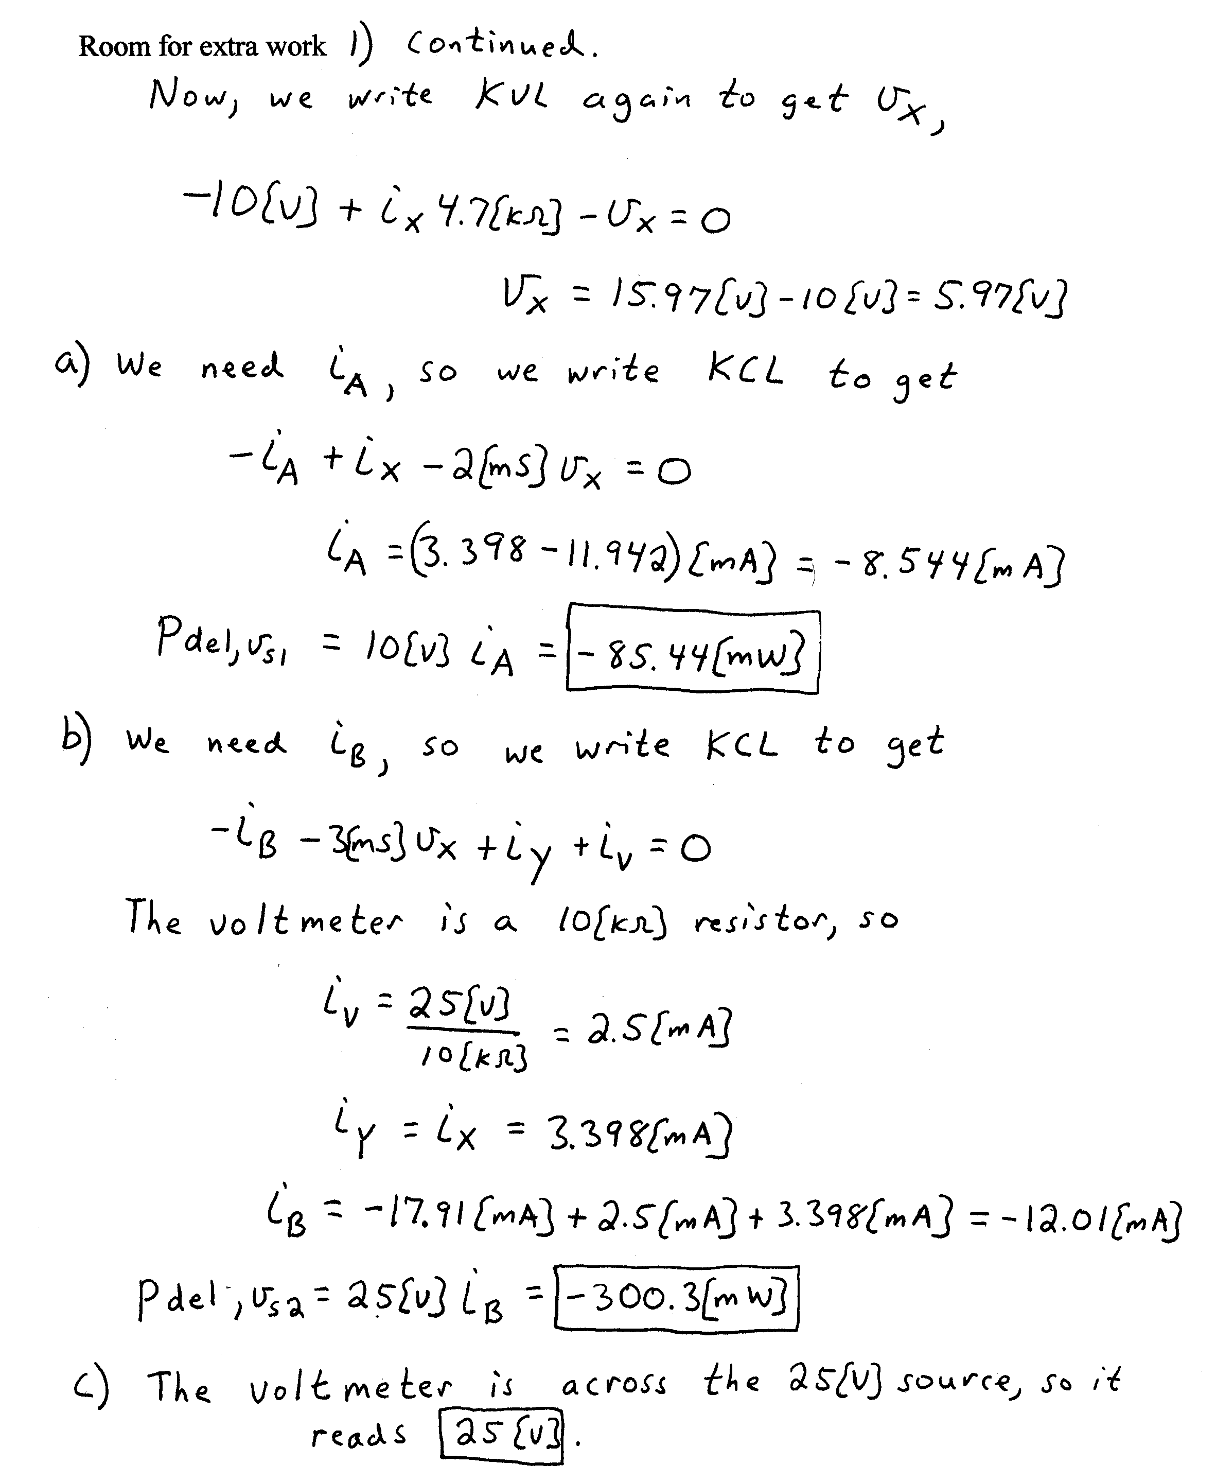
2) {35 Points} The device shown in the figures below can be modeled by a voltage source in series with a resistance. The device was connected to the circuit shown in Figure 1, and a voltage v_{X} of 23[V] resulted. The same device was then connected to the circuit shown in Figure 2, and a current i_{X} of -430[mA] resulted.
Find the power delivered to a 10[Ω] resistor that is connected to the same device, as shown in Figure 3.
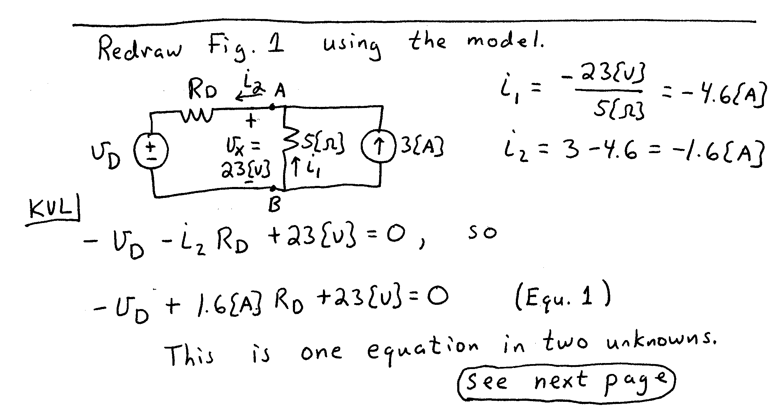
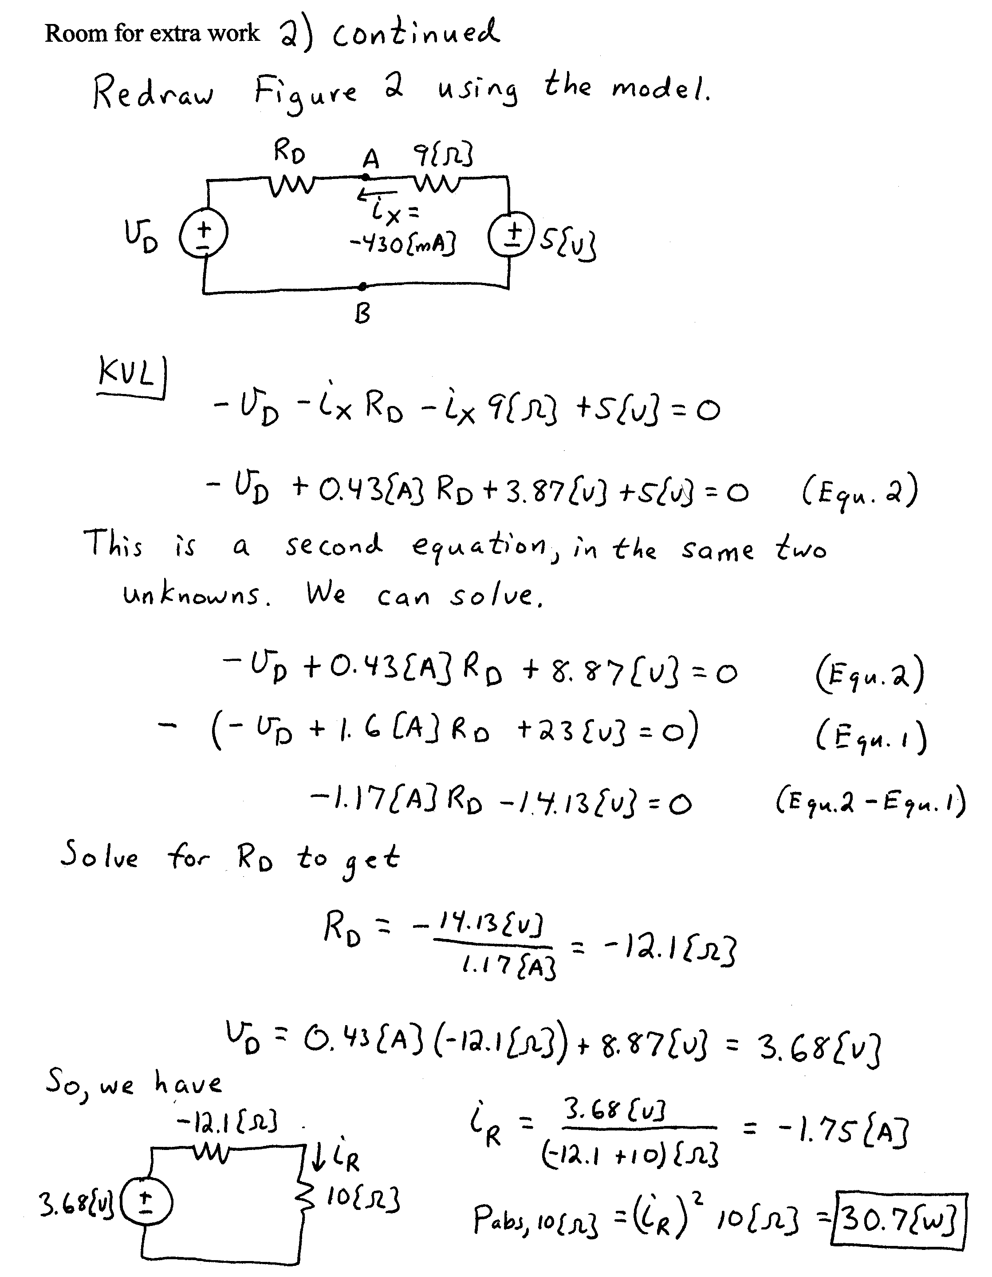
3) {35 Points} For the circuit shown, use the node-voltage method to write a complete set of independent equations that could be used to solve this circuit. Do not attempt to solve the equations. Do not attempt to simplify the circuit.


