Name: _____________________________ (please print)
Signature: __________________________

ECE 2202 – Final Exam
August 9, 2017

Keep this exam closed until you are told to begin.
1. This exam is closed book, closed notes. You may use one 8.5” x 11” crib sheet, or its equivalent.
2. Show all work on these pages. Show all work necessary to complete the problem. A solution without the appropriate work shown will receive no credit. A solution that is not given in a reasonable order will lose credit. Clearly indicate your answer (for example by enclosing it in a box).
3. It is assumed that your work will begin on the same page as the problem statement. If you choose to begin your work on another page, you must indicate this on the page with the problem statement, with a clear indication of where the work can be found. If your work continues on to another page, indicate clearly where your work can be found. Failure to indicate this clearly will result in a loss of credit.
4. Show all units in solutions, intermediate results, and figures. Units in the exam will be included between square brackets.
5. Do not use red ink. Do not use red pencil.
6. You will have 170 minutes to work on this exam.

1. ________________/25
2. ________________/35
3. ________________/35
4. ________________/40
5. ________________/40
6. ________________/25
Total = 200
Room for extra work
1. {25 Points} Use the circuit below to solve.
a) Find the Norton equivalent as seen by the 22[V] voltage source. Draw the Norton equivalent, and attach the 22[V] source to the equivalent in your diagram.
b) Find the power delivered by the 22[V] source.

Room for extra work

2. {35 Points} In this circuit, the switch SWA was closed for a long time before
t = 0, and switch SWB was open for a long time before t = 0. Then, at t = 0, both switches changed position.
a) Find the energy stored in L₁ at t = 0⁻.
b) Find the energy stored in L₂ at t = 0⁺.
c) Find the energy stored in L₂ at $t=∞$.
d) Find the power absorbed by R₃ at t = 50[μs].

Room for extra work

3. {35 Points} The switch SW1 was closed and switch SW2 was in position b for a long time before t = 0. Then, at t = 0, switch SW1opened, followed 50[μs] later by switch SW2 moving to position a. Find v_{X}(100[μs]).

Room for extra work

4. {40 Points} The circuit shown below operates in steady-state. We are given that
Find the value or values for C_{X} , if any, so that θ = 71.5°.

Room for extra work

5. {40 Points} The circuit shown below operates in steady-state.
Load 1 absorbs (47∠ -35°)[kVA].
Load 2 absorbs 15[kW], and delivers 20[kVAR].
Load 3 absorbs 20[kW] at a leading power factor of 0.62.
Find i_{S}(t).

Room for extra work

6. {25 Points} A power system operates in steady-state, at a frequency of 60[Hz]. The rms value of the voltage across the load is 220[V_{rms}]. The line feeding the load from the source can be modeled as a 5[Ω] resistor in series with a 500[mH] inductor. The load can be modeled as a 25[Ω] resistor in parallel with a 150[μF] capacitor.
a) Find the power factor for the load.
b) Find the reactive power absorbed by the load.

Solutions:
1. {25 Points} Use the circuit below to solve.
a) Find the Norton equivalent as seen by the 22[V] voltage source. Draw the Norton equivalent, and attach the 22[V] source to the equivalent in your diagram.
b) Find the power delivered by the 22[V] source.
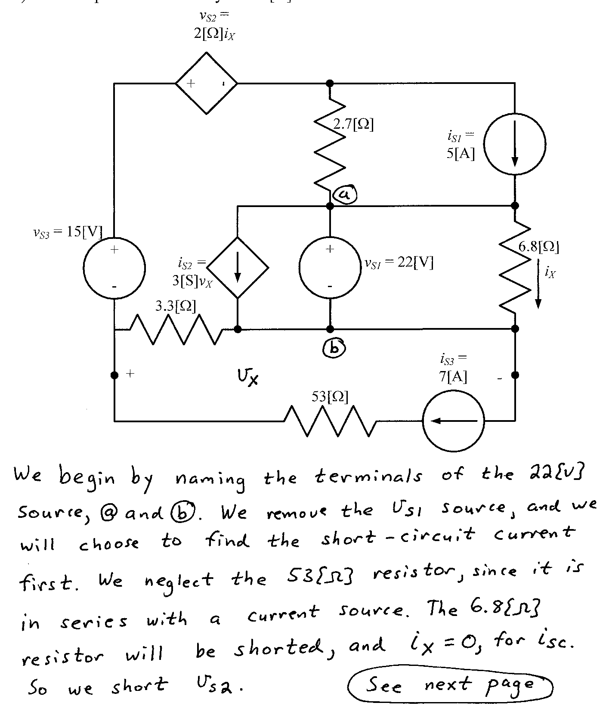
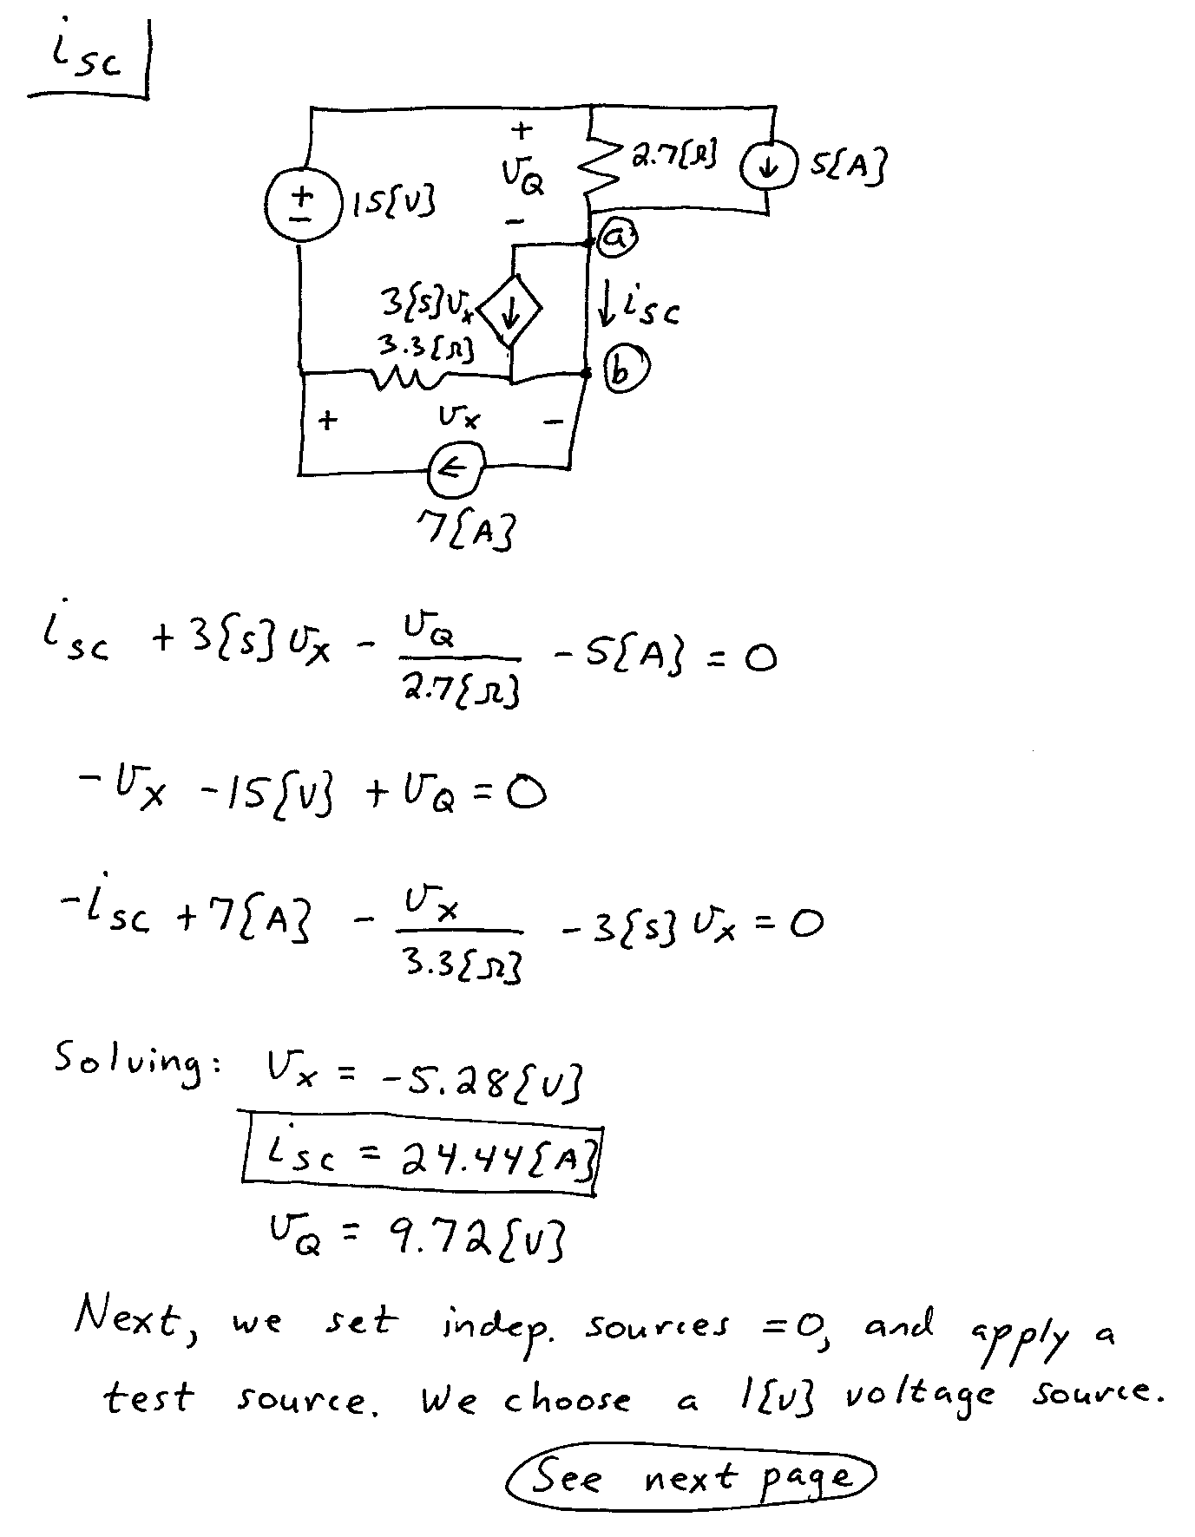
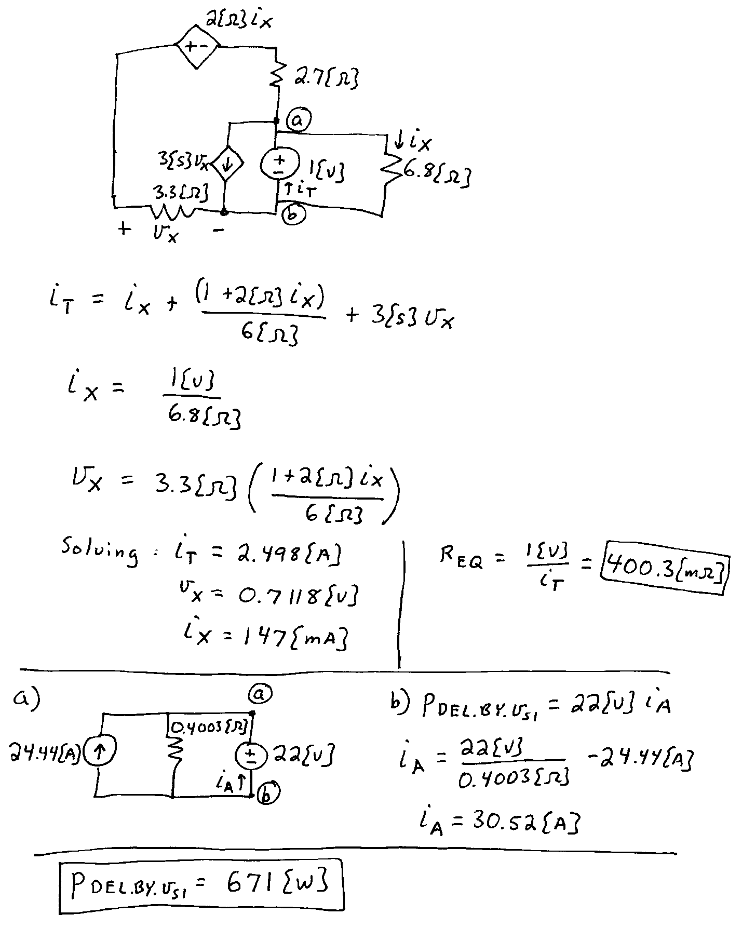

2. {35 Points} In this circuit, the switch SWA was closed for a long time before
t = 0, and switch SWB was open for a long time before t = 0. Then, at t = 0, both switches changed position.
a) Find the energy stored in L₁ at t = 0⁻.
b) Find the energy stored in L₂ at t = 0⁺.
c) Find the energy stored in L₂ at $t=∞$.
d) Find the power absorbed by R₃ at t = 50[μs].
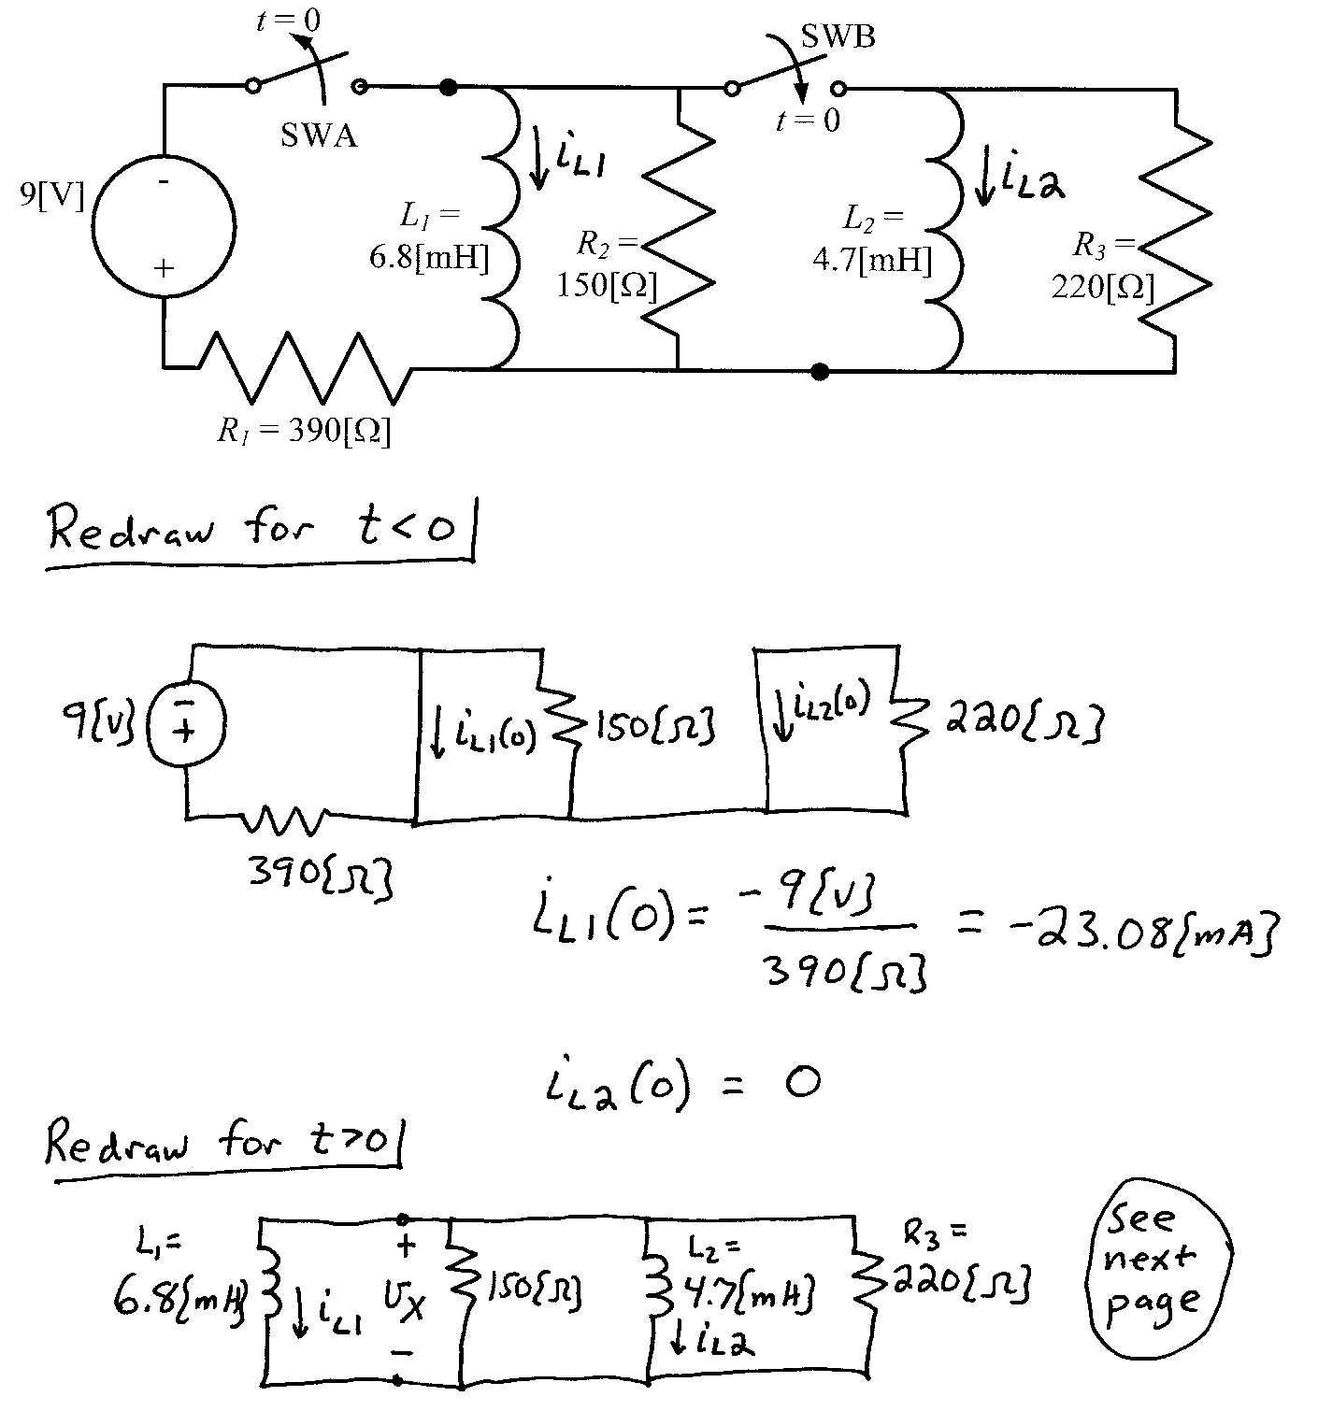
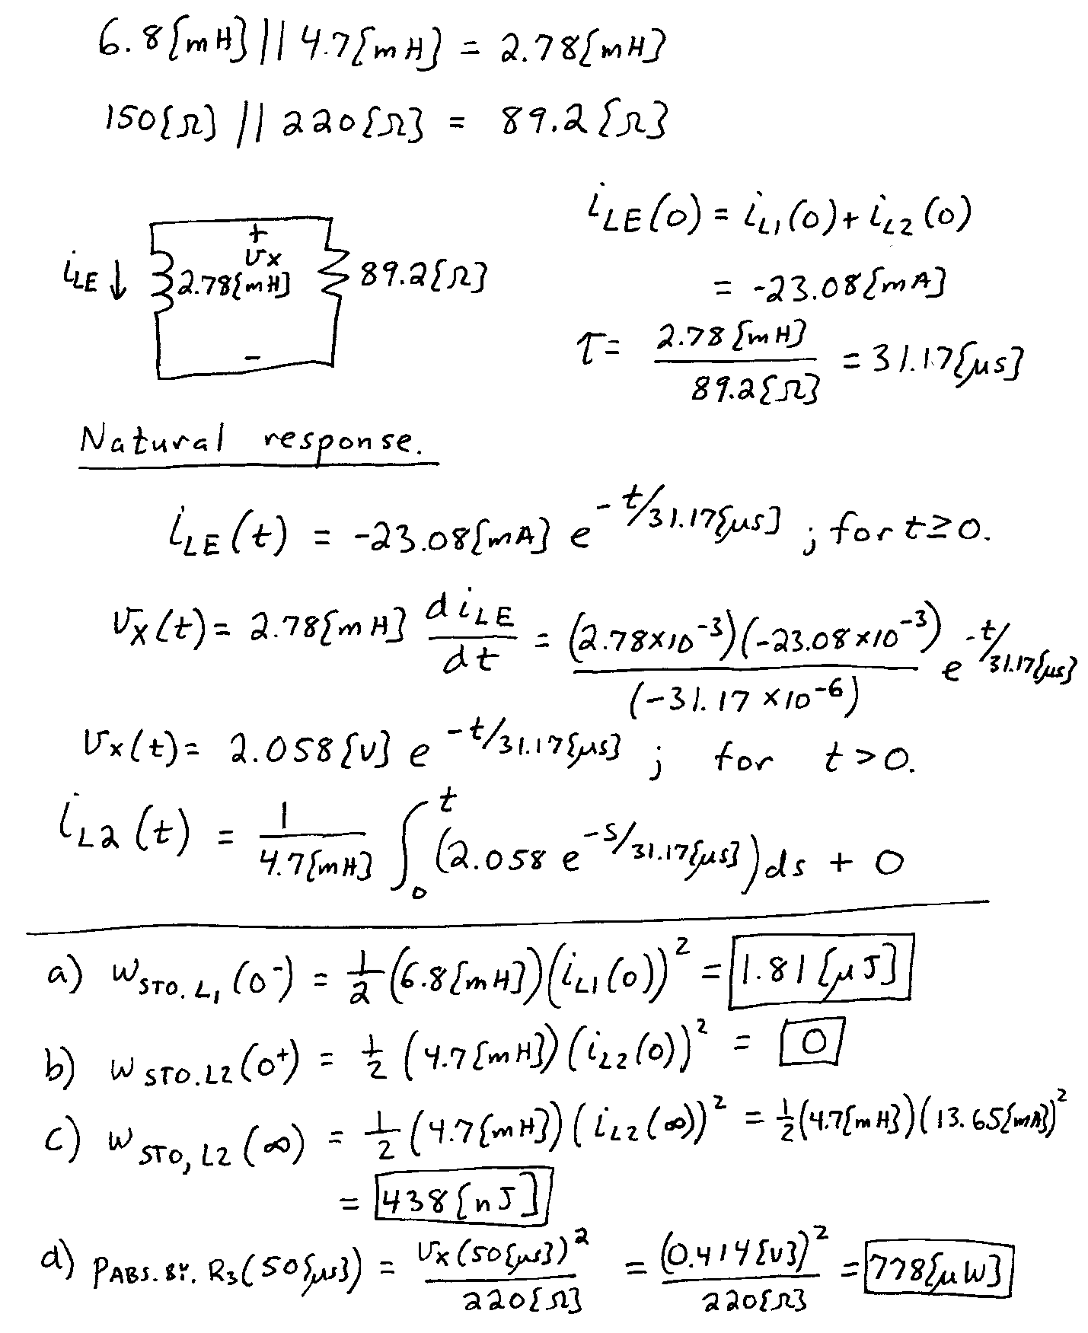

3. {35 Points} The switch SW1 was closed and switch SW2 was in position b for a long time before t = 0. Then, at t = 0, switch SW1opened, followed 50[μs] later by switch SW2 moving to position a. Find v_{X}(100[μs]).

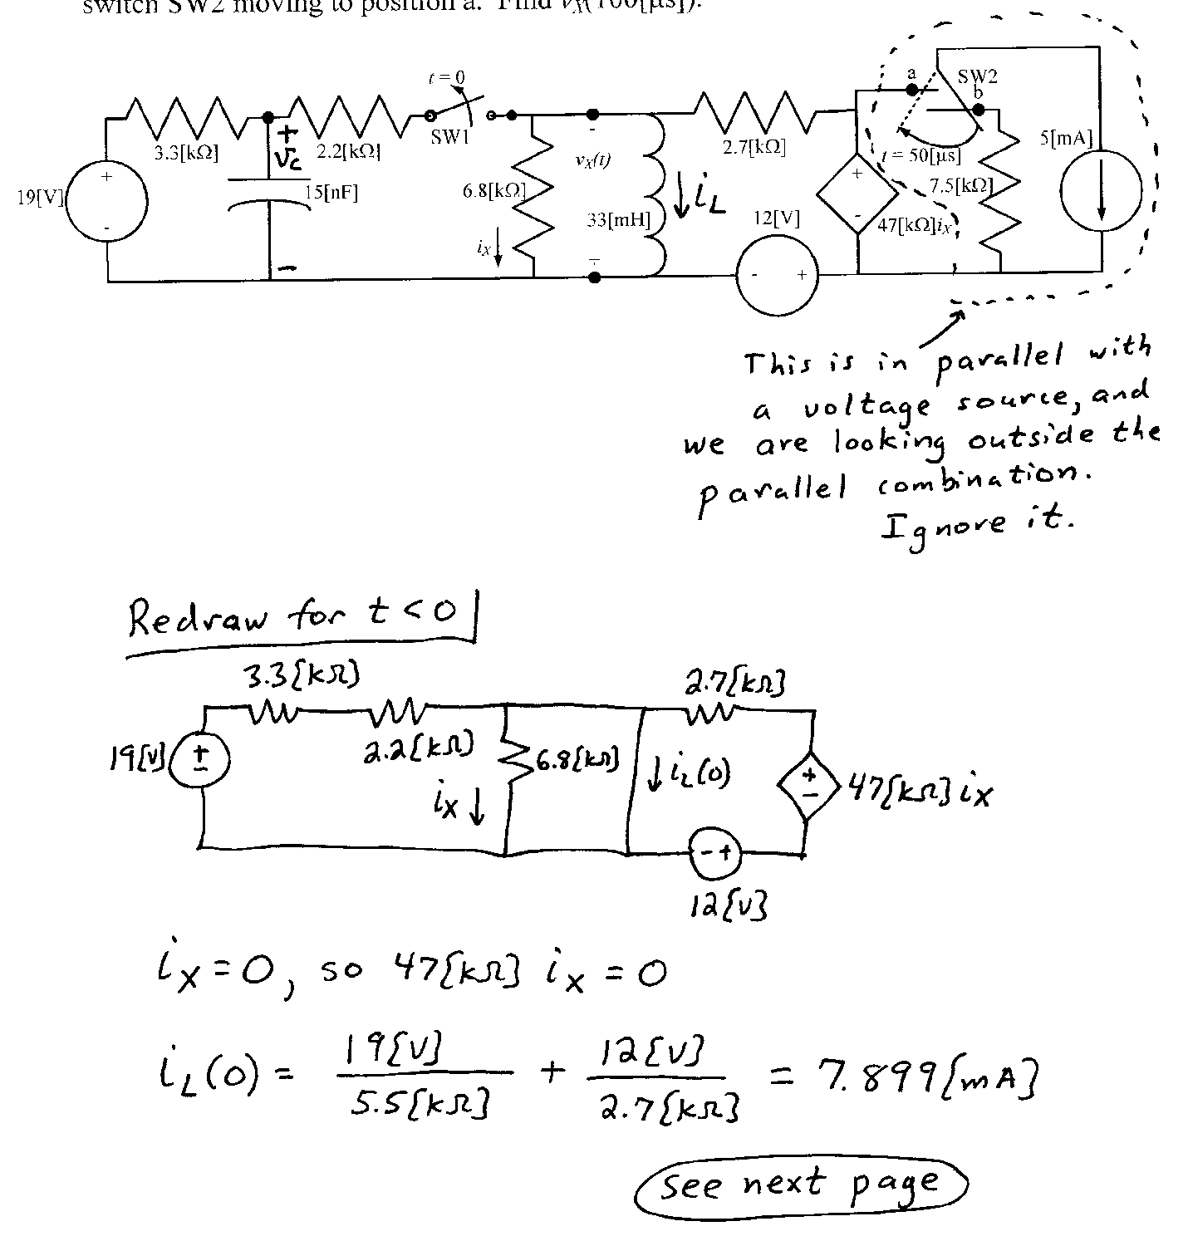
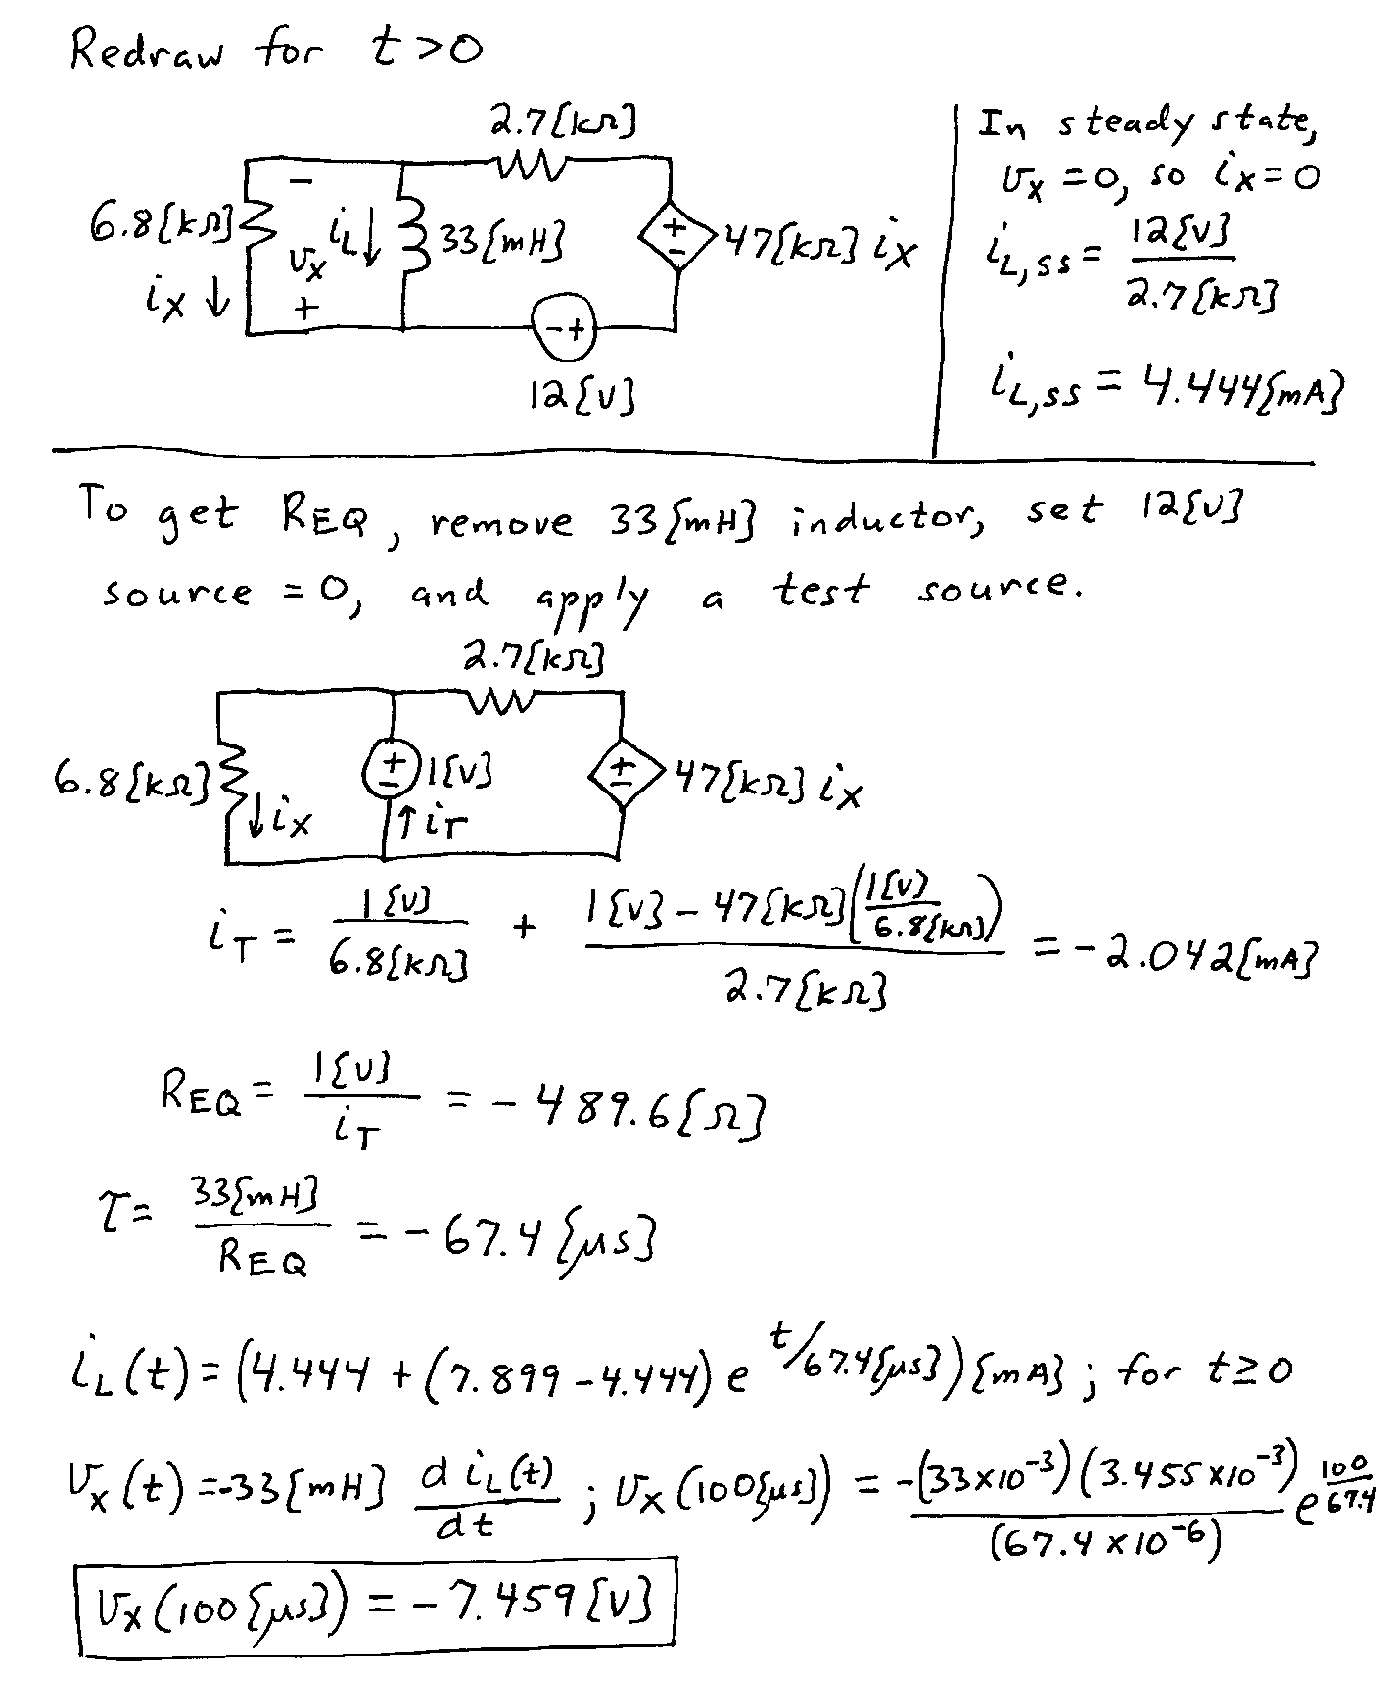

4. {40 Points} The circuit shown below operates in steady-state. We are given that
Find the value or values for C_{X} , if any, so that θ = 71.5°.

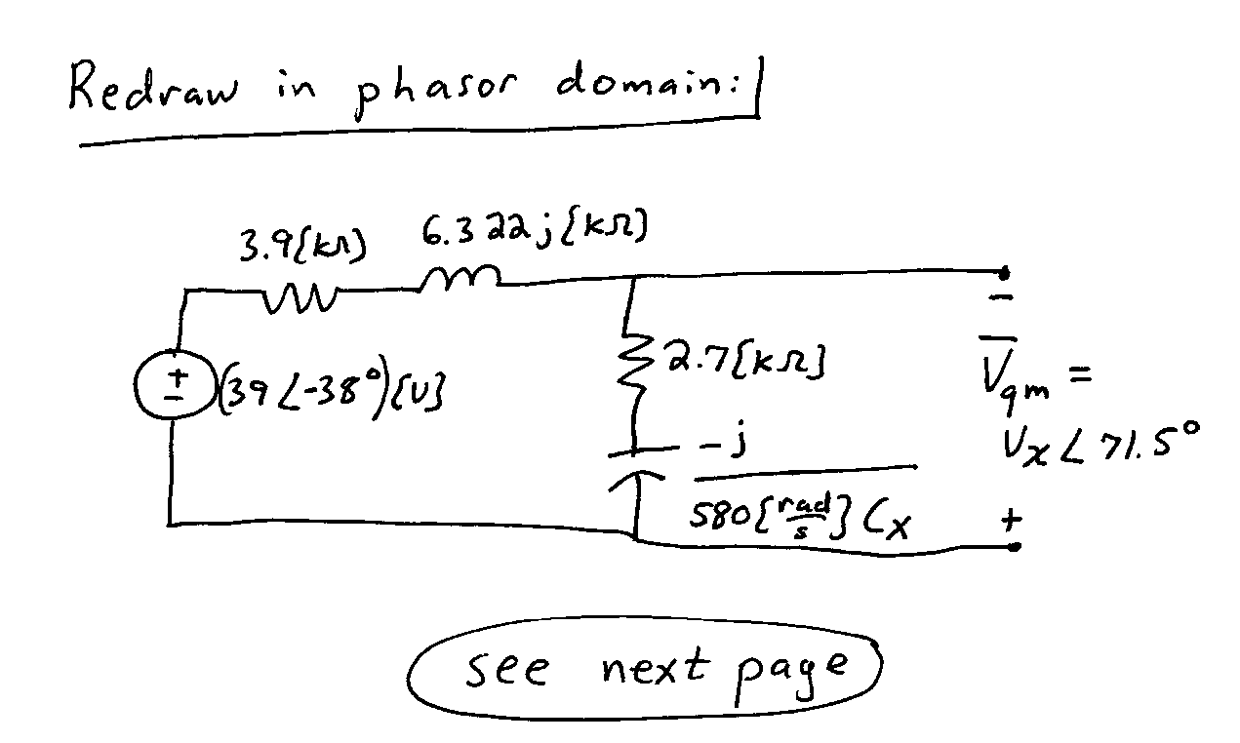
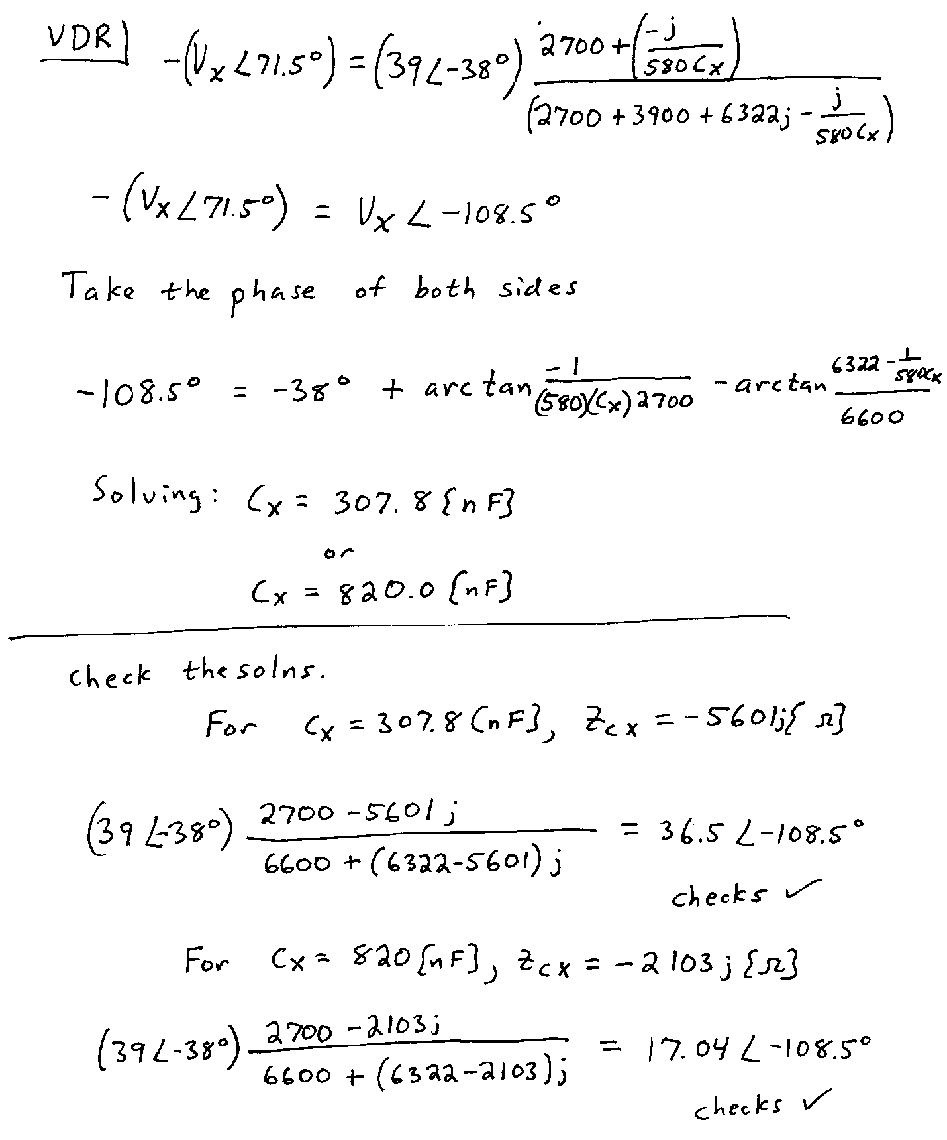

5. {40 Points} The circuit shown below operates in steady-state.
Load 1 absorbs (47∠ -35°)[kVA].
Load 2 absorbs 15[kW], and delivers 20[kVAR].
Load 3 absorbs 20[kW] at a leading power factor of 0.62.
Find i_{S}(t).

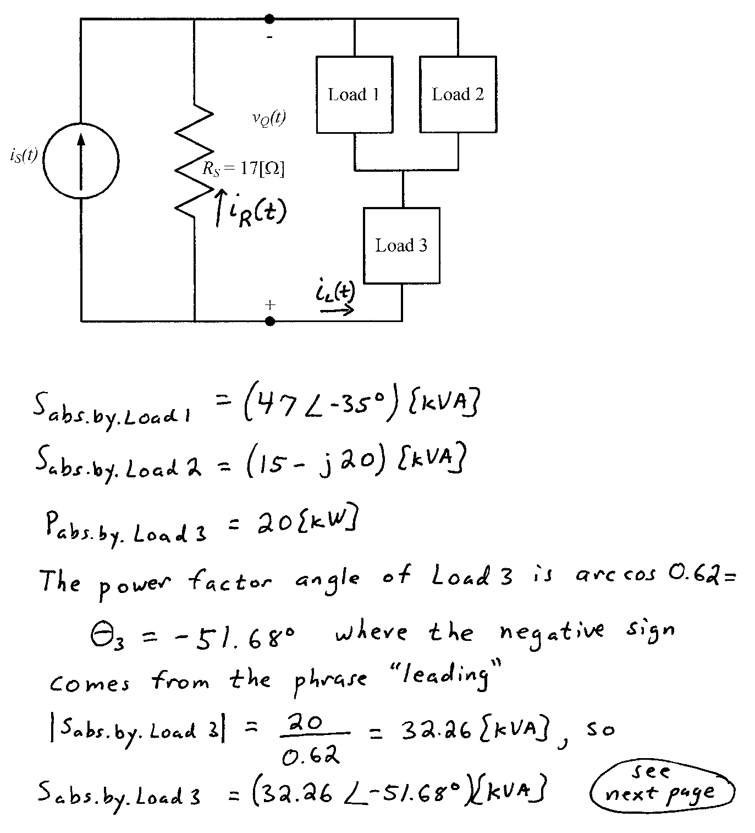
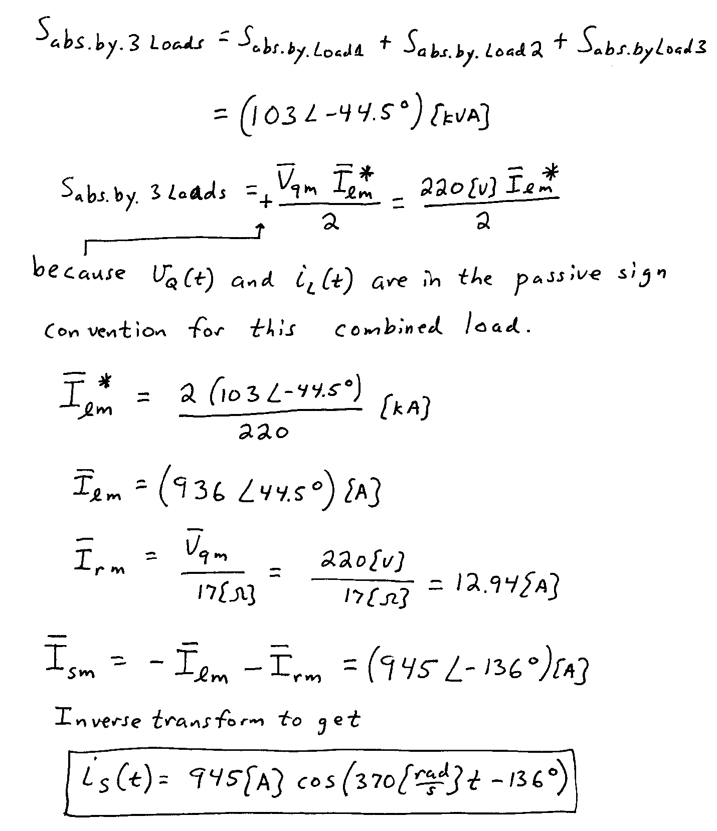

6. {25 Points} A power system operates in steady-state, at a frequency of 60[Hz]. The rms value of the voltage across the load is 220[V_{rms}]. The line feeding the load from the source can be modeled as a 5[Ω] resistor in series with a 500[mH] inductor. The load can be modeled as a 25[Ω] resistor in parallel with a 150[μF] capacitor.
a) Find the power factor for the load.
b) Find the reactive power absorbed by the load.
