Name: _____________________________ (please print)
Signature: __________________________

ECE 2202 – Midterm Exam
July 25, 2017

Keep this exam closed until you are told to begin.

1. This exam is closed book, closed notes. You may use one 8.5” x 11” crib sheet, or its equivalent.
2. Show all work on these pages. Show all work necessary to complete the problem. A solution without the appropriate work shown will receive no credit. A solution that is not given in a reasonable order will lose credit. Clearly indicate your answer (for example by enclosing it in a box).
3. It is assumed that your work will begin on the same page as the problem statement. If you choose to begin your work on another page, you must indicate this on the page with the problem statement, with a clear indication of where the work can be found. If your work continues on to another page, indicate clearly where your work can be found. Failure to indicate this clearly will result in a loss of credit.
4. Show all units in solutions, intermediate results, and figures. Units in the exam will be included between square brackets.
5. Do not use red ink. Do not use red pencil.
6. You will have 100 minutes to work on this exam.

1. ________________/30
2. ________________/35
3. ________________/35
Total = 100
Room for extra work
1. {30 Points} In the circuit shown below, all three switches were open for t < 0. Then, switch SWA closed at t = 0, switch SWB closed at t = 1[s], and switch SWC closed at t = 2[s]. Find the time constant for the capacitor voltage expression for the time period t > 2[s].

Room for extra work

2. {35 Points} For the circuit shown, the current source i_{S}(t) is given as
The energy stored in capacitor C_{X} was zero at t = 0.
- Find v_{X}(0.5[s]).
- Find the energy stored in the capacitor C_{X} at t = 2[s].
- Find the energy stored in the inductor L_{X} at t = 3[s].

Room for extra work

3. {35 Points} The circuit shown below had switch SW1 in position A for a long time, and switch SW2 open for a long time, before t = 0.
Then, at t = 0, switch SW1 moved to position B, and switch SW2 closed.
- Find numerical expressions for v_{X}(t) for the time period
-10[μs] < t < +10[μs]. Note that there may be more than one expression in your solution.
- Find v_{X} (10[μs]), if it is defined at that time. If it is not defined at that time, explain why not.

Room for extra work

Solutions:
1. {30 Points} In the circuit shown below, all three switches were open for t < 0. Then, switch SWA closed at t = 0, switch SWB closed at t = 1[s], and switch SWC closed at t = 2[s]. Find the time constant for the capacitor voltage expression for the time period t > 2[s].
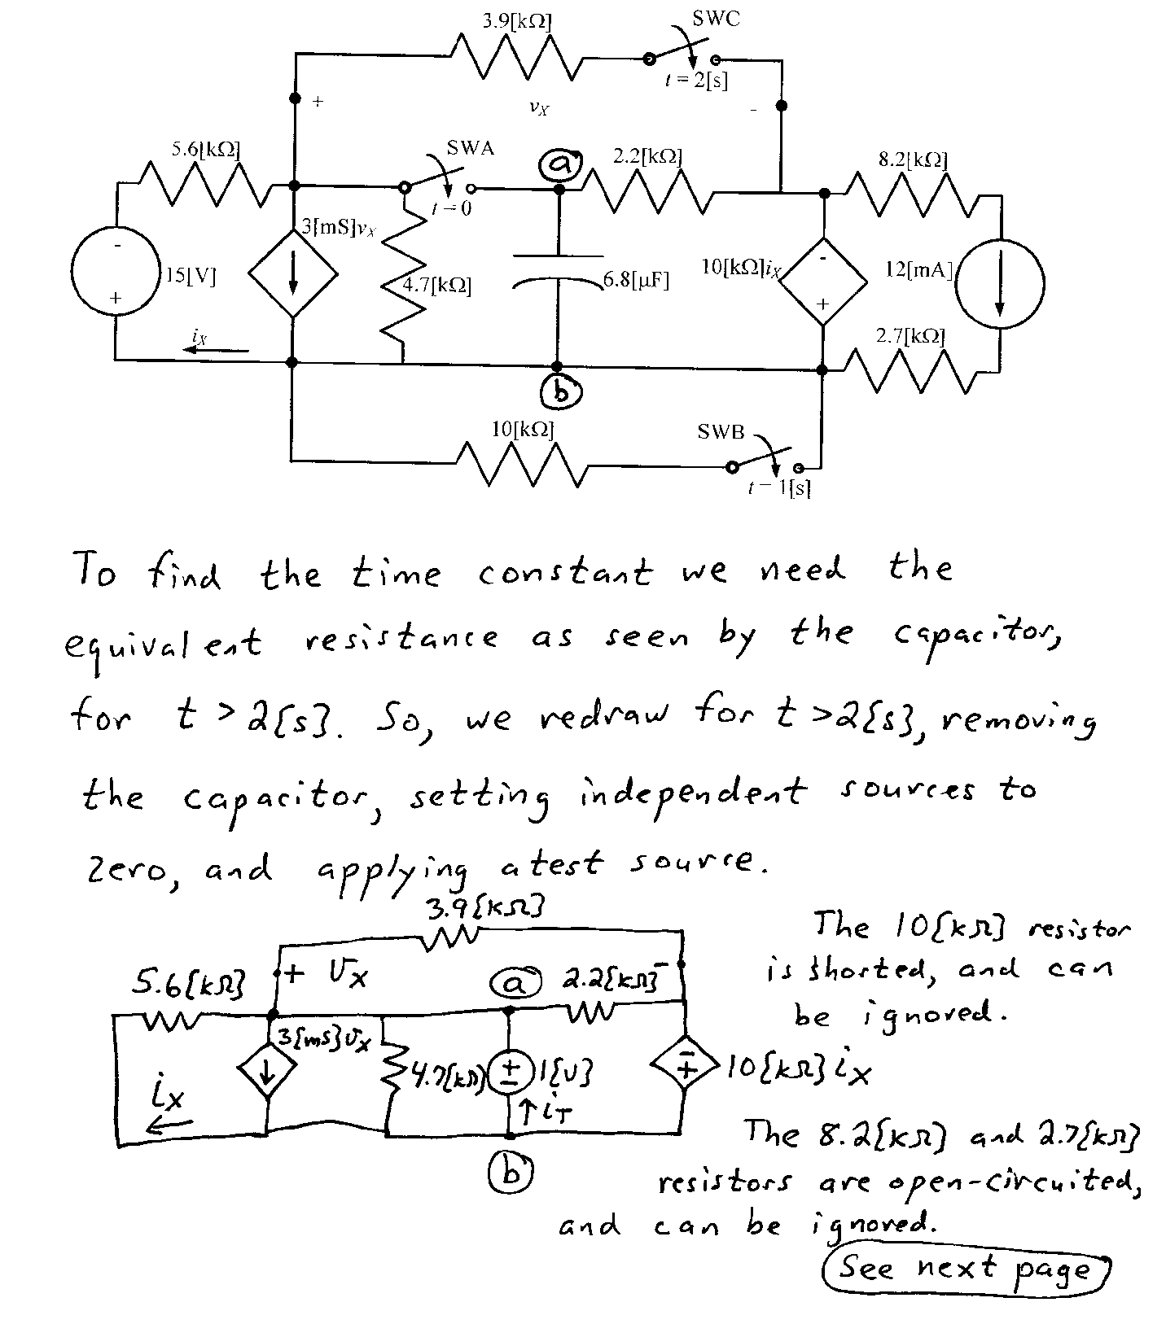
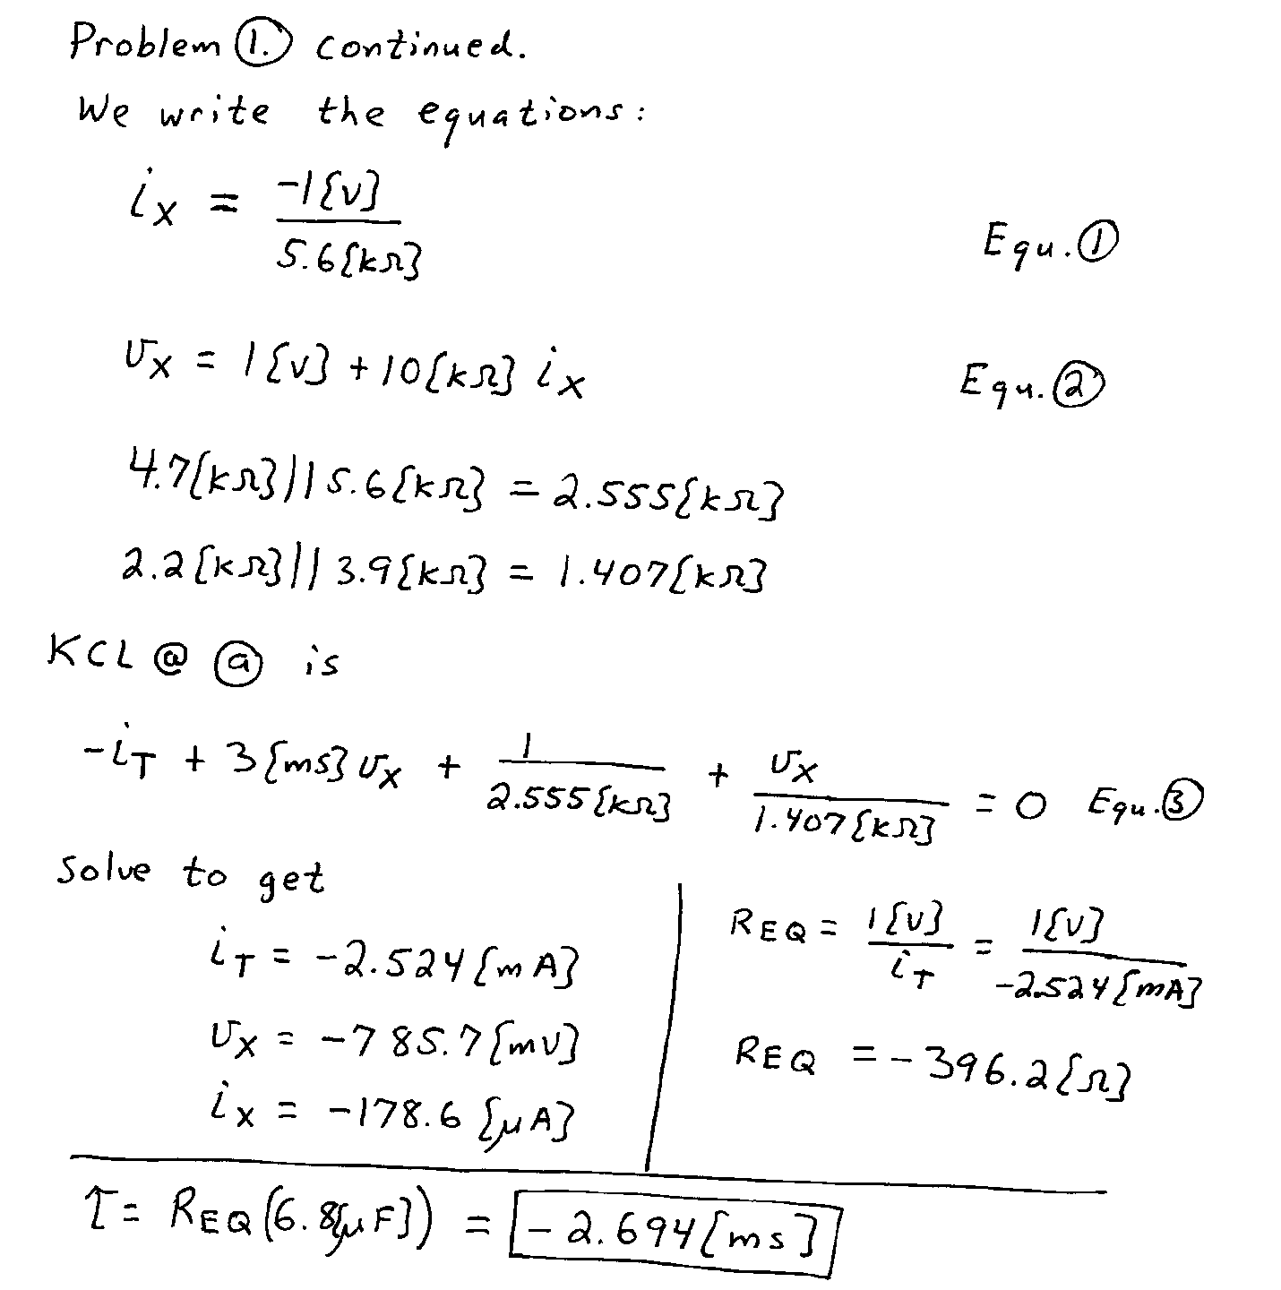

2. {35 Points} For the circuit shown, the current source i_{S}(t) is given as
The energy stored in capacitor C_{X} was zero at t = 0.
- Find v_{X}(0.5[s]).
- Find the energy stored in the capacitor C_{X} at t = 2[s].
- Find the energy stored in the inductor L_{X} at t = 3[s].
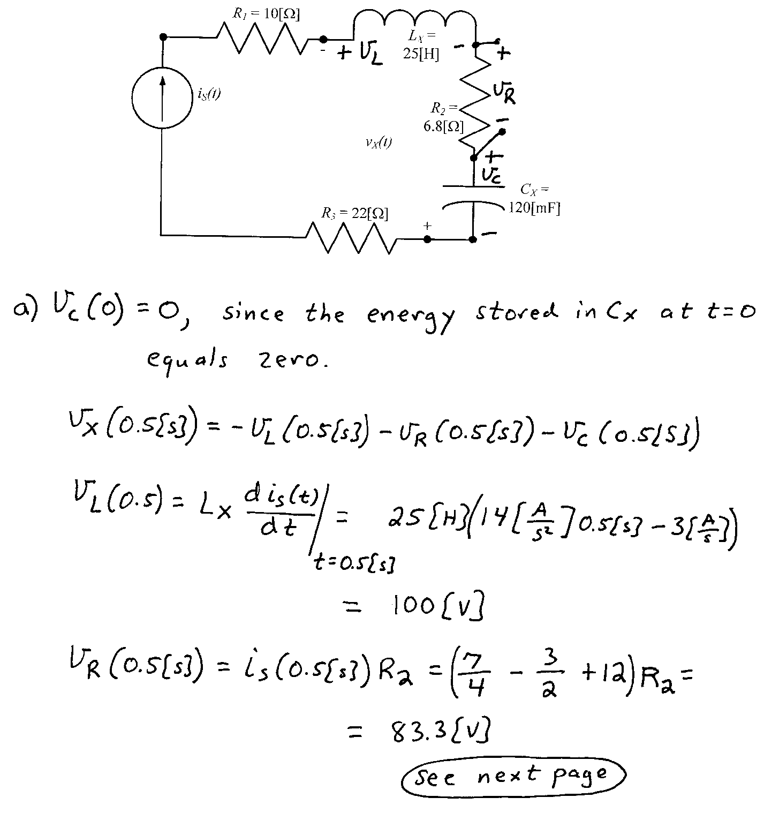
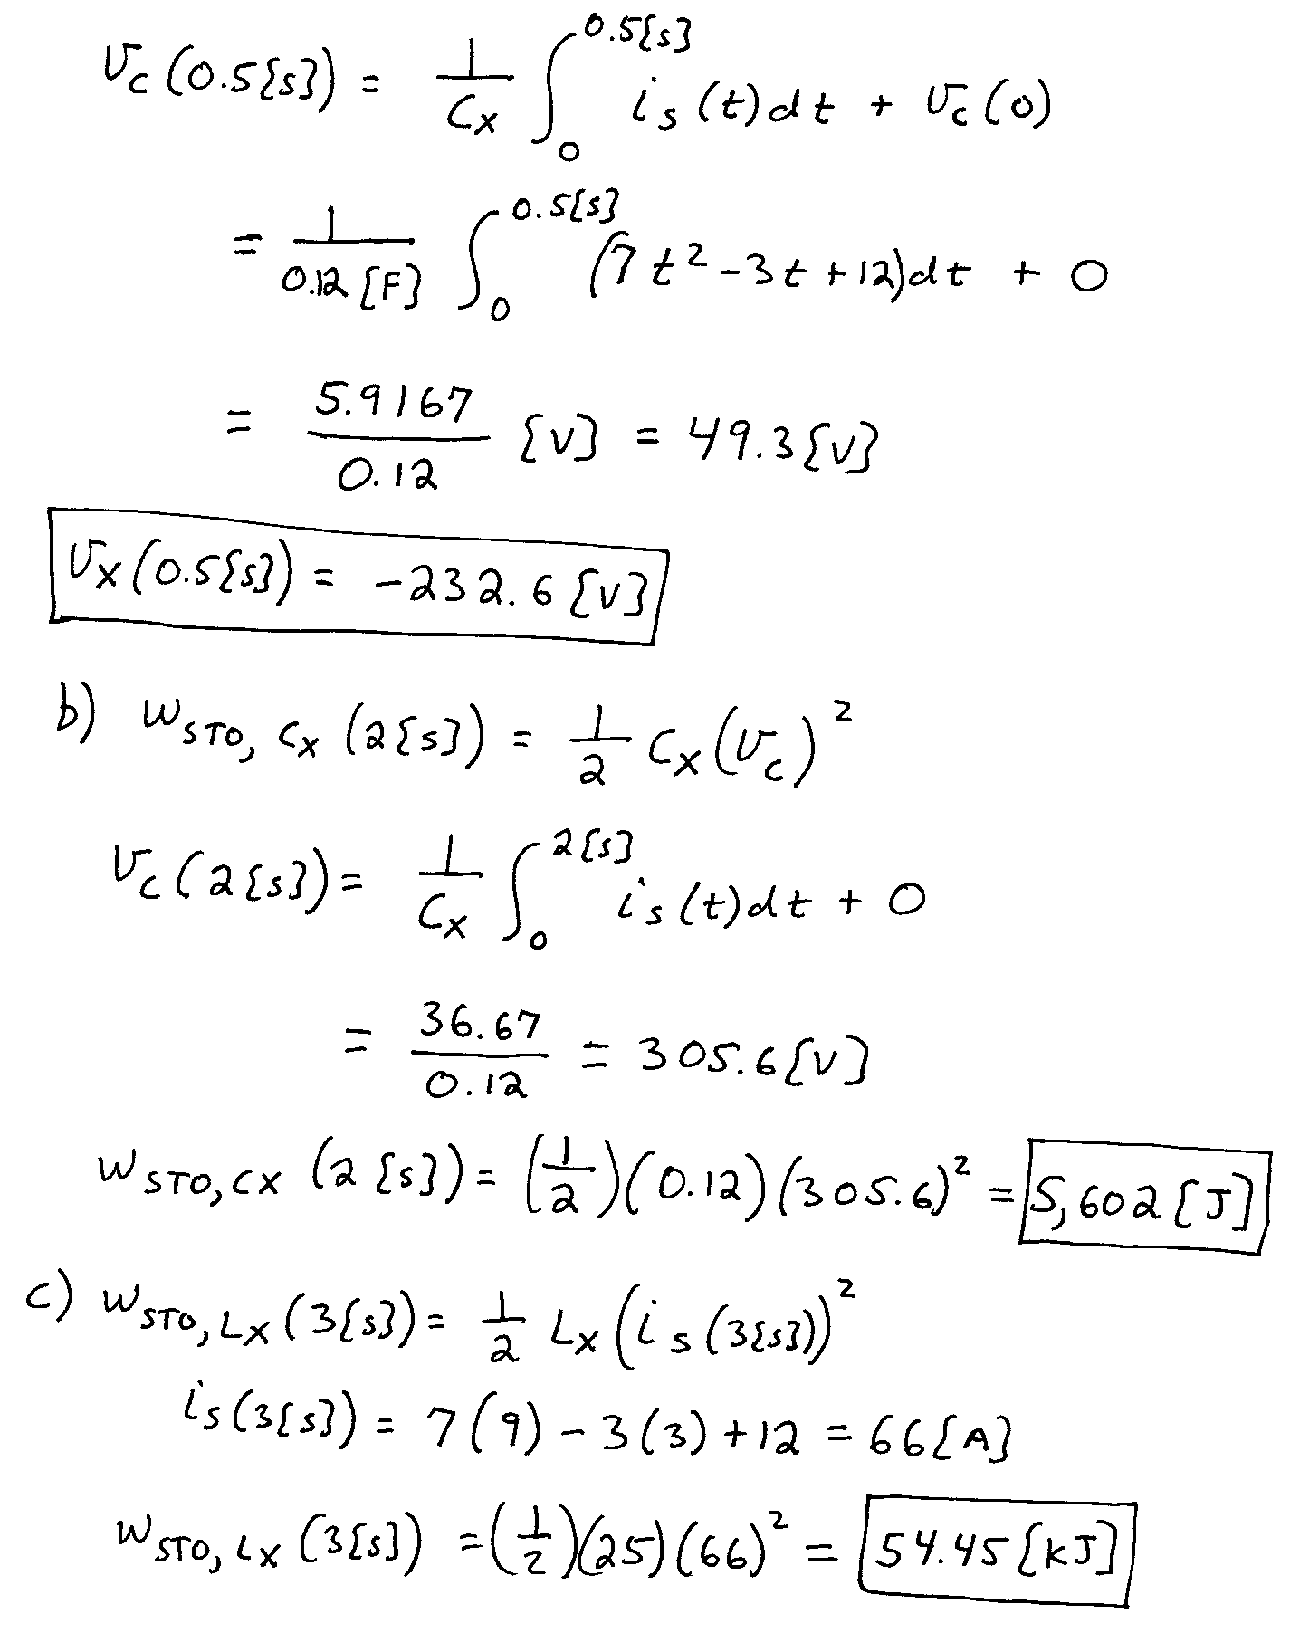

3. {35 Points} The circuit shown below had switch SW1 in position A for a long time, and switch SW2 open for a long time, before t = 0.
Then, at t = 0, switch SW1 moved to position B, and switch SW2 closed.
- Find numerical expressions for v_{X}(t) for the time period
-10[μs] < t < +10[μs]. Note that there may be more than one expression in your solution.
- Find v_{X} (10[μs]), if it is defined at that time. If it is not defined at that time, explain why not.

