Name: _____________________________ (please print)
Signature: __________________________

ECE 2202 – Final Exam
August 8, 2018

Keep this exam closed until you are told to begin.
1. This exam is closed book, closed notes. You may use one 8.5” x 11” crib sheet, or its equivalent.
2. Show all work on these pages. Show all work necessary to complete the problem. A solution without the appropriate work shown will receive no credit. A solution that is not given in a reasonable order will lose credit. Clearly indicate your answer (for example by enclosing it in a box).
3. It is assumed that your work will begin on the same page as the problem statement. If you choose to begin your work on another page, you must indicate this on the page with the problem statement, with a clear indication of where the work can be found. If your work continues on to another page, indicate clearly where your work can be found. Failure to indicate this clearly will result in a loss of credit.
4. Show all units in solutions, intermediate results, and figures. Units in the exam will be included between square brackets.
5. Do not use red ink. Do not use red pencil.
6. You will have 170 minutes to work on this exam.

1. ________________/30
2. ________________/35
3. ________________/35
4. ________________/25
5. ________________/40
6. ________________/35
Total = 200
Room for extra work
1. {30 Points} Three identical devices have been connected as shown in the circuit in Figure 1. Each device has terminals a and b as shown in Figure 2. The orientations of the devices in Figure 1 are shown by the terminal names with a number added to indicate the terminals of the three devices.
The open-circuit voltage at terminal D with respect to C was measured, and found to be 2.57[V]. When a 1[kΩ] resistor is placed across terminals C and D, then the voltage at D with respect to C was found to be -4.59[V]. Find the Thevenin equivalent of the device, and draw it, labeling terminals a and b.

Room for extra work

2. {35 Points} In this circuit, the switch was open for a long time before it closed at t = 0.
a) Find the time, or times, if any, when the voltage across the capacitor is equal to +20[V] or -20[V]. If it does not ever reach one of those voltages, show how you know that.
b) Find the energy stored in the inductor at t = 1[μs].

Room for extra work

3. {35 Points} The switches were open for a long time before they both closed at
t = 0. Find the sum of the energies stored in the two inductors a long time after the two switches closed.

Room for extra work

4. {25 Points} The variables a and b are real. Find all of the solutions for a and b that are valid for the following equation. Show your work, showing the steps you have taken to get your answer or answers.

Room for extra work

5. {40 Points} The circuit shown is in steady state.
a) Redraw the entire circuit in the phasor domain. Do not simplify the circuit in this step.
b) Find the numerical expression for v_{D}(t) in steady state, as a function of time t.

Room for extra work

6. {35 Points} The circuit shown below operates in steady-state.
Load 1 absorbs (57∠ 33°)[kVA].
Load 2 absorbs 35[kW], and delivers 17[kVAR].
Load 3 absorbs 48[kW] at a leading power factor of 0.82.
Load 4 absorbs 53[kVA] at a lagging power factor of 0.78.
- Find v_{X}(t).
- Find i_{A}(t).

1. {30 Points} Three identical devices have been connected as shown in the circuit in Figure 1. Each device has terminals a and b as shown in Figure 2. The orientations of the devices in Figure 1 are shown by the terminal names with a number added to indicate the terminals of the three devices.
The open-circuit voltage at terminal D with respect to C was measured, and found to be 2.57[V]. When a 1[kΩ] resistor is placed across terminals C and D, then the voltage at D with respect to C was found to be -4.59[V]. Find the Thevenin equivalent of the device, and draw it, labeling terminals a and b.
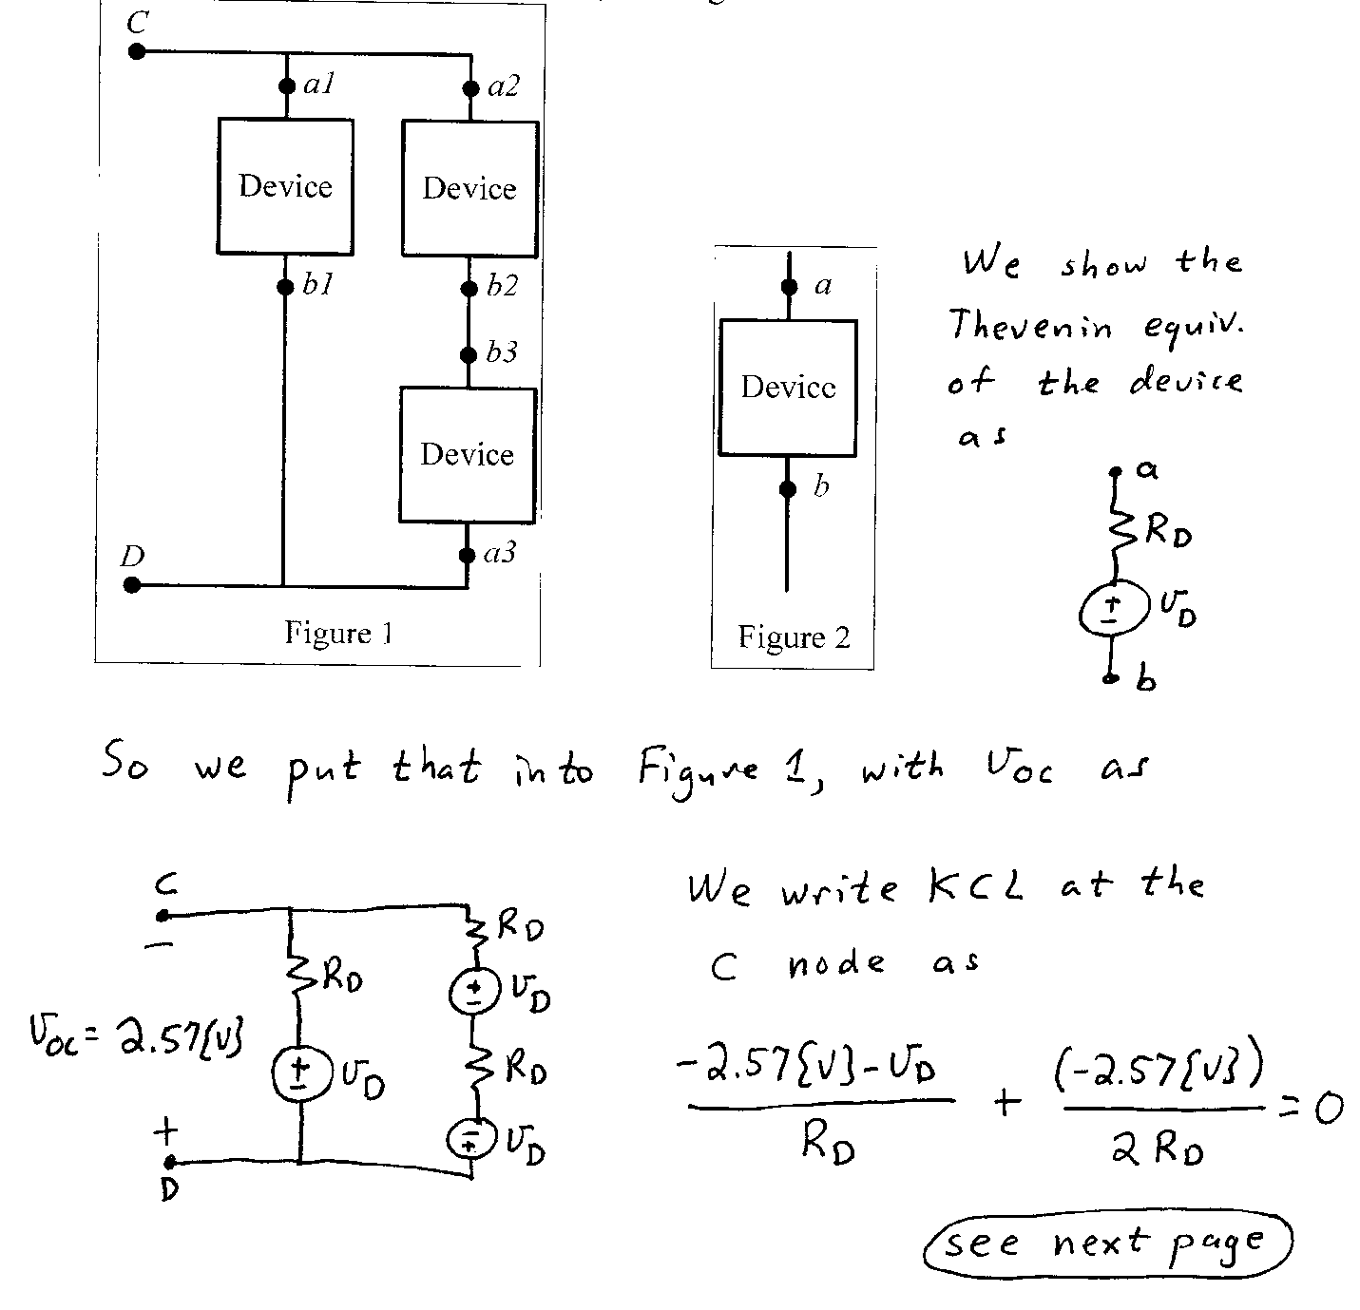
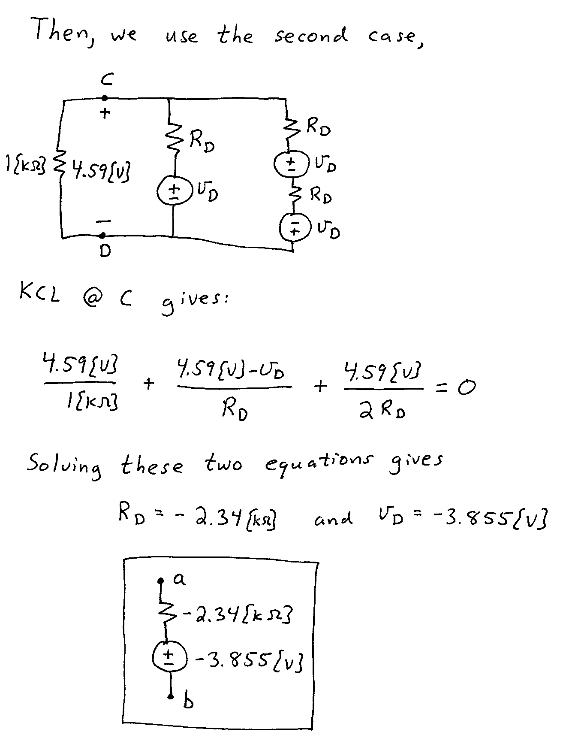

2. {35 Points} In this circuit, the switch was open for a long time before it closed at t = 0.
a) Find the time, or times, if any, when the voltage across the capacitor is equal to +20[V] or -20[V]. If it does not ever reach one of those voltages, show how you know that.
b) Find the energy stored in the inductor at t = 1[μs].
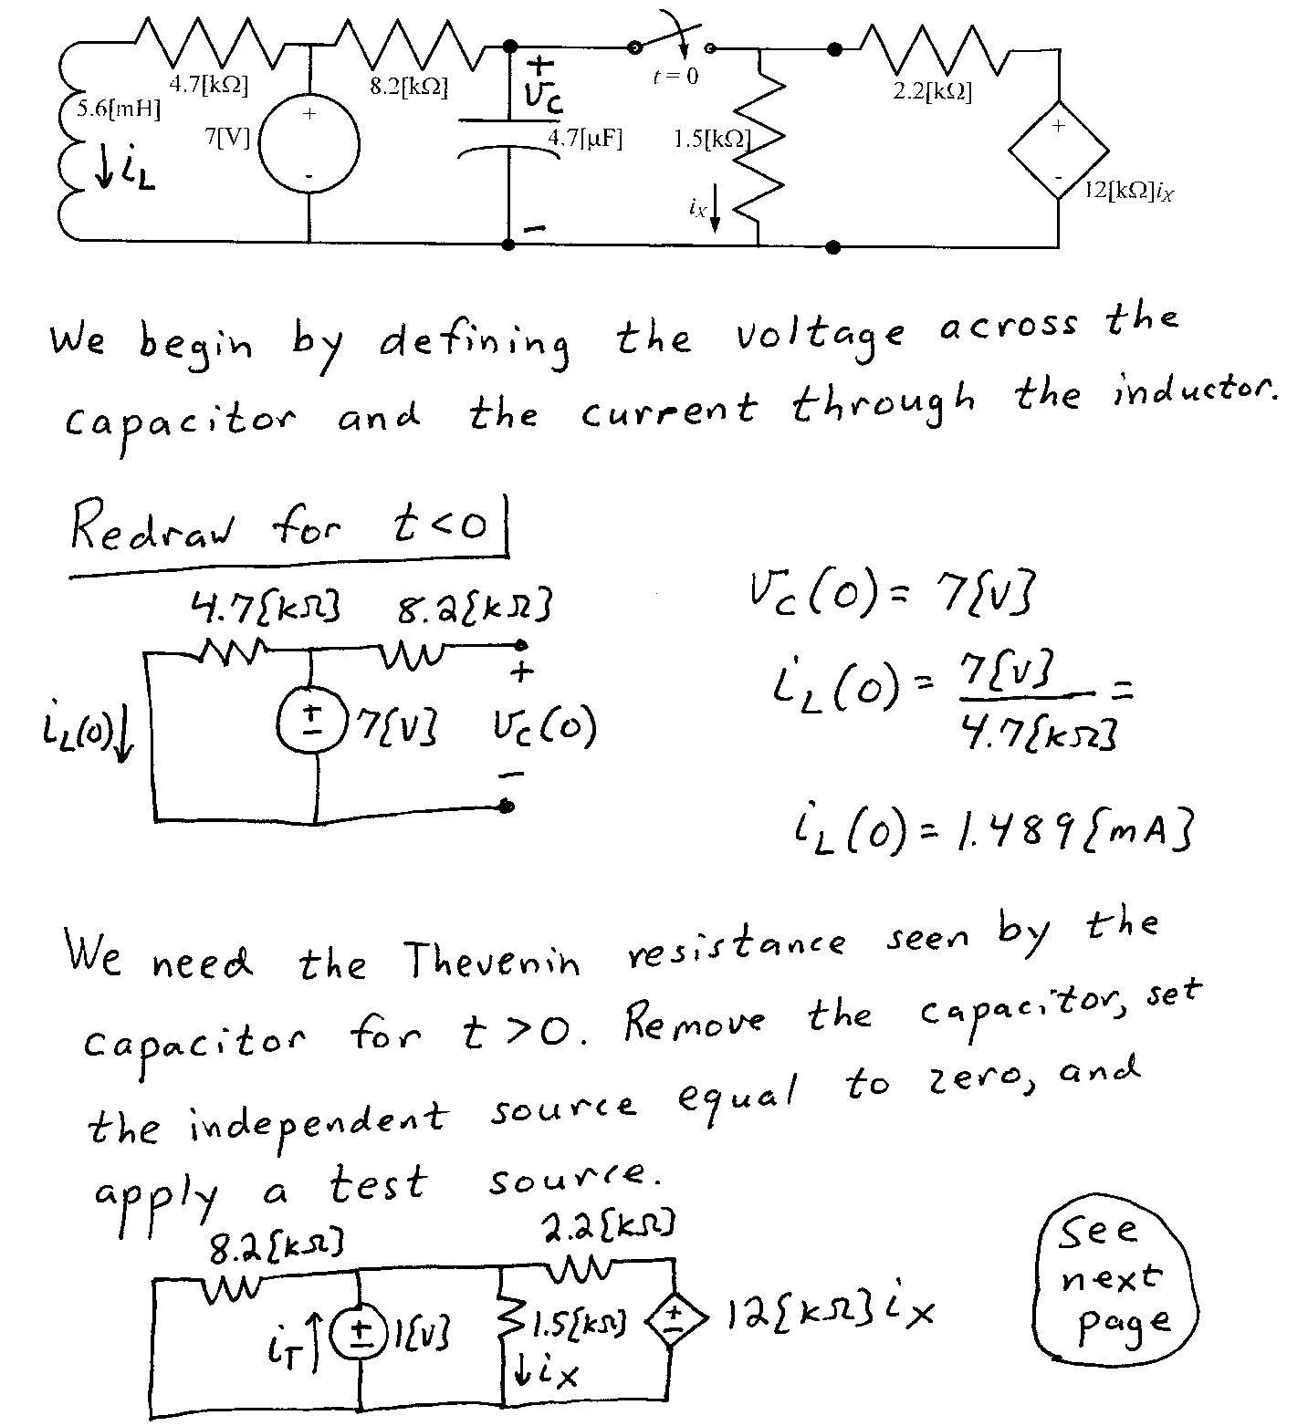
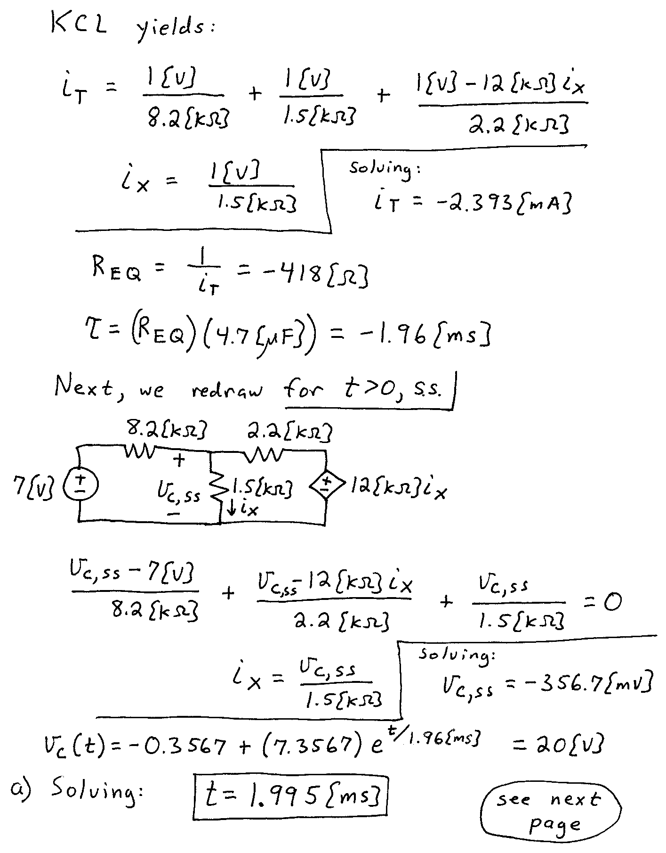
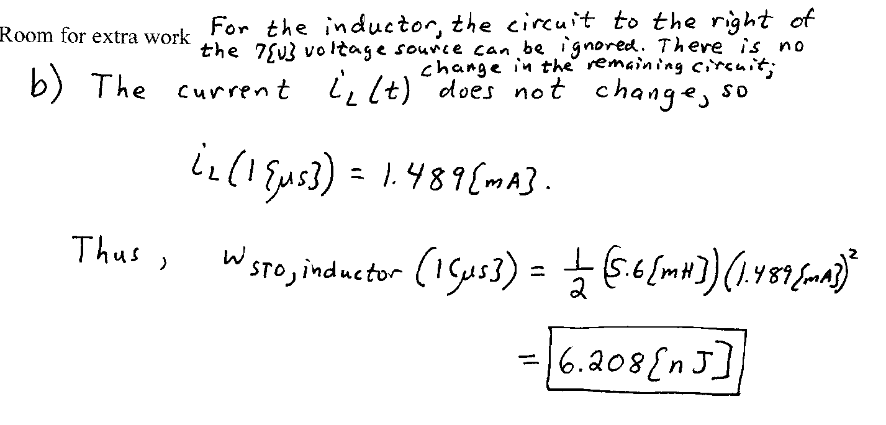

3. {35 Points} The switches were open for a long time before they both closed at
t = 0. Find the sum of the energies stored in the two inductors a long time after the two switches closed.
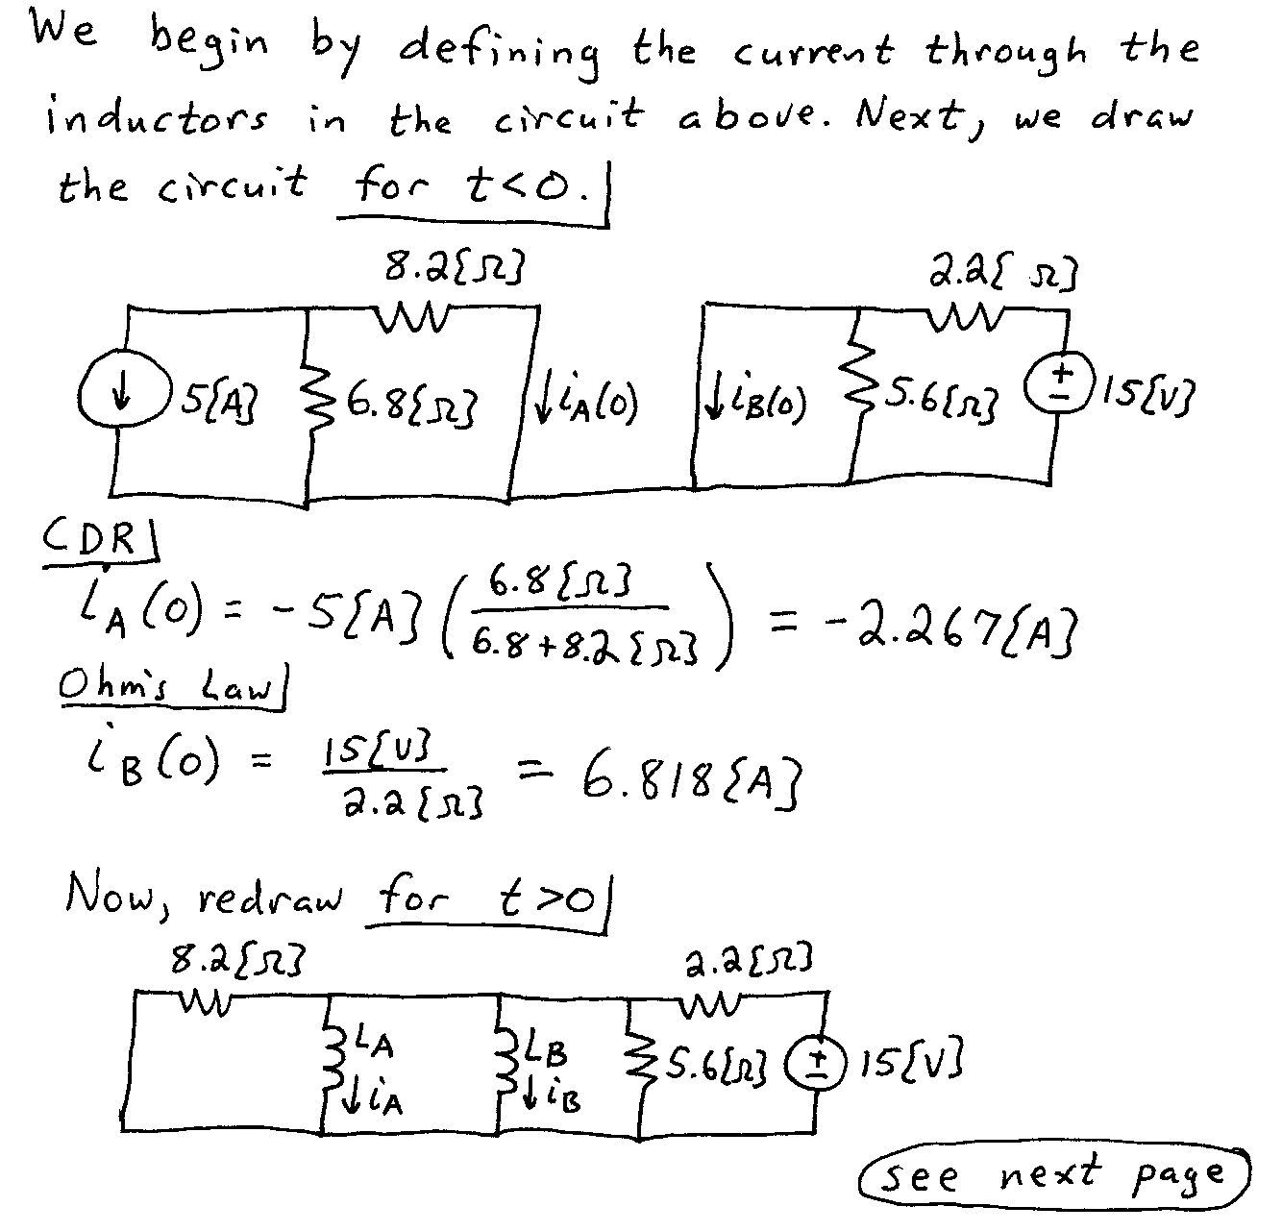
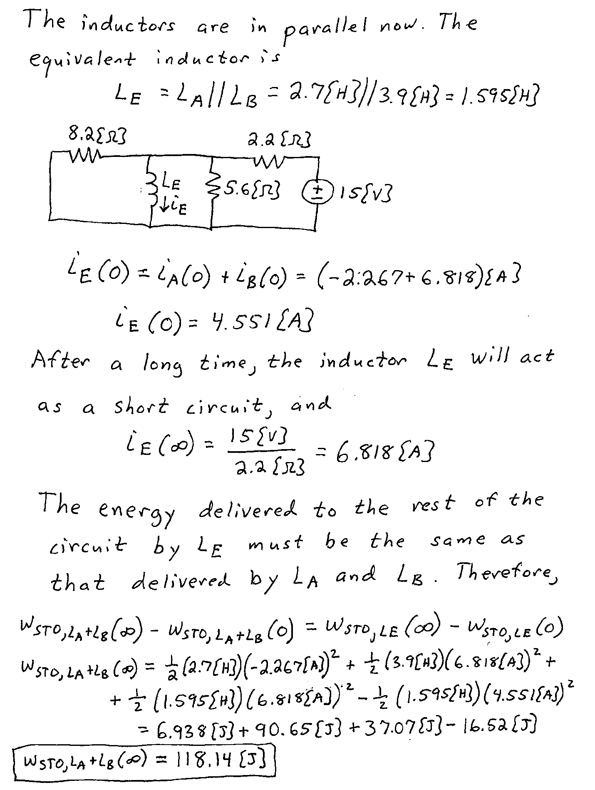

4. {25 Points} The variables a and b are real. Find all of the solutions for a and b that are valid for the following equation. Show your work, showing the steps you have taken to get your answer or answers.
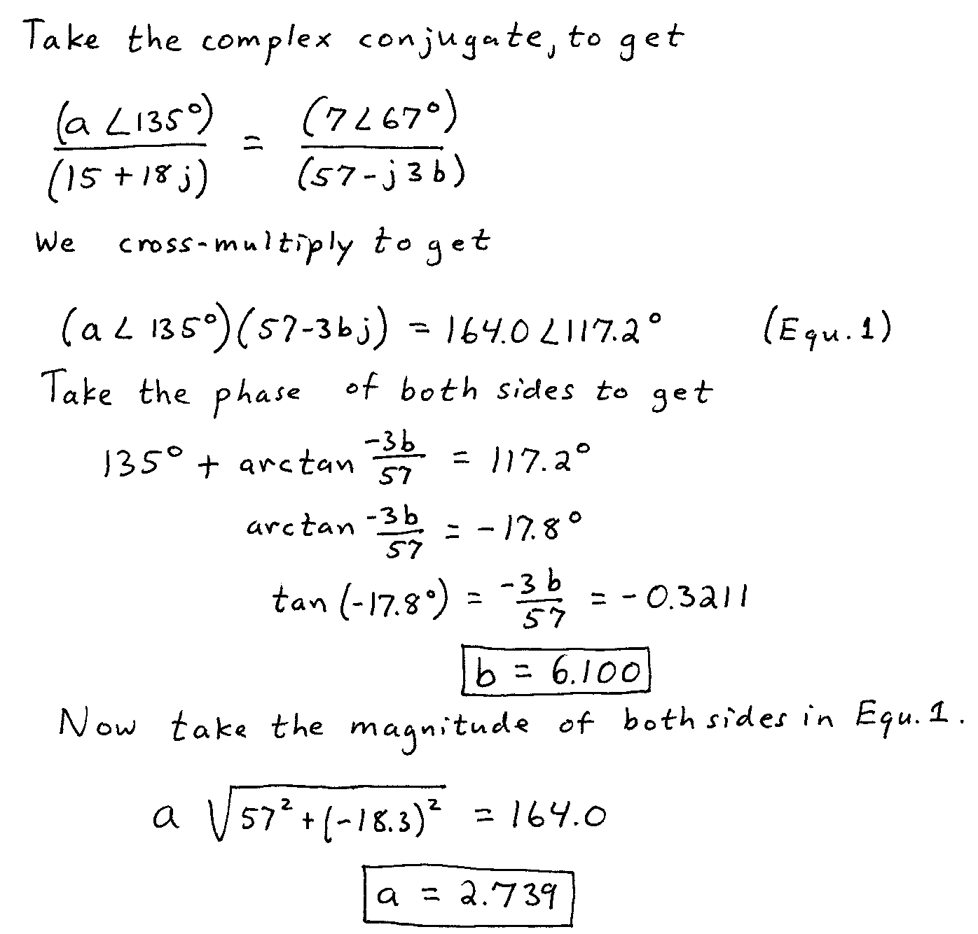

5. {40 Points} The circuit shown is in steady state.
a) Redraw the entire circuit in the phasor domain. Do not simplify the circuit in this step.
b) Find the numerical expression for v_{D}(t) in steady state, as a function of time t.
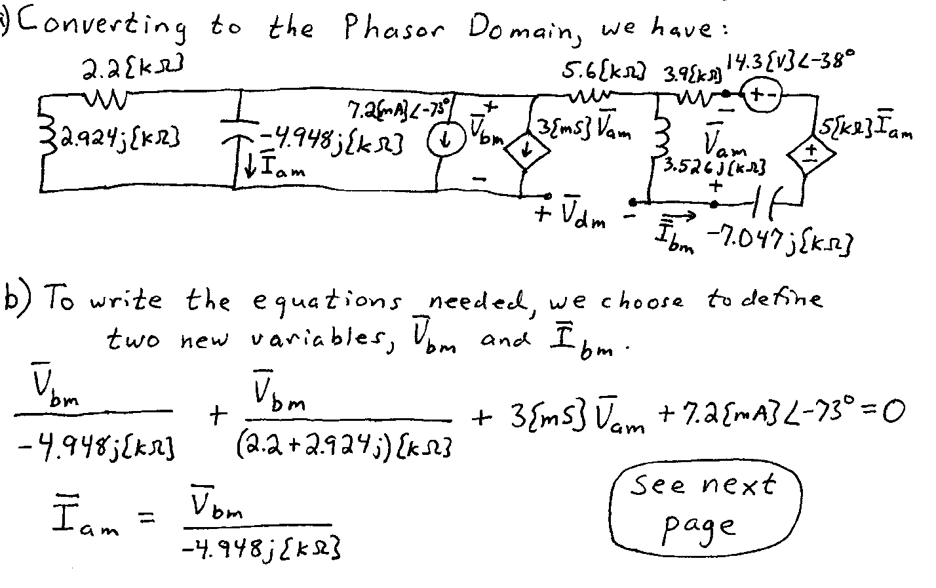
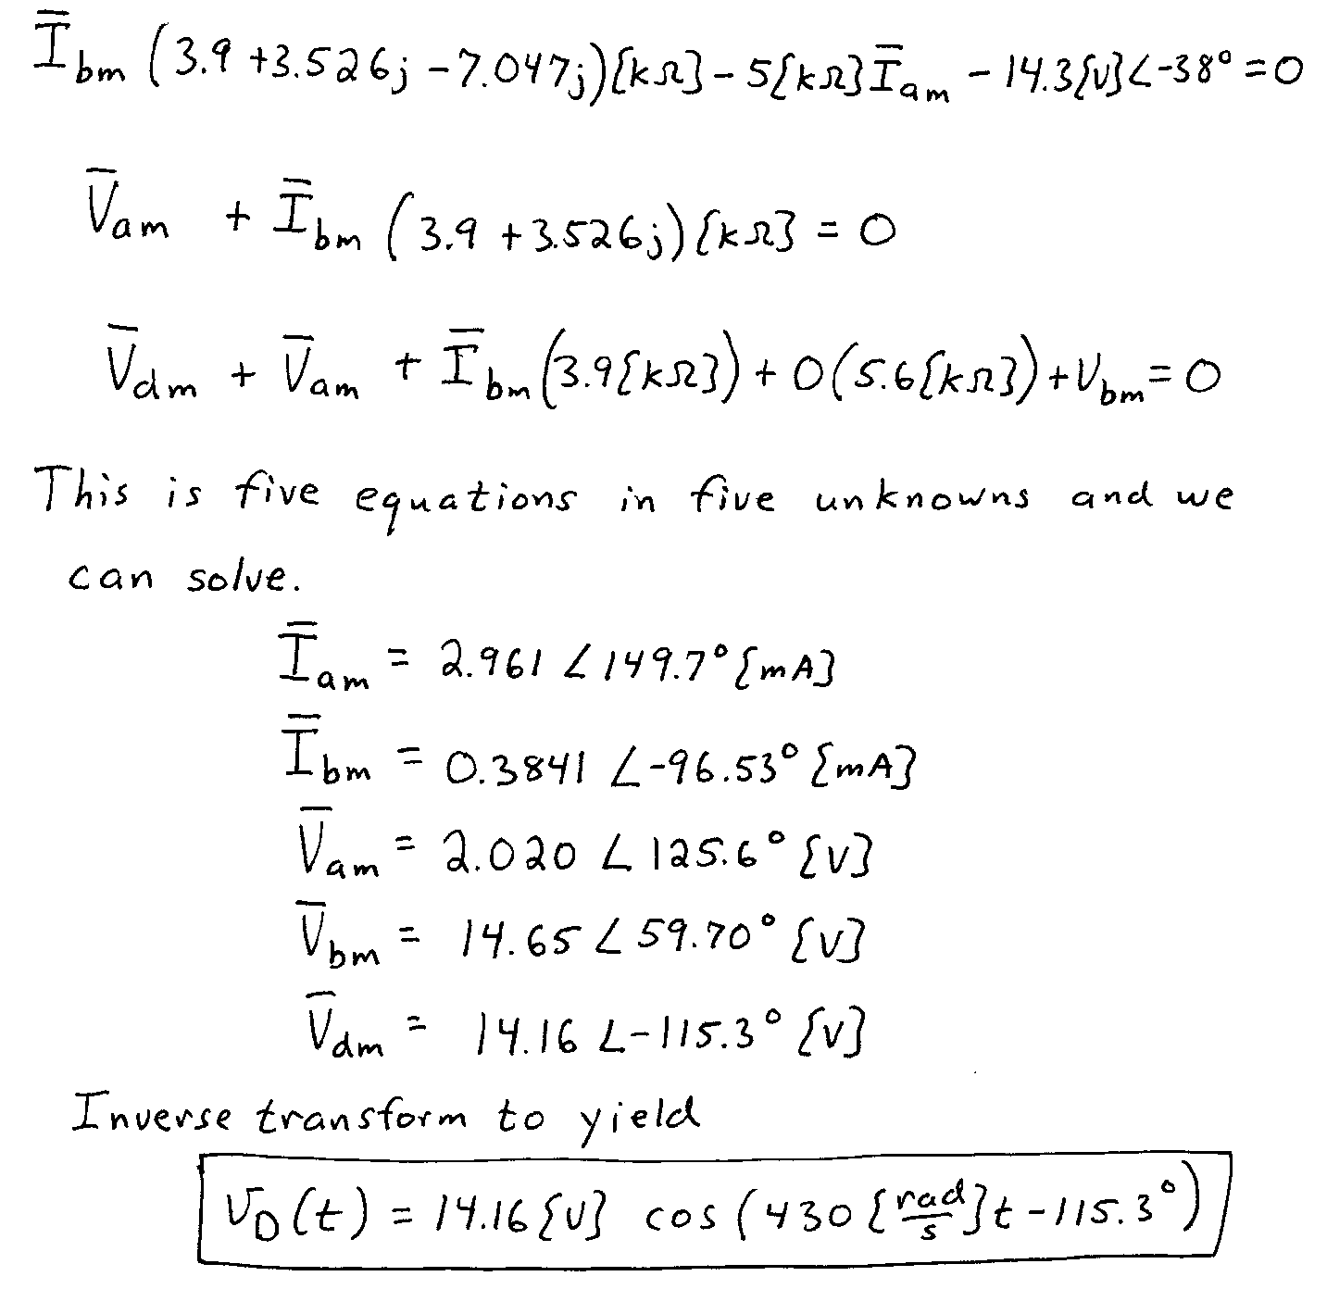

6. {35 Points} The circuit shown below operates in steady-state.
Load 1 absorbs (57∠ 33°)[kVA].
Load 2 absorbs 35[kW], and delivers 17[kVAR].
Load 3 absorbs 48[kW] at a leading power factor of 0.82.
Load 4 absorbs 53[kVA] at a lagging power factor of 0.78.
- Find v_{X}(t).
- Find i_{A}(t).
