Name: _____________________________ (please print)
Signature: __________________________

ECE 2202 – Mid-semester Exam
July 24, 2018

Keep this exam closed until you are told to begin.

1. This exam is closed book, closed notes. You may use one 8.5” x 11” crib sheet, or its equivalent.
2. Show all work on these pages. Show all work necessary to complete the problem. A solution without the appropriate work shown will receive no credit. A solution that is not given in a reasonable order will lose credit. Clearly indicate your answer (for example by enclosing it in a box).
3. It is assumed that your work will begin on the same page as the problem statement. If you choose to begin your work on another page, you must indicate this on the page with the problem statement, with a clear indication of where the work can be found. If your work continues on to another page, indicate clearly where your work can be found. Failure to indicate this clearly will result in a loss of credit.
4. Show all units in solutions, intermediate results, and figures. Units in the exam will be included between square brackets.
5. Do not use red ink. Do not use red pencil.
6. You will have 100 minutes to work on this exam.

1. ________________/30
2. ________________/35
3. ________________/35
Total = 100
Room for extra work
- {30 Points} A device has an equivalent circuit as shown in Figure 1. The equivalent is between two terminals, labeled a and b. Three identical versions of this device are connected in the circuit in Figure 2, with terminals a and b shown for each device, to indicate the polarity. Find the Thevenin equivalent resistance as seen by the 20[mA] current source in Figure 2.

Room for extra work

- {35 Points}The switch was in position a for a long time, then moved to position b at t = 0.
- Find a numerical expression for v_{X}(t) for t > 0.
- Find the energy stored in inductor L_{A} a long time after t = 0.

Room for extra work

Room for extra work

- {35 Points} Switch SWA was closed, switch SWB was closed, and switch SWC was open for a long time before t = 0. Then switch SWA opened at
t = 0. After that, switch SWB opened and switch SWC closed at t = 30[ms].
- Find i_{X}(50[ms]).
- Find the energy stored in C₉ at t = 50[ms].

Room for extra work

- {30 Points} A device has an equivalent circuit as shown in Figure 1. The equivalent is between two terminals, labeled a and b. Three identical versions of this device are connected in the circuit in Figure 2, with terminals a and b shown for each device, to indicate the polarity. Find the Thevenin equivalent resistance as seen by the 20[mA] current source in Figure 2.
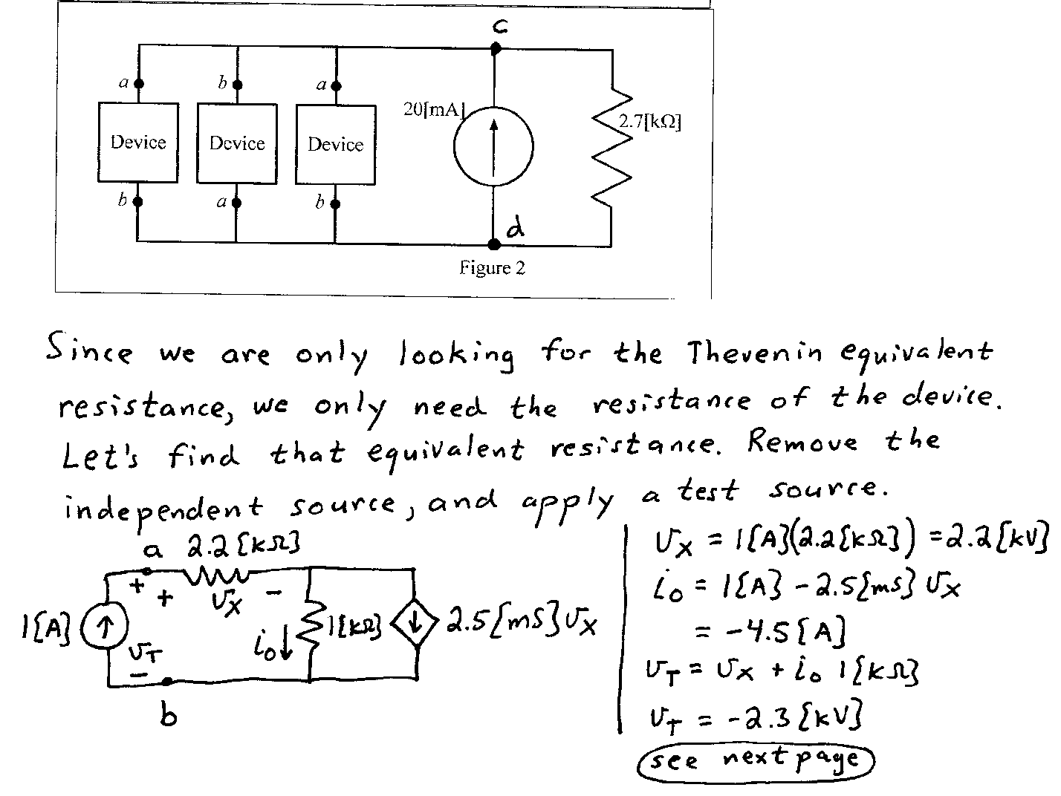
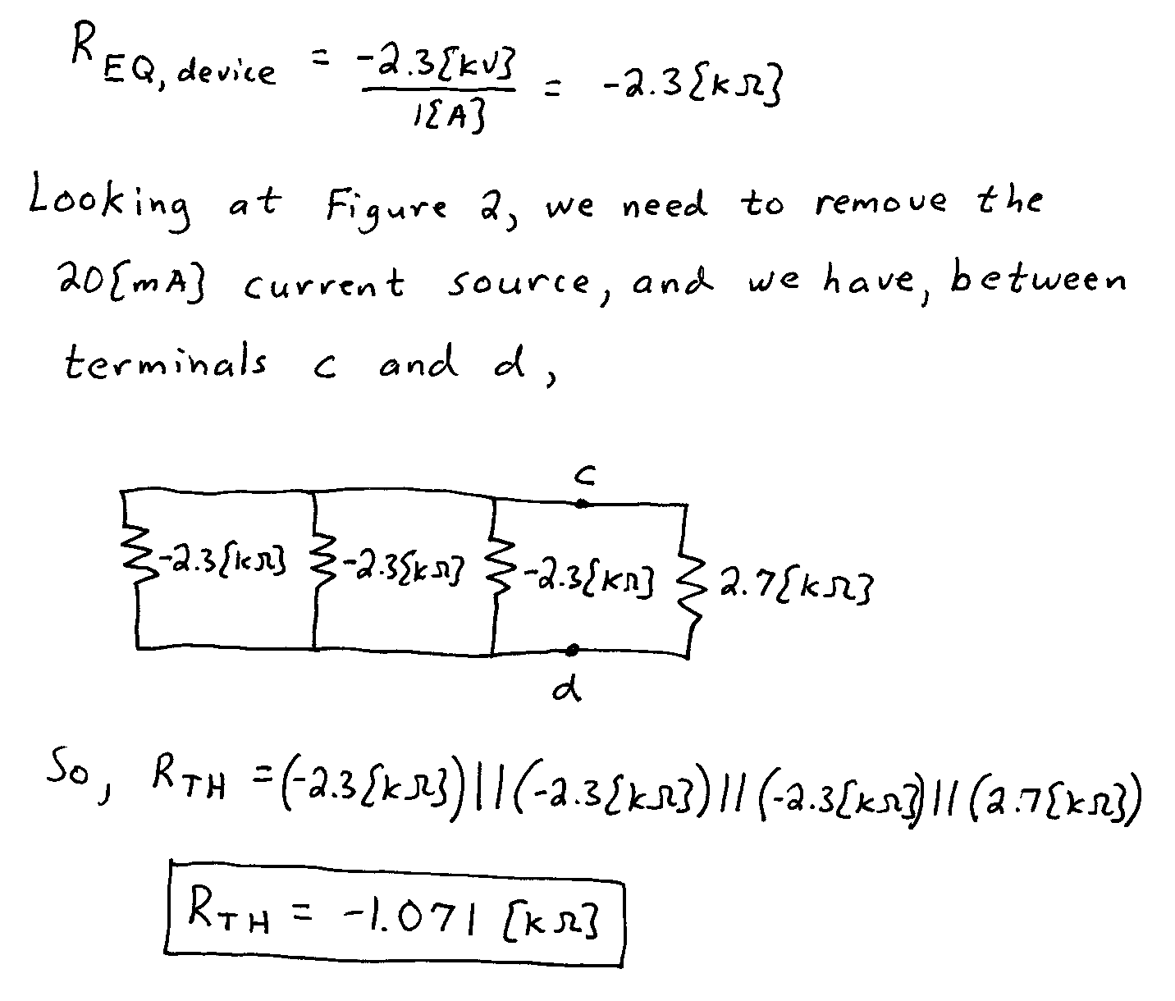

- {35 Points}The switch was in position a for a long time, then moved to position b at t = 0.
- Find a numerical expression for v_{X}(t) for t > 0.
- Find the energy stored in inductor L_{A} a long time after t = 0.
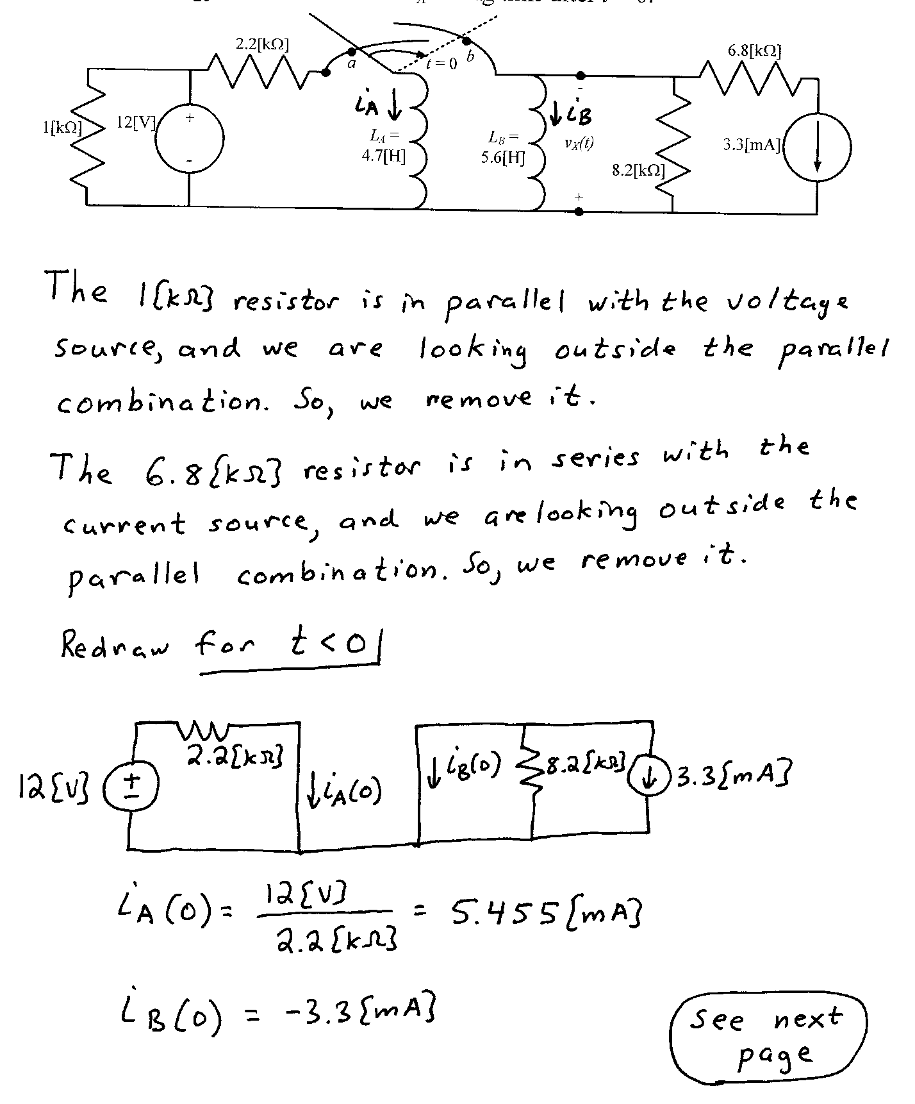
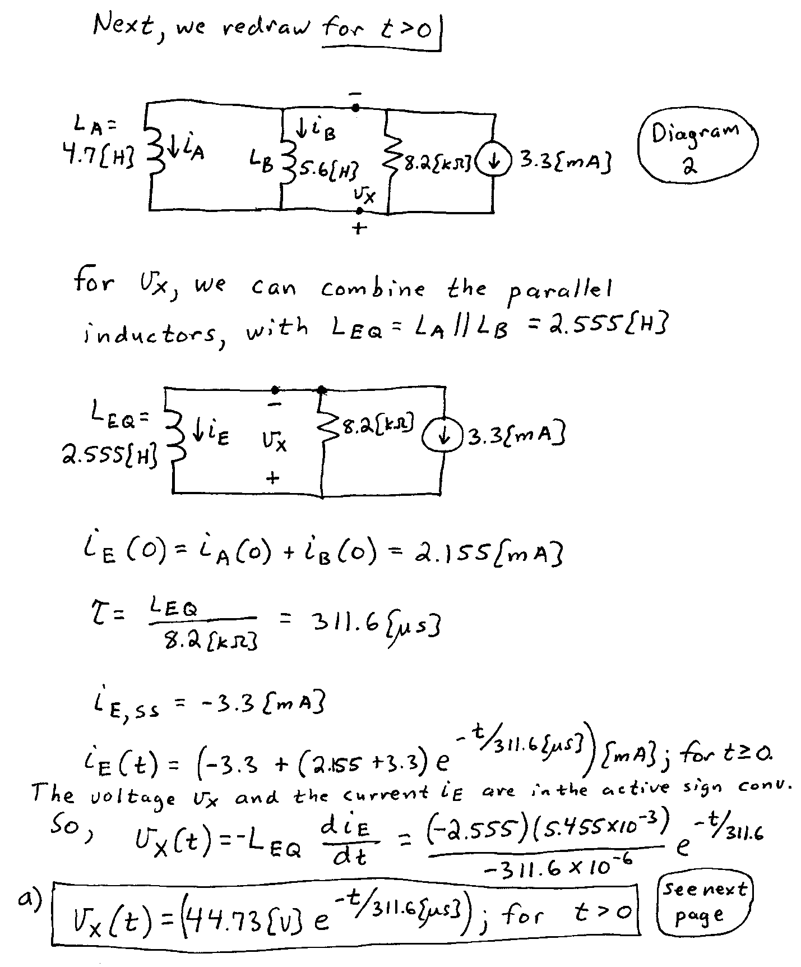
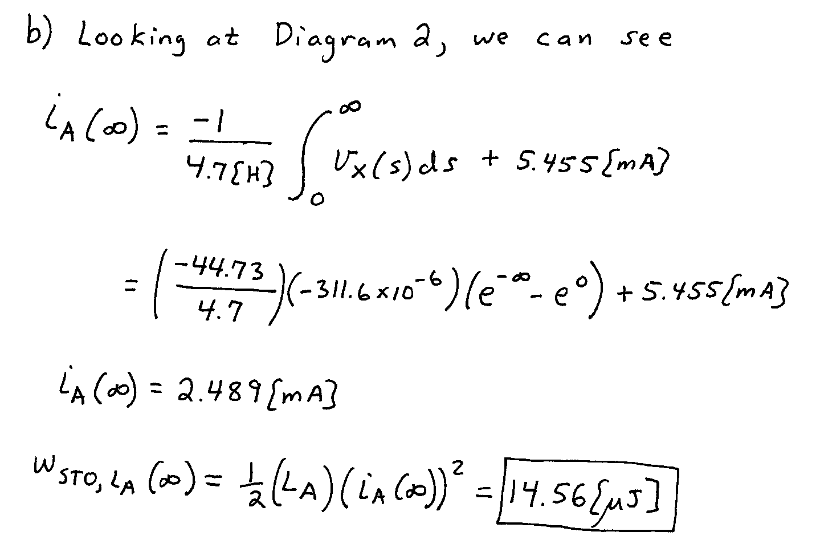

- {35 Points} Switch SWA was closed, switch SWB was closed, and switch SWC was open for a long time before t = 0. Then switch SWA opened at
t = 0. After that, switch SWB opened and switch SWC closed at t = 30[ms].
- Find i_{X}(50[ms]).
- Find the energy stored in C₉ at t = 50[ms].
