Peoplesoft ID Number: _____________________________

ECE 2202 – Final Exam Problem 1
August 11, 2021

1. You may use one 8.5” x 11” crib sheet, or its equivalent. Do not communicate with anyone except Dr. Dave Shattuck while you are taking this exam.
2. Show all work necessary to complete the problem. Use additional sheets of paper as needed. A solution without the appropriate work shown will receive no credit. A solution which is not given in a reasonable order will lose credit. Include this page with your Peoplesoft ID Number, or include a different, separate page with your Peoplesoft ID Number. Do not write your name on this exam. Failure to follow these rules will result in points being deducted.
3. Show all units in solutions, intermediate results, and figures. Units in the exam will be included between square brackets.
4. Do not use red ink. Do not use red pencil.
5. You will have 40 minutes to work on this exam, plus additional time to print, scan and email your work. Use a filename which is your Peoplesoft ID Number, followed by Problem 1. Post your solution on Blackboard, in the same way you submit homework assignments. It must be submitted by 3:00pm, or points will be deducted.

________________/40
Use the circuit shown below to solve.
All resistances in the diagram have units of [Ohms].
- Find the Norton equivalent as seen by the v_{S2} voltage source.
- Draw the Norton equivalent as seen by the v_{S2} voltage source, and connect the v_{S2} voltage source to the equivalent. Show numerical values for all components in your circuit diagram.
- Find the power delivered by the v_{S2} voltage source.

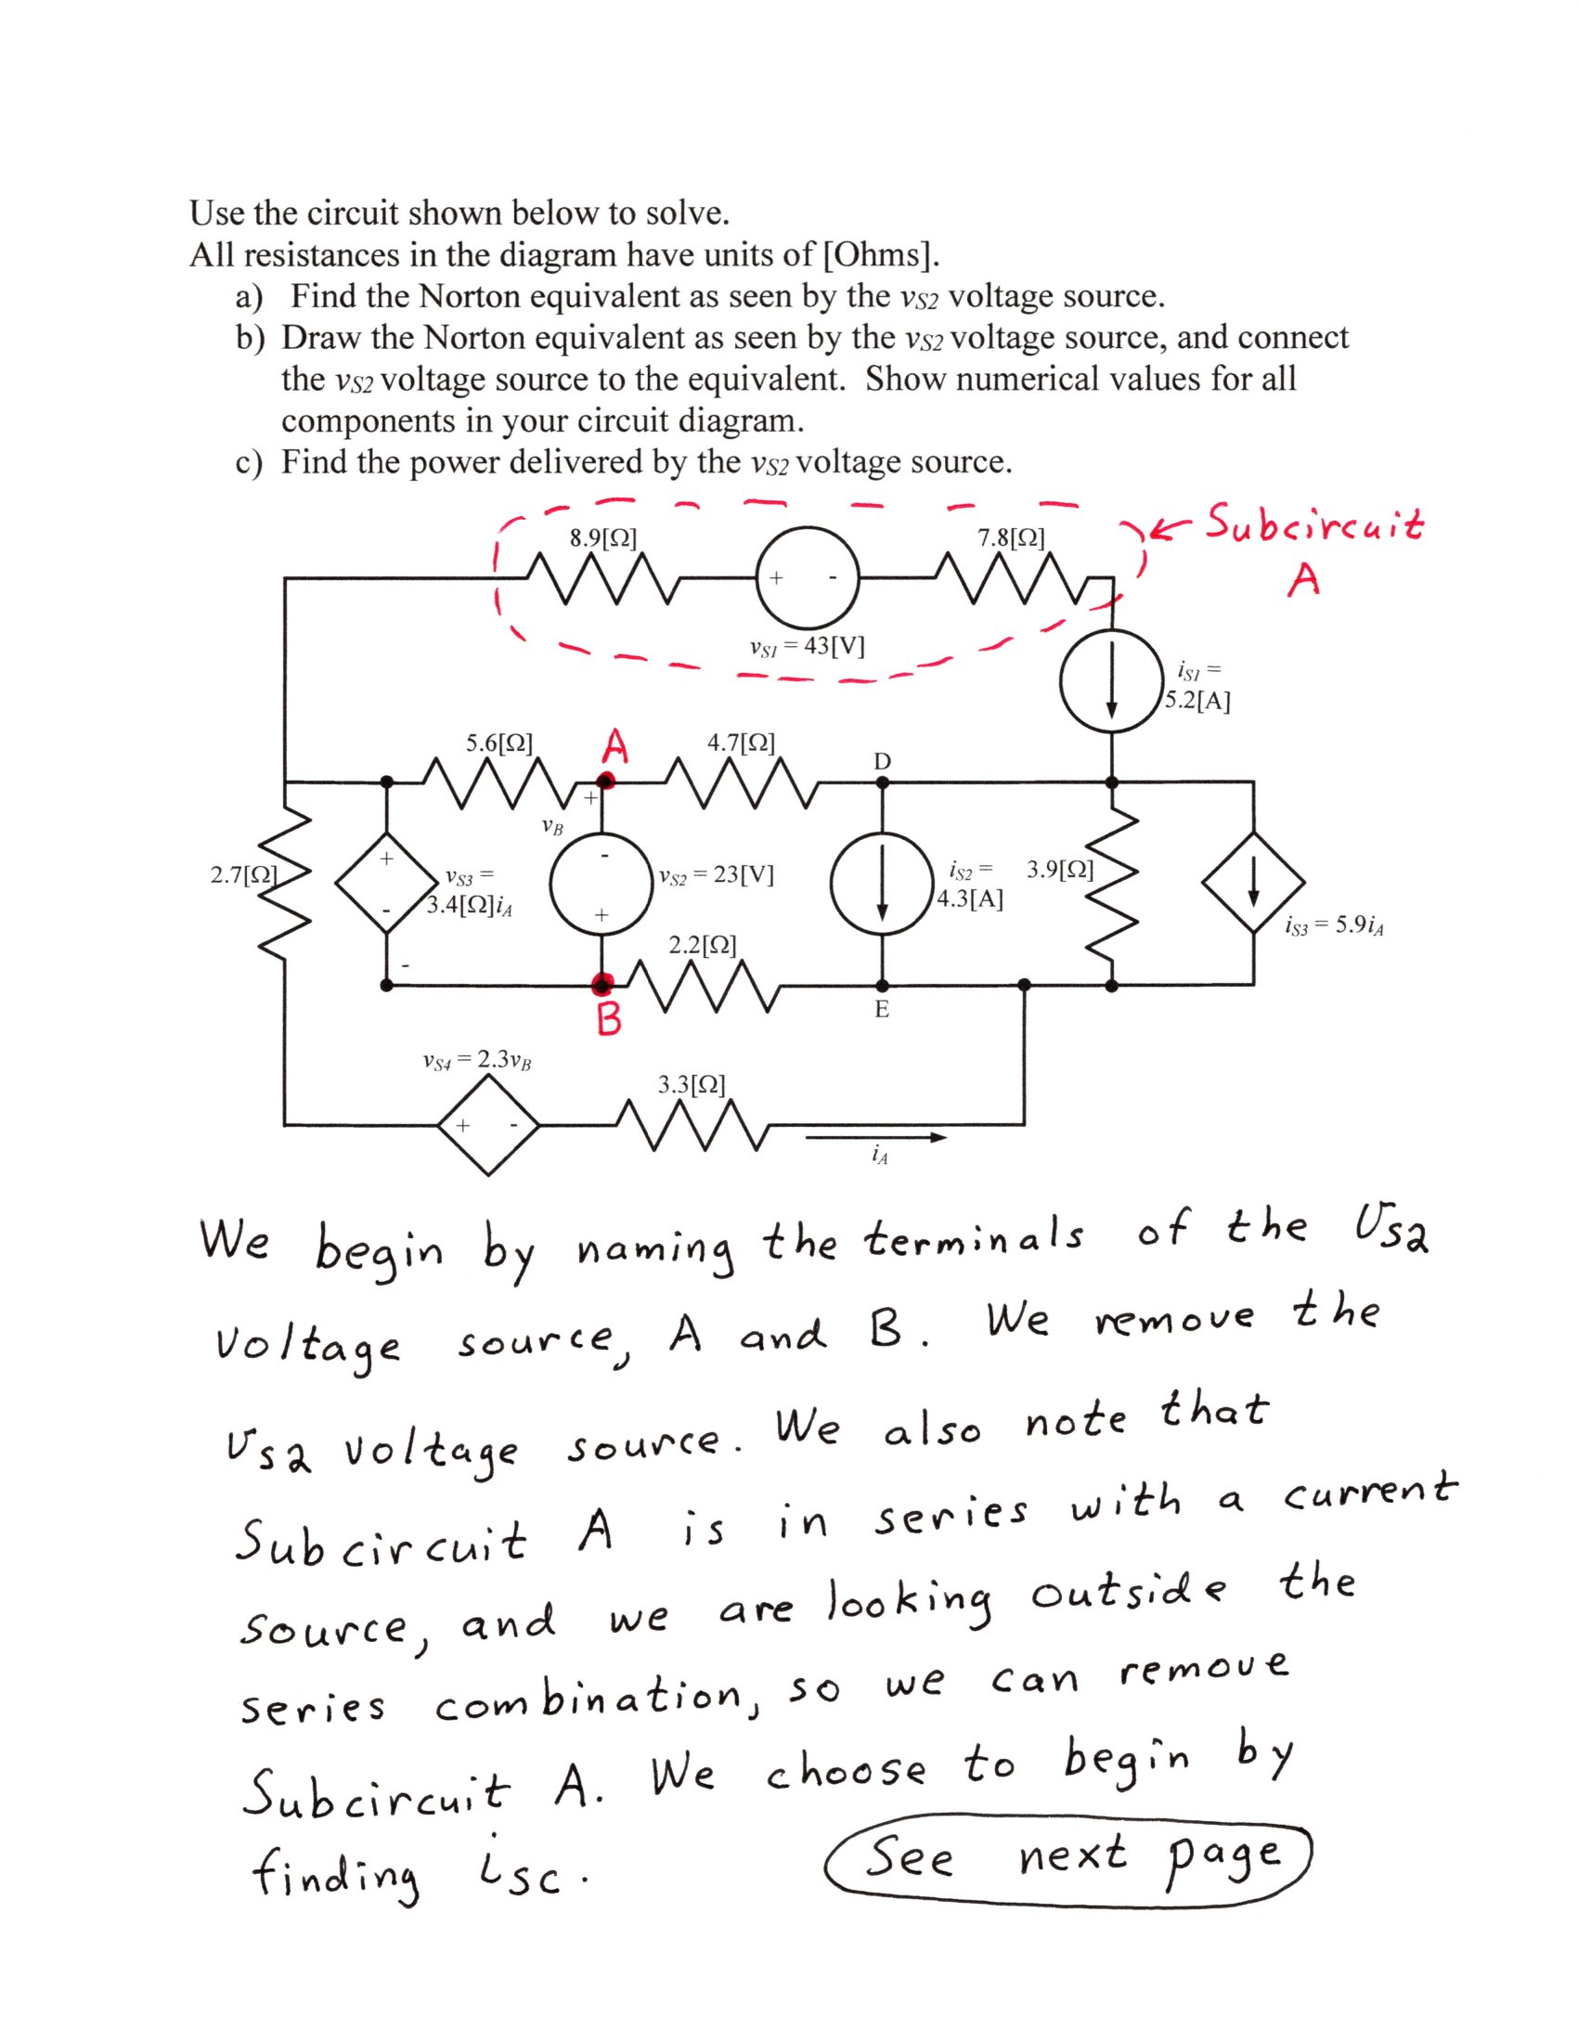
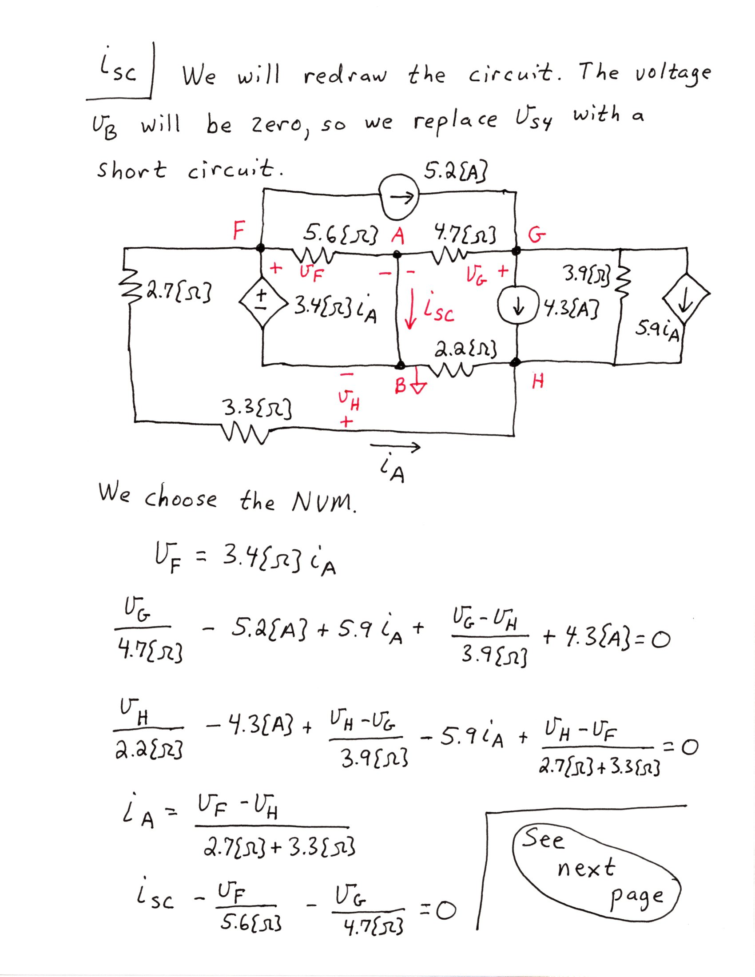
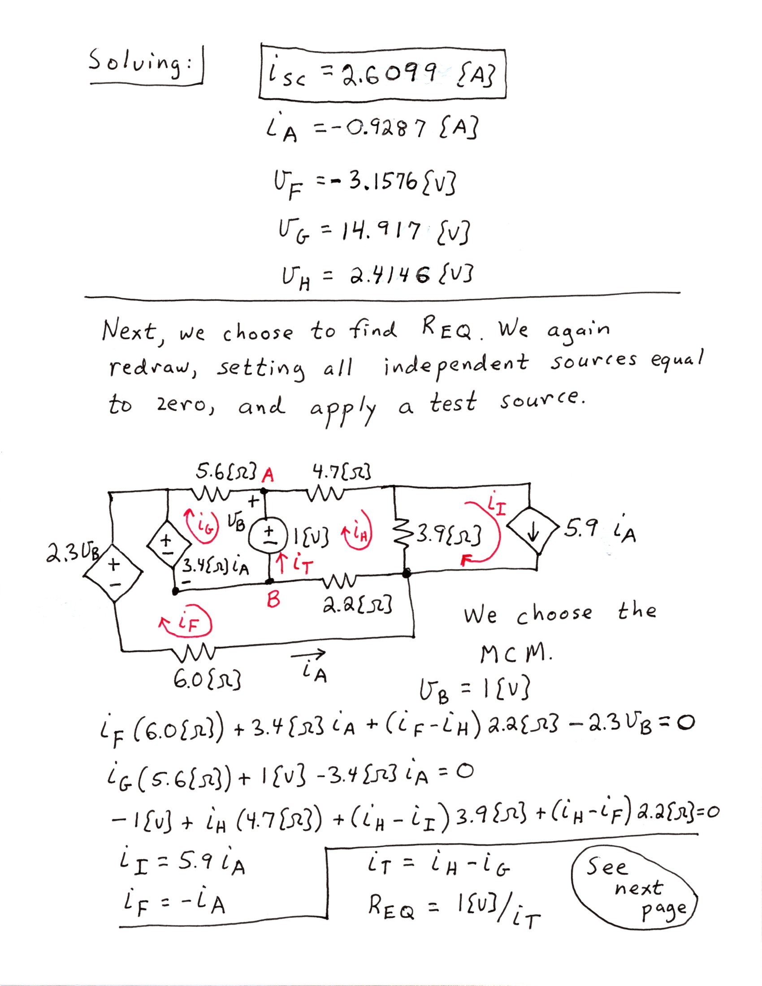
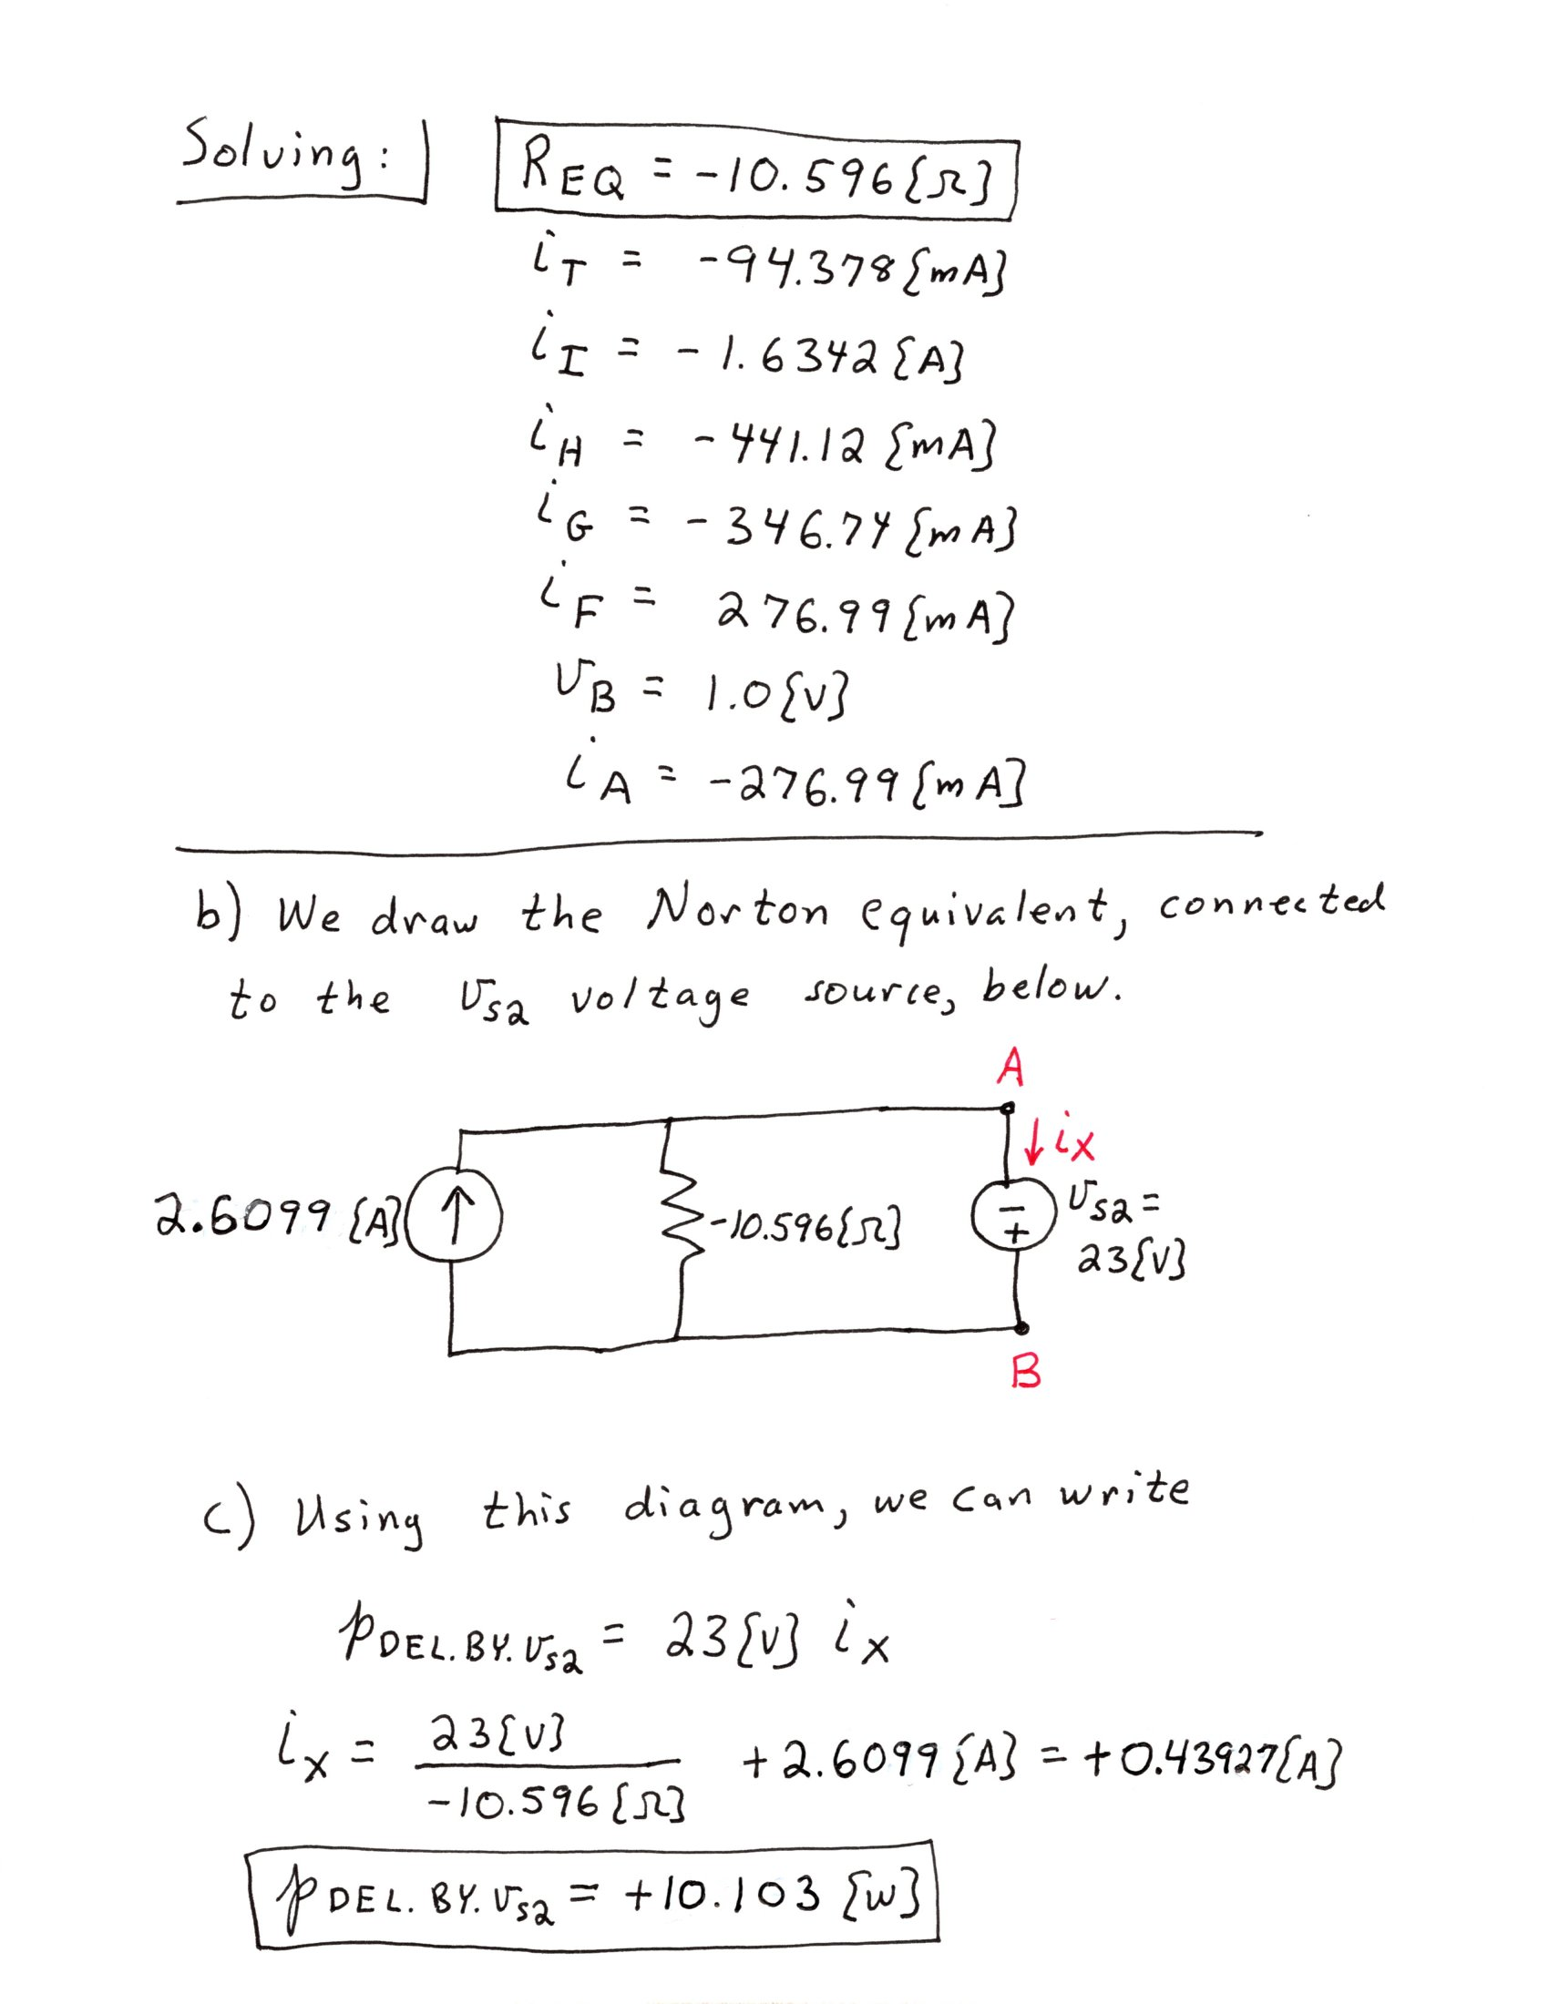

Peoplesoft ID Number: _____________________________

ECE 2202 – Final Exam Problem 2
August 11, 2021

1. You may use one 8.5” x 11” crib sheet, or its equivalent. Do not communicate with anyone except Dr. Dave Shattuck while you are taking this exam.
2. Show all work necessary to complete the problem. Use additional sheets of paper as needed. A solution without the appropriate work shown will receive no credit. A solution which is not given in a reasonable order will lose credit. Include this page with your Peoplesoft ID Number, or include a different, separate page with your Peoplesoft ID Number. Do not write your name on this exam. Failure to follow these rules will result in points being deducted.
3. Show all units in solutions, intermediate results, and figures. Units in the exam will be included between square brackets.
4. Do not use red ink. Do not use red pencil.
5. You will have 40 minutes to work on this exam, plus additional time to print, scan and email your work. Use a filename which is your Peoplesoft ID Number, followed by Problem 2. Post your solution on Blackboard, in the same way you submit homework assignments. It must be submitted by 3:45pm, or points will be deducted.

________________/40
Use the circuit shown below to solve. Switch SWA was closed, and switch SWB was open, for a long time before t = 0. At t = 0, switch SWA opened. Then, 1.2[s] later switch SWB closed.
All resistances in the diagram have units of [Ohms].
- Find i_{B}(2.5[s]).
- Find the energy stored in the C_{A} capacitor at t = 3.9[s].

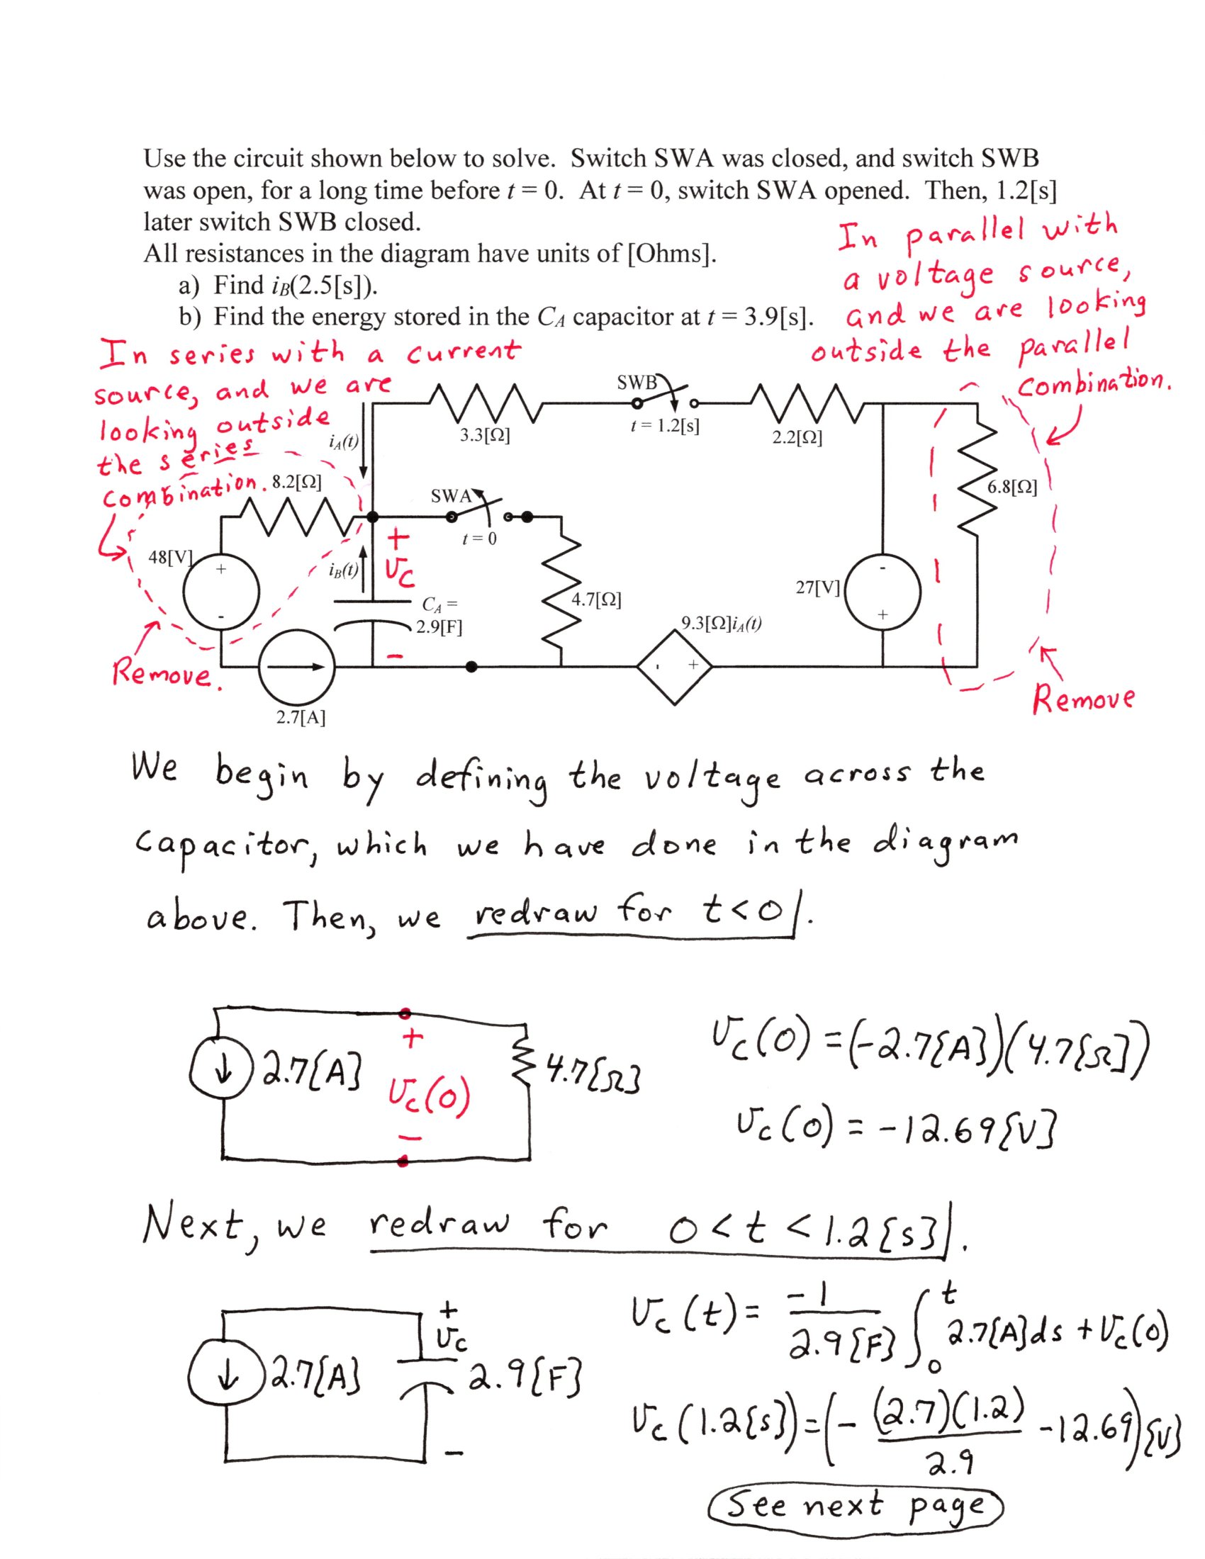
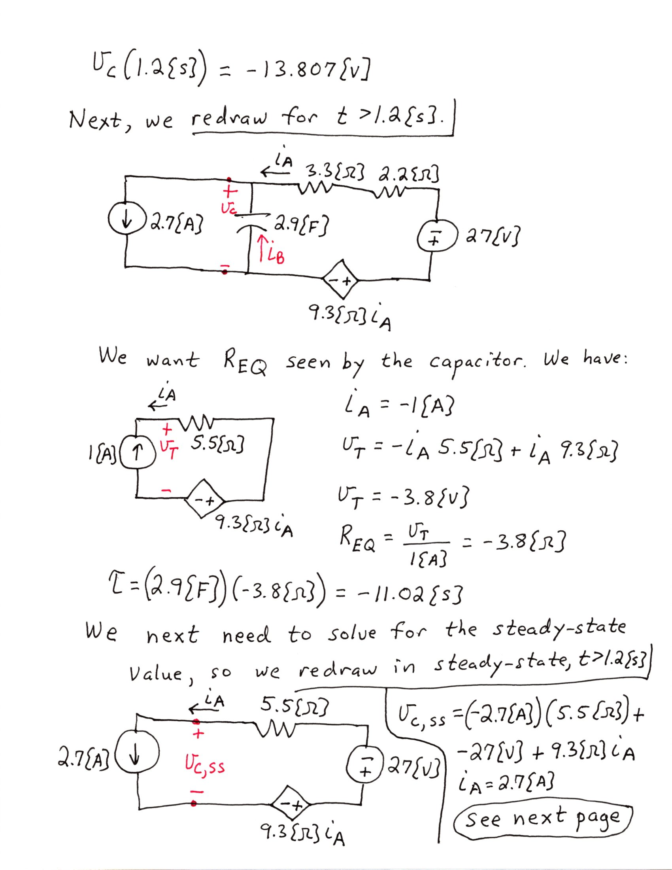
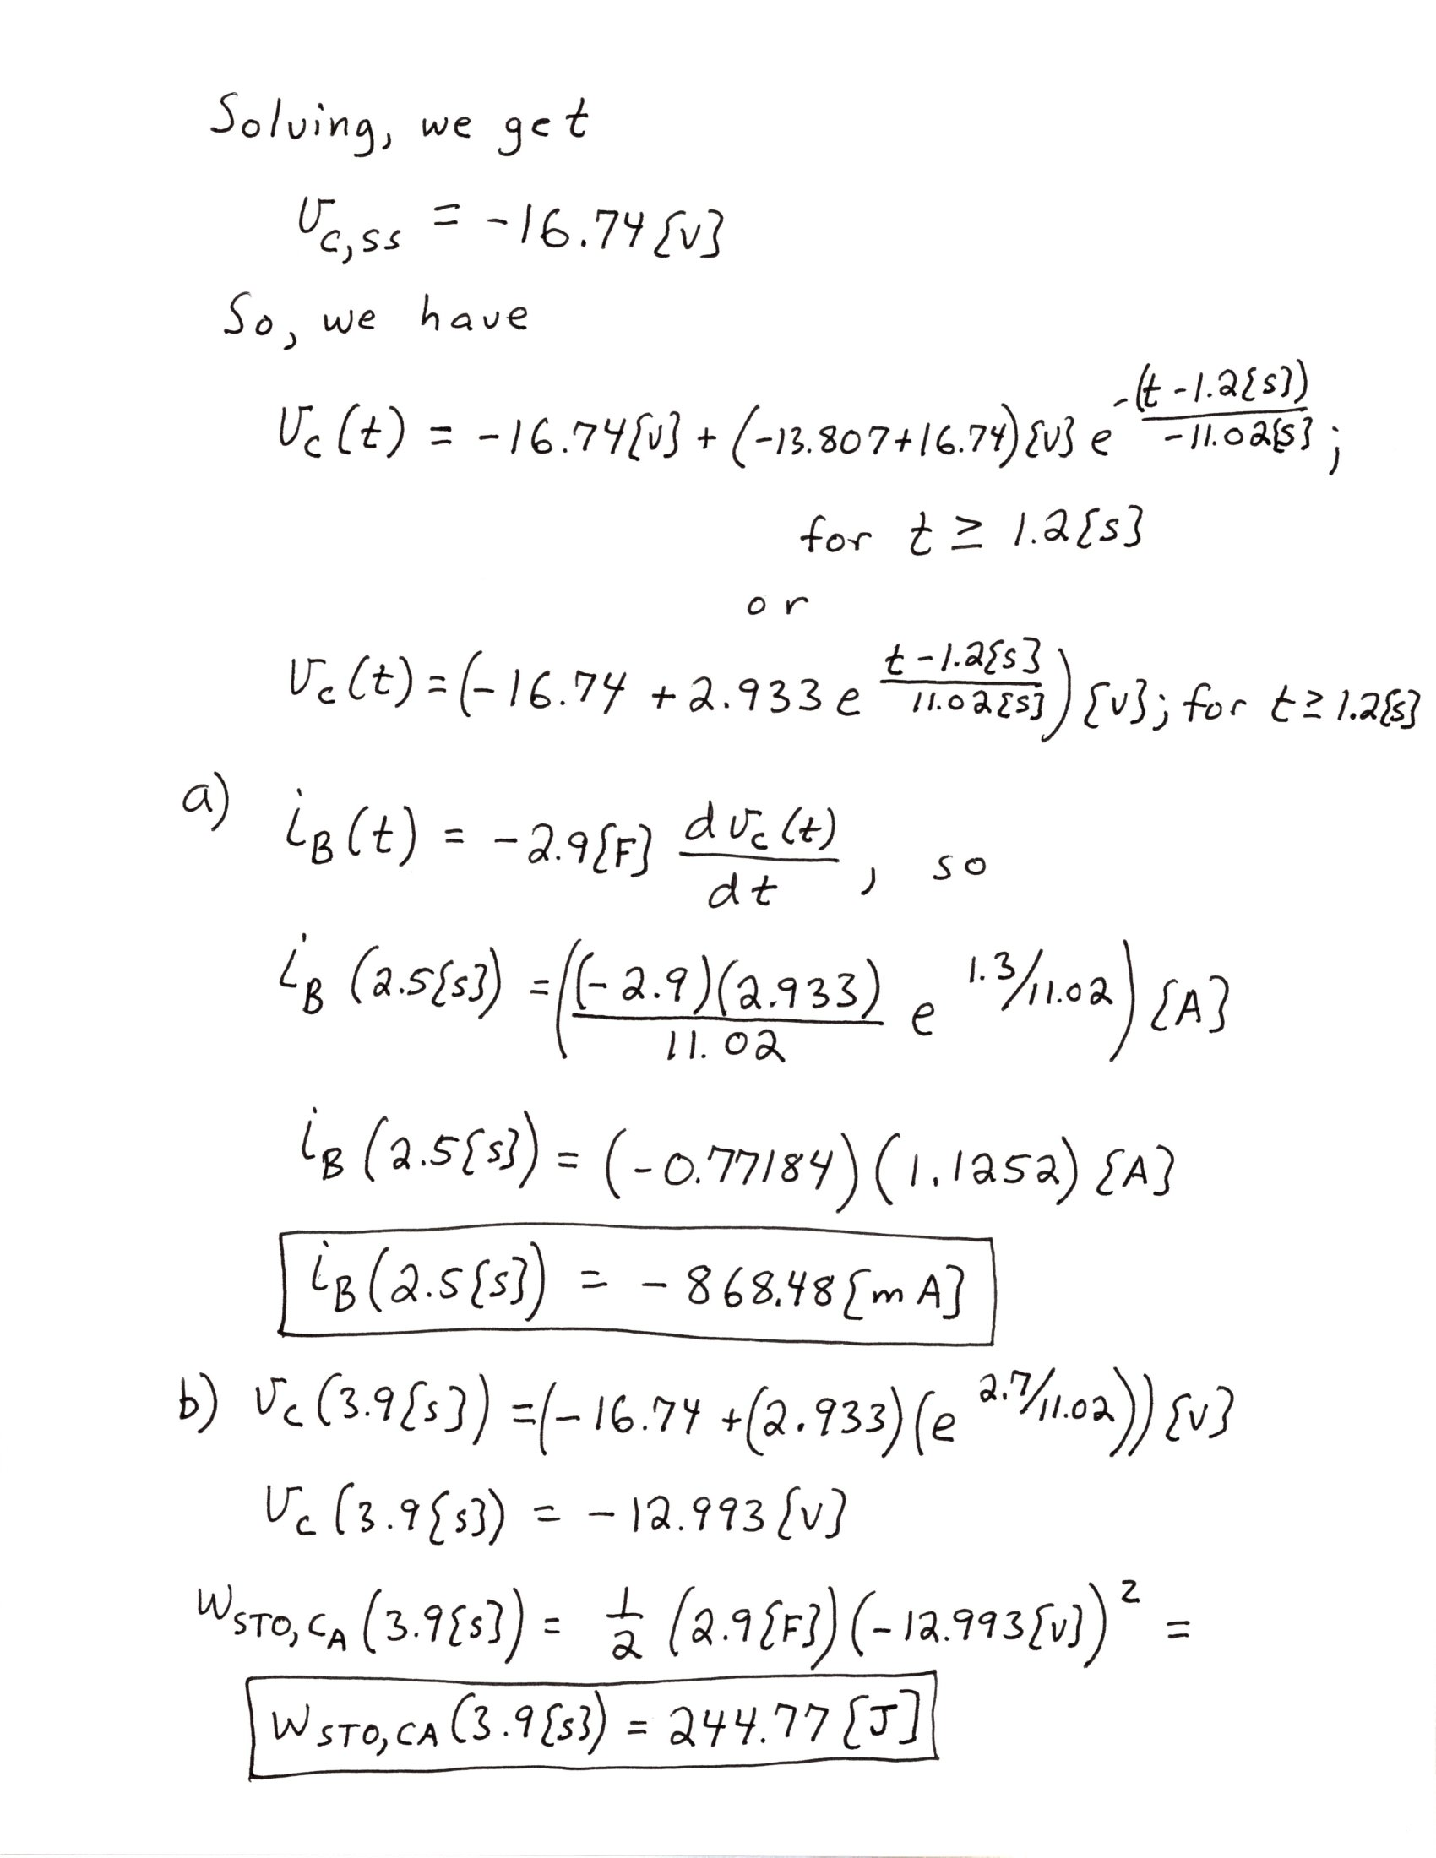

Peoplesoft ID Number: _____________________________

ECE 2202 – Final Exam Problem 3
August 11, 2021

1. You may use one 8.5” x 11” crib sheet, or its equivalent. Do not communicate with anyone except Dr. Dave Shattuck while you are taking this exam.
2. Show all work necessary to complete the problem. Use additional sheets of paper as needed. A solution without the appropriate work shown will receive no credit. A solution which is not given in a reasonable order will lose credit. Include this page with your Peoplesoft ID Number, or include a different, separate page with your Peoplesoft ID Number. Do not write your name on this exam. Failure to follow these rules will result in points being deducted.
3. Show all units in solutions, intermediate results, and figures. Units in the exam will be included between square brackets.
4. Do not use red ink. Do not use red pencil.
5. You will have 35 minutes to work on this exam, plus additional time to print, scan and email your work. Use a filename which is your Peoplesoft ID Number, followed by Problem 3. Post your solution on Blackboard, in the same way you submit homework assignments. It must be submitted by 4:20pm, or points will be deducted.

________________/35
Use the circuit shown below to solve. The circuit is in steady-state.
Find a numerical expression for v_{A} as a function of time, t.
All resistances in the diagram have units of [Ohms].

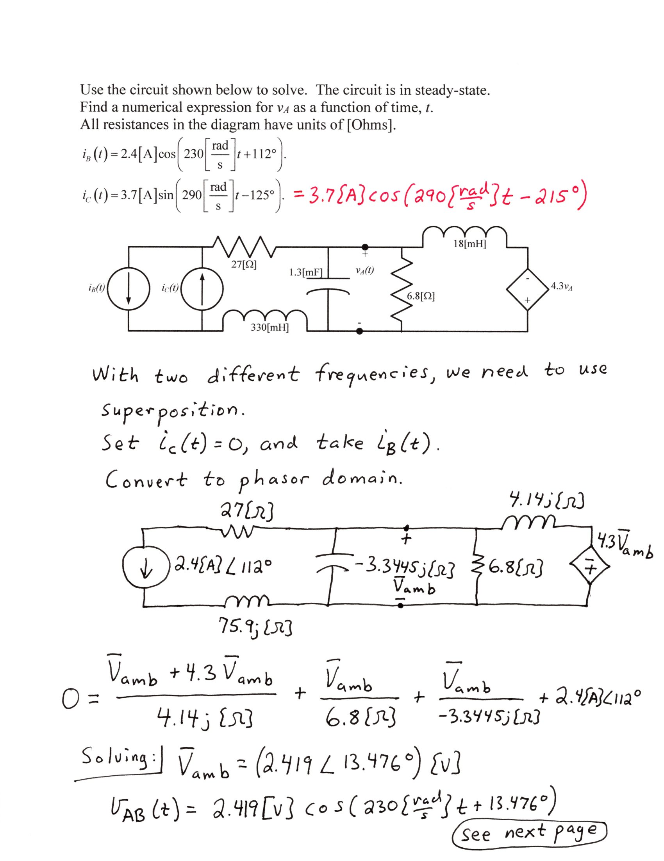
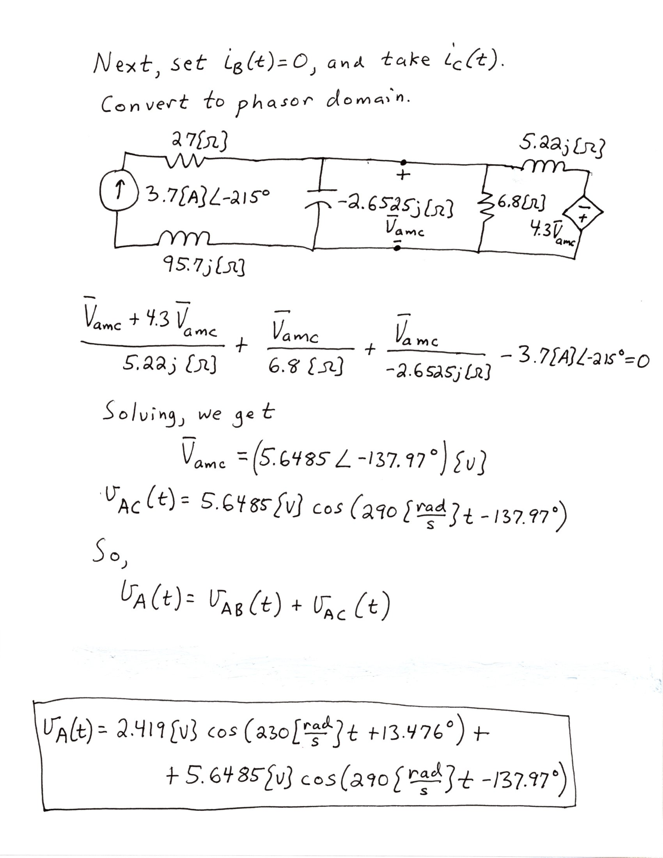

Peoplesoft ID Number: _____________________________

ECE 2202 – Final Exam Problem 4
August 11, 2021

1. You may use one 8.5” x 11” crib sheet, or its equivalent. Do not communicate with anyone except Dr. Dave Shattuck while you are taking this exam.
2. Show all work necessary to complete the problem. Use additional sheets of paper as needed. A solution without the appropriate work shown will receive no credit. A solution which is not given in a reasonable order will lose credit. Include this page with your Peoplesoft ID Number, or include a different, separate page with your Peoplesoft ID Number. Do not write your name on this exam. Failure to follow these rules will result in points being deducted.
3. Show all units in solutions, intermediate results, and figures. Units in the exam will be included between square brackets.
4. Do not use red ink. Do not use red pencil.
5. You will have 35 minutes to work on this exam, plus additional time to print, scan and email your work. Use a filename which is your Peoplesoft ID Number, followed by Problem 4. Post your solution on Blackboard, in the same way you submit homework assignments. It must be submitted by 4:50pm, or points will be deducted.

________________/35
Use the circuit shown below to solve. The circuit is in steady-state.
The line absorbs 6.33[VAR].
The source delivers 25.93[VAR].
- Find all of the positive values for R_{L} that fit the conditions given.
- Find i_{L}(t) for all of the values of R_{L} that you found in part a). If you did not solve part a), use R_{L} = 4.7[kOhms].

