##### DO NOT BEGIN THIS EXAM UNTIL TOLD TO START

# Name: __________________________________________

**PeopleSoft ID: ___________________________________**

#### ECE 3317

#### Applied Electromagnetic Waves

**Exam II**

#### Nov. 28, 2018

1. This exam is open book and open notes. However, you are not allowed to use a computer or any electronic device other than a calculator. Any devices that may be used to communicate are not allowed.
2. Show all of your work. No credit will be given if the work required to obtain the solutions is not shown.
3. Perform all your work on the exam in the space allowed.
4. Write neatly. You will not be given credit for work that is not **easily legible**.
5. Leave answers in terms of the parameters given in the problem.
6. Show units in all of your final answers.
7. Circle your final answers.
8. Double-check your answers. For simpler problems, partial credit may not be given.
9. If you have any questions, ask the instructor. You will not be given credit for work that is based on a wrong assumption.
10. Make sure you sign the academic honesty statement on the next page.

**Academic Honesty Statement**

I agree to abide by the UH Academic Honesty Policy during this exam. I understand that the punishment for violating this policy will be most severe, including getting an F in the class and getting expelled from the University.

­­­­­­­­­­­­­­­­­­_______________________________________________

Signature

FORMULA SHEET



























































































































































Problem 1 (30 pts)

A RHCP plane wave at 1.575 GHz from a GPS satellite is incident on the earth. The earth has a relative permittivity of *εr* = 6.0 and is taken as lossless. The angle of incidence is *θi* = 60o. The power density in the incident plane wave from the GPS satellite (at an altitude of 20,200 km) is 10-13 [W/m2].

(a) Calculate the power density in the reflected plane wave.

(b) Calculate the percentage of the reflected power density that is in the TM*z* polarization.

(c) What would the angle of incidence have to be if we wanted no power to be reflected in the TM*z* polarization?

Earth

RHCP

Reflected



Room for work

Room for work

Problem 2 (40 pts)

A twin-lead transmission line with *Z*0 = 300 [Ω] is connected to a load impedance that is given by *ZL* = 100 - *j*(100) [Ω]. Assume that the frequency is 500 MHz and the effective permittivity of the line is 1.0 (the line is in air). In order to match the line to the load, a shorted-circuited stub with characteristic impedance *Z*0s = *Z*0 is inserted a distance *d* from the load.

Determine the distance *d* using the Smith chart that is on the next page (use the smallest *d* possible). Then find the length *l*s of the stub line using the Smith chart that is attached.



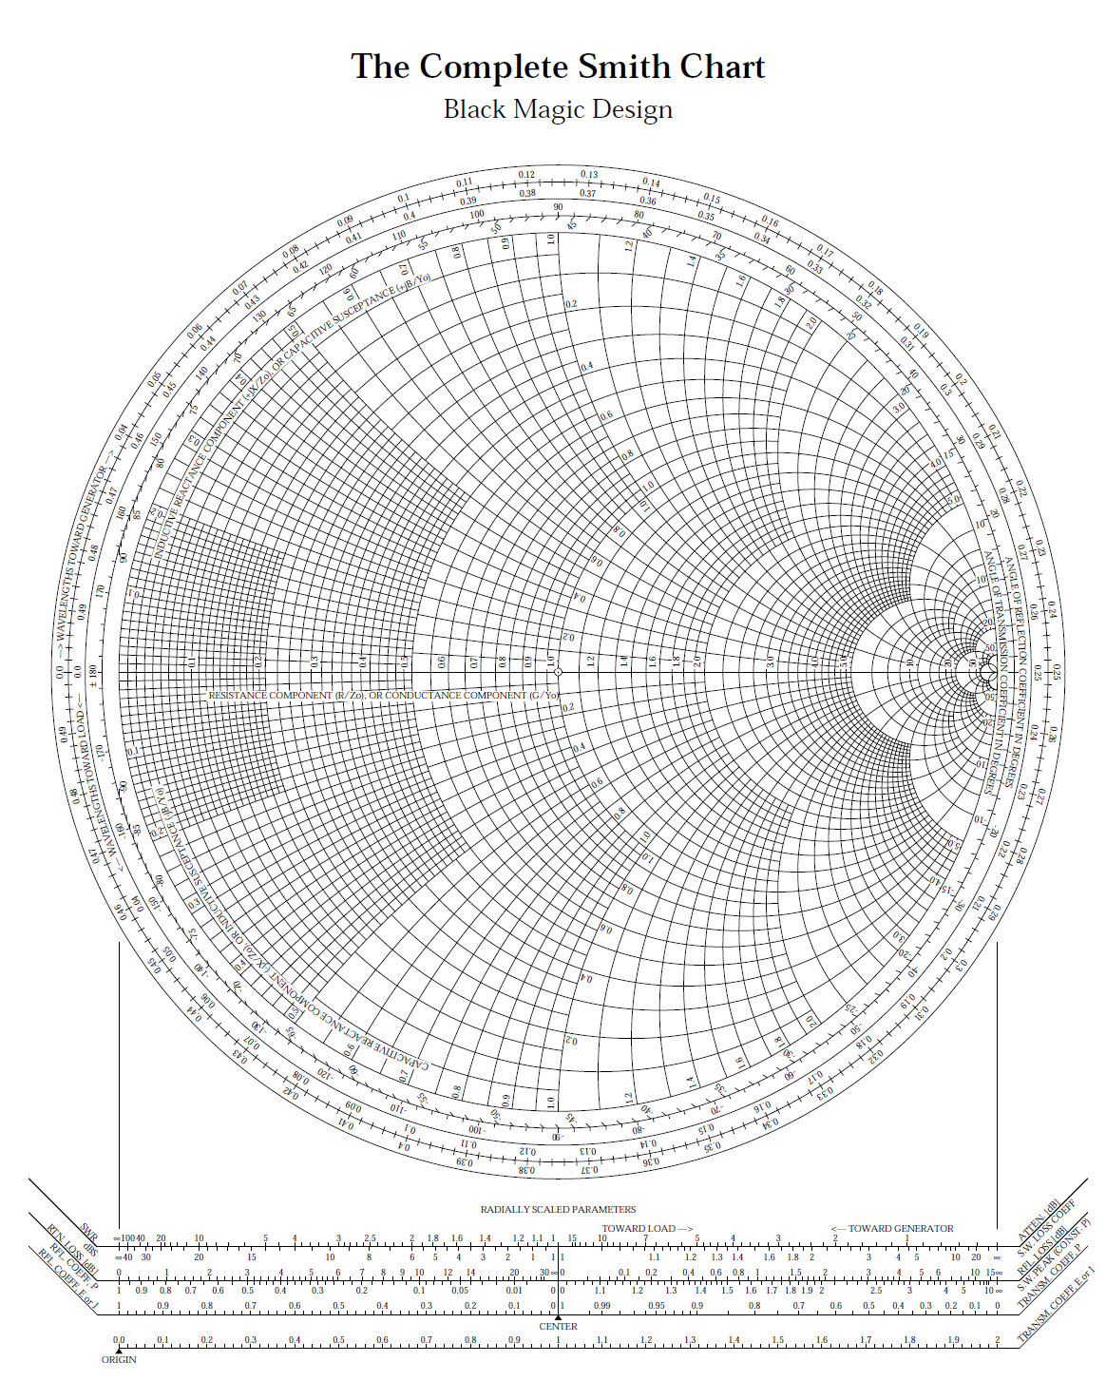Room for work

Problem 3 (30 pts)

Consider the following plane wave that is traveling in air:

.

(a) Find the polarization (linear, circular, or elliptical) and handedness (left-handed or right-handed) for the wave.

(b) Find the axial ratio of this wave.

(c) Find the magnetic field vector for this plane wave.

Room for work