#### ECE 3317

#### Applied Electromagnetic Waves

#### Exam 2

#### Dec. 3, 2020

**General Information:**

The exam is open-book and open-notes. You are not allowed to use any device that has communication functionality (laptop, cell phone, ipad, etc.), except for the computer that you use during for the exam, and this must not be used to communicate in any way with anyone other than the instructor during the exam. 

**Remember, you are bound by the UH Academic Honesty Policy during the exam!**

**Instructions:**

* Please make sure that you have your camera active at all times during the exam.
* Be prepared to share your screen with the instructor at any time if requested to do so.
* The exam will be in three parts (three problems). For each one, you will have 25 minutes to do the problem, and 5 minutes to scan your solution, convert it to a pdf file, and upload it on Blackboard. Each exam problem will be placed on Blackboard on a page called “Exam 2” at the time you are to begin on each part (2:30 pm, 3:00 pm, 3:30 pm). The upload links for the different parts of the exam will also be on this page.
* If you need to ask any questions, please chat in private with the instructor (not to everyone!)
* If you have any problems with the upload of one of the exam parts, please notify the instructor by private chat immediately and email your pdf file to the instructor (djackson@uh.edu).
* When you create your pdf file for each exam part (problem), please name your file using the following convention: **Exam 2 Part 1 Smith Mary.pdf**. Please name your file exactly as shown. Put spaces between each word of the file name as shown. Do not put hyphens or underscores between the different words. Capitalize only the first letter of each word in the file name as shown.
* Show all of your work. No credit will be given if the work required to obtain the solutions is not shown.
* Write neatly. You will not be given credit for work that is not easily legible.
* Leave answers in terms of the parameters given in the problem.
* Show units in all of your final answers.
* Circle your final answers.
* Double-check your answers. For simpler problems, partial credit may not be given.
* If you have any questions, ask the instructor. You will not be given credit for work that is based on a wrong assumption.
* Make sure you sign the academic honesty statement below.

**Academic Honesty Statement**

By taking this exam, you agree to abide by the UH Academic Honesty Policy during this exam. You understand and agree that the punishment for violating this policy will be most severe, including getting an F in the class and getting expelled from the University.

Problem 1 (30 pts)

A coaxial cable has an inner radius of [mm] and an outer radius of  [mm]. The coax is filled with (nonmagnetic) Teflon having  and . The conductors are made of copper, having a conductivity of [S/m]. The copper conductors are nonmagnetic ().

a) Find the attenuation constant  in [nepers/m] at a frequency of 100 [MHz].

b) Assume that we are now operating at a frequency where  [nepers/m]. How far along the cable do we have to go so that the signal amplitude is 15 dB smaller than at the beginning?

**ROOM FOR WORK**

**ROOM FOR WORK**

Problem 2 (35 pts)

A transmission line has a characteristic impedance of 50 [Ω]. On the line the voltage maximum is measured as 4.0 [V] and the voltage minimum is measured as 2.0 [V]. The voltage minimum is measured to be at a distance of 0.15 *λ* from the load.

Determine the unknown load impedance by using formulas (do not use the Smith chart).

**ROOM FOR WORK**

**ROOM FOR WORK**

Problem 3 (35 pts)

A microstrip line has a characteristic impedance of 50 [Ω]. The microstrip line meets a load impedance  [Ω]. A stub line also has a characteristic impedance of 50 [Ω]. This stub line is open-circuited at the end. It has a length of  and is placed at a distance of *d* from the load. The stub line is placed so that there is a perfect match on the main line to the left of the stub line. A top view is shown below.

Use the Smith chart to find *d* and  (in terms of the guided wavelength  on the lines). Use the smallest value of *d* possible.

Clearly explain how you are using the Smith chart, and make sure that you attach your Smith chart showing your work. You may use the Smith chart on the next page, or one of your own.



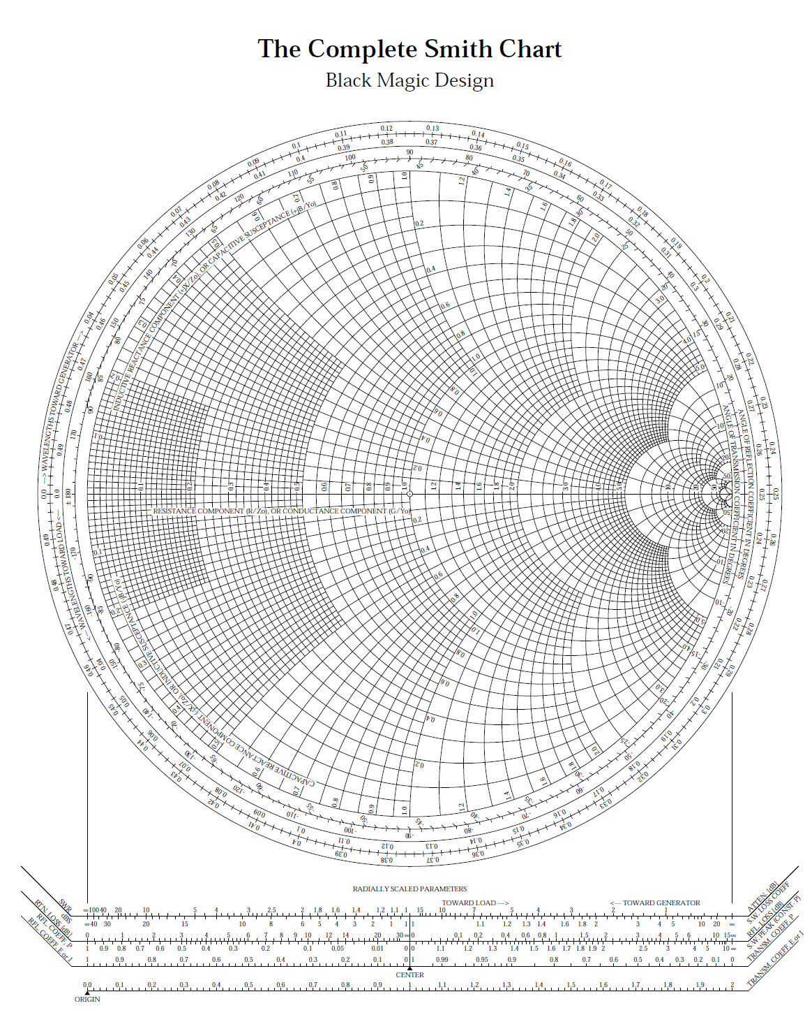

**ROOM FOR WORK**