#### ECE 3317

#### Applied Electromagnetic Waves

#### Final Exam

#### Dec. 13, 2022

**General Information:**

The exam is open-book and open-notes. You are not allowed to use any device that has communication functionality (laptop, cell phone, ipad, etc.). 

**Instructions:**

* Show all of your work. No credit will be given if the work required to obtain the solutions is not shown.
* Write neatly. You will not be given credit for work that is not easily legible.
* Leave answers in terms of the parameters given in the problem.
* Show units in all of your final answers.
* Circle your final answers.
* Double-check your answers. For simpler problems, partial credit may not be given.
* If you have any questions, ask the instructor. You will not be given credit for work that is based on a wrong assumption.
* Make sure you sign the academic honesty statement below.

**Academic Honesty Statement**

By taking this exam, you agree to abide by the UH Academic Honesty Policy during this exam. You understand and agree that the punishment for violating this policy will be most severe, including getting an F in the class and getting expelled from the University.

Signature: __________________________________________

**Problem 1 (20 pts)**

A load on a printed circuit board has an impedance of  [Ω]. We want to match the load to an incoming 50 [Ω] microstrip feed line. To do this we put two identical open-circuited stubs in parallel with the main feed line at a distance of *d* from the load. Each stub has a length of *ls*. The stub lines also have a characteristic impedance of 50 [Ω]. The frequency is 10 [GHz] and the relative effective permittivity of the microstrip lines is 1.75. The distance *d* is chosen to be as short as possible.

a) Design the dimensions *d* and *l­s* (the physical dimensions in mm, cm, or m) using the Smith charts on the next two pages (use one for *d* and one for *l­s*).

b) Find the SWR on the section of microstrip line that is between the load and the stubs.



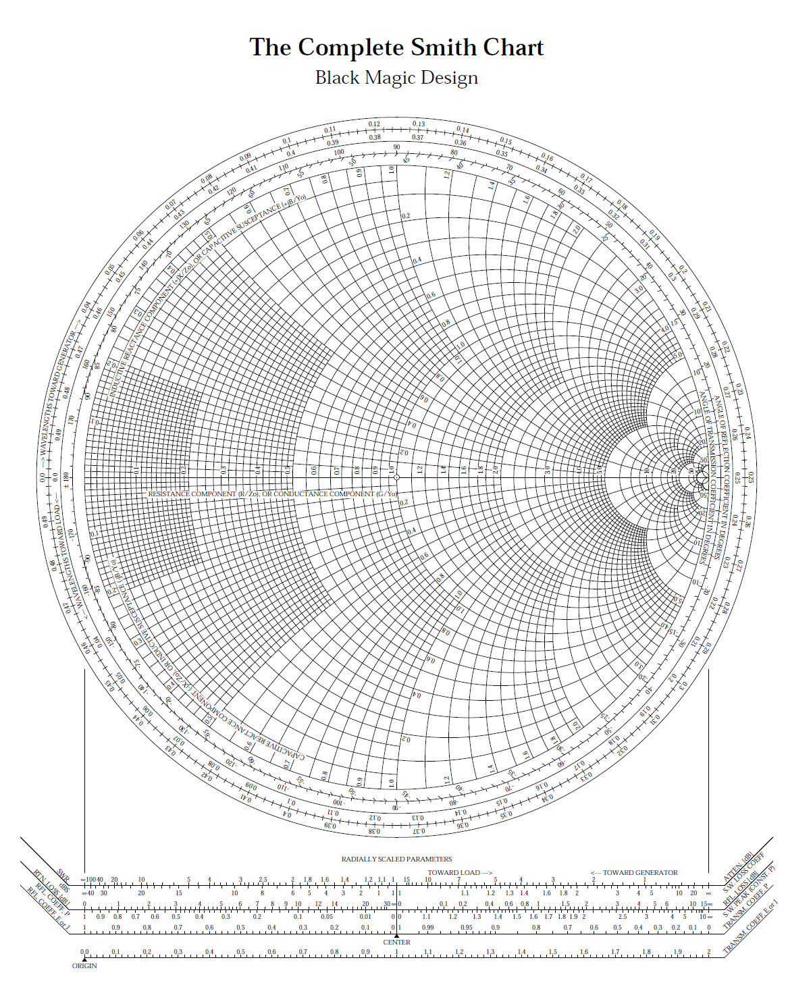**ROOM FOR WORK**



**ROOM FOR WORK**

**Problem 2 (20 pts)**

A microstrip line has a characteristic impedance of 50 [Ω]. At the end of the line is a vertical via (a round wire) that runs between the line and the ground plane below. This via acts as a load for the microstrip line. This vertical via is made of copper (nonmagnetic) with a conductivity *σ* = 3.0×107 [S/m]. The radius of the via is 0.1 [mm] and the vertical length (height) of the via is 1.524 [mm] (the same as the substrate thickness). The frequency is 12 [GHz].

a) Find an equivalent circuit for the via, and give values for the resistance and reactance that appear in your model.

b) Find the reflection coefficient seen by the microstrip line, with the via as the load. It is recommended that you keep at least 5 significant figures in your calculation, to get a reliable answer.

c) If the via were an ideal short circuit, what would the reflection coefficient be?



**ROOM FOR WORK**

**ROOM FOR WORK**

**Problem 3 (20 pts)**

A RHCP wave at 18 GHz from a satellite is incident on the earth, which is assumed to be lossless (and nonmagnetic) with a relative permittivity of 8.0. The RHCP wave is incident at an angle of *θi* = 45o from the vertical.

a) Find the reflection coefficients  and .

b) Calculate the percentage of power in the incident wave that is reflected from the earth.

c) Assume that the polarization ellipse of the reflected wave has a major axis in the TE direction and a minor axis in the TM direction. Also assume that the phase difference between these two components is still 90o (the same as for the incident wave). This is true since both reflection coefficients are real numbers that have the same phase. What is the axial ratio of the reflected wave?



**ROOM FOR WORK**

**ROOM FOR WORK**

**Problem 4 (20 pts)**

a) Design the dimensions *a* and *b* of an air-filled rectangular waveguide that is to be used for transmission of electromagnetic power at 9.0 GHz. This frequency should be at the middle of the operating frequency band, which is the band over which only the TE10 mode can propagate. Choose the height *b* of the waveguide so that it can carry maximum power without sacrificing the bandwidth of the operating frequency band.

b) Assume now that a signal at a frequency of 5.0 [GHz] is inside the same waveguide. What is the attenuation of the signal in dB/m?



**ROOM FOR WORK**

**ROOM FOR WORK**

**Problem 5 (20 pts)**

The Mars Odyssey orbiter (a satellite orbiting mars) is at a distance of 5.0×1010 [m] from earth. Onboard the orbiter is a transmitting dish antenna with a radius of 1.5 [m] and an aperture efficiency of 90%. The antenna is being fed an input power of 35 watts from the power amplifier. NASA is receiving the signal from a large dish antenna on earth that has a radius of 35 [m] (the dish at Goldstone, CA that is part of the Deep Space Network). This antenna also has an aperture efficiency of 90%. The frequency is 18 [GHz]. Assume that both antennas are lossless.

a) Calculate the power density in [W/m2] that is incident on the dish antenna at Goldstone.

b) Assume that the receive dish antenna in Goldstone is connected to a receiver that is a conjugate matched load. How much power (in watts) will be picked up by the receiver?

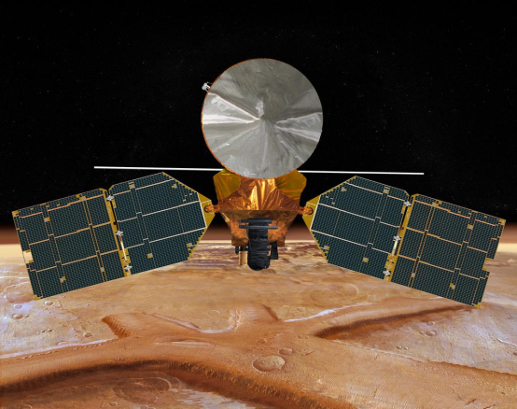



**ROOM FOR WORK**

**ROOM FOR WORK**