#### ECE 3317

#### Applied Electromagnetic Waves

#### Exam 1

#### Oct. 19, 2023

**Name:**  **SOLUTION**

**General Information:**

The exam is open-book and open-notes. You are not allowed to use any device that has communication functionality (laptop, cell phone, ipad, etc.). 

**Remember, you are bound by the UH Academic Honesty Policy during the exam!**

**Instructions:**

* Show all of your work. No credit will be given if the work required to obtain the solutions is not shown.
* Write neatly. You will not be given credit for work that is not easily legible.
* Leave answers in terms of the parameters given in the problem.
* Show units in all of your final answers.
* Circle your final answers.
* Double-check your answers. For simpler problems, partial credit may not be given.
* If you have any questions, ask the instructor. You will not be given credit for work that is based on a wrong assumption.
* Make sure you sign the academic honesty statement below.

**Academic Honesty Statement**

By taking this exam, you agree to abide by the UH Academic Honesty Policy during this exam. You understand and agree that the punishment for violating this policy will be most severe, including getting an F in the class and getting expelled from the University.

Signature: ________________________________________________

Problem 1 (35 pts)

A vertical (*z*-directed) wire antenna radiates a field along the surface of the earth in the *x* direction. Away from the antenna, the fields in the *x* direction are given in the phasor domain as

,

,

where

 and  are constants that are real.

(They are called the intrinsic impedance of free space and the wavenumber of free space.) The constant *E*0 is an arbitrary complex number.

1. Find the electric field vector in the time domain at *x* = *x*0.
2. Find the complex Poynting vector at *x* = *x*0.
3. Find the complex power flowing (in the positive *x* direction) through a rectangular surface *S* that is perpendicular to the *x* axis and is one meter wide in the *y* direction and 2 meters tall in the *z* direction. The surface is located at *x* = *x*0.
4. Find the watts crossing the surface *S* in the positive *x* direction.
5. Find the vars crossing the surface *S* in the positive *x* direction.









**SOLUTION**

**Part a)**

In the phasor domain we have

,

Where *φ* is the phase angle of.

Converting to the time domain, we multiply by  and take the real part. We also note that the phase angle of 1/j (for the second term inside the parenthesis) is . We then have

.

**Part b)**

The complex Poynting vector is



Hence, we have

.

**Part c)**

The complex power flow through the surface *S* (in the positive *x* direction) is then



Or

,

where *A* is the surface area of surface *S*. We then have

.

**Part d)**

The time-average of the instantaneous power flow through the surface *S* (in the positive *x* direction) is then given by the real part of the complex power. Hence, we have

.

**Part e)**

The reactive power (vars) crossing the surface *S* is given by the real part of the complex power. Hence, we have

.

Problem 2 (30 pts)

A voltage source is applied at the left end of a transmission line as shown below. A plot of the generator voltage  is shown below. The pulse peak is  and the width of the pulse is . The transmission line is filled with Teflon, having a relative permittivity of .

a) Plot the voltage  measured by an oscilloscope that is connected to the line at *z* = 1.0 [m]. Plot to a time of 20 [ns].

b) Plot a snapshot of the voltage on the line at 5 [nS].

Use the graphs on the next page to make your plots. Label all important values of voltage, time, and distance on your plot, so that the pulse amplitude and the start and end times (or locations) of the waveform can be clearly seen.





+

-









**SOLUTION**

(Please make your voltage plots on the next two pages.)

The voltage divider constant is

.

Thus, the peak amplitude of the voltage pulse (sawtooth pulse) is *V*0 /2 = 2 [V].

The reflection coefficient at the load is

.

**a) Oscilloscope trace**

Using the formula from the class notes, we have

.

There are no more terms in the series, since the reflection coefficient from the generator is zero. We also have that

.

Hence, we have

.

Hence, we have



The plot is shown below.

**b) Snapchat**

At 5 [ns] the sawtooth pulse has moved down the line, but has not yet hit the load. The starting point (tip) of the pulse at *t* = 5 [ns] will be at

.

The width of the pulse on the line is

.

Therefore, the left end of the pulse will be *z* = 0.5 [m].

The snapshot is shown below.

**Make your plots here:**

**Part (a)**

5.0



-5.0

0.0







**Make your plots here:**

**Part (b)**

5.0



-5.0

0.0



Problem 3 (30 pts)

A voltage source is applied at the left end of a transmission line as shown below. The transmission line meets a second transmission line, which is then terminated by a load. Each line is filled with a dielectric material having .

A plot of the generator voltage  is shown below. The pulse peak is  and the width of the pulse is .

(a) Make a bounce diagram for this problem, for the left line. Plot to a time of 40 [ns]. Put your bounce diagram on the next page.

(b) Plot the voltage  measured by an oscilloscope that is connected to the first (left) line at a point halfway down the first line (halfway between the generator and the junction). Plot to a time of 20 [ns]. Please use the graph on the page after the bounce diagram to make your voltage plot. Label all important voltage values and important times (start and end times of all pulses) on your plot.







+

-





**SOLUTION**

The transit time on line 1 is

.

The voltage divider constant is

.

Thus, the peak amplitude of the voltage pulse (sawtooth pulse) is *V*0 (2/3) = 2 [V].

The reflection coefficient at the load is

.

However, we don’t care about this if we only plot out to 40 [ns].

The reflection coefficient at the junction is

.

The bounce diagram is shown below. (The red dashed line that is needed for part (b) is also added.)

From the bounce diagram we get the oscilloscope trace for the step function. We then shift it by the width of the pulse, which is 2 [ns], and then subtract to get the oscilloscope trace for the rectangular pulse function.

The plots are shown below. The blue sold line is the original step function response. The dashed blue line is the shifted step function response. The red curve is the difference between the two blue curves (solid minus dashed, which gives us the voltage plot for the rectangular pulse function.

Make your bounce diagram here:

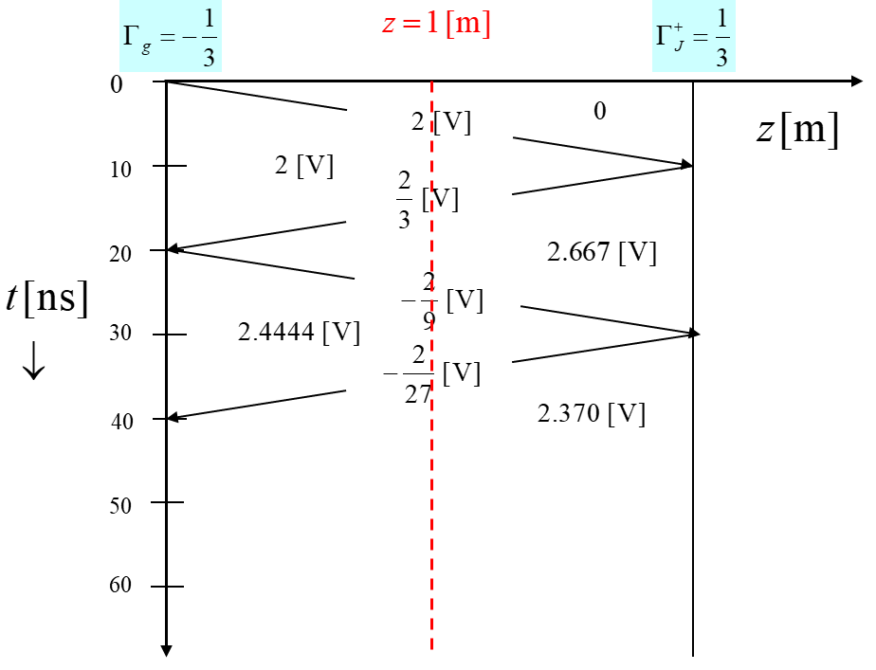

Make your voltage plot here:

5.0



-5.0

0.0





