##### DO NOT BEGIN THIS EXAM UNTIL TOLD TO START

# Name: ____________Solution_______________________

**PeopleSoft ID: ___________________________________**

#### ECE 3317

#### Applied Electromagnetic Waves

**Exam II**

#### Nov. 28, 2018

1. This exam is open book and open notes. However, you are not allowed to use a computer or any electronic device other than a calculator. Any devices that may be used to communicate are not allowed.
2. Show all of your work. No credit will be given if the work required to obtain the solutions is not shown.
3. Perform all your work on the exam in the space allowed.
4. Write neatly. You will not be given credit for work that is not **easily legible**.
5. Leave answers in terms of the parameters given in the problem.
6. Show units in all of your final answers.
7. Circle your final answers.
8. Double-check your answers. For simpler problems, partial credit may not be given.
9. If you have any questions, ask the instructor. You will not be given credit for work that is based on a wrong assumption.
10. Make sure you sign the academic honesty statement on the next page.

**Academic Honesty Statement**

I agree to abide by the UH Academic Honesty Policy during this exam. I understand that the punishment for violating this policy will be most severe, including getting an F in the class and getting expelled from the University.

­­­­­­­­­­­­­­­­­­_______________________________________________

Signature

FORMULA SHEET



























































































































































Problem 1 (30 pts)

A RHCP plane wave at 1.575 GHz from a GPS satellite is incident on the earth. The earth has a relative permittivity of *εr* = 6.0 and is taken as lossless. The angle of incidence is *θi* = 60o. The power density in the incident plane wave from the GPS satellite (at an altitude of 20,200 km) is 10-13 [W/m2].

(a) Calculate the power density in the reflected plane wave.

(b) Calculate the percentage of the reflected power density that is in the TM*z* polarization.

(c) What would the angle of incidence have to be if we wanted no power to be reflected in the TM*z* polarization?

Earth

RHCP

Reflected



Room for work

Answer

**Part (a)**

The reflection coefficients are



.

The power density is

,

where

.

This gives

.

**Part (b)**

We have

.

Hence, we have

.

**Part (c)**

The wave would be incident at the Brewster angle,

.

Hence, we have

.

Problem 2 (40 pts)

A twin-lead transmission line with *Z*0 = 300 [Ω] is connected to a load impedance that is given by *ZL* = 100 - *j*(100) [Ω]. Assume that the frequency is 500 MHz and the effective permittivity of the line is 1.0 (the line is in air). In order to match the line to the load, a shorted-circuited stub with characteristic impedance *Z*0s = *Z*0 is inserted a distance *d* from the load.

Determine the distance *d* using the Smith chart that is on the next page (use the smallest *d* possible). Then find the length *l*s of the stub line using the Smith chart that is attached.



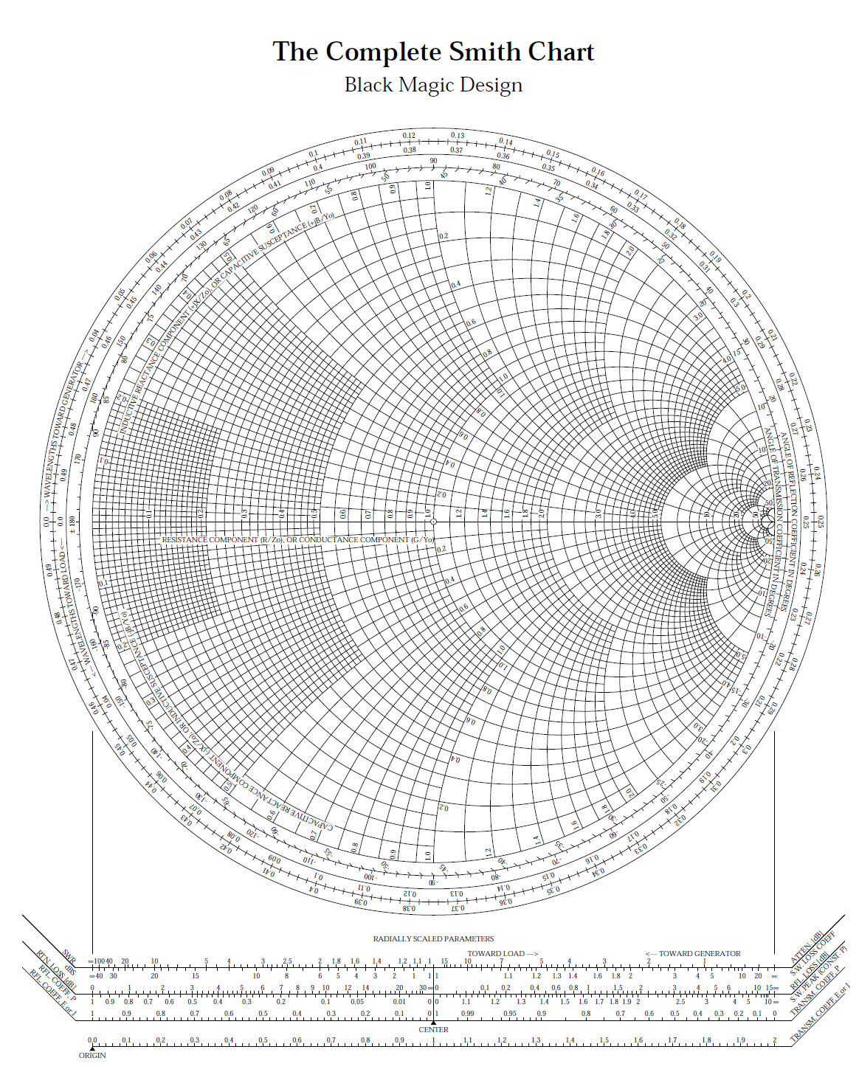Room for work

Answer

The normalized load impedance is

.

The normalized admittance is

.

We stay on a circle of constant radius, and rotate clockwise until we reach the circle . This corresponds to a distance *d* that is

.

At this point, the normalized input admittance is

.

Hence, for the stub we have

.

We find the stub length, we start at the short-circuit position (the right most point on the real axis of the Smith chart when used as ad admittance chart) and rotate clockwise until we reach this normalized admittance. This corresponds to a distance *ls* that is

.

At the frequency of 500 [MHz] we have 

so that

.

Problem 3 (30 pts)

Consider the following plane wave that is traveling in air:

.

(a) Find the polarization (linear, circular, or elliptical) and handedness (left-handed or right-handed) for the wave.

(b) Find the axial ratio of this wave.

(c) Find the magnetic field vector for this plane wave.

Room for work

Answer

**Part (a)**

We can rotate the coordinates so that we have

.

At *z* = 0 we have



.

Plotting these two points in the complex plane, we see that *Ey* leads *Ex*, but not by 90o. Also, the magnitudes are not equal. Thus we have

.

**Part (b)**

We can factor out the (1-*j*3) term to write

.

Hence, we can choose



,

so that

.

We also have



.

This gives us

.

**Part (c)**

Each electric field component of the plane wave has a corresponding magnetic field component, whose amplitude is related by *η*0.

Hence, using

,

we have

.