#### ECE 3317

#### Applied Electromagnetic Waves

#### Exam 2

#### Nov. 30, 2021

**Name: __________SOLUTION__________________________**

**General Information:**

The exam is open-book and open-notes. You are not allowed to use any device that has communication functionality (laptop, cell phone, ipad, etc.). 

**Remember, you are bound by the UH Academic Honesty Policy during the exam!**

**Instructions:**

* Show all of your work. No credit will be given if the work required to obtain the solutions is not shown.
* Write neatly. You will not be given credit for work that is not easily legible.
* Leave answers in terms of the parameters given in the problem.
* Show units in all of your final answers.
* Circle your final answers.
* Double-check your answers. For simpler problems, partial credit may not be given.
* If you have any questions, ask the instructor. You will not be given credit for work that is based on a wrong assumption.
* Make sure you sign the academic honesty statement below.

**Academic Honesty Statement**

By taking this exam, you agree to abide by the UH Academic Honesty Policy during this exam. You understand and agree that the punishment for violating this policy will be most severe, including getting an F in the class and getting expelled from the University.

Signature: _____________________________________

Problem 1 (30 pts)

A coaxial cable has an inner radius of [mm] and an outer radius of  [mm]. The coax is filled with (nonmagnetic) Teflon having  and . The conductors are made of copper, having a conductivity of [S/m]. The copper conductors are nonmagnetic ().

a) Find (*R*, *L*, *G*, *C*) for the coaxial cable at a frequency of 500 [MHz].

b) Find the attenuation constant  in [nepers/m] at a frequency of 500 [MHz].

c) Assume that at 1.0 GHz the attenuation on this line is now 0.5 [nepers/m]. What is the maximum length of cable that we can have if we want to keep the attenuation along the cable to be less than 10 dB?

**Solution**

**Part (a)**









**Part (b)**







**Part (c)**

 → 



Problem 2 (35 pts)

A coaxial cable transmission line has a characteristic impedance of 50 [Ω]. The cable may be assumed to be lossless, and filled with a dielectric material having an unknown relative permittivity. The line is operating at 1.0 GHz.

On this line the magnitude of the voltage is maximum at a distance of 3.0 [cm] from the load, and the magnitude of the maximum voltage is measured as 3.0 [V]. The closest voltage minimum to this voltage maximum point is at a distance of 5.17 [cm] from the voltage maximum, and at this point the magnitude of the voltage is measured to be 1.0 [V].

a) What is the relative permittivity of the dielectric that is filling the coax?

b) Determine the unknown load impedance by using the Smith chart.

For part (b), clearly explain how you are using the Smith chart, and make sure that you attach your Smith chart showing your work. You may use the Smith chart below, or one of your own (it is preferred that you use the one below to reduce the risk of losing your Smith chart).

**Solution**

**Part (a)**

 , 

Hence,



**Part (b)**



 → 





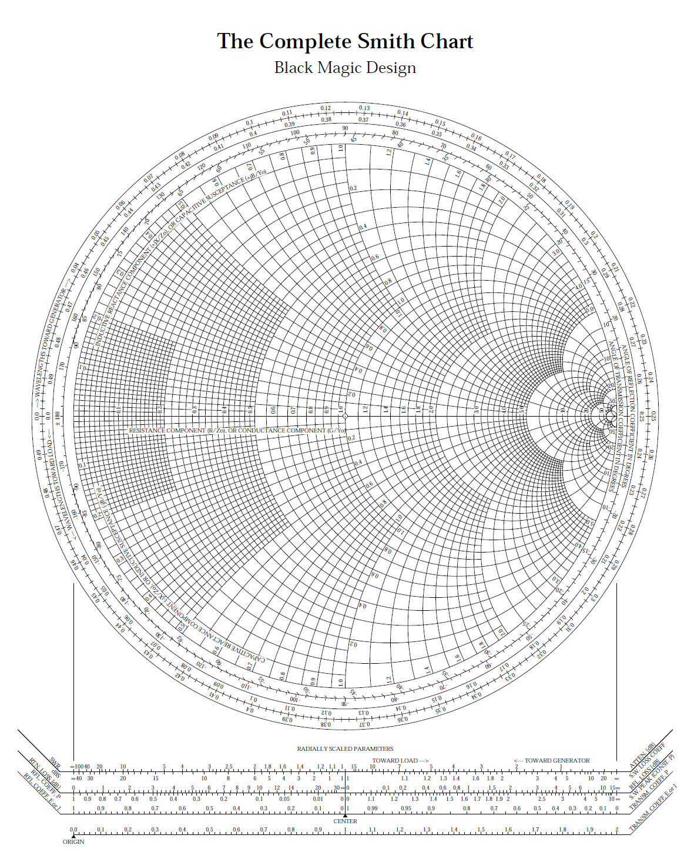 

****Problem 3 (35 pts)

A microstrip line of length *d*1 has a characteristic impedance of  [Ω]. The microstrip line meets a load impedance  [Ω]. The length *d*1 is one-half of a guided wavelength. At the left end of this line a short-circuited stub line (also with a characteristic impedance of 50 [Ω]) is placed in order to make the input impedance at this point purely real. A second line (also with a characteristic impedance of 50 [Ω]) is then placed to the left of the stub, having a length *d*2 that is one-fourth of a guided wavelength. To the left of this second line is a quarter-wave transformer, which transforms the impedance to 50 [Ω].

a) Use the Smith chart to find the length  of the stub line (in terms of the guided wavelength  on the lines). Use the smallest value of  possible.

b) Find the characteristic impedance  of the transformer line.

Clearly explain how you are using the Smith chart, and make sure that you attach your Smith chart showing your work. You may use the Smith chart below, or one of your own (it is preferred that you use the one below to reduce the risk of losing your Smith chart).



**Solution**

Because , the impedance seen looking to the right of the stub line is

.

The normalized impedance at this point is .

The normalized admittance is .

The stub will have

.

This corresponds to a stub length of

.

To the left of the stub we then have



so

.

After the quarter-wave section, we then have

.

The load seen by the transformer is then

.

We then have



so that



