#### ECE 3317

#### Applied Electromagnetic Waves

#### Exam 2

#### Dec. 1, 2022

**Name: _____SOLUTION__________________________________**

**General Information:**

The exam is open-book and open-notes. You are not allowed to use any device that has communication functionality (laptop, cell phone, ipad, etc.). 

**Remember, you are bound by the UH Academic Honesty Policy during the exam!**

**Instructions:**

* Show all of your work. No credit will be given if the work required to obtain the solutions is not shown.
* Write neatly. You will not be given credit for work that is not easily legible.
* Leave answers in terms of the parameters given in the problem.
* Show units in all of your final answers.
* Circle your final answers.
* Double-check your answers. For simpler problems, partial credit may not be given.
* If you have any questions, ask the instructor. You will not be given credit for work that is based on a wrong assumption.
* Make sure you sign the academic honesty statement below.

**Academic Honesty Statement**

By taking this exam, you agree to abide by the UH Academic Honesty Policy during this exam. You understand and agree that the punishment for violating this policy will be most severe, including getting an F in the class and getting expelled from the University.

Signature: _____________________________________

Problem 1 (35 pts)

A microstrip line of length  has a characteristic impedance of  [Ω]. The length  is 0.1 of a guided wavelength on this line. The microstrip line meets a load impedance  [Ω]. At the left end of this line an open-circuited stub line (also with a characteristic impedance of 50 [Ω]) is placed. To the left of this stub line is another section of 50 [Ω] line that has a length  that is one guided wavelength on this line. To the left of this line is a quarter-wave transformer, which transforms the impedance to 50 [Ω], so that the incoming feed line to the left of the transformer sees a match. A top view is shown below.

a) Use the first Smith chart below to find the input impedance (in Ohms) seen looking to the right, at a point that is just to the right of the stub line.

b) Use the same first Smith chart to find the SWR on the line that is connected to the load.

c) Use the second Smith chart below to find the length  of the stub line (in terms of the guided wavelength  on the 50 [Ω] stub line). Use the smallest value of  possible.

d) Find the characteristic impedance  of the transformer line.

Clearly explain how you are using the Smith charts.



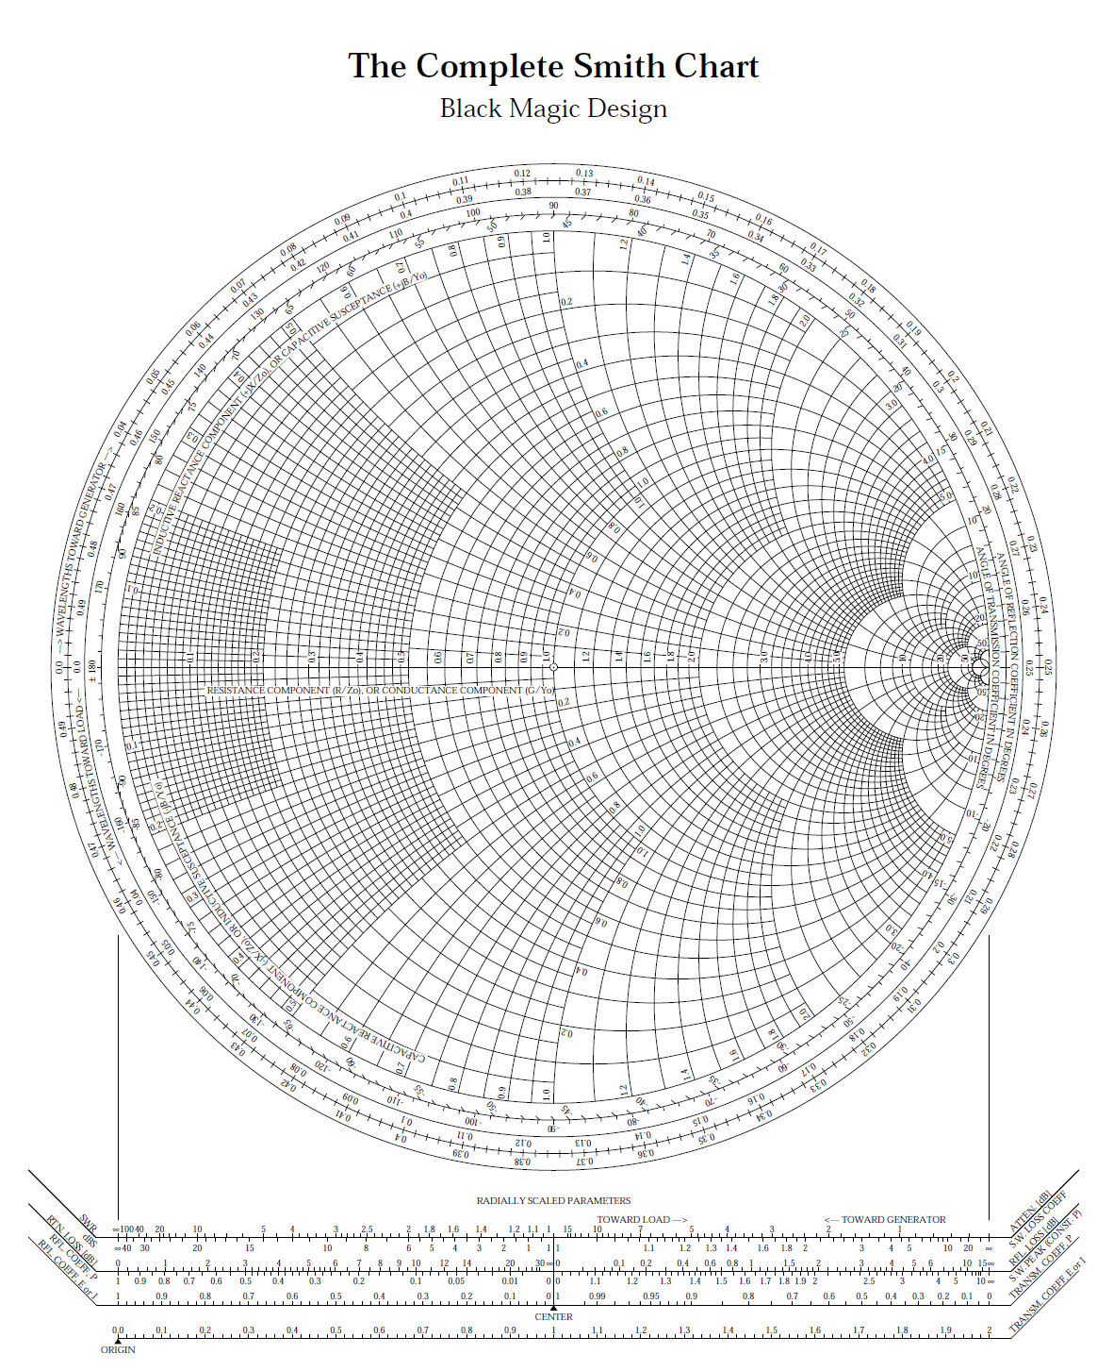







**SOLUTION**

**Part (a)**

From the Smith chart,

.

Hence,

.

**Part (b)**

From where the SWR circle intersects the positive real axis, we see that

.

**Part (c)**

From the Smith chart (going halfway around), we have

.

Therefore,

.

From the second Smith chart we then have

.

**Part (d)**

We have, just to the left of the stub line,



so

.

We then have

.

We then have

.

Problem 2 (35 pts)

A plane wave in air is incident vertically on the ocean at 18 GHz. The plane wave is polarized with the electric field in the *x* direction. The relative permittivity of the ocean water at this frequency is . The ocean water also has a conductivity of  [S/m]. The ocean water is nonmagnetic.

a) Find the complex relative effective permittivity  of the ocean water.

b) Find the loss tangent of the ocean water.

c) Find the attenuation in [dB/m] in the ocean water.

d) Find the percentage of power that gets reflected from the surface of the ocean.

Note: In part (d) it doesn’t matter if you take the wave to be TM or TE, since they are the same for vertical incidence.



**SOLUTION**

**Part (a)**

We have



so

.

This gives us

.

**Part (b)**

The loss tangent is

.

Hence, we have

.

**Part (c)**

The wavenumber of the seawater is

.

This gives us



The attenuation is thus

.

Multiplying by 8.686, we then have



**Part (d)**

Because of the vertical incidence (), we have



.

Hence,

.

This gives us

.

The percent power reflected is

.

This gives us

.

That is, 61.46% of the incident power is reflected.

Problem 3 (30 pts)

A plane wave in air has the following electric field:

.

(a) Classify the polarization of this wave (linear, LHCP, RHCP, LHEP, RHEP).

(b) Find the axial ratio of this wave.

(c) Find the magnetic field for this wave.

**SOLUTION**

**Part (a)**

At *z* = 0 we have

.

Normalizing (dividing by 1+*j*), we can write



or

.

Hence *Ey* lags *Ex*. In time, the wave therefore rotates from the *x* axis to the *y* axis. The wave propagates in the +*z* direction. Hence, the wave is left-handed. Since the magnitude of *Ey* and *Ex* are not equal, and the phase difference is not ±90o, the wave is not circularly-polarized.

Hence, we have

.

**Part (b)**

We have



.

This gives us

.

We have

.

From this we get

.

**Part (c)**

The magnetic field is found the components of the electric field, noting that each component of the magnetic field comes from the corresponding perpendicular component of the electric field after dividing by given by *η*0. In particular,

.

We then have

.

**ROOM FOR WORK**