#### ECE 3317

#### Applied Electromagnetic Waves

#### Exam 2

#### Nov. 30, 2023

**Name: SOLUTION**

**General Information:**

The exam is open-book and open-notes. You are not allowed to use any device that has communication functionality (laptop, cell phone, ipad, etc.). 

**Remember, you are bound by the UH Academic Honesty Policy during the exam!**

**Instructions:**

* Show all of your work. No credit will be given if the work required to obtain the solutions is not shown.
* Write neatly. You will not be given credit for work that is not easily legible.
* Leave answers in terms of the parameters given in the problem.
* Show units in all of your final answers.
* Circle your final answers.
* Double-check your answers. For simpler problems, partial credit may not be given.
* If you have any questions, ask the instructor. You will not be given credit for work that is based on a wrong assumption.
* Make sure you sign the academic honesty statement below.

**Academic Honesty Statement**

By taking this exam, you agree to abide by the UH Academic Honesty Policy during this exam. You understand and agree that the punishment for violating this policy will be most severe, including getting an F in the class and getting expelled from the University.

Signature: _____________________________________

Problem 1 (40 pts)

1. A microstrip line on a circuit board having [Ω] is connected to a load impedance [Ω]. The frequency is 3.0 GHz and the effective relative permittivity of the line is . Find the location of the first voltage minimum on the line (i.e., the one that is closest to the load). Do not use the Smith chart.
2. A microstrip line on a circuit board having [Ω] is connected to a load . The frequency is 5.0 GHz. One voltage minimum occurs at [cm]. The voltage maximum that is closest to this voltage minimum (going away from the load) is located at [cm]. Find the effective relative permittivity of the line. Do not use the Smith chart.
3. A microstrip line on a circuit board having [Ω] is connected to an unknown load . The frequency is 4.0 GHz. One voltage minimum occurs at [cm]. The maximum voltage measured on the line is 4.0 [V] and the minimum voltage measured is 2.0 [V]. The effective relative permittivity of the line is . Find the unknown load impedance using the Smith chart (please show your work on the first Smith chart on the following pages).
4. A microstrip line having [Ω] is connected to a load impedance [Ω]. The frequency is 3.0 GHz and the effective relative permittivity of the line is . Find the distance *d* in cm (as small as possible) to put a quarter-wave transformer and the characteristic impedance  of the transformer to get a matched system (see the figure below). Use the Smith chart for this problem (please show your work on the second Smith chart on the following pages).

**SOLUTION**

**Part (a)**

We use



The normalized load impedance is

.

We therefore have

.

Therefore, we have

.

We also have



This gives us (with *n* = -1)

.

**Part (b)**

The distance between the maximum and nearest minimum is



This is one fourth of a guided wavelength, so that

.

We also know that at 5.0 GHz



Using



gives us

.

**Part (c)**

At 4 GHz, we have

.

Therefore, we have

.

The SWR is 2.0. This defines the “SWR circle” on the Smith chart. Using the Smith chart, we rotate on this circle from the voltage minimum point (on the negative real axis) counterclockwise a distance of 0.26476 wavelengths to get to the unknown load. (This means that rotating clockwise on the Smith chart from the load to the voltage minimum point will but us at the voltage minimum point.)

The Smith chart is shown below. From the Smith chart we have

.

Therefore, we have

.

**Part (d)**

The normalized load impedance is

.

From the Smith chart, we see that the distance is

.

At 3.0 GHz we have

.

Therefore, we have

.

The normalized input impedance on the positive real axis is 3.4. Therefore, the input impedance at this point is

.

We have

.

Therefore, the transformer impedance is

.

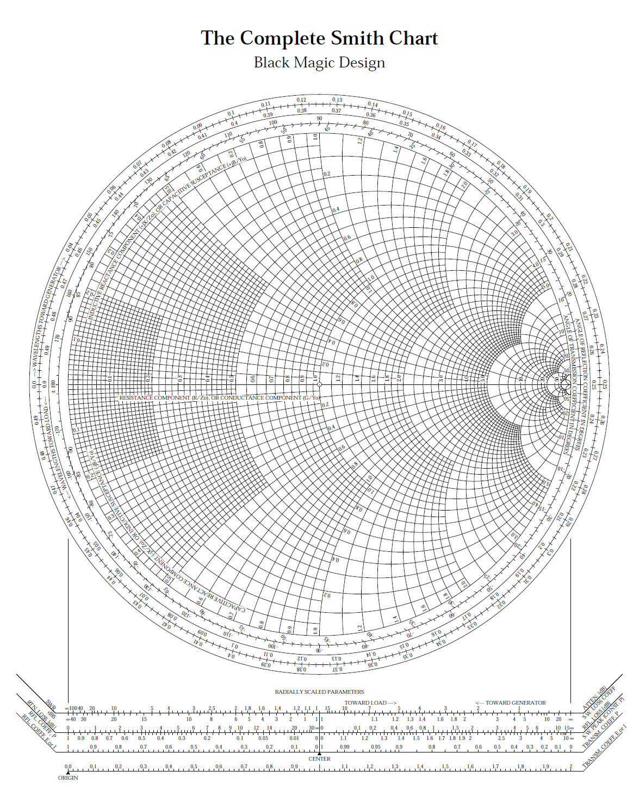







Problem 2 (30 pts)

A plane wave in air is incident on the ocean at 12 GHz. The angle of incidence is . The ocean water at this frequency has a relative permittivity of . The ocean water also has a conductivity  [S/m]. The ocean water is nonmagnetic .

a) Find the reflections coefficients  and .

b) Find the percentage of power that gets reflected from the surface of the ocean if the incoming wave is a circularly polarized wave.

c) Find the attenuation in [dB/m] inside the ocean water in the vertical direction for this wave.



**SOLUTION**

The complex relative effective permittivity is

.

**Part (a)**

From the complex effective permittivity we obtain



**Part (b)**

For the CP wave the percent power reflected is

.

This gives us

.

**Part (c)**

From the complex effective permittivity we have

.

This gives us

.

Multiplying by 8.686, we have

.

Problem 3 (30 pts)

A plane wave in air has the following electric field:

.

(a) Classify the polarization of this wave (linear, LHCP, RHCP, LHEP, RHEP).

(b) Find the axial ratio of this wave.

**SOLUTION**

**Part (a)**

The wave is travelling in the – *y* direction (direction of the thumb). The electric field vector is rotation from the *z* axis towards the *x* axis (fingers). Hence, this is a left-handed wave. The magnitudes of the two components are not equal, so it is not a CP wave.

The wave is LHEP wave.

**Part (b)**

In the rotated coordinate system we have

.

Normalizing (optional), we have

.

From this we have



This gives us



**Note:** We cannot tell from the formulas which title angle it correct. It turns out that the correct value is 116.565o.