#### ECE 3317

#### Applied Electromagnetic Waves

#### Final Exam

#### Dec. 10, 2020

**General Information:**

The exam is open-book and open-notes. You are not allowed to use any device that has communication functionality (laptop, cell phone, ipad, etc.), except for the computer that you use during for the exam, and this must not be used to communicate in any way with anyone other than the instructor during the exam. 

**Remember, you are bound by the UH Academic Honesty Policy during the exam!**

**Instructions:**

* Please make sure that you have your camera active at all times during the exam.
* Be prepared to share your screen with the instructor at any time if requested to do so.
* The exam will be in five parts (five problems, including the bonus). For each one, you will have 25 minutes to do the problem, and 5 minutes to scan your solution, convert it to a pdf file, and upload it on Blackboard. Each exam problem will be placed on Blackboard on a page called “Final Exam” at the time you are to begin on each part. The upload links for the different parts of the exam will also be on this page.
* If you need to ask any questions, please chat in private with the instructor (not to everyone!)
* If you have any problems with the upload of one of the exam parts, please notify the instructor by private chat immediately and email your pdf file to the instructor (djackson@uh.edu).
* When you create your pdf file for each exam part (problem), please name your file using the following convention: **Final Exam Part 1 Smith Mary.pdf**. Please name your file exactly as shown. Put spaces between each word of the file name as shown. Do not put hyphens or underscores between the different words. Capitalize only the first letter of each word in the file name as shown.
* Show all of your work. No credit will be given if the work required to obtain the solutions is not shown.
* Write neatly. You will not be given credit for work that is not easily legible.
* Leave answers in terms of the parameters given in the problem.
* Show units in all of your final answers.
* Circle your final answers.
* Double-check your answers. For simpler problems, partial credit may not be given.
* If you have any questions, ask the instructor. You will not be given credit for work that is based on a wrong assumption.
* Make sure you sign the academic honesty statement below.

**Academic Honesty Statement**

By taking this exam, you agree to abide by the UH Academic Honesty Policy during this exam. You understand and agree that the punishment for violating this policy will be most severe, including getting an F in the class and getting expelled from the University.

Problem 1 (25 pts)

A voltage source is applied at the left end of a transmission line as shown below. A plot of the generator voltage is shown below. The pulse width is  and the pulse voltage is .

a) Construct a bounce diagram for this problem that extends to a time of 16 [ns]. (Make your bounce diagram on the next page.)

b) Make an accurate oscilloscope trace of the voltage *v*(*t*) on the line at . Make your plot on the graph that is given below on the next page, up to a time of 8 [ns]. Label all voltage values on your plot.

+

-



Make your bounce diagram here:



Make your plot here:

5.0

1.0



Problem 2 (25 pts)

A microstrip line has a characteristic impedance of 50 [Ω]. The microstrip line meets a load impedance  [Ω]. A quarter-wave matching transformer is placed at a distance *d* from the load so that a perfect match is seen on the main feed line, which also has a characteristic impedance of 50 [Ω]. A top view is shown below.

a) Use the Smith chart to find *d* (in terms of the guided wavelength *λg* on the microstrip line). Use the smallest value of *d* possible.

b) Find the characteristic impedance of the transformer line .

c) Assume that  for the transformer line. Find the length of the transformer line if the design is at 3.0 GHz.

Clearly explain how you are using the Smith chart, and make sure that you attach your Smith chart showing your work. You may use the Smith chart on the next page, or one of your own.



**Part (a)**



**Part (b)**



**Part (c)**



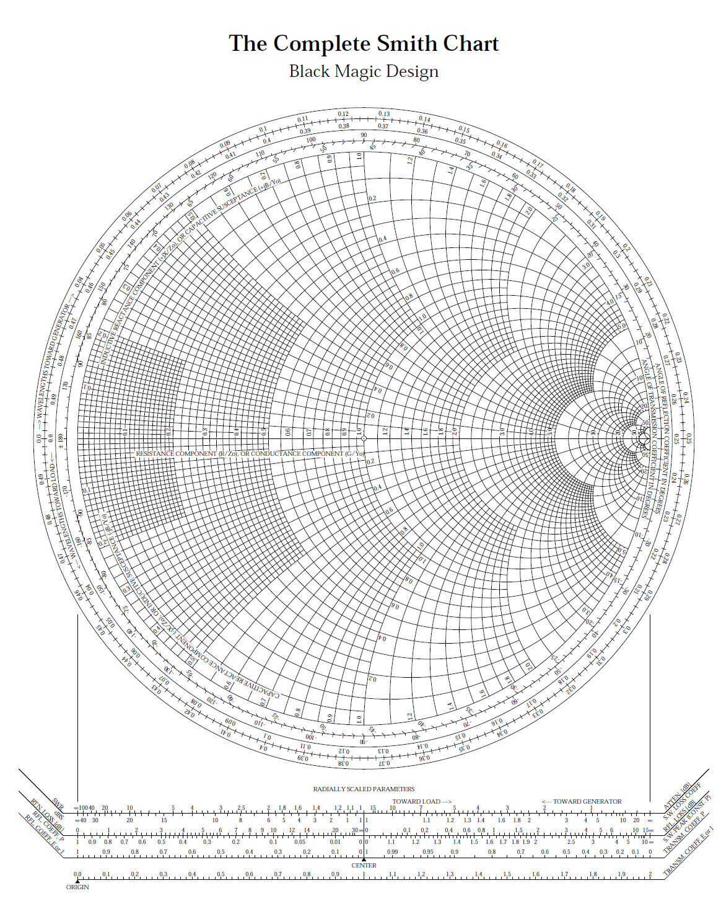



Problem 3 (25 pts)

A laser beam is bouncing inside of a fiber-optic guide (dielectric rod) as shown below. The relative permittivity (dielectric constant) of the rod is , and the rod may be assumed to be lossless. Assume that the angle of incidence is , and the wave is TM*z* polarized. Although the rod is circular, ignore this and assume that the wave reflection and transmission can be modeled as that of a planar boundary.

a) Find the reflection coefficient  as the wave bounces from the bottom edge of the rod.

b) Find the percentage of power that is reflected as the wave bounces from the bottom edge of the rod.

c) Find the distance *d* from the rod boundary where the wave is attenuated by 10 dB from what it is immediately outside the rod. Assume that the wavelength in air is .



**Part (a)**



.

**Part (b)**

.

**Part (c)**





.

Problem 4 (25 pts)

a) Design the dimensions *a* and *b* of an air-filled rectangular waveguide that is to be used for transmission of electromagnetic power at 2.45 GHz. This frequency should be at the middle of the operating frequency band, which is the band over which only the TE10 mode can propagate. Choose the height *b* of the waveguide so that it can carry maximum power without sacrificing the bandwidth of the operating frequency band.

b) An air-filled rectangular waveguide has  [cm] and  [cm]. At 1.0 GHz, find the attenuation of the TE10 mode in dB after a distance of 10 cm in the *z* direction.

**Part (a)**

The operating frequency of 2.45 GHz is halfway between that of the TE10 mode and the TE20 mode. Also, .



.

**Part (b)**





.

Problem 5 (25 pts) (Bonus problem)

A CubeSat is orbiting the earth at an altitude of 300 [km]. Onboard the CubeSat is a microstrip antenna with a gain of 6.0 (7.8 dB). The CubeSat transmits at 2.5 GHz down to earth with a power of 1 [W], where the signal is received by a ground station using a Yagi antenna that has a gain of 30 (14.8 dB). Find the amount of power that a receiver can receive from the Yagi antenna. Assume that the receiver is conjugate matched to the Yagi antenna, there is a perfect polarization match between the transmit and receive antennas, and the Yagi antenna is pointing directly towards the CubeSat (each antenna points toward the other in the direction of its maximum gain). Assume that both antennas are lossless.

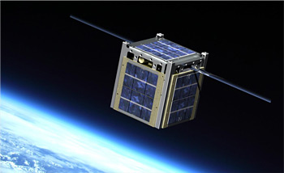

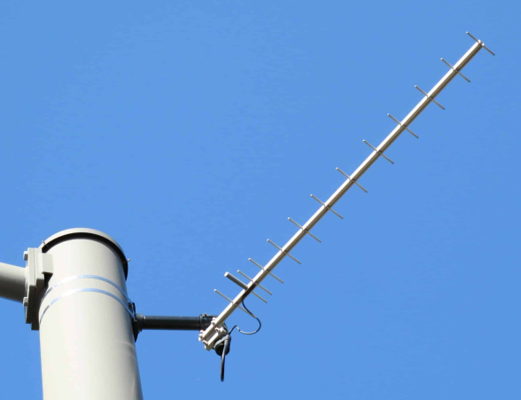

CubeSat in orbit

Yagi antenna on earth

.

Hence we have

.

We can also write this as -97.40 [dBm].