#### ECE 3317

#### Applied Electromagnetic Waves

#### Final Exam

#### Dec. 14, 2021

**General Information:**

The exam is open-book and open-notes. You are not allowed to use any device that has communication functionality (laptop, cell phone, ipad, etc.). 

**Instructions:**

* Show all of your work. No credit will be given if the work required to obtain the solutions is not shown.
* Write neatly. You will not be given credit for work that is not easily legible.
* Leave answers in terms of the parameters given in the problem.
* Show units in all of your final answers.
* Circle your final answers.
* Double-check your answers. For simpler problems, partial credit may not be given.
* If you have any questions, ask the instructor. You will not be given credit for work that is based on a wrong assumption.
* Make sure you sign the academic honesty statement below.

**Academic Honesty Statement**

By taking this exam, you agree to abide by the UH Academic Honesty Policy during this exam. You understand and agree that the punishment for violating this policy will be most severe, including getting an F in the class and getting expelled from the University.

Signature: __________________________________________

Problem 1 (20 pts)

A microstrip line has a characteristic impedance of 50 [Ω]. The microstrip line meets a load impedance  [Ω]. A second microstrip line has a characteristic impedance of 25 [Ω] and meets the first line at a distance *d* from the load. A top view is shown below.

a) Assume that *d* is 3 [cm] and the frequency is 5 [GHz]. Assume that the effective relative permittivity of the 50 [Ω] microstrip line is 1.75. Find the load impedance (in Ohms) seen by the 25 [Ω] microstrip line using the Smith chart.

b) Find the SWR seen on the 25 [Ω] microstrip line using the Smith chart.

It is preferred that you use the Smith chart on the next page.



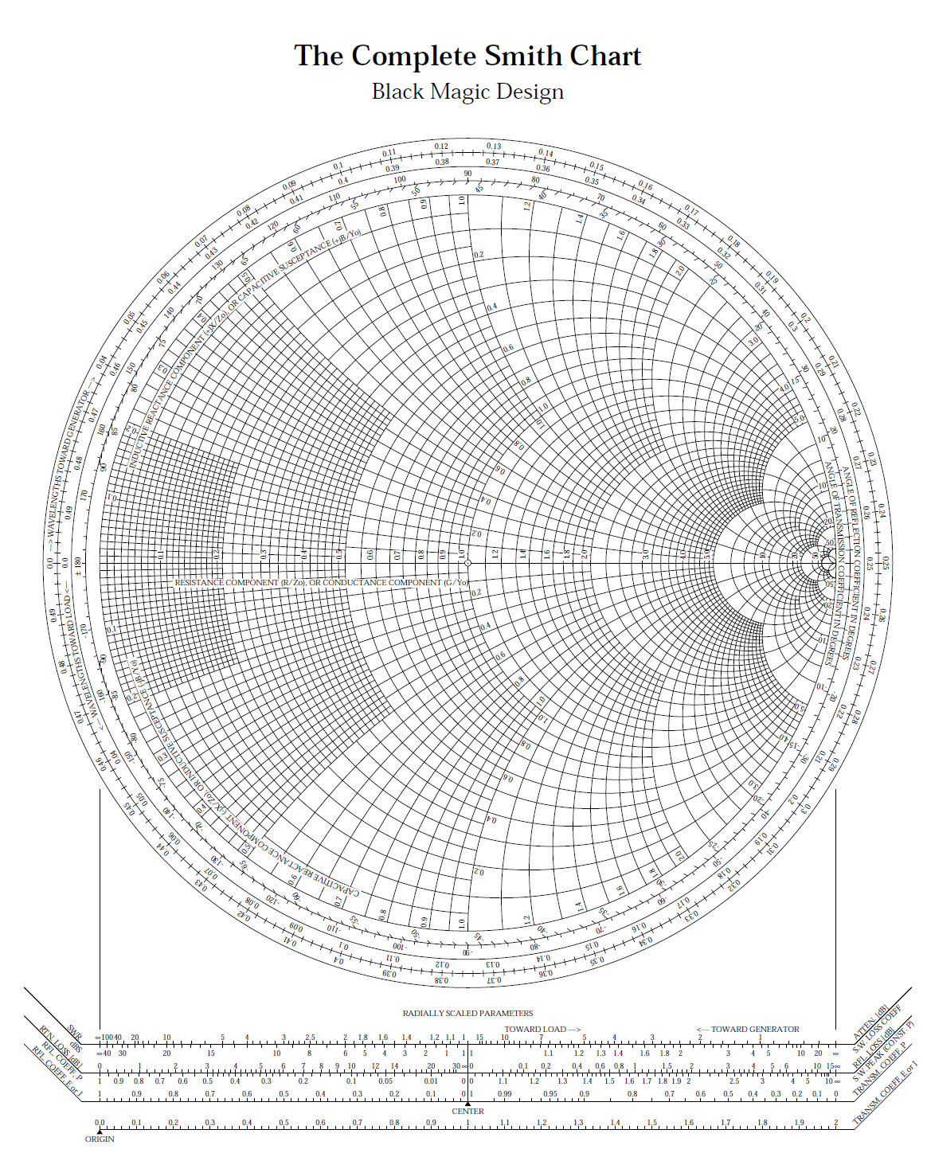**ROOM FOR WORK**



**ROOM FOR WORK**

**Solution**

**Part (a)**

We have



Hence



From the Smith chart we have

.

Hence, we have

.

**Part (b)**

On the 25 Ω line, the normalized load impedance is

.

From the Smith chart we then have

.

Problem 2 (20 pts)

A GPS signal at 1.575 [GHz] is traveling vertically down in the ocean. The ocean water has a relative permittivity of 80 and a conductivity of 4.0 [S/m]. How many dB of attenuation will there be in the signal after it travels one meter in the ocean?



**ROOM FOR WORK**

**Solution**

We have

 .

,

where

.

This gives us



so that



Problem 3 (20 pts)

Sunlight is incident on a puddle of water at an angle of 45o from the vertical. The incident light has equal powers densities in the TM*z* and TE*z* polarizations. The relative permittivity of the water is 1.7689. (The water may be assumed to be lossless here.)

a) Find the reflection coefficients  and .

b) Calculate the percentage of incident power density that is reflected from the puddle.

c) The sunlight now passes through a Polaroid sunglass filter that blocks the TE*z* polarization and lets the TM*z* polarization go through. Calculate the percentage of incident power density that gets through the sunglasses.



**ROOM FOR WORK**

**Solution**

**Part (a)**

We have







From Snell’s law we have

.

This gives us



.

We then have



.

**Part (b)**

****.

Hence, we have



**Part (c)**

We have

****.

Hence, we have

****.Problem 4 (20 pts)

a) Design the dimensions *a* and *b* of an air-filled rectangular waveguide that is to be used for transmission of electromagnetic power at 12.0 GHz. This frequency should be at the middle of the operating frequency band, which is the band over which only the TE10 mode can propagate. Choose the height *b* of the waveguide so that it can carry maximum power without sacrificing the bandwidth of the operating frequency band.

b) An air-filled rectangular waveguide has  [cm] and  [cm]. At 5.0 GHz, find the attenuation of the TE10 mode in dB after a distance of 10 cm in the *z* direction.

**Solution**

**Part (a)**

We have



****.

This gives us



**.**

**Part (b)**



,

with *z* = 0.1 [m].

At 5.0 GHz we have

.

Hence, we have

.

This gives us

.

Problem 5 (20 pts)

A GPS satellite is orbiting the earth at an altitude of 18,000 [km]. Onboard the satellite is a antenna with a gain of 13 dB (*G* = 19.953). The antenna is being fed an input power of 50 watts from the power amplifier.

a) Calculate the power density in [W/m2] that a user on the earth below sees coming from the satellite.

b) Assume that the incident power density from the GPS satellite is now 1.0×10-13 [W/m2]. The signal is being picked up by a receive antenna at the GPS frequency of 1.575 GHz. The receive antenna has a gain of 6 dB (*G* = 3.981). The receive antenna is connected to a receiver that is a conjugate matched load. How much power (in watts) will be picked up by the receiver?



GPS satellite antenna on earth

**Solution**

**Part (a)**

We have

.

Hence, we have

.

**Part (b)**

We have

.

We also have

.

Hence, we have

.