#### ECE 3317

#### Applied Electromagnetic Waves

#### Final Exam

#### Dec. 7, 2023

**Name: _______________________________________**

**General Information:**

The exam is open-book and open-notes. You are not allowed to use any device that has communication functionality (laptop, cell phone, ipad, etc.). 

**Instructions:**

* Show all of your work. No credit will be given if the work required to obtain the solutions is not shown.
* Write neatly. You will not be given credit for work that is not easily legible.
* Leave answers in terms of the parameters given in the problem.
* Show units in all of your final answers.
* Circle your final answers.
* Double-check your answers. For simpler problems, partial credit may not be given.
* If you have any questions, ask the instructor. You will not be given credit for work that is based on a wrong assumption.
* Make sure you sign the academic honesty statement below.

**Academic Honesty Statement**

By taking this exam, you agree to abide by the UH Academic Honesty Policy during this exam. You understand and agree that the punishment for violating this policy will be most severe, including getting an F in the class and getting expelled from the University.

Signature: __________________________________________

**Problem 1 (25 pts)**

A TDR (time-domain reflectometer) has a generator voltage *vg*(*t*) that is a step function with an amplitude of *V*0 volts. The TDR has a 50 [Ω] Thévenin impedance. The TDR is connected to a transmission line with a characteristic impedance of 75 [Ω]. At the end of the line there is a load *RL*. The transmission line is a coax that has a Teflon filling (with a relative permittivity of 2.1). The TDR records the total voltage *v*(0) at *z* = 0, and this is shown in the plot below.

1. What is the length of the line *L* in meters?
2. What is the amplitude *V*0 of the step function ?
3. What is the load resistance ?







**SOLUTION**

**Part (a)**

The speed of the signal is the velocity of light in the dielectric. We have

.

The length of the line is related to the time *td* that the change in the voltage is recorded by the TDR.

.

Solving for *L* we have

.

**Part (b)**

From the voltage divider equation we have

.

Hence,

.

This gives us

.

**Part (c)**

We have

.

Hence, we have



or



or

.

We also have

.

Hence,

.

This gives us

.

**Problem 2 (25 pts)**

A device (load) on a printed circuit board has an input impedance of  [Ω]. We want to match the load to an incoming 50 [Ω] microstrip feed line. To do this we put an open-circuited stub in parallel with the main feed line at a distance *d* = 0.15*λg* from the load. The stub has a length of *ls* and also has a characteristic impedance of 50 [Ω]. A quarter-wave transformer is then placed at a distance of *λg* / 2 from the stub.

The frequency is 5 [GHz] and the relative effective permittivity of the microstrip lines is 1.75.

a) What is the normalized input admittance just to the right of the stub? Use the first Smith chart on the next pages.

b) Design the stub length *l­s* in terms of *λg* . Use the second Smith chart on the next pages.

c) Find the value of  in mm.

d) Find value of the transformer characteristic impedance .









**SOLUTION**

**Part (a)**

From the first Smith chart we have

.

**Part (b)**

From the second Smith chart we have

.

**Part (c)**

We have

.

This gives us

.

**Part (d)**

At a point just to the right of the stub, the normalized input admittance (from the first smith chart) is 0.65. The normalized impedance is then 1 / 0.65 = 1.54. Unnormalized, this corresponds to 76.9 [Ω].

We the have

.

Hence,

.

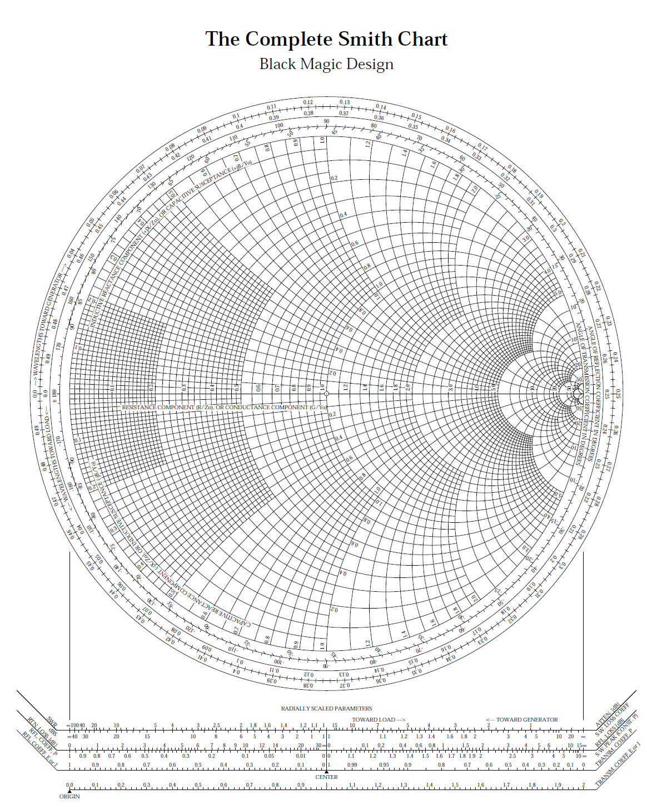**ROOM FOR WORK**





**Problem 3 (25 pts)**

Sunlight is incident on the ocean, which at optical frequencies is assumed to be lossless (and nonmagnetic) with a relative permittivity of 1.7689. The sunlight is randomly polarized, so that it has equal power densities in the TM*z* and TE*z* parts. The incident angle *θi* is 60o. The sunlight reflects off of the ocean and then goes through polarizing sunglasses to reach a person’s eyes. The polarizing sunglasses allow the TM*z* polarization to go through, but they block the TE*z* polarization.

Find the percentage of the incident power density that makes it through the sunglasses, after reflecting off the ocean.



**SOLUTION**

**Part (a)**

The transmitted angle is, from Snell’s law,

.

Only the TM reflected wave makes it thought the sunglasses. Therefore, the percent power that makes it through the sunglasses is (assuming the incident power density is 1.0 [W/m2])

.

We have





.

This gives us



.

**Problem 4 (25 pts)**

a) Design the dimensions *a* and *b* of an air-filled rectangular waveguide that is to be used for transmission of electromagnetic power at 6.0 [GHz]. This frequency should be at the center of the operating frequency band, which is the frequency band over which only the TE10 mode can propagate. Choose the height *b* of the waveguide so that it can carry maximum power without sacrificing the bandwidth of the operating frequency band.

b) Find the power in watts that the waveguide can carry at 6.0 [GHz] if the magnitude of the electric field inside the waveguide is not allowed to exceed a value of *Ec* = 3.0 ×106 [V/m] (the breakdown field strength of air at normal atmospheric pressure).



**SOLUTION**

**Part (a)**

The design frequency should be halfway between the cutoff frequencies of the TE10 mode and the TE20 mode, since *b* = *a*/2. Therefore, we have

.

This gives us

.

We then have

.

Note that

.

**Part (b)**

We use

.

We set .

We also have

.

We then have

.

**Bonus Problem (20 pts)**

A CubeSat satellite orbits the Earth as shown below. It radiates at 3.0 GHz with 2 [W] of power that is input to a dipole antenna that has a gain of *G* = 1.5. A student on earth receives the signal from the CubeSat using a Yagi antenna that has a gain of *G* = 30. The receive antenna (the Yagi) has an input impedance of 50 [Ω] and is connected to a receiver that is modeled as a 50 [Ω] load. The CubeSat is at an altitude of 350 [km]. Both antennas may be assumed to be lossless.

a) Calculate the power received by the receiver circuit that is connected to the Yagi antenna.

b) Calculate the magnitude of the open-circuit (Thévenin) signal voltage of the Yagi antenna.

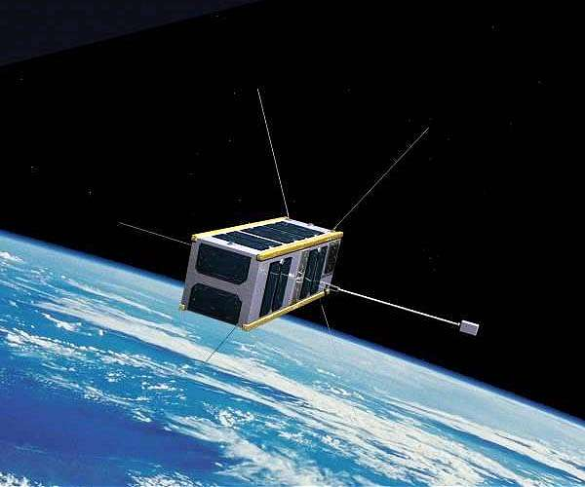

A CubeSat orbiting the Earth.

**SOLUTION**

**Part (a)**

The power received is



Inserting the numbers, we have

.

This gives us

.

**Part (b)**

We have

.

This gives us



so that

.