DO NOT BEGIN THIS EXAM UNTIL TOLD TO START

Name: __________________________________________

Student Number: _________________________________

Instructor: ________________________________________

ELEE 2317

Applied Electricity and Magnetism
Final Exam

Dec. 9, 1999

- This exam is closed book and closed notes. No calculators or computers of any kind are allowed.
- Show all of your work. No credit will be given if the work required to obtain the solutions is not shown.
- Perform all your work on the paper provided.
- Write neatly. You will not be given credit for work that is not easily legible.
- Show units in all of your final answers.
- Circle your final answers.
- If you have any questions, ask the instructors. You will not be given credit for work that is based on a wrong assumption.
- You will have a total of 180 minutes.

_____/20 Prob. 1 _____/20 Prob. 4

_____/20 Prob. 2 _____/20 Prob. 5

_____/20 Prob. 3 _____/20 Prob. 6

Total _______/120
ROOM FOR EXTRA WORK

Problem 1 (20 pts)

A planar sheet of uniform surface charge density 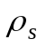[C/m²] is suspended at a height h above a perfectly conducting ground plane, as shown below.

- Determine the electric field vector E in the regions 0 < x < h and x > h.
- Assume that the potential at the ground plane is taken as zero Volts. Calculate the potential function 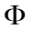 for both regions 0 < x < h and x > h.

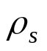
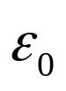
x
h

ROOM FOR EXTRA WORK

Problem 2 (20 pts)

Determine the magnetic field H at the point (x, 0, 0) due to the infinitely long wire with a right-angle bend, as shown below (the wire goes to infinity in the -x and -y directions)

x
y
I
I
(x, 0, 0)

Helpful integral:

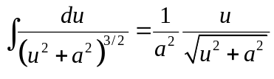
ROOM FOR EXTRA WORK

Problem 3 (20 pts)

Below are listed (in random order) steps for finding the inductance and capacitance per unit length for a coaxial line with a hollow center conductor of radius and a thin outer conductor of radius .

- Determine the stored magnetic energy per unit length.

- Use Gauss's Law to determine the electric field between the conductors (sketch a figure showing the correct Gaussian surface).

- Assume a total current [A] is carried on the surface of the inner conductor and a return current of the same magnitude is carried on the outer conductor.

- Divide the charge per unit length by the potential difference between the conductors.

- Use Ampere's Law to determine the magnetic field between the conductors (sketch a figure showing the correct Amperian path).

- Assume a total effective line charge density of 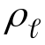[C/m] on the center conductor and 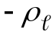 [C/m] on the outer conductor.

- Divide twice the stored magnetic energy per unit length by the current squared.

- Integrate the electric field to obtain the potential difference between the conductors.

- Write in the step number below in the proper order to compute the capacitance per unit length, 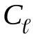, and after each step, carry out the calculation indicated (if any).

Step 1 ______

Step 2 ______

Step 3 ______

Step 4 ______

=________________

- Write in the step number below in the proper order to compute the inductance per unit length, 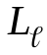, and after each step, carry out the calculation indicated (if any).

Step 1 ______

Step 2 ______

Step 3 ______

Step 4 ______

=________________
Problem 4 (20 pts)
A cylindrical electrolysis tank consists of a cylindrical tank of length L and radius b filled with saltwater, having a conductivity of σ. An inner electrode wire of radius a runs down the center of the tank. A voltage V is placed between this center wire and the tank.

- Derive a formula for the resistance between the center electrode wire and the outside tank.
- Assume a current I emerges from the center wire, spreading equally in all directions along the length of the wire. Determine what the electric field at the surface of the wire is, in terms of I.

V
σ
b
L
I

ROOM FOR EXTRA WORK
Problem 5 (20 pts)

Two rectangular loops are positioned as shown in the figure. The outer loop (loop #1) consists of two wires spaced d apart. Assume that the closure of the outer loop is very far away from the inner loop (loop #2).

Find the mutual inductance between the pair of loops.

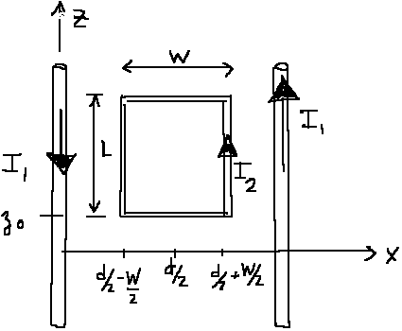

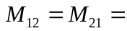____________________________________

ROOM FOR EXTRA WORK

Problem 6 (20 pts)

The space between a parallel-plate capacitor of area A is filled with a dielectric whose permittivity 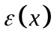 varies linearly from 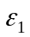 at one plate (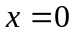) to 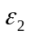 at the other plate (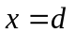). There is no charge density inside the dielectric. The lower plate (x = 0) is at zero Volts, while the upper plate is at V₀ Volts.

- Show that 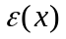can be written as 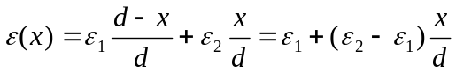.

- Using Gauss’s law and 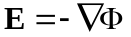, derive the “modified Laplace’s equation”

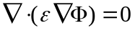

which holds in the charge free region between the plates.

- Assuming the potential varies only with , find an expression for the potential for 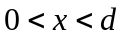.

- Using the results above, find the capacitance of the structure.

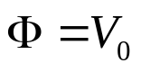
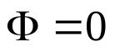
x
d
ε(x)

ROOM FOR EXTRA WORK

