Name: _____________________________ (please print)
Signature: __________________________

ECE 3455 Electronics
Exam #2 – November 6, 1999

DO NOT OPEN THIS QUIZ BOOKLET UNTIL YOU ARE TOLD TO BEGIN

1. This quiz is open book and open notes. Any calculator may be used.
2. You will have 90 minutes to complete this exam.
3. Show all work on these pages. Show all work necessary to complete the problem. If your work goes on to another page, indicate this with a note. A solution without the work shown will receive no credit.
4. Use appropriate notation.
5. Show units in all answers and in all major intermediate results. Units in the exam questions will be enclosed in square brackets.
6. Do not use red ink. Do not use red pencil.

1) ______________/35
2) ______________/35
3) ______________/30
4) ______________/10

Room for extra work
1) (35 Points) You may assume that all of the op amps are ideal. You may assume that op amp #1 has negative feedback. Find the voltage gains for
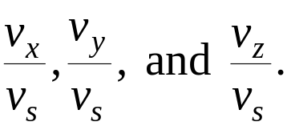
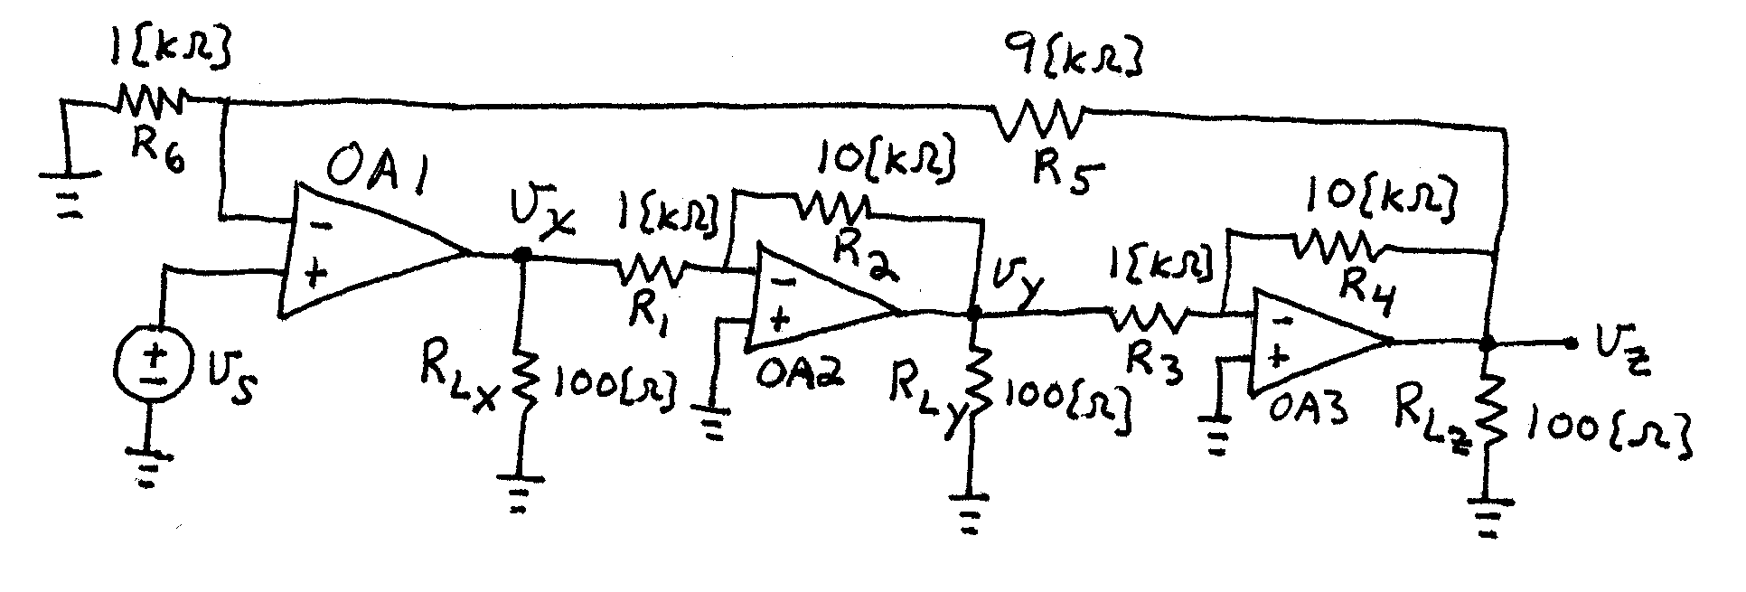
ROOM for Extra Work
2. (35 Points) Assume a piecewise linear diode model for all the diodes. Use the parameters V_{f} = 1[V], r_{d} = 100[Ω], and I_{s} = 1[mA]. Find V_{O}. State your assumptions, and test them, showing your test steps explicitly. Remember that you will be graded on the process that you follow in solving this circuit. I expect that you will be able to complete at least 2 guesses in the time allowed.
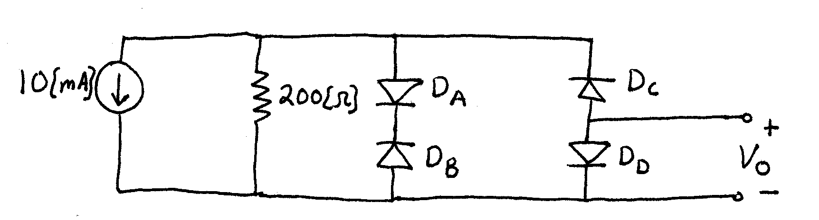
Room for Extra Work
3) (30 Points) The transistors in the circuit below have β = 200, and are operated at room temperature. Find the dc values of V₁ and V₂. State your assumptions, and test them, showing your test steps explicitly. Remember that you will be graded on the process that you follow in solving this circuit. I expect that you will be able to complete at least 1 guess in the time allowed.
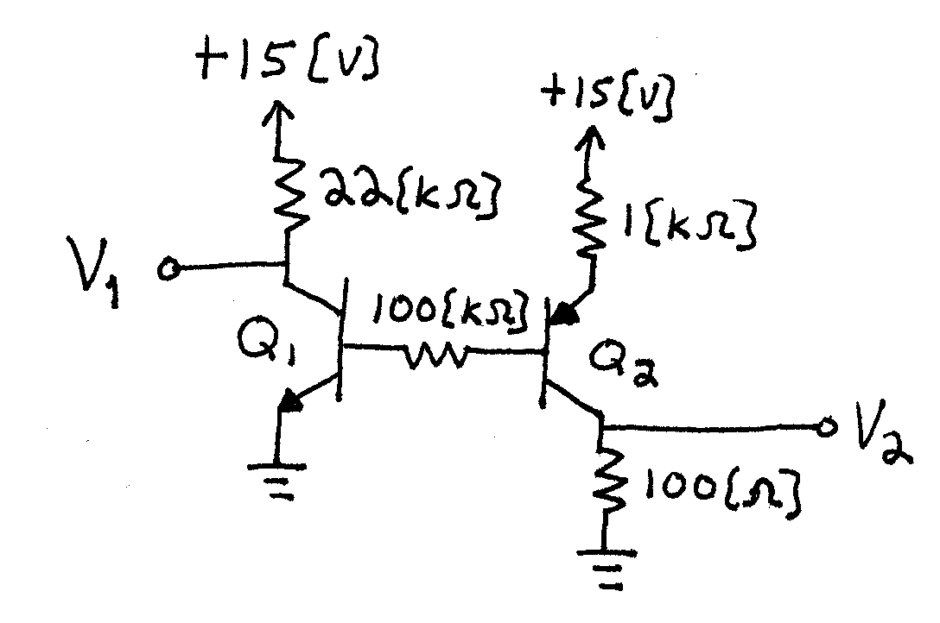
Room for Extra work

4) (10 Points) Assume an ideal op amp. Assume an ideal diode. The transistor in the circuit below is a power transistor with high current capability and has a β = 20. It is also given that
V_{S} = -5[V].
a) Find I₂.
b) Find I₁.
c) Considering the values of I₂ and I₁, what do you think is the point of including the transistor in this circuit?
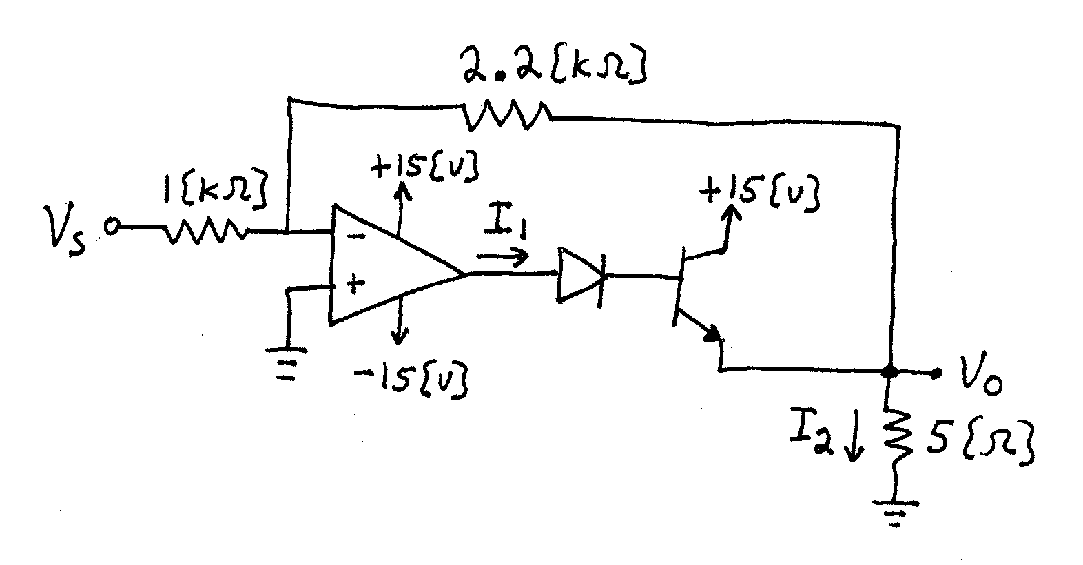
Room for Extra Work
1) (35 Points) You may assume that all of the op amps are ideal. You may assume that op amp #1 has negative feedback. Find the voltage gains for

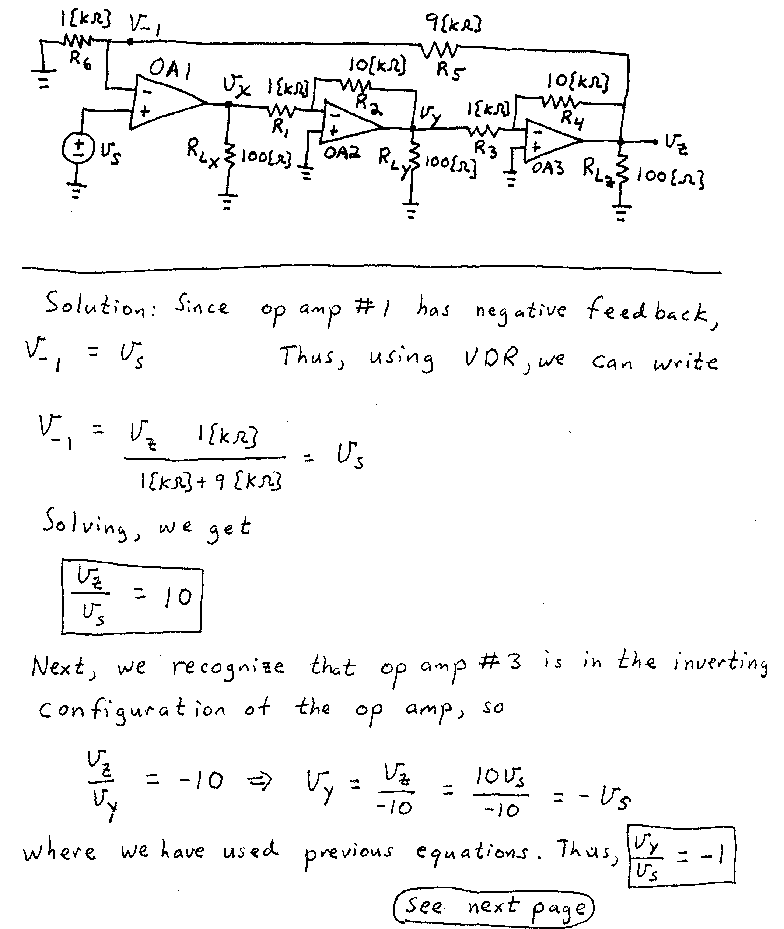
ROOM for Extra Work
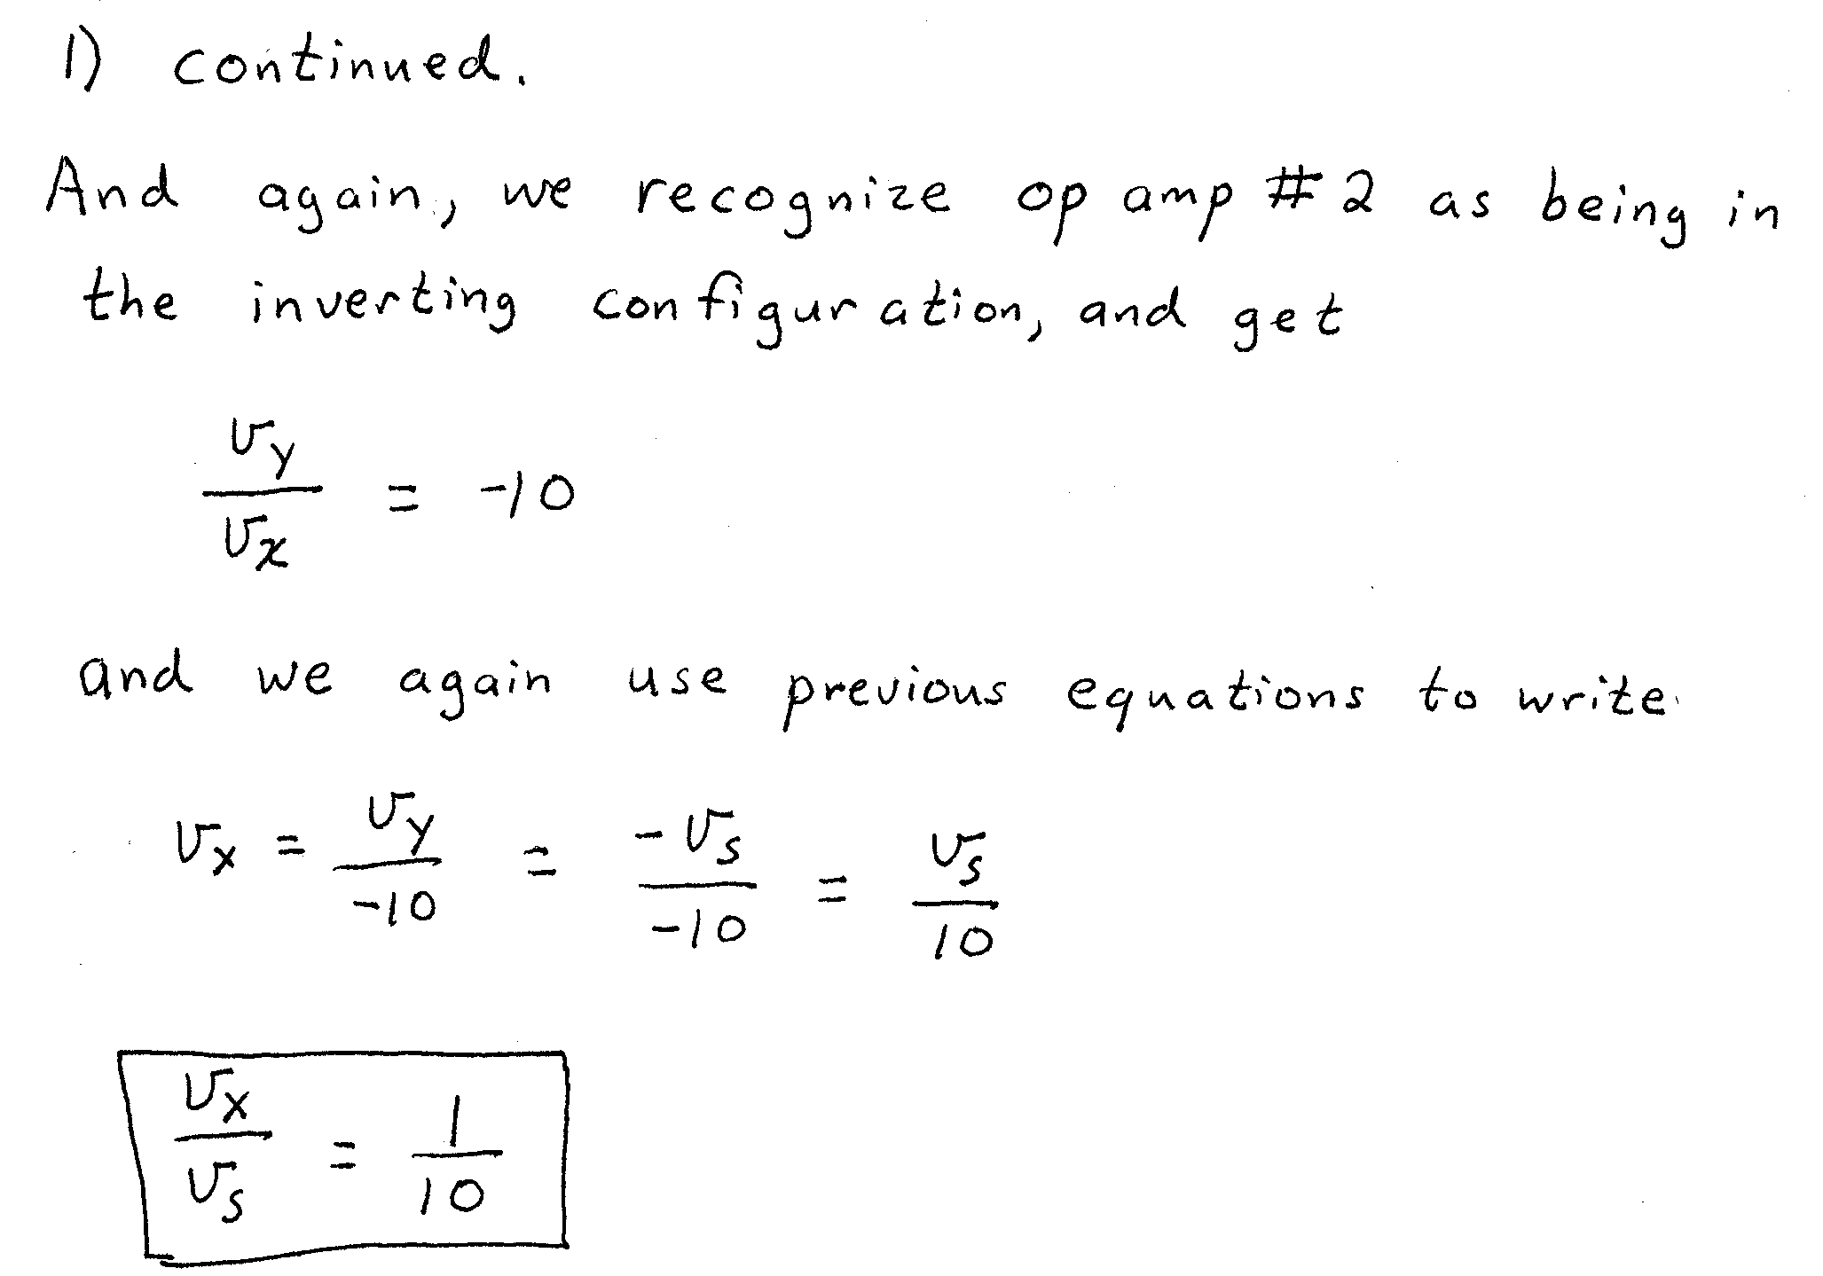
2. (35 Points) Assume a piecewise linear diode model for all the diodes. Use the parameters V_{f} = 1[V], r_{d} = 100[Ω], and I_{s} = 1[mA]. Find V_{O}. State your assumptions, and test them, showing your test steps explicitly. Remember that you will be graded on the process that you follow in solving this circuit. I expect that you will be able to complete at least 2 guesses in the time allowed.
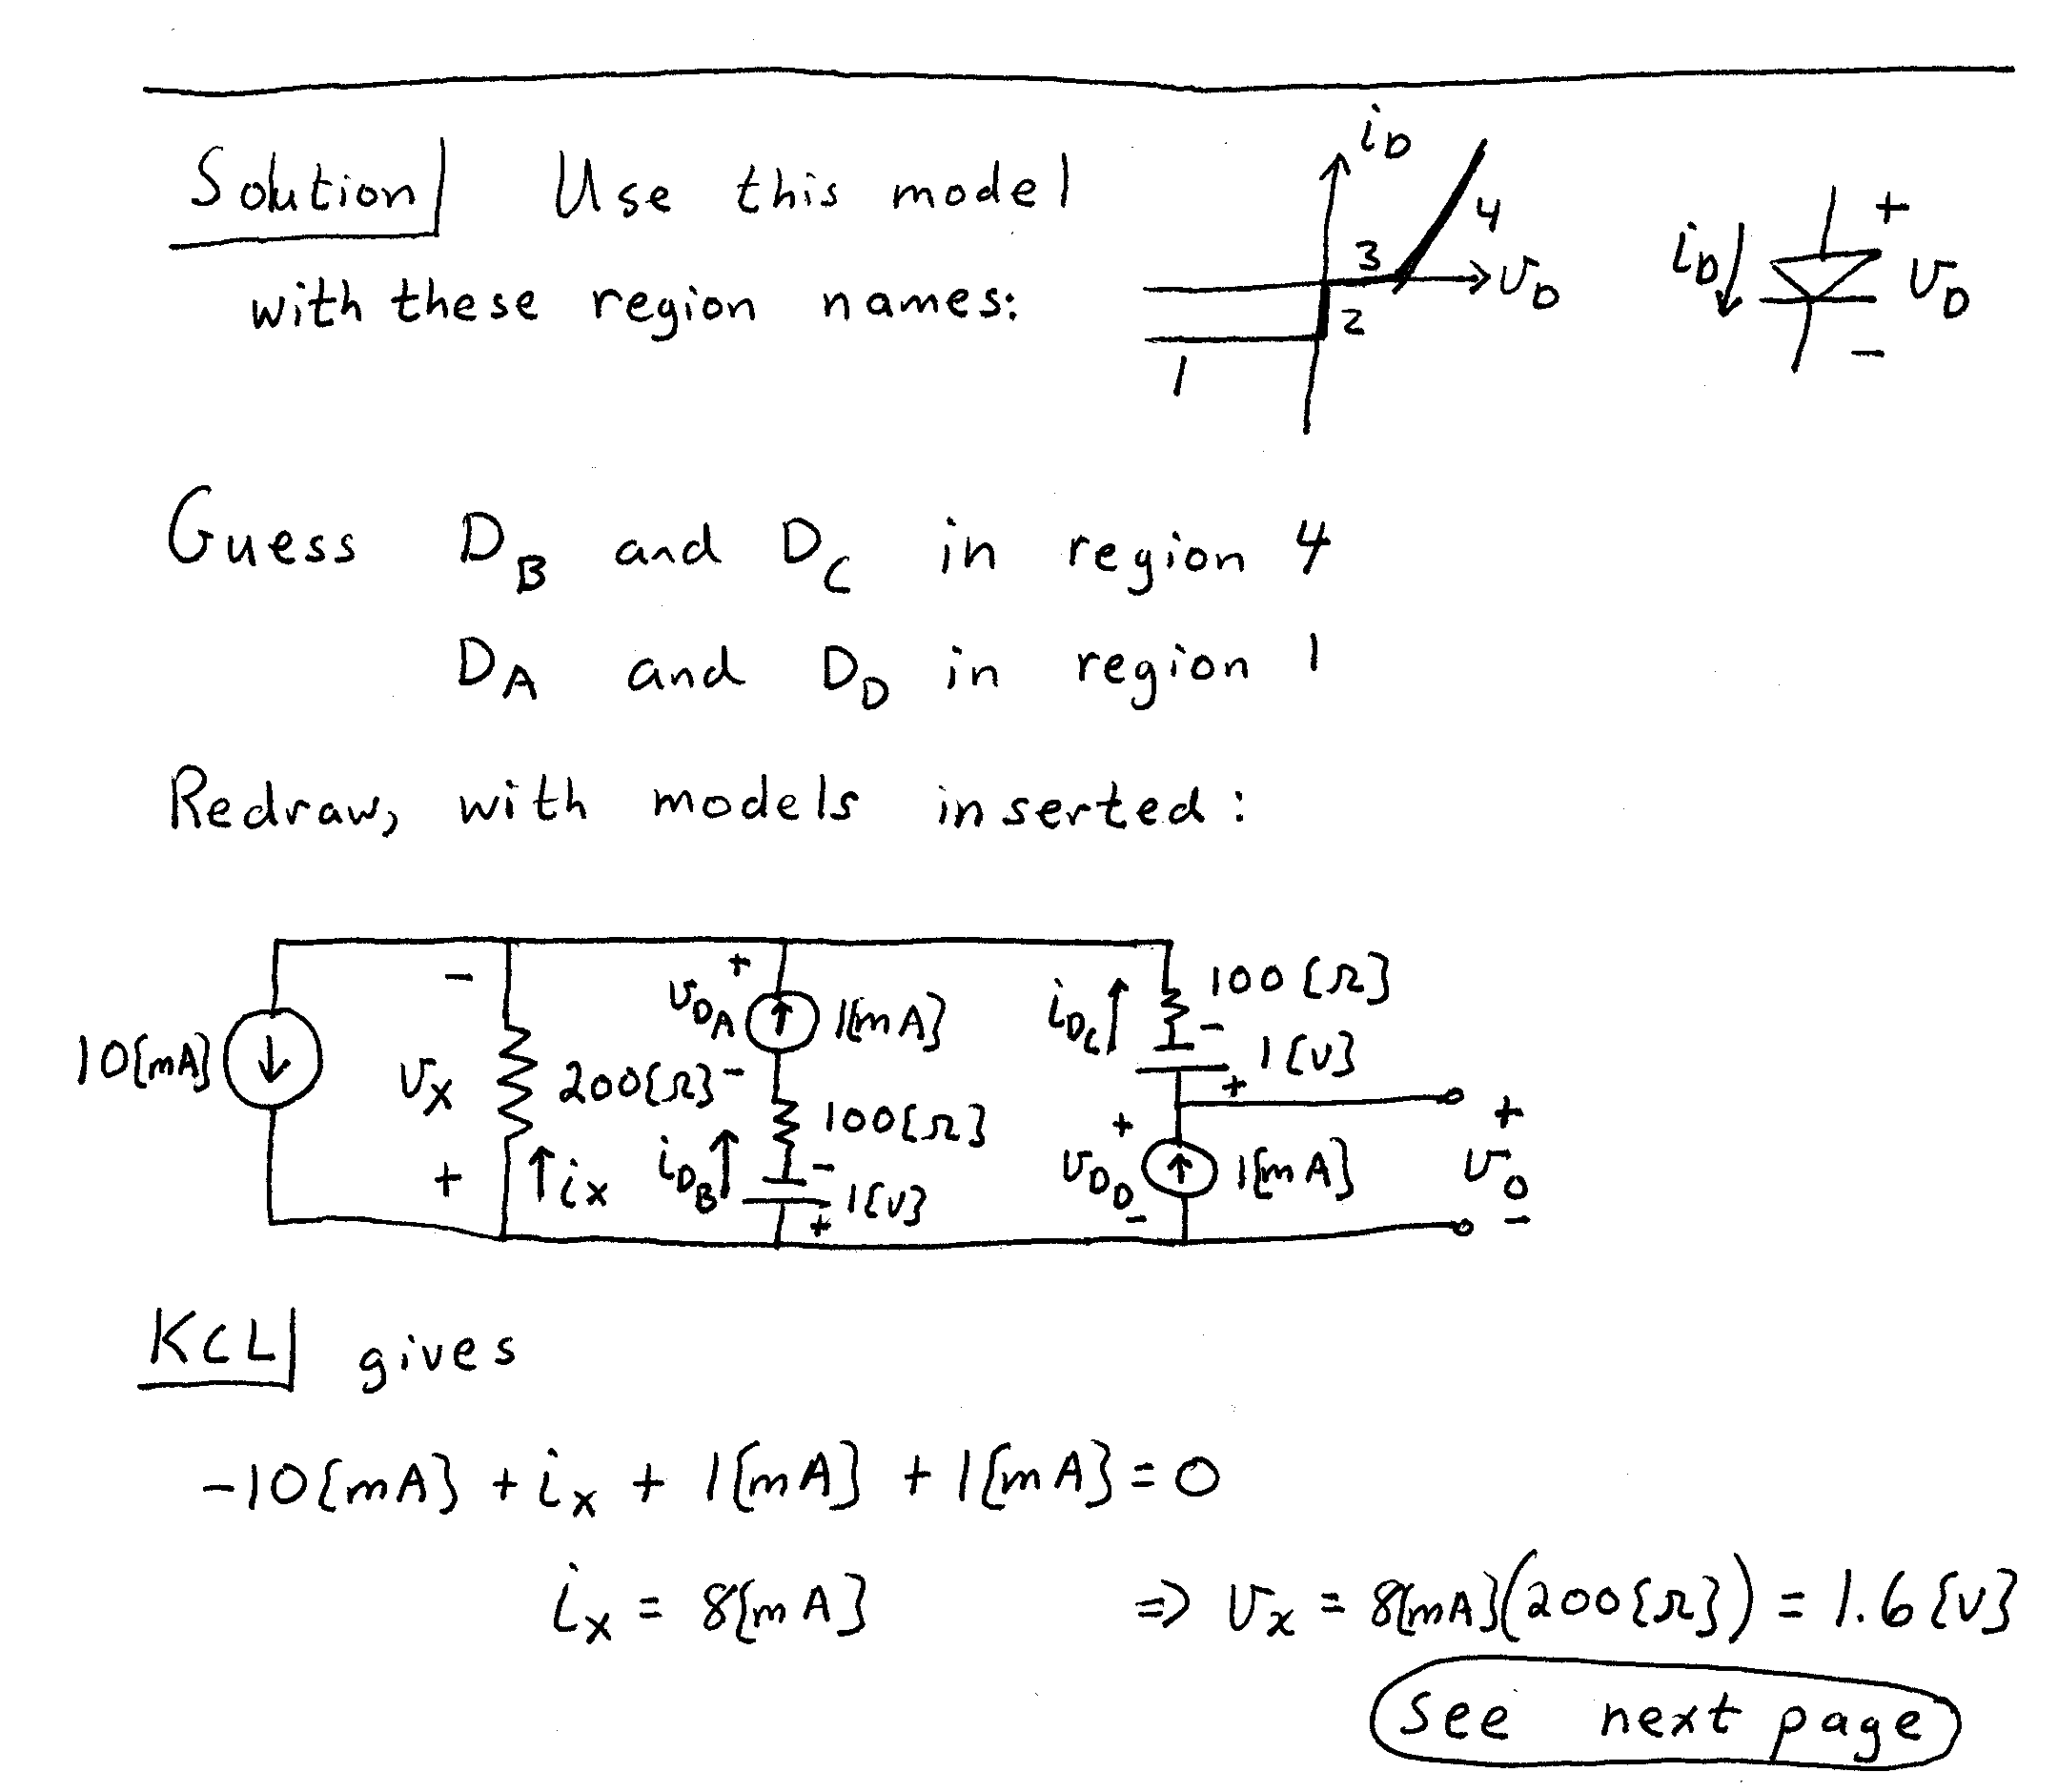
Room for Extra Work
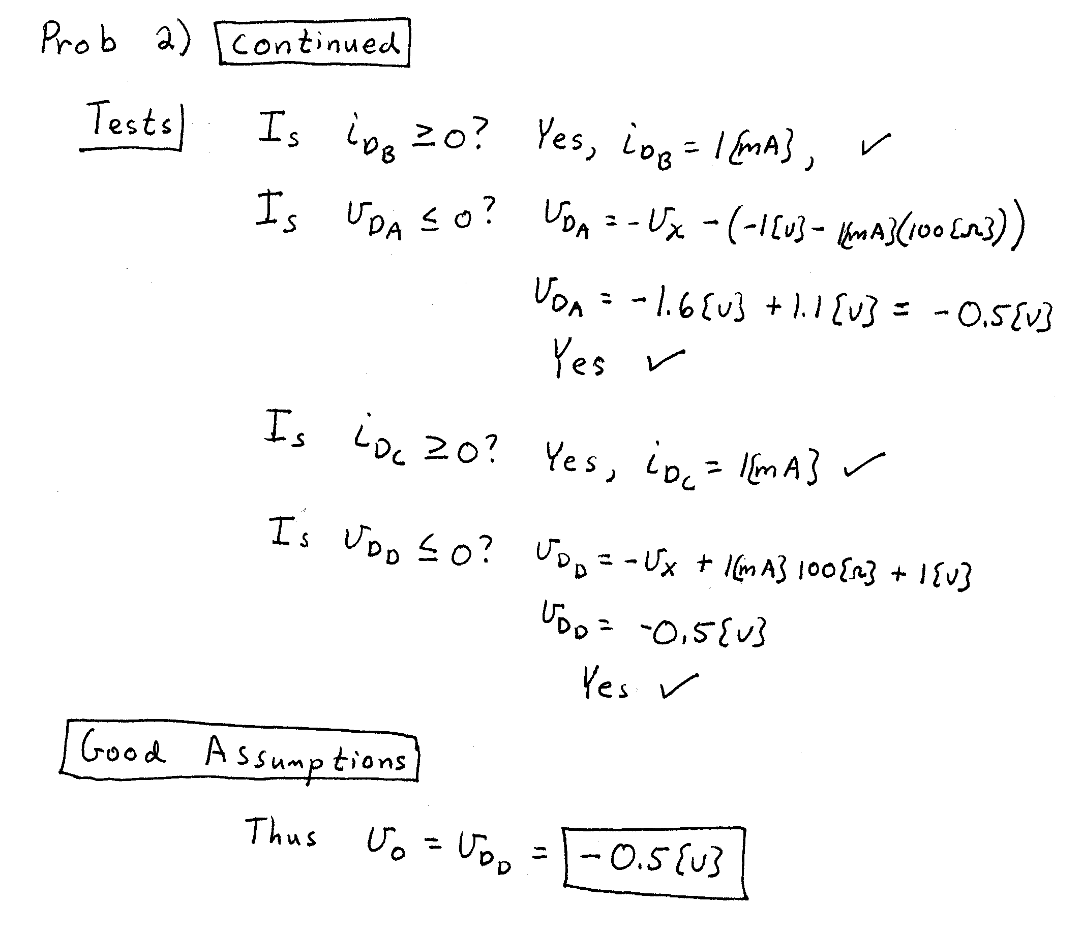
3) (30 Points) The transistors in the circuit below have β = 200, and are operated at room temperature. Find the dc values of V₁ and V₂. State your assumptions, and test them, showing your test steps explicitly. Remember that you will be graded on the process that you follow in solving this circuit. I expect that you will be able to complete at least 1 guess in the time allowed.
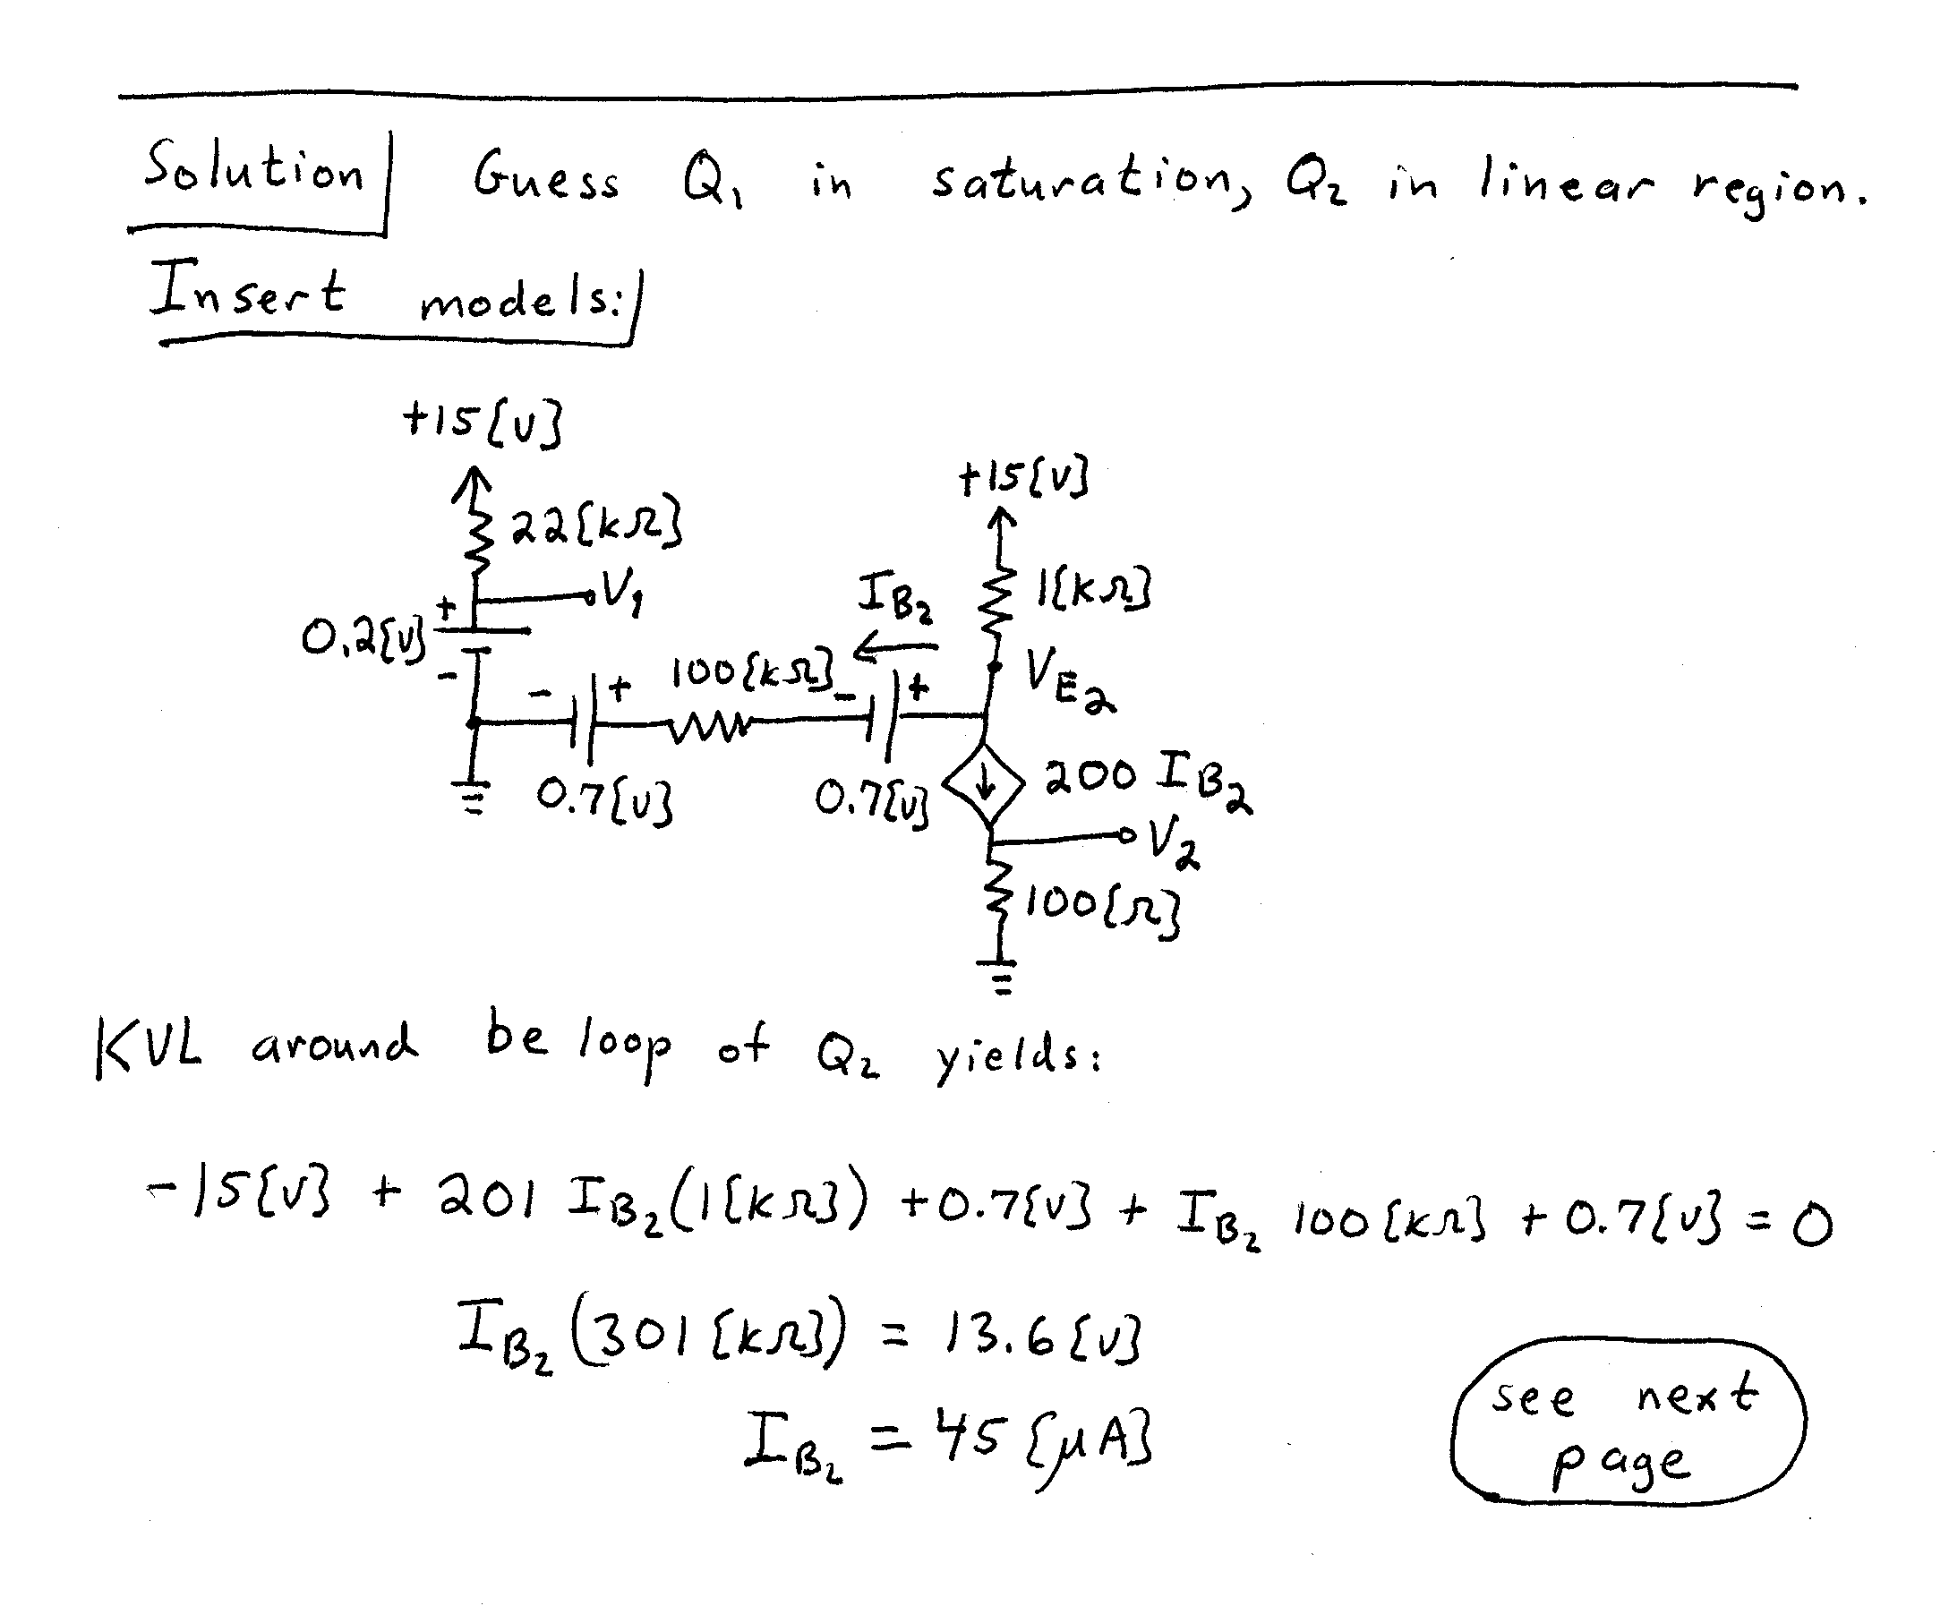
Room for Extra work
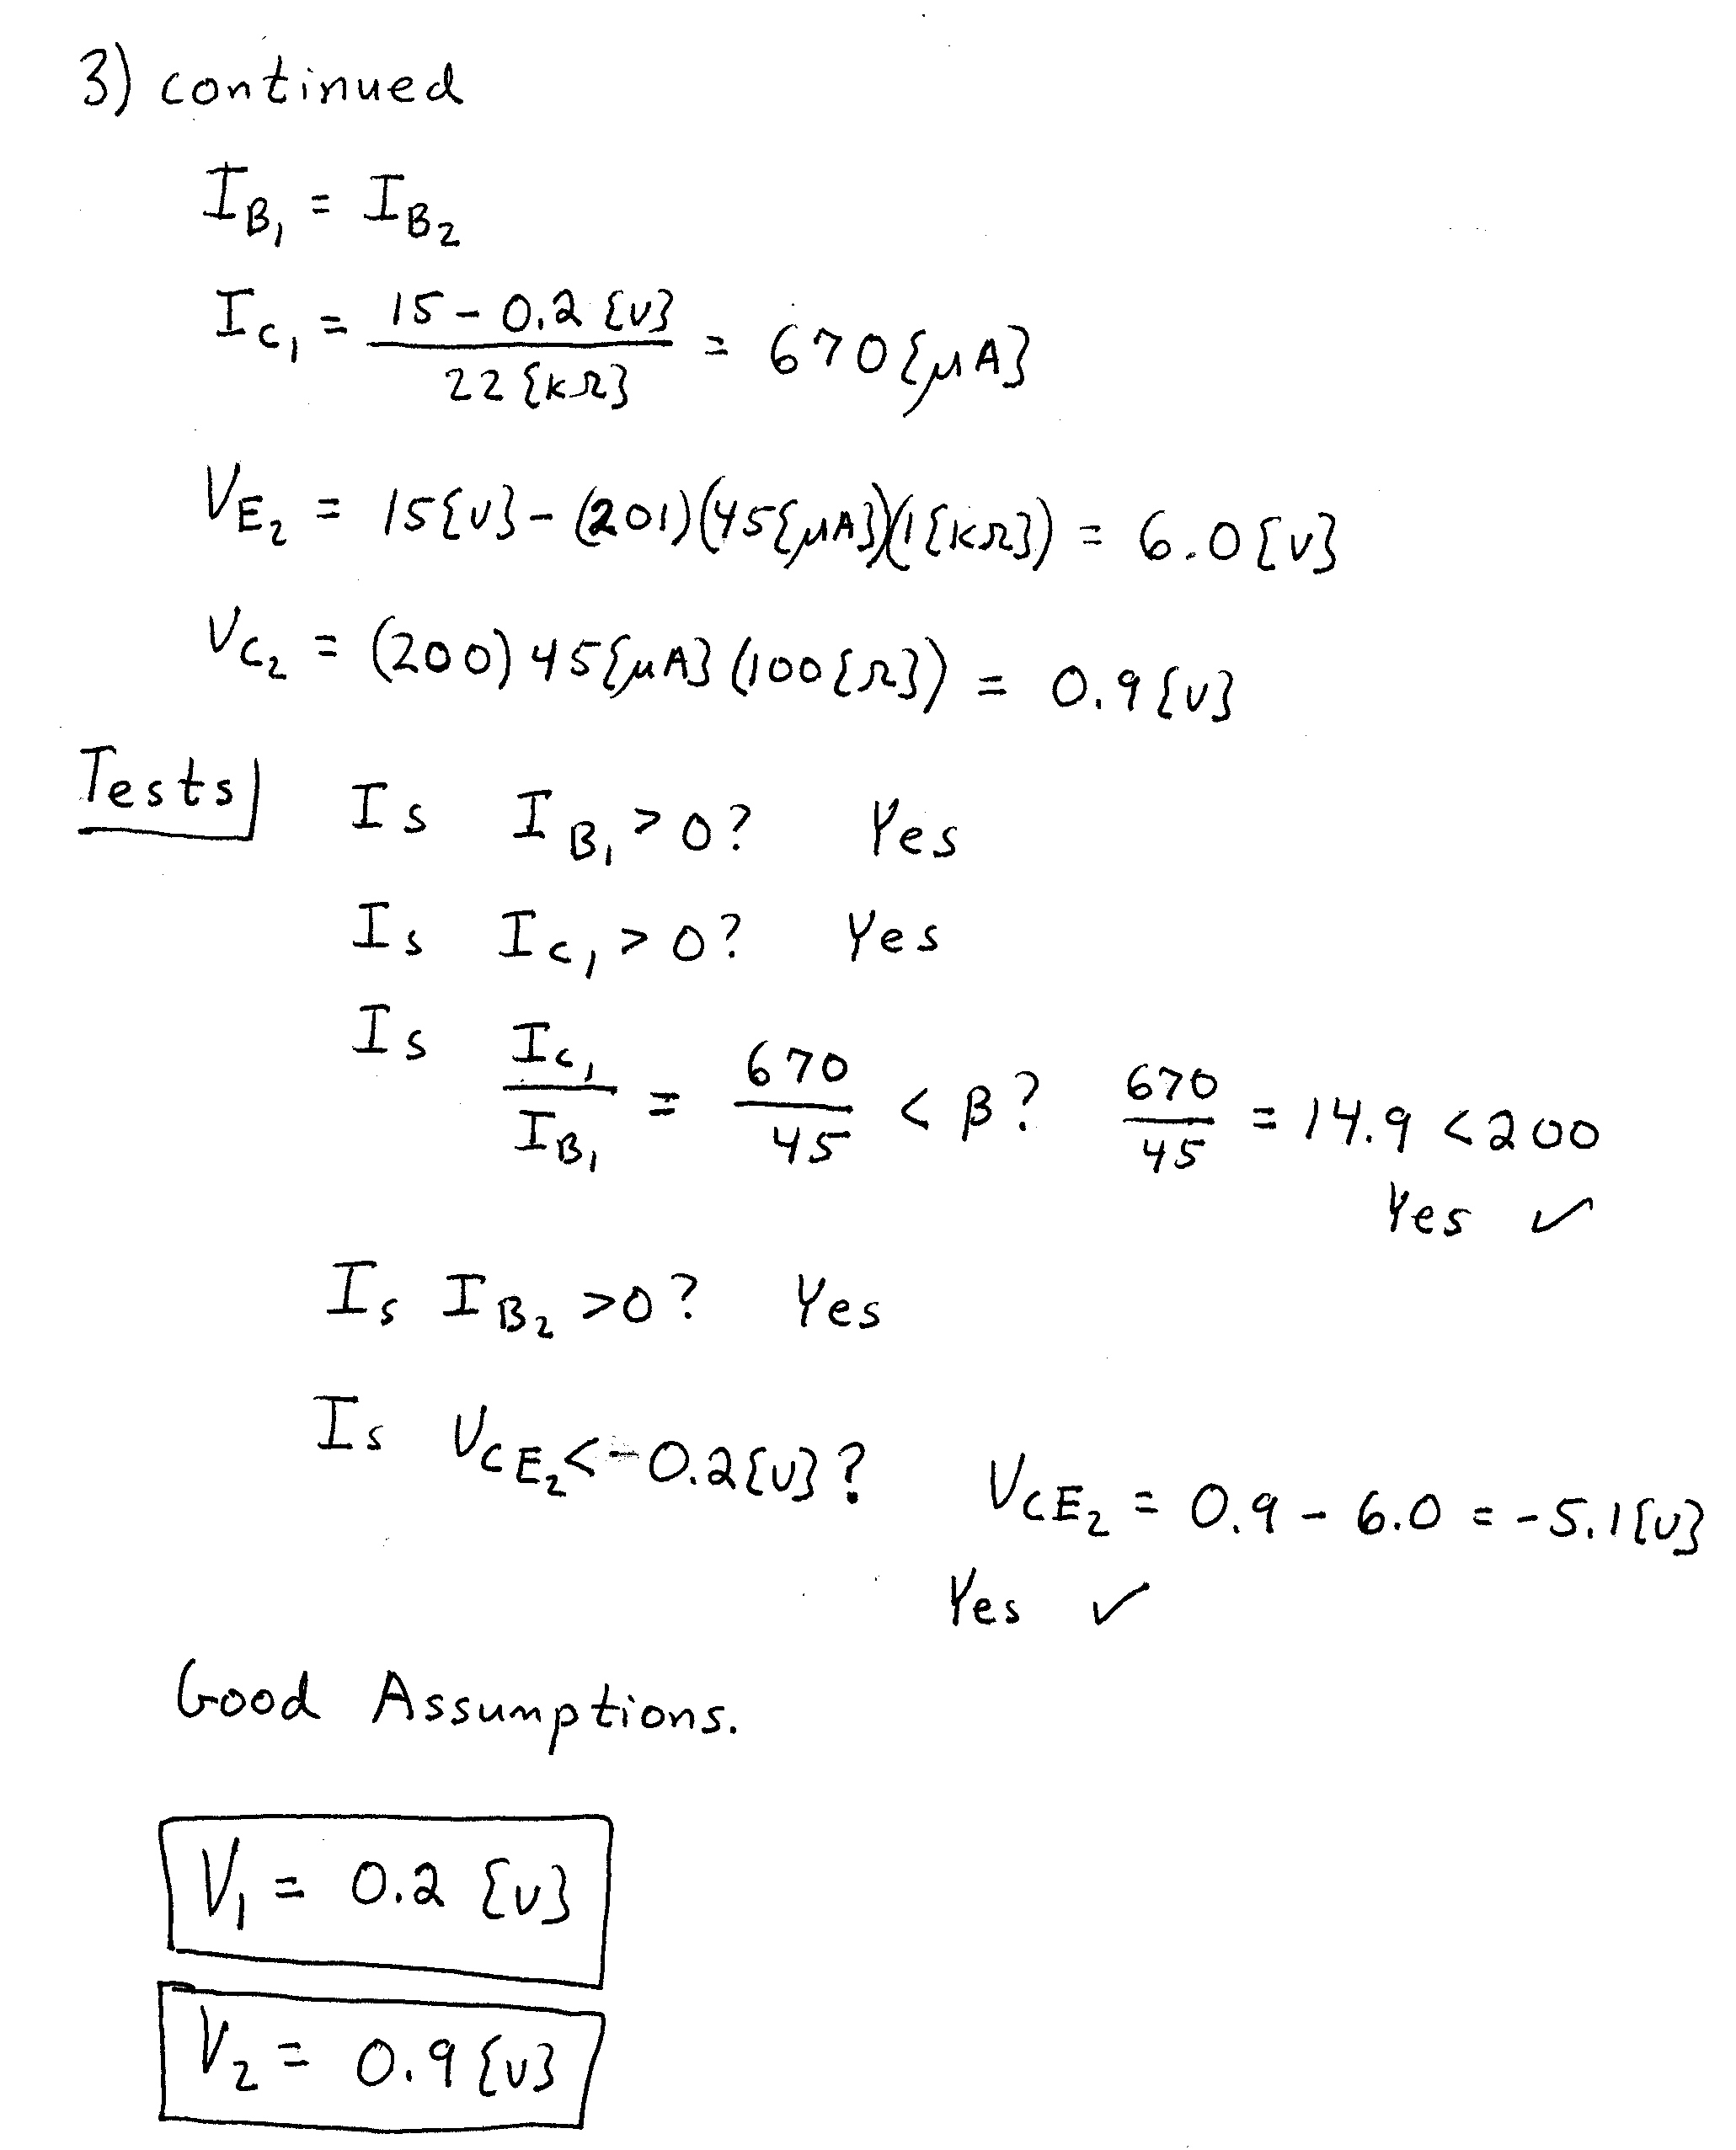

4) (10 Points) Assume an ideal op amp. Assume an ideal diode. The transistor in the circuit below is a power transistor with high current capability and has a β = 20. It is also given that
V_{S} = -5[V].
a) Find I₂.
b) Find I₁.
c) Considering the values of I₂ and I₁, what do you think is the point of including the transistor in this circuit?



