Name: _____________________________ (please print)
Signature: __________________________

ECE 3455 Electronics
Final Exam – December 8, 1999

DO NOT OPEN THIS QUIZ BOOKLET UNTIL YOU ARE TOLD TO BEGIN

1. This exam is open book and open notes. Any calculator may be used.
2. You will have 180 minutes to complete this exam.
3. Show all work on these pages. Show all work necessary to complete the problem. If your work goes on to another page, indicate this with a note. A solution without the work shown will receive no credit.
4. Use appropriate notation.
5. Show units in all answers and in all major intermediate results. Units in the exam questions will be enclosed in square brackets.
6. Do not use red ink. Do not use red pencil.

1) ______________/10
2) ______________/22
3) ______________/15
4) ______________/35
5) ______________/18
6) ______________/15

Room for extra work
1) (10 Points) Assume that the op amp is ideal.
a) Find the voltage gain, 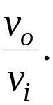
b) Find the input resistance seen by the source.
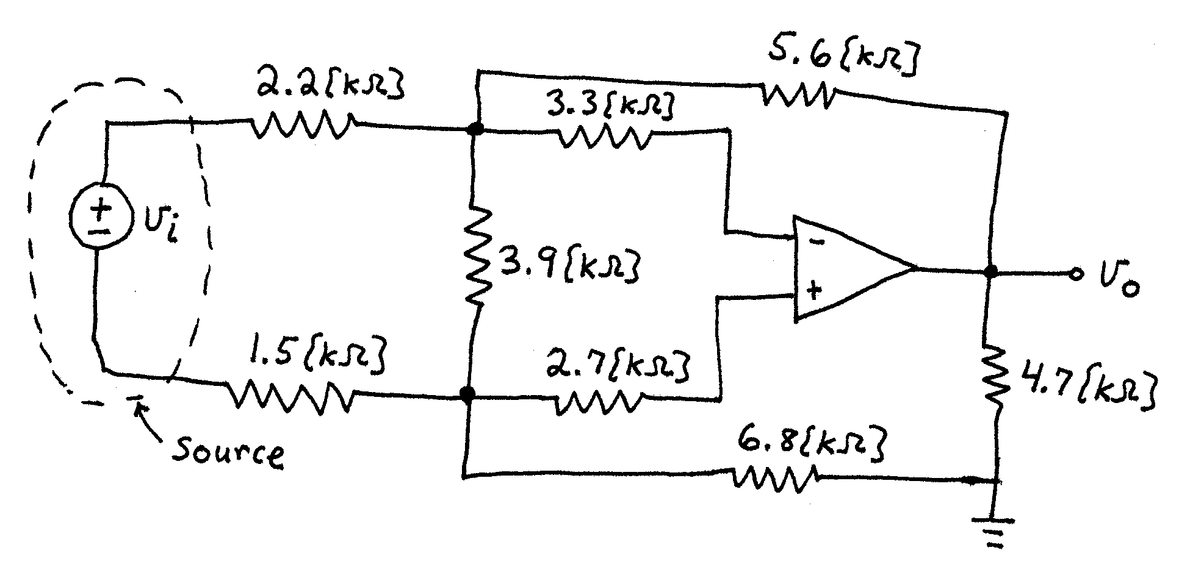
ROOM for Extra Work
2. (22 Points) A device called the Shadramatic has a schematic symbol given below in Fig. 1. The transfer characteristic for this device is given in Fig. 2. Two identical versions of the Shadramatic are included in the circuit in Fig. 3. Find V_{X} and I_{X}. State your assumptions, and test them, showing your tests. You will be graded on the approach that you take. I expect you to be able to complete at least 1 guess in the time allowed.
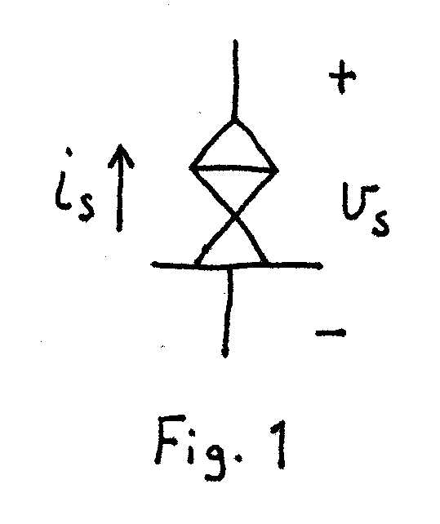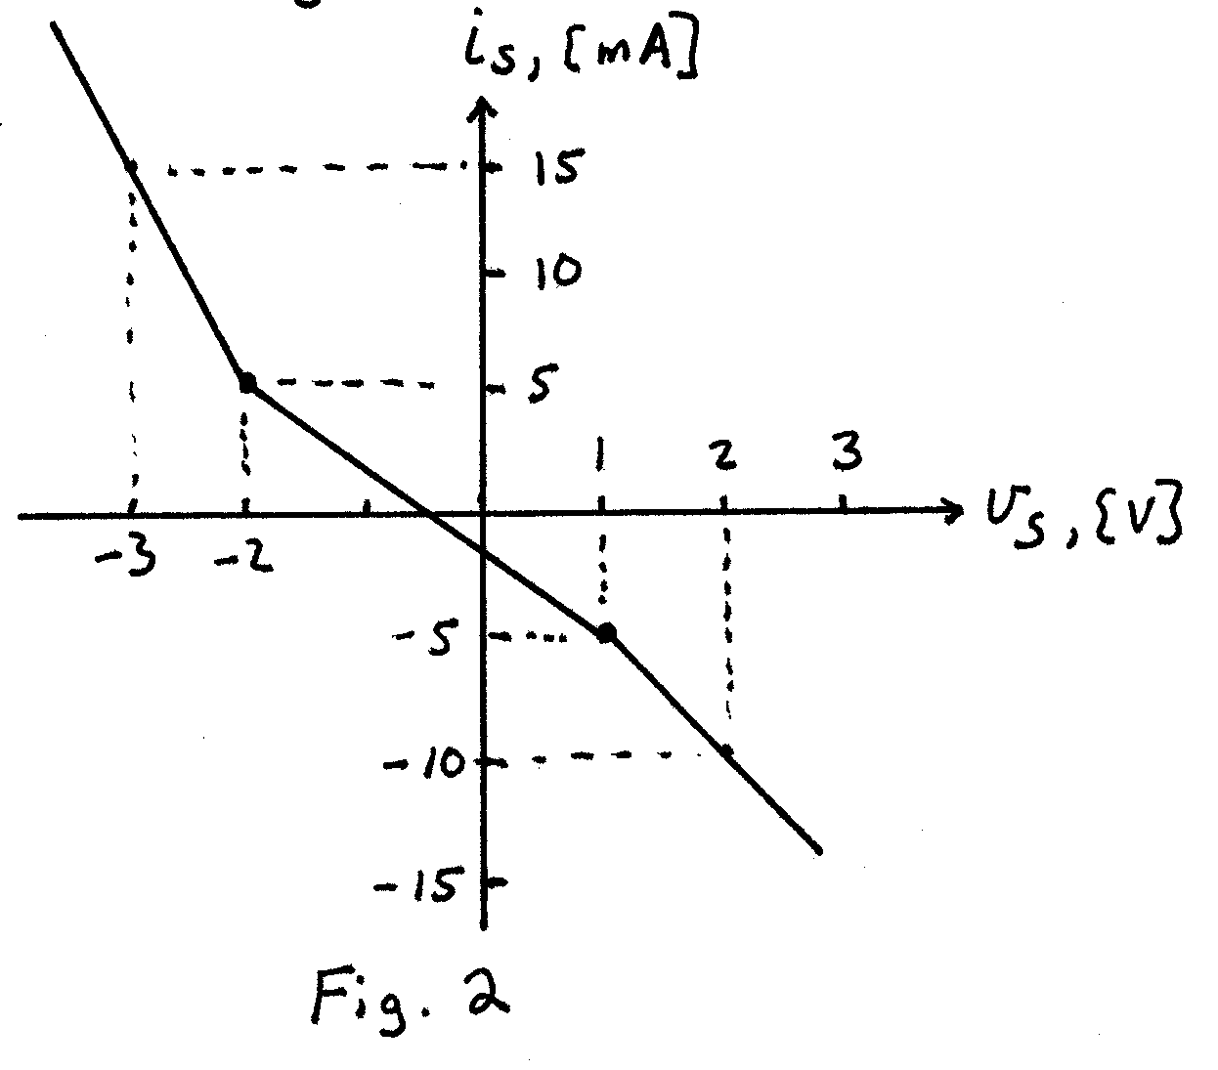
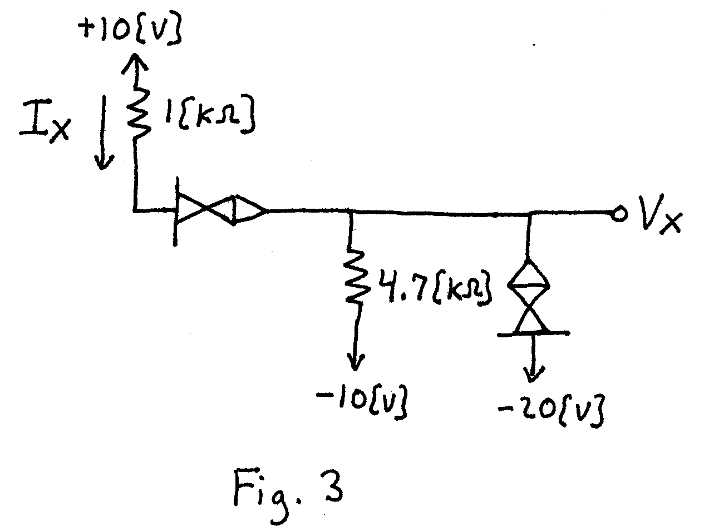
Room for Extra Work
3) (15 Points) Assume an ideal op amp in Fig. 4. Assume that the output of the op amp saturates at the dc power supply levels. Answer the questions given below.
a) When V_{I} = -20[V], find V_{O}.
b) When V_{I} = +10[V], find V_{O}.
a) For v_{I}(t) given in Fig. 5, sketch v_{O}(t). Use the same set of axes.
a) Are I₁ and I₂ equal to zero in this circuit? Explain your answer briefly, using complete sentences.
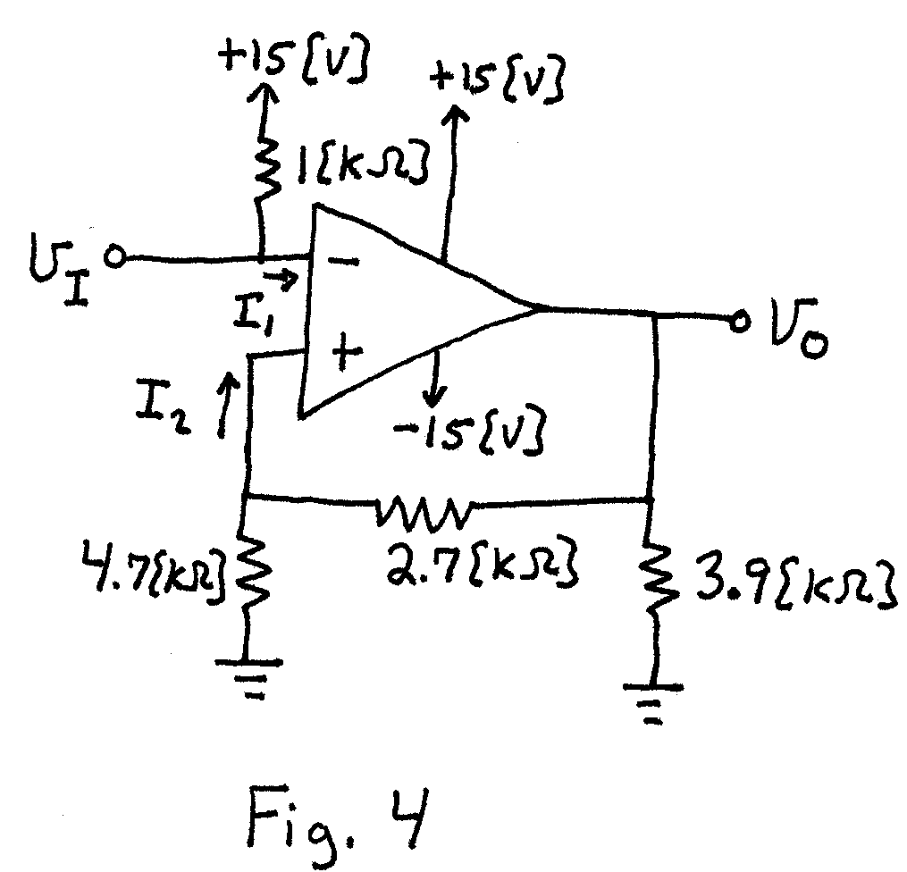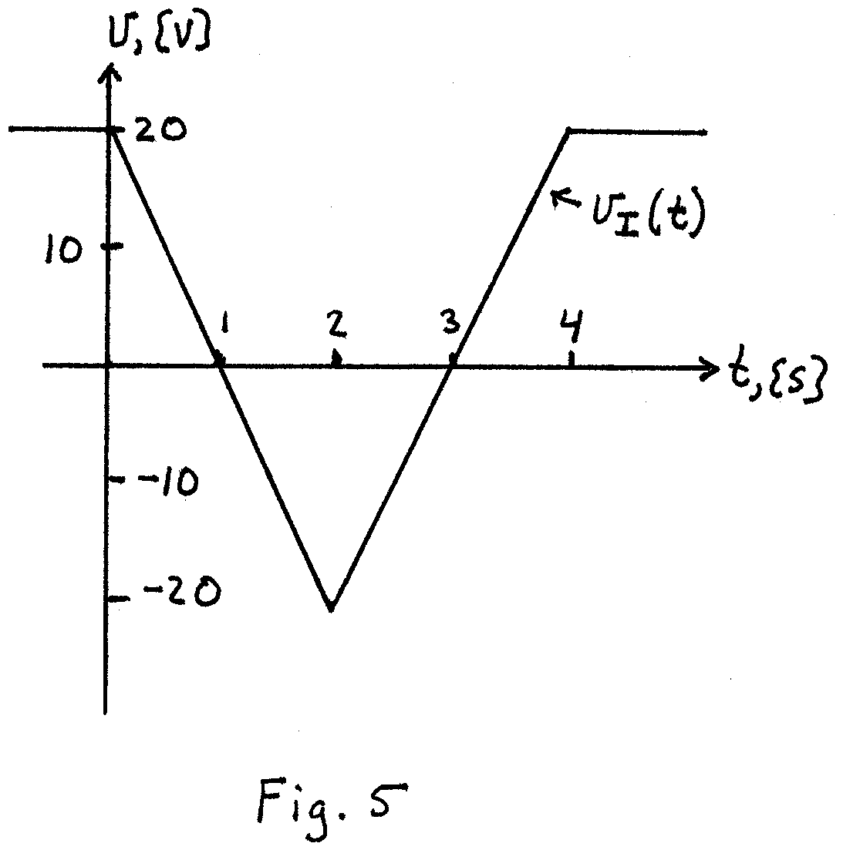
Room for Extra work
4) (35 Points) Assume room temperature operation, β = 100, and that V_{A} = ∞.
a) Plot the straight-line approximation to the Bode plot for the amplifier in Fig. 6. State your assumptions, and test them. Use the axes on the next page. Include all nonzero poles and zeroes in your plot.
b) Find the 3[dB] bandwidth for this amplifier.
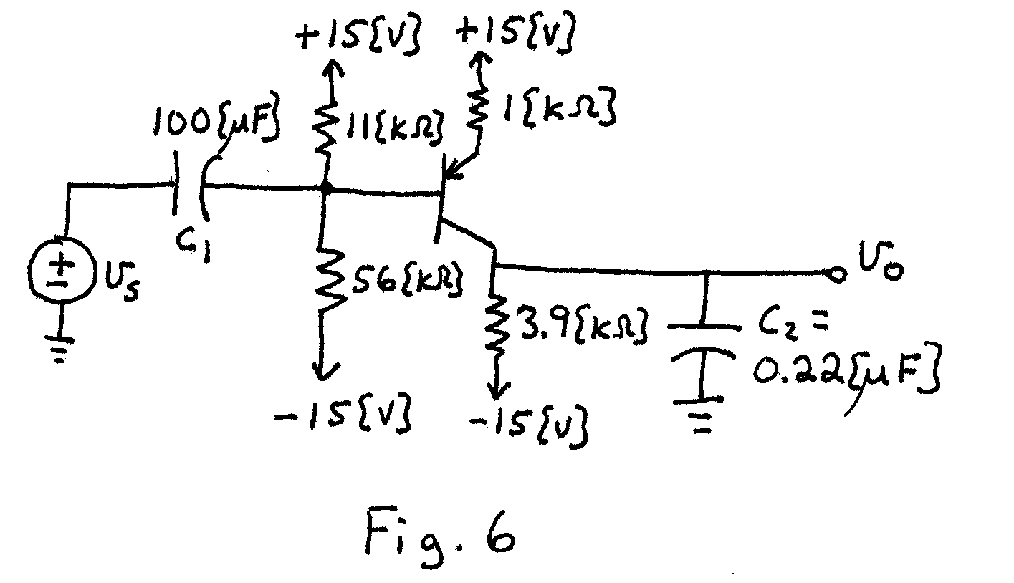
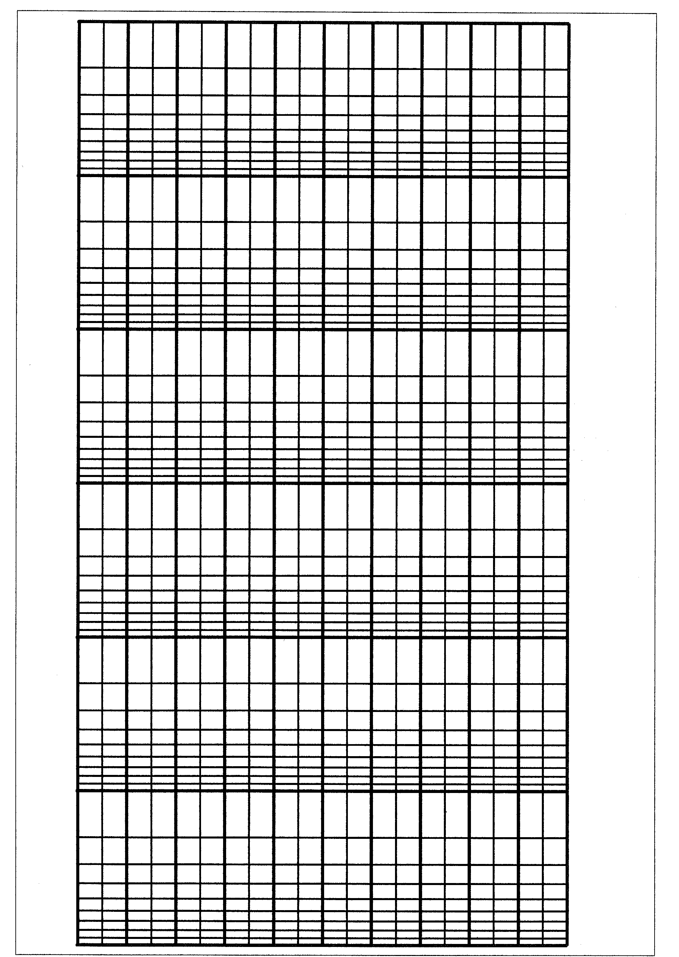
Room for Extra Work
Room for Extra Work
5) (18 Points) A digital logic family has the characteristics described below.
a) The output appears as the equivalent circuit in Fig. 7 when the output is in the high state. The output appears the equivalent circuit in Fig. 8 when the output is in the low state.
b) The input appears as the equivalent circuit in Fig. 9 when the input is in the high state. The input appears the equivalent circuit in Fig. 10 when the input is in the low state.
c) The gate dissipates 250[mW] when the output is in the high state, and dissipates 240[mW] when the output is in the low state.
d) Assume room temperature operation, β = 100, and V_{A} = ∞.
e) The lowest input voltage that behaves like a high input is 2[V]. The highest input voltage that behaves like a low input is -2[V].

Find the fanout for high and low noise margins of 1[V].

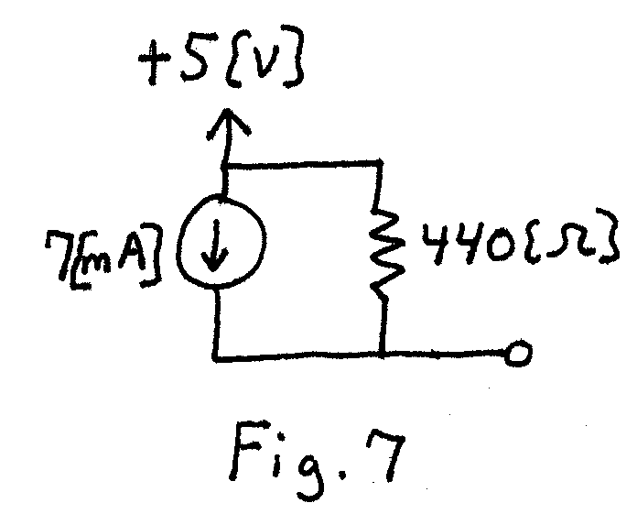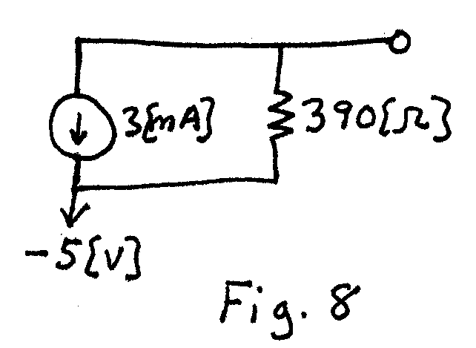
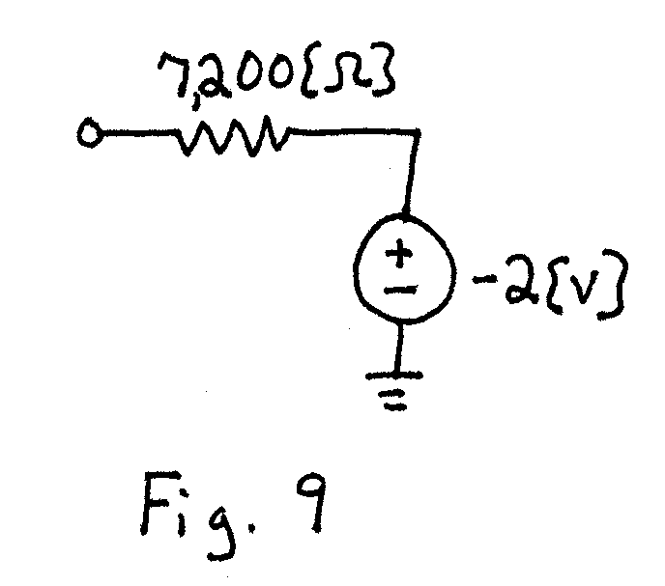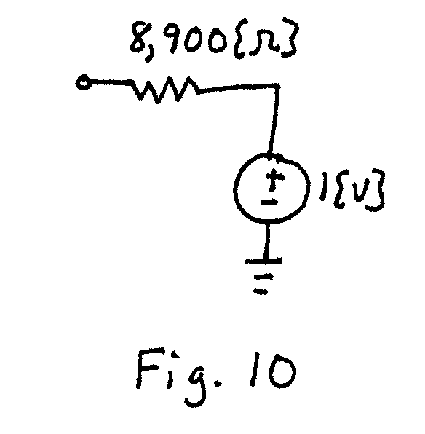
Room for extra work
6) (15 Points) In this problem assume that the diodes can be modeled with a piecewise linear diode model, with V_{f} = 0.8[V],
r_{d} = 100[Ω], and I_{s} = 0. Assume that the op amp is ideal. The design goal is for v_{O}(t) to be a half-wave rectified version of v_{I}(t). The v_{I}(t) is a 2[V_{pp}] signal with zero mean.
Evaluate the two designs in Fig. 11 and Fig. 12. Show your approach and steps in this evaluation. One recommendation is that you pick dc inputs for each circuit, and find the output that would result for each dc input. Use your results to choose the better design for a half-wave rectifier.
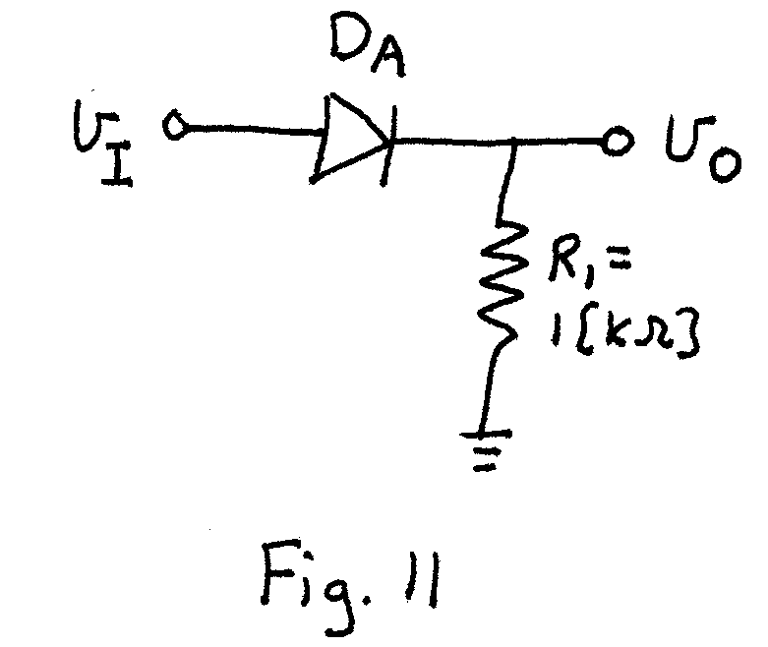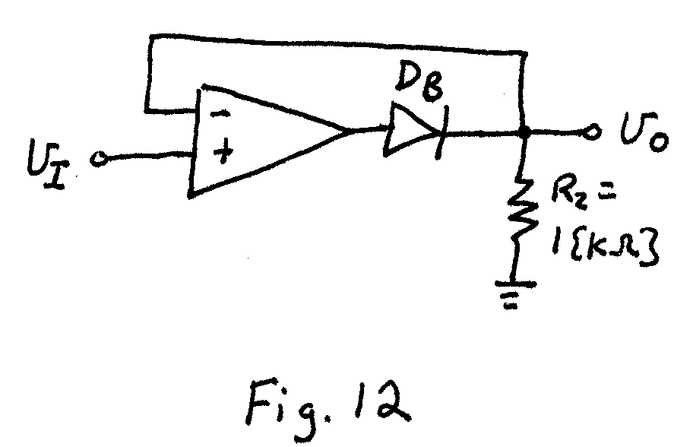
Room for extra work

1) (10 Points) Assume that the op amp is ideal.
a) Find the voltage gain,
b) Find the input resistance seen by the source.
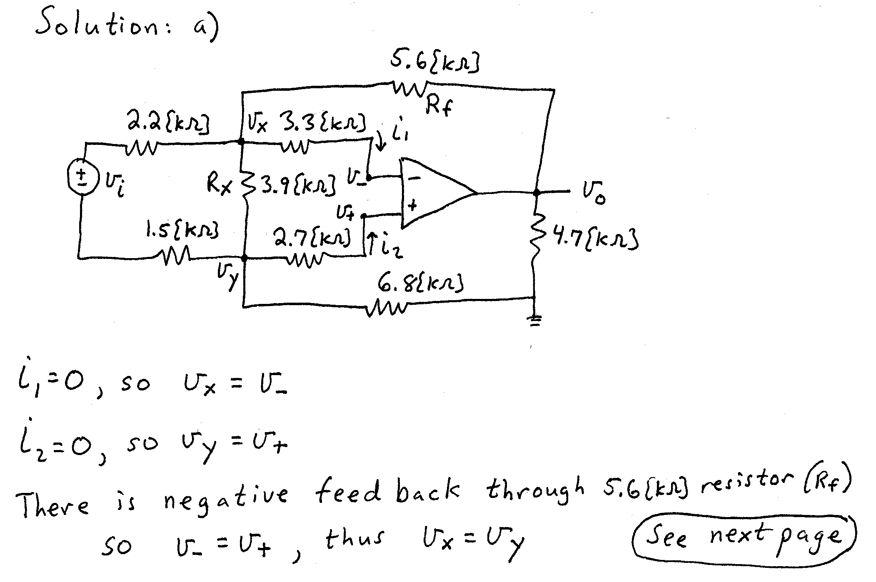
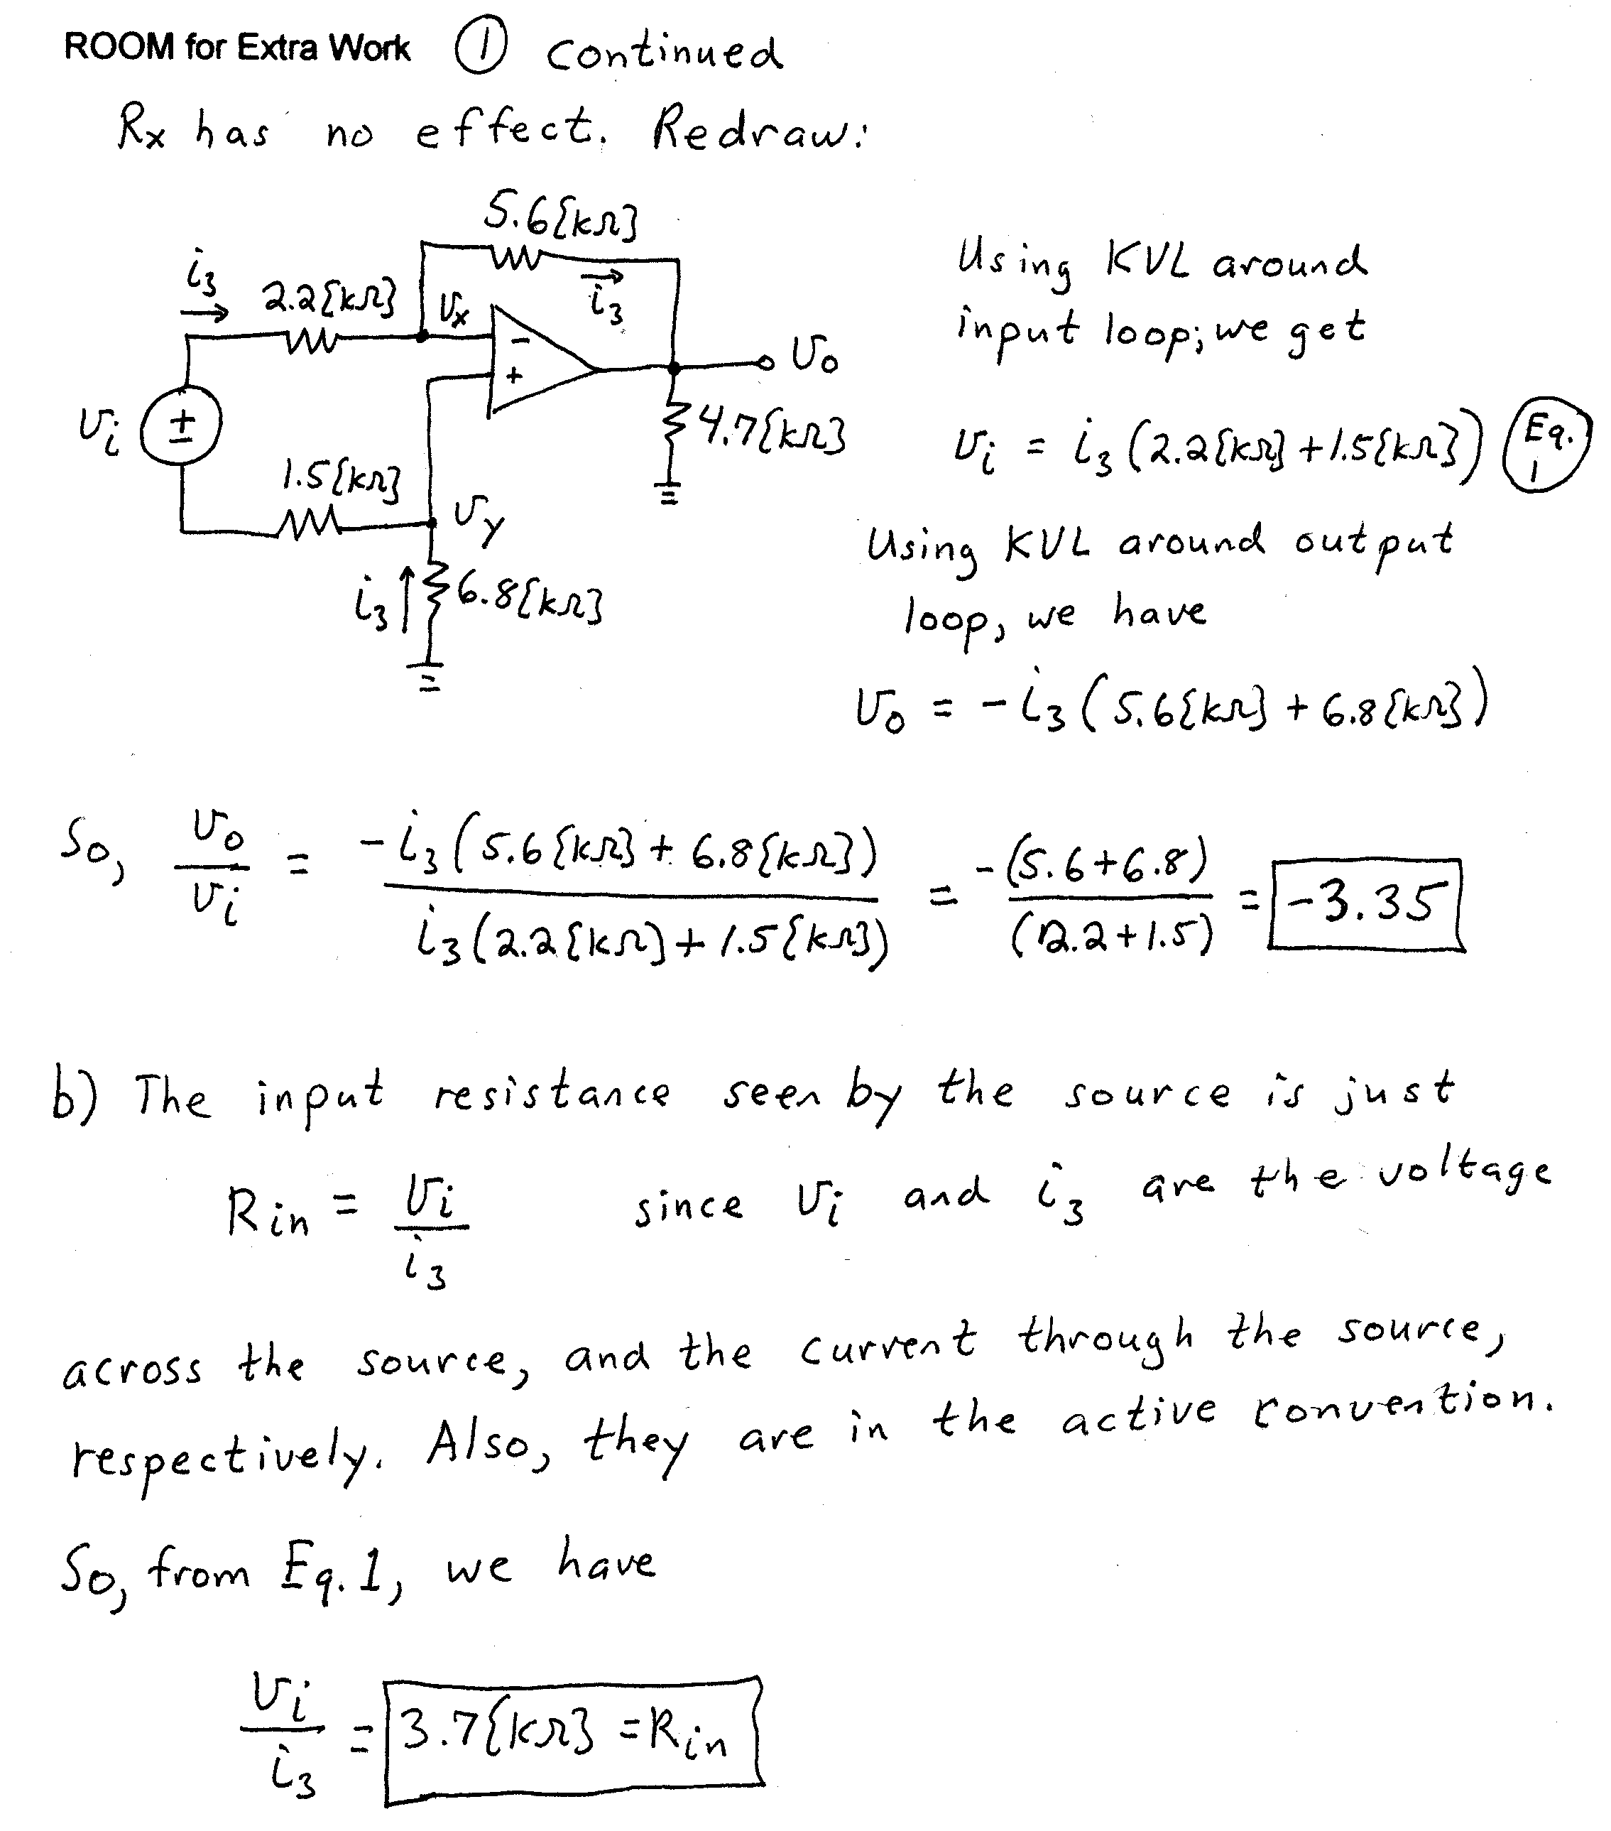
2. (22 Points) A device called the Shadramatic has a schematic symbol given below in Fig. 1. The transfer characteristic for this device is given in Fig. 2. Two identical versions of the Shadramatic are included in the circuit in Fig. 3. Find V_{X} and I_{X}. State your assumptions, and test them, showing your tests. You will be graded on the approach that you take. I expect you to be able to complete at least 1 guess in the time allowed.
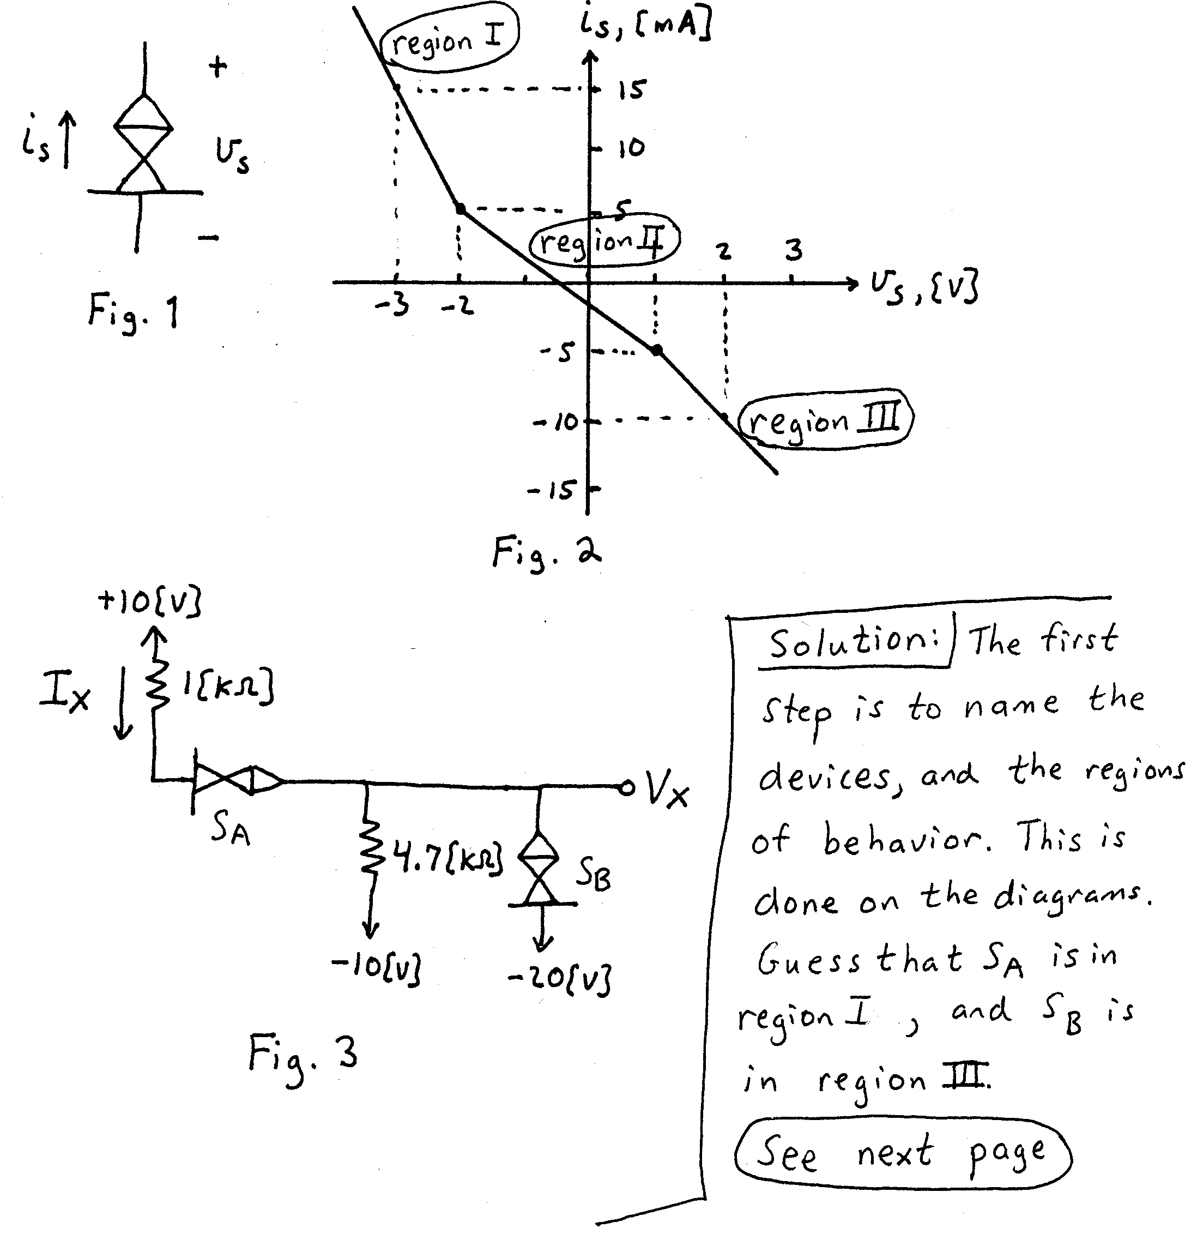

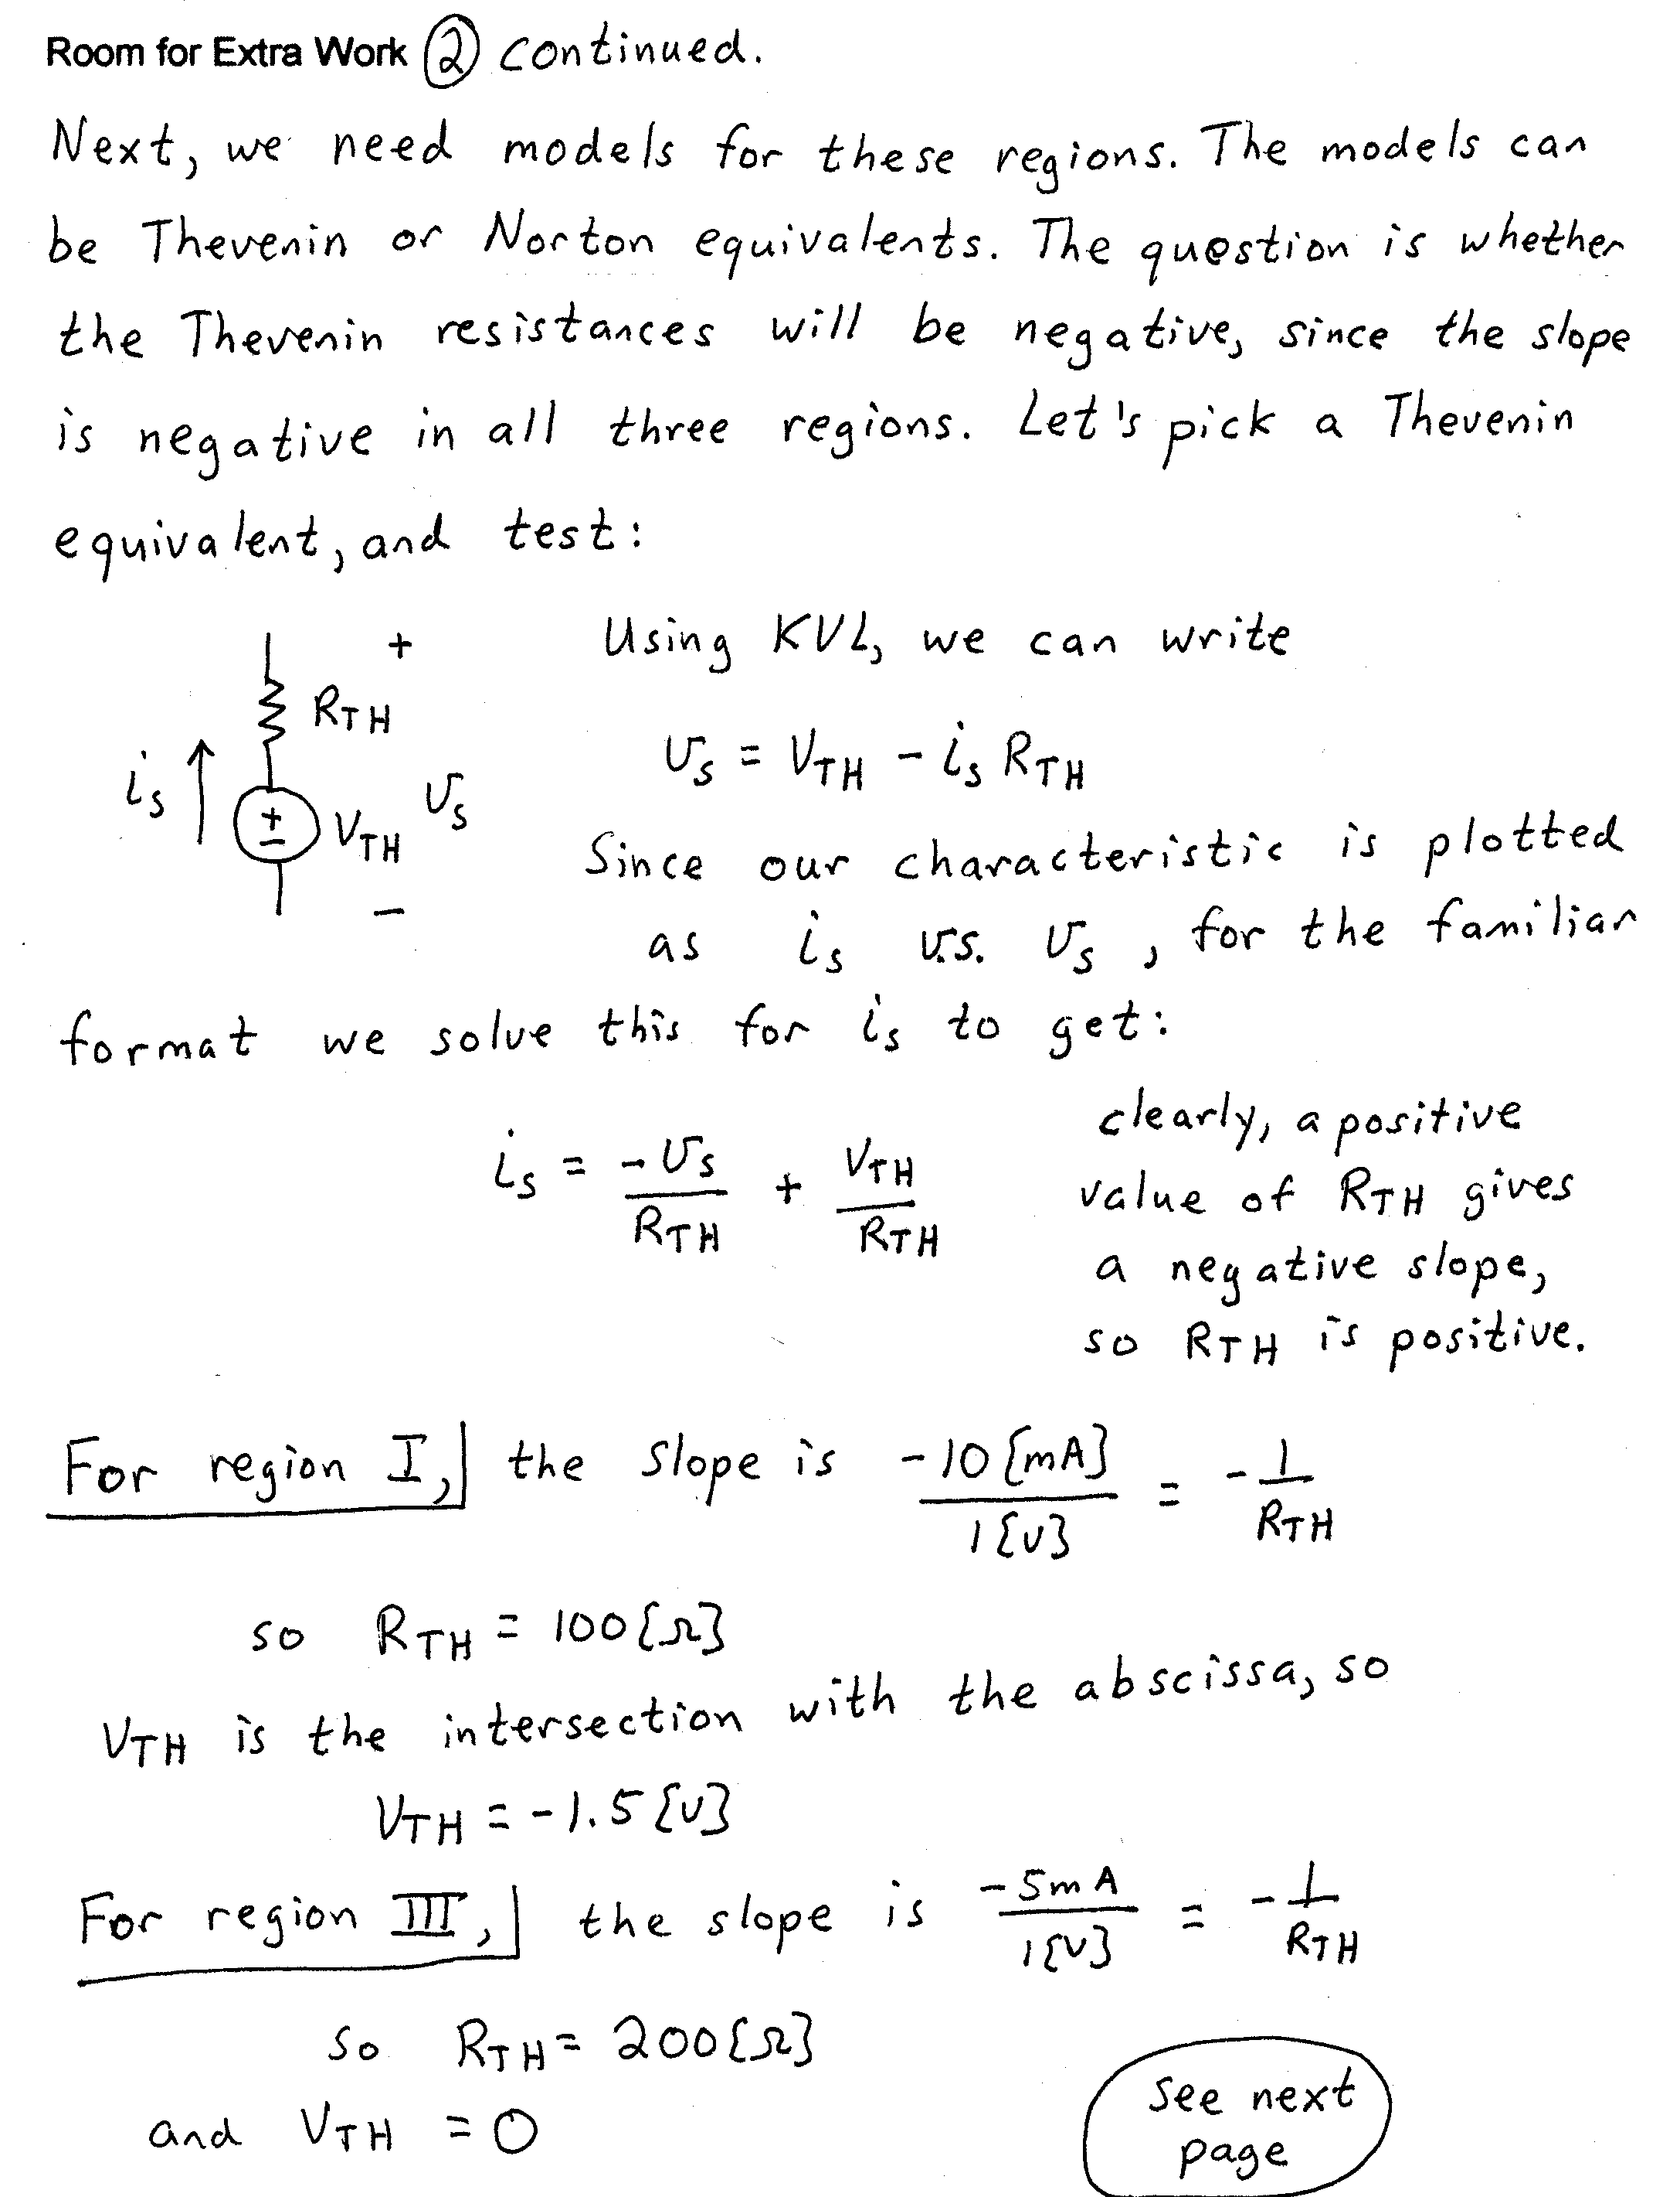
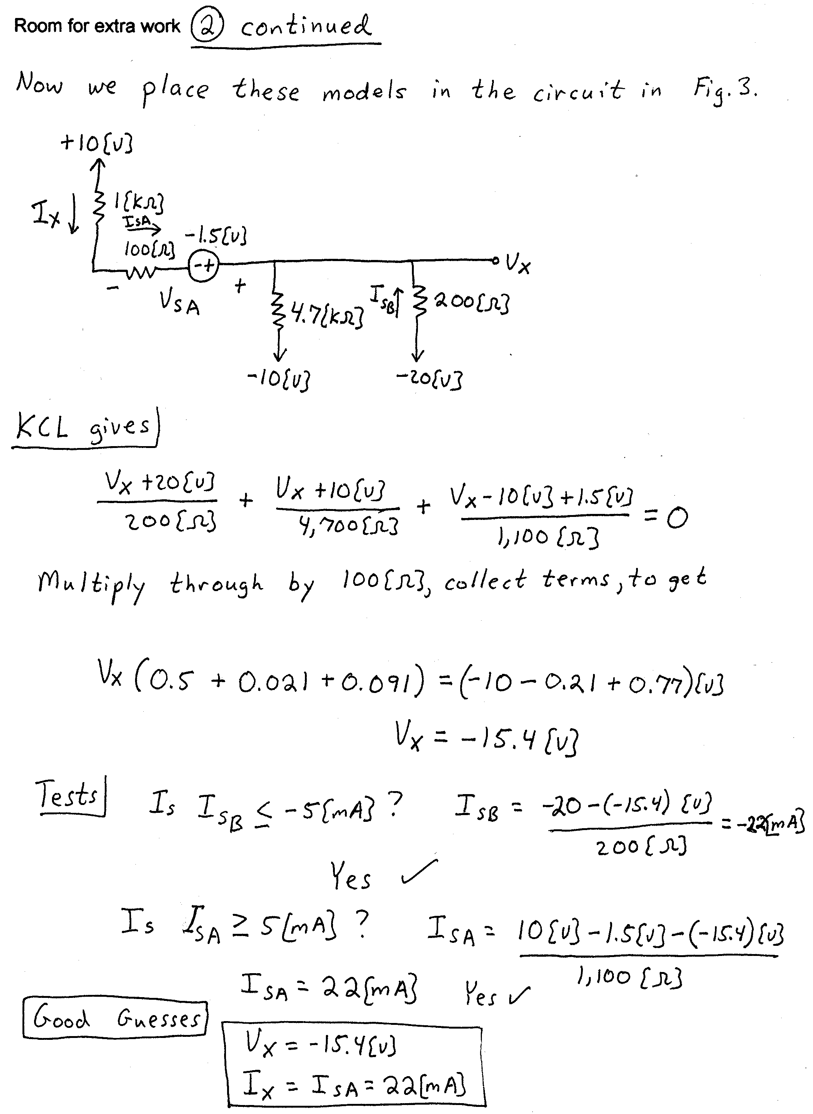
3) (15 Points) Assume an ideal op amp in Fig. 4. Assume that the output of the op amp saturates at the dc power supply levels. Answer the questions given below.
a) When V_{I} = -20[V], find V_{O}.
b) When V_{I} = +10[V], find V_{O}.
a) For v_{I}(t) given in Fig. 5, sketch v_{O}(t). Use the same set of axes.
a) Are I₁ and I₂ equal to zero in this circuit? Explain your answer briefly, using complete sentences.
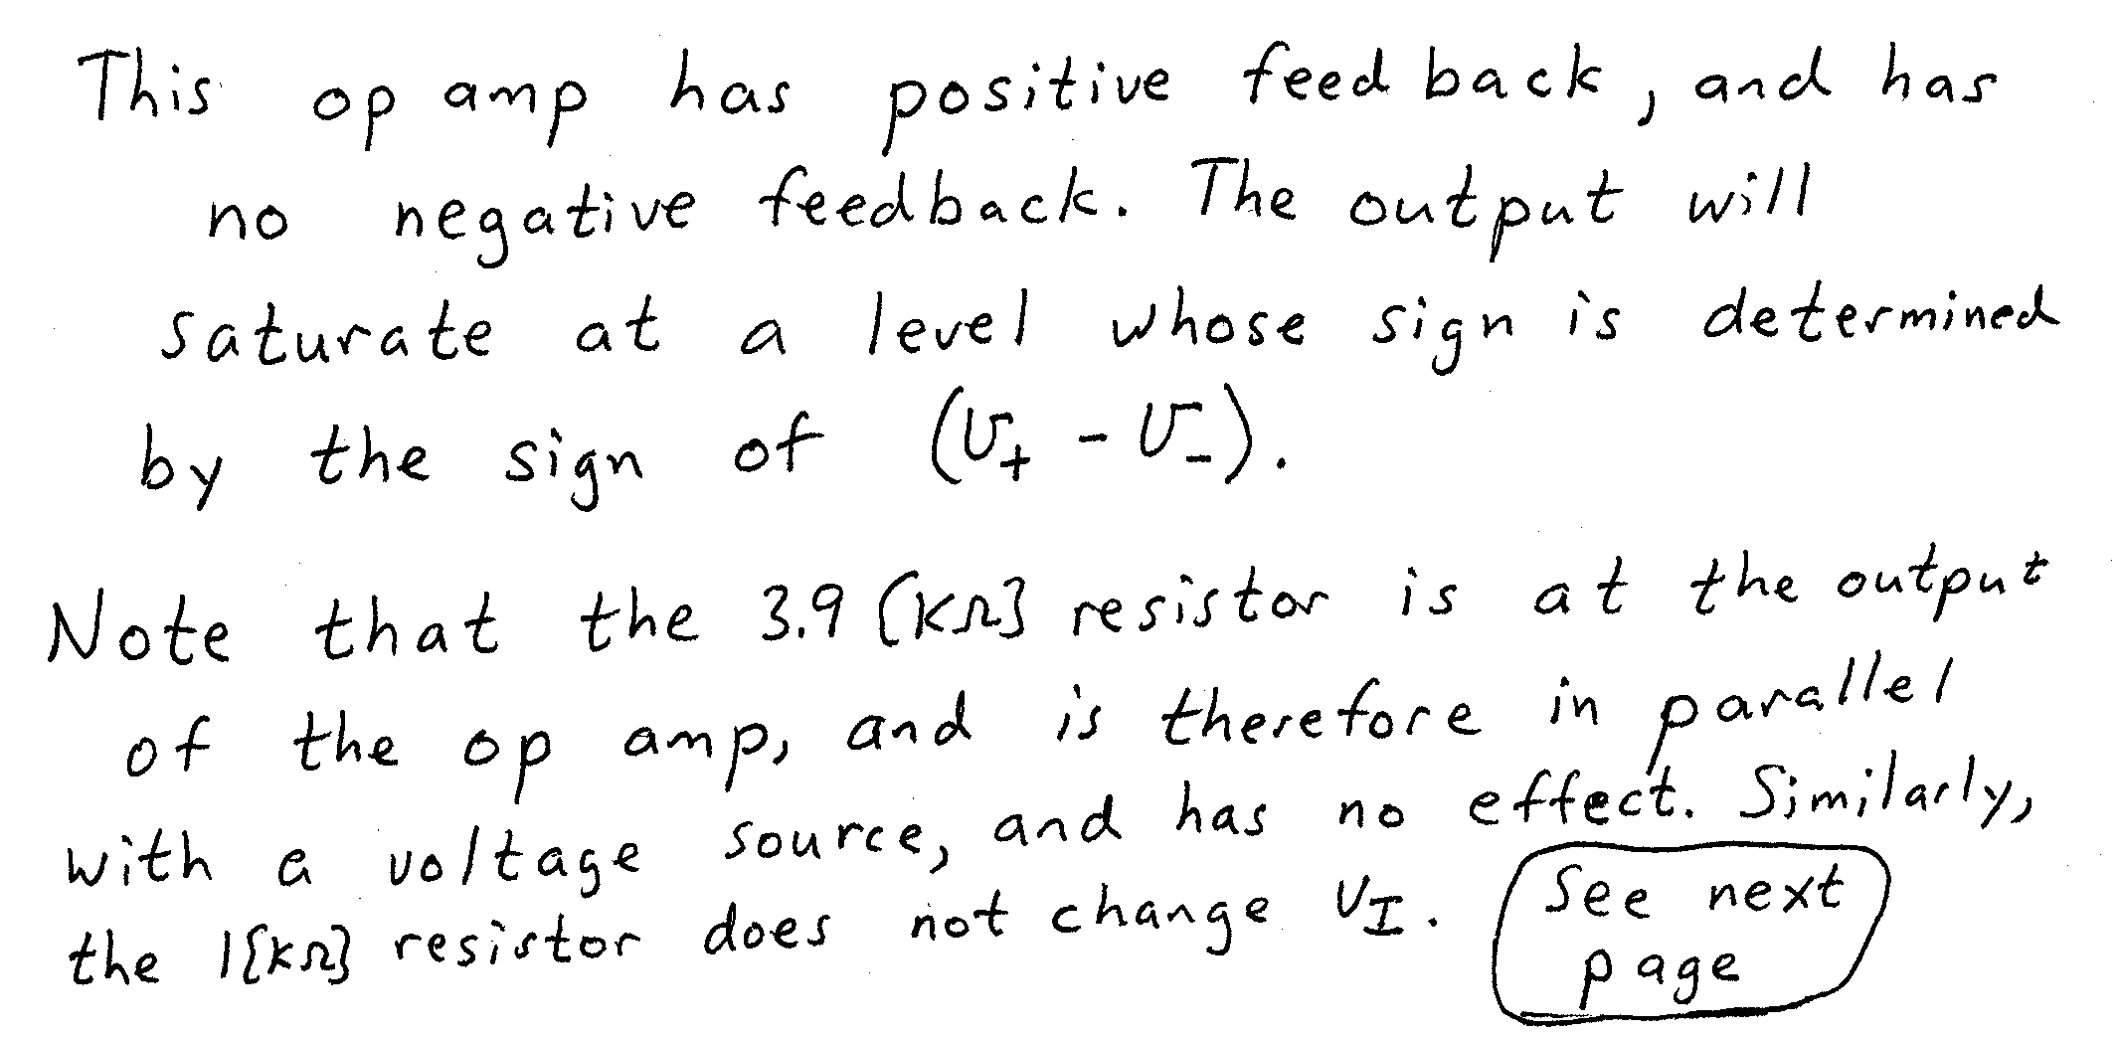
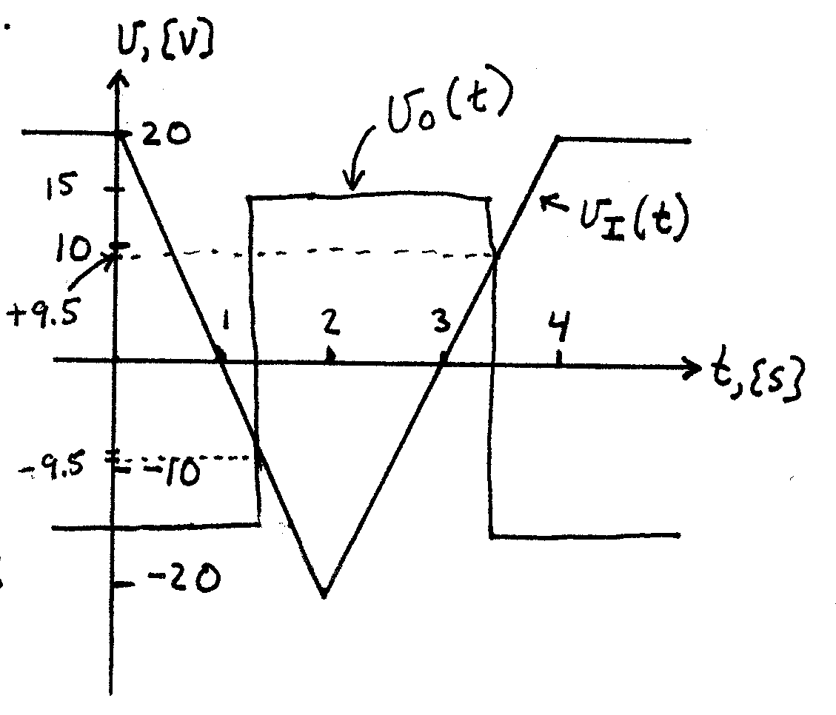
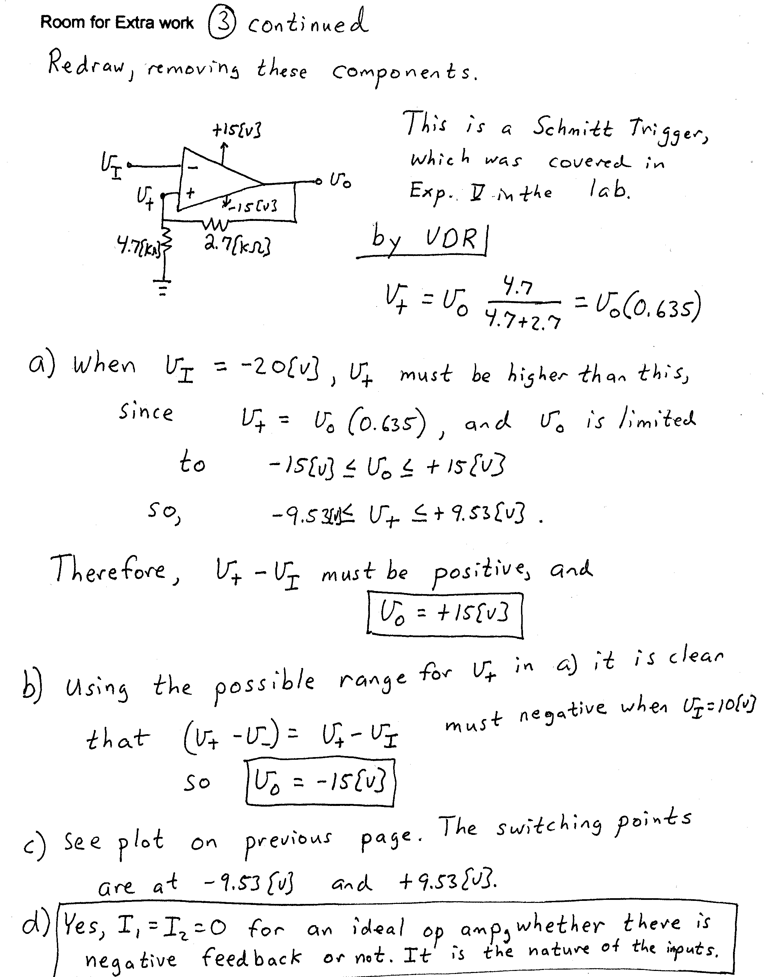
4) (35 Points) Assume room temperature operation, β = 100, and that V_{A} = ∞.
a) Plot the straight-line approximation to the Bode plot for the amplifier in Fig. 6. State your assumptions, and test them. Use the axes on the next page. Include all nonzero poles and zeroes in your plot.
b) Find the 3[dB] bandwidth for this amplifier.
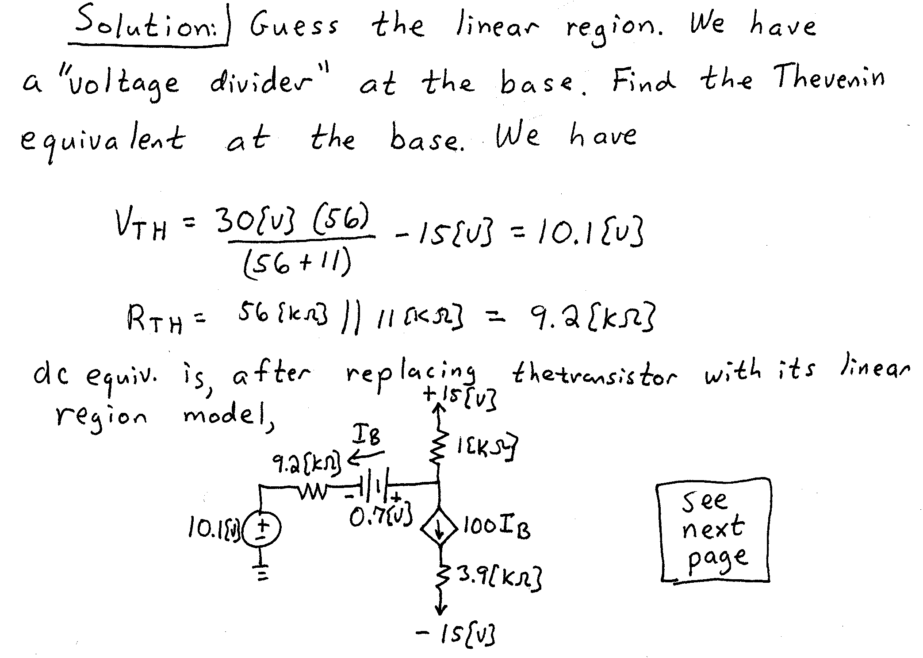
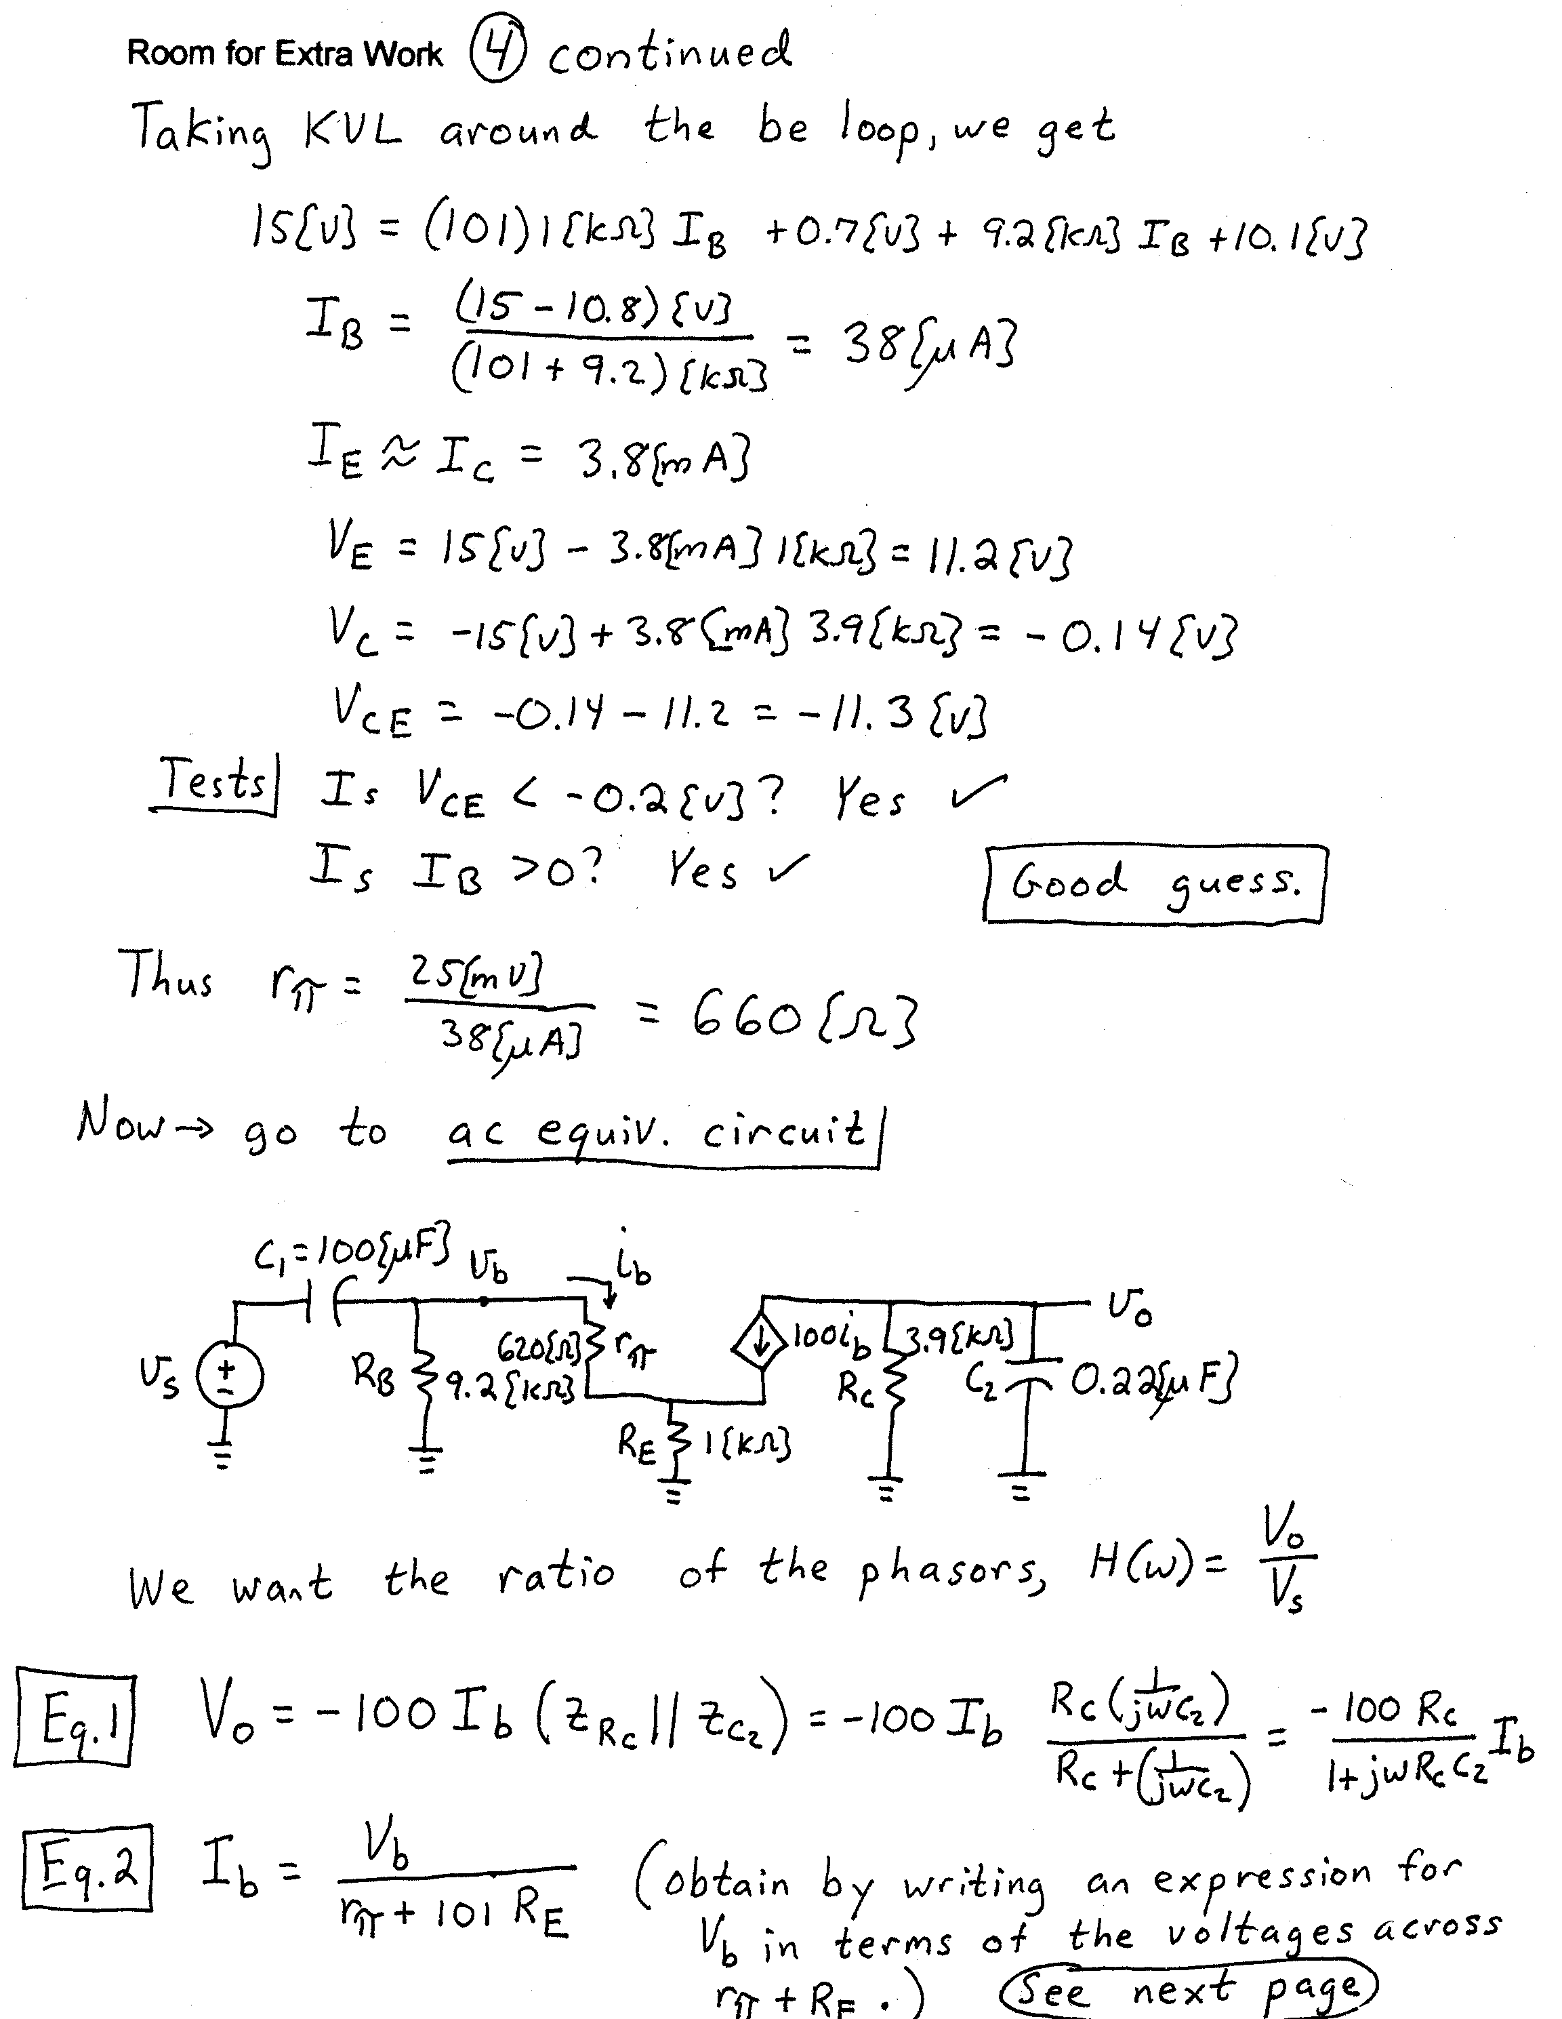
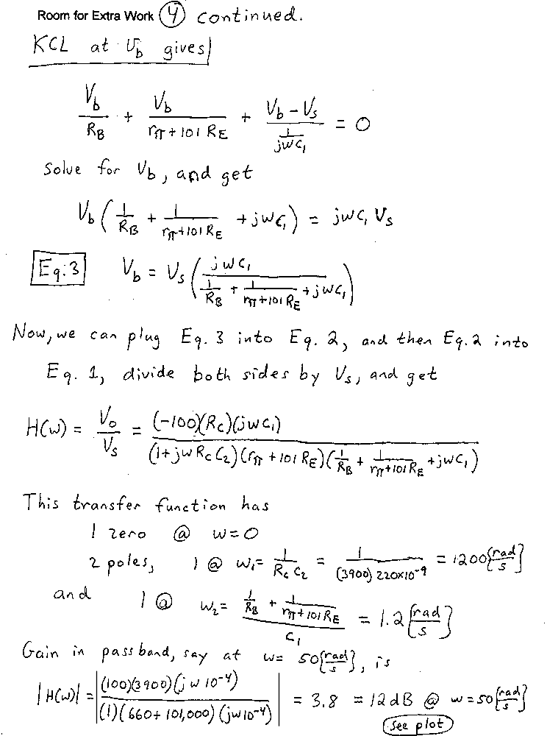
BW = ω₁ – ω₂ = 1200 – 1.2 = 1200[rad/s].
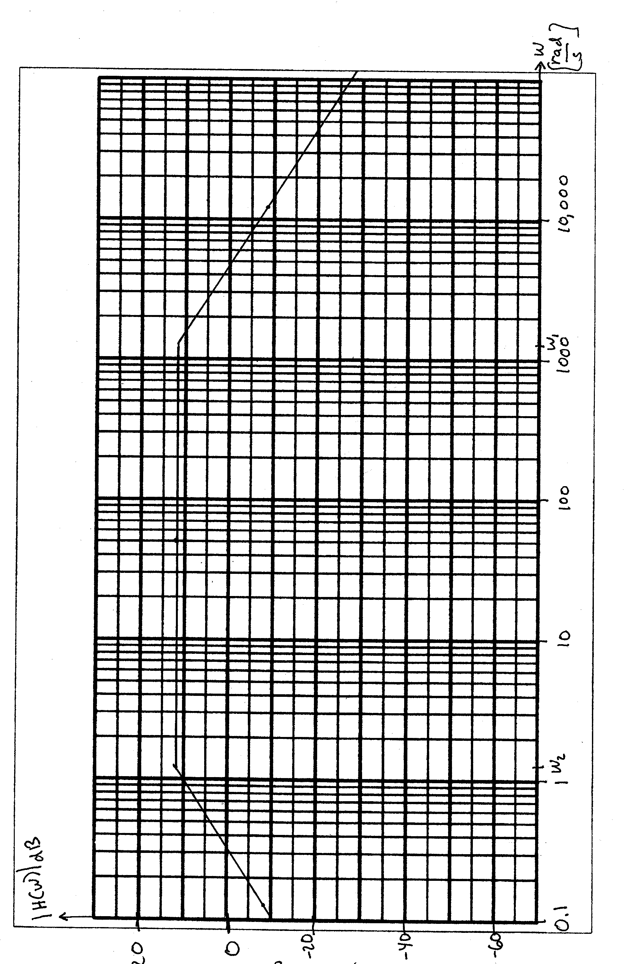
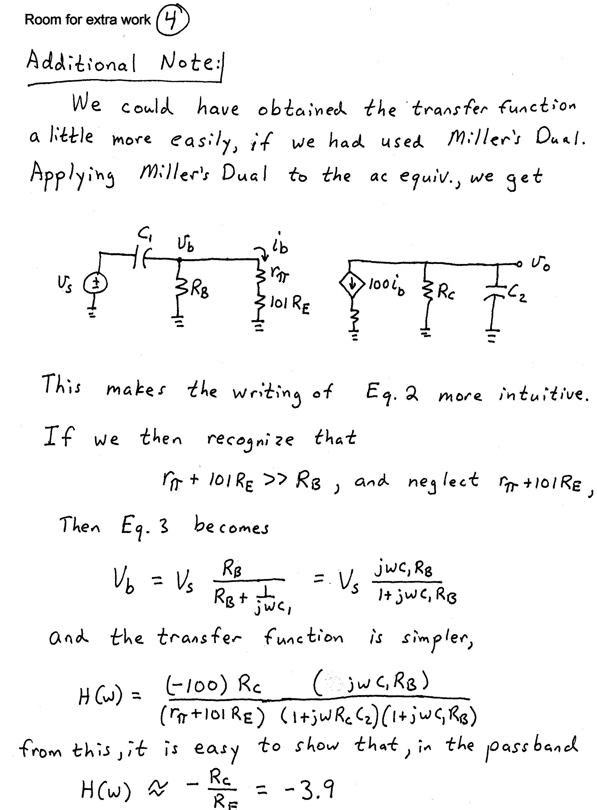
5) (18 Points) A digital logic family has the characteristics described below.
a) The output appears as the equivalent circuit in Fig. 7 when the output is in the high state. The output appears the equivalent circuit in Fig. 8 when the output is in the low state.
b) The input appears as the equivalent circuit in Fig. 9 when the input is in the high state. The input appears the equivalent circuit in Fig. 10 when the input is in the low state.
c) The gate dissipates 250[mW] when the output is in the high state, and dissipates 240[mW] when the output is in the low state.
d) Assume room temperature operation, β = 100, and V_{A} = ∞.
e) The lowest input voltage that behaves like a high input is 2[V]. The highest input voltage that behaves like a low input is -2[V].

Find the fanout for high and low noise margins of 1[V].

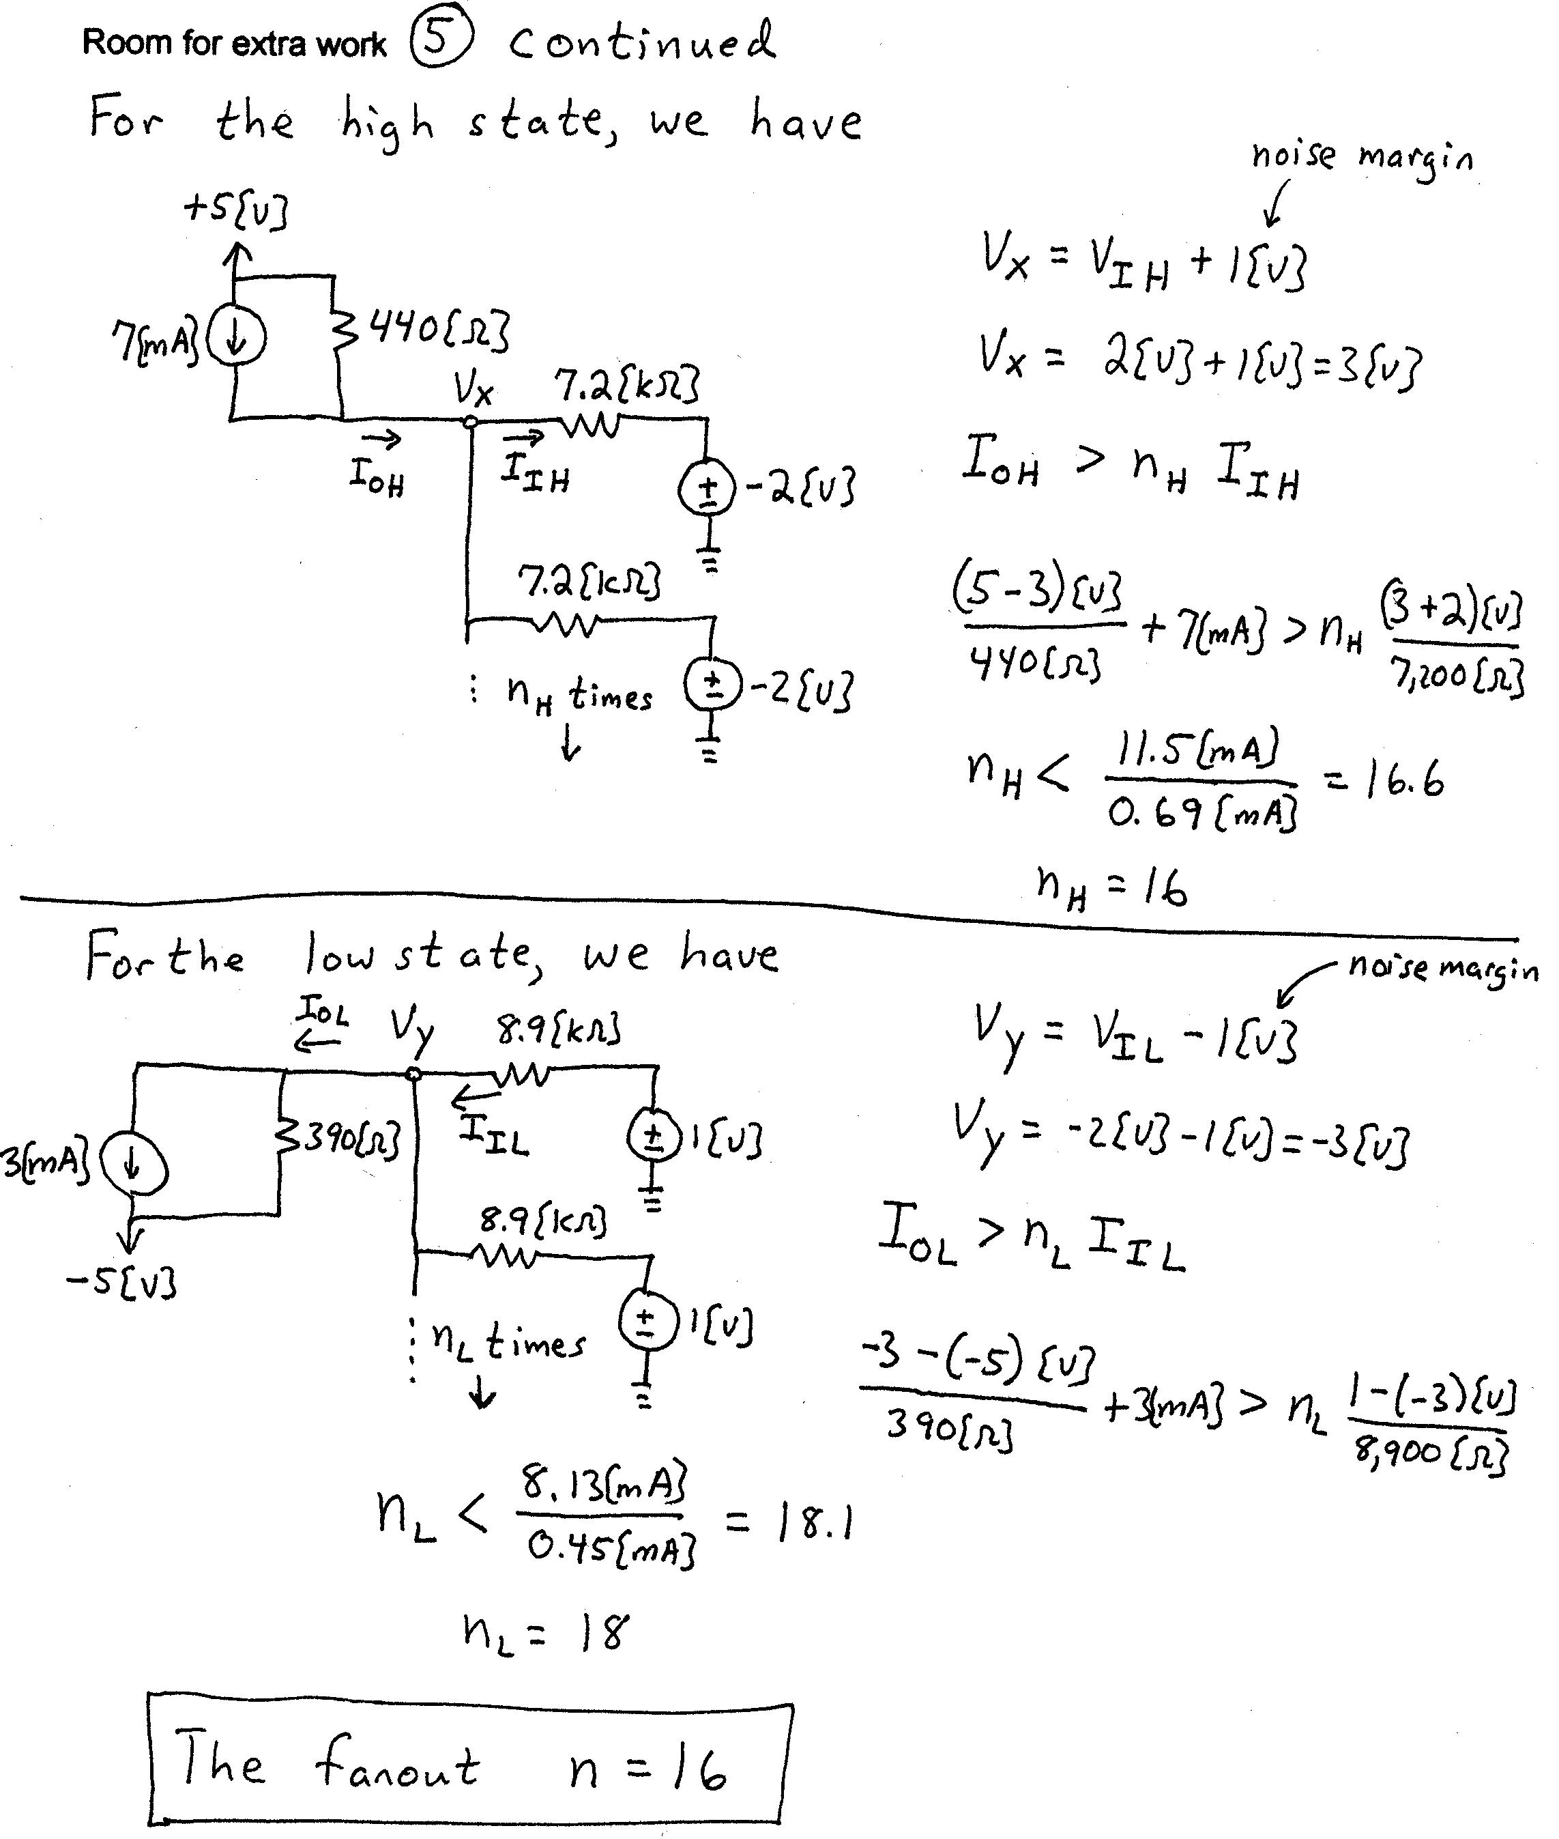
6) (15 Points) In this problem assume that the diodes can be modeled with a piecewise linear diode model, with V_{f} = 0.8[V],
r_{d} = 100[Ω], and I_{s} = 0. Assume that the op amp is ideal. The design goal is for v_{O}(t) to be a half-wave rectified version of v_{I}(t). The v_{I}(t) is a 2[V_{pp}] signal with zero mean.
Evaluate the two designs in Fig. 11 and Fig. 12. Show your approach and steps in this evaluation. One recommendation is that you pick dc inputs for each circuit, and find the output that would result for each dc input. Use your results to choose the better design for a half-wave rectifier.


