Name: _____________________________ (please print)
Signature: __________________________

ECE 3455
Exam 1

October 11, 2003

1. This exam is closed book. You may have a crib sheet consisting of one 8 ½ x 11” sheet of paper written on both sides (or the equivalent area on another medium). You may use any calculator, but no computers or laptops are allowed.
2. Show all work necessary to complete the problem on these pages. If you go on to another page, indicate clearly where your work can be found. A solution without the work shown will receive no credit.
- Show all units in expressions and figures.
- You will have 90 minutes to work on this quiz.
- This exam has 9 pages, including the cover sheet. Raise your hand if you are missing a page.

1 ________________/35

2 ________________/35

3 ________________/30

Total ________________/100
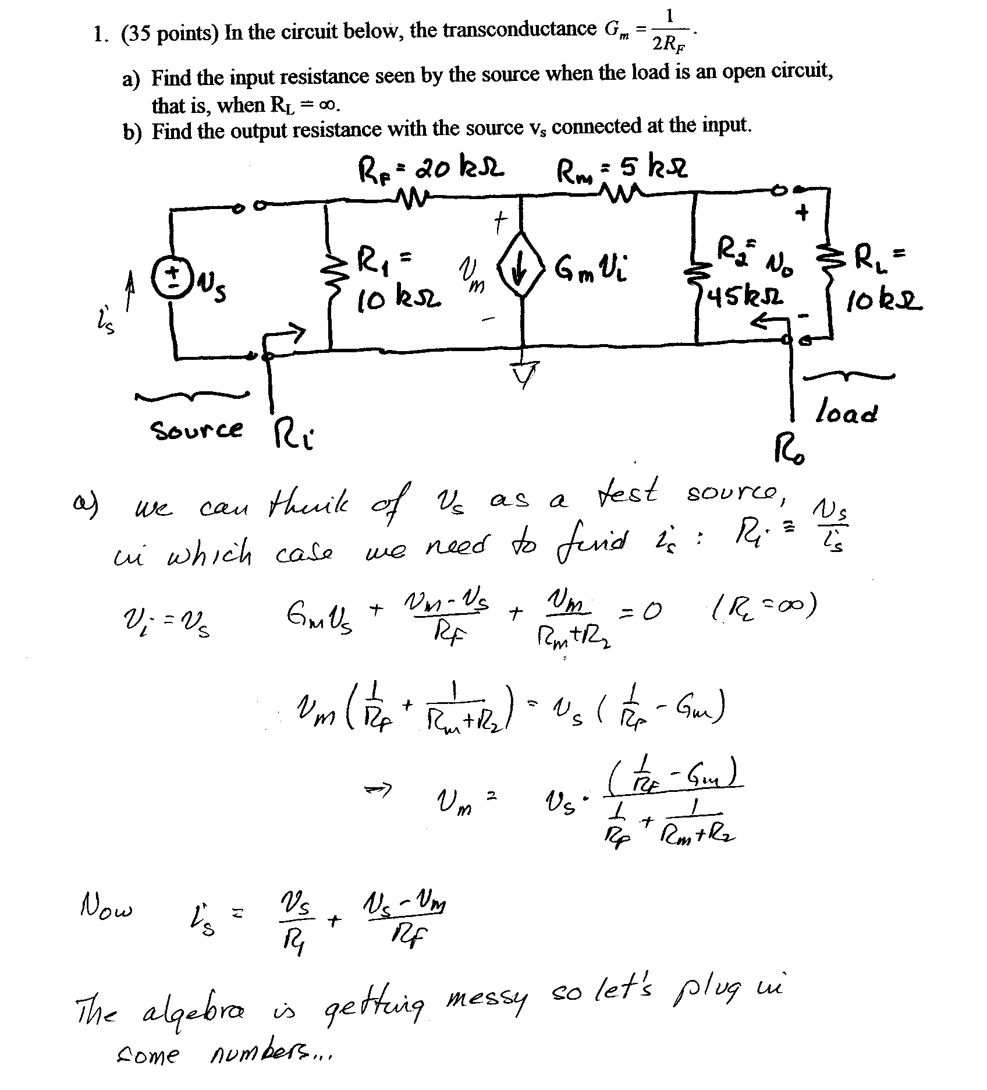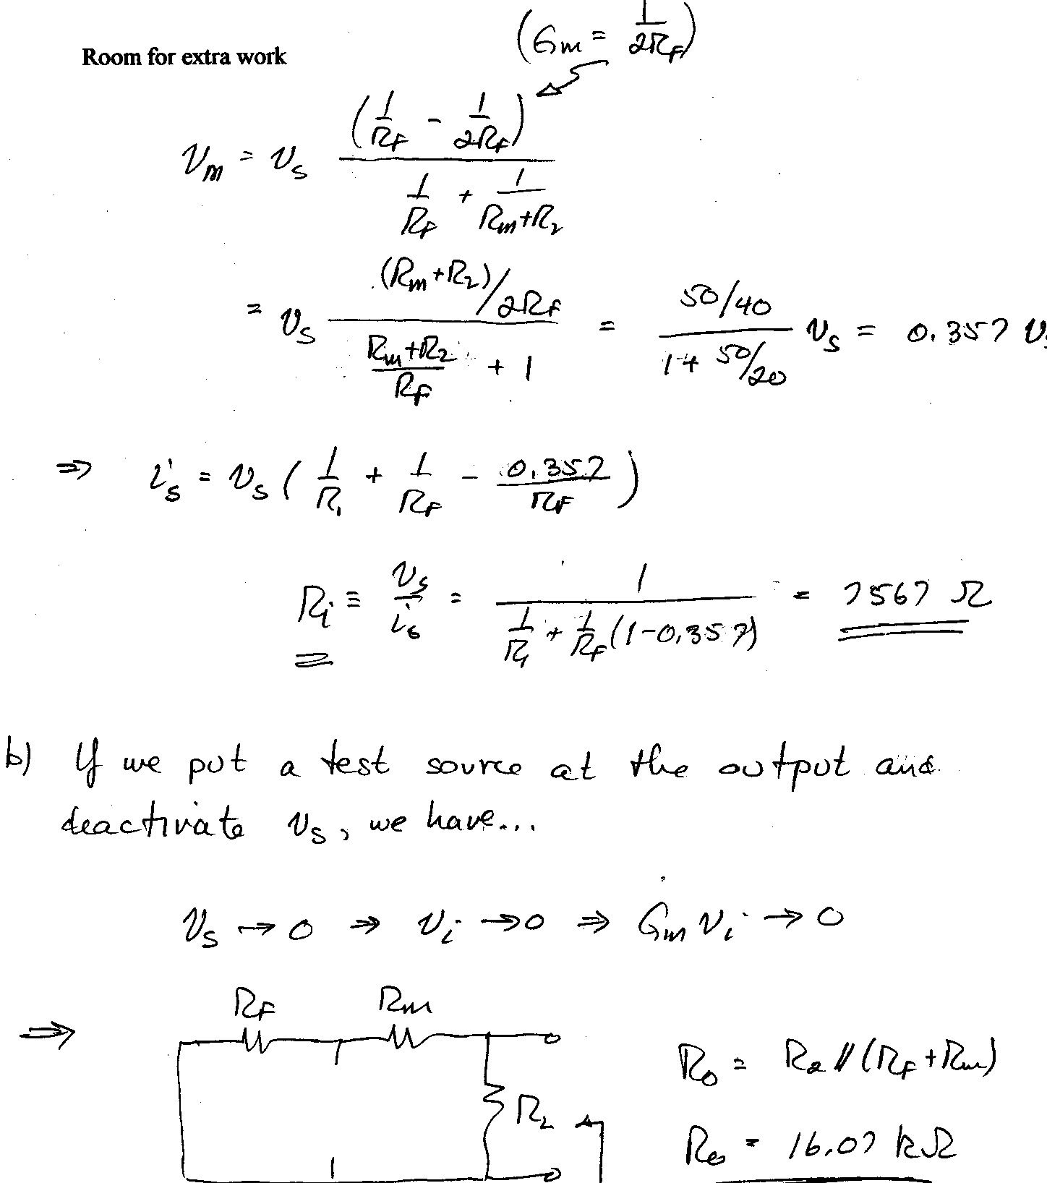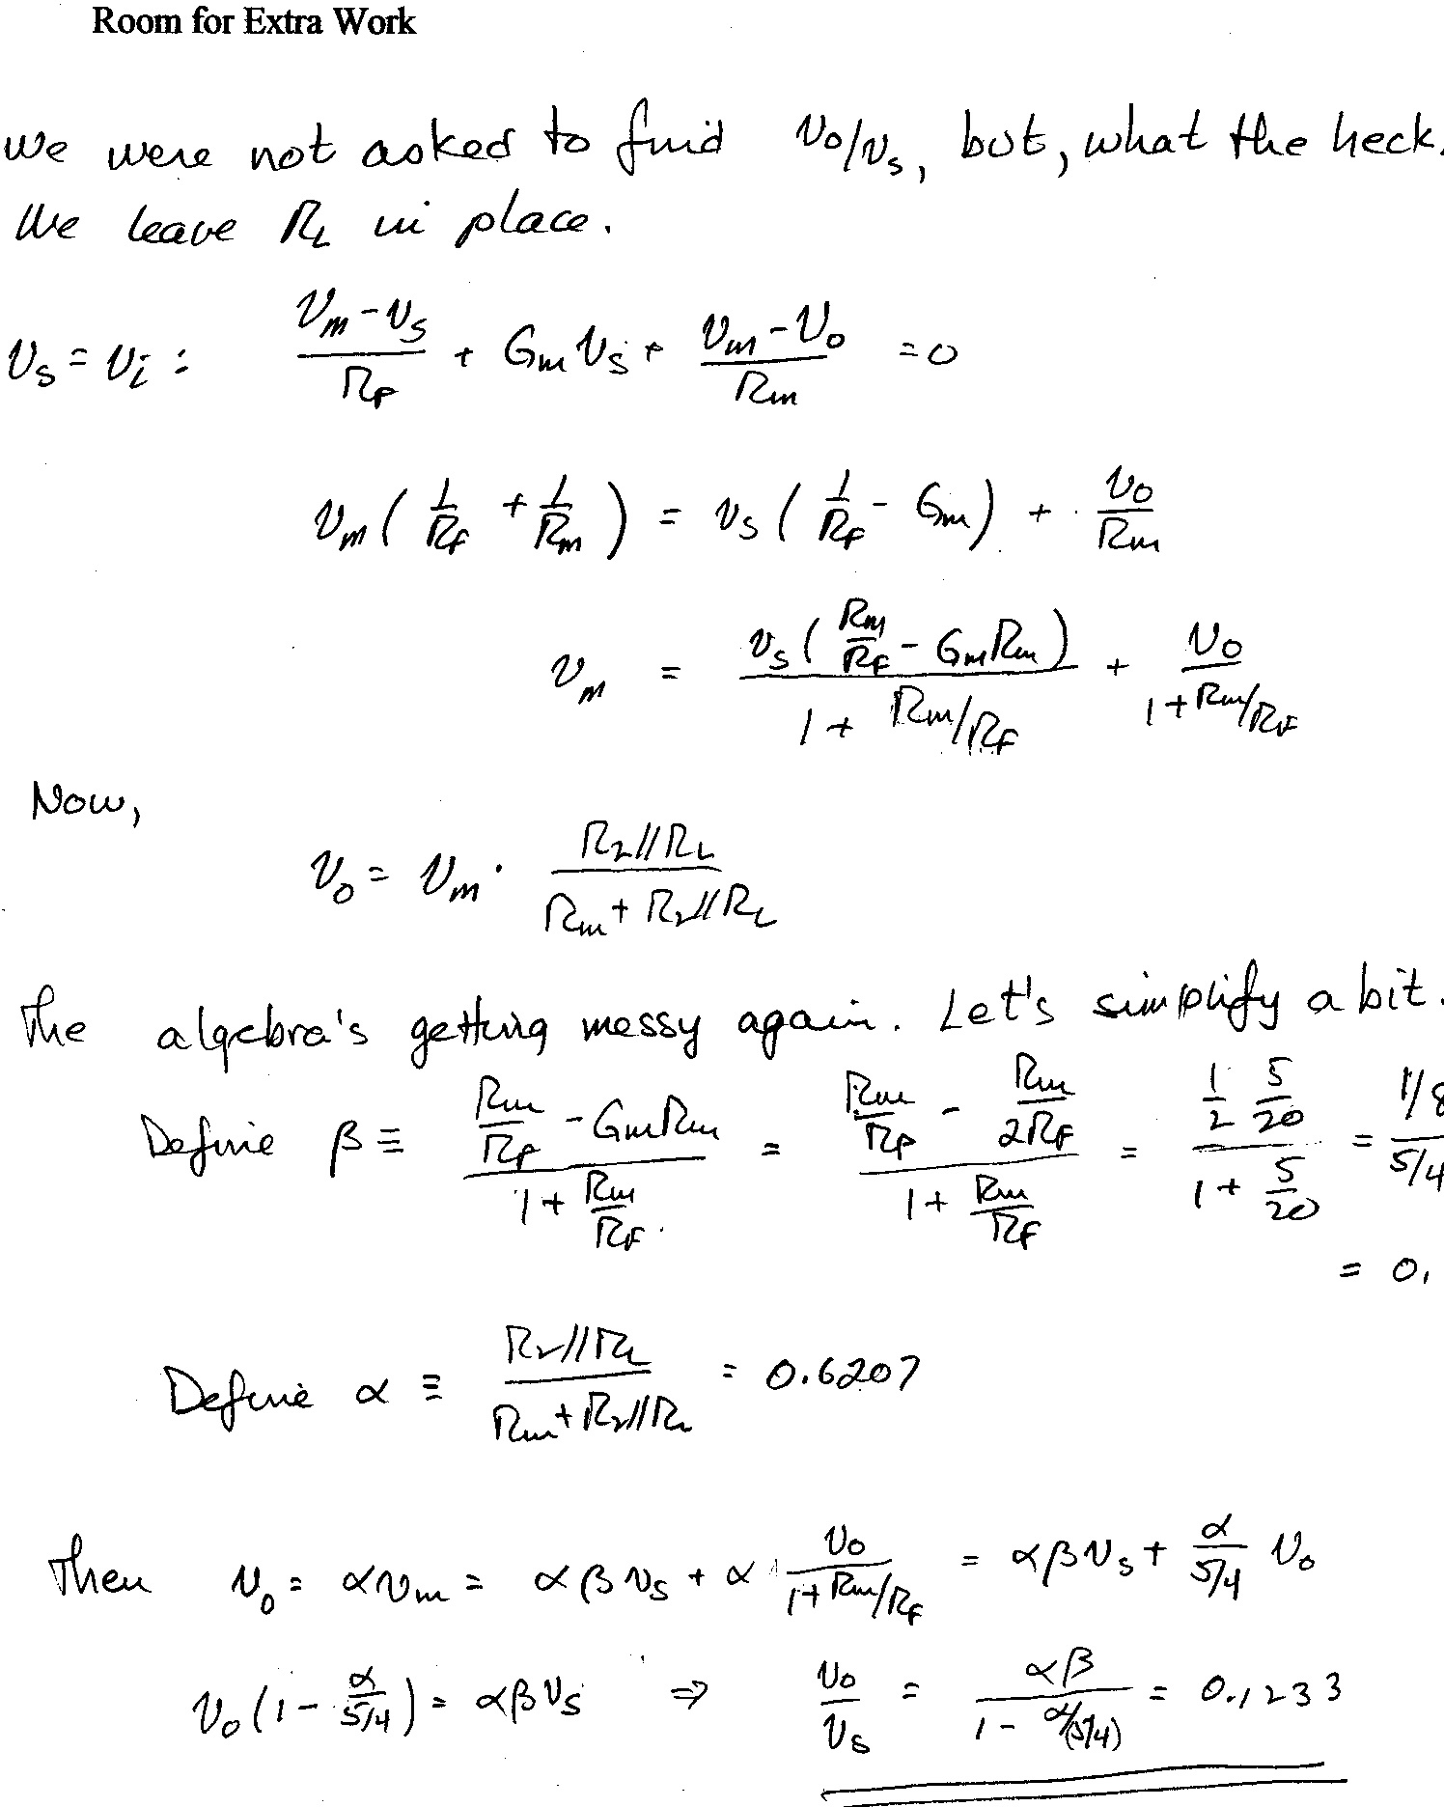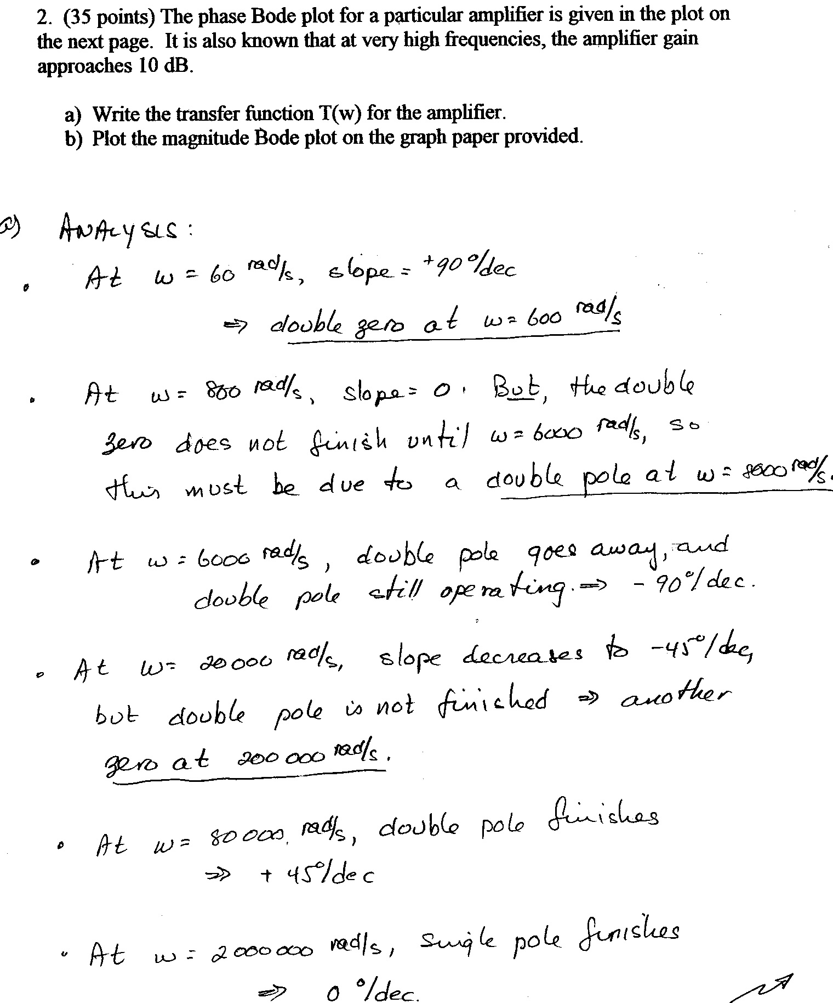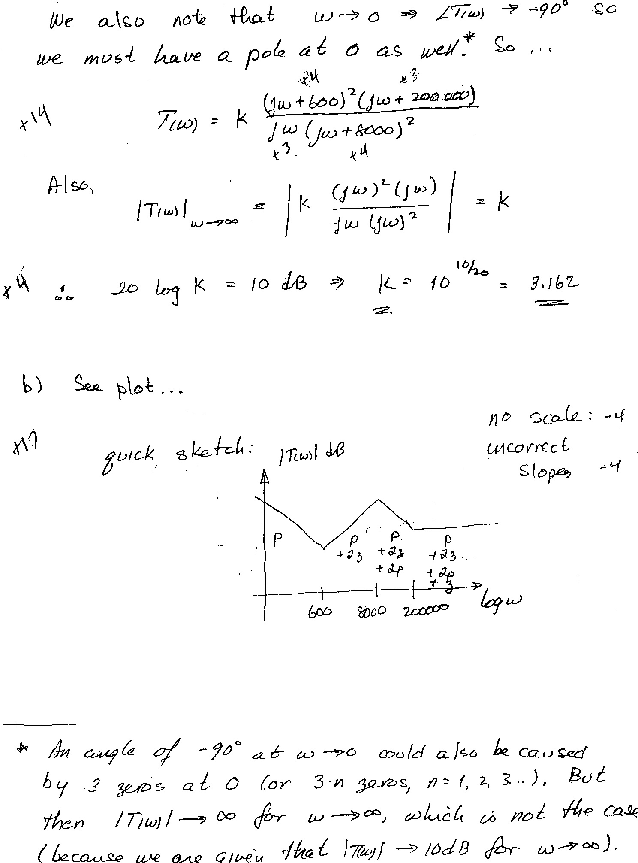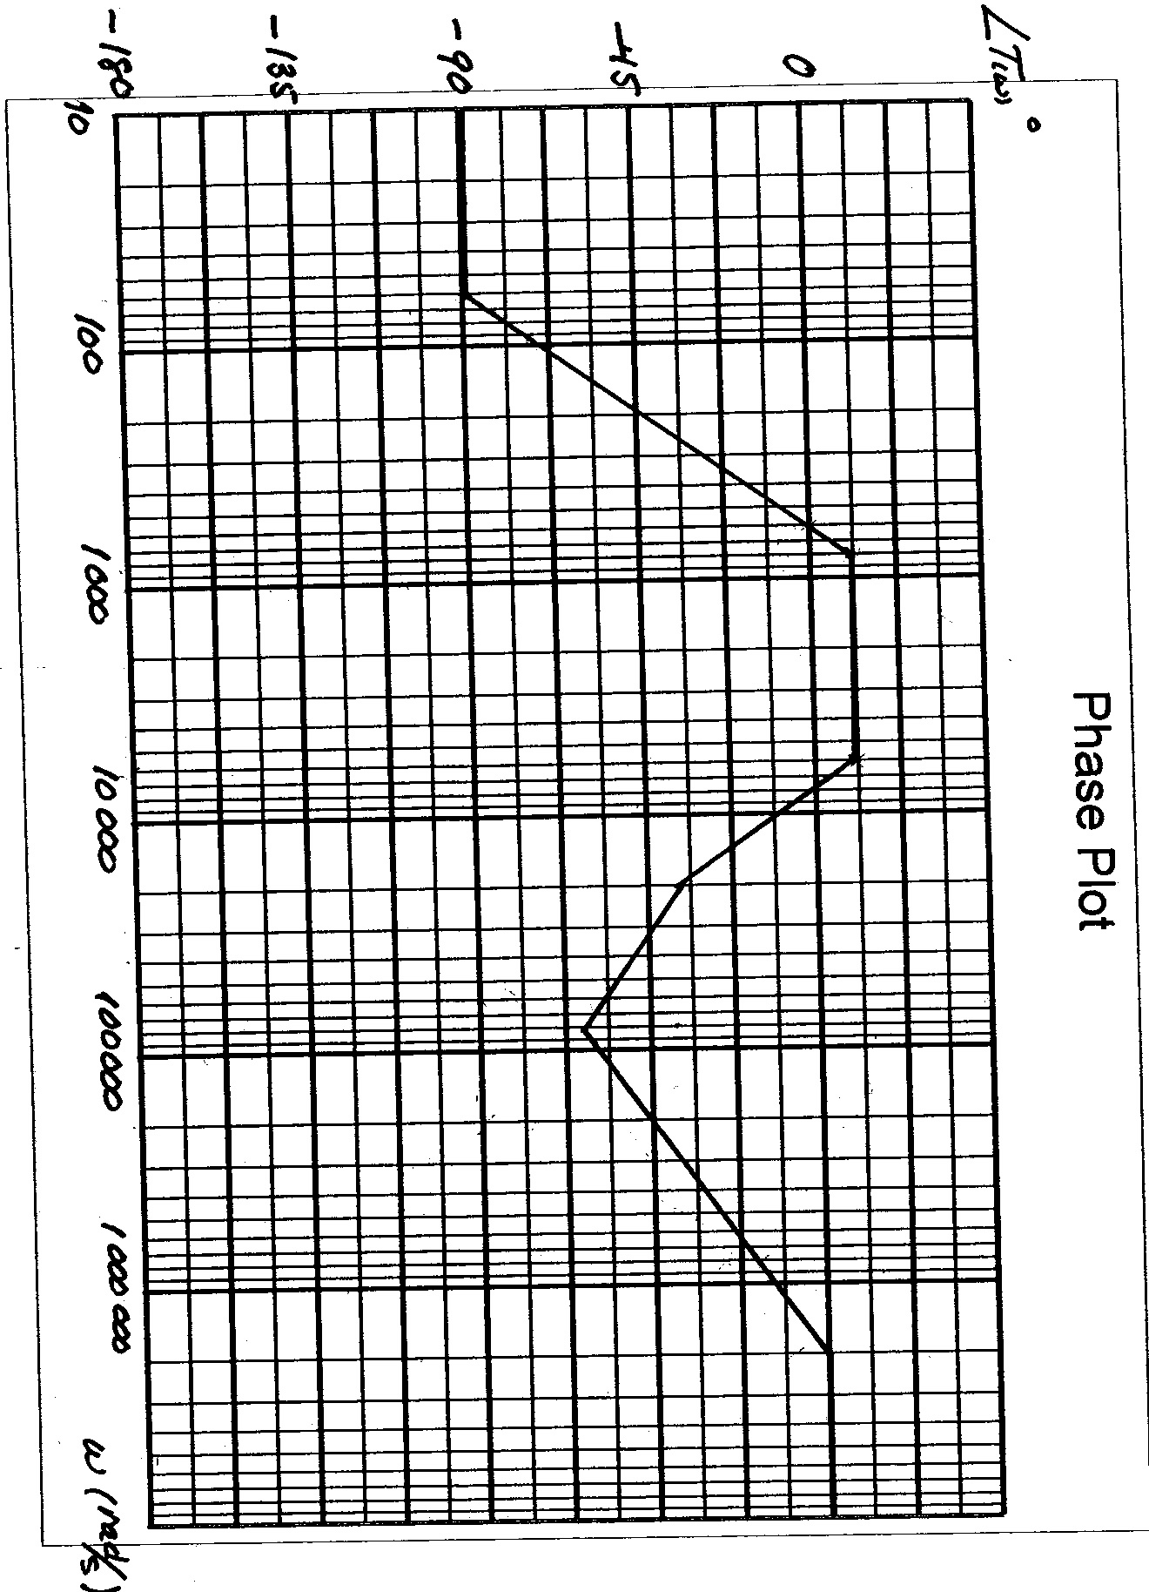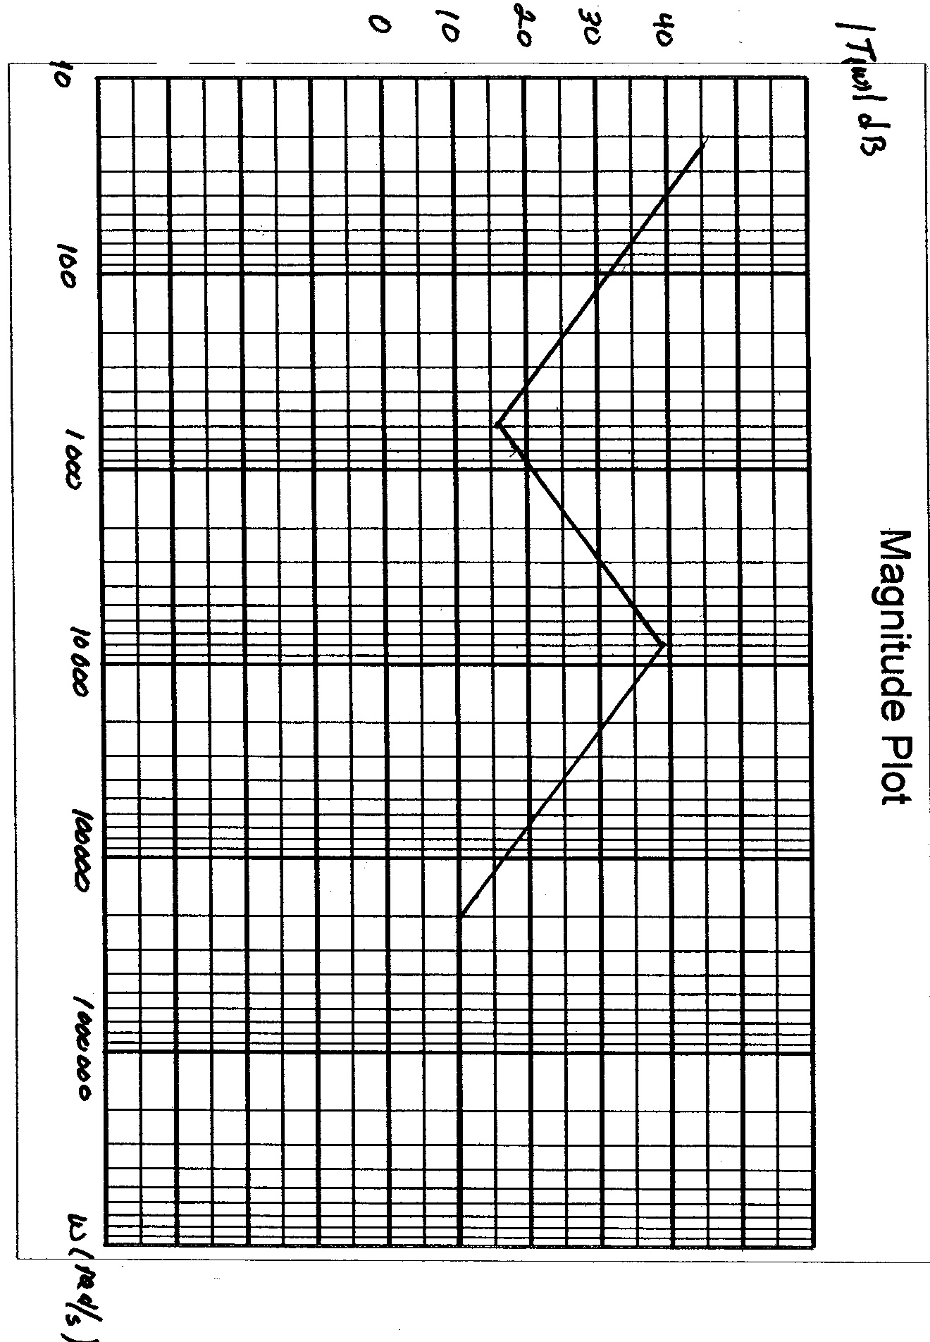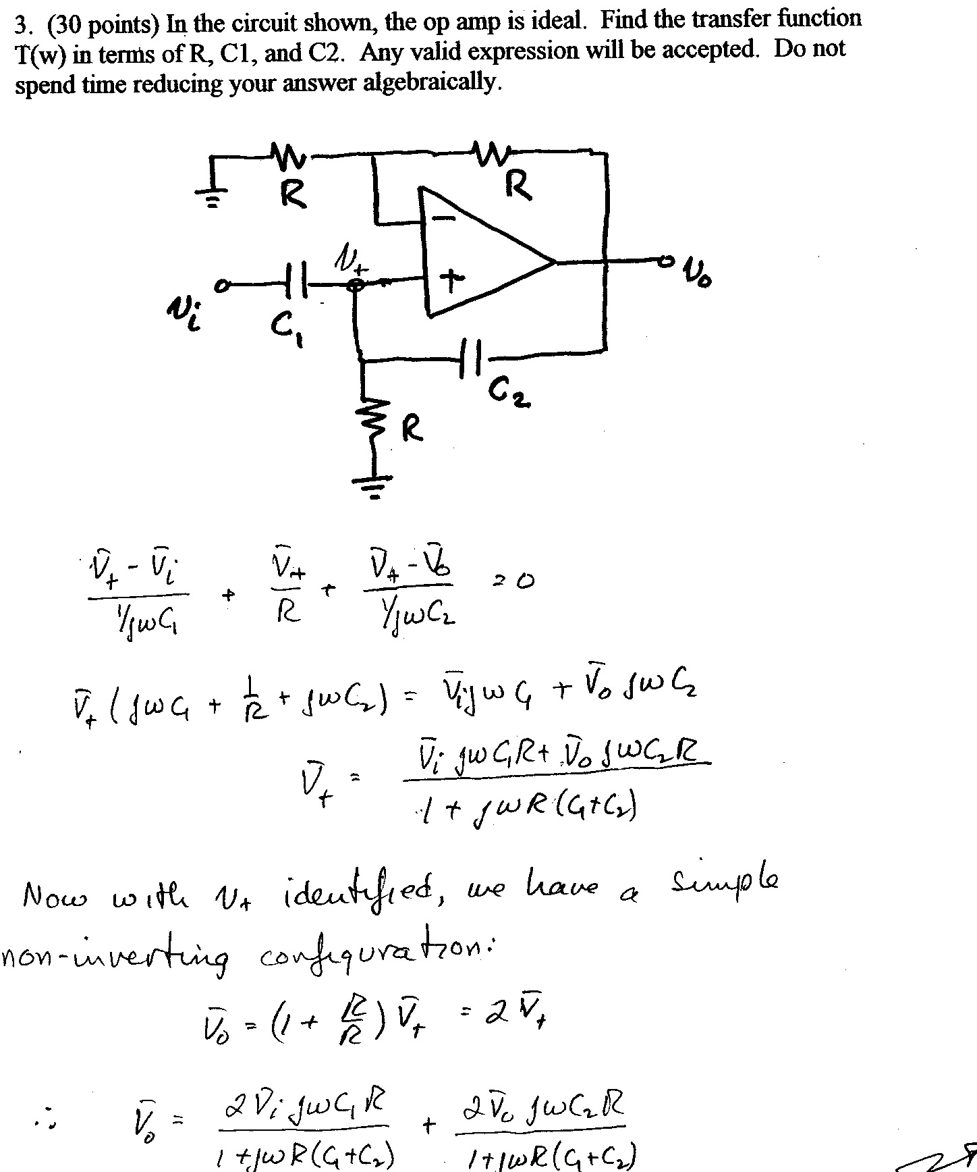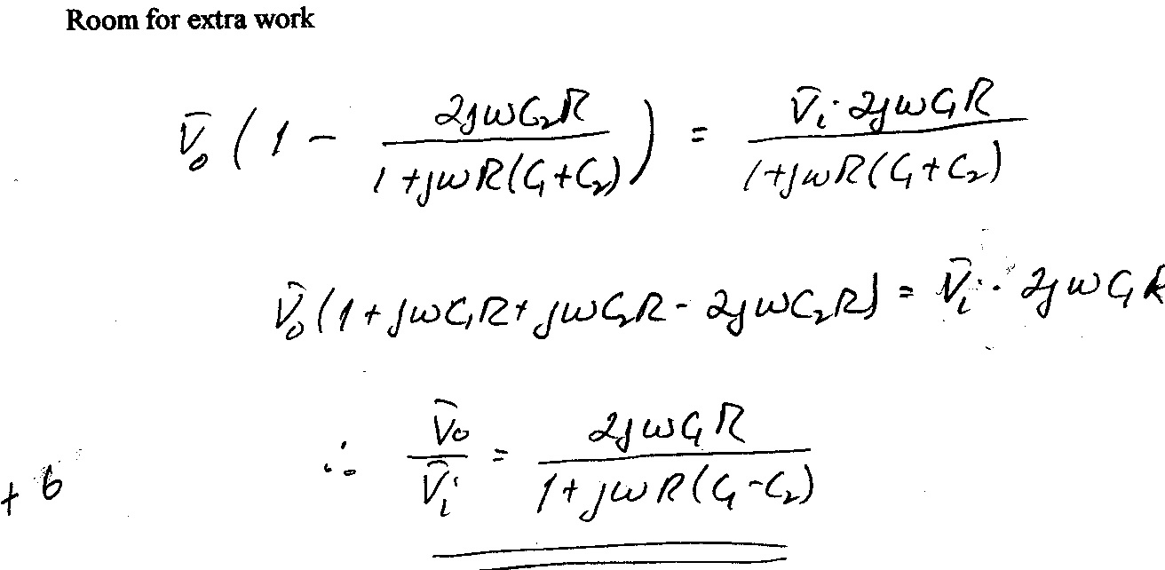
a

