Name: _____________________________ (please print)
Signature: __________________________

ECE 3455 -- Exam #2
November 13, 2004

Keep this exam closed until you are told to begin.

1. This exam is closed book, closed notes. You may use one 8.5” x 11” crib sheet, or its equivalent.
2. Show all work on these pages. Show all work necessary to complete the problem. A solution without the appropriate work shown will receive no credit. A solution that is not given in a reasonable order will lose credit. Clearly indicate your answer (for example by enclosing it in a box).
3. It is assumed that your work will begin on the same page as the problem statement. If you choose to begin your work on another page, you must indicate this on the page with the problem statement, with a clear indication of where the work can be found. If your work continues on to another page, indicate clearly where your work can be found. Failure to indicate this clearly will result in a loss of credit.
4. Show all units in solutions, intermediate results, and figures. Units in the exam will be included between square brackets.
5. Do not use red ink. Do not use red pencil.
6. You will have 90 minutes to work on this exam.

1. ________________/30
2. ________________/30
3. ________________/45
Total = 105

Room for extra work
1. {30 Points} Assume an ideal op amp. This op amp has negative feedback when the op amp is not saturated.
The voltage v_{s}(t) is a zero-mean triangle wave with peak-to-peak amplitude of 2[V_{pp}].
Find the input resistance seen by the source.
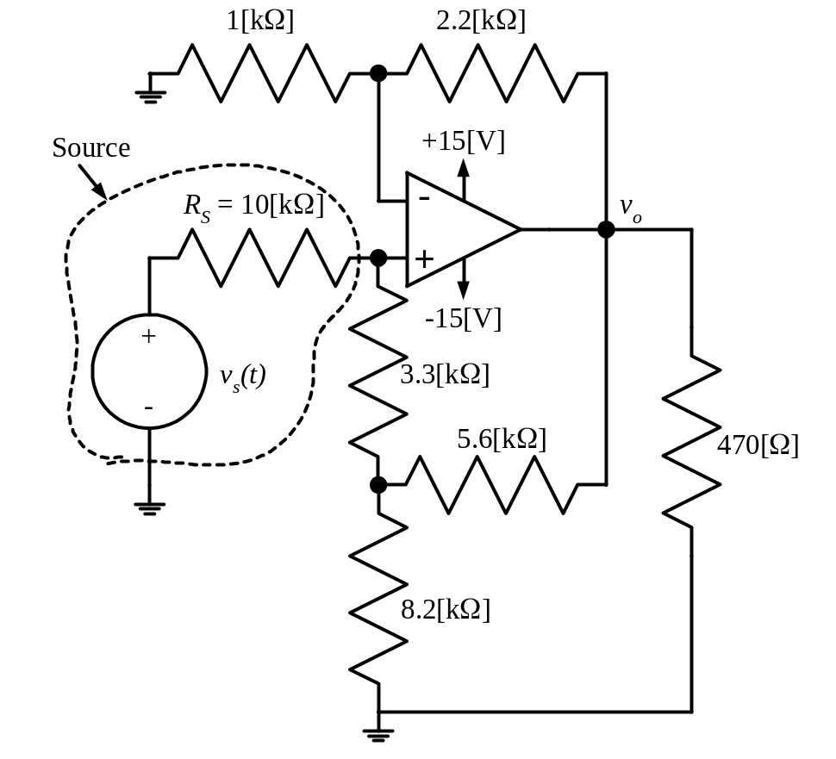

Room for extra work

2. {30 Points} Assume that the diodes can be modeled with a piecewise linear diode model with I_{s} = 0, V_{f} = 1[V], and r_{d} = 1[kΩ].
Find V_{X}.
Show your work.

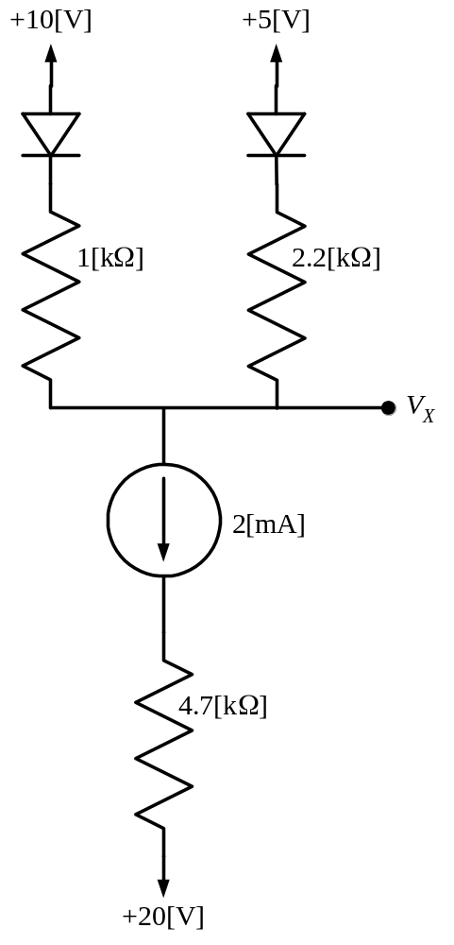

Room for extra work

3. {45 Points} Assume an ideal op amp. Assume that the diode can be modeled with a piecewise linear diode model with I_{s} = 1[mA], V_{f} = 0.7[V], and r_{d} = 1[kΩ].
- What values of v_{I} will give diode conditions at the transitions between two adjacent regions of the diode model?
- What values of v_{I} will make the op amp saturate?

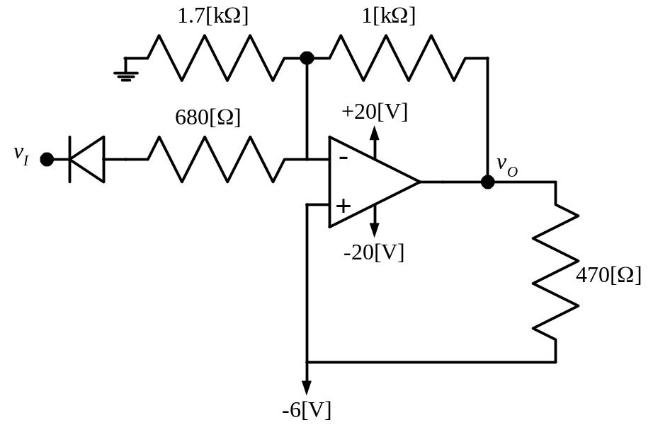

Room for extra work

1. {30 Points} Assume an ideal op amp. This op amp has negative feedback when the op amp is not saturated.
The voltage v_{s}(t) is a zero-mean triangle wave with peak-to-peak amplitude of 2[V_{pp}].
Find the input resistance seen by the source.
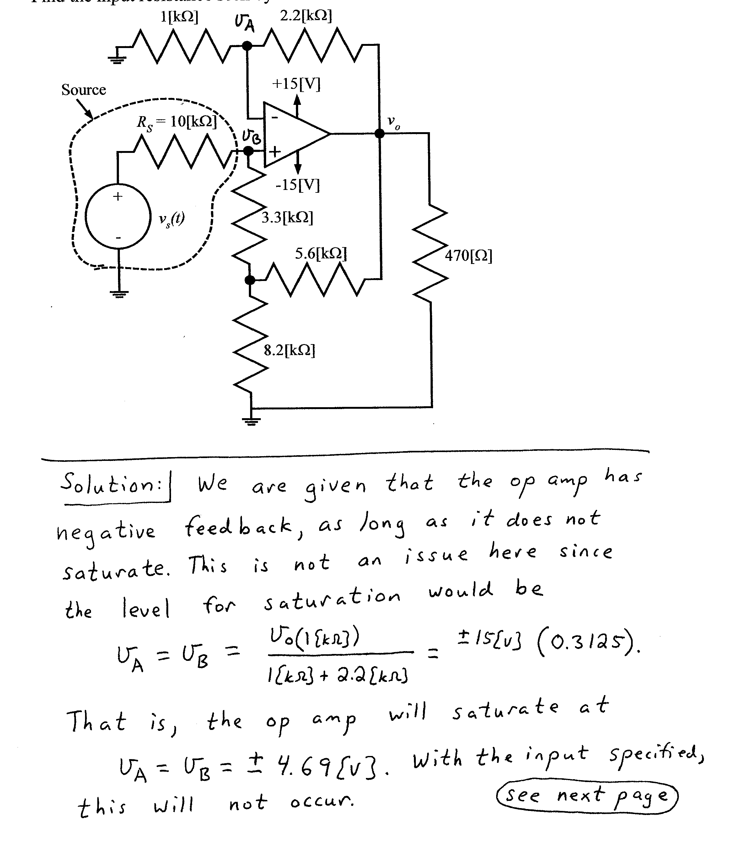
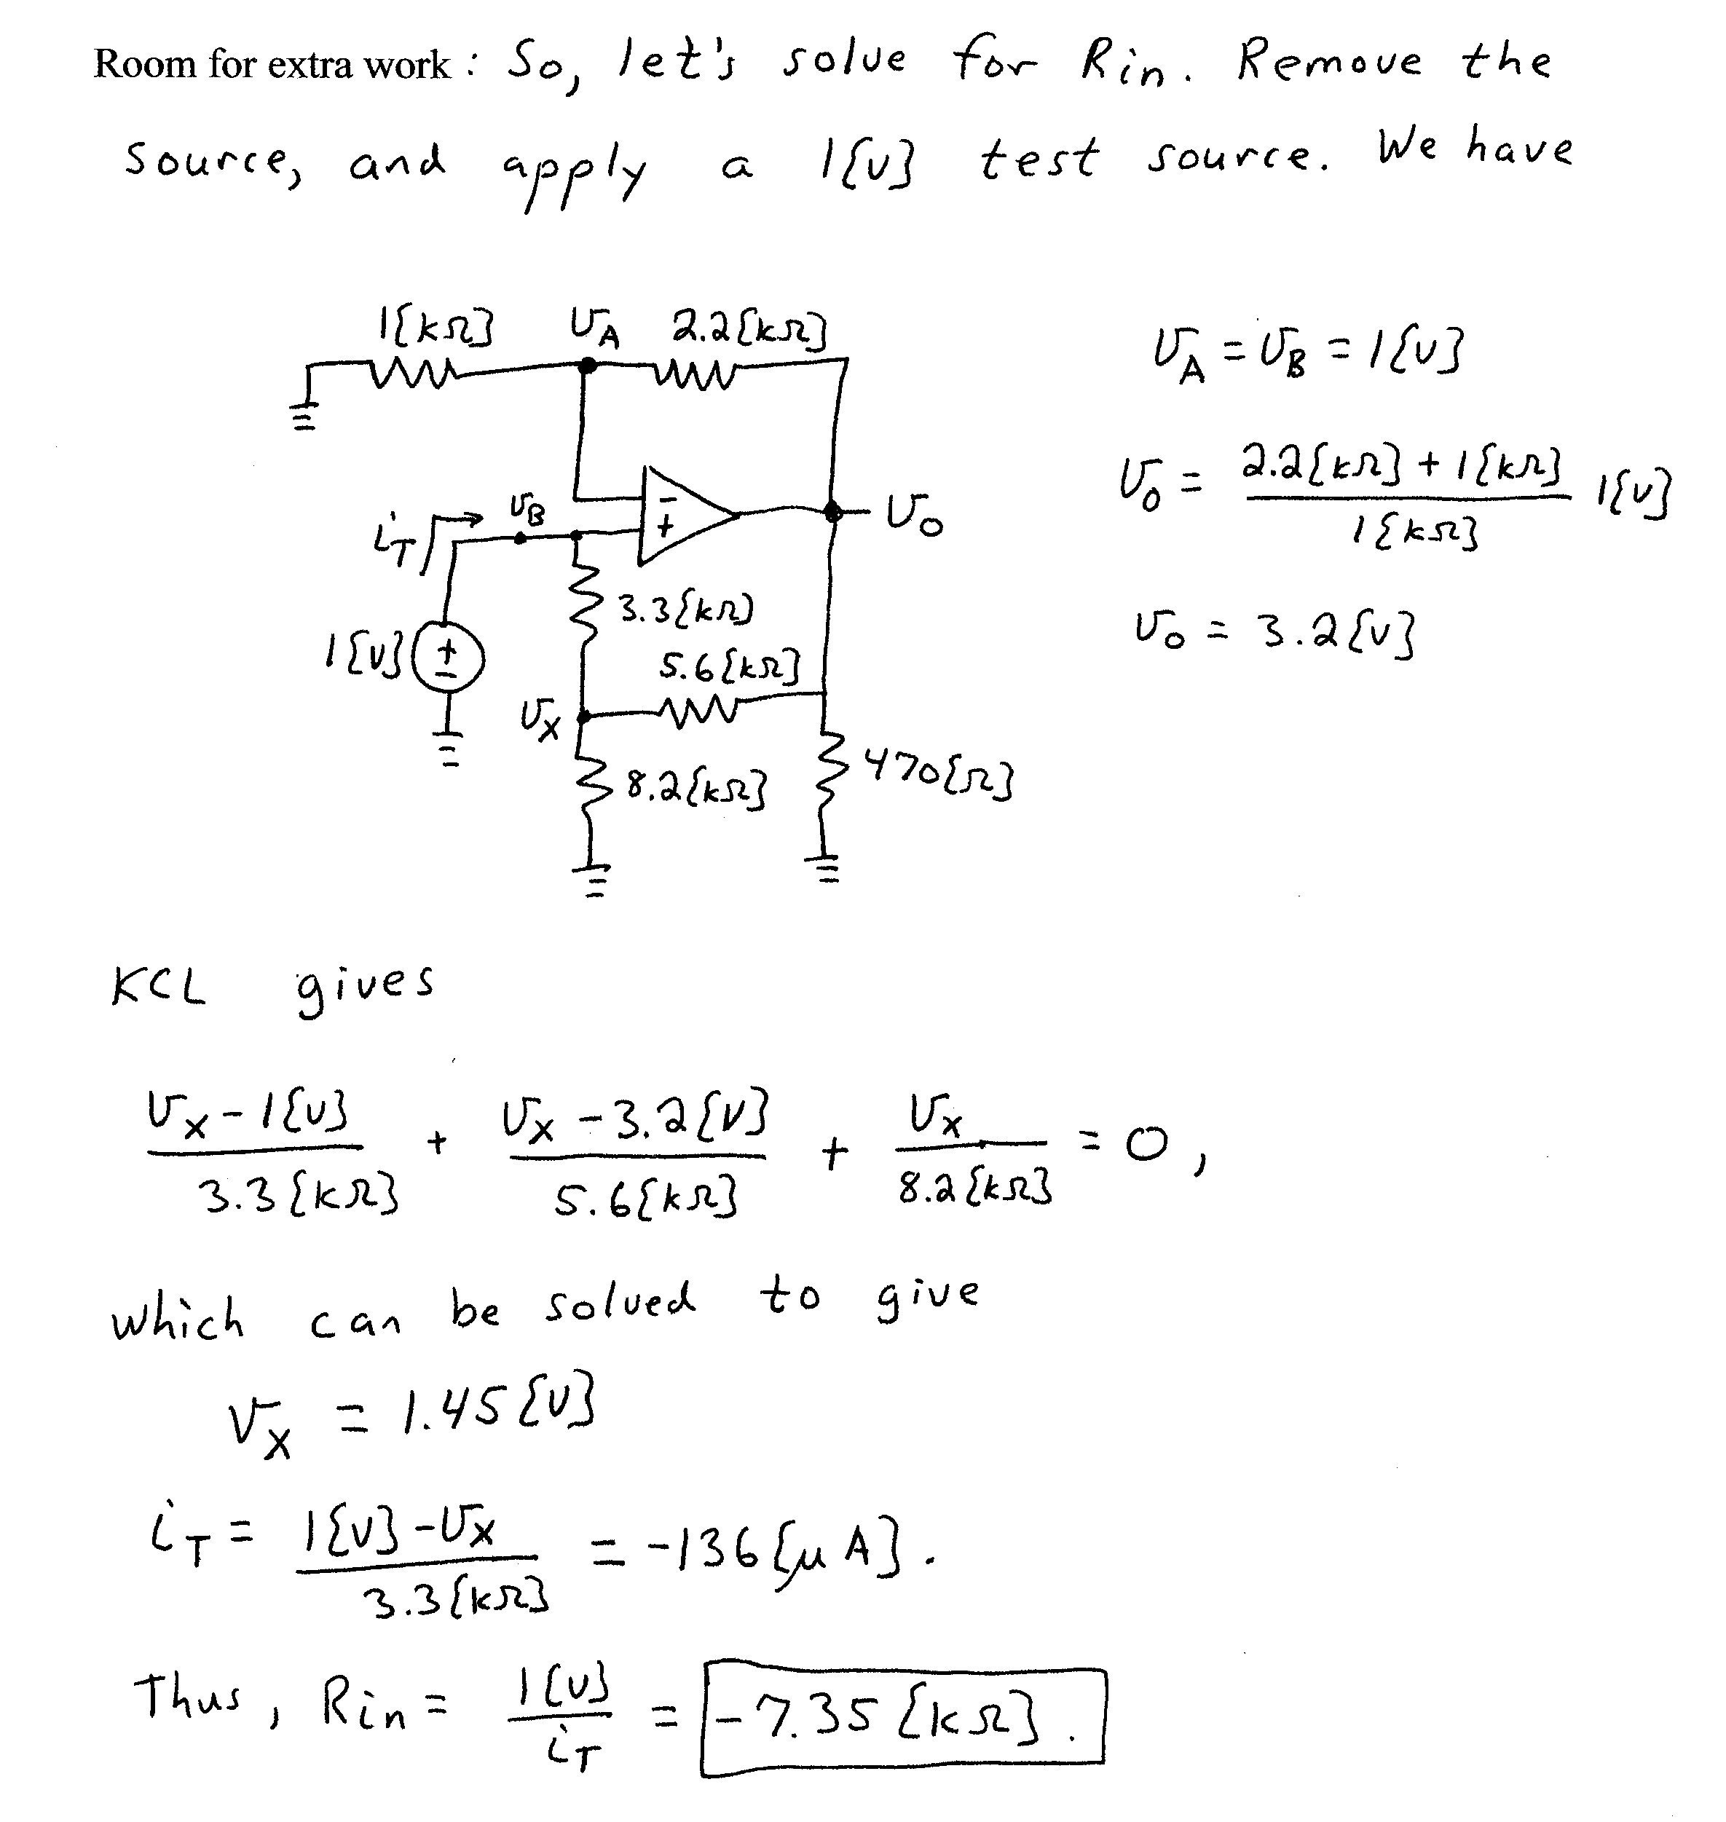

2. {30 Points} Assume that the diodes can be modeled with a piecewise linear diode model with I_{s} = 0, V_{f} = 1[V], and r_{d} = 1[kΩ].
Find V_{X}.
Show your work.
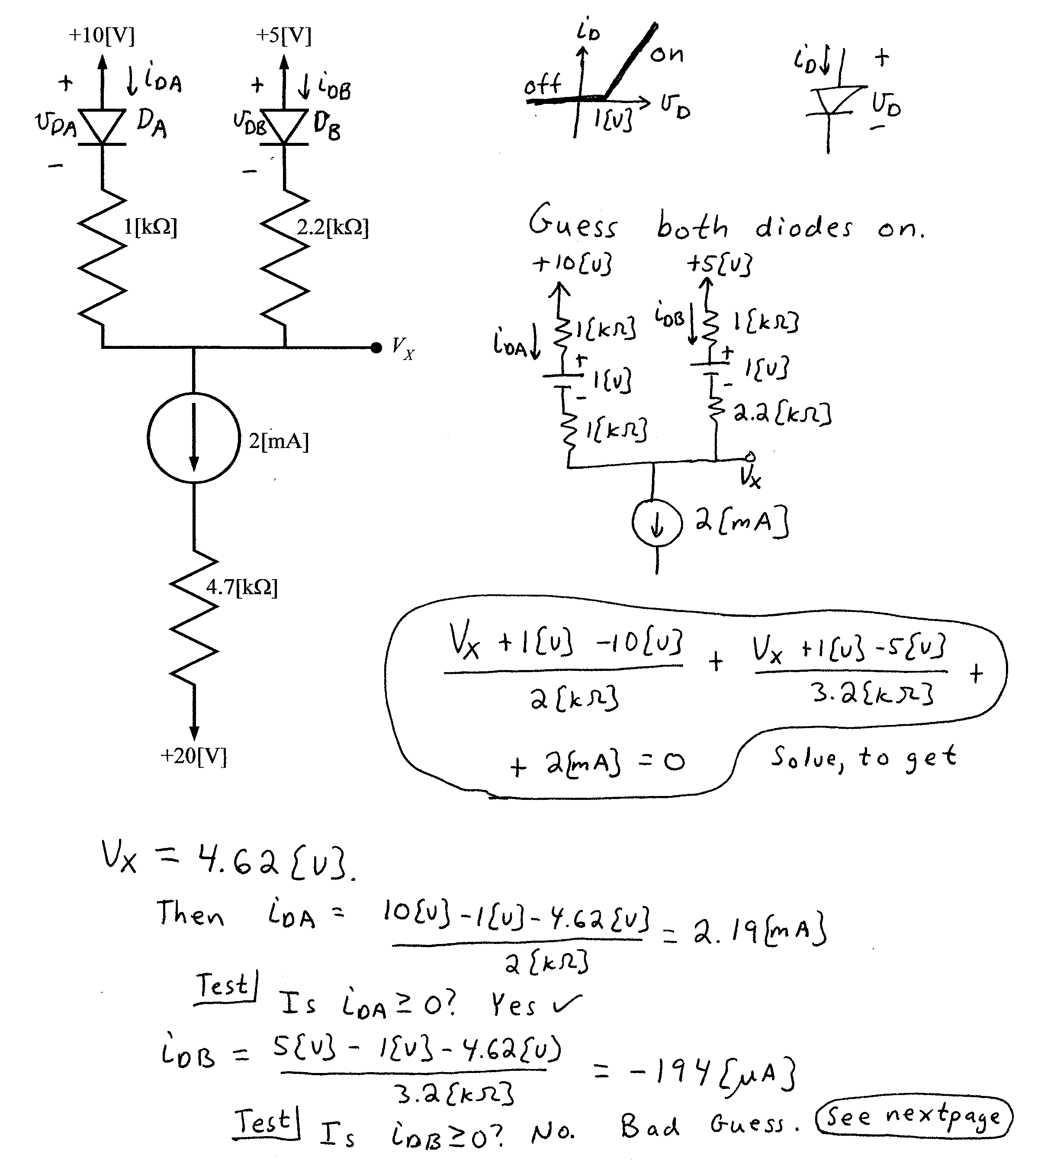
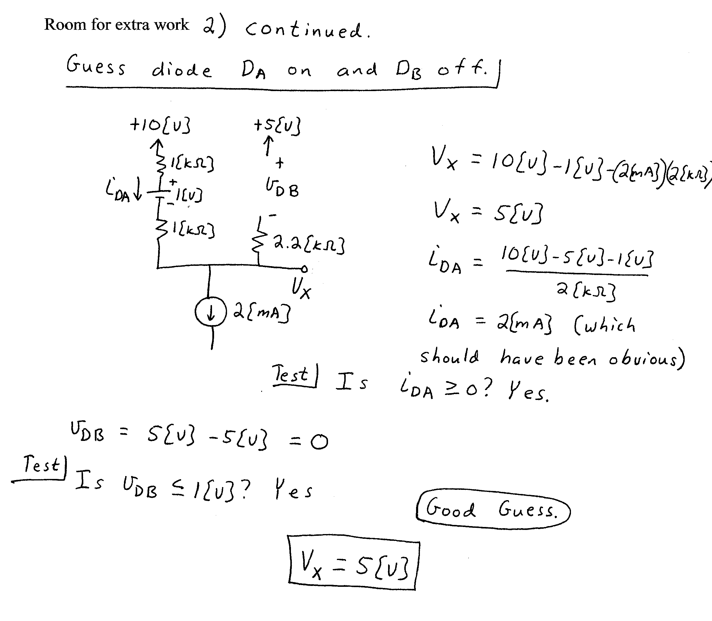

3. {45 Points} Assume an ideal op amp. Assume that the diode can be modeled with a piecewise linear diode model with I_{s} = 1[mA], V_{f} = 0.7[V], and r_{d} = 1[kΩ].
- What values of v_{I} will give diode conditions at the transitions between two adjacent regions of the diode model?
- What values of v_{I} will make the op amp saturate?



