Name: _____________________________ (please print)
Signature: __________________________

ECE 3455 – Final Exam
December 6, 2004

Keep this exam closed until you are told to begin.

1. This exam is closed book, closed notes. You may use one 8.5” x 11” crib sheet, or its equivalent.
2. Show all work on these pages. Show all work necessary to complete the problem. A solution without the appropriate work shown will receive no credit. A solution that is not given in a reasonable order will lose credit. Clearly indicate your answer (for example by enclosing it in a box).
3. It is assumed that your work will begin on the same page as the problem statement. If you choose to begin your work on another page, you must indicate this on the page with the problem statement, with a clear indication of where the work can be found. If your work continues on to another page, indicate clearly where your work can be found. Failure to indicate this clearly will result in a loss of credit.
4. Show all units in solutions, intermediate results, and figures. Units in the exam will be included between square brackets.
5. Do not use red ink. Do not use red pencil.
6. You will have 180 minutes to work on this exam.

1. ________________/20
2. ________________/20
3. ________________/20
4. ________________/20
5. ________________/20
6. ________________/20
Total = 120

Room for extra work
1. {20 Points} Assume ideal op amps.
Find the voltage gain, v_{o}/v_{i}.

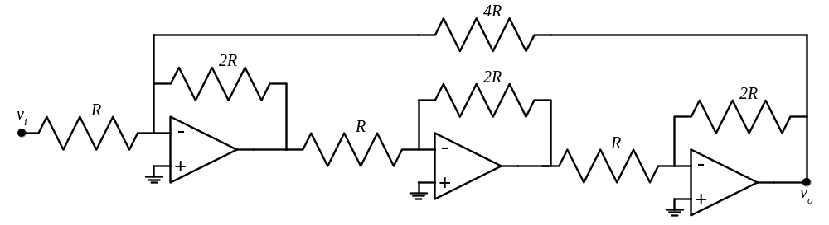

Room for extra work

2. {20 Points} Assume that the diode in Figure 1 can be modeled with the piecewise linear diode model shown in Figure 2. Note that the scale for positive values and the scale for negative values are different.
a) For each of the five regions shown, state a test that could be used to determine whether the diode has been biased into that region.
b) Find the ac model that could be used to model the diode, when it has been biased into each of the five regions. The model should be valid for small signals, which keep the diode within that region. Note that this question asks for the signal model only.

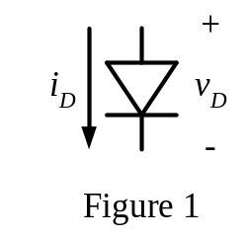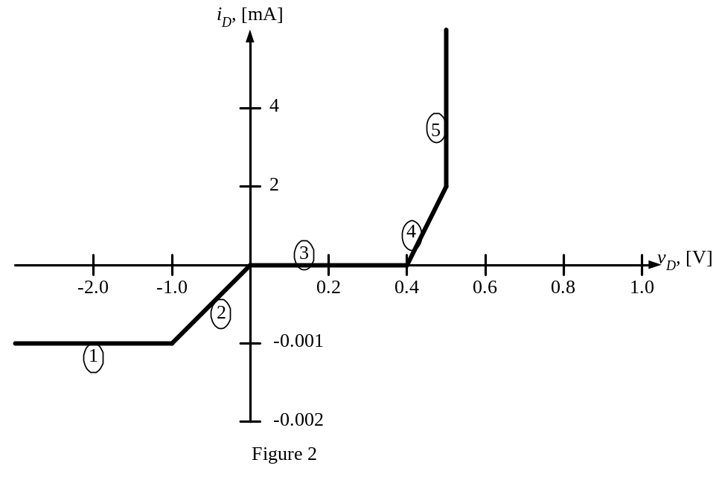

Room for extra work

3. {20 Points} Assume an ideal op amp. Note that the power supply levels are +25[V] and –10[V]. Quantitatively describe the voltage v_{A}(t). Use diagrams and plots as necessary to make your work and your answers clear.

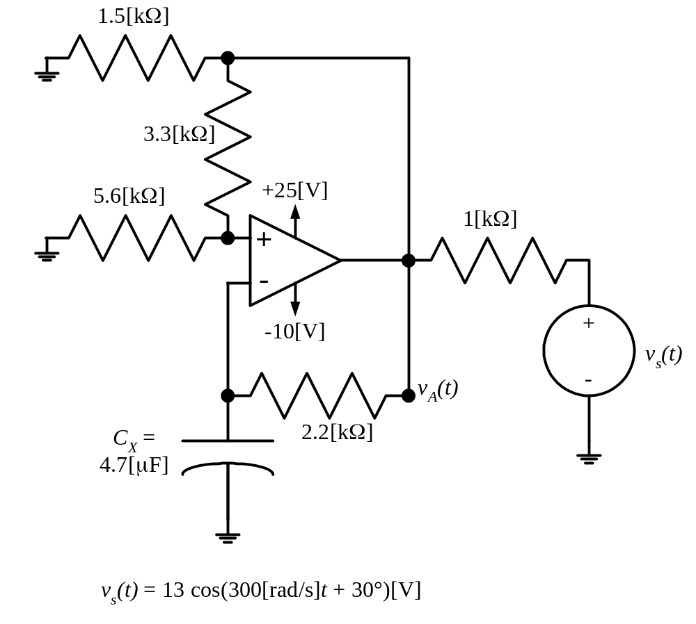

Room for extra work

4. {20 Points} Assume that the β for each of these transistors is 200. Find V_{Q}. Show your work. The transistors are biased into the linear region.

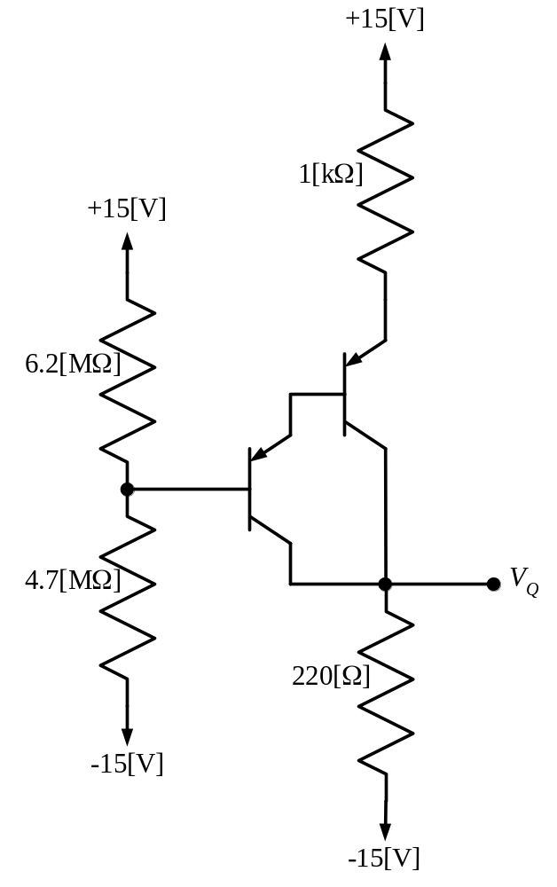

Room for extra work

5. {20 Points} Assume that the transistor shown has a β = 100 and that it is operating at room temperature.
a) Find the voltage gain, v_{o}/v_{s}, in the passband.
b) Find the current gain, i_{o}/i_{s}, in the passband.

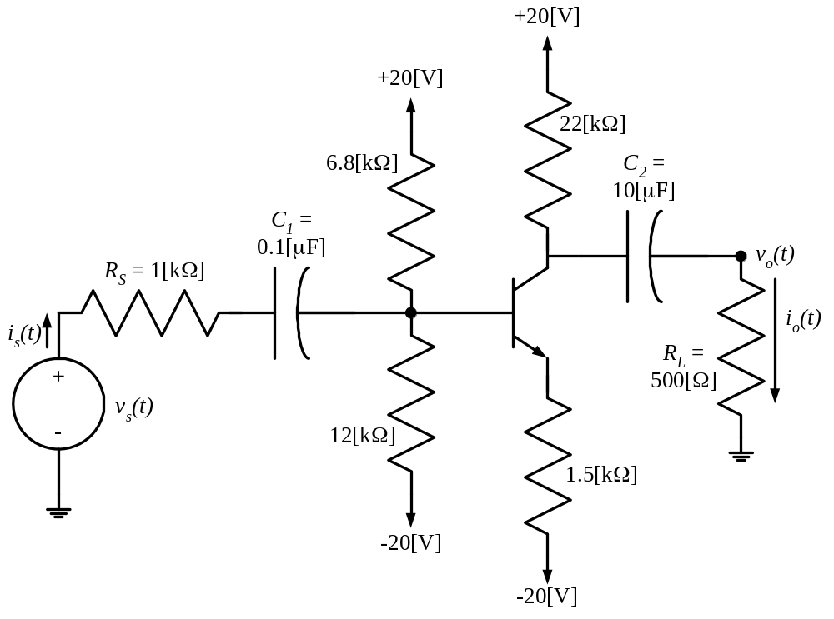

Room for extra work

6. {20 Points} The schematic symbol for a Giambulator is shown in Figure 1. Two characteristic curves for this device are shown in Figure 2 and Figure 3. Find a model that could be used to predict the behavior of a Giambulator that has been biased into Region 1, for small signals. Draw the model, labeling all components with their numerical values, and labeling terminals a, b, and c.

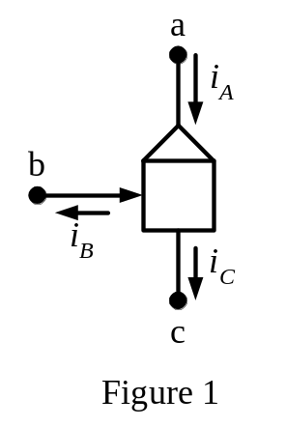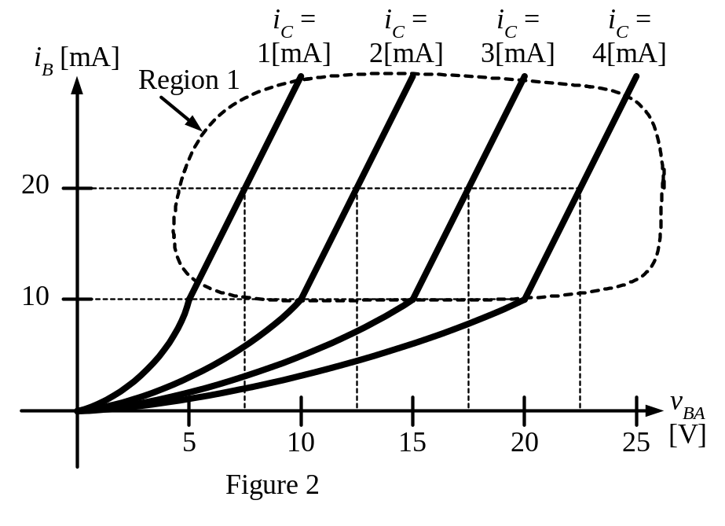
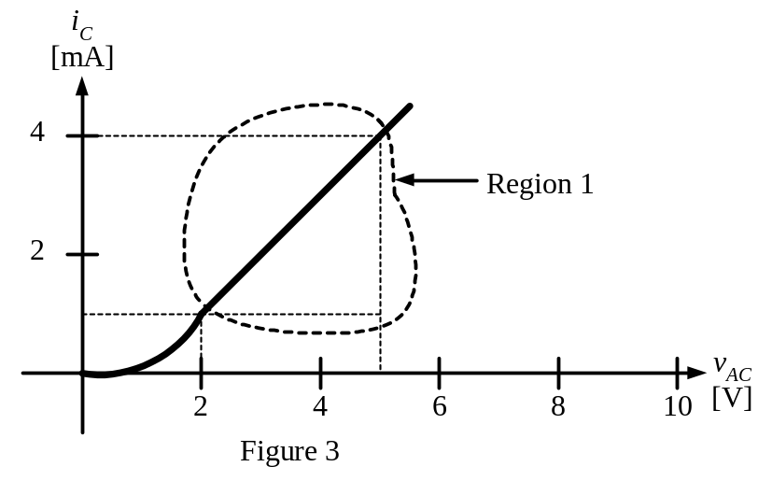

SOLUTION:
1. {20 Points} Assume ideal op amps.
Find the voltage gain, v_{o}/v_{i}.

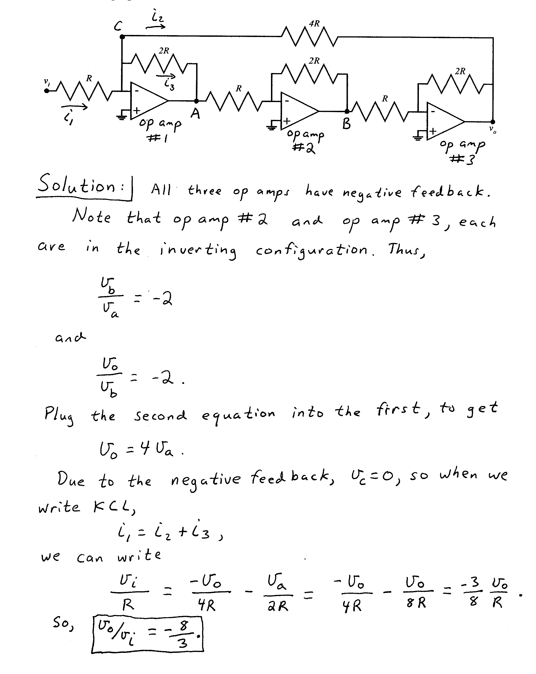

2. {20 Points} Assume that the diode in Figure 1 can be modeled with the piecewise linear diode model shown in Figure 2. Note that the scale for positive values and the scale for negative values are different.
a) For each of the five regions shown, state a test that could be used to determine whether the diode has been biased into that region.
b) Find the ac model that could be used to model the diode, when it has been biased into each of the five regions. The model should be valid for small signals, which keep the diode within that region. Note that this question asks for the signal model only.


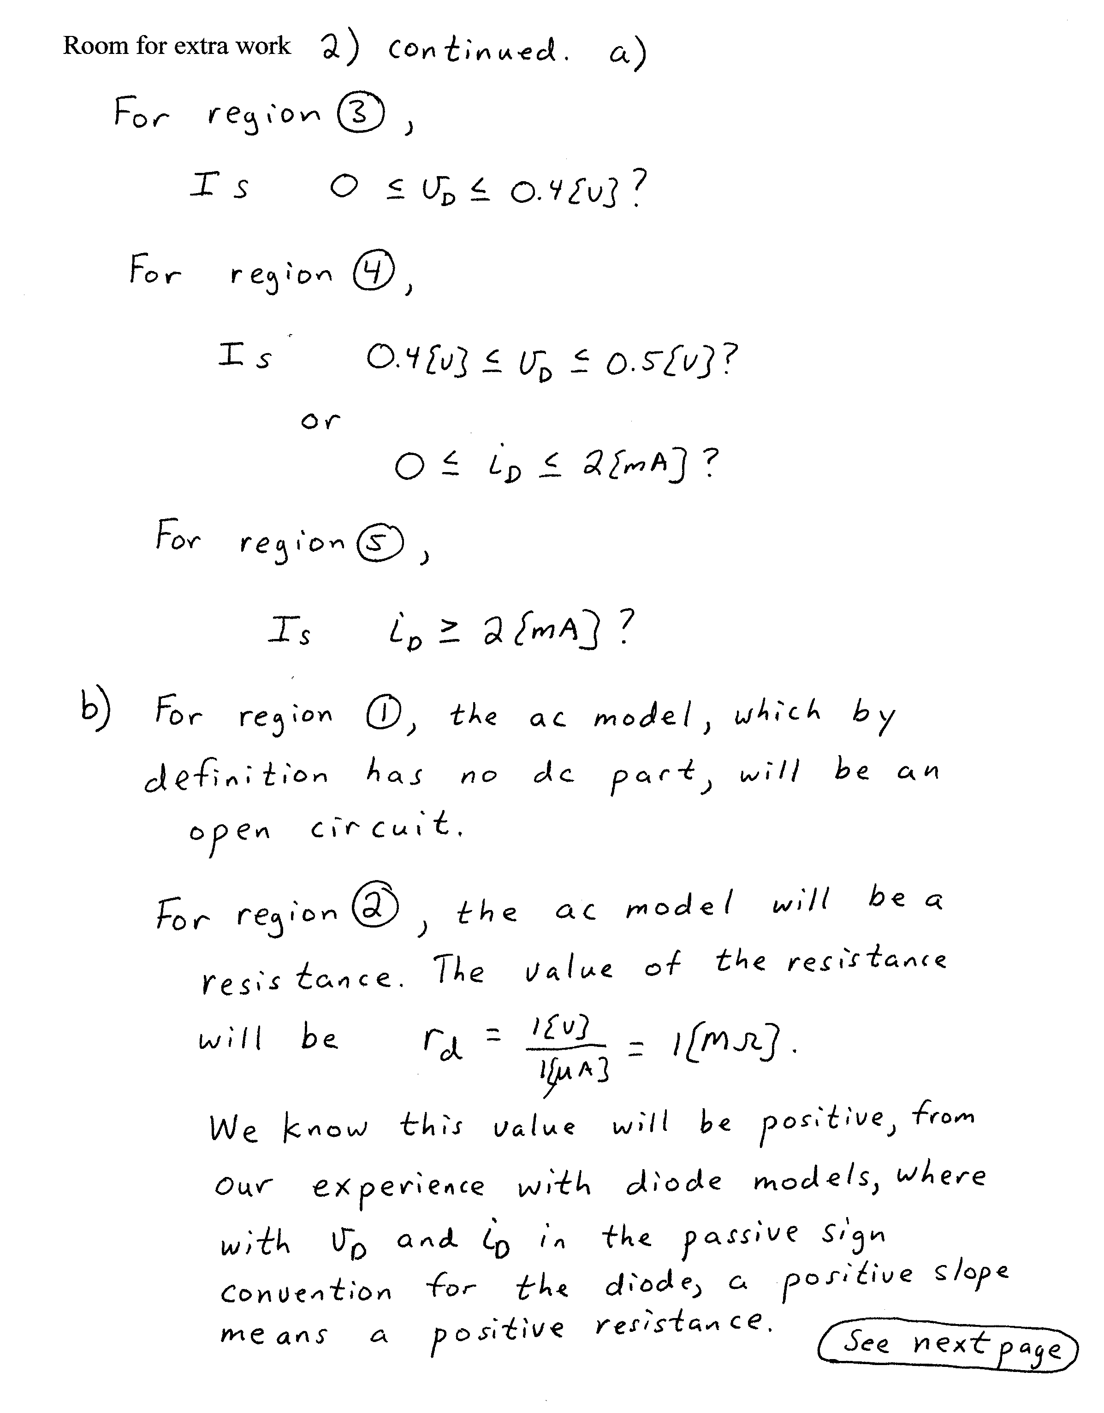
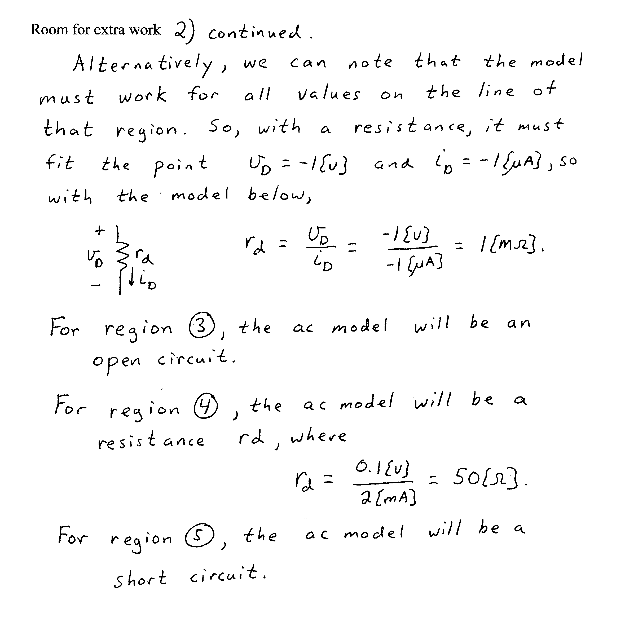

3. {20 Points} Assume an ideal op amp. Note that the power supply levels are +25[V] and –10[V]. Quantitatively describe the voltage v_{A}(t). Use diagrams and plots as necessary to make your work and your answers clear.

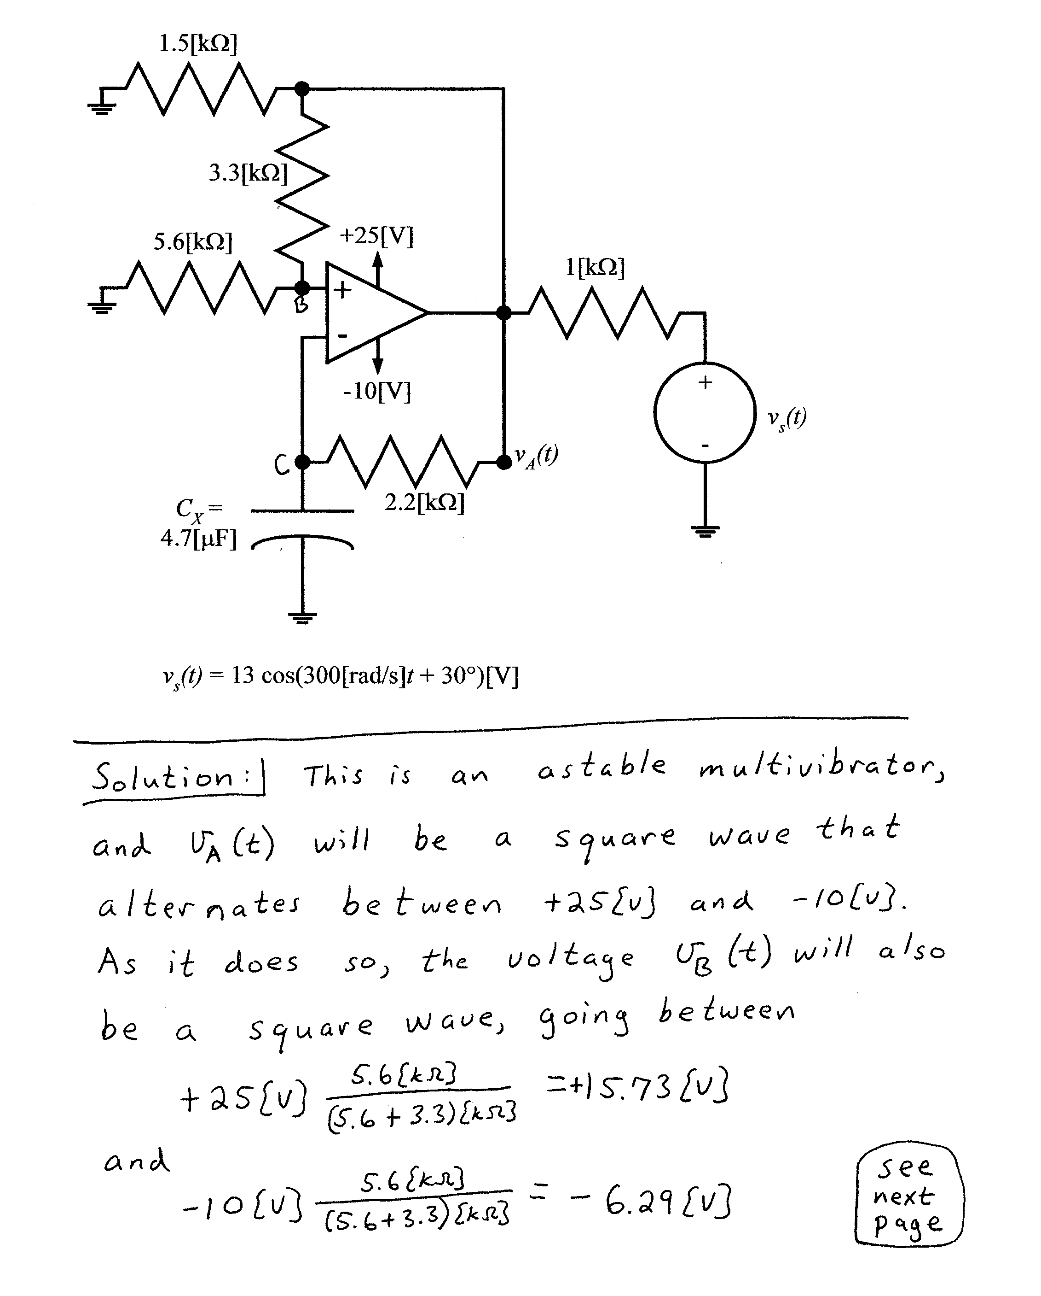
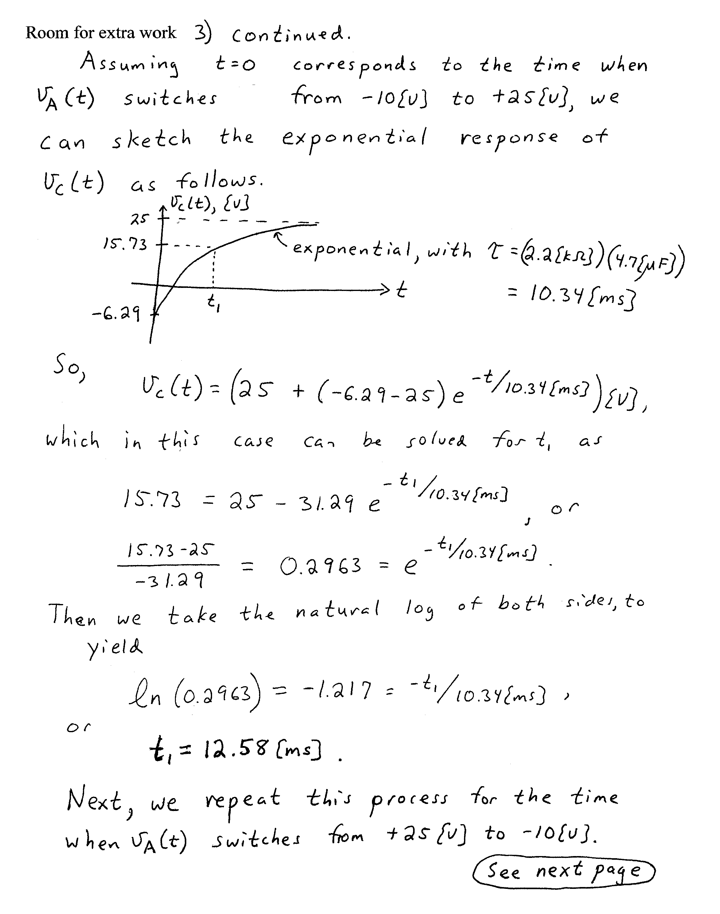
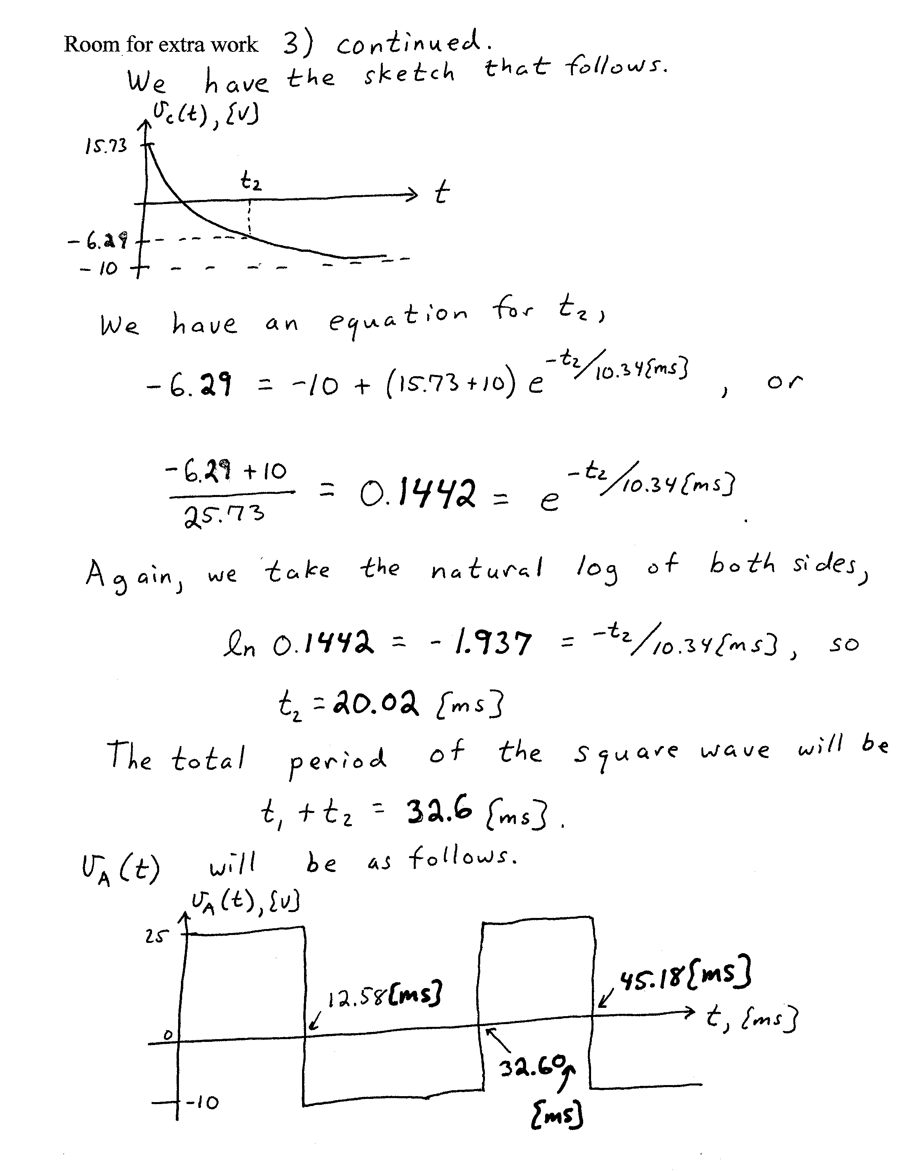

4. {20 Points} Assume that the β for each of these transistors is 200. Find V_{Q}. Show your work. The transistors are biased into the linear region.

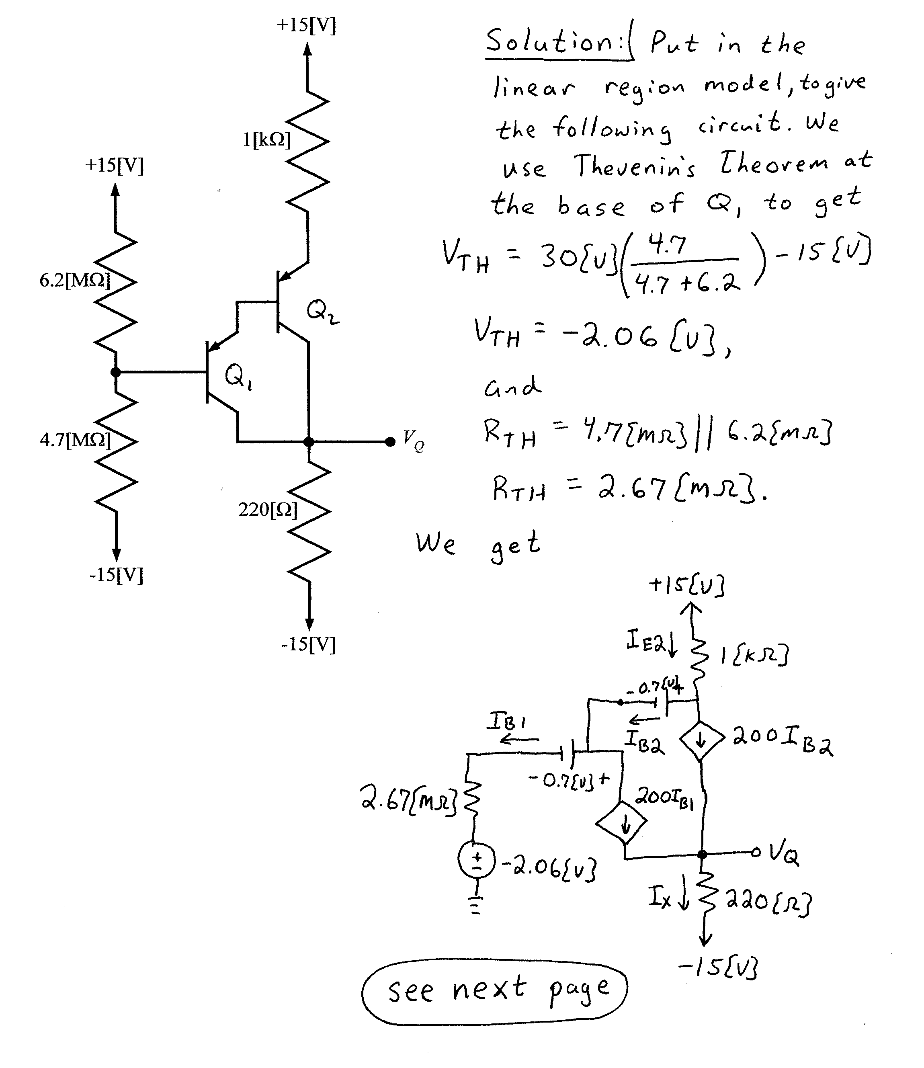
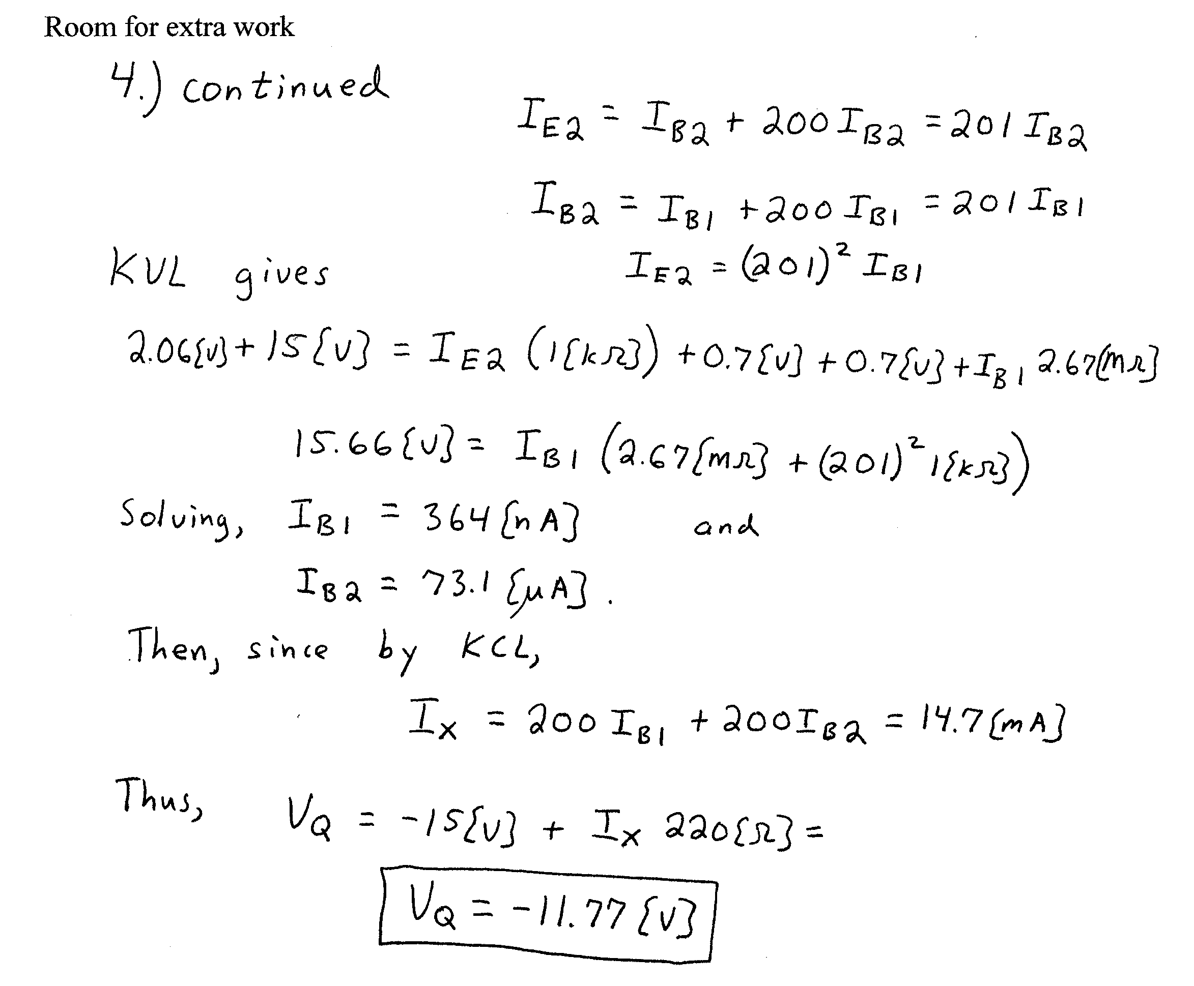

5. {20 Points} Assume that the transistor shown has a β = 100 and that it is operating at room temperature.
a) Find the voltage gain, v_{o}/v_{s}, in the passband.
b) Find the current gain, i_{o}/i_{s}, in the passband.

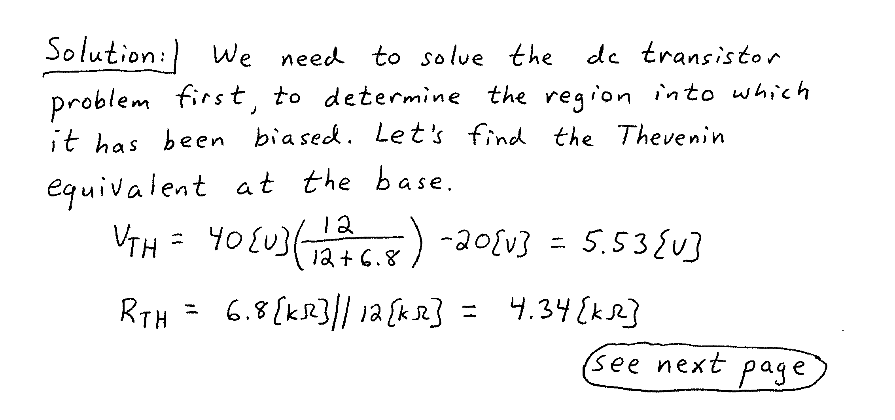
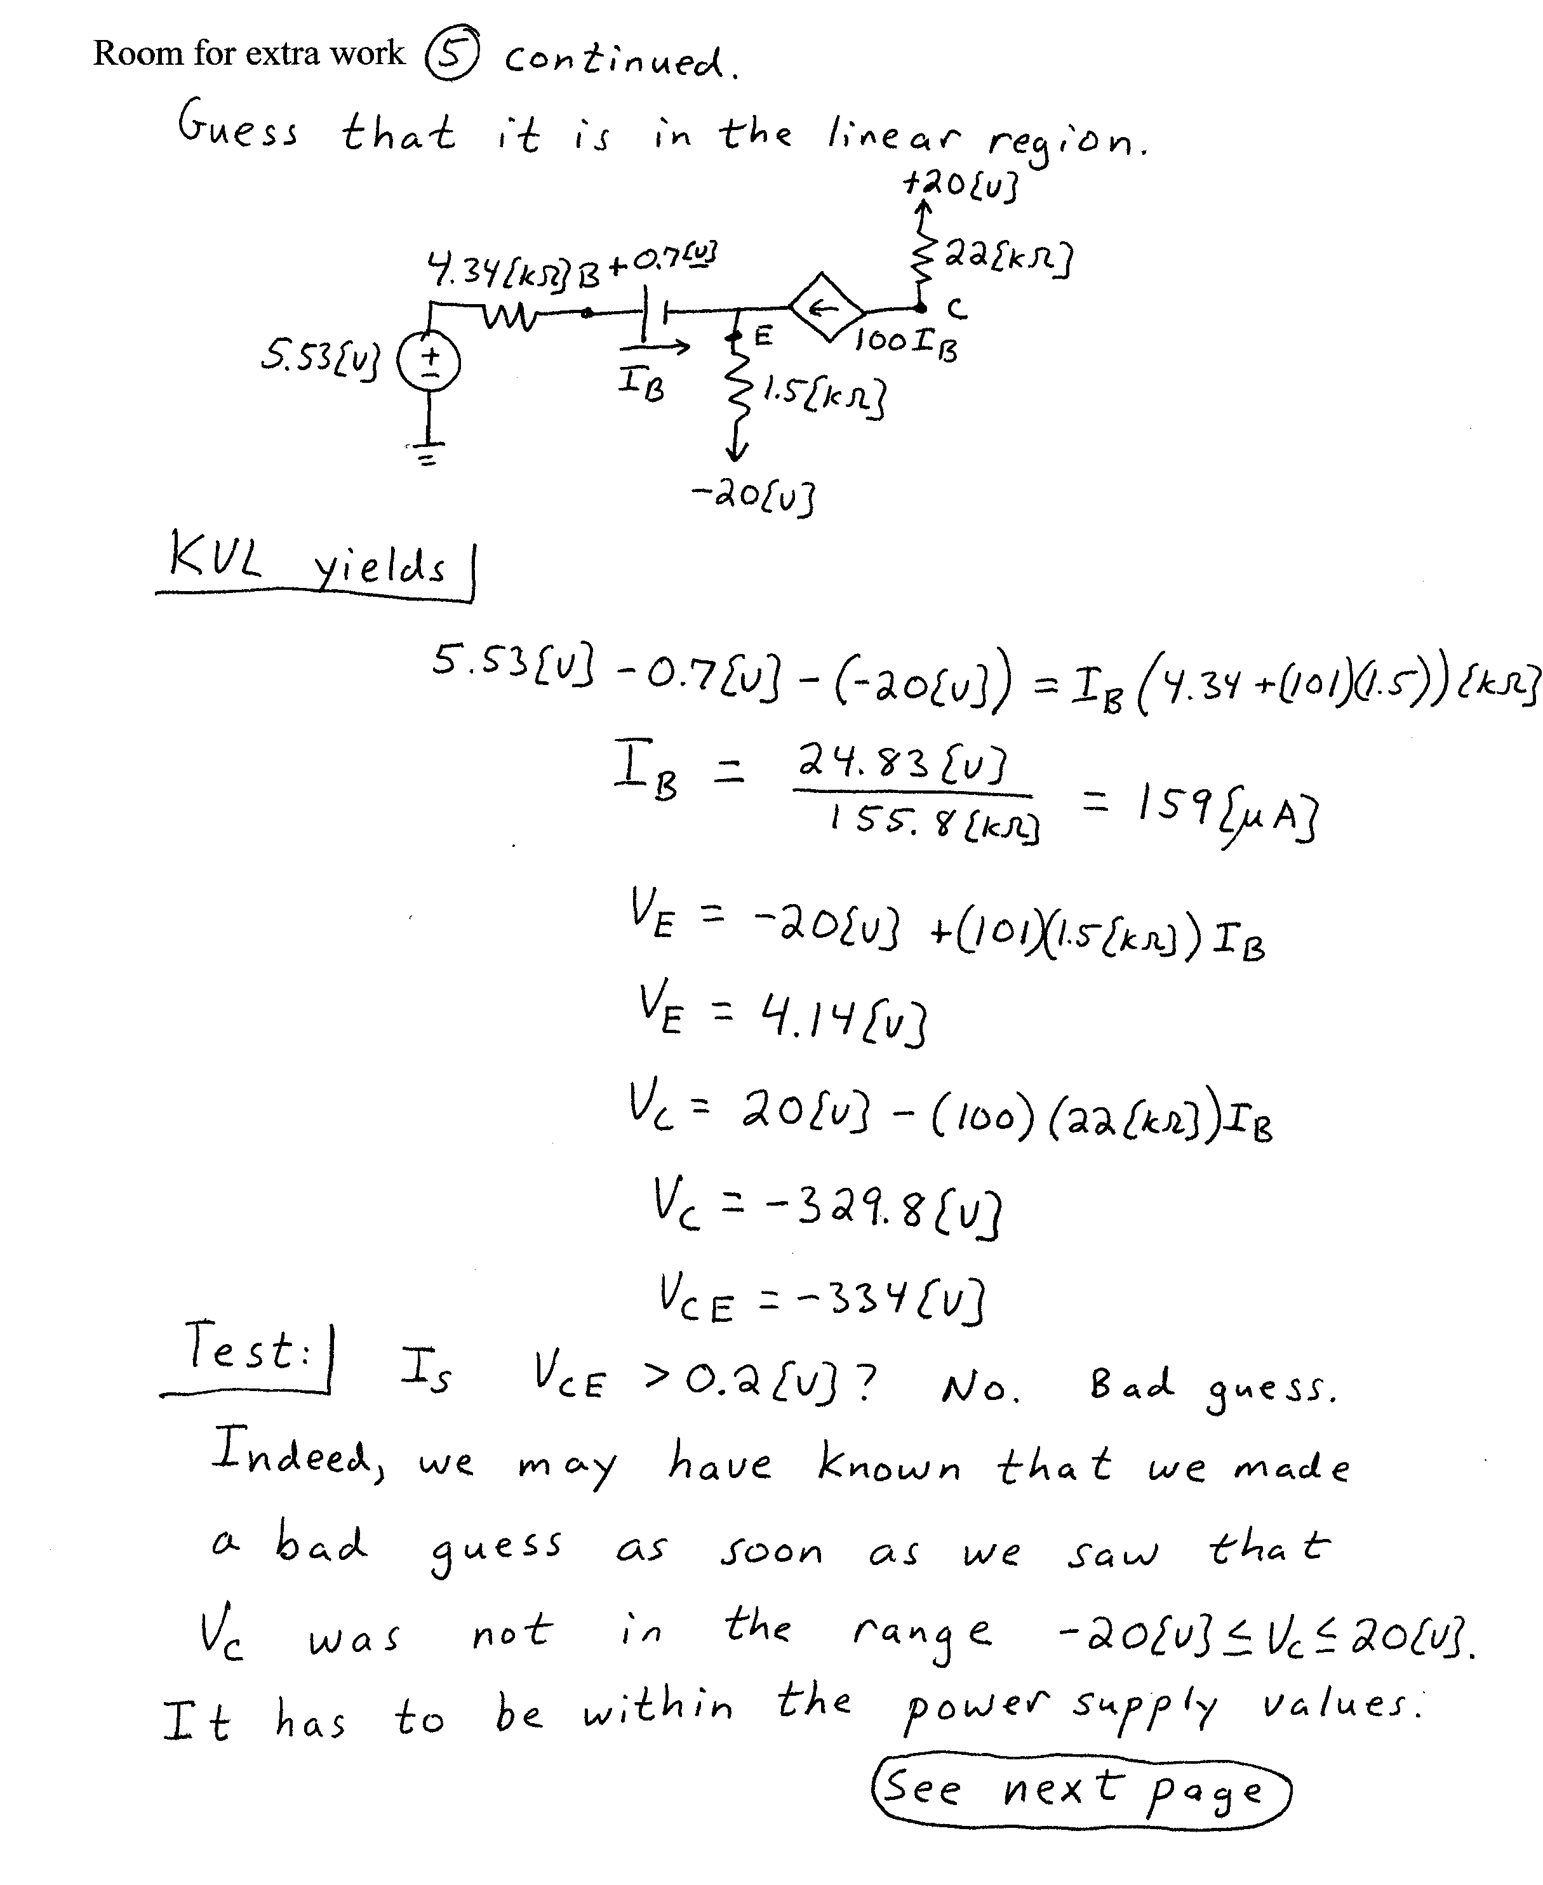
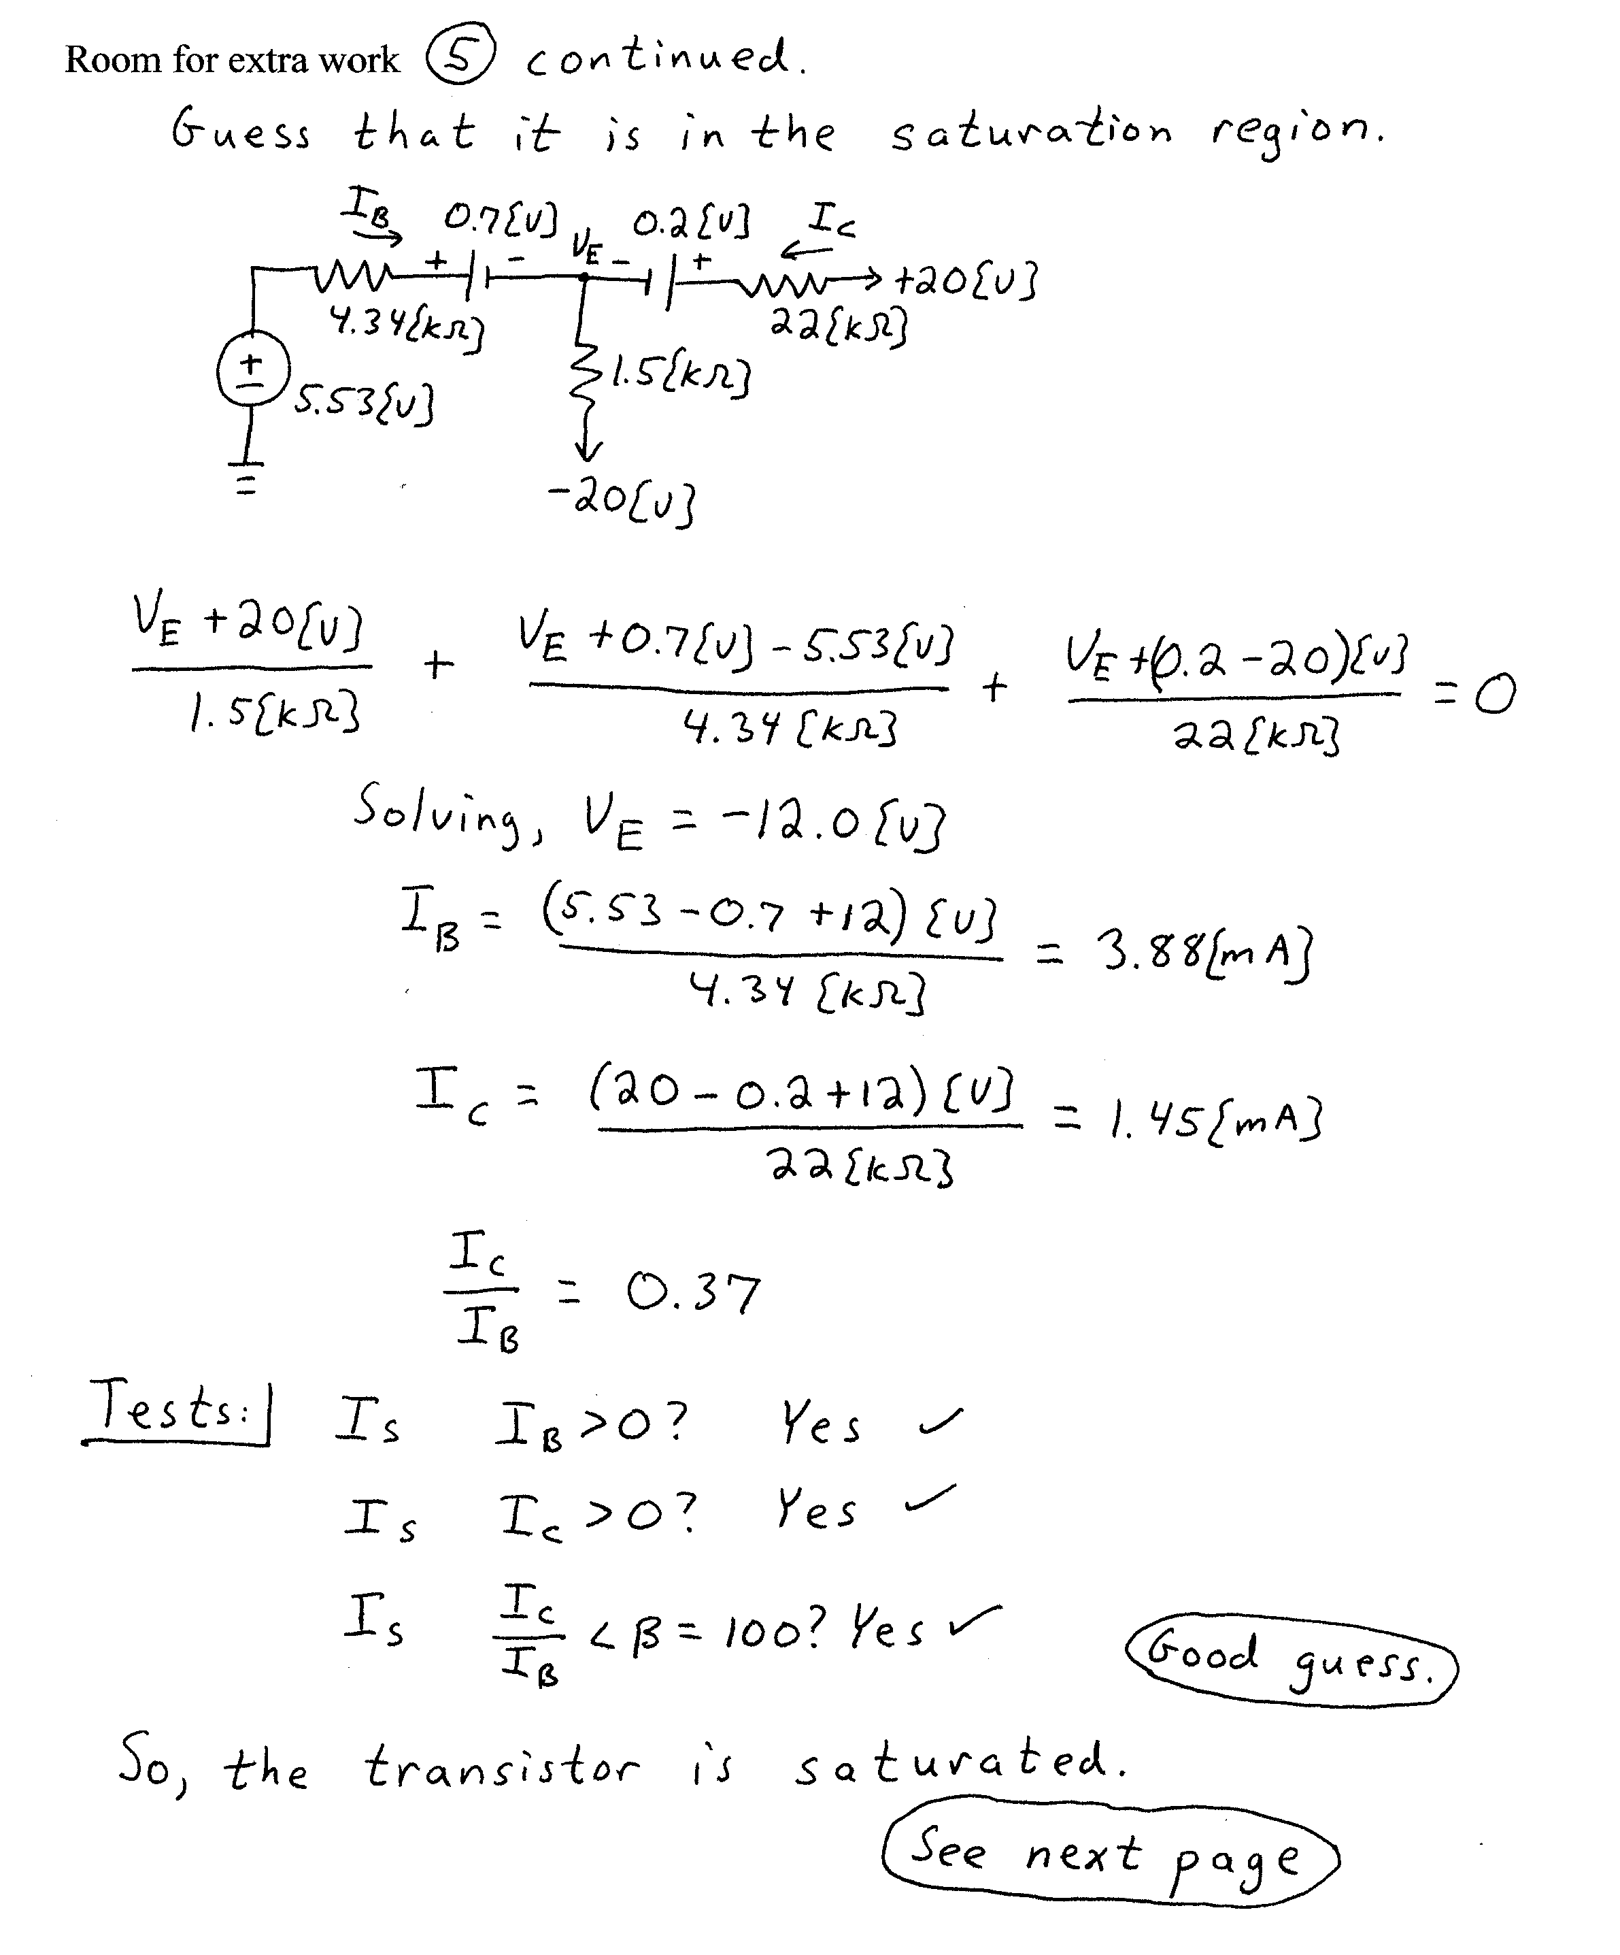
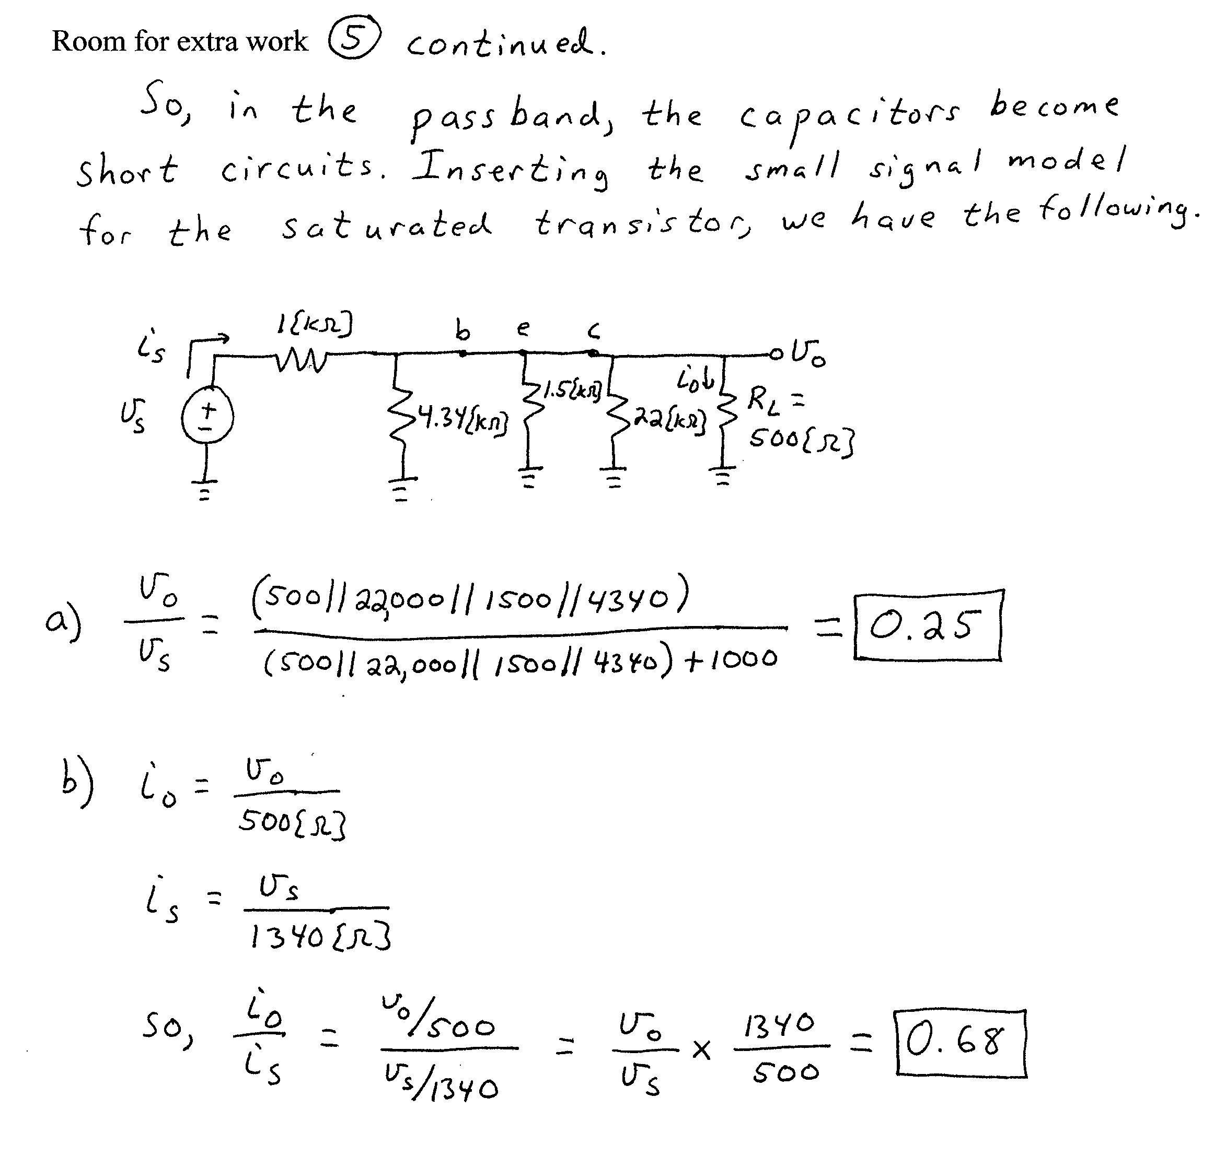

6. {20 Points} The schematic symbol for a Giambulator is shown in Figure 1. Two characteristic curves for this device are shown in Figure 2 and Figure 3. Find a model that could be used to predict the behavior of a Giambulator that has been biased into Region 1, for small signals. Draw the model, labeling all components with their numerical values, and labeling terminals a, b, and c.
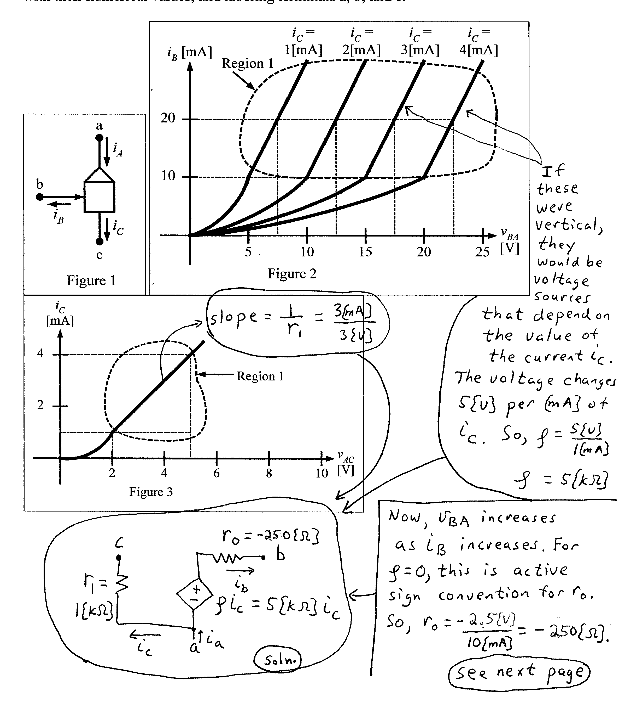
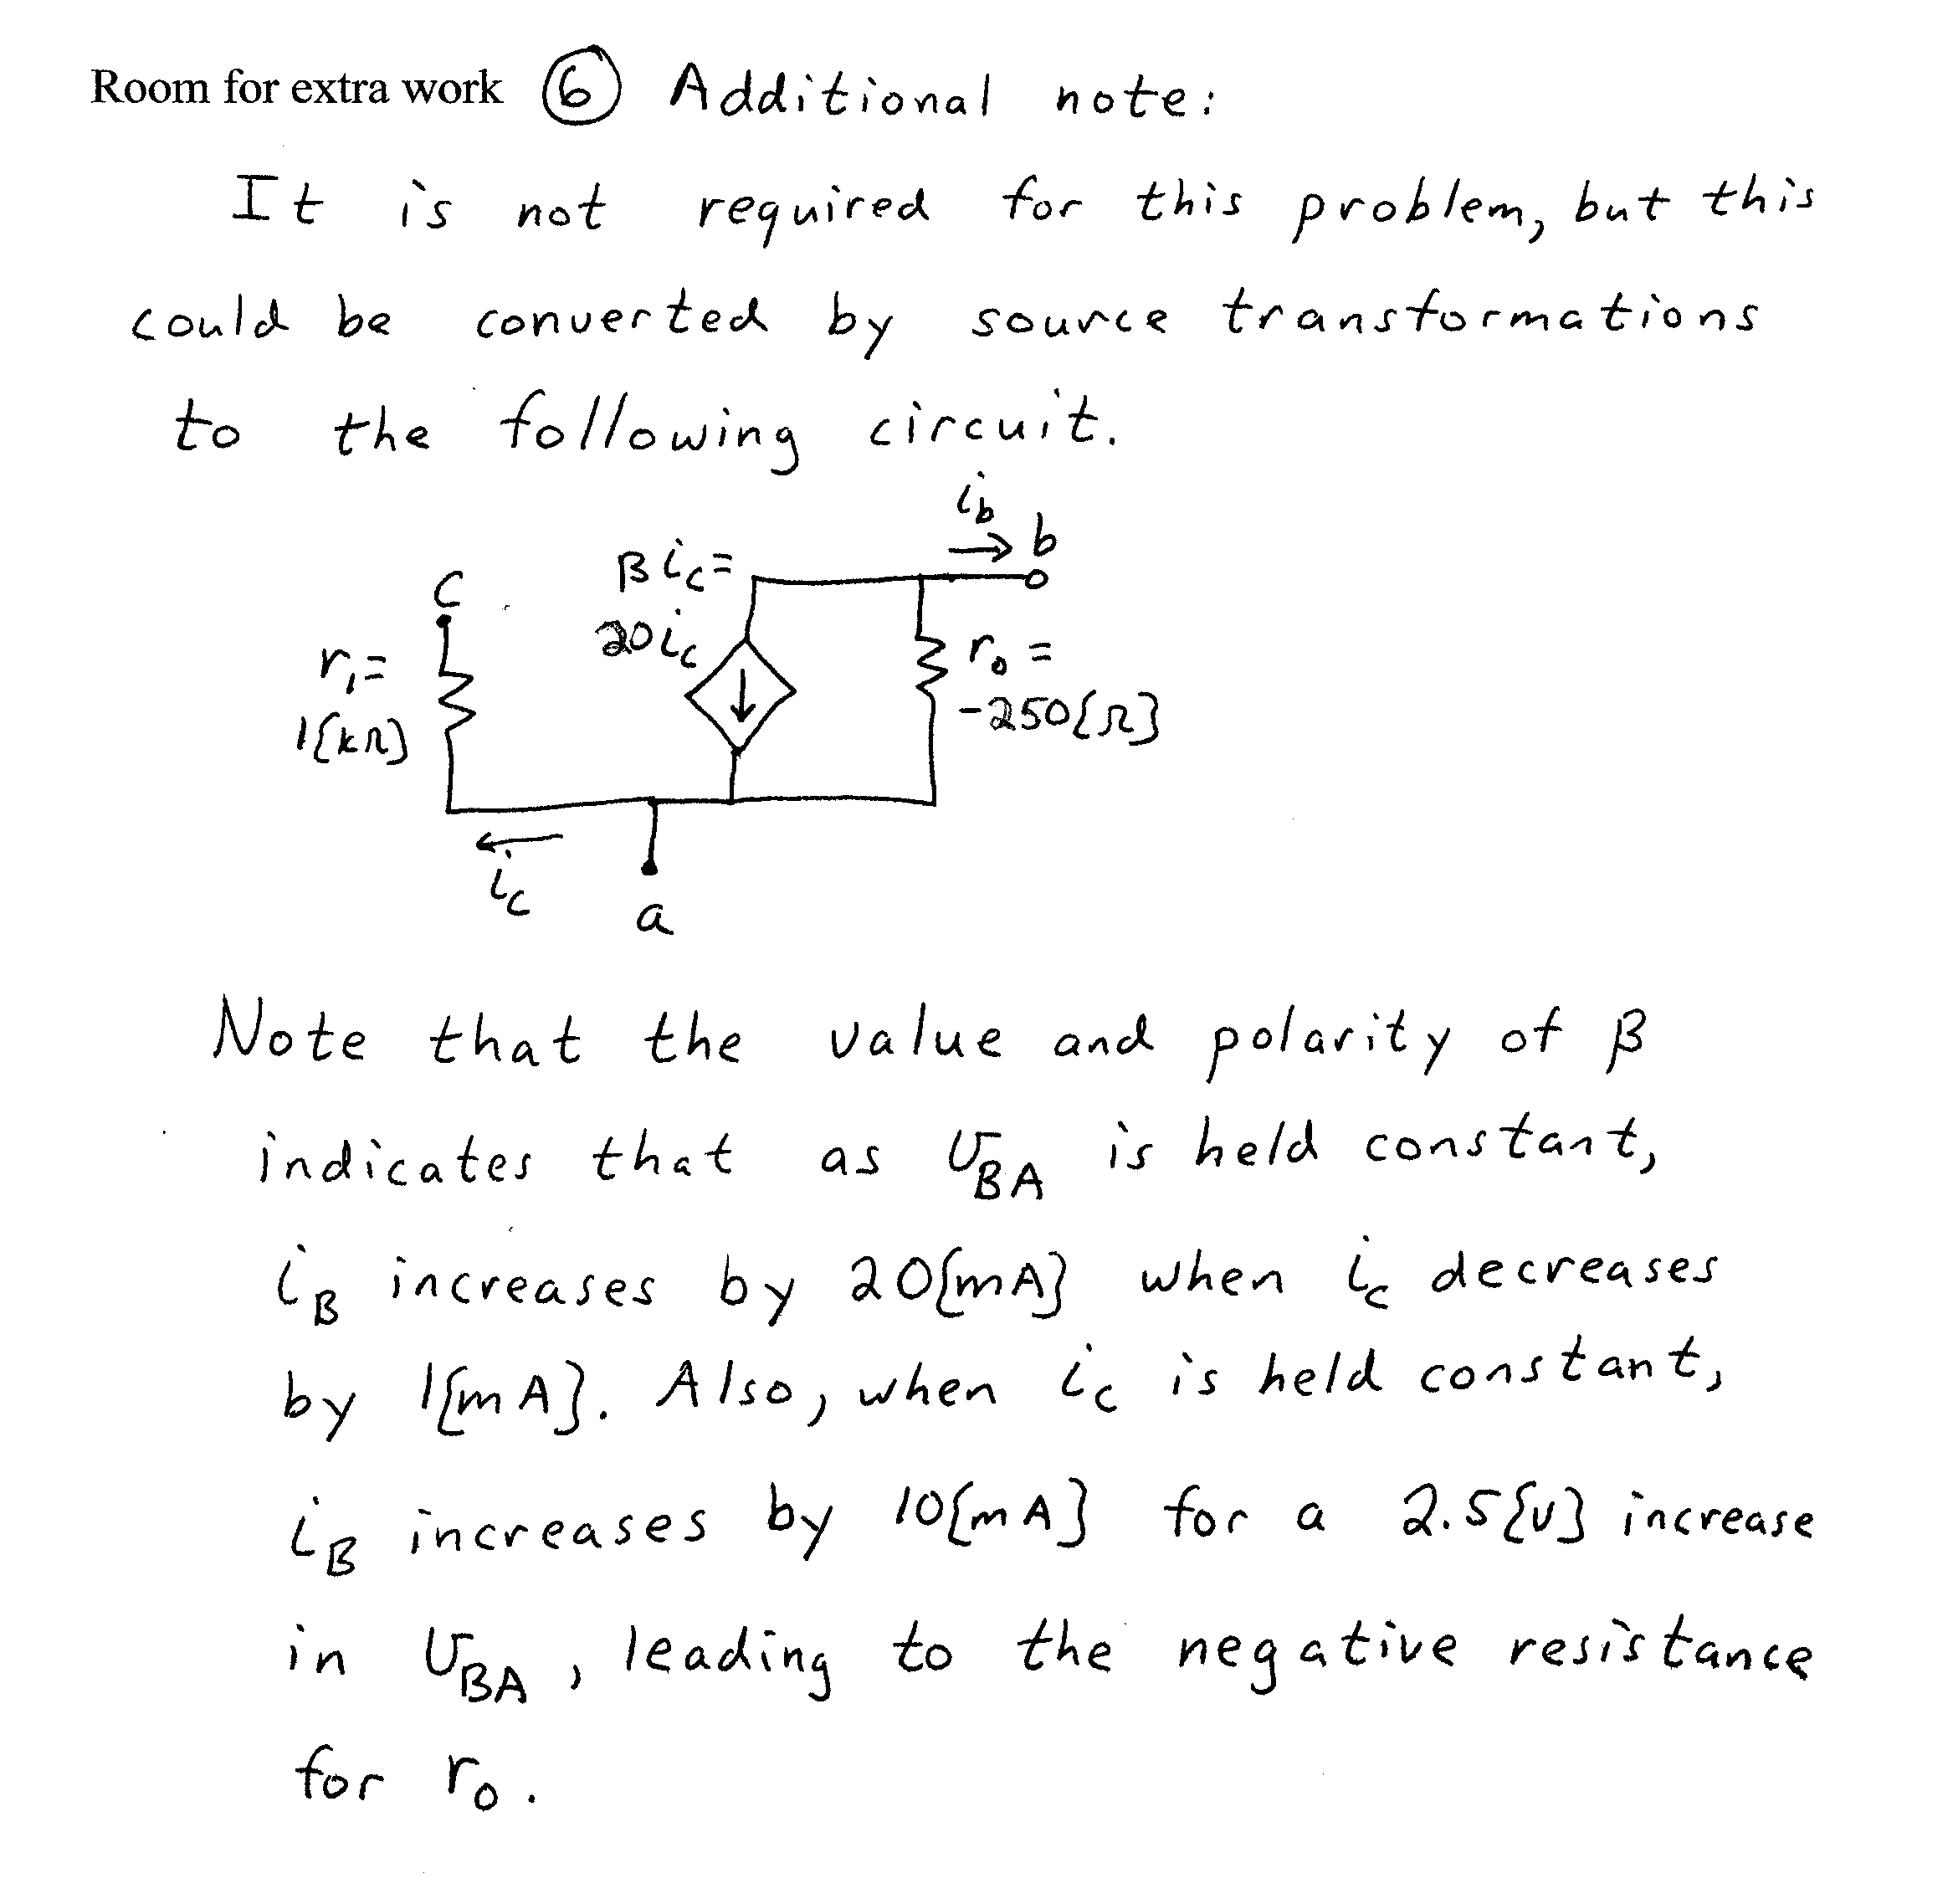
Thus, this model using a dependent current source also models the behavior shown in the plots on the previous page.

