Name: _____________________________ (please print)
Signature: __________________________

ECE 3455 -- Exam #1
October 8, 2005
Keep this exam closed until you are told to begin.

1. This exam is closed book, closed notes. You may use one 8.5” x 11” crib sheet, or its equivalent.
2. Show all work on these pages. Show all work necessary to complete the problem. A solution without the appropriate work shown will receive no credit. A solution that is not given in a reasonable order will lose credit. Clearly indicate your answer (for example by enclosing it in a box).
3. It is assumed that your work will begin on the same page as the problem statement. If you choose to begin your work on another page, you must indicate this on the page with the problem statement, with a clear indication of where the work can be found. If your work continues on to another page, indicate clearly where your work can be found. Failure to indicate this clearly will result in a loss of credit.
4. Show all units in solutions, intermediate results, and figures. Units in the exam will be included between square brackets.
5. Do not use red ink. Do not use red pencil.
6. You will have 90 minutes to work on this exam.

1. ________________/40
2. ________________/40
3. ________________/35
Total = 115

Room for extra work
1. {40 Points} The transfer function, H₁(ω), is given below. It is known that k₁ is a negative real constant. The straight-line approximation to the magnitude Bode plot for H₁(ω) is given below. All the nonzero poles and zeroes are included in this range of frequencies.
- Find the values for a, b, c, d, e, f, g, h, and k₁.
- Use the semilog graph paper on the next page to plot the straight-line approximation to the phase Bode plot for H₁(ω). Include in your frequency range all the nonzero zeroes and poles.
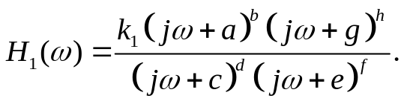.
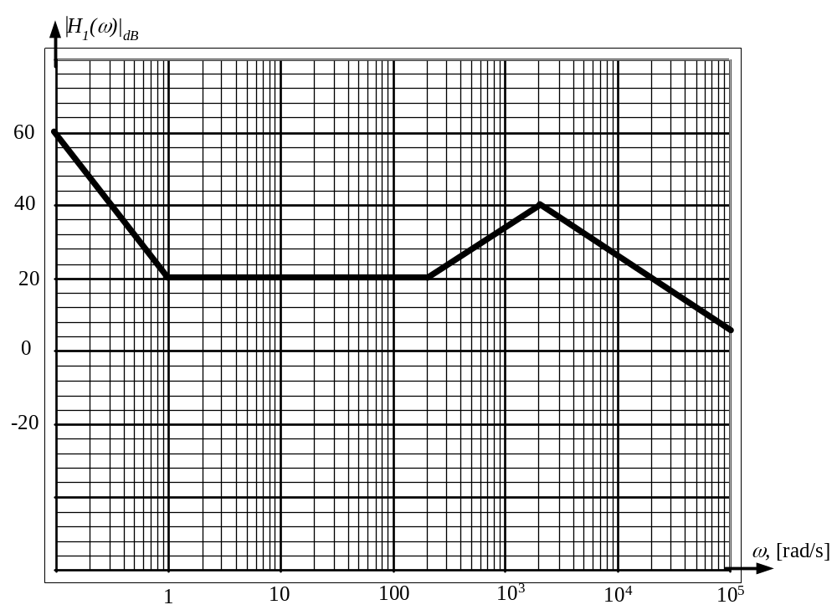

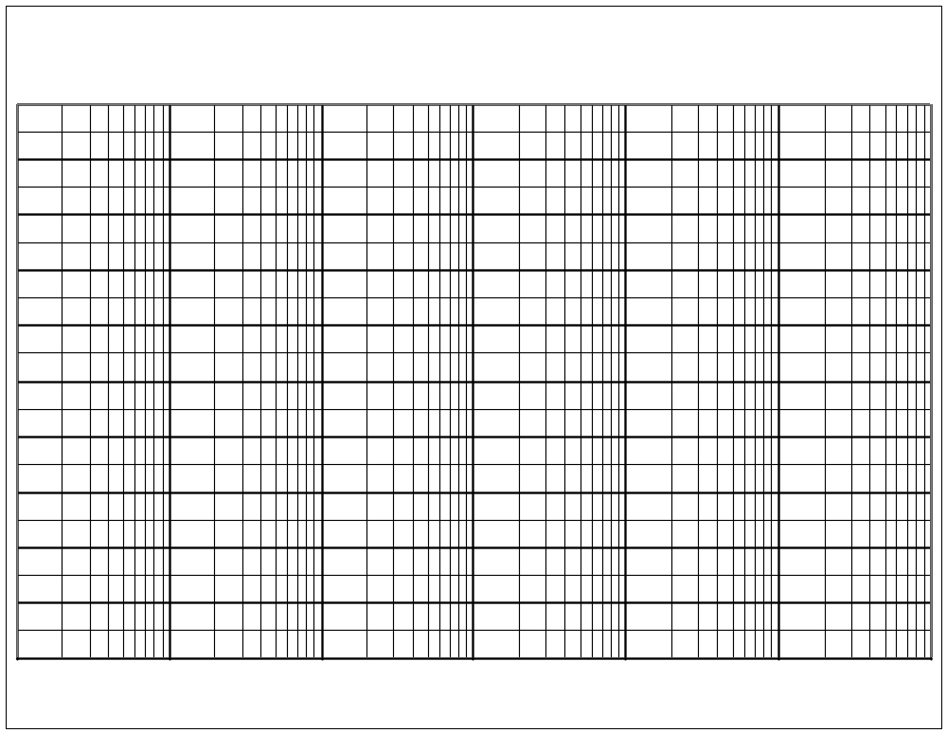
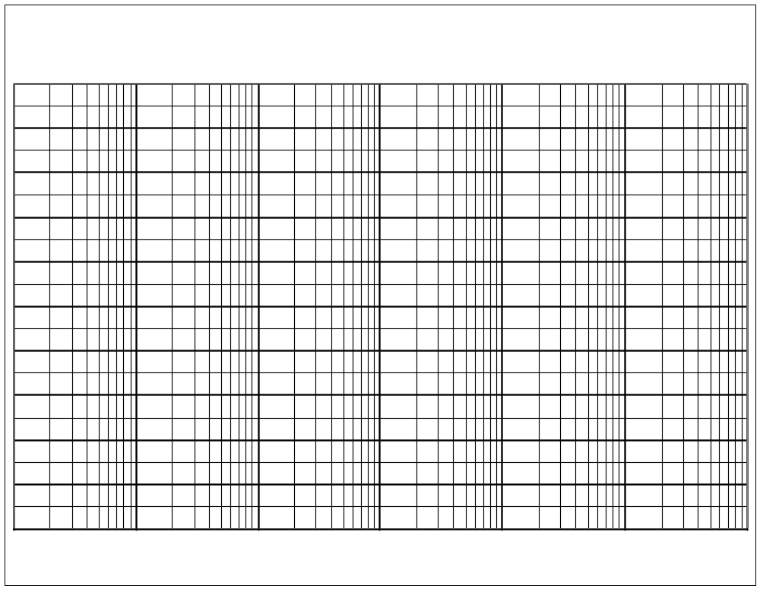
Room for extra work

2. {40 Points} Use the circuit below to find the following values.
- Find the output resistance seen by the load.
- Find the input resistance seen by the source.
It is known that
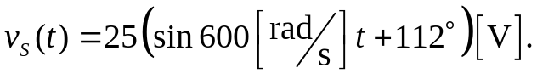
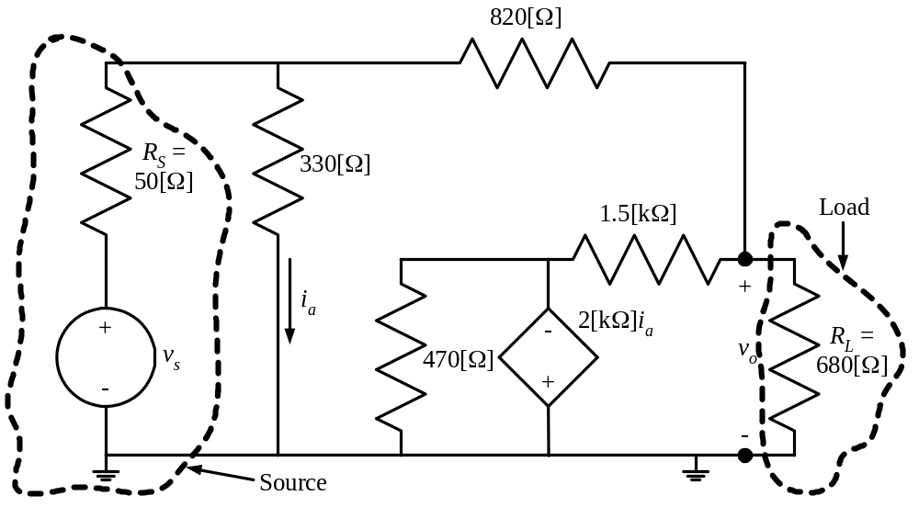

Room for extra work

3. {35 Points} Find a transconductance amplifier that would be equivalent to the amplifier below, with respect to terminals 1, 2, 3, and 4. Draw your equivalent circuit, labeling terminals 1, 2, 3, and 4.
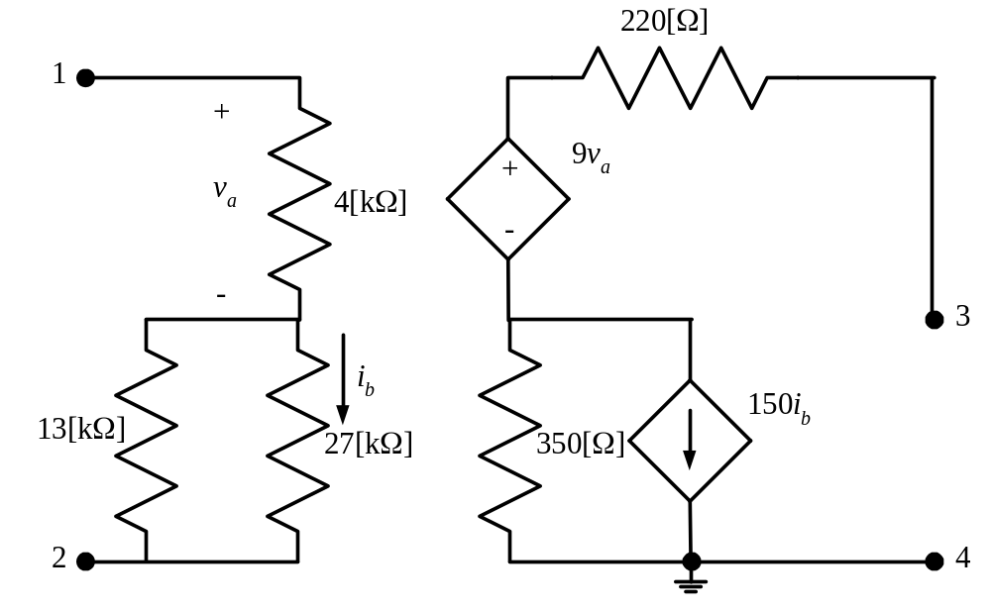

1. {40 Points} The transfer function, H₁(ω), is given below. It is known that k₁ is a negative real constant. The straight-line approximation to the magnitude Bode plot for H₁(ω) is given below. All the nonzero poles and zeroes are included in this range of frequencies.
- Find the values for a, b, c, d, e, f, g, h, and k₁.
- Use the semilog graph paper on the next page to plot the straight-line approximation to the phase Bode plot for H₁(ω). Include in your frequency range all the nonzero zeroes and poles.
.
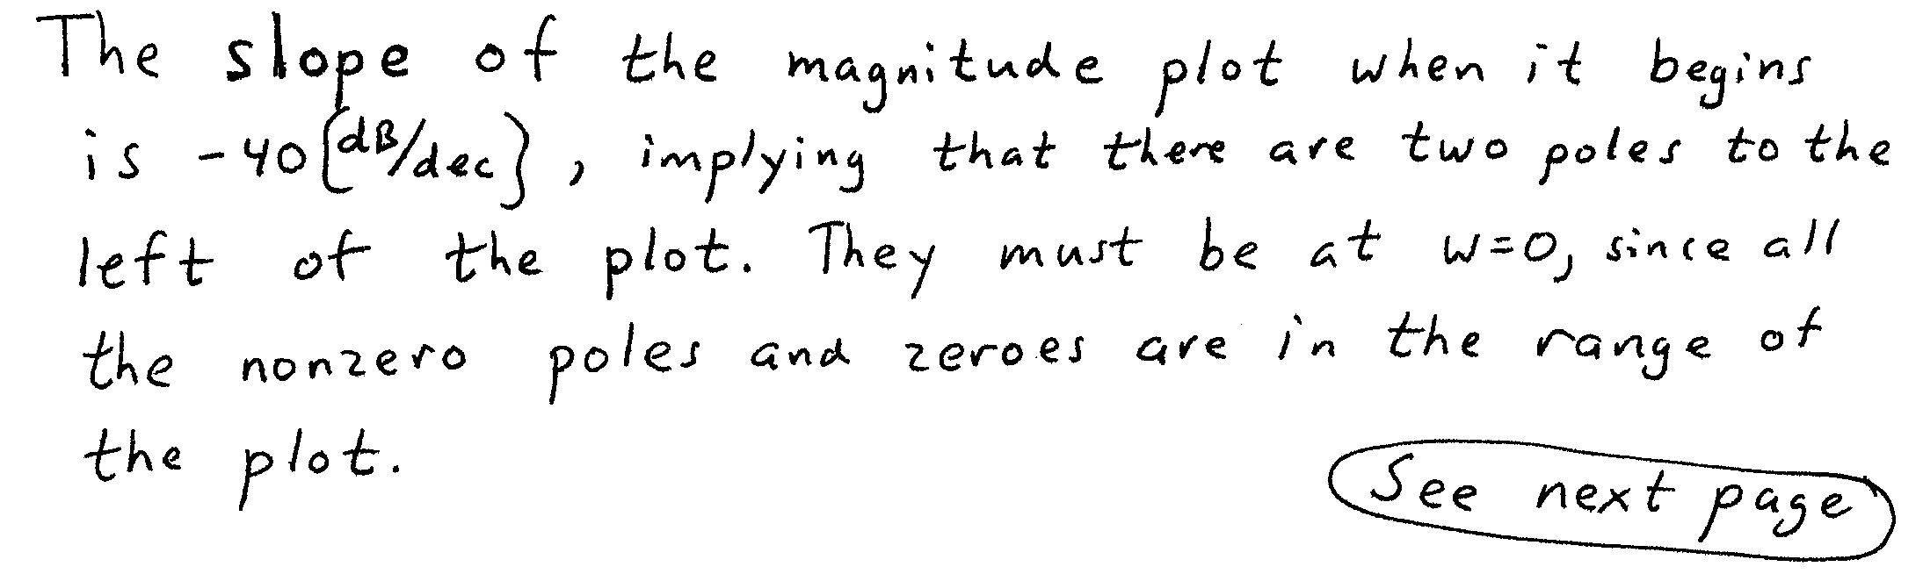
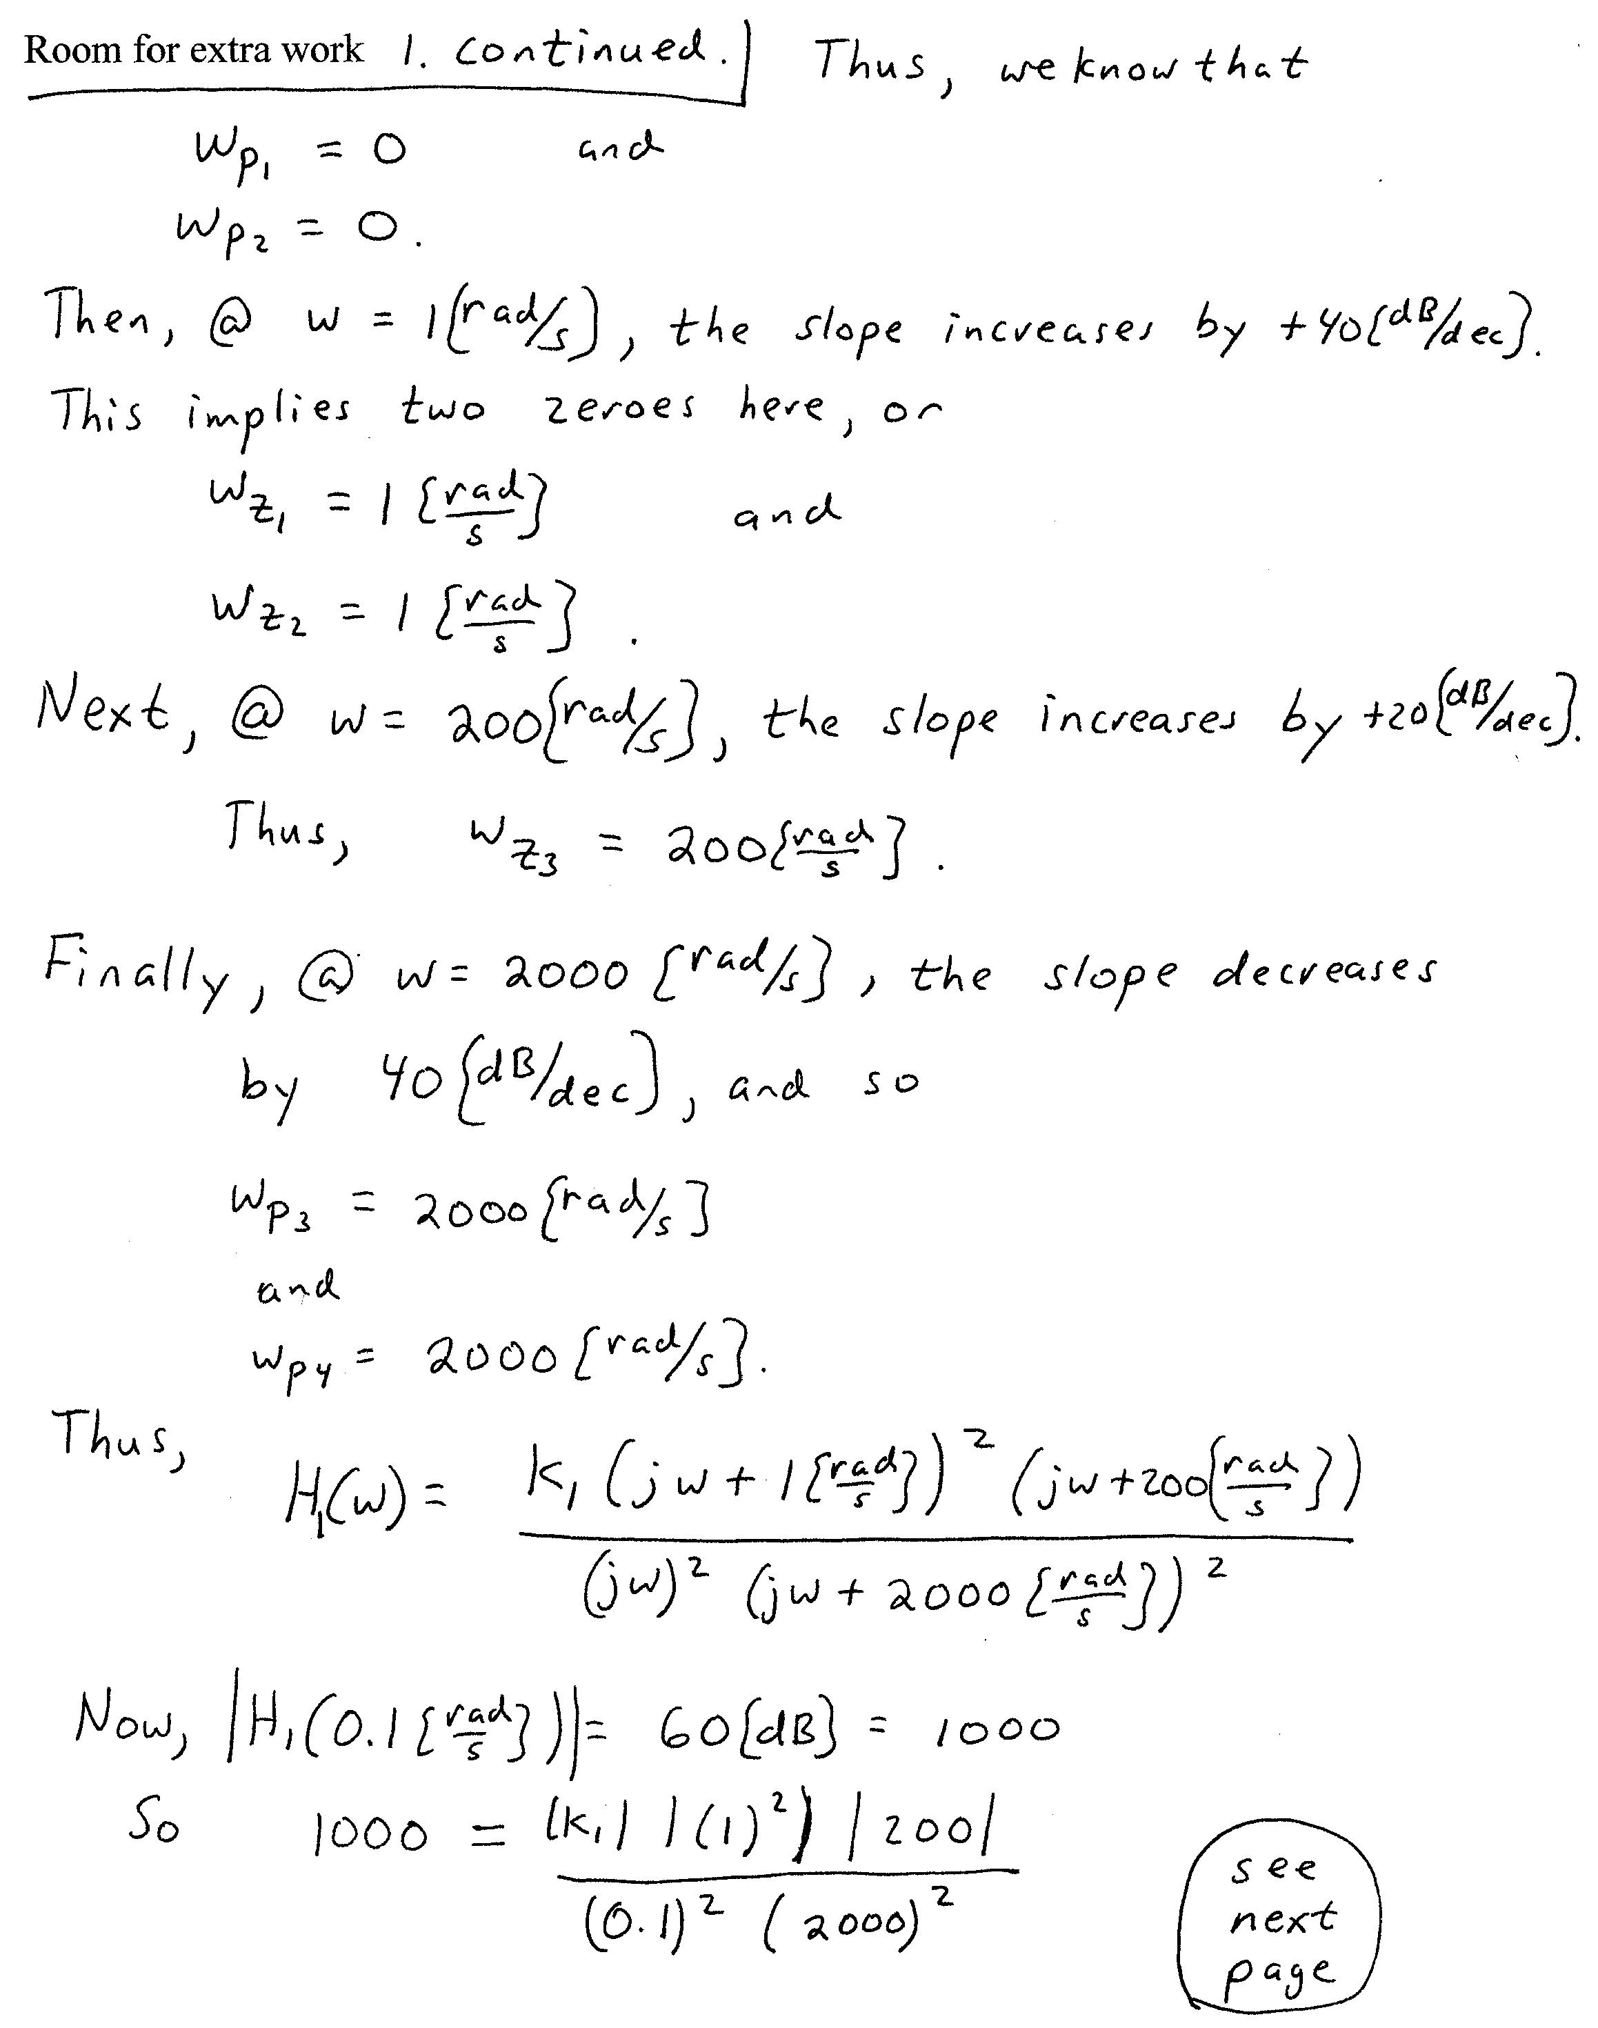
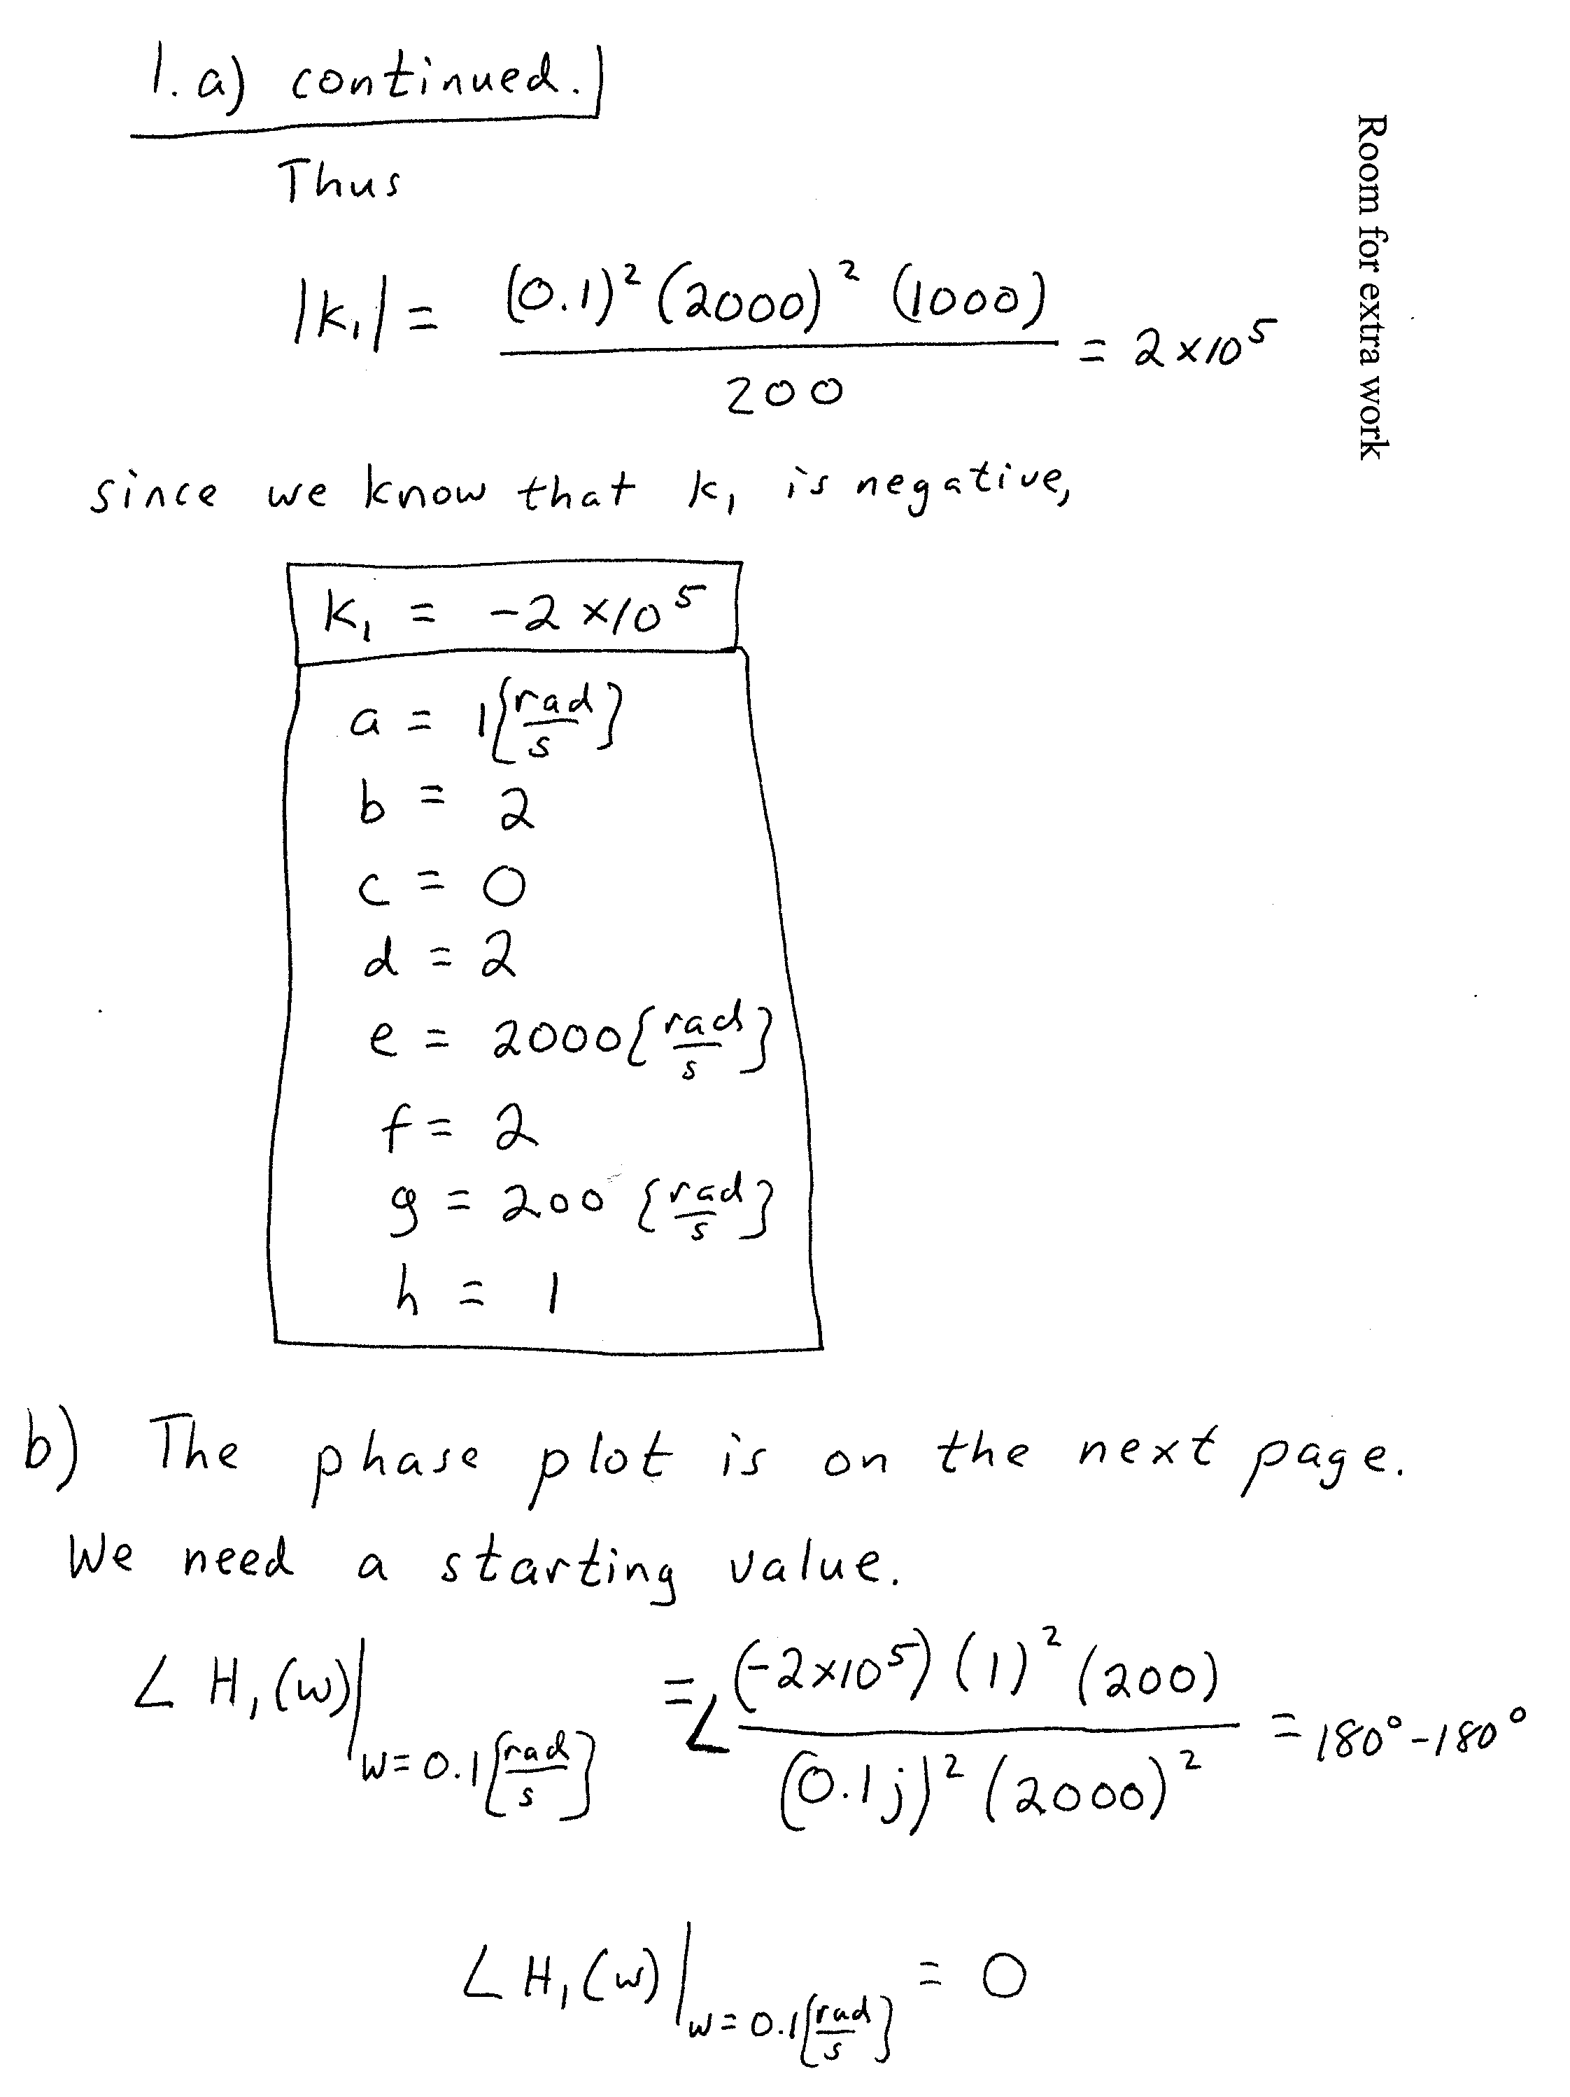

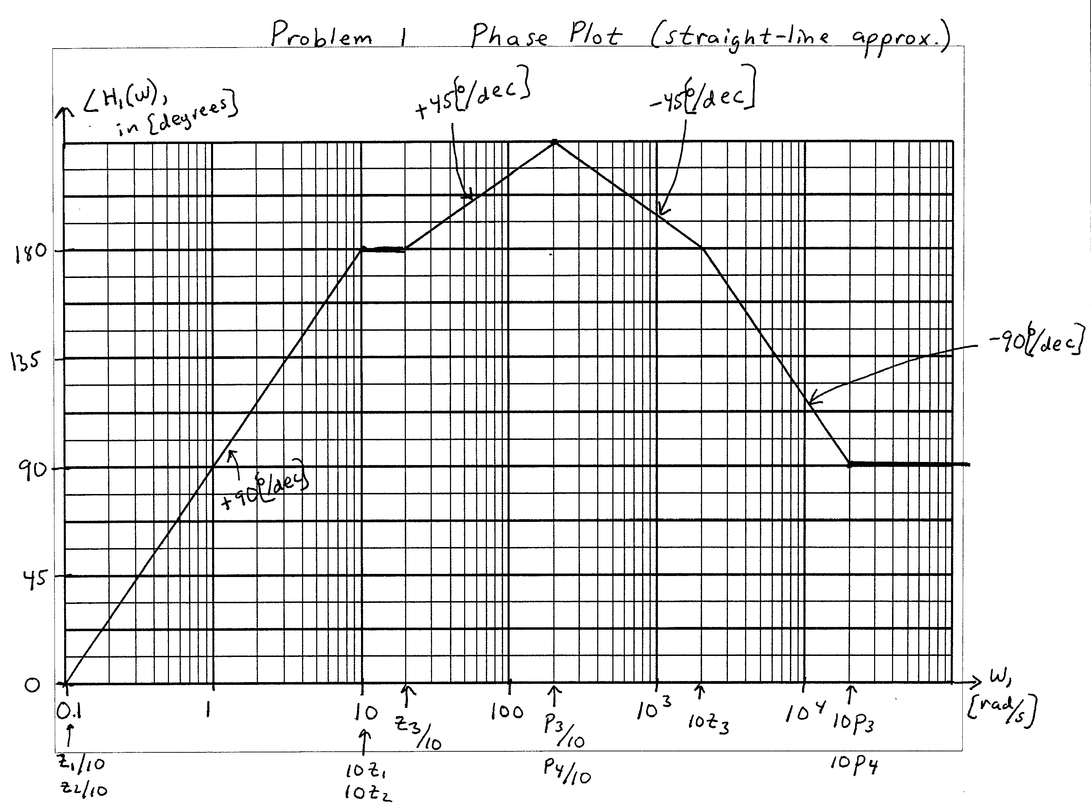

2. {40 Points} Use the circuit below to find the following values.
- Find the output resistance seen by the load.
- Find the input resistance seen by the source.
It is known that
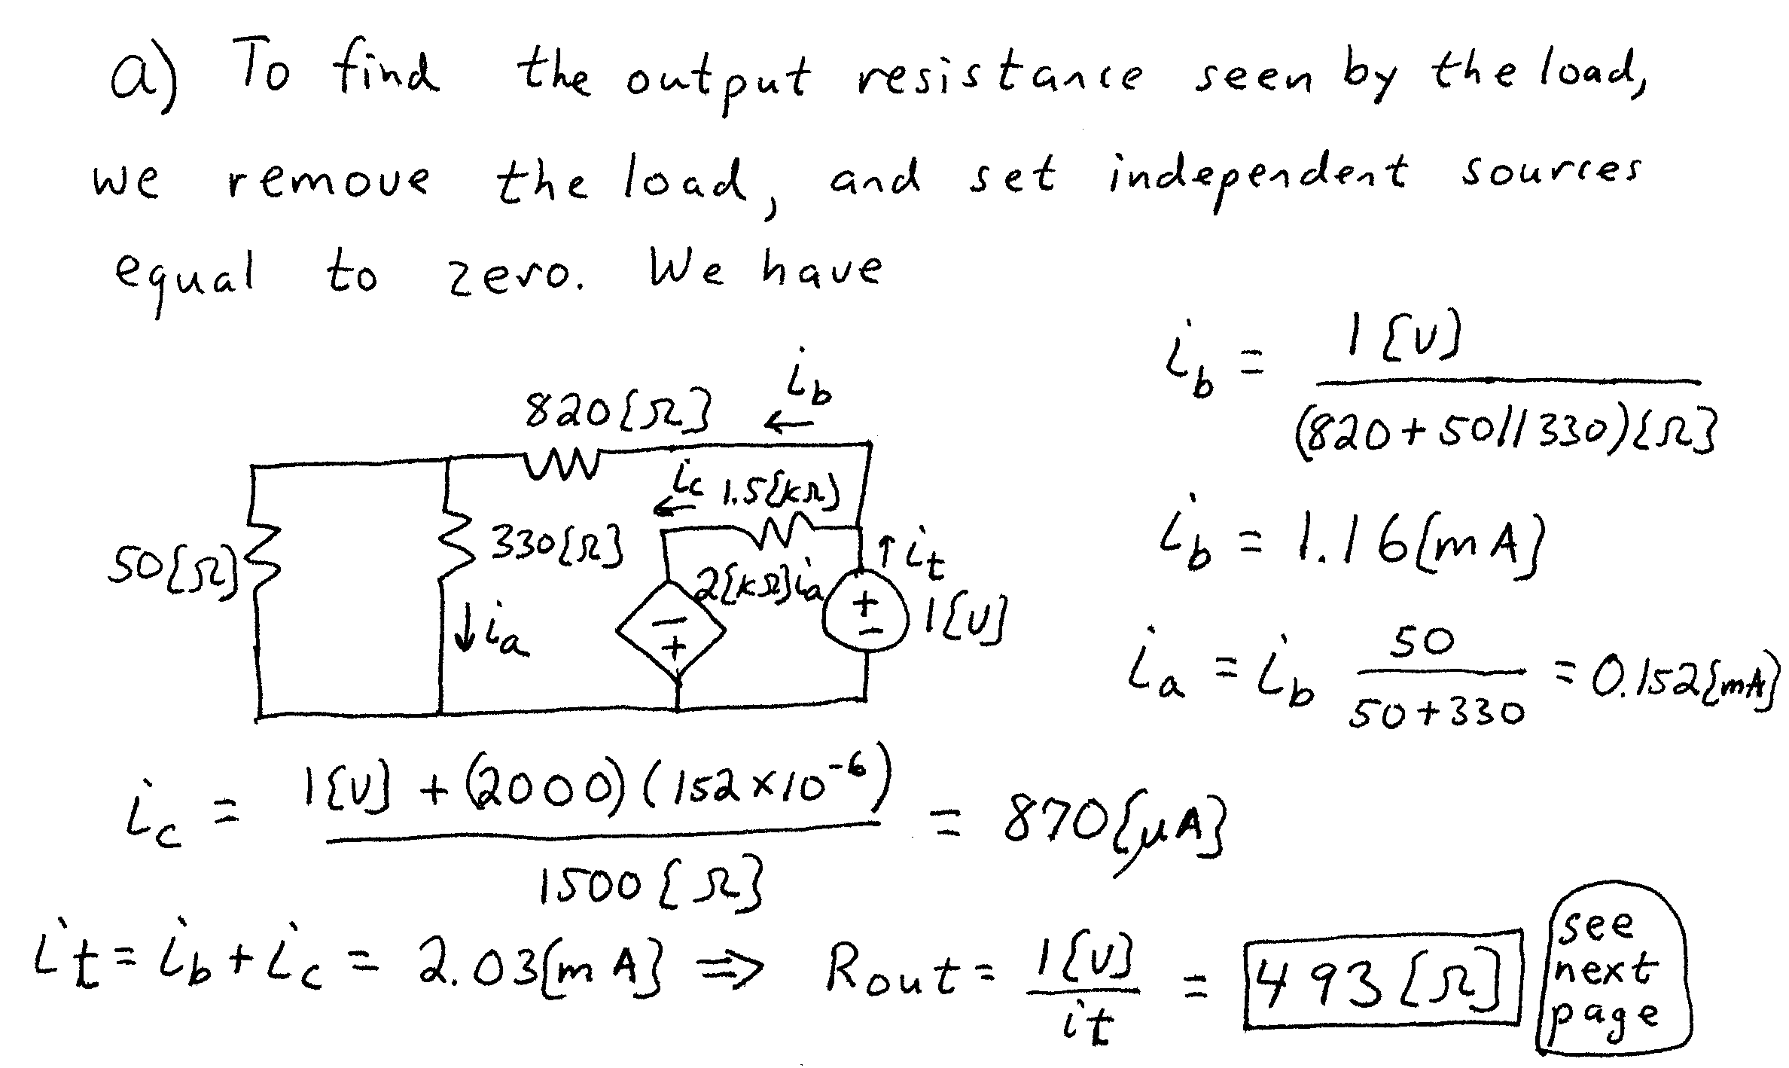
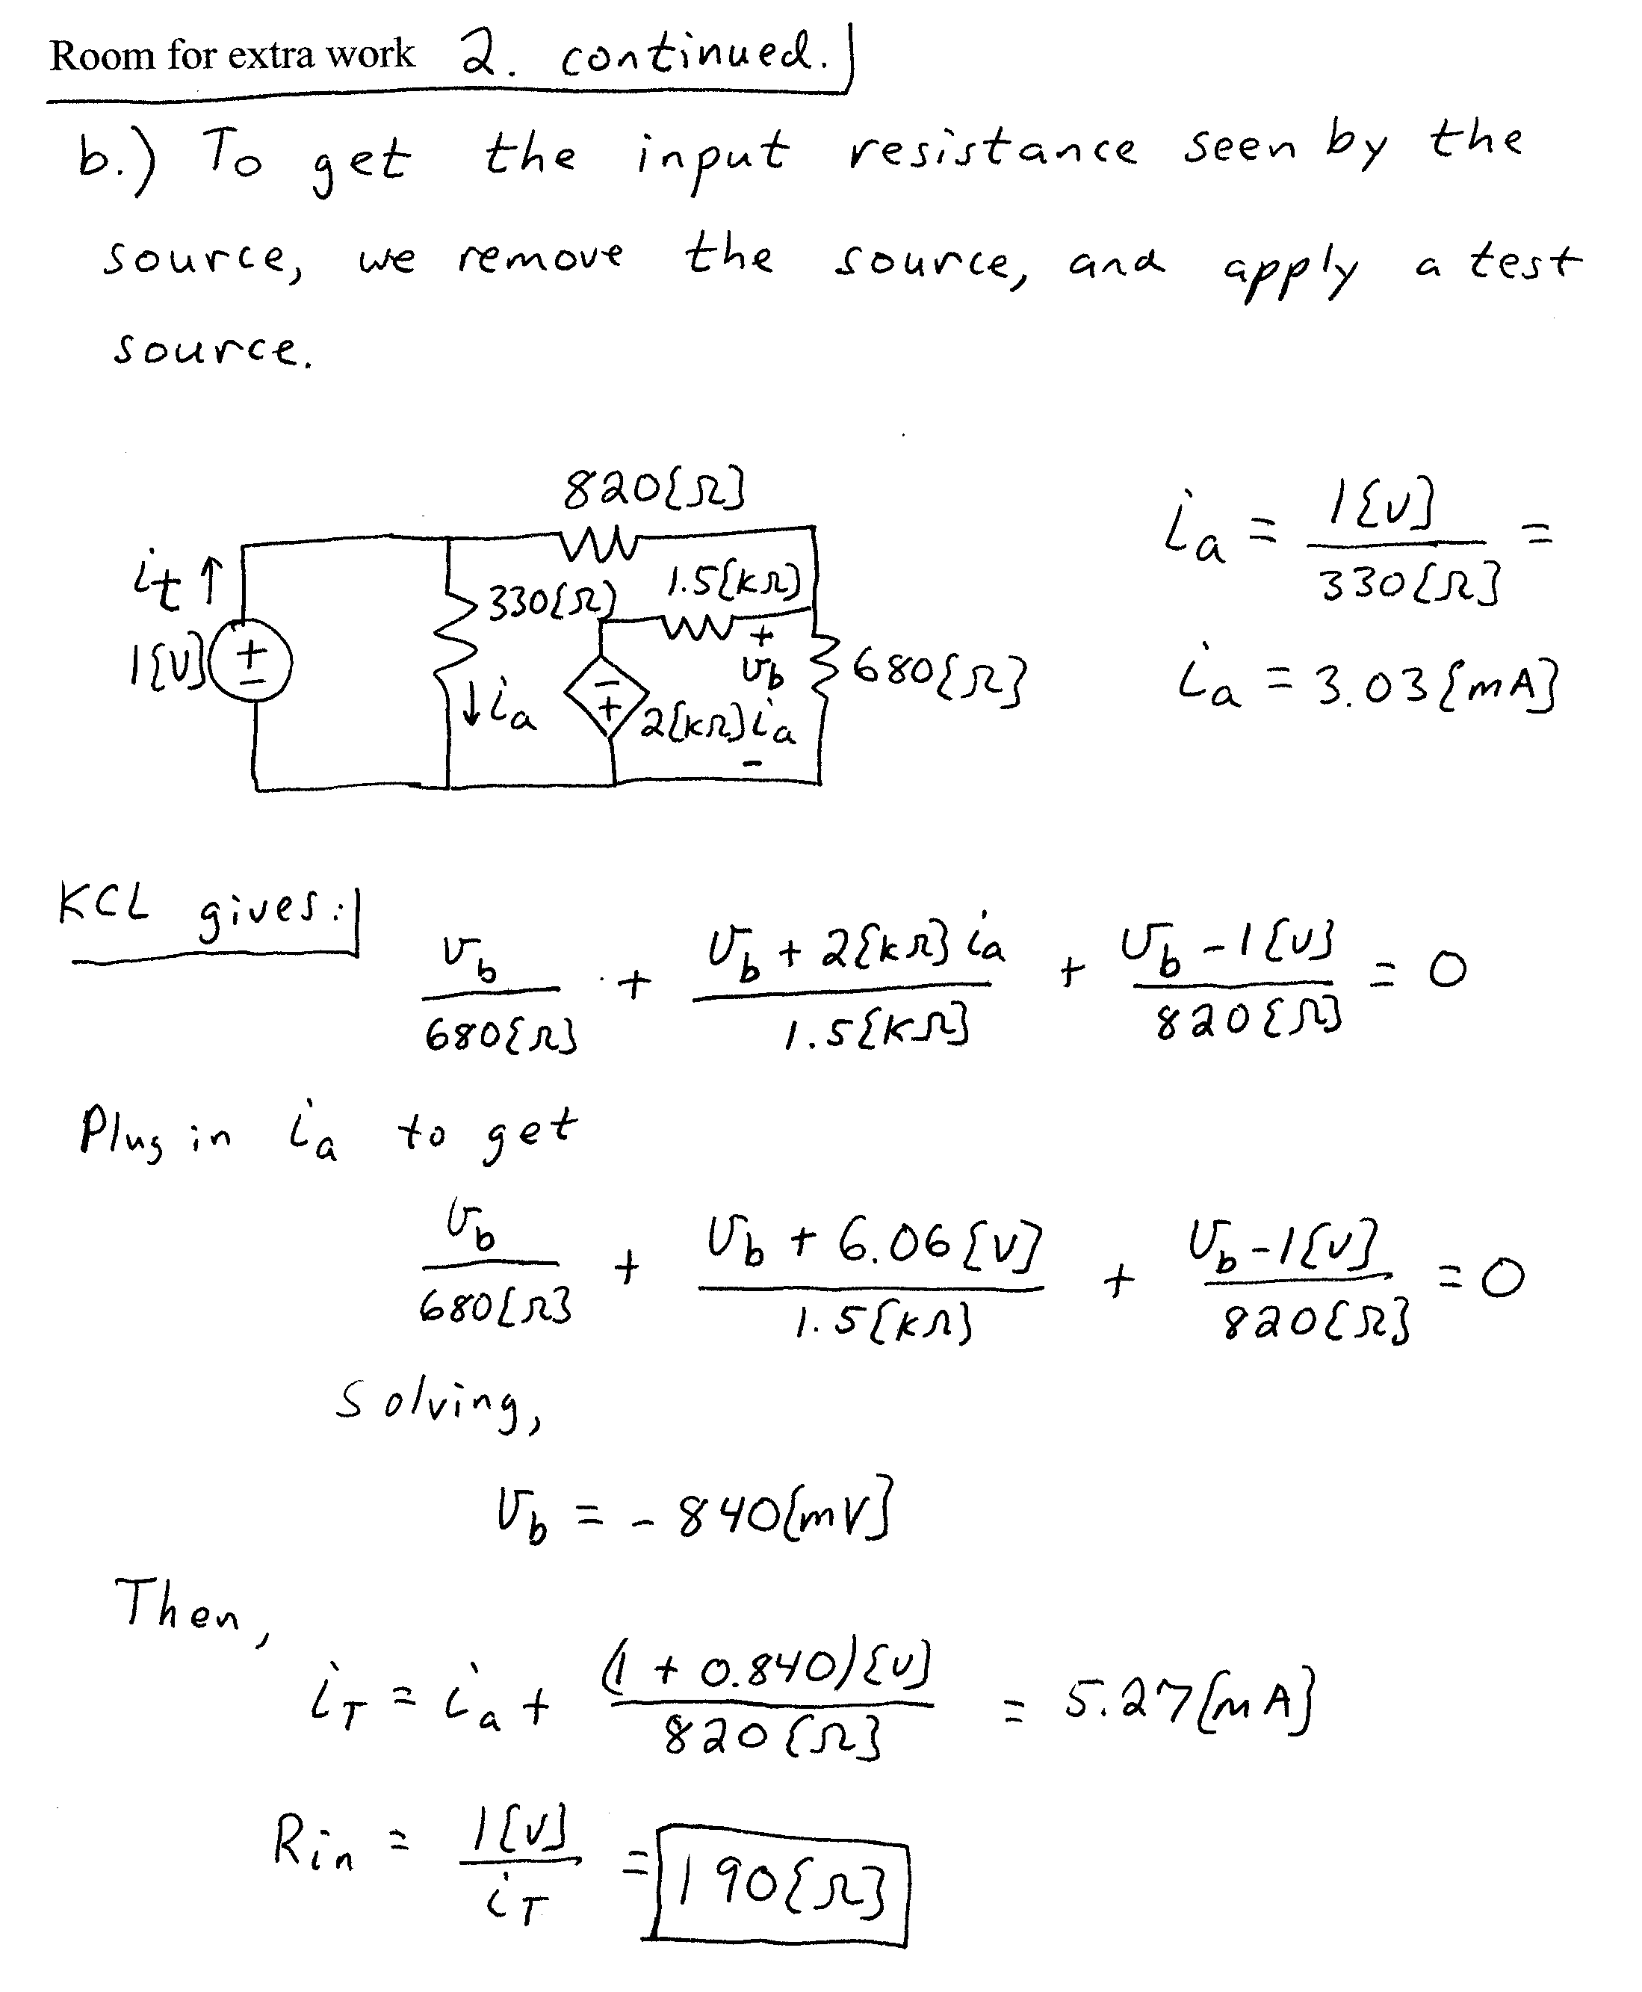

3. {35 Points} Find a transconductance amplifier that would be equivalent to the amplifier below, with respect to terminals 1, 2, 3, and 4. Draw your equivalent circuit, labeling terminals 1, 2, 3, and 4.


