Name: _____________________________ (please print)
Signature: __________________________

ECE 3455 -- Exam #2
November 5, 2005
Keep this exam closed until you are told to begin.

1. This exam is closed book, closed notes. You may use one 8.5” x 11” crib sheet, or its equivalent.
2. Show all work on these pages. Show all work necessary to complete the problem. A solution without the appropriate work shown will receive no credit. A solution that is not given in a reasonable order will lose credit. Clearly indicate your answer (for example by enclosing it in a box).
3. It is assumed that your work will begin on the same page as the problem statement. If you choose to begin your work on another page, you must indicate this on the page with the problem statement, with a clear indication of where the work can be found. If your work continues on to another page, indicate clearly where your work can be found. Failure to indicate this clearly will result in a loss of credit.
4. Show all units in solutions, intermediate results, and figures. Units in the exam will be included between square brackets.
5. Do not use red ink. Do not use red pencil.
6. You will have 90 minutes to work on this exam.

1. ________________/30
2. ________________/35
3. ________________/35
Total = 100

Room for extra work
1. {30 Points} Assume an ideal op amp.
- Find the poles and zeroes for the transfer function
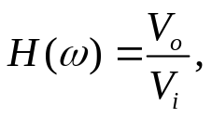
as functions of the component values.
- Find the gain, v_{o}/v_{i}, of this amplifier at very low frequencies, that is, at frequencies lower than all of the nonzero poles and zeroes.
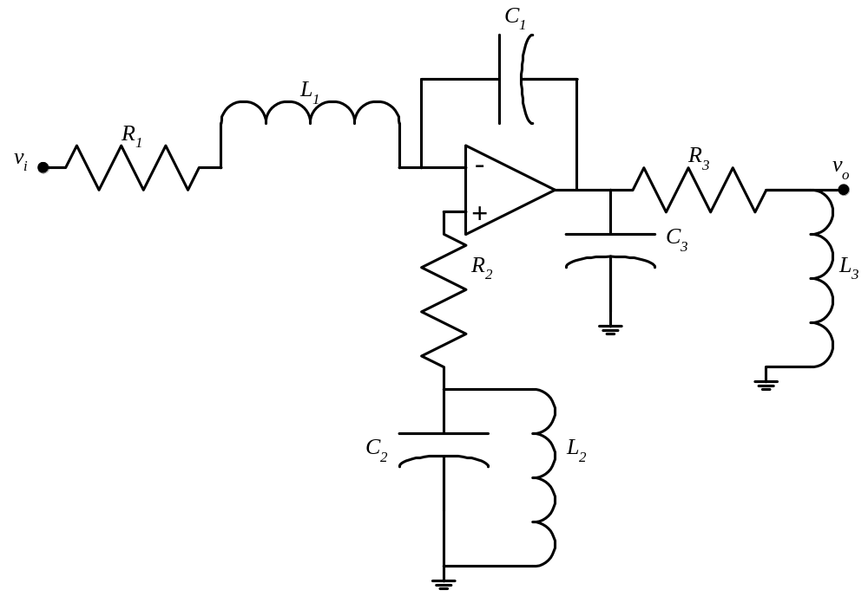

Room for extra work

2. {35 Points} Assume ideal op amps.
- Find v_{O}.
- Find i_{A}.
- Find i_{B}.

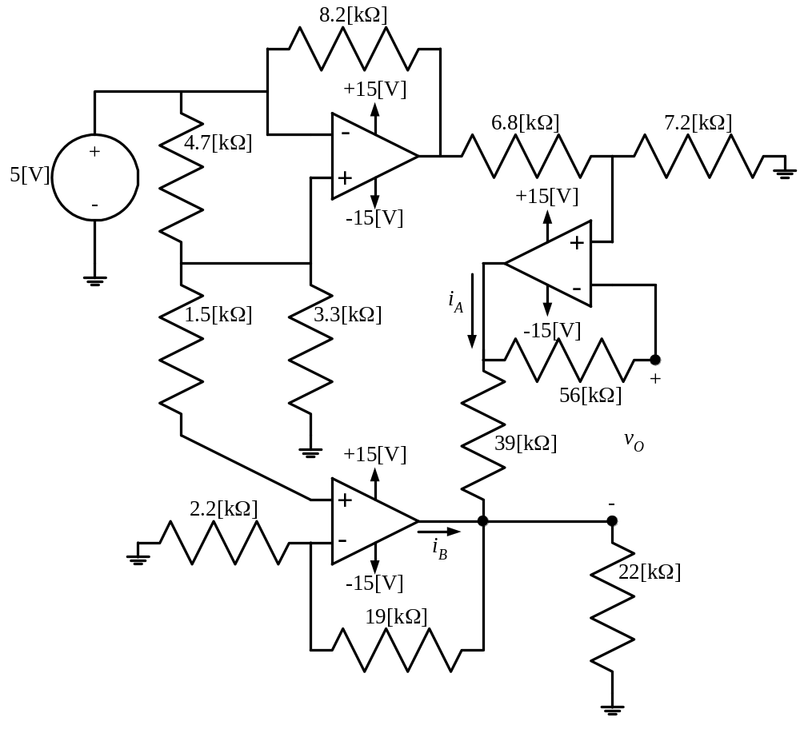

Room for extra work

3. {35 Points} Assume that each of the diodes in the circuit given can be modeled using a piecewise-linear model with V_{f} = 1[V], r_{d} = 1[kΩ], and
I_{s} = 1[mA]. Find V_{X}. I expect that you will be able to complete at least two guesses in the time period given. State your guesses. Test your guesses, showing your tests explicitly.

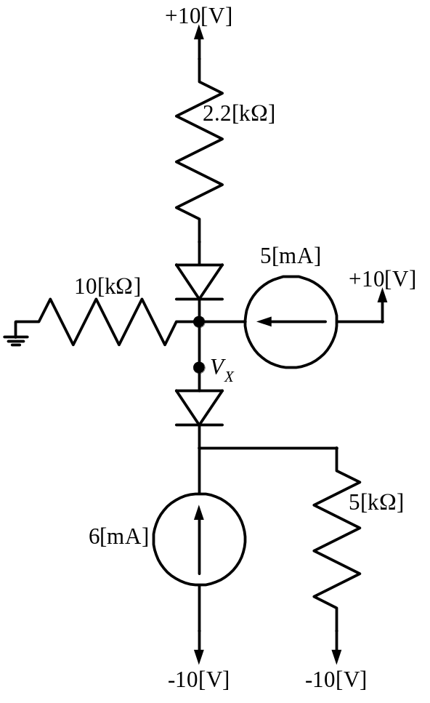

Solutions:
1. {30 Points} Assume an ideal op amp.
  - Find the poles and zeroes for the transfer function
as functions of the component values.
- Find the gain, v_{o}/v_{i}, of this amplifier at very low frequencies, that is, at frequencies lower than all of the nonzero poles and zeroes.
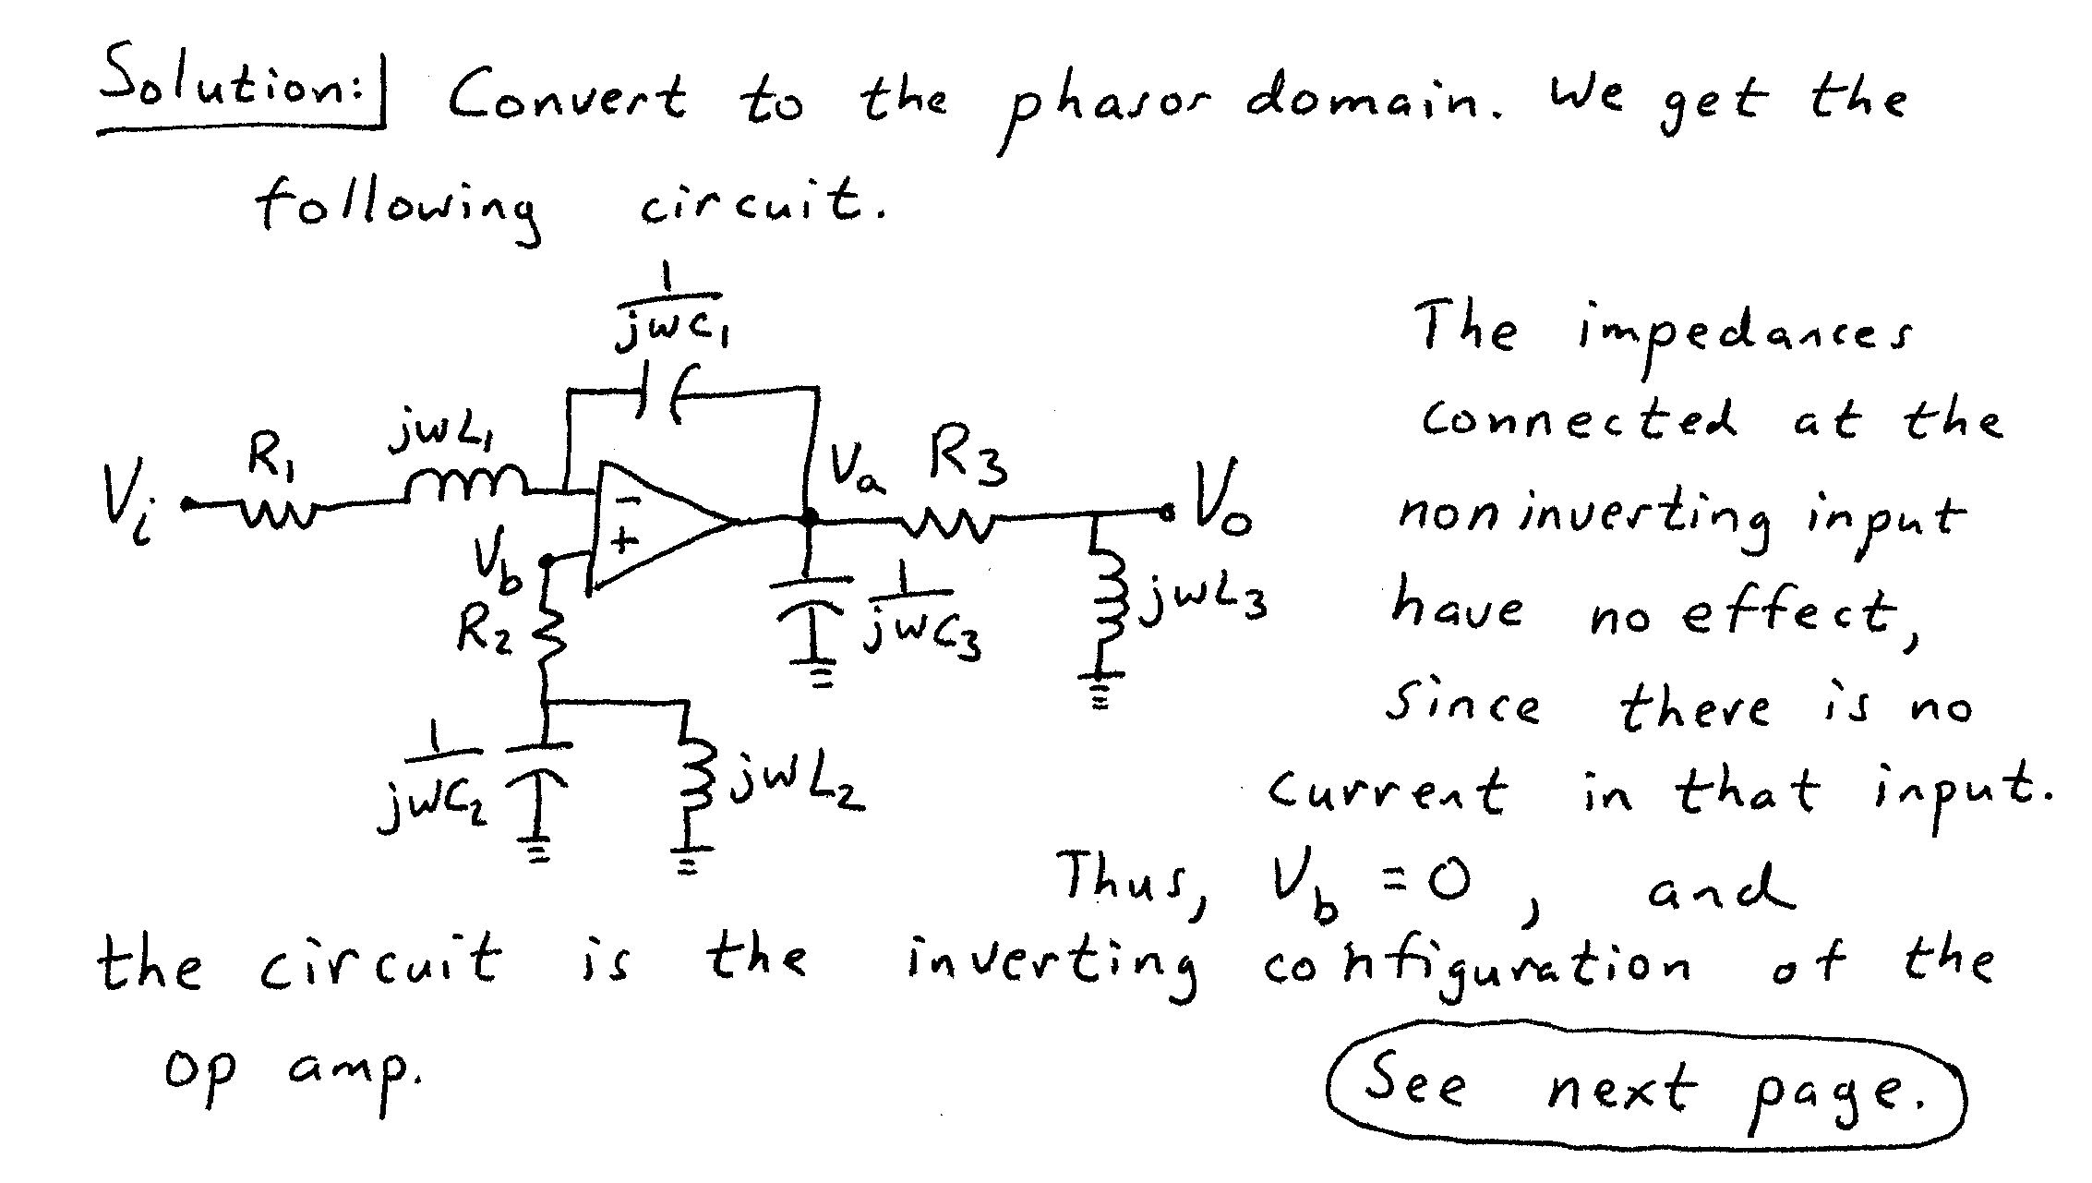
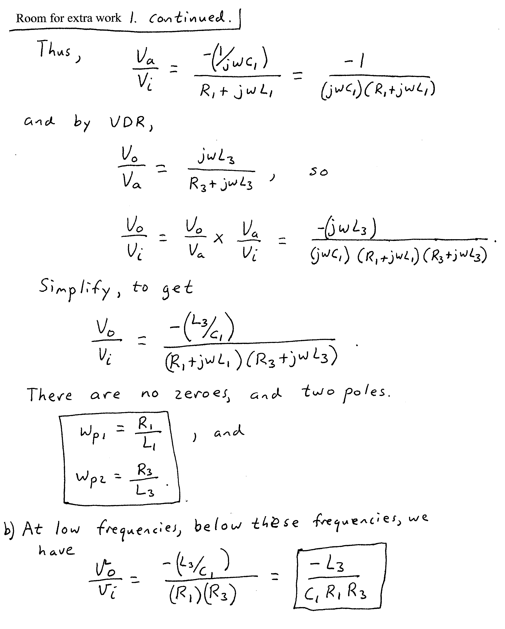

2. {35 Points} Assume ideal op amps.
- Find v_{O}.
- Find i_{A}.
- Find i_{B}.
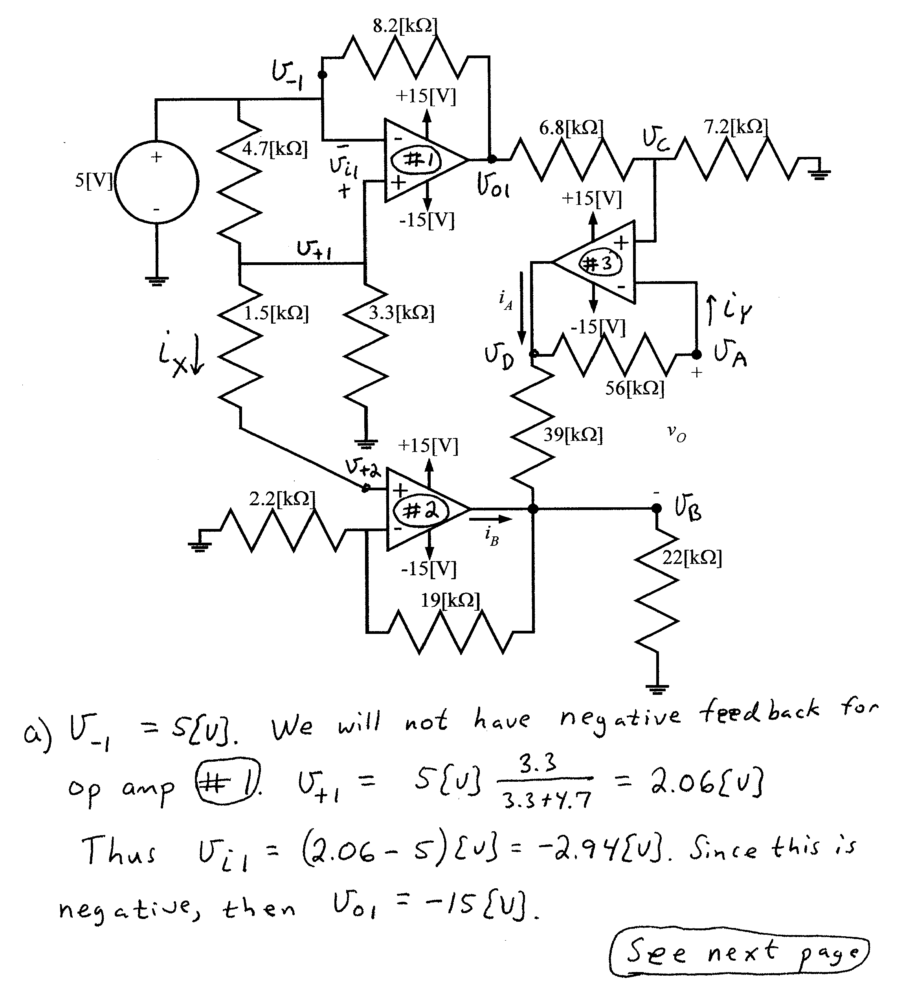
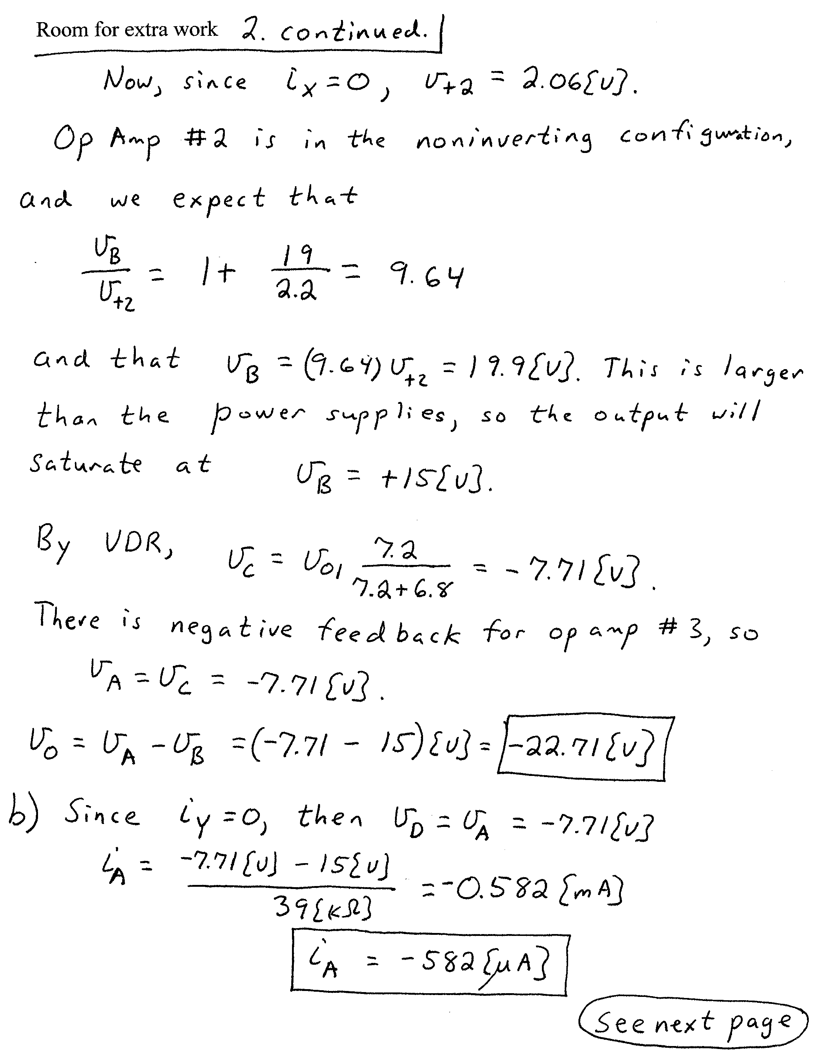
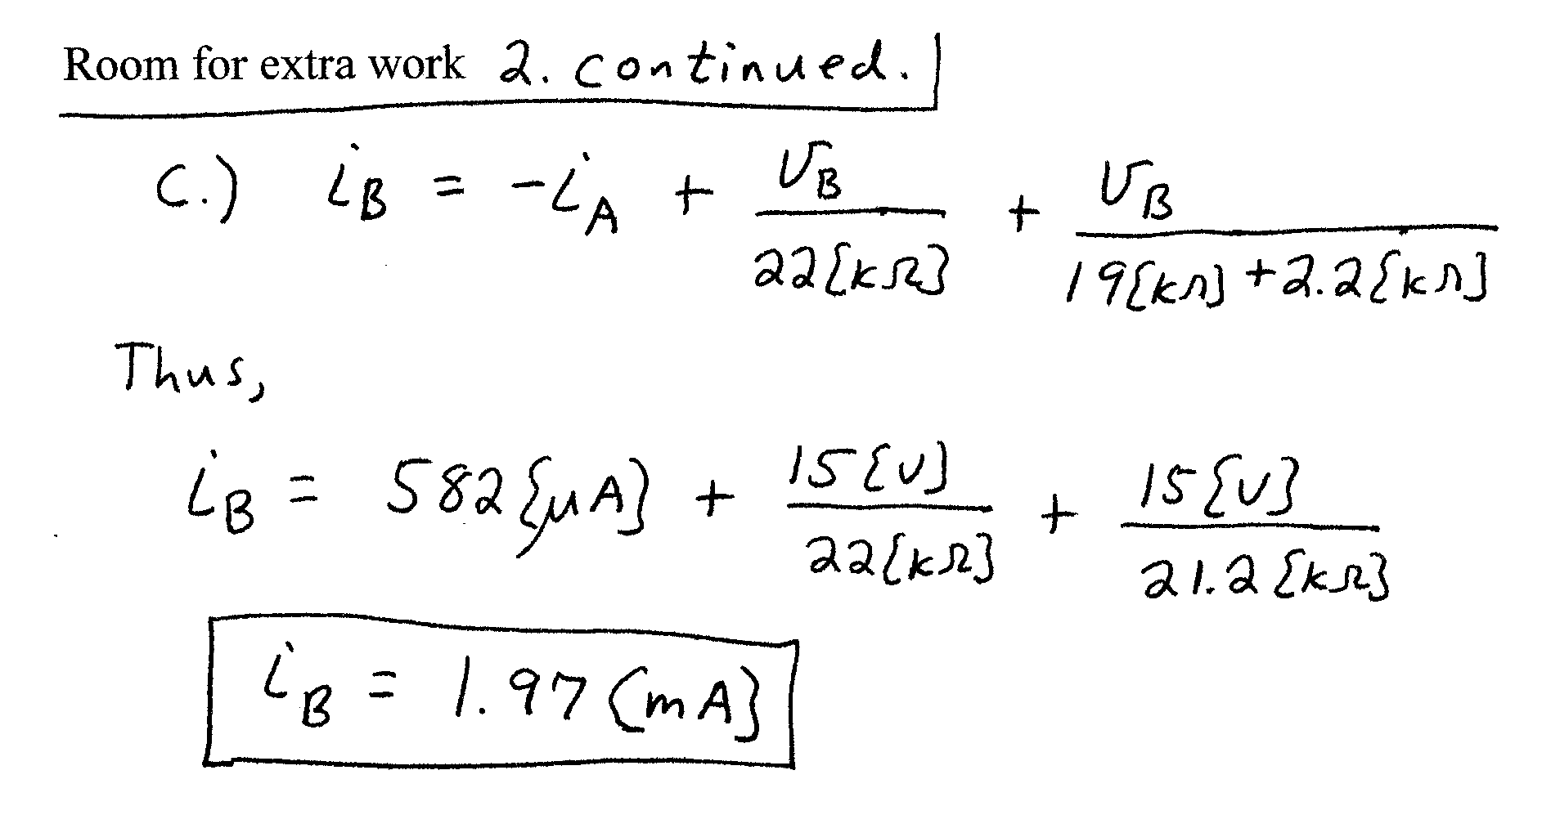

3. {35 Points} Assume that each of the diodes in the circuit given can be modeled using a piecewise-linear model with V_{f} = 1[V], r_{d} = 1[kΩ], and
I_{s} = 1[mA]. Find V_{X}. I expect that you will be able to complete at least two guesses in the time period given. State your guesses. Test your guesses, showing your tests explicitly.


