Name: _____________________________ (please print)
Signature: __________________________

ECE 3455 -- Exam #1
October 14, 2006
Keep this exam closed until you are told to begin.

1. This exam is closed book, closed notes. You may use one 8.5” x 11” crib sheet, or its equivalent.
2. Show all work on these pages. Show all work necessary to complete the problem. A solution without the appropriate work shown will receive no credit. A solution that is not given in a reasonable order will lose credit. Clearly indicate your answer (for example by enclosing it in a box).
3. It is assumed that your work will begin on the same page as the problem statement. If you choose to begin your work on another page, you must indicate this on the page with the problem statement, with a clear indication of where the work can be found. If your work continues on to another page, indicate clearly where your work can be found. Failure to indicate this clearly will result in a loss of credit.
4. Show all units in solutions, intermediate results, and figures. Units in the exam will be included between square brackets.
5. Do not use red ink. Do not use red pencil.
6. You will have 90 minutes to work on this exam.

1. ________________/30
2. ________________/30
3. ________________/20
4. ________________/20
Total = 100
Room for extra work

1. {30 Points} Find the input impedance seen by the source in the circuit shown. Your answer should be given as a function of ω.
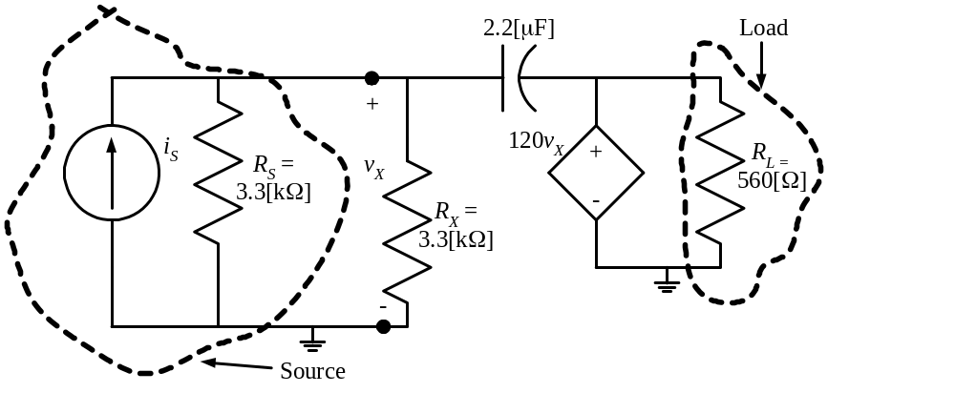

Room for extra work
2. {30 Points} The transfer function, H₂(ω), for a circuit is given below. Find the values of the poles and zeroes of this transfer function, if any. If a value has more than one pole or zero associated with it, indicate the order of the pole or zero. Use the semilog graph paper on the next pages to plot the straight-line approximations to the magnitude and phase Bode plots for H₂(ω). Include in your frequency range all of the slope changes in each plot.
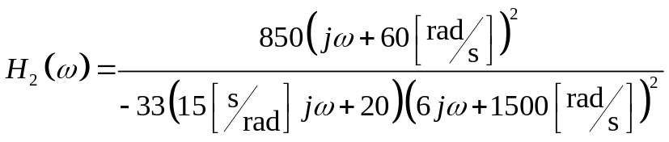

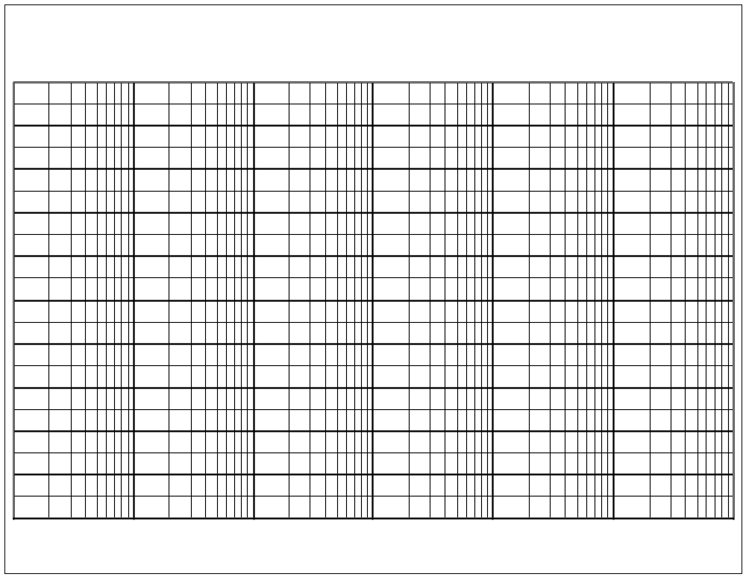
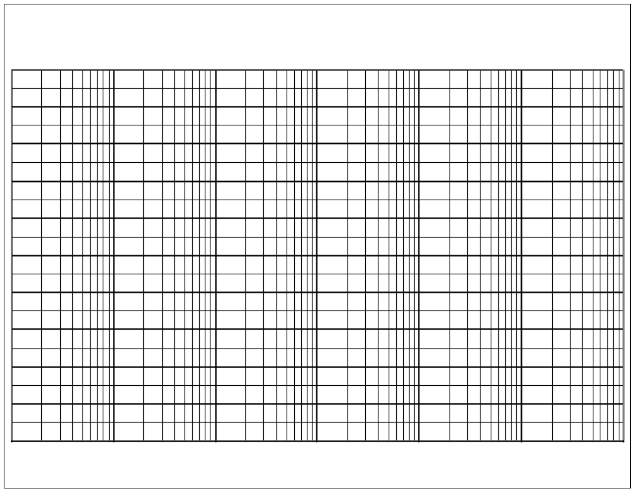
Room for extra work

3. {20 Points} Assume an ideal op amp.
Find v_{O}.

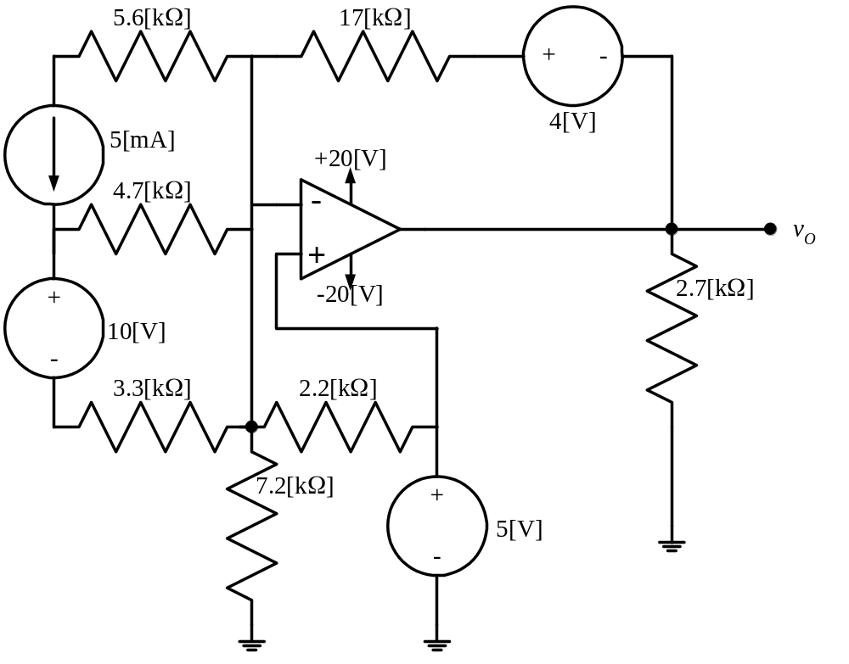

Room for extra work
4. {20 Points} It is given that the current through the inductor shown, is given in the expression that follows.
a) Find I_{A}.
b) Find i_{a}.
c) Find V_{L}.
d) Find v_{l}.
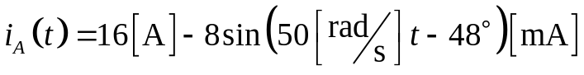
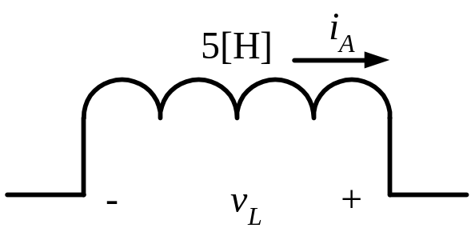

Solution:
1. {30 Points} Find the input impedance seen by the source in the circuit shown. Your answer should be given as a function of ω.
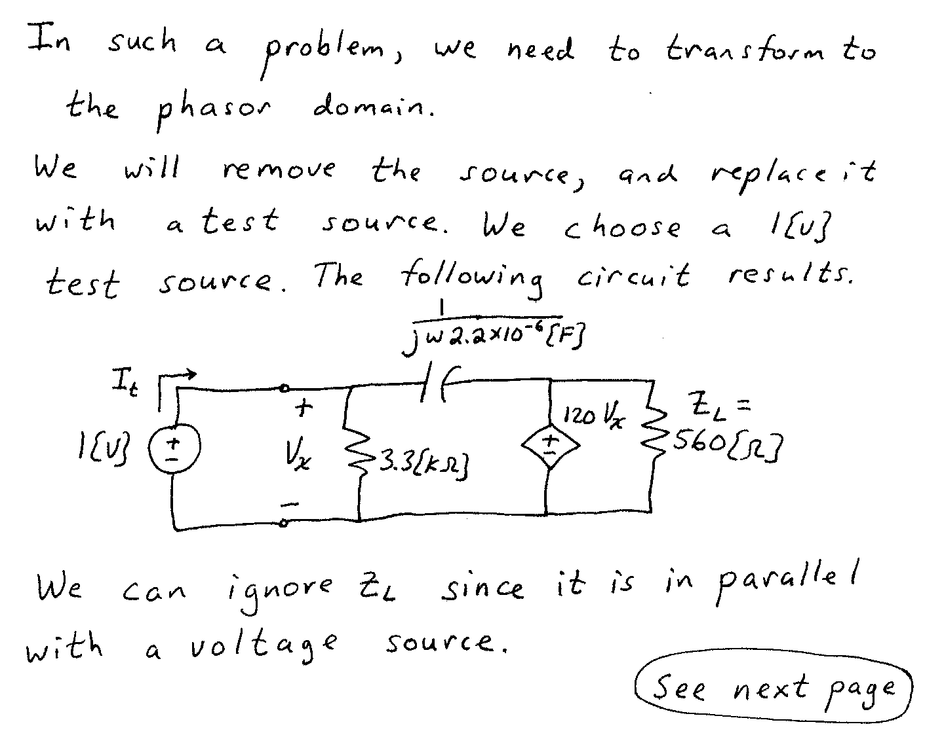
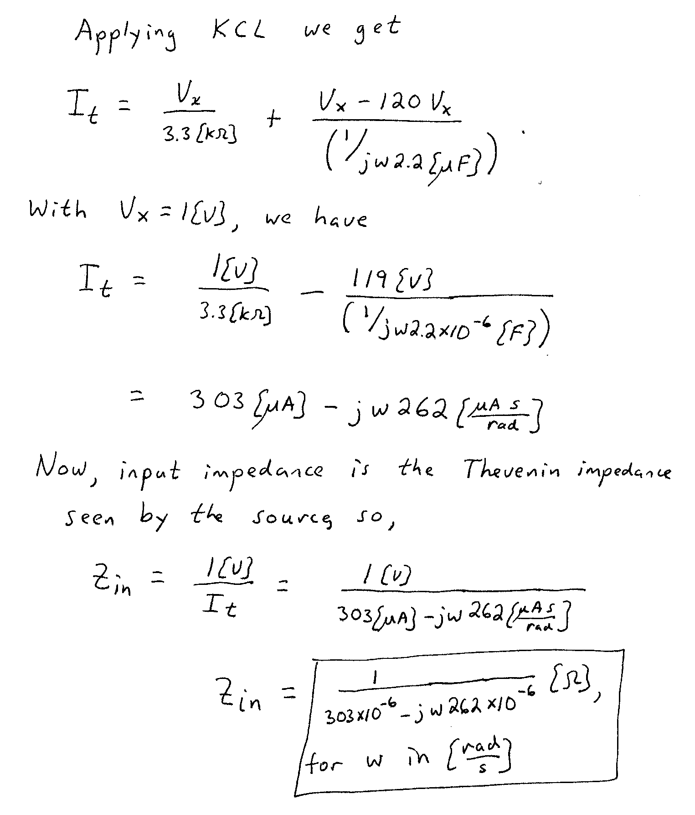

2. {30 Points} The transfer function, H₂(ω), for a circuit is given below. Find the values of the poles and zeroes of this transfer function, if any. If a value has more than one pole or zero associated with it, indicate the order of the pole or zero. Use the semilog graph paper on the next pages to plot the straight-line approximations to the magnitude and phase Bode plots for H₂(ω). Include in your frequency range all of the slope changes in each plot.
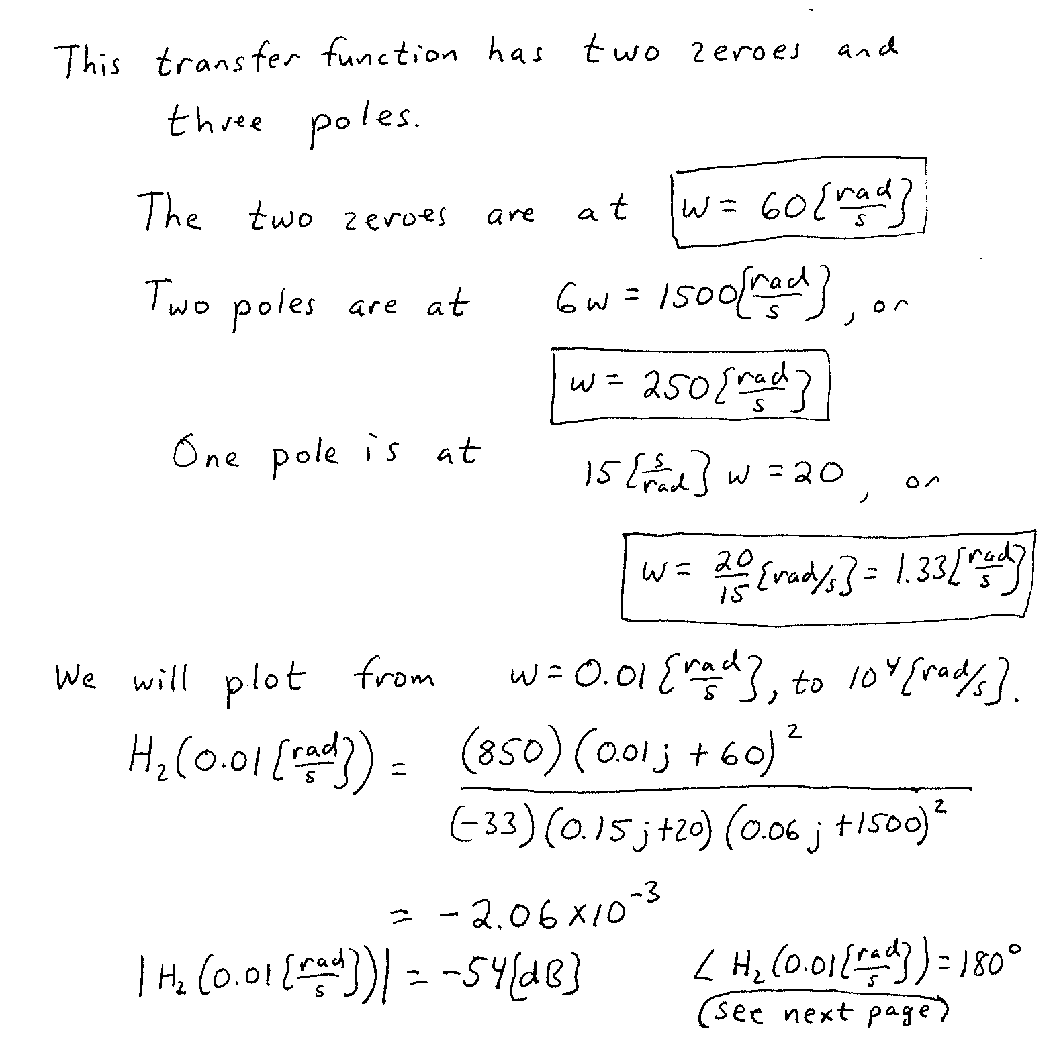
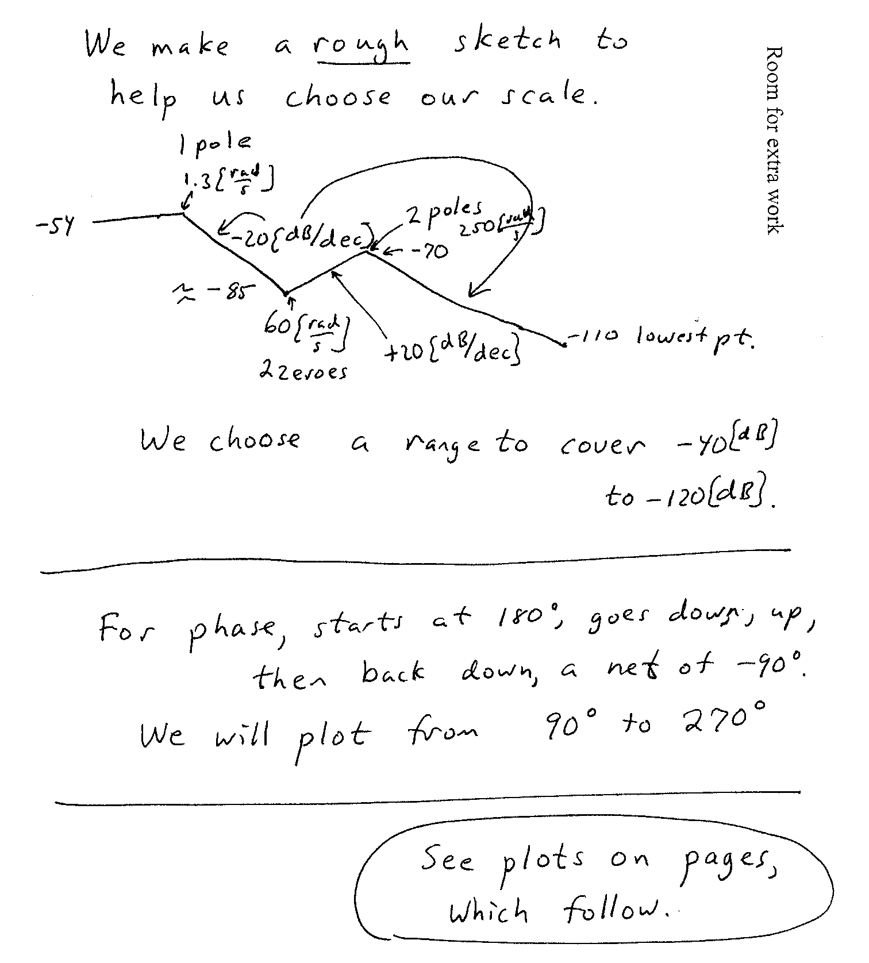
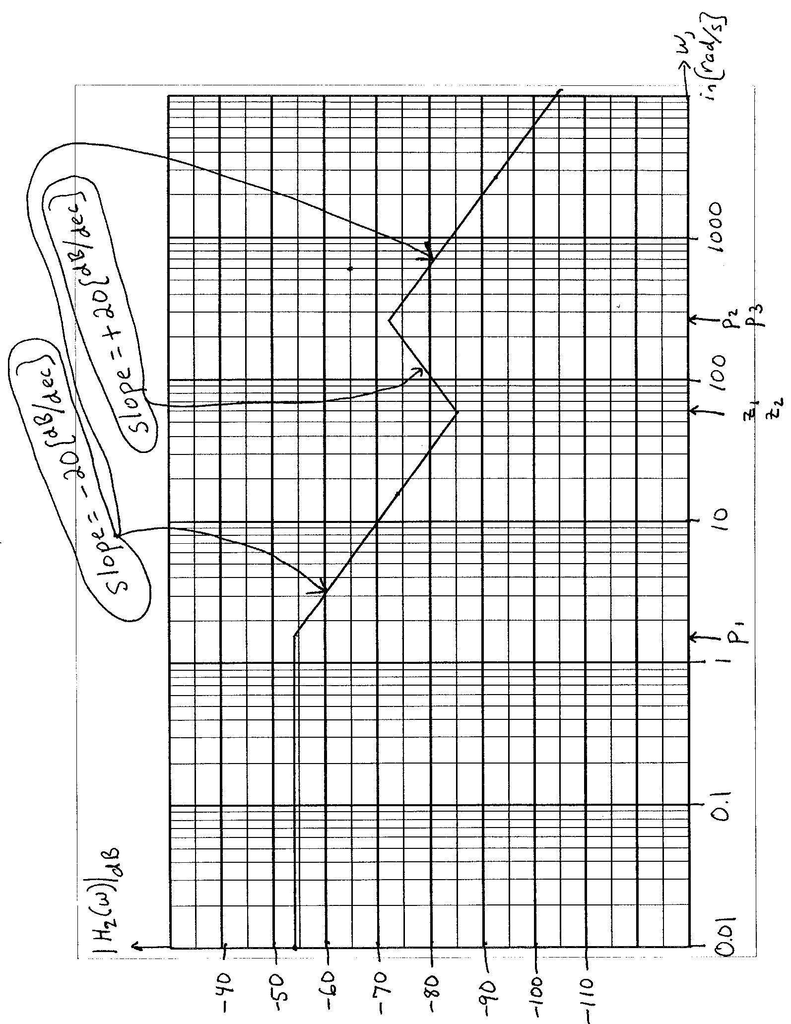

3. {20 Points} Assume an ideal op amp.
Find v_{O}.
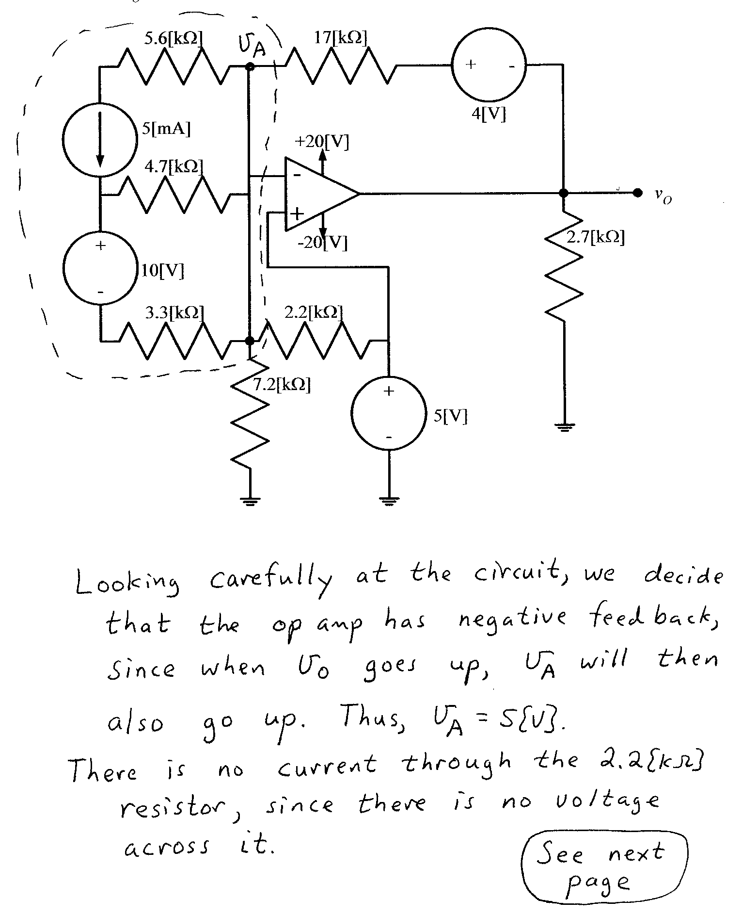
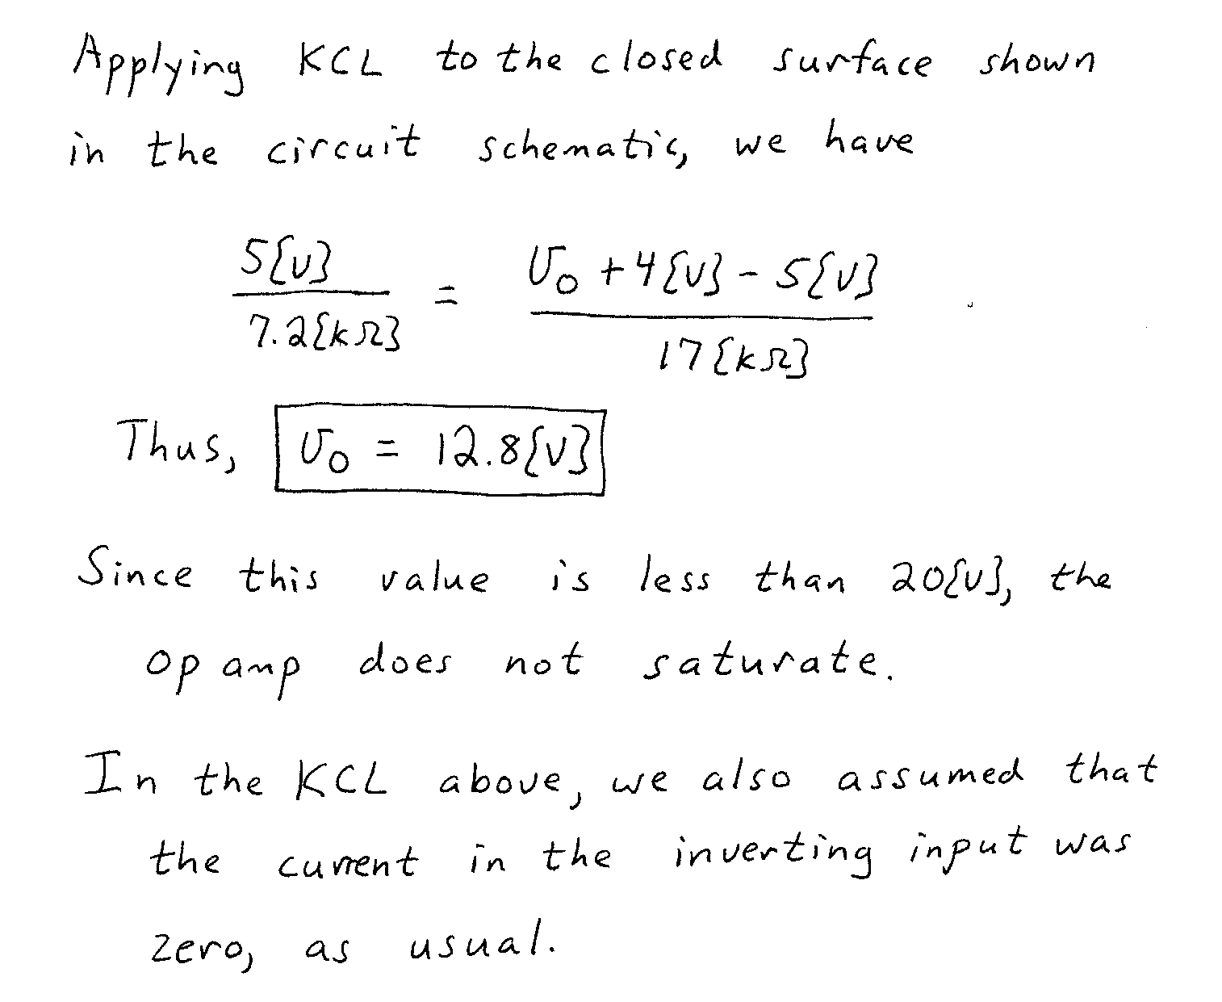

4. {20 Points} It is given that the current through the inductor shown, is given in the expression that follows.
a) Find I_{A}.
b) Find i_{a}.
c) Find V_{L}.
d) Find v_{l}.


