Name: _____________________________ (please print)
Signature: __________________________

ECE 3355 – Final Exam
December 10, 2011

Keep this exam closed until you are told to begin.

1. This exam is closed book, closed notes. You may use one 8.5” x 11” crib sheet, or its equivalent.
2. Show all work on these pages. Show all work necessary to complete the problem. A solution without the appropriate work shown will receive no credit. A solution that is not given in a reasonable order will lose credit. Clearly indicate your answer (for example by enclosing it in a box). If your answer is a plot, no box is needed.
3. It is assumed that your work will begin on the same page as the problem statement. If you choose to begin your work on another page, you must indicate this on the page with the problem statement, with a clear indication of where the work can be found. If your work continues on to another page, indicate clearly where your work can be found. Failure to indicate this clearly will result in a loss of credit.
4. Show all units in solutions, intermediate results, and figures. Units in the exam will be included between square brackets.
5. Do not use red ink. Do not use red pencil.
6. You will have 170 minutes to work on this exam.

1. ________________/20
2. ________________/20
3. ________________/10
4. ________________/25
5. ________________/25

Total = 100
Room for extra work

1. {20 Points} Use the circuit below to solve this problem. Assume ideal op amps.
a) Find V_{A}.
b) Find V_{B}.
c) Find V_{C}.
d) Find V_{D}.

Room for extra work

2. {20 Points} Assume that the diodes can be modeled using a piece-wise linear diode model with V_{f} = 1[V], r_{d} = 1[kΩ], and I_{s} = 1[mA]. Find V_{X}. Show your work, stating your tests explicitly. Define all variables appropriately. You are expected to be able to complete at least two guesses, if needed, in the time period allotted.

Room for extra work

3. {10 Points} The op amps in the circuits given are ideal, except for the fact that the output current, i_{X}, is limited to a magnitude of 20[mA]. That is,
-20[mA] < i_{X} < 20[mA]. The input is given below. Assume that for the transistor, β = 300. Assume that the diodes can be modeled using a piece-wise linear diode model with V_{f} = 0.7[V], r_{d} = 150[Ω], and I_{s} = 1[nA]. Assume that the source v_{I}(t) is
- Sketch the output voltage v_{A}(t) that would result, in Figure 1.
- Sketch the output voltage v_{B}(t) that would result, in Figure 2.
- If the goal for both circuits was to have a half-wave rectifier, compare the effectiveness of the two solutions.

Room for extra work

4. {25 Points} Use the circuit in Figure 1 below to solve this problem. Assume that for the transistor, β = 100, and that it is operating at room temperature. Assume that the capacitor C₁ has a large enough value so that it is effectively infinite for this problem. The straight line approximation to the magnitude Bode Plot is shown in Figure 2.
a) Find μ_{PB}.
b) Find C₂ so that f₂ = 22[kHz].
c) Find f₁ for the solution in part b).
Room for extra work

5. {25 Points} You have at your disposal an unlimited supply of ideal op amps, resistors, potentiometers, capacitors, inductors, diodes and transistors. Your transistors have β = 100, and operate at room temperature. Your diodes can be modeled using a piece-wise linear diode model with V_{f} = 0.7[V], r_{d} = 0, and I_{s} = 0. You have two dc power supplies, one at +15[V], and one at -15[V]. Design a circuit to produce the waveform v_{X}(t) given in the plot below.
The V_{off} is an offset voltage that should be adjustable, in the range
-3[V] < V_{off} < +3[V], using a potentiometer.
Show your design, explaining how you achieve the desired voltage. Describe your design and how it meets the specifications, using complete sentences.
Room for extra work

1. {20 Points} Use the circuit below to solve this problem. Assume ideal op amps.
a) Find V_{A}.
b) Find V_{B}.
c) Find V_{C}.
d) Find V_{D}.
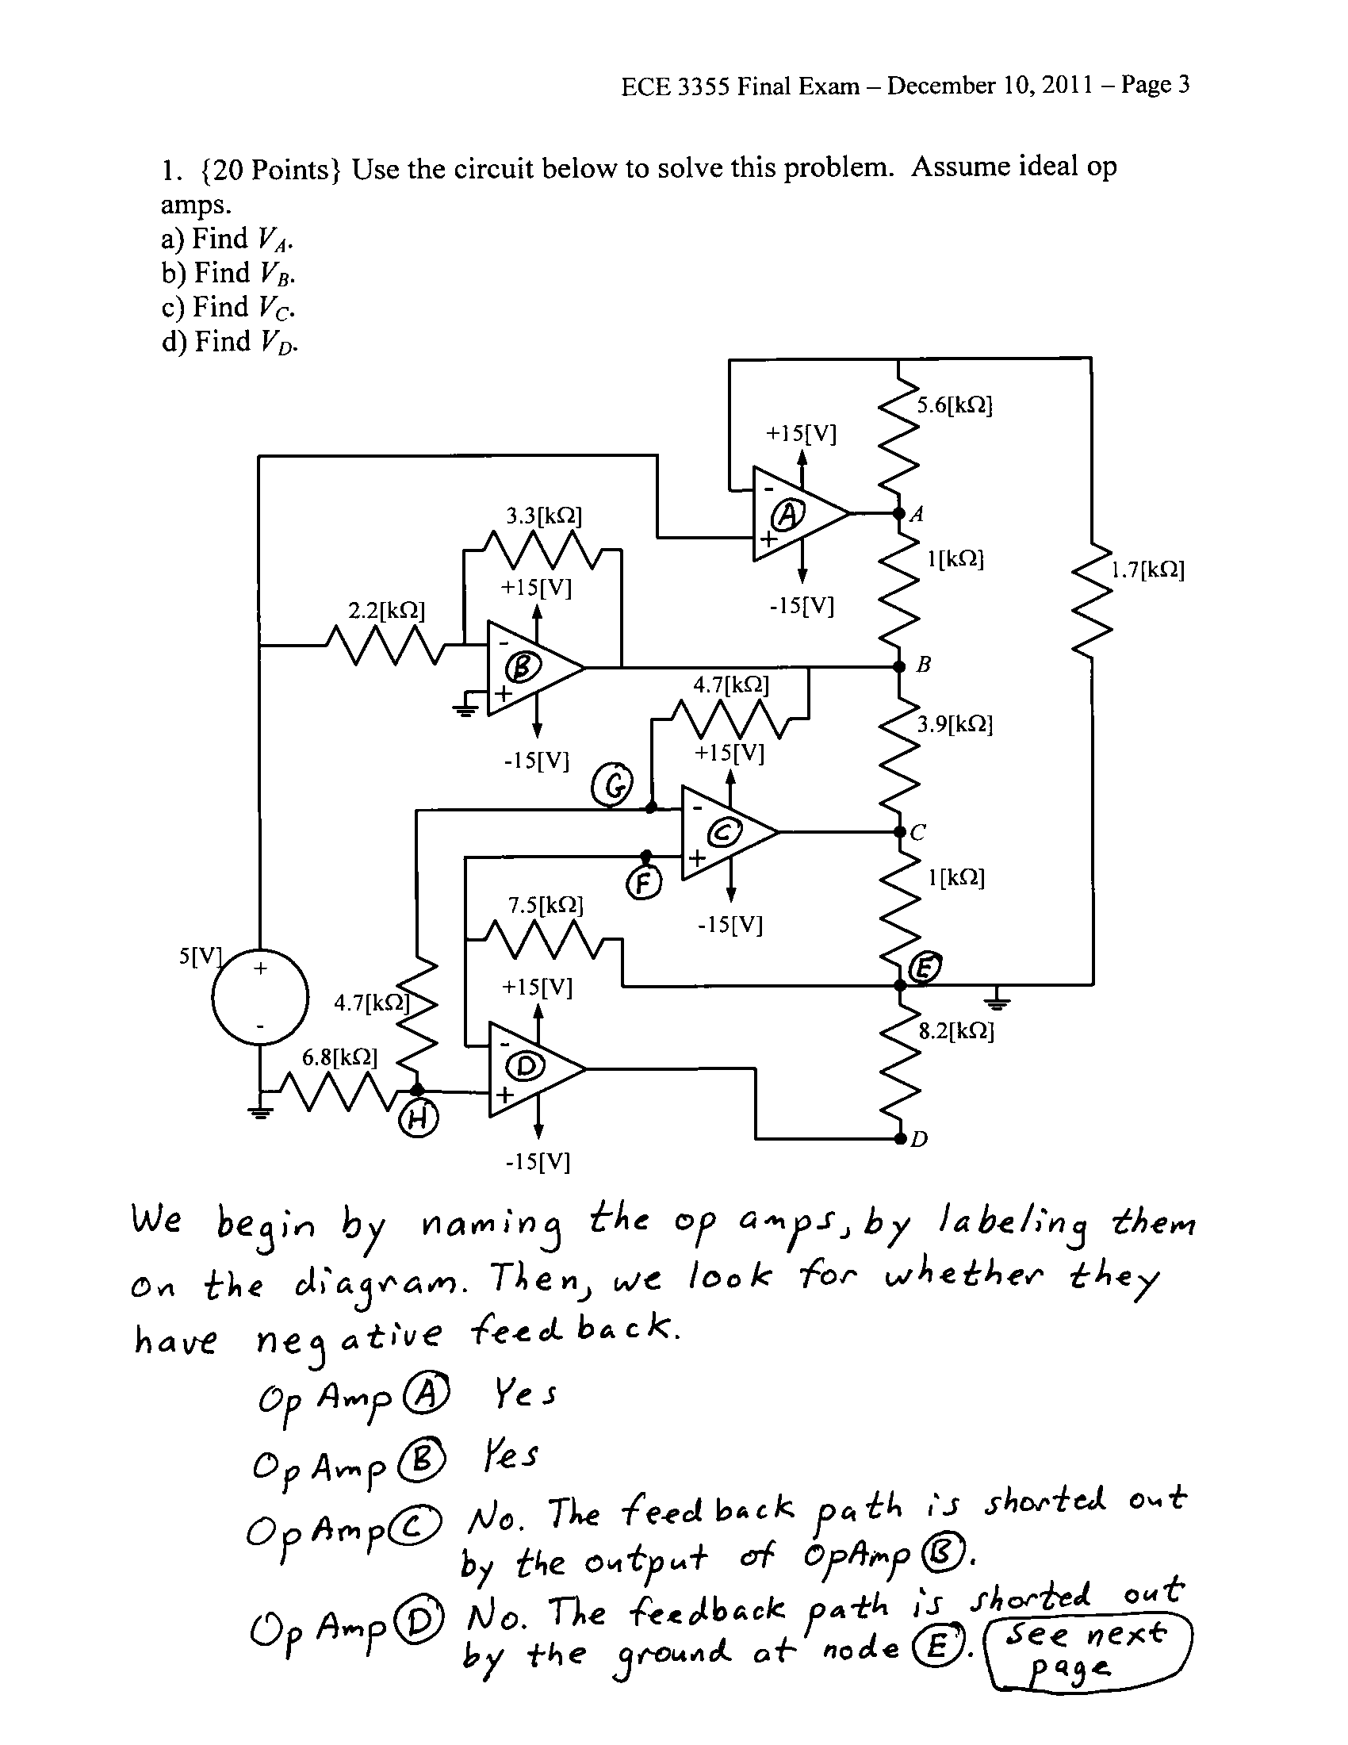
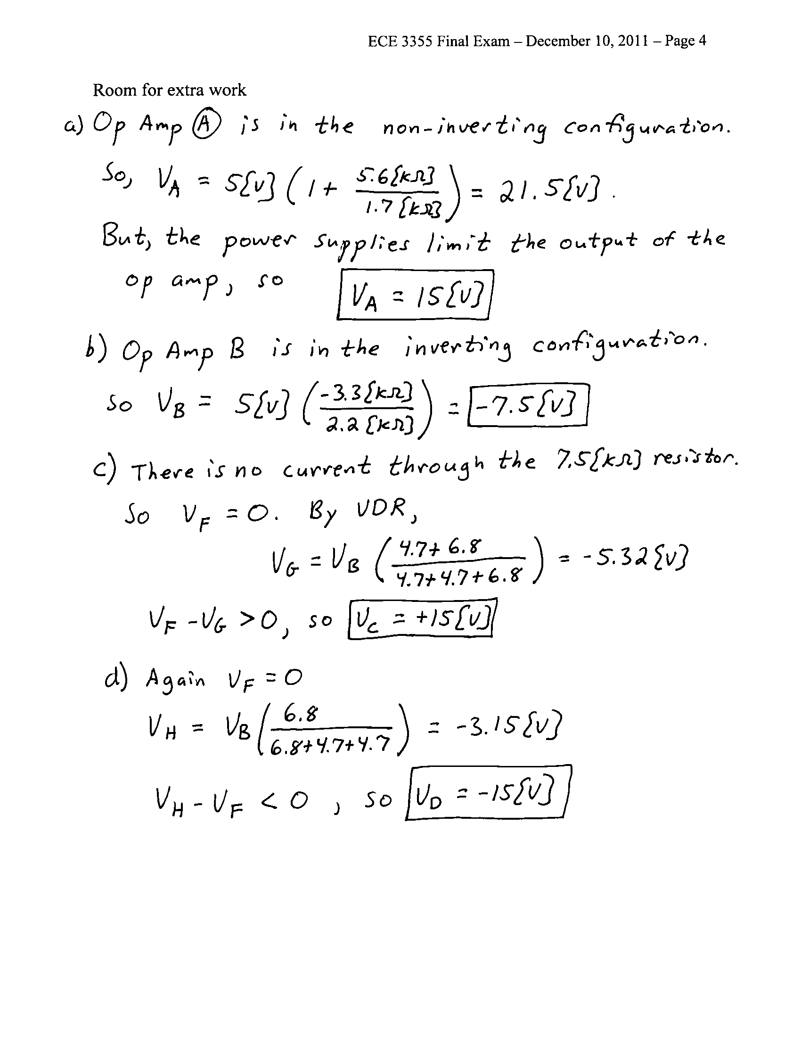

2. {20 Points} Assume that the diodes can be modeled using a piece-wise linear diode model with V_{f} = 1[V], r_{d} = 1[kΩ], and I_{s} = 1[mA]. Find V_{X}. Show your work, stating your tests explicitly. Define all variables appropriately. You are expected to be able to complete at least two guesses, if needed, in the time period allotted.
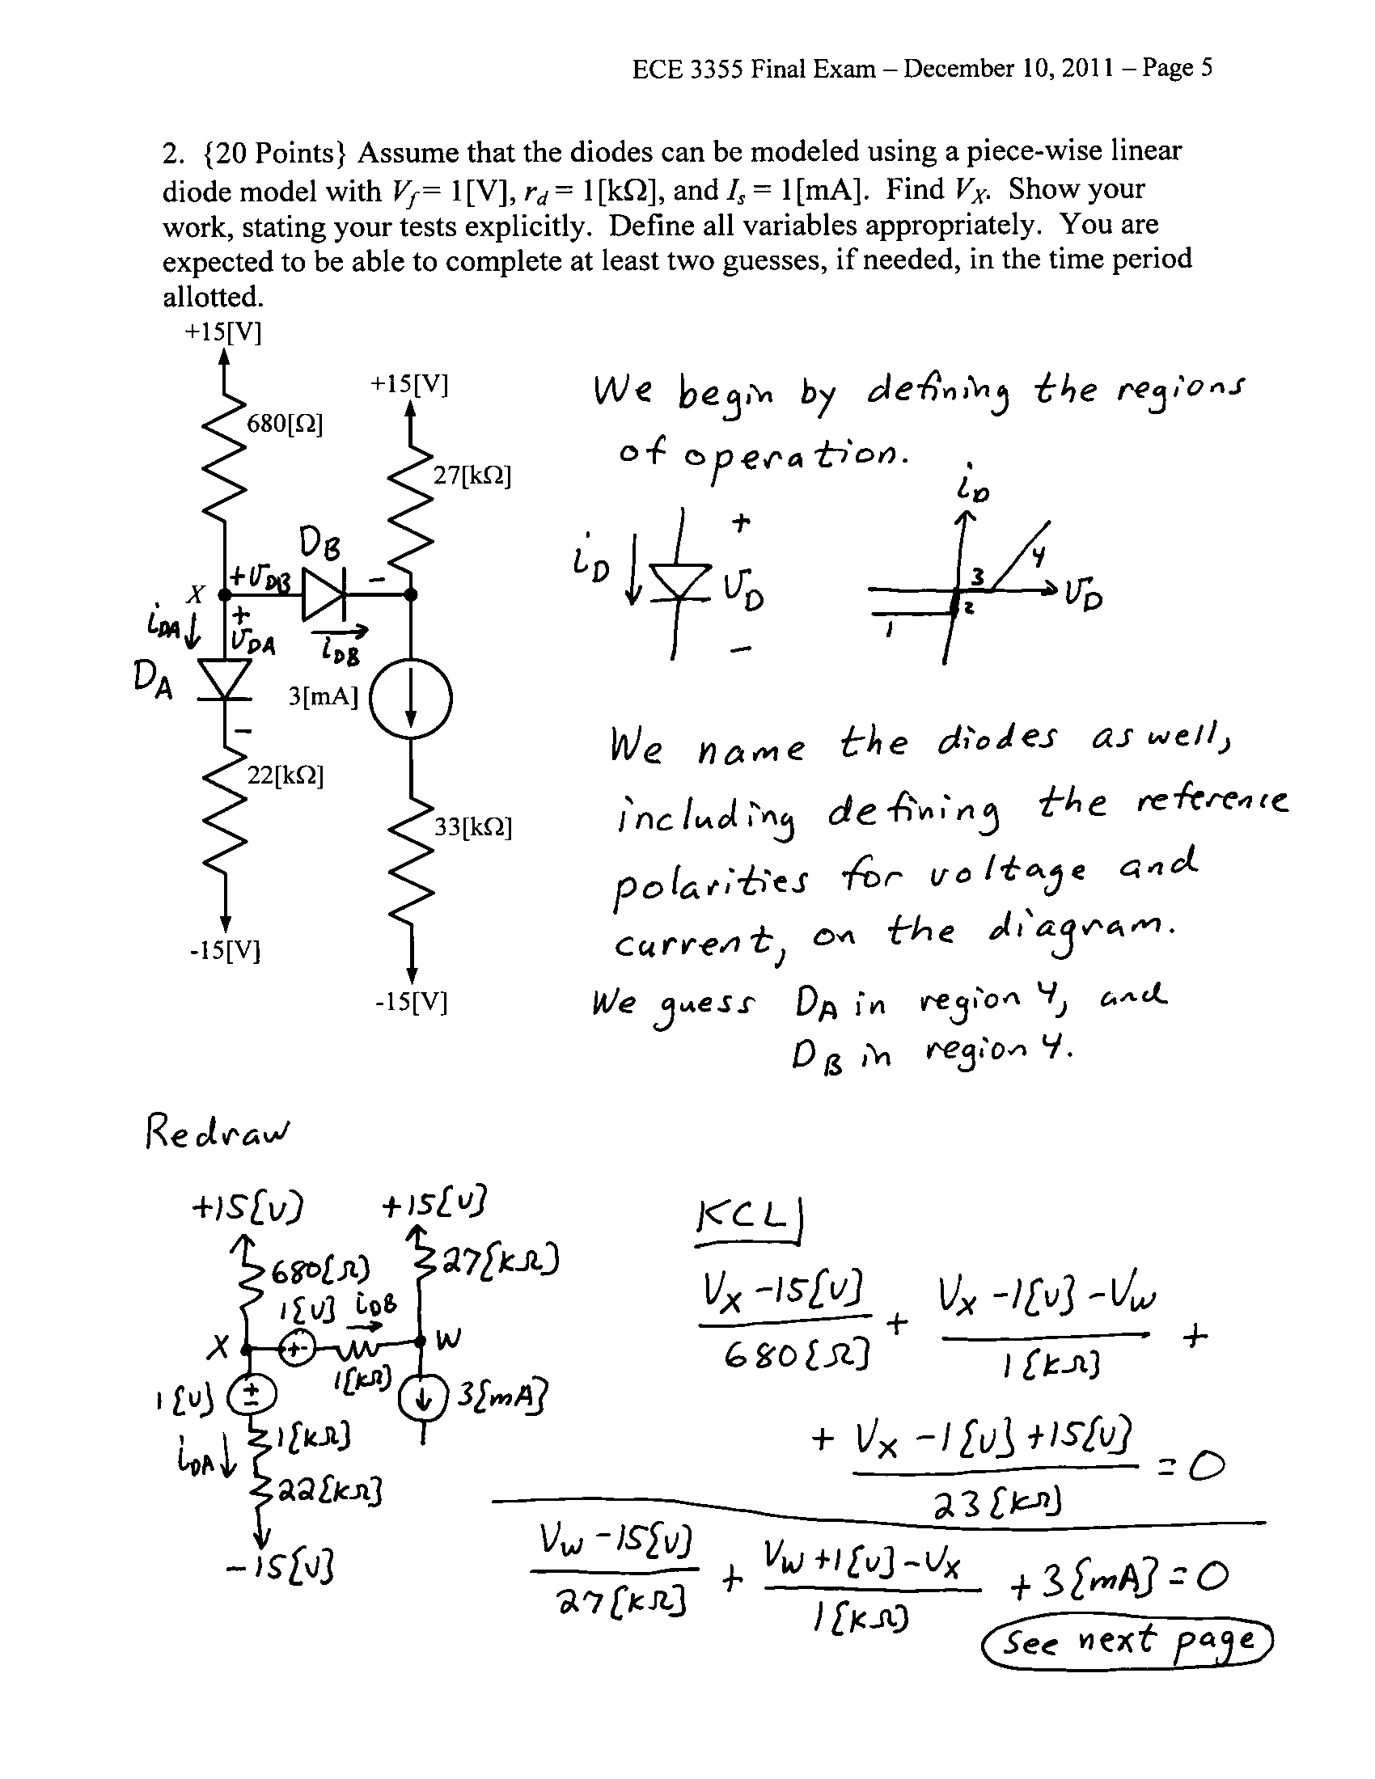

3. {10 Points} The op amps in the circuits given are ideal, except for the fact that the output current, i_{X}, is limited to a magnitude of 20[mA]. That is,
-20[mA] < i_{X} < 20[mA]. The input is given below. Assume that for the transistor, β = 300. Assume that the diodes can be modeled using a piece-wise linear diode model with V_{f} = 0.7[V], r_{d} = 150[Ω], and I_{s} = 1[nA]. Assume that the source v_{I}(t) is
- Sketch the output voltage v_{A}(t) that would result, in Figure 1.
- Sketch the output voltage v_{B}(t) that would result, in Figure 2.
- If the goal for both circuits was to have a half-wave rectifier, compare the effectiveness of the two solutions.
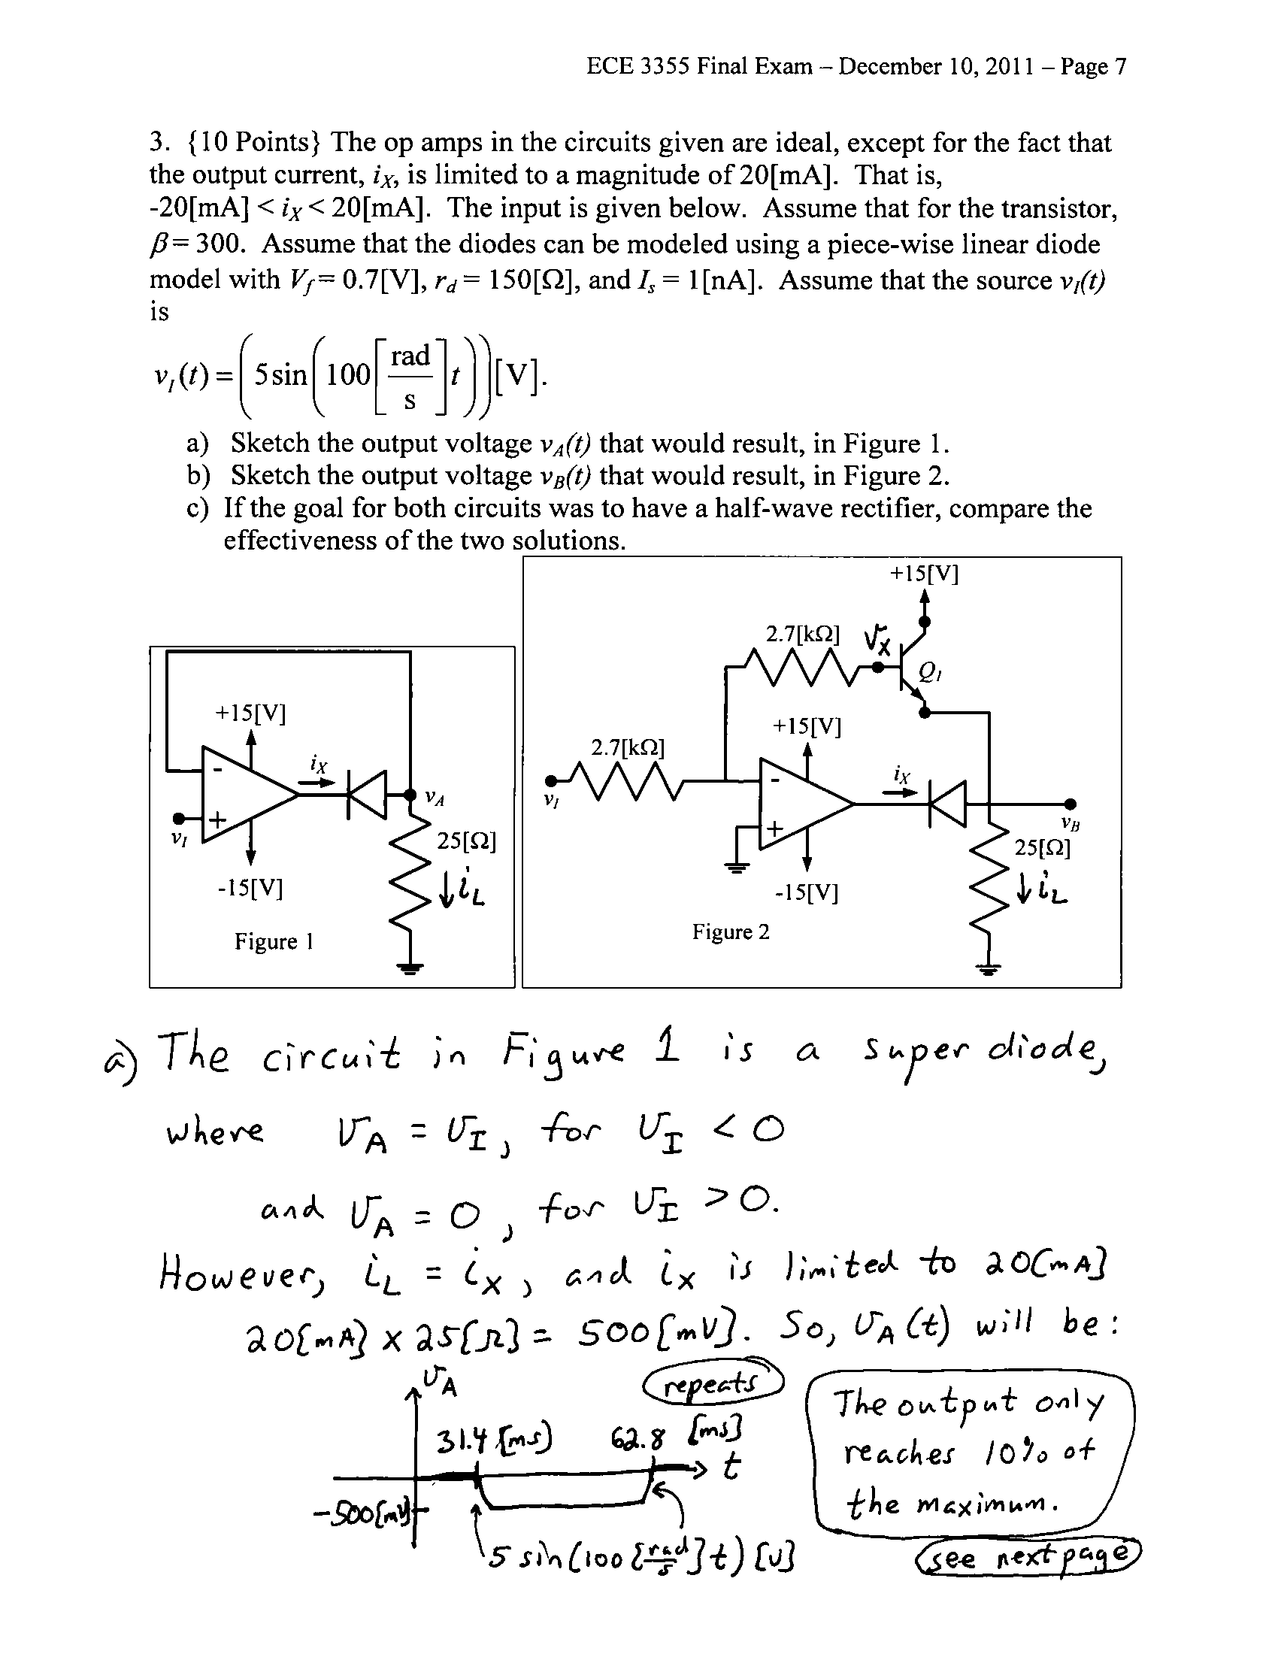
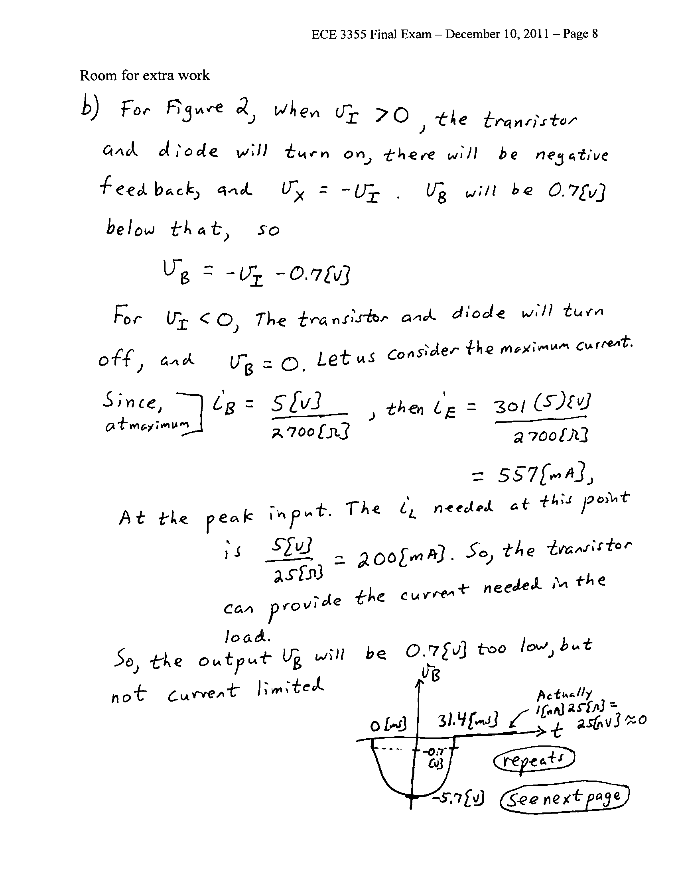

4. {25 Points} Use the circuit in Figure 1 below to solve this problem. Assume that for the transistor, β = 100, and that it is operating at room temperature. Assume that the capacitor C₁ has a large enough value so that it is effectively infinite for this problem. The straight line approximation to the magnitude Bode Plot is shown in Figure 2.
a) Find μ_{PB}.
b) Find C₂ so that f₂ = 22[kHz].
c) Find f₁ for the solution in part b).
See next page.
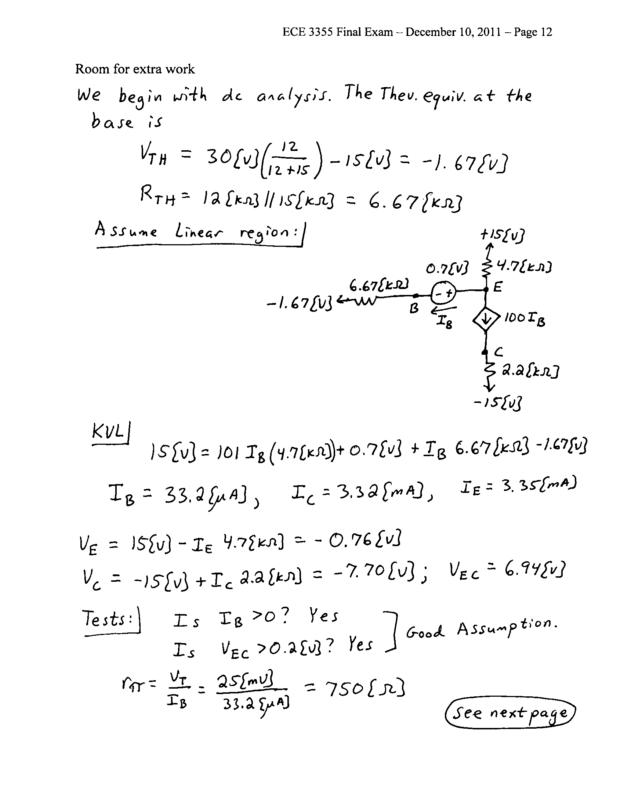
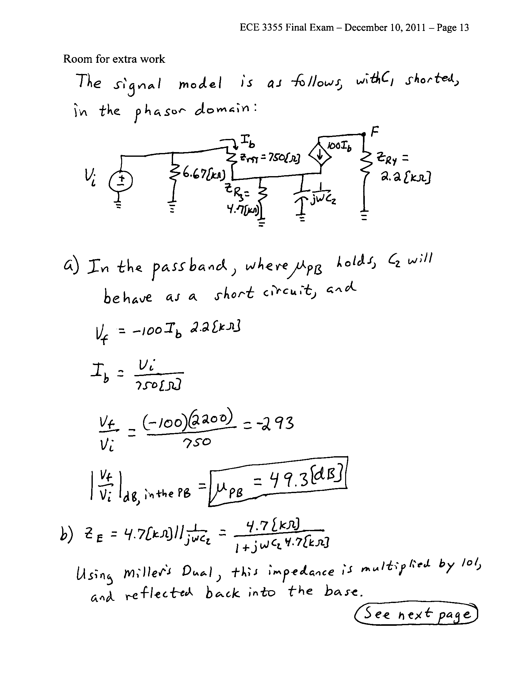
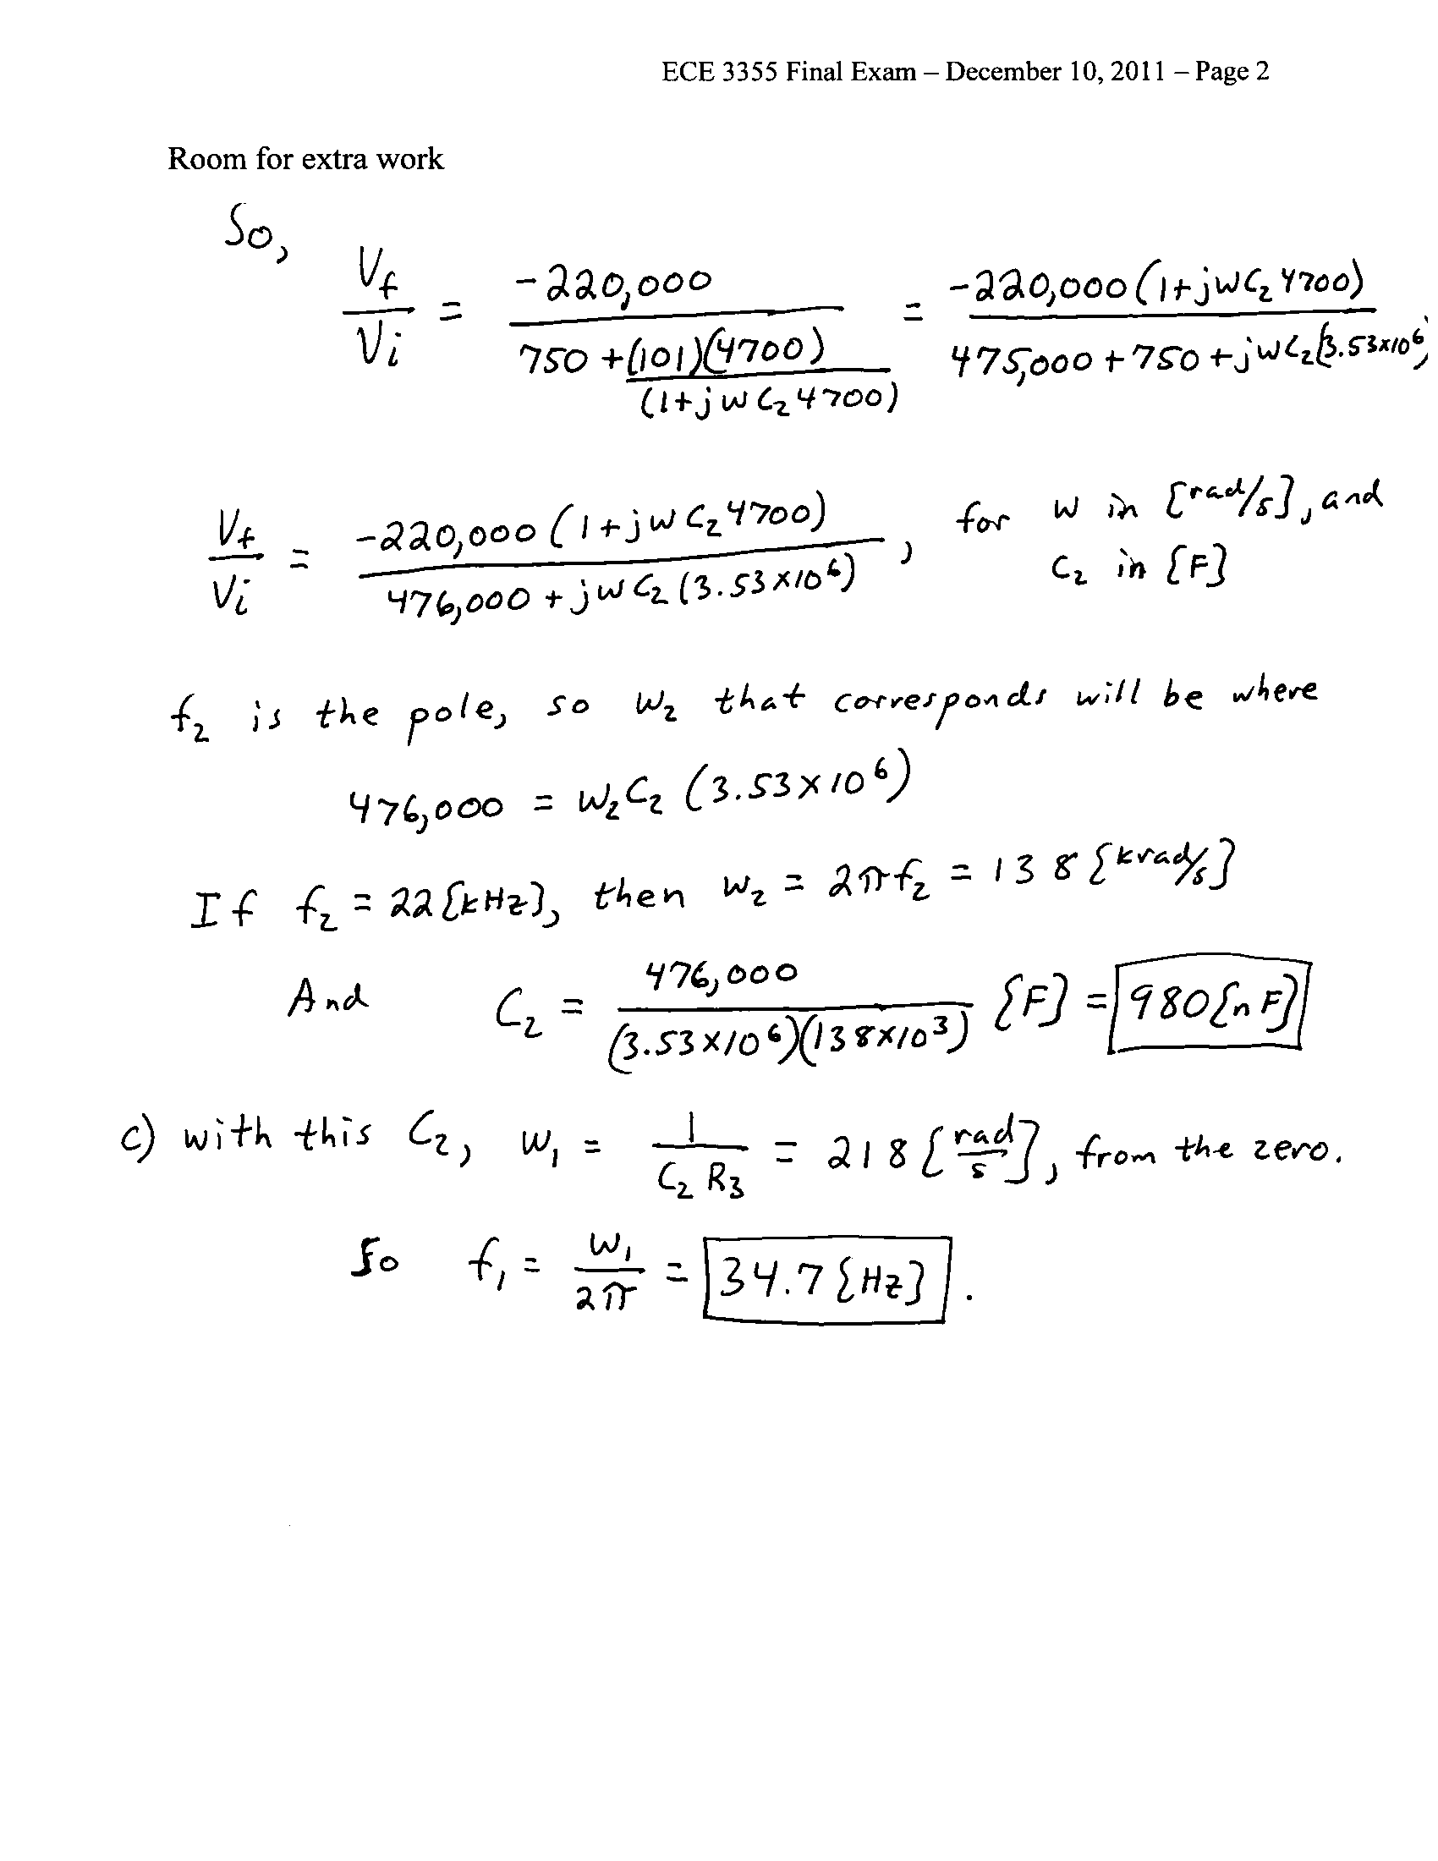
5. {25 Points} You have at your disposal an unlimited supply of ideal op amps, resistors, potentiometers, capacitors, inductors, diodes and transistors. Your transistors have β = 100, and operate at room temperature. Your diodes can be modeled using a piece-wise linear diode model with V_{f} = 0.7[V], r_{d} = 0, and I_{s} = 0. You have two dc power supplies, one at +15[V], and one at -15[V]. Design a circuit to produce the waveform v_{X}(t) given in the plot below.
The V_{off} is an offset voltage that should be adjustable, in the range
-3[V] < V_{off} < +3[V], using a potentiometer.
Show your design, explaining how you achieve the desired voltage. Describe your design and how it meets the specifications, using complete sentences.

