Name: _____________________________ (please print)
Signature: __________________________

ECE 3355 –Exam 1
October 8, 2011

Keep this exam closed until you are told to begin.

1. This exam is closed book, closed notes. You may use one 8.5” x 11” crib sheet, or its equivalent.
2. Show all work on these pages. Show all work necessary to complete the problem. A solution without the appropriate work shown will receive no credit. A solution that is not given in a reasonable order will lose credit. Clearly indicate your answer (for example by enclosing it in a box). If your answer is a plot, no box is needed.
3. It is assumed that your work will begin on the same page as the problem statement. If you choose to begin your work on another page, you must indicate this on the page with the problem statement, with a clear indication of where the work can be found. If your work continues on to another page, indicate clearly where your work can be found. Failure to indicate this clearly will result in a loss of credit.
4. Show all units in solutions, intermediate results, and figures. Units in the exam will be included between square brackets.
5. Do not use red ink. Do not use red pencil.
6. You will have 90 minutes to work on this exam.

1. ________________/35
2. ________________/35
3. ________________/35
Total = 105
Room for extra work
1. {35 Points} A circuit is shown in Figure 1. The equivalent circuits for amplifiers A, B, and C, in this circuit are shown in Figures 2, 3, and 4, respectively.
a) Draw the circuit in Figure 1, using the equivalent circuits for amplifiers A, B, and C.
b) Find the transconductance, i_{o}/v_{s}.
c) Find an equivalent amplifier that can be used to replace all the circuit with respect to the source and the load. In other words, leave the source and the load in place, and replace the rest of the circuit with an equivalent circuit.

Room for extra work

2. {35 Points} The transfer function H(f) for an amplifier at f = 10⁷[Hz] is -1738. All the poles and zeroes for the transfer function occur in the range from 1[Hz] to 1[MHz]. The straight-line approximation to the phase Bode plot for the H(f) is shown in the plot given below. Plot the straight-line approximation to the magnitude Bode plot for H(f) on the semilog graph paper given on the next page. Include all nonzero poles and zeroes in the range of frequencies that you plot.

Room for extra work

3. {35 Points} Use the circuit below to solve this problem. Assume ideal op amps. Pick values of C₁, C₂, L₁, L₂, R₃, and R₅ so that for the transfer function V_{o}/V_{i} there will be:
- One pole at f = 380[Hz].
- One pole at f = 15,400[Hz].
- One zero at f = 9,500[Hz].
Explain each of your choices, and how you made that choice. Do not be concerned with picking “realistic” values of these components. Rather, just pick values that will meet the specifications given. All values must be positive.

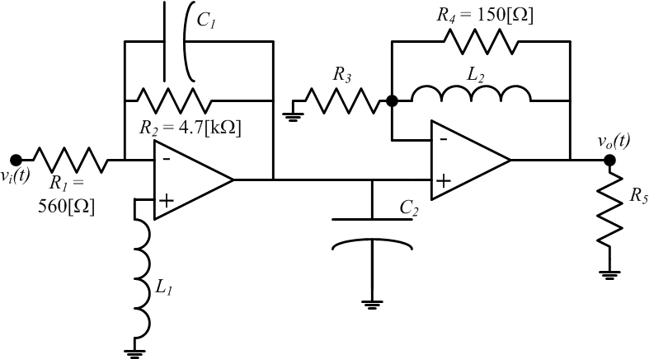

Room for extra work

Solutions:
1. {35 Points} A circuit is shown in Figure 1. The equivalent circuits for amplifiers A, B, and C, in this circuit are shown in Figures 2, 3, and 4, respectively.
a) Draw the circuit in Figure 1, using the equivalent circuits for amplifiers A, B, and C.
b) Find the transconductance, i_{o}/v_{s}.
c) Find an equivalent amplifier that can be used to replace all the circuit with respect to the source and the load. In other words, leave the source and the load in place, and replace the rest of the circuit with an equivalent circuit.
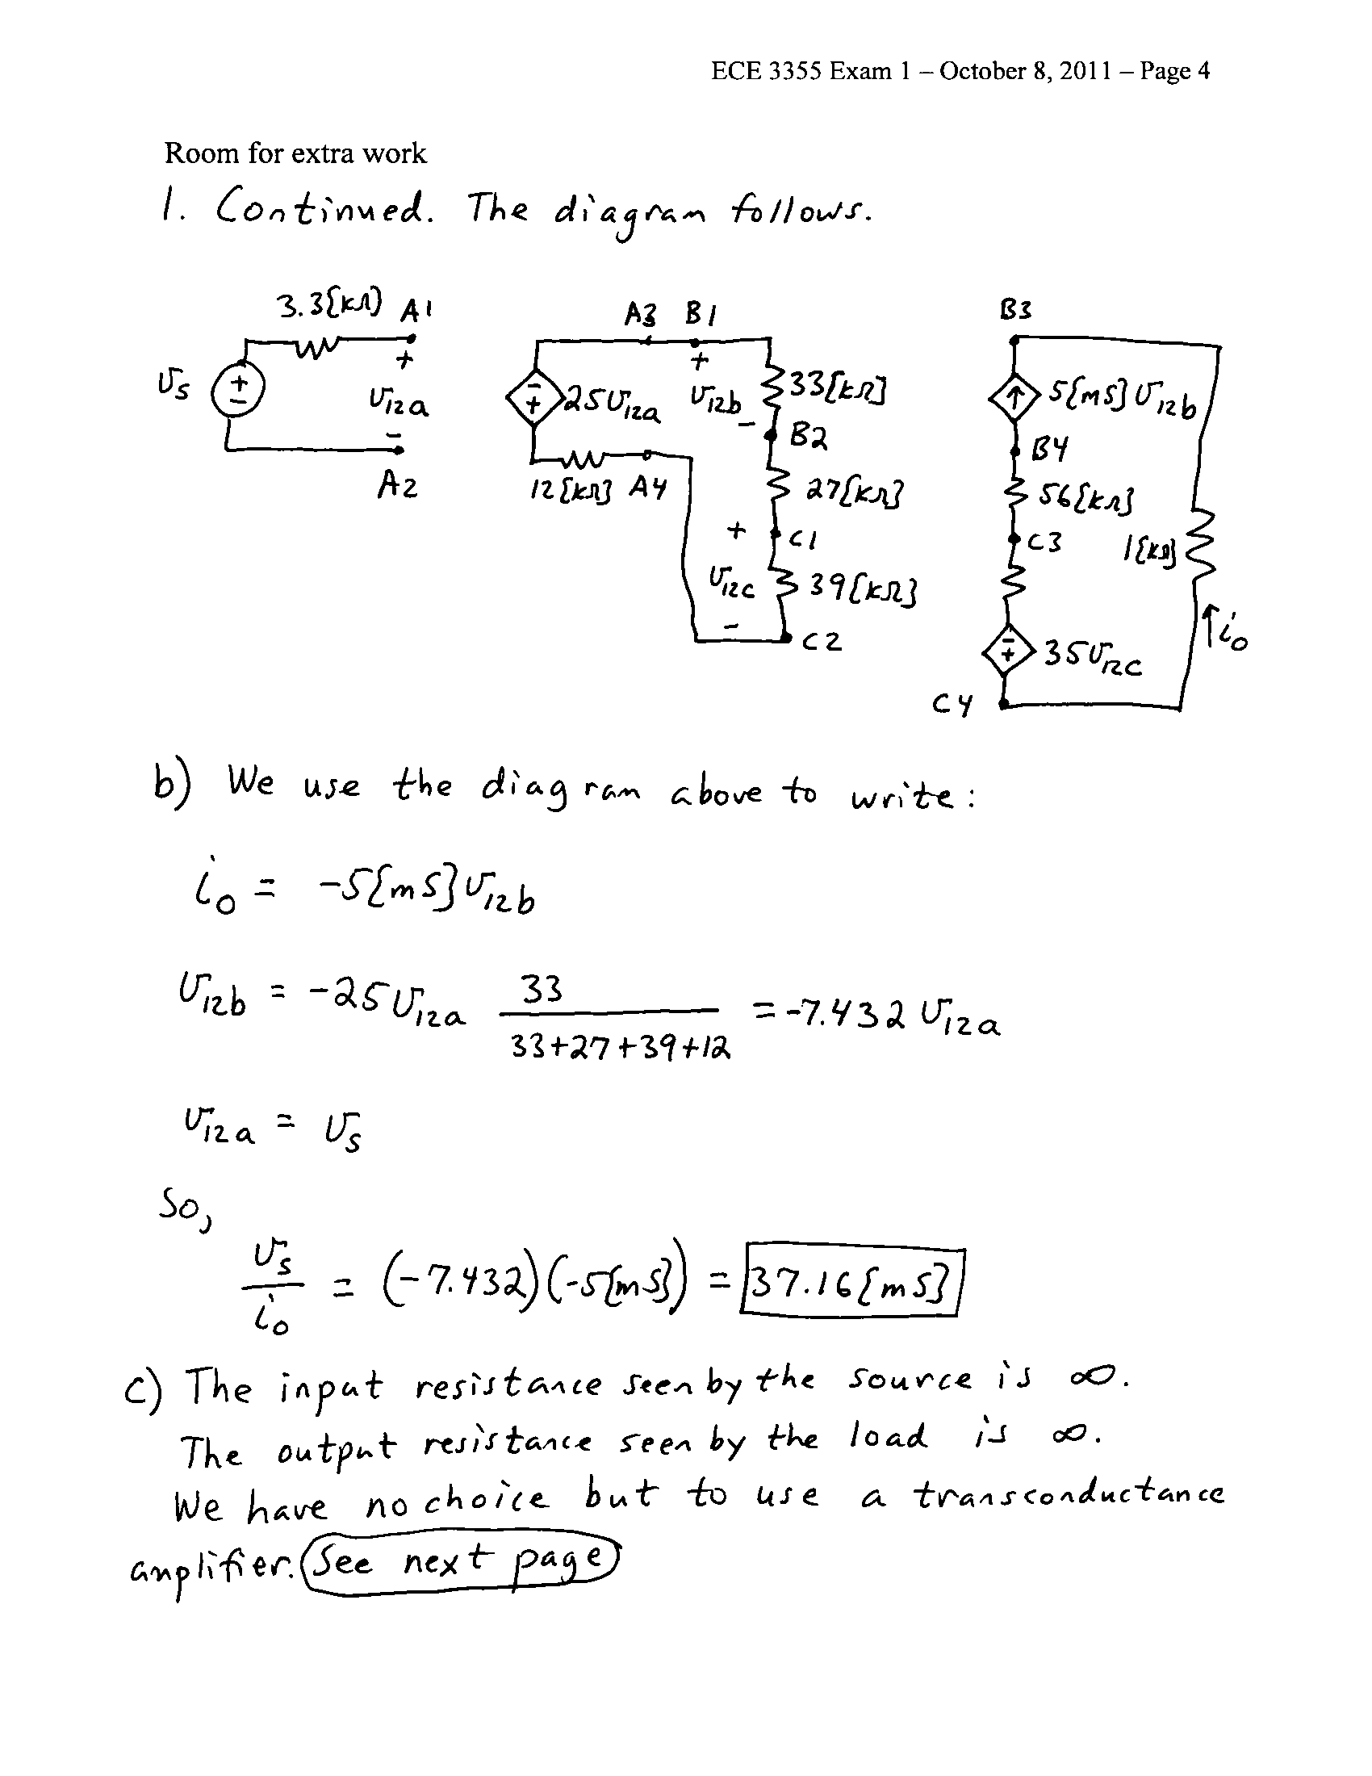

2. {35 Points} The transfer function H(f) for an amplifier at f = 10⁷[Hz] is -1738. All the poles and zeroes for the transfer function occur in the range from 1[Hz] to 1[MHz]. The straight-line approximation to the phase Bode plot for the H(f) is shown in the plot given below. Plot the straight-line approximation to the magnitude Bode plot for H(f) on the semilog graph paper given on the next page. Include all nonzero poles and zeroes in the range of frequencies that you plot.

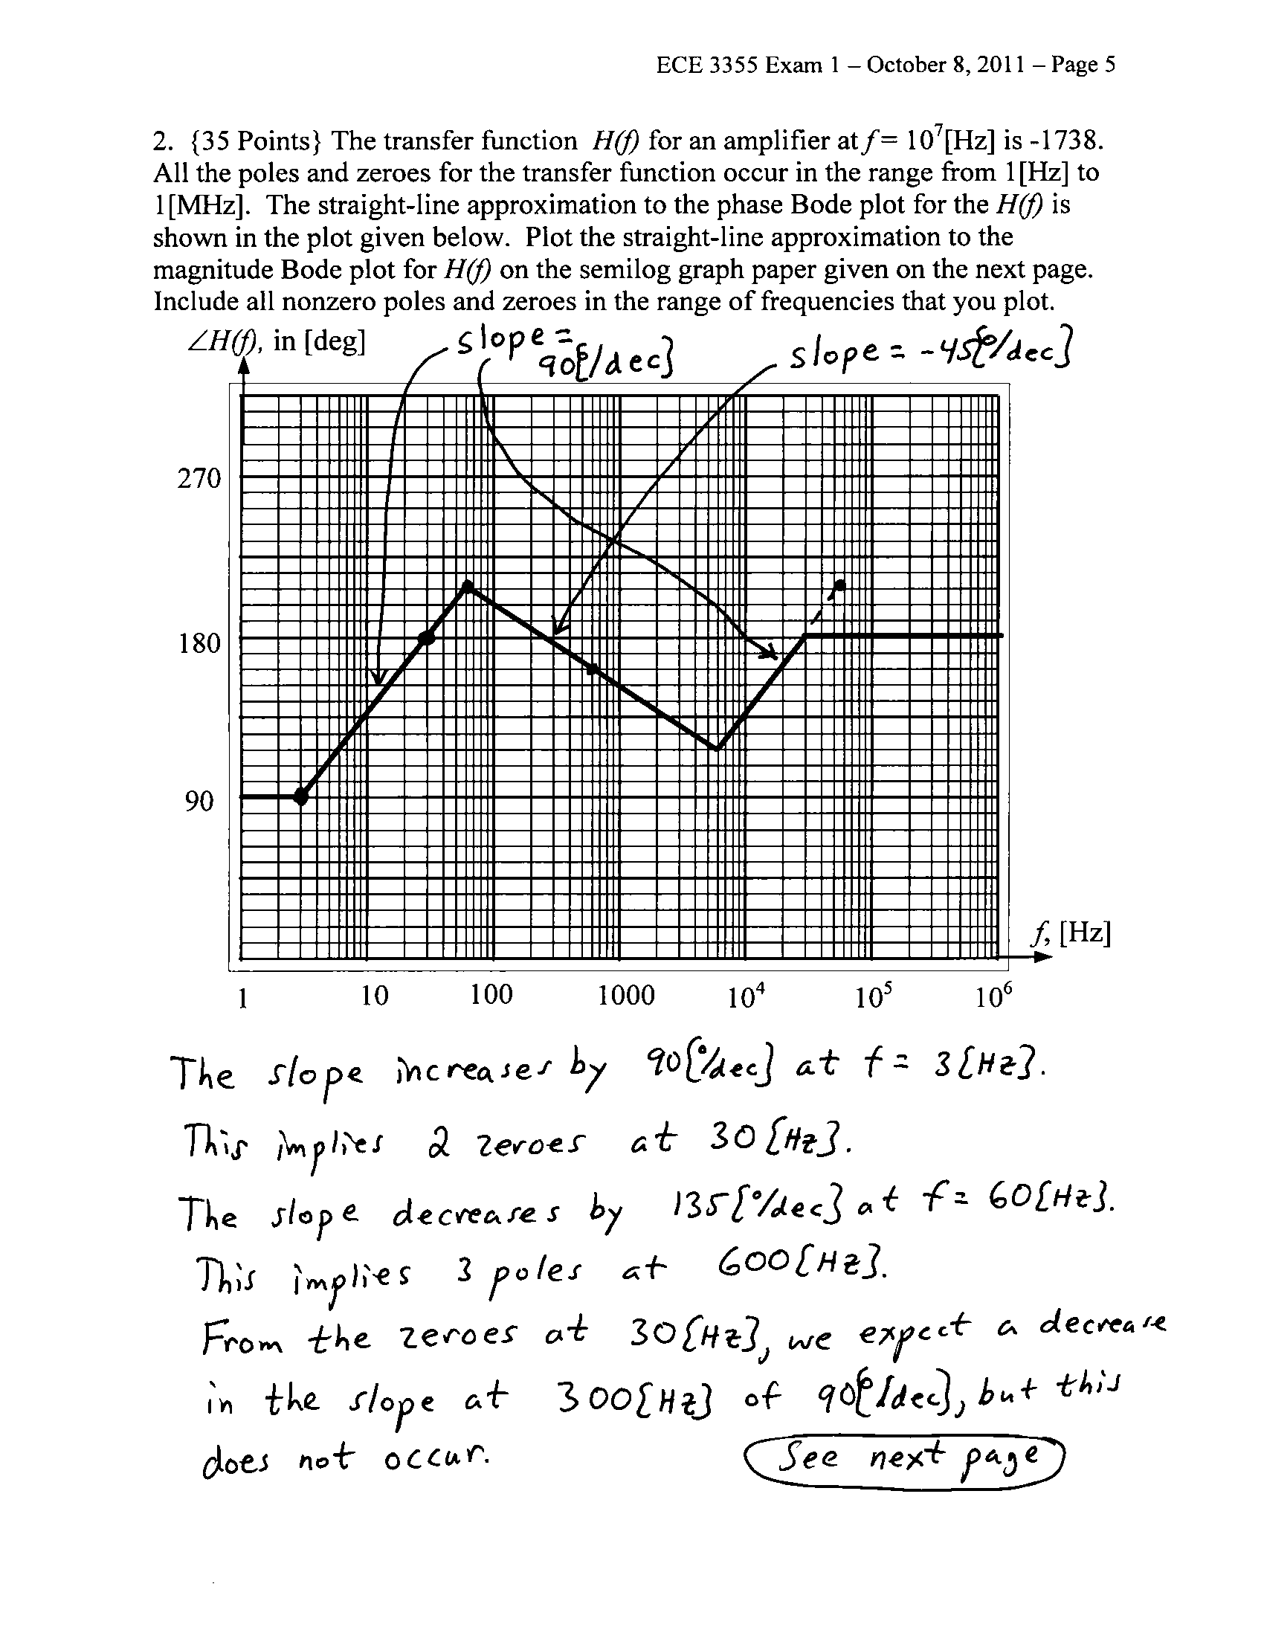
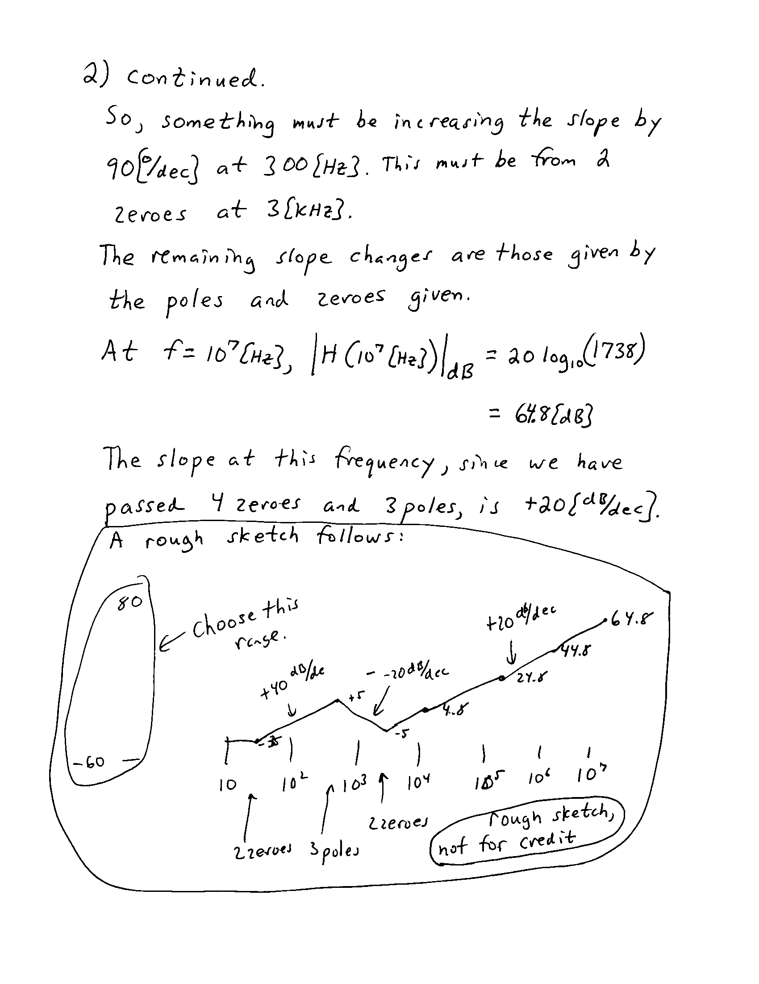
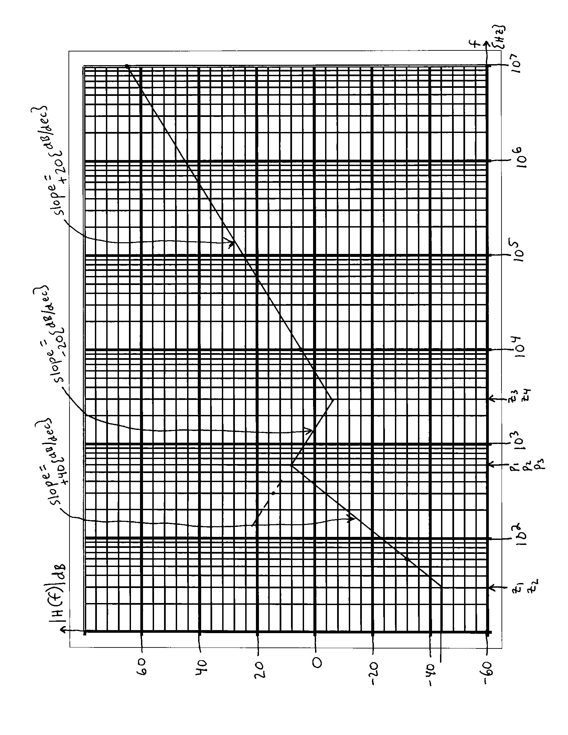
3. {35 Points} Use the circuit below to solve this problem. Assume ideal op amps. Pick values of C₁, C₂, L₁, L₂, R₃, and R₅ so that for the transfer function V_{o}/V_{i} there will be:
- One pole at f = 380[Hz].
- One pole at f = 15,400[Hz].
- One zero at f = 9,500[Hz].
Explain each of your choices, and how you made that choice. Do not be concerned with picking “realistic” values of these components. Rather, just pick values that will meet the specifications given. All values must be positive.

