Name: _____________________________ (please print)

Signature: __________________________

ECE 3355 –Exam 1

October 6, 2012

Keep this exam closed until you are told to begin.

1. This exam is closed book, closed notes. You may use one 8.5” x 11” crib sheet, or its equivalent.

2. Show all work on these pages. Show all work necessary to complete the problem. A solution without the appropriate work shown will receive no credit. A solution that is not given in a reasonable order will lose credit. Clearly indicate your answer (for example by enclosing it in a box). If your answer is a plot, no box is needed.

3. It is assumed that your work will begin on the same page as the problem statement. If you choose to begin your work on another page, you must indicate this on the page with the problem statement, with a clear indication of where the work can be found. **If your work continues on to another page, indicate clearly where your work can be found. Failure to indicate this clearly will result in a loss of credit.**

4. Show all units in solutions, intermediate results, and figures. Units in the exam will be included between square brackets.

5. Do not use red ink. Do not use red pencil.

6. You will have 90 minutes to work on this exam.

1. ________________/35

2. ________________/35

3. ________________/35

Total = 105

Room for extra work

1. {35 Points} A circuit is shown in Figure 1. The circuit shown is in steady-state. The equivalent circuits for amplifiers A, and B, in this circuit are shown in Figures 2, and 3, respectively.

a) Find the voltage gain *vout/vf1*.

b) Find the input resistance seen by the source *vf1*.





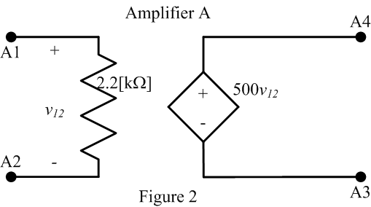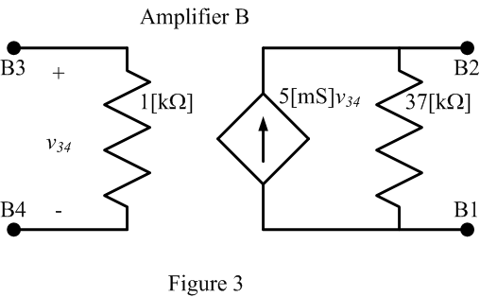

# Room for extra work

2. {35 Points} The circuit shown below is in steady-state.

a) Find the input resistance seen by the signal source.

b) Find the transresistance *vload/isource* for this amplifier, with this source and load.

c) Find the output resistance seen by the load.





Room for extra work

3. {35 Points} Assume that the input of an oscilloscope can be modeled with a 10[k] resistance in series with a 5.6[mH] inductance. Design a 7:1 probe that could be used with this oscilloscope to guarantee that square waves with repetition rates from 10[Hz] to 20[MHz] will appear as square waves on the oscilloscope. Explain why your design will work, and show appropriate analysis to justify that your design meets the specifications. You may assume in your analysis that the square wave source has amplitudes that vary from 100[mVpp] to 10[Vpp], and has a Thévenin resistance of 15[k].

Room for extra work

Solution:

1. {35 Points} A circuit is shown in Figure 1. The circuit shown is in steady-state. The equivalent circuits for amplifiers A, and B, in this circuit are shown in Figures 2, and 3, respectively.

a) Find the voltage gain *vout/vf1*.

b) Find the input resistance seen by the source *vf1*.





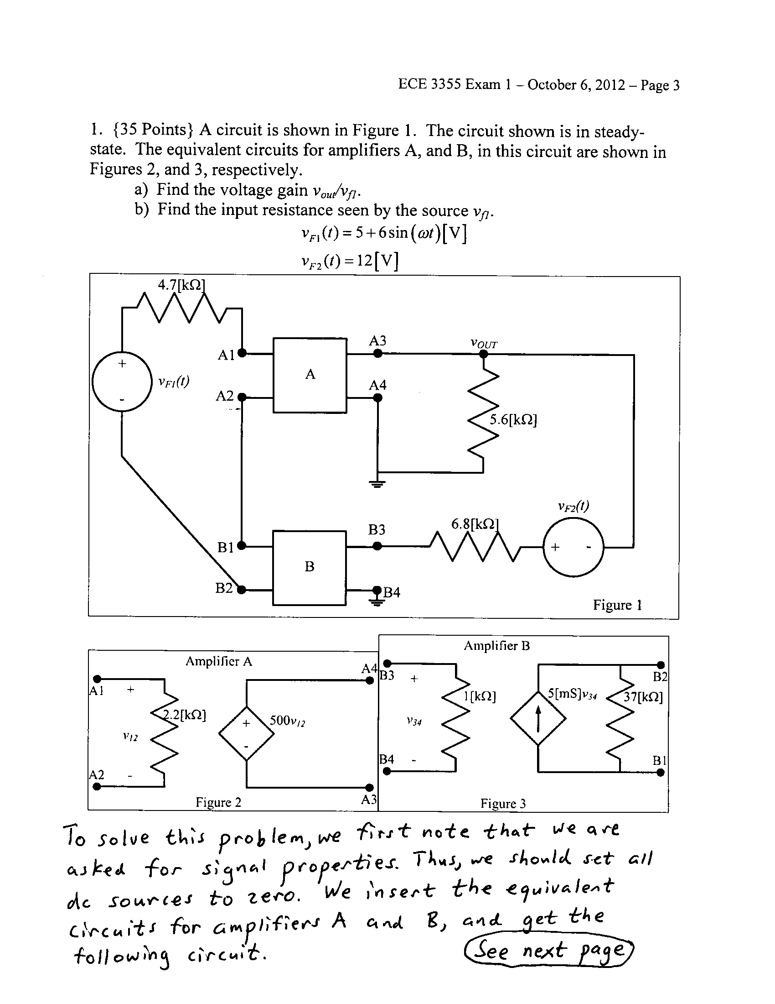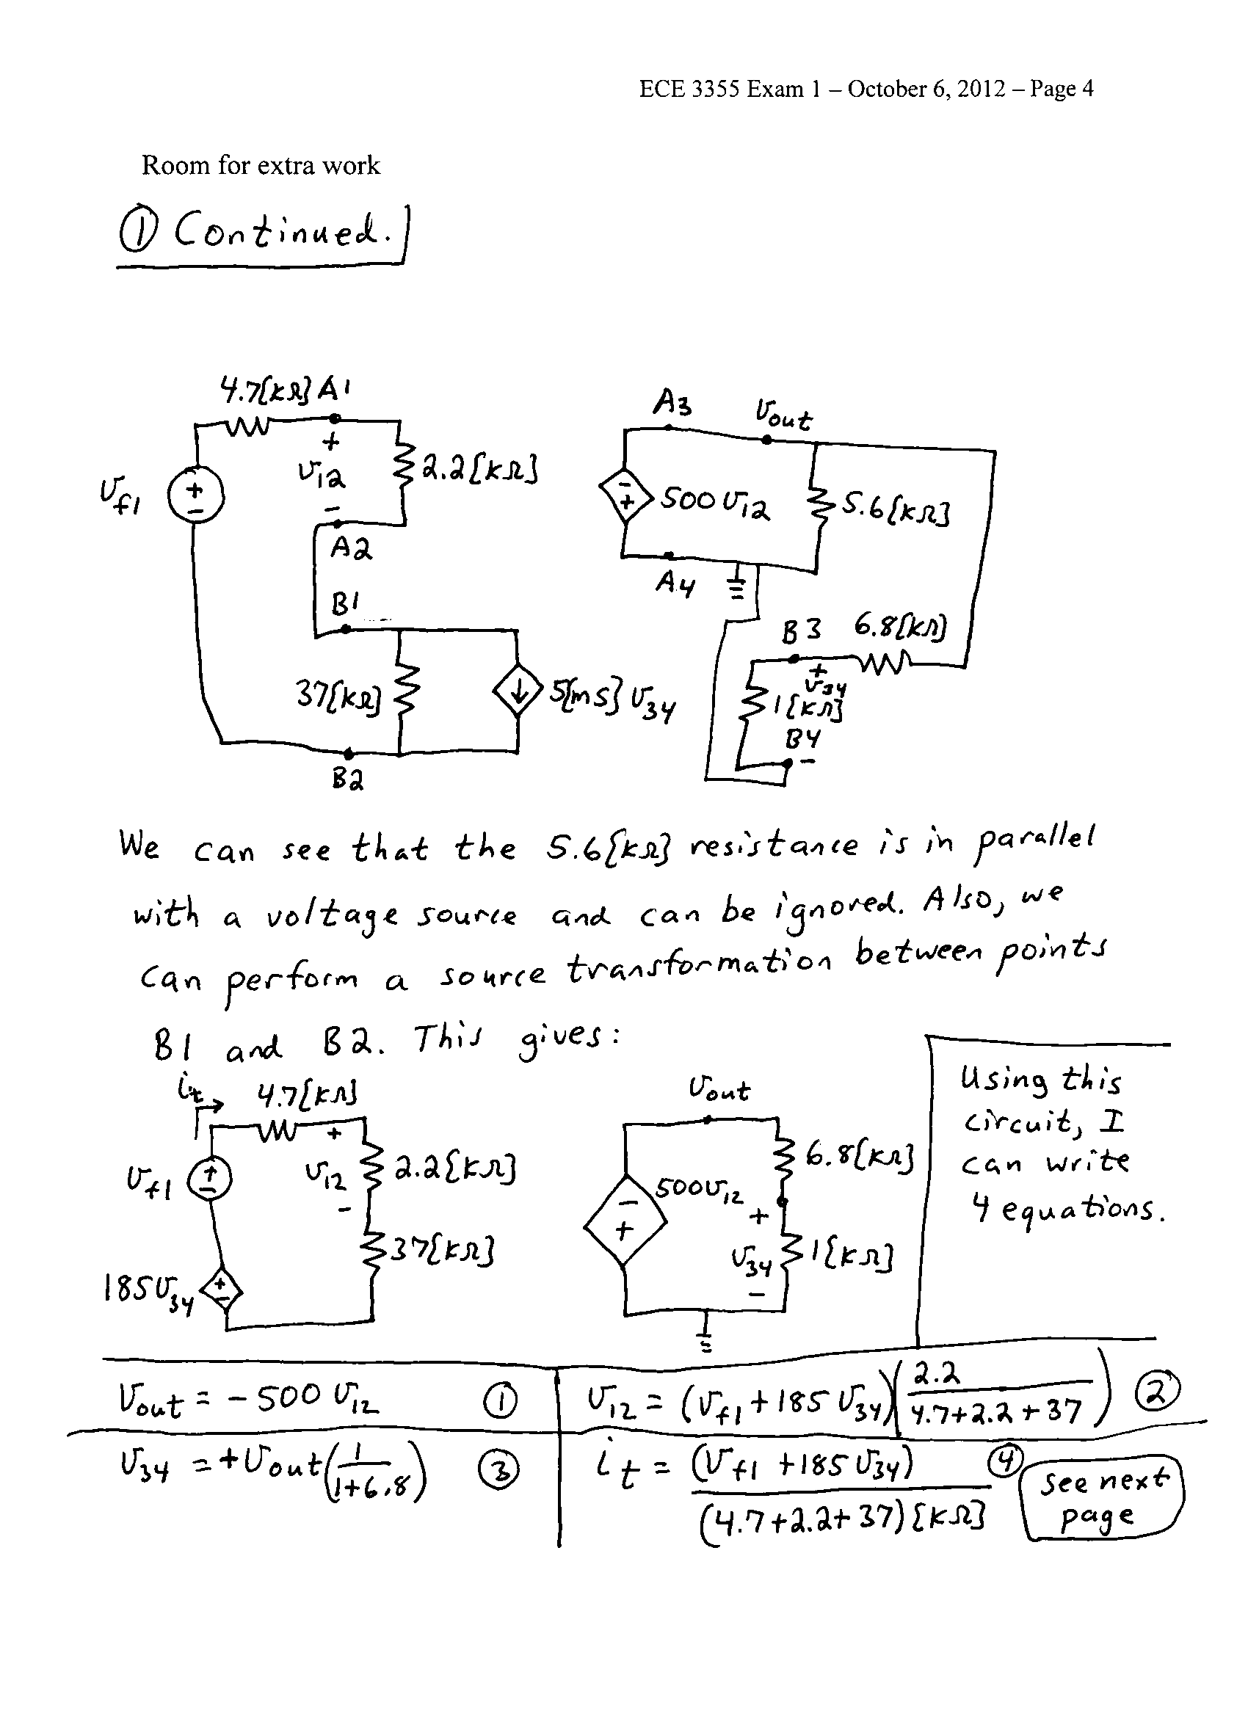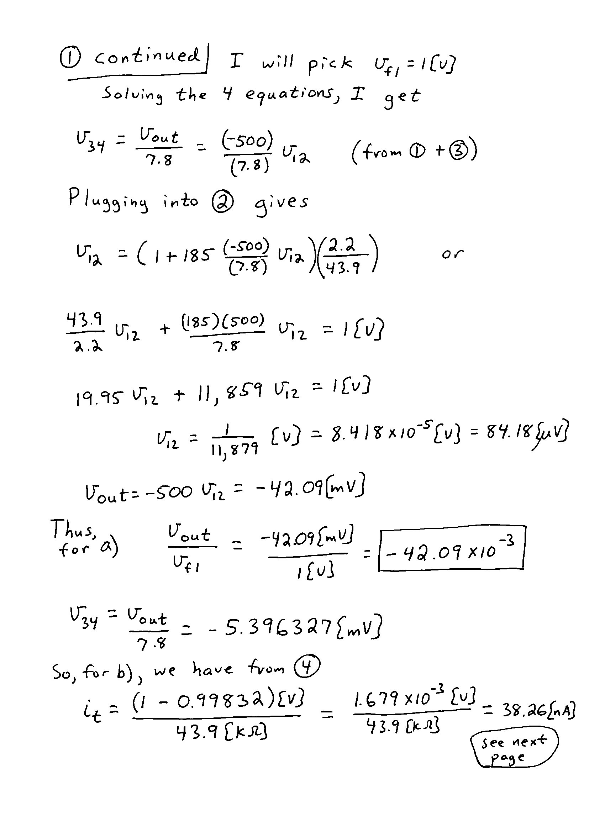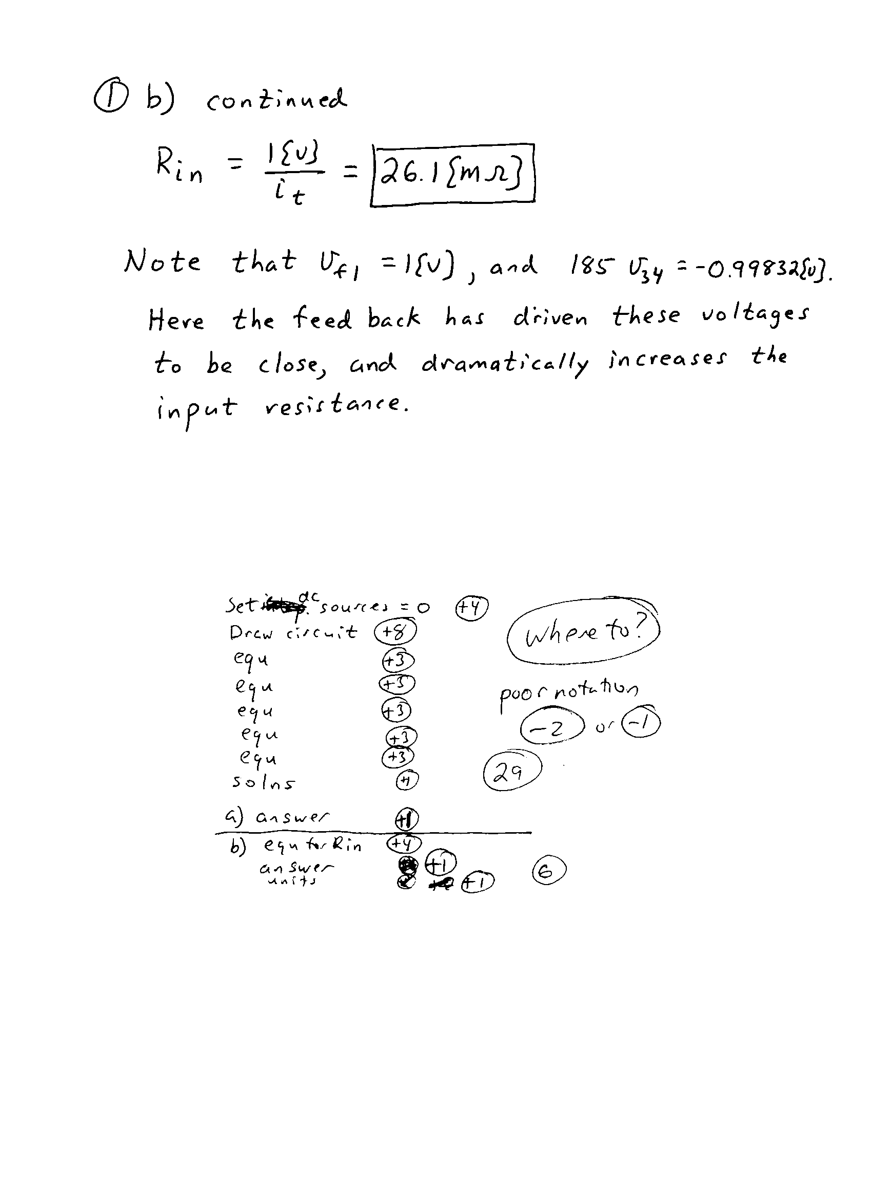

2. {35 Points} The circuit shown below is in steady-state.

a) Find the input resistance seen by the signal source.

b) Find the transresistance *vload/isource* for this amplifier, with this source and load.

c) Find the output resistance seen by the load.





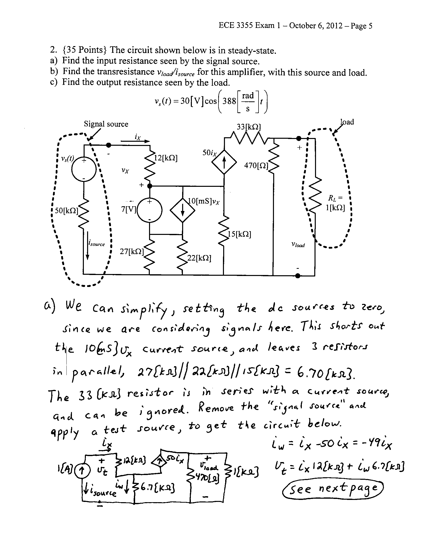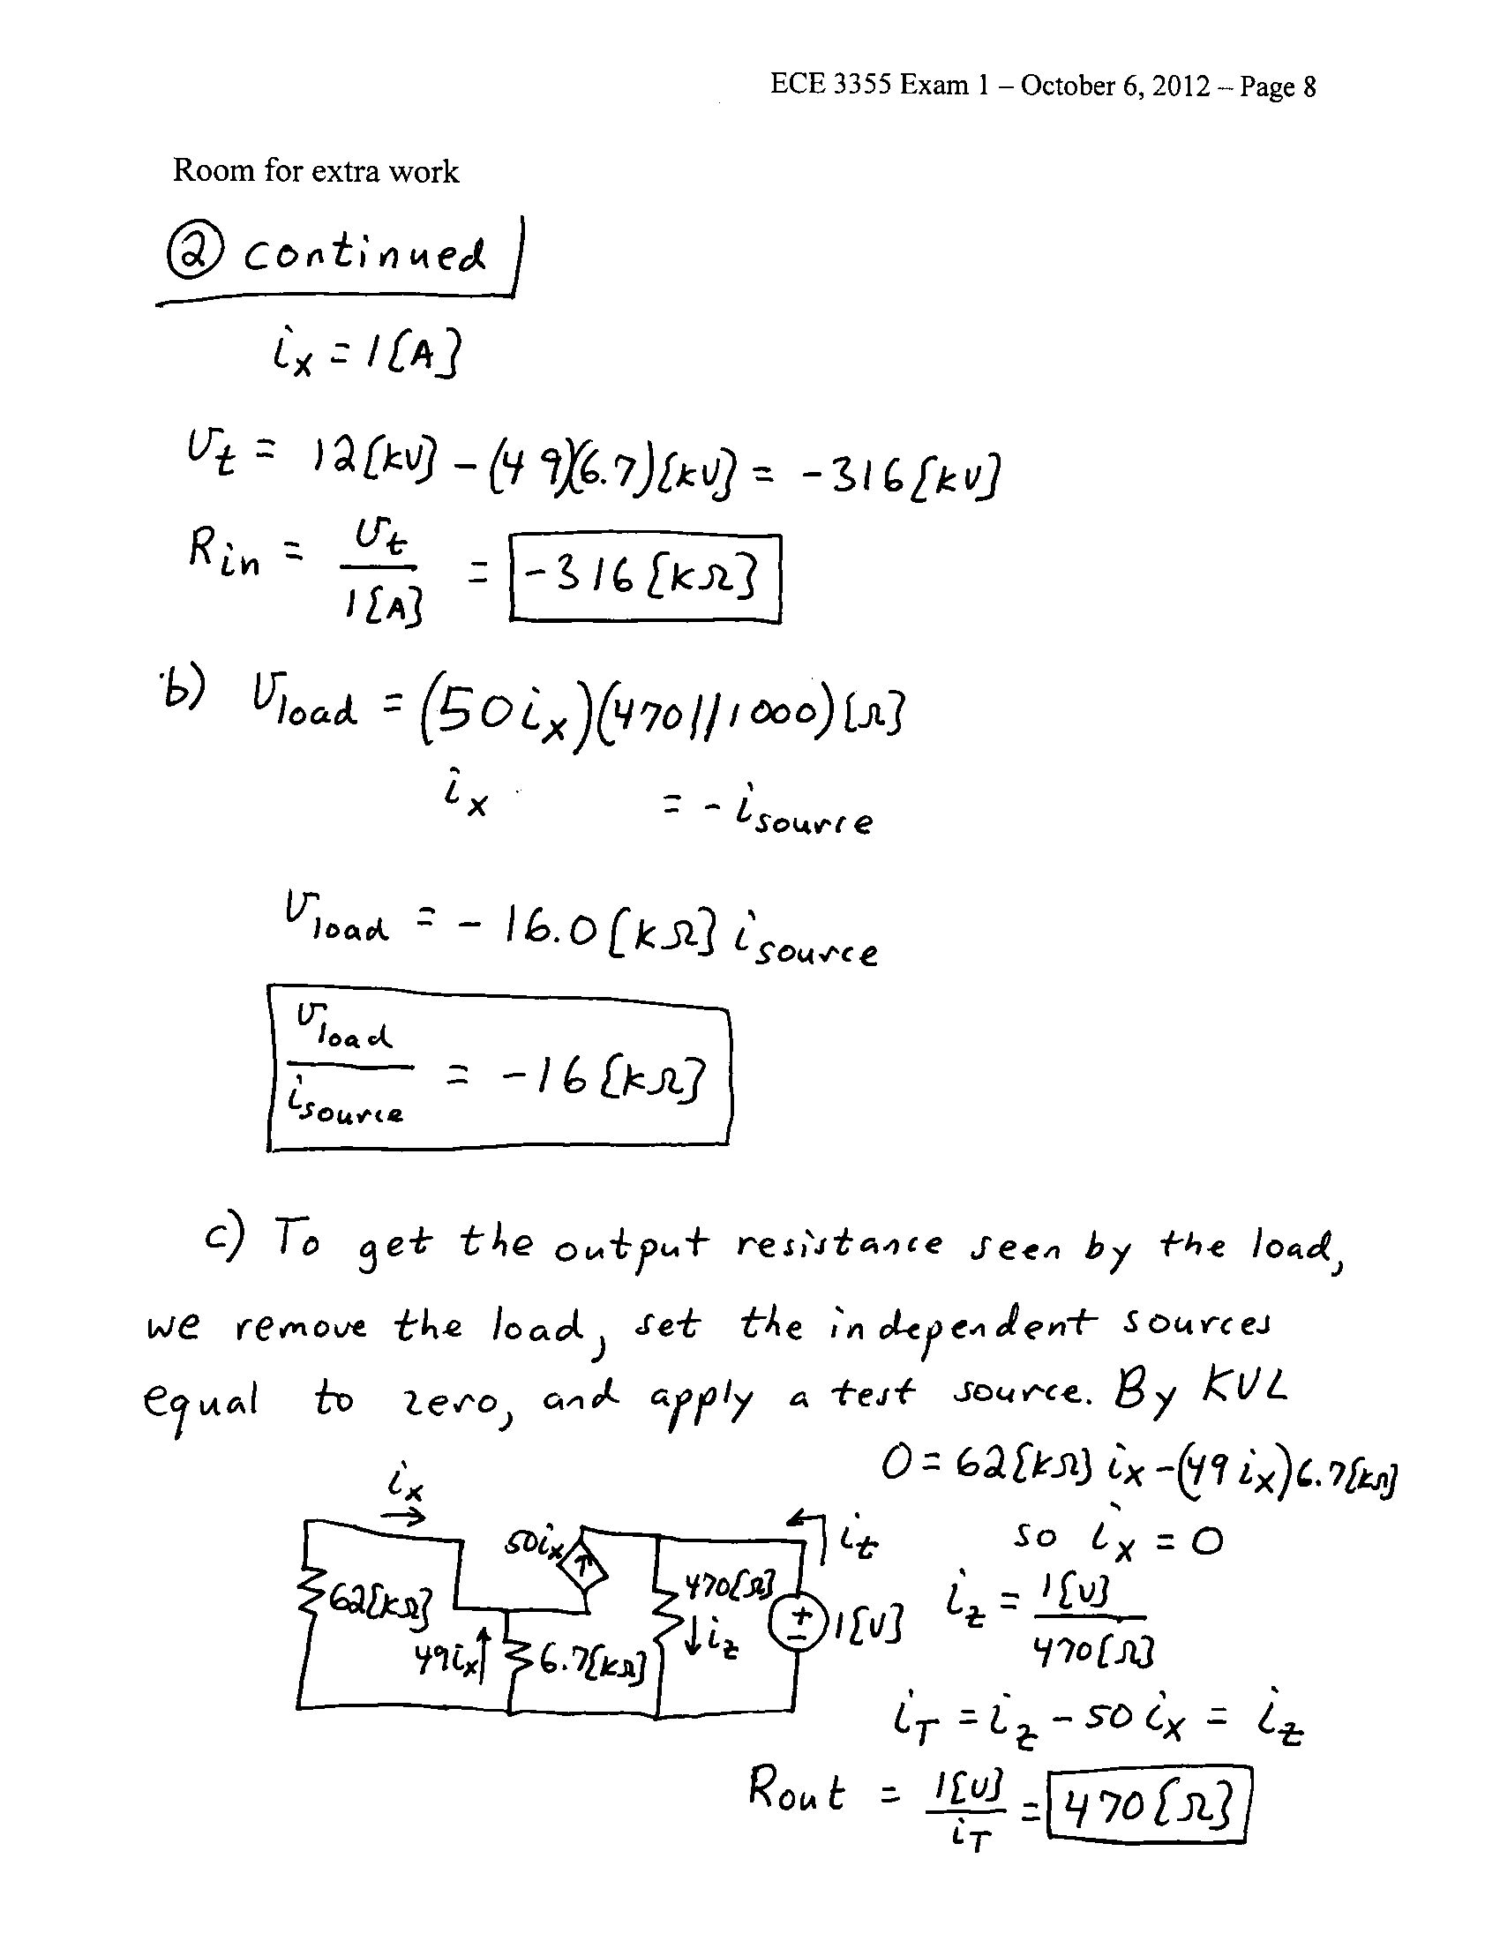

3. {35 Points} Assume that the input of an oscilloscope can be modeled with a 10[k] resistance in series with a 5.6[mH] inductance. Design a 7:1 probe that could be used with this oscilloscope to guarantee that square waves with repetition rates from 10[Hz] to 20[MHz] will appear as square waves on the oscilloscope. Explain why your design will work, and show appropriate analysis to justify that your design meets the specifications. You may assume in your analysis that the square wave source has amplitudes that vary from 100[mVpp] to 10[Vpp], and has a Thévenin resistance of 15[k].

