Name: _____________________________ (please print)
Signature: __________________________

ECE 3355 – Final Exam
December 15, 2012

Keep this exam closed until you are told to begin.

1. This exam is closed book, closed notes. You may use one 8.5” x 11” crib sheet, or its equivalent.
2. Show all work on these pages. Show all work necessary to complete the problem. A solution without the appropriate work shown will receive no credit. A solution that is not given in a reasonable order will lose credit. Clearly indicate your answer (for example by enclosing it in a box). If your answer is a plot, no box is needed.
3. It is assumed that your work will begin on the same page as the problem statement. If you choose to begin your work on another page, you must indicate this on the page with the problem statement, with a clear indication of where the work can be found. If your work continues on to another page, indicate clearly where your work can be found. Failure to indicate this clearly will result in a loss of credit.
4. Show all units in solutions, intermediate results, and figures. Units in the exam will be included between square brackets.
5. Do not use red ink. Do not use red pencil.
6. You will have 170 minutes to work on this exam.

1. ________________/20
2. ________________/20
3. ________________/20
4. ________________/20
5. ________________/20
5. ________________/20
Total = 120
Room for extra work

1. {20 Points} Use the circuit below to solve this problem. Assume an ideal op amp. Find v_{a} /v_{b}.

Room for extra work

2. {20 Points} Use the circuit below to solve this problem. Assume an ideal op amp.
a) Find the input resistance seen by the source.
b) Find the output resistance seen by the load.

Room for extra work

3. {20 Points} Assume an ideal op amp. Assume that the diodes can be modeled using a piece-wise linear diode model with V_{f} = 1.2[V], r_{d} = 600[Ω], and I_{s} = 0.
a) Sketch a plot of v_{B} versus v_{A} for -15[V] < v_{A} < +15[V].
b) For V_{A} = 2[V], find v_{b}/v_{a}.

Room for extra work

4. {20 Points} The characteristic curve, for the device in Figure 1, is shown in Figure 2. It is given that
- Find a model for each of the six regions of this device.
- Find a test that could be used to determine whether the correct region had been chosen in a guess and test analysis process. There should be one test for each region.
- Find v_{A}(t) for the circuit in Figure 1.

Room for extra work

5. {20 Points} Use the circuit shown to solve this problem. Assume that for the transistor, β = 100, and that it is operating at room temperature. Assume that the capacitors C₁ and C₂ have large enough values so that they are effectively infinite for this problem. Find v_{f} /v_{a} in the passband.

Room for extra work

6. {20 Points} The schematic symbol for a Gangnamor is shown in Figure 1. Two characteristic curves for this device are shown in Figure 2 and Figure 3. Find a model that could be used to predict the behavior of a Gangnamor that has been biased into the Linear Region, for small signals. Draw the model, labeling all components with their numerical values, and labeling terminals A, B, and C.
Solutions follow:
1. {20 Points} Use the circuit below to solve this problem. Assume an ideal op amp.
Find v_{a} /v_{b}.
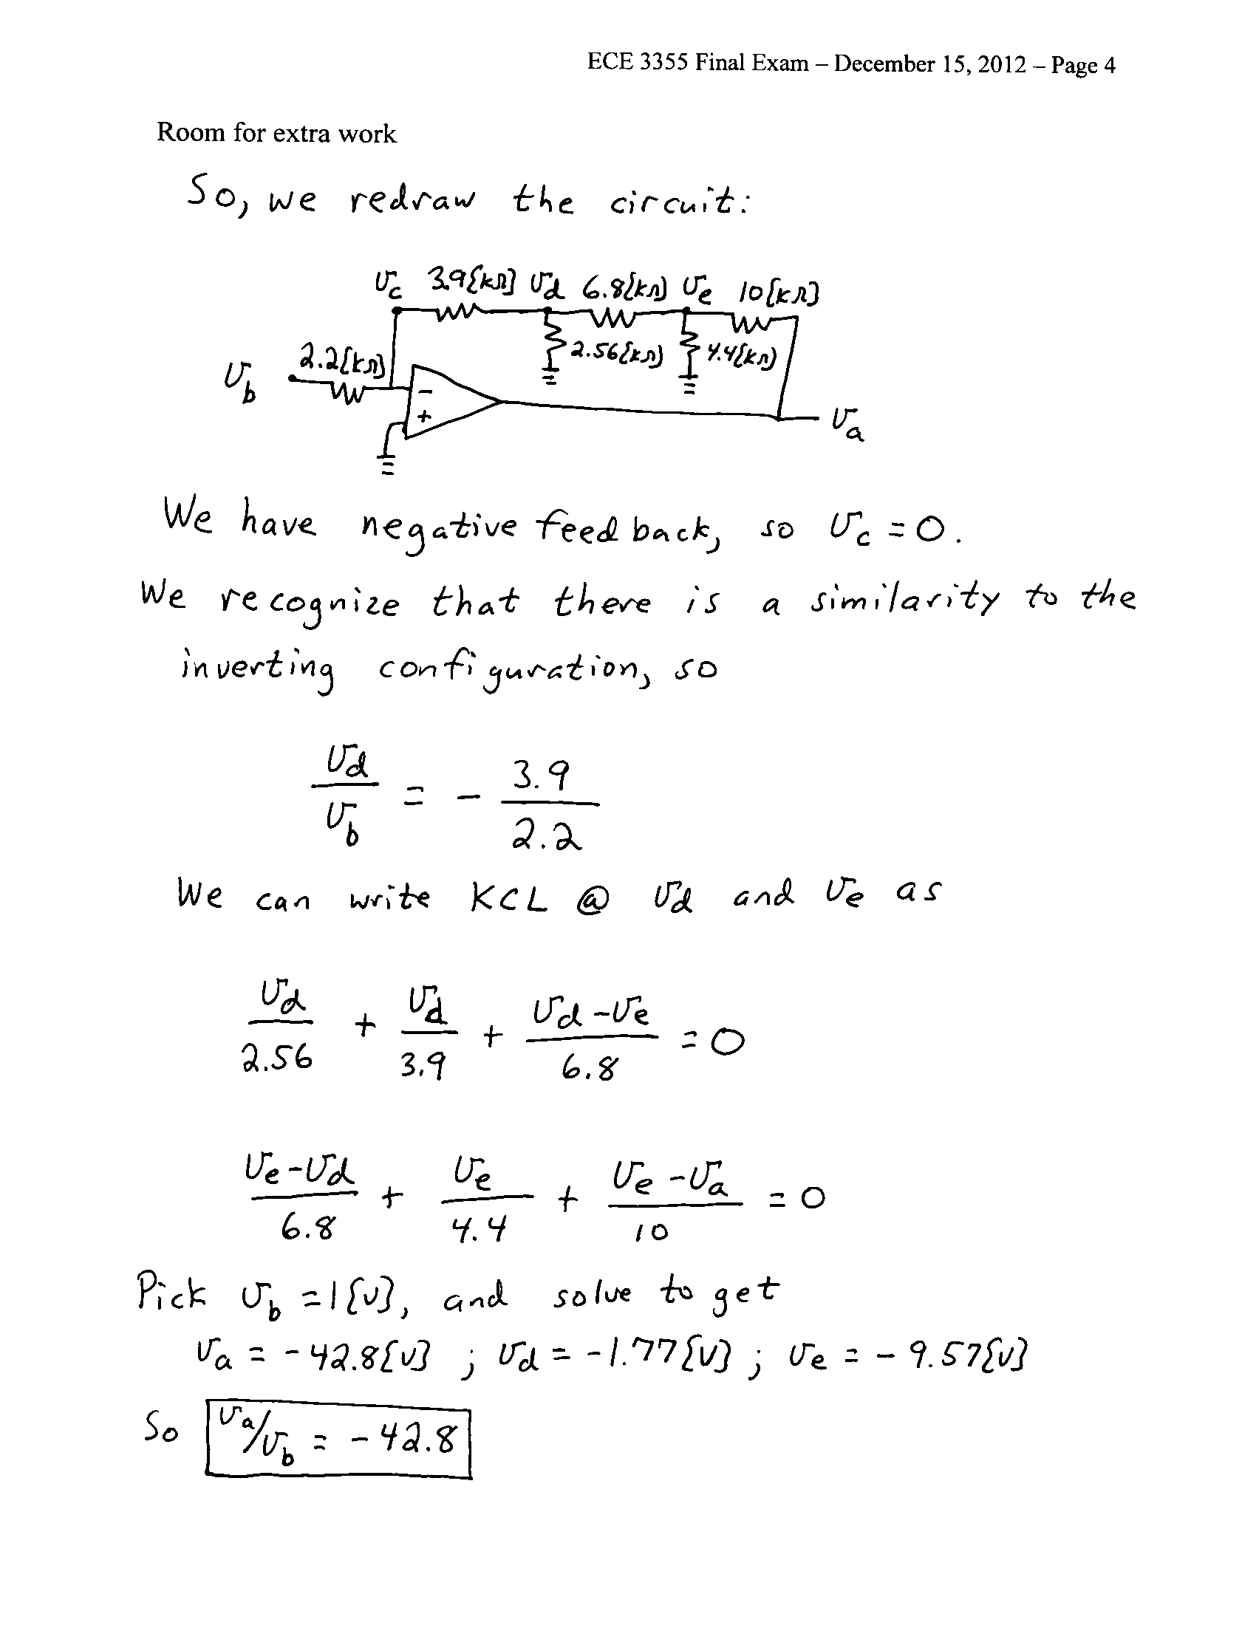
2. {20 Points} Use the circuit below to solve this problem. Assume an ideal op amp.
a) Find the input resistance seen by the source.
b) Find the output resistance seen by the load.
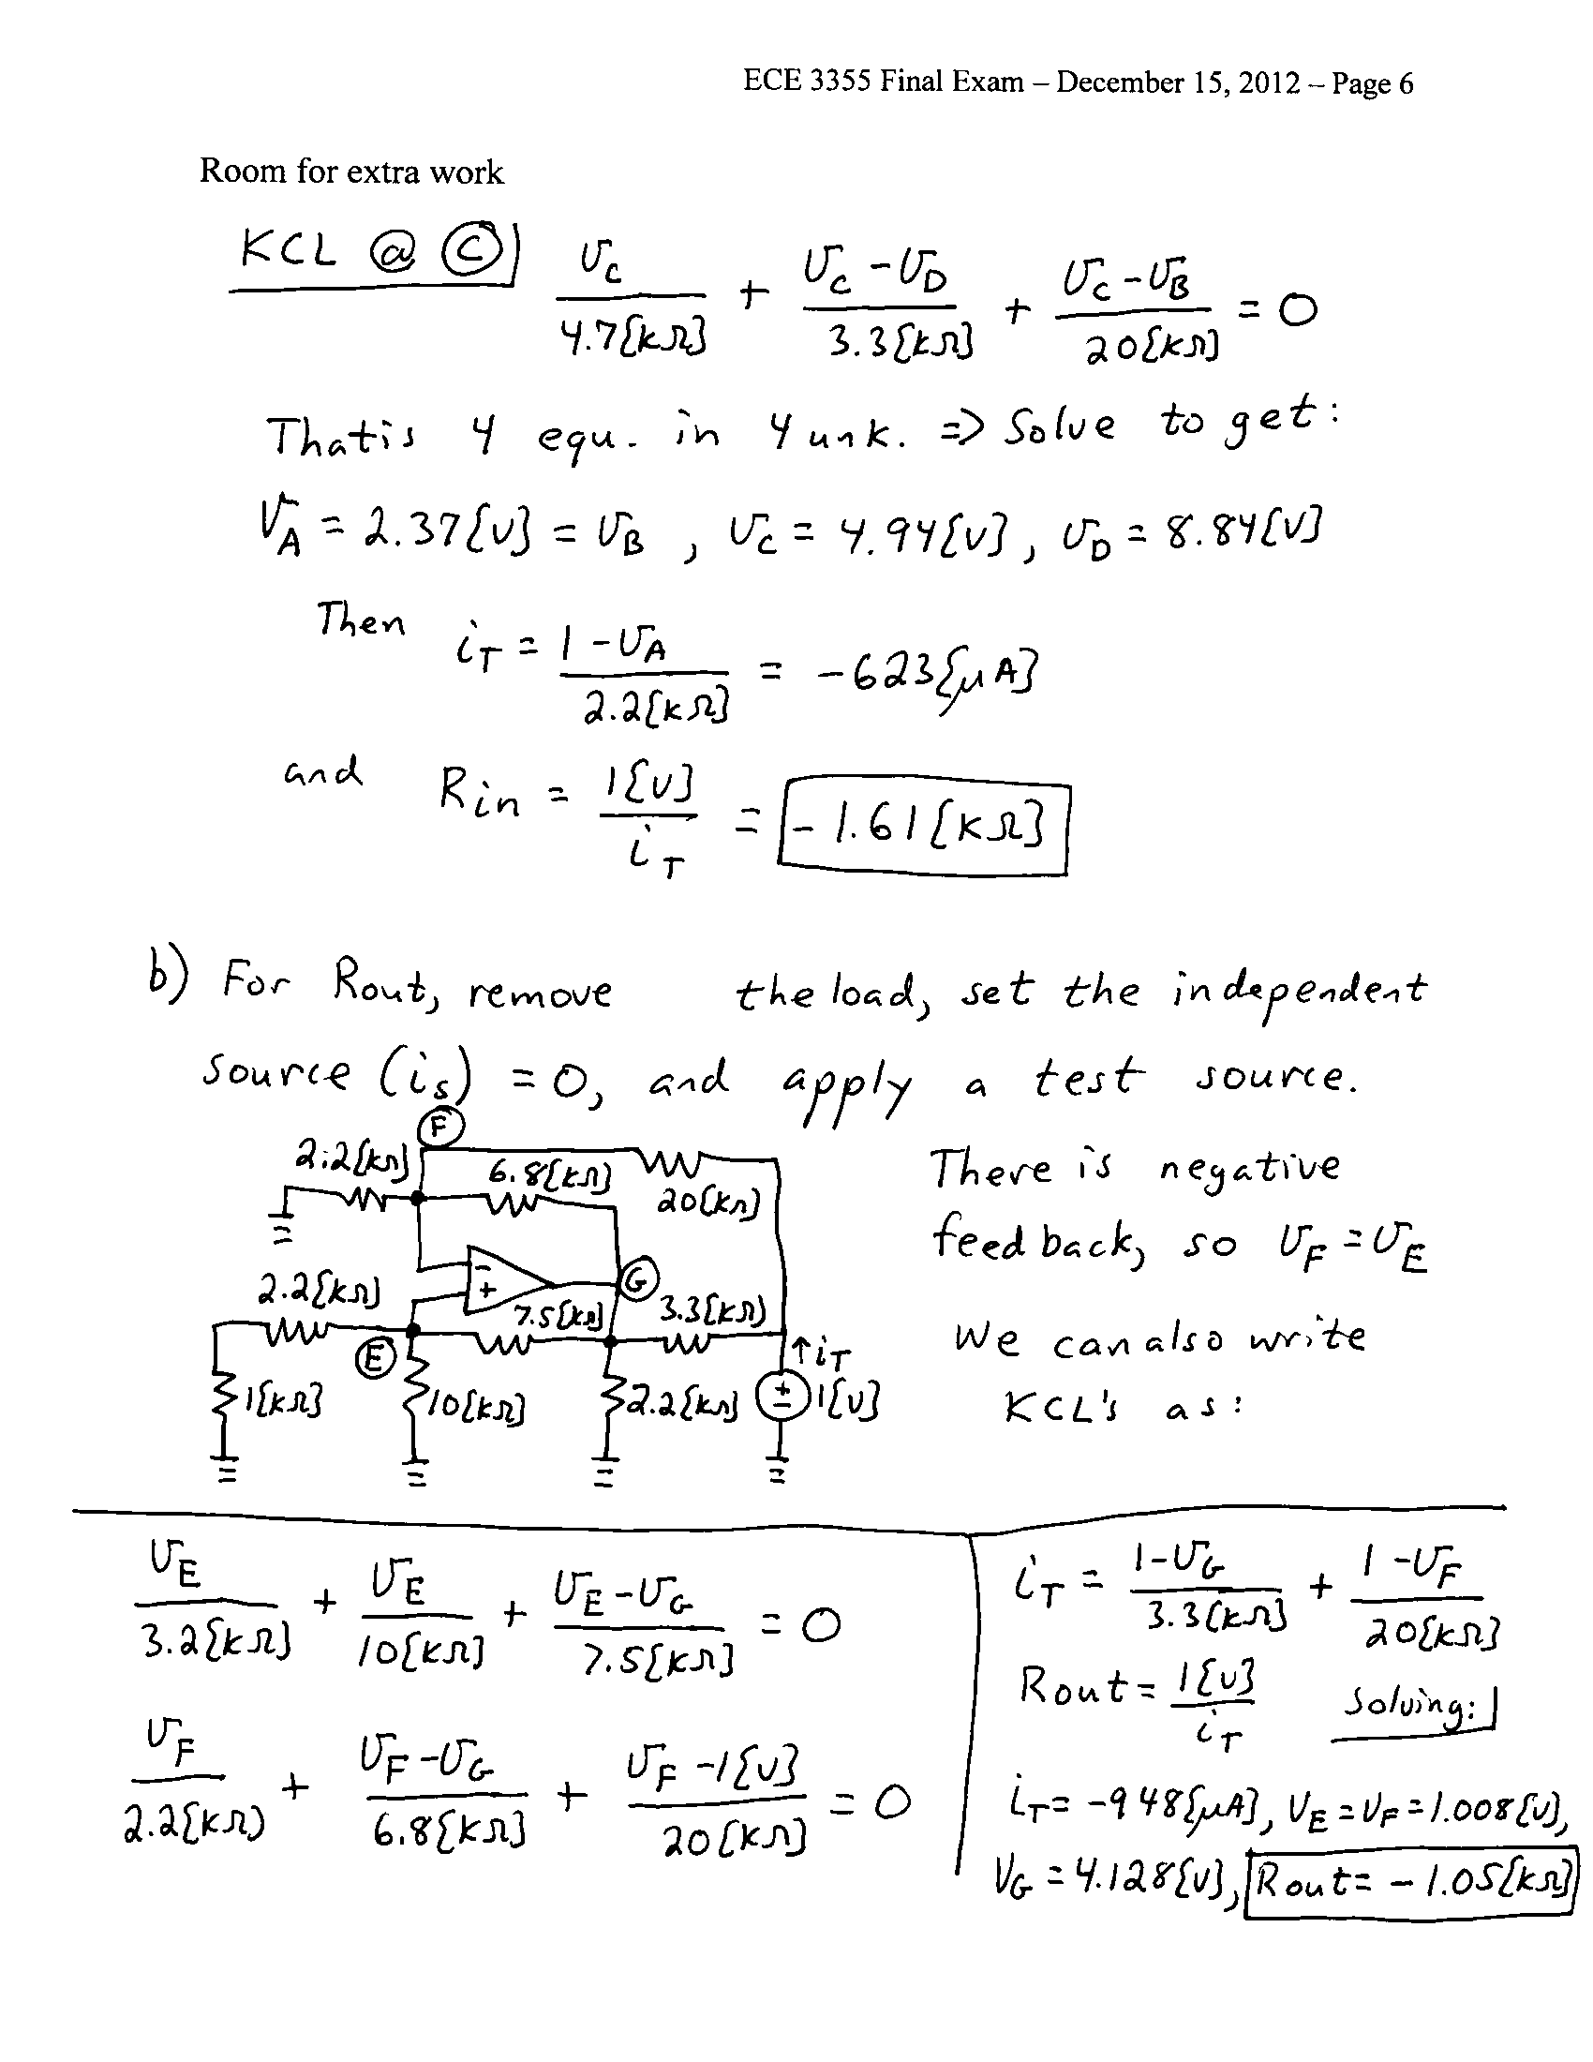

3. {20 Points} Assume an ideal op amp. Assume that the diodes can be modeled using a piece-wise linear diode model with V_{f} = 1.2[V], r_{d} = 600[Ω], and I_{s} = 0.
a) Sketch a plot of v_{B} versus v_{A} for -15[V] < v_{A} < +15[V].
b) For V_{A} = 2[V], find v_{b}/v_{a}.
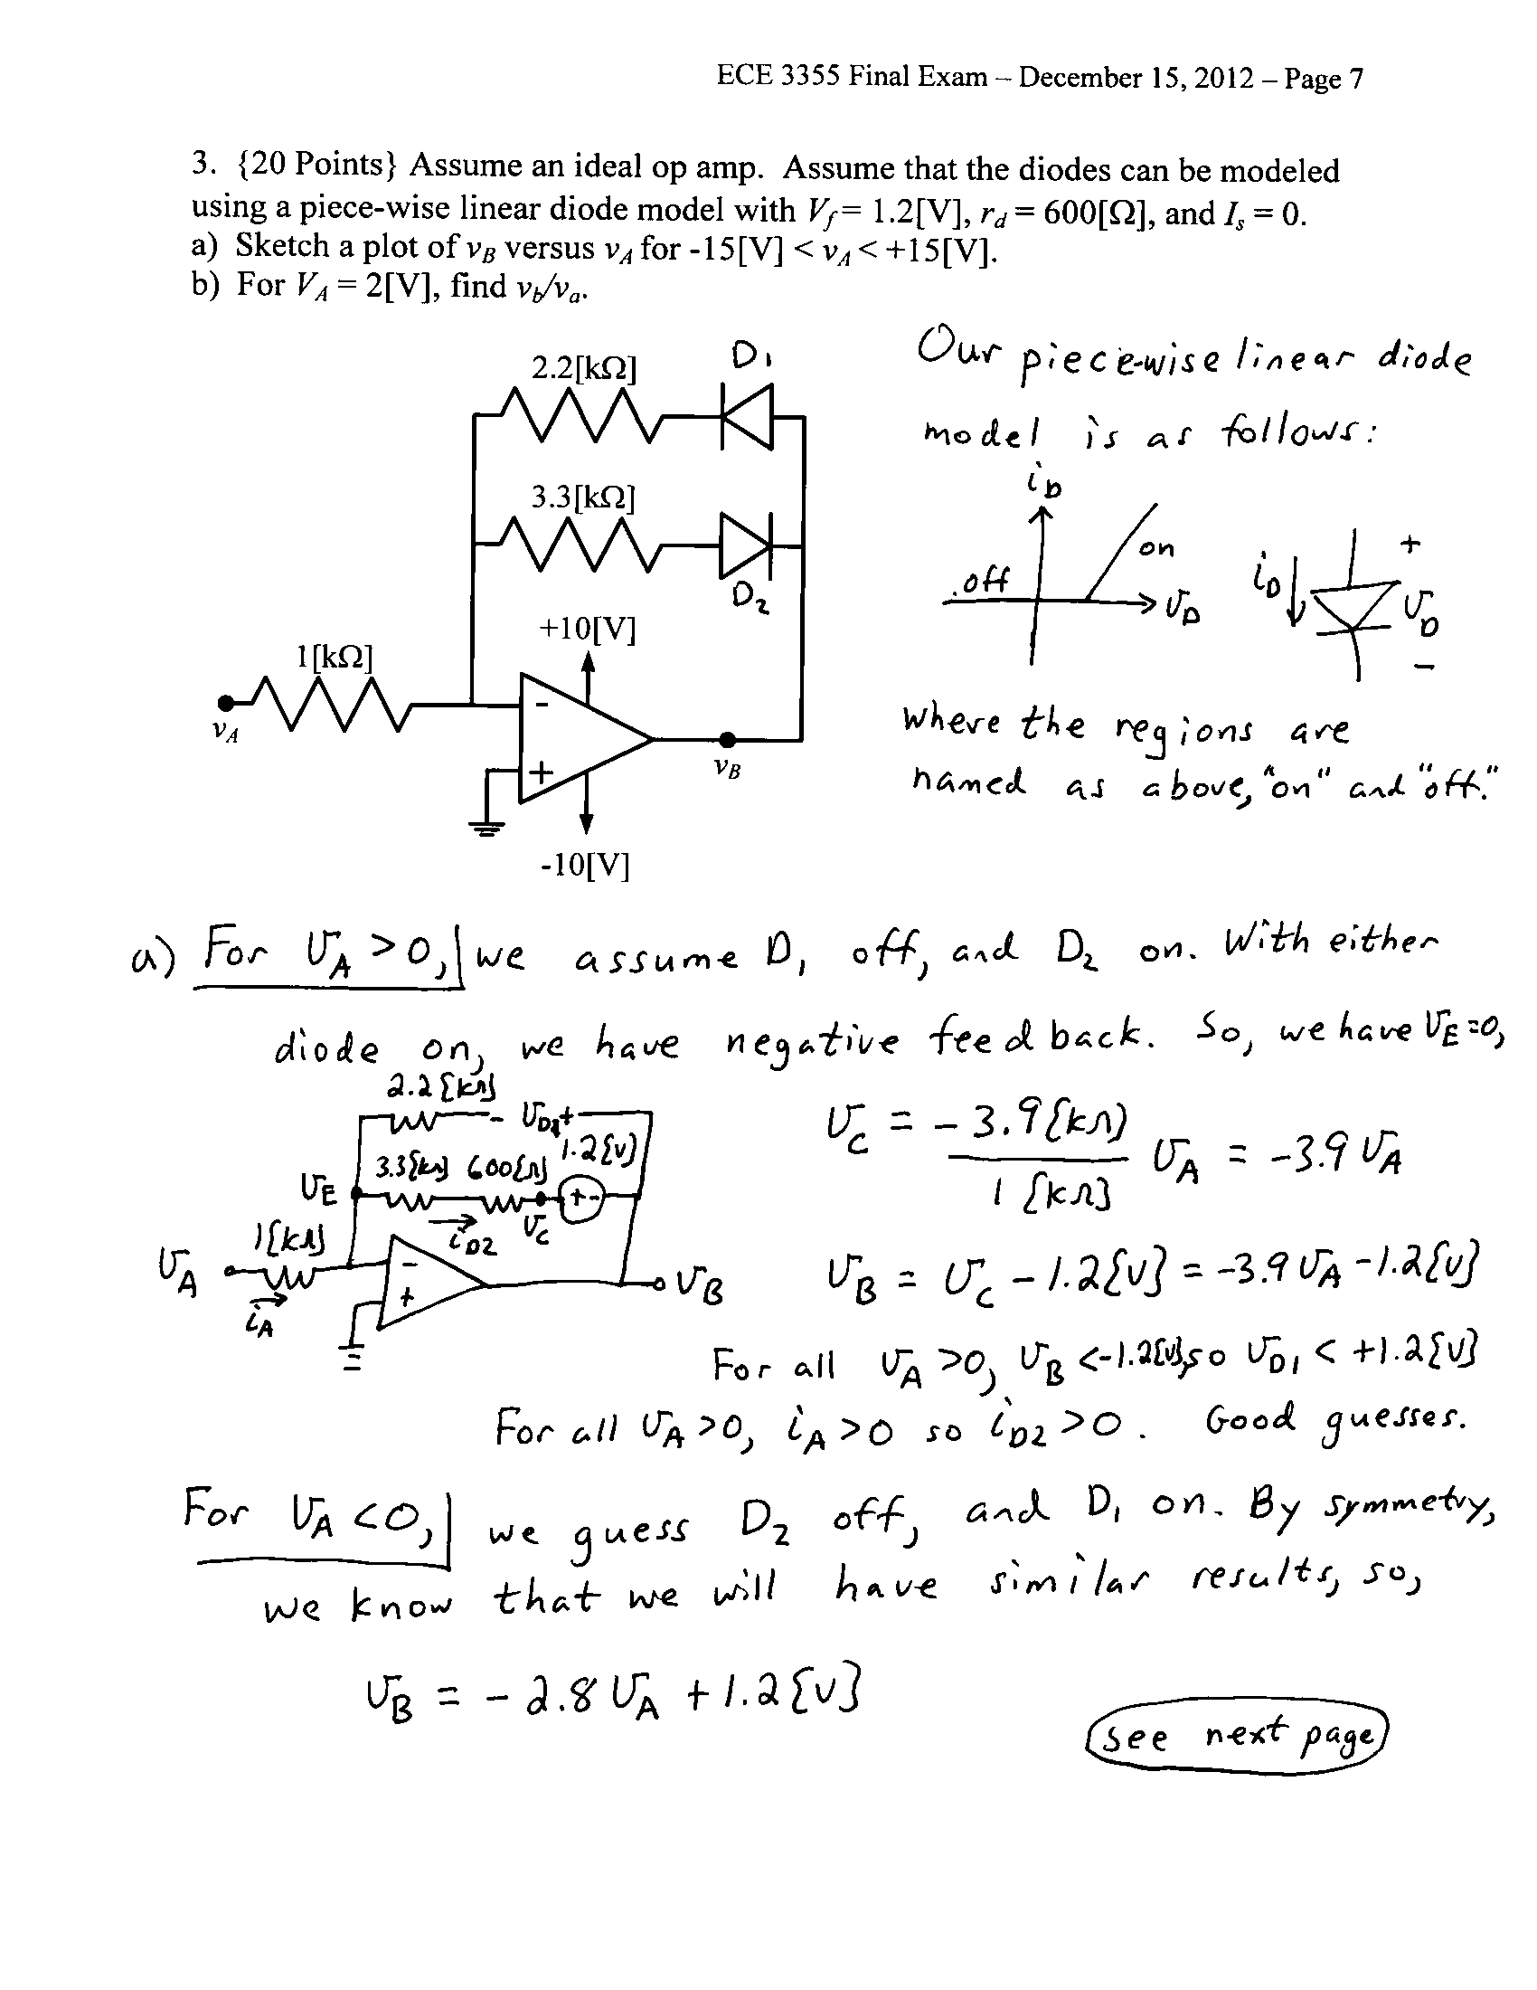

4. {20 Points} The characteristic curve, for the device in Figure 1, is shown in Figure 2. It is given that
- Find a model for each of the six regions of this device.
- Find a test that could be used to determine whether the correct region had been chosen in a guess and test analysis process. There should be one test for each region.
- Find v_{A}(t) for the circuit in Figure 1.
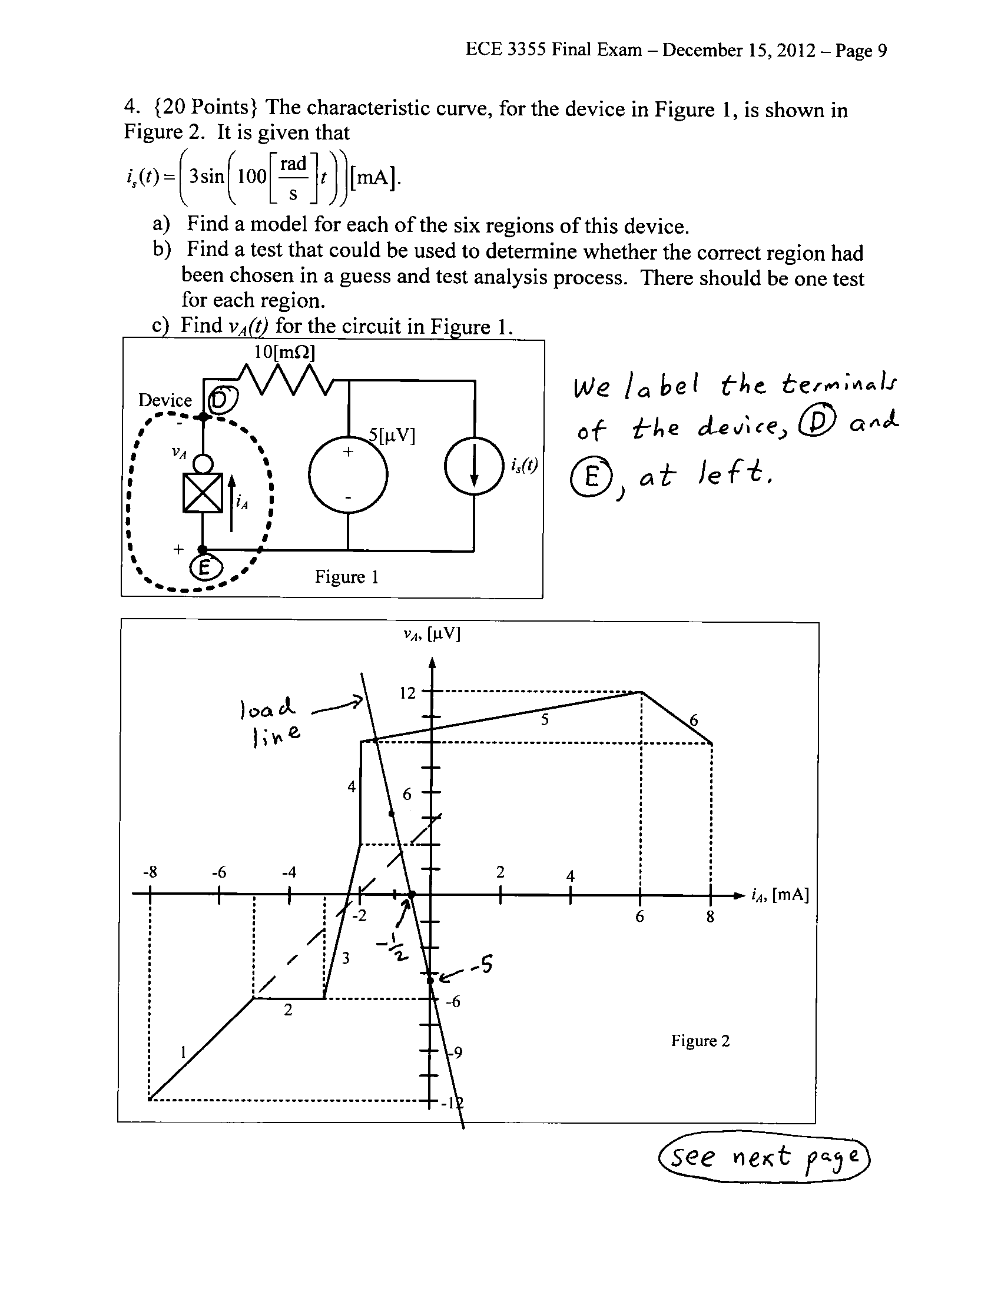
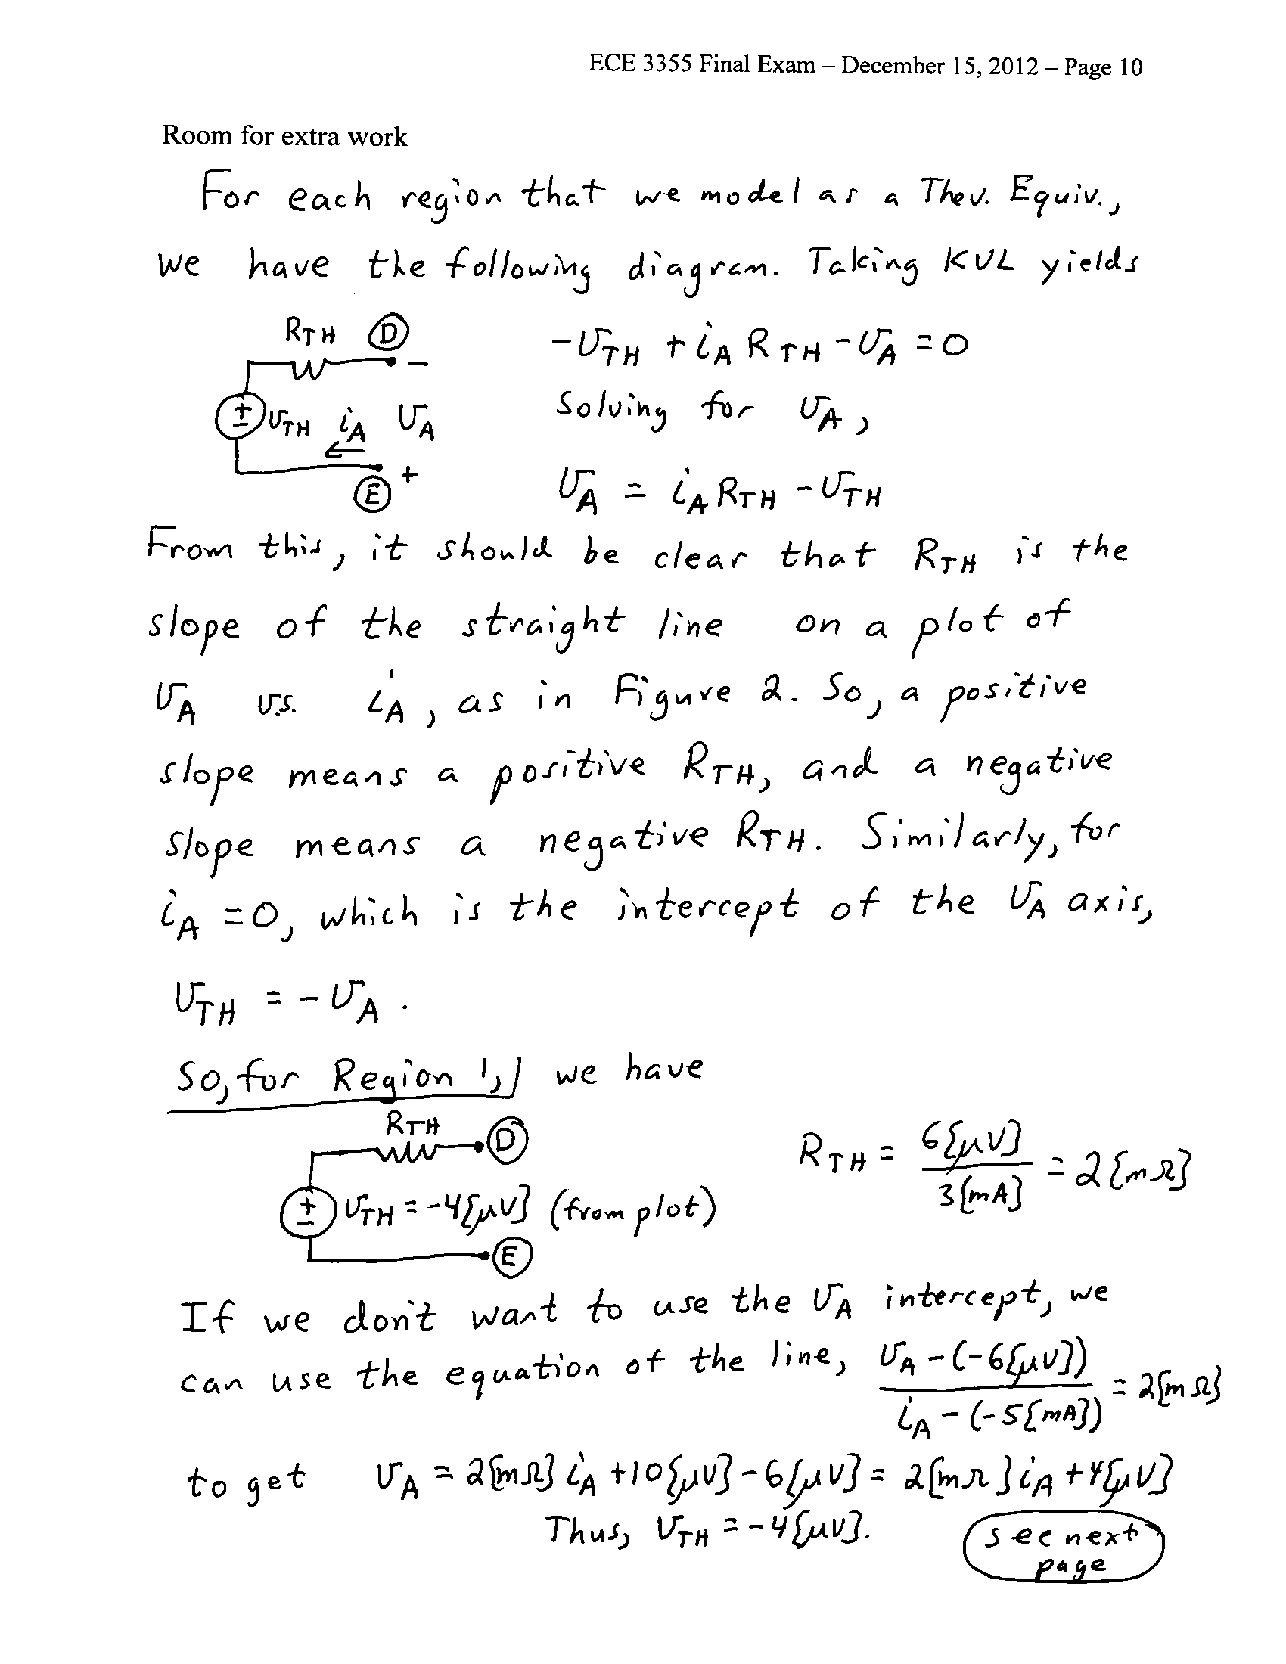
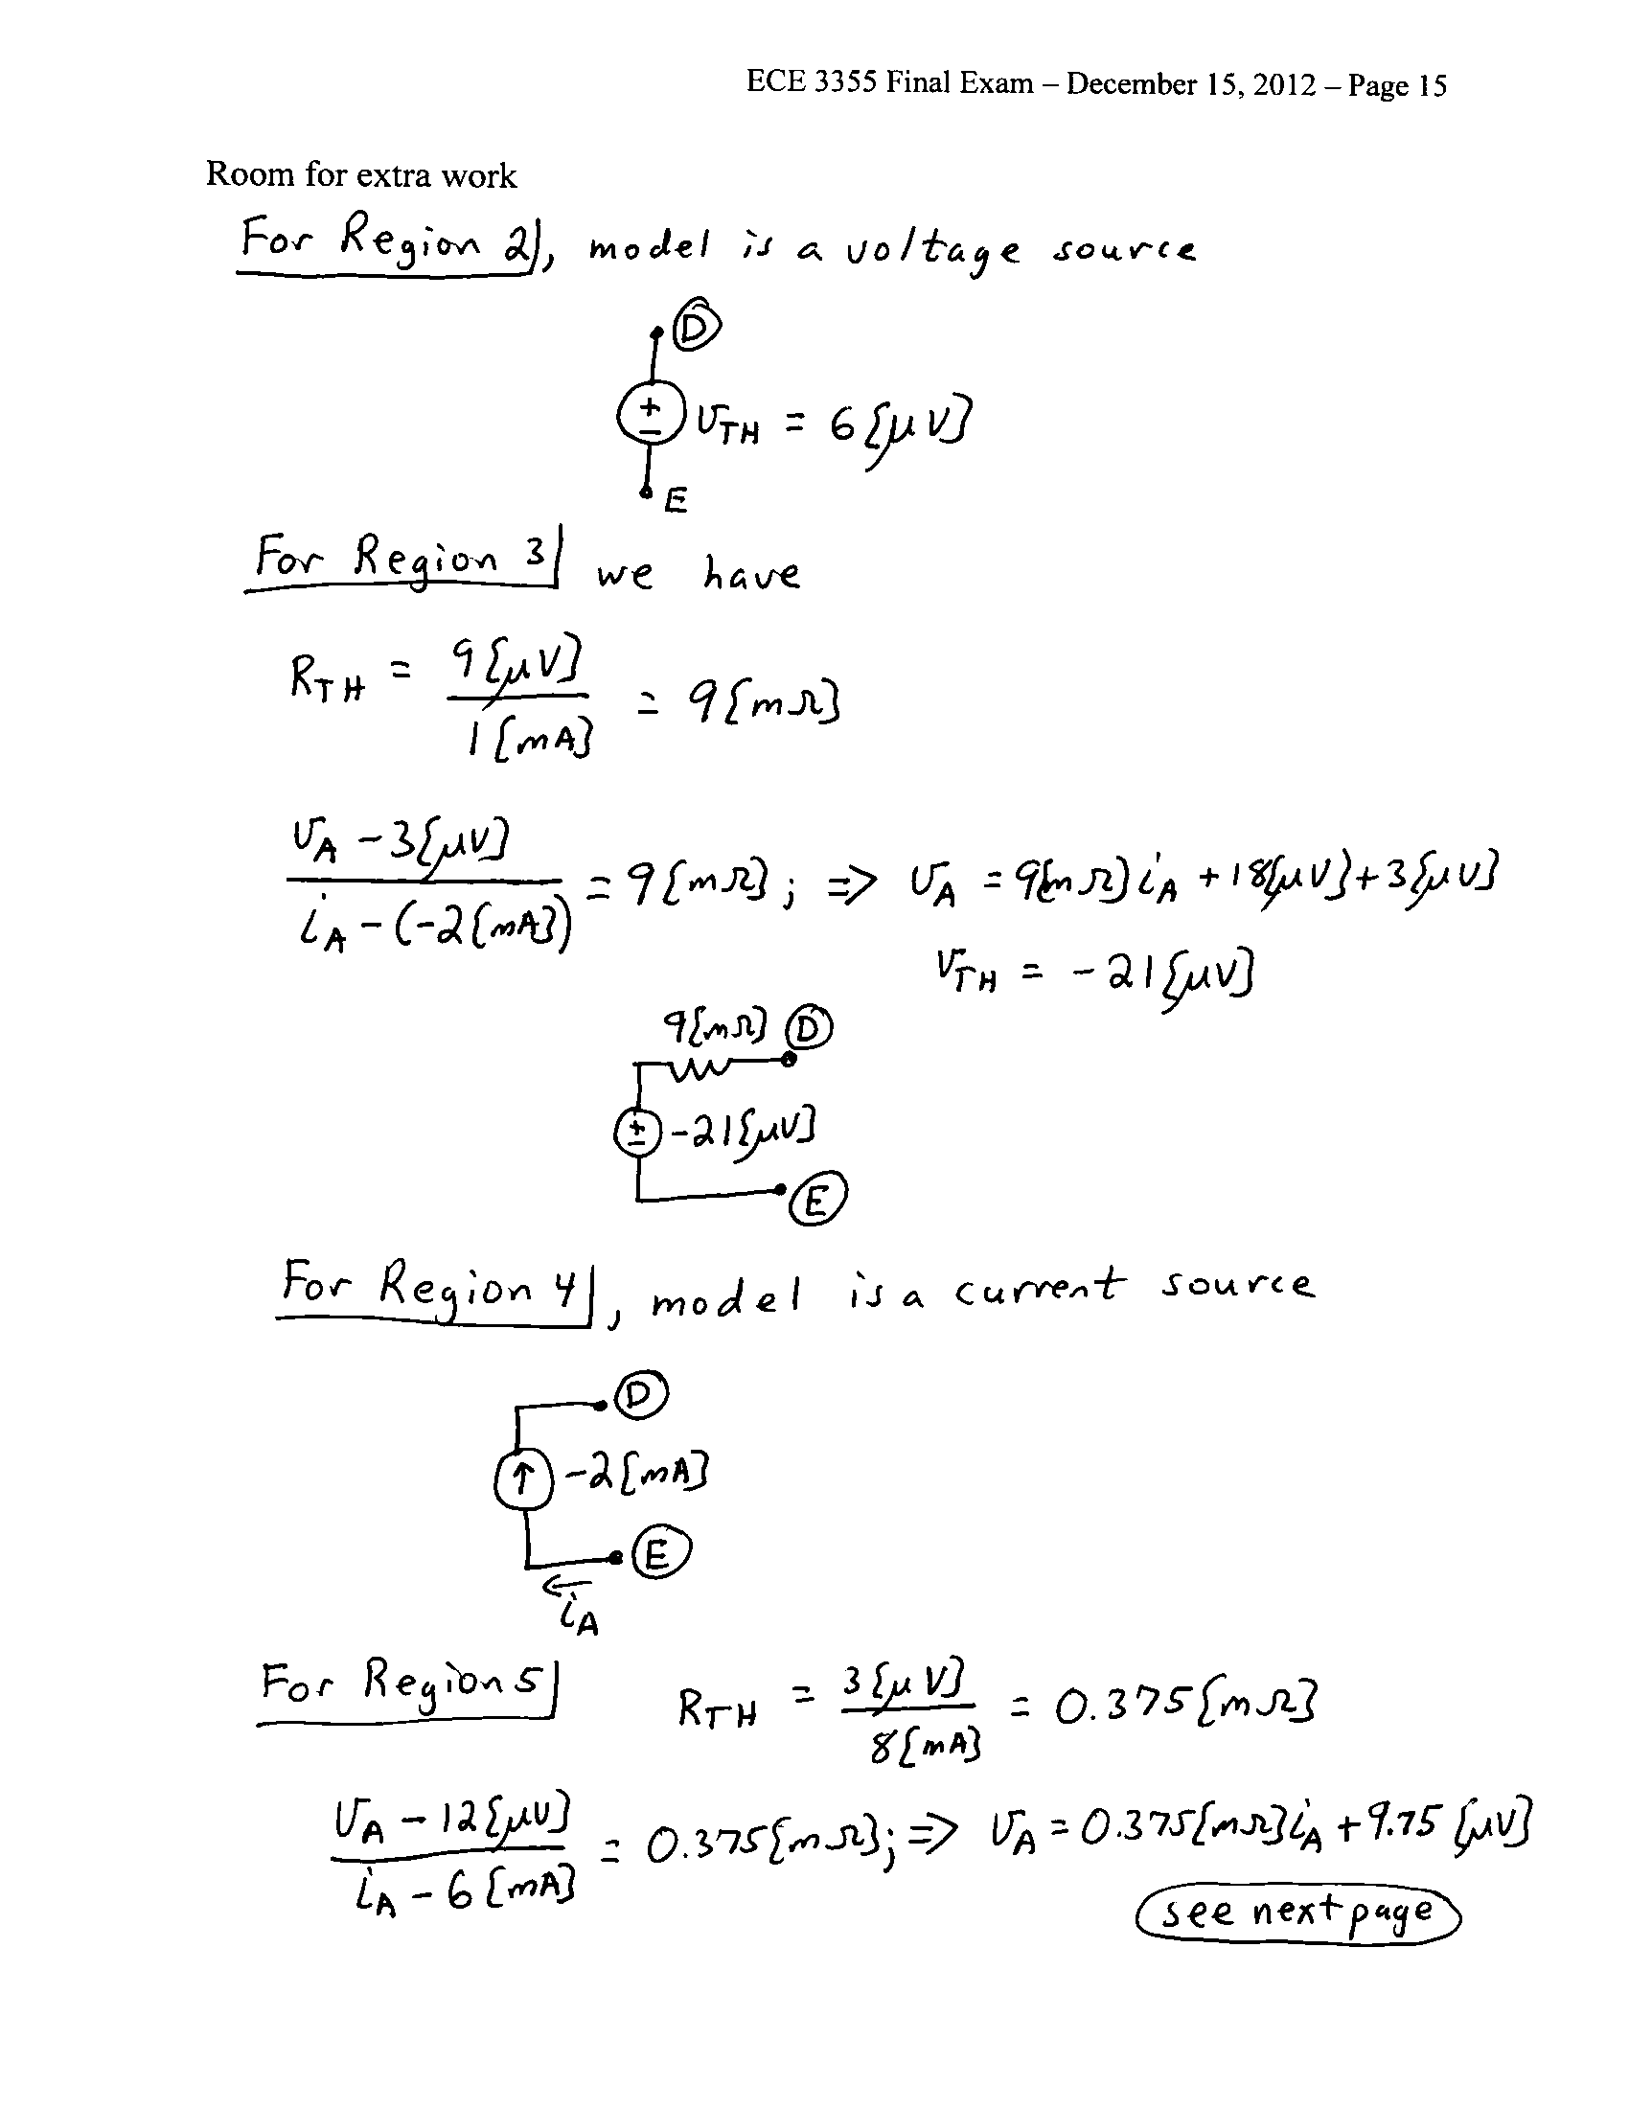
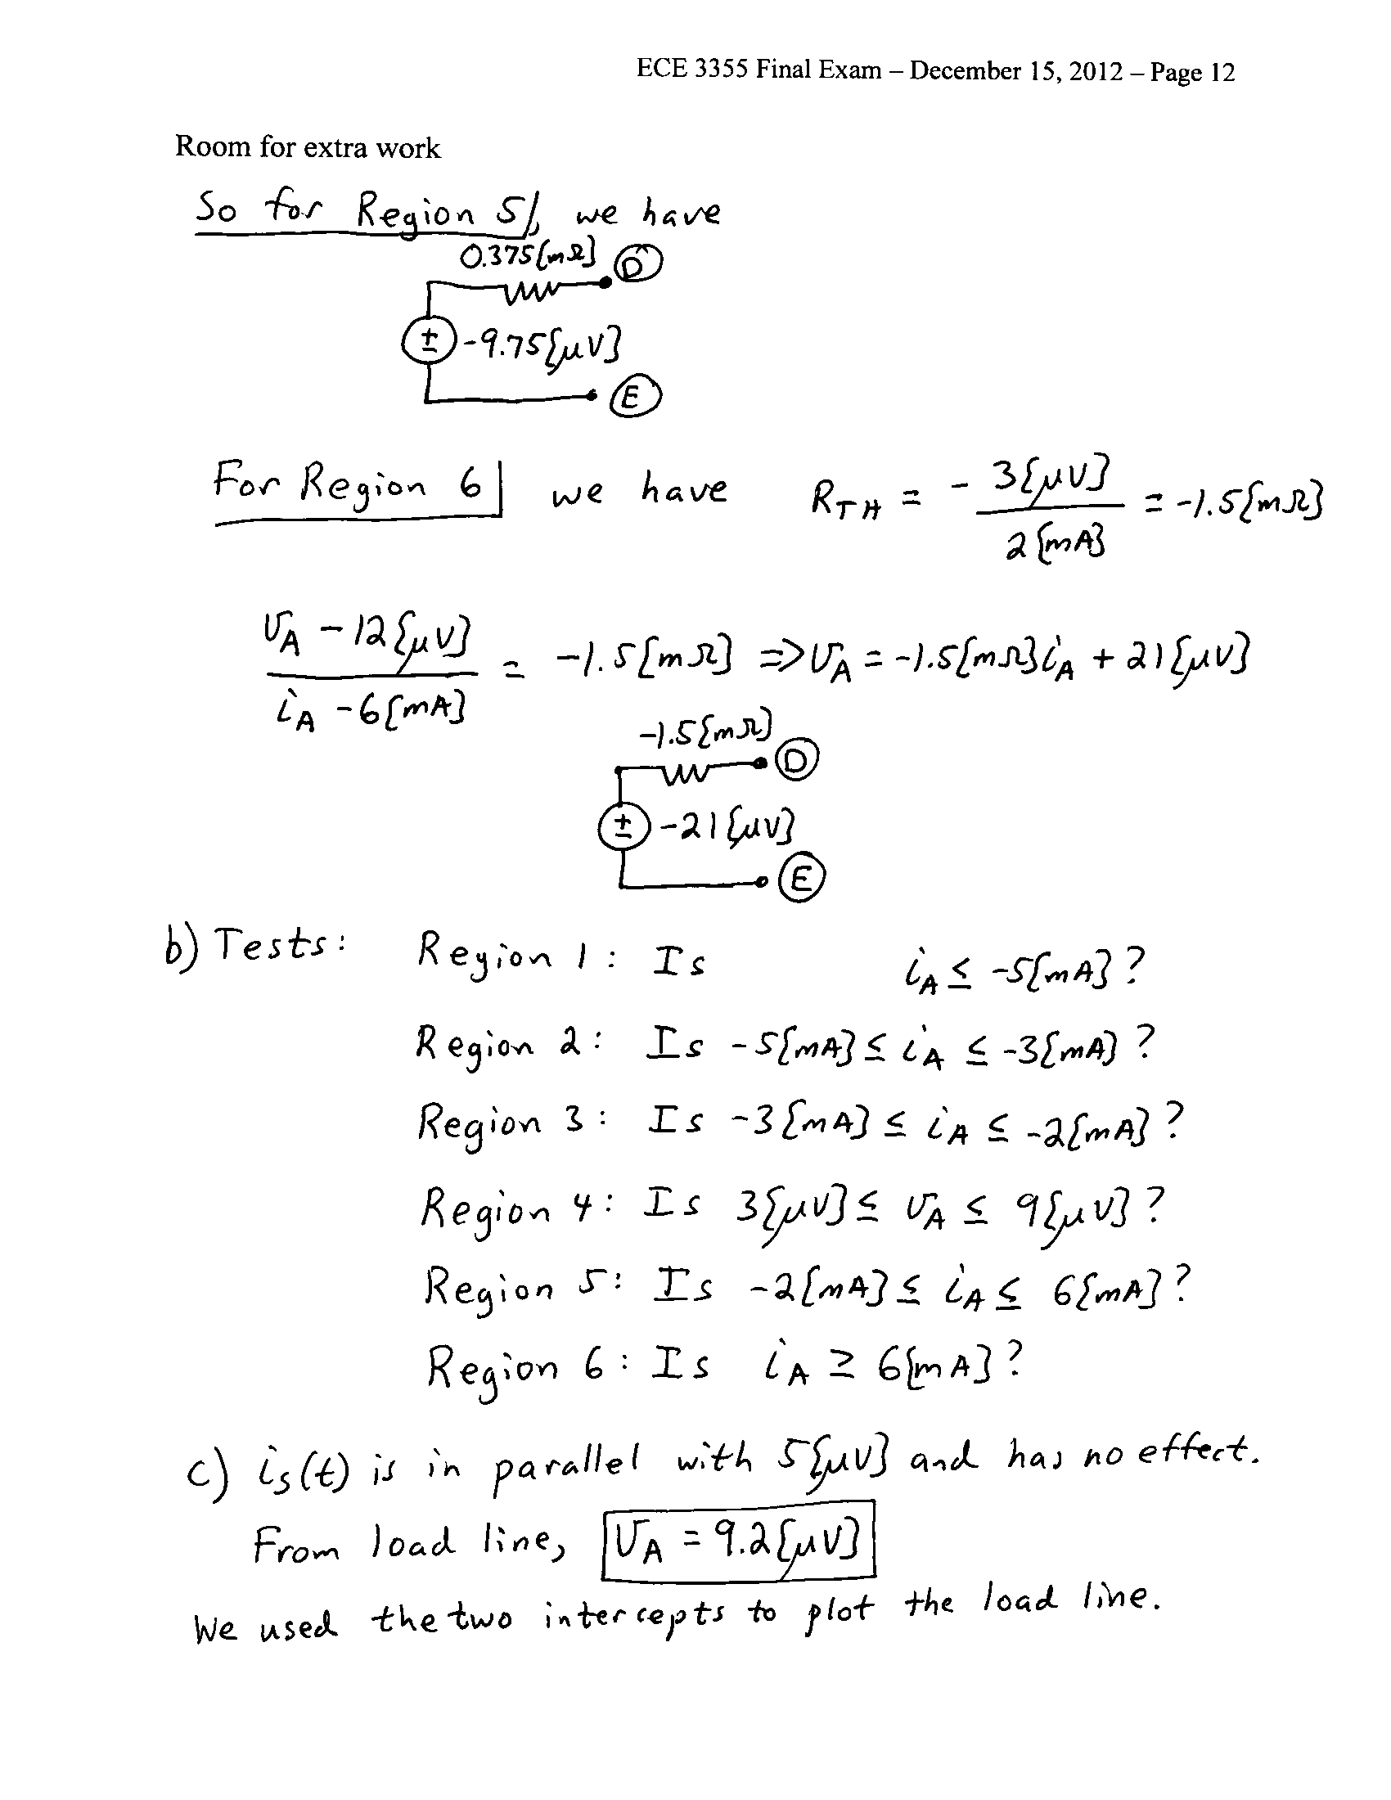
5. {20 Points} Use the circuit shown to solve this problem. Assume that for the transistor, β = 100, and that it is operating at room temperature. Assume that the capacitors C₁ and C₂ have large enough values so that they are effectively infinite for this problem. Find v_{f} /v_{a} in the passband.
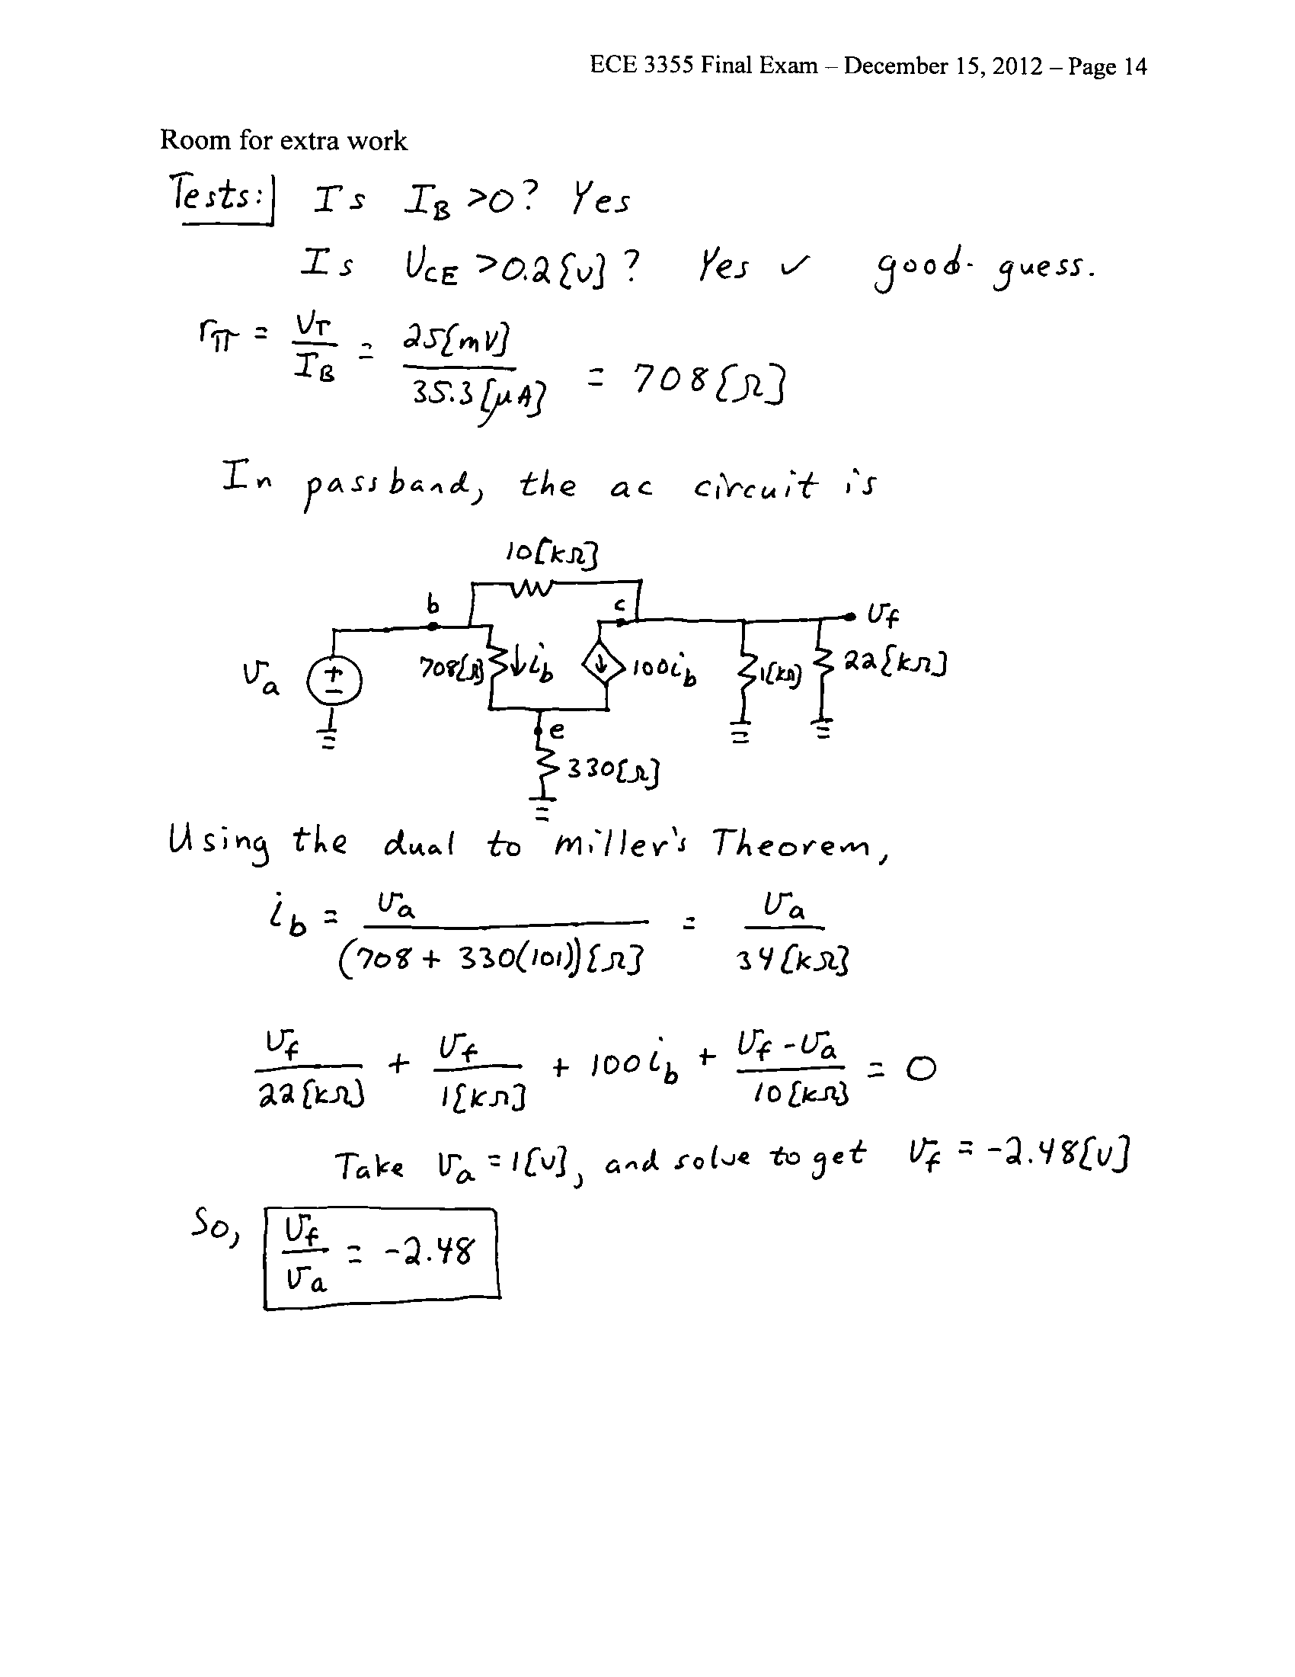
6. {20 Points} The schematic symbol for a Gangnamor is shown in Figure 1. Two characteristic curves for this device are shown in Figure 2 and Figure 3. Find a model that could be used to predict the behavior of a Gangnamor that has been biased into the Linear Region, for small signals. Draw the model, labeling all components with their numerical values, and labeling terminals A, B, and C.
