Name: _____________________________ (please print)
Signature: __________________________

ECE 3355 –Exam 2
November 14, 2015

Keep this exam closed until you are told to begin.

1. This exam is closed book, closed notes. You may use one 8.5” x 11” crib sheet, or its equivalent.
2. Show all work on these pages. Show all work necessary to complete the problem. A solution without the appropriate work shown will receive no credit. A solution that is not given in a reasonable order will lose credit. Clearly indicate your answer (for example by enclosing it in a box). If your answer is a plot, no box is needed.
3. It is assumed that your work will begin on the same page as the problem statement. If you choose to begin your work on another page, you must indicate this on the page with the problem statement, with a clear indication of where the work can be found. If your work continues on to another page, indicate clearly where your work can be found. Failure to indicate this clearly will result in a loss of credit.
4. Show all units in solutions, intermediate results, and figures. Units in the exam will be included between square brackets.
5. Do not use red ink. Do not use red pencil.
6. You will have 90 minutes to work on this exam.

1. ________________/30
2. ________________/40
3. ________________/30
Total = 100
Room for extra work
1. {30 Points} Assume that the diodes can be modeled using a piece-wise linear diode model with V_{f} = 1[V], r_{d} = 1[kΩ], and I_{s} = 1[mA]. Find V_{X}. Show your work, stating your tests explicitly. Define all variables appropriately. You are expected to be able to complete at least two reasonable guesses, if needed, in the time period allotted.

Room for extra work

2. {40 Points} Assume ideal op amps.
a) Find i_{X}/v_{I} when v_{I} = 1[V].
b) Find i_{X}/v_{I} when v_{I} = 2[V].
c) Find the value of v_{I} that causes i_{X} to begin to change, as you increase v_{I} to values higher than 2[V].

Room for extra work

Room for extra work

3. {30 Points} The switch was open for a long time before t = 0. Then, at t = 0, the switch closed. Assume an ideal op amp. Sketch v_{A}(t) for the time period from 0 to 10[s]. Show your work, and explain briefly how you got your plot.

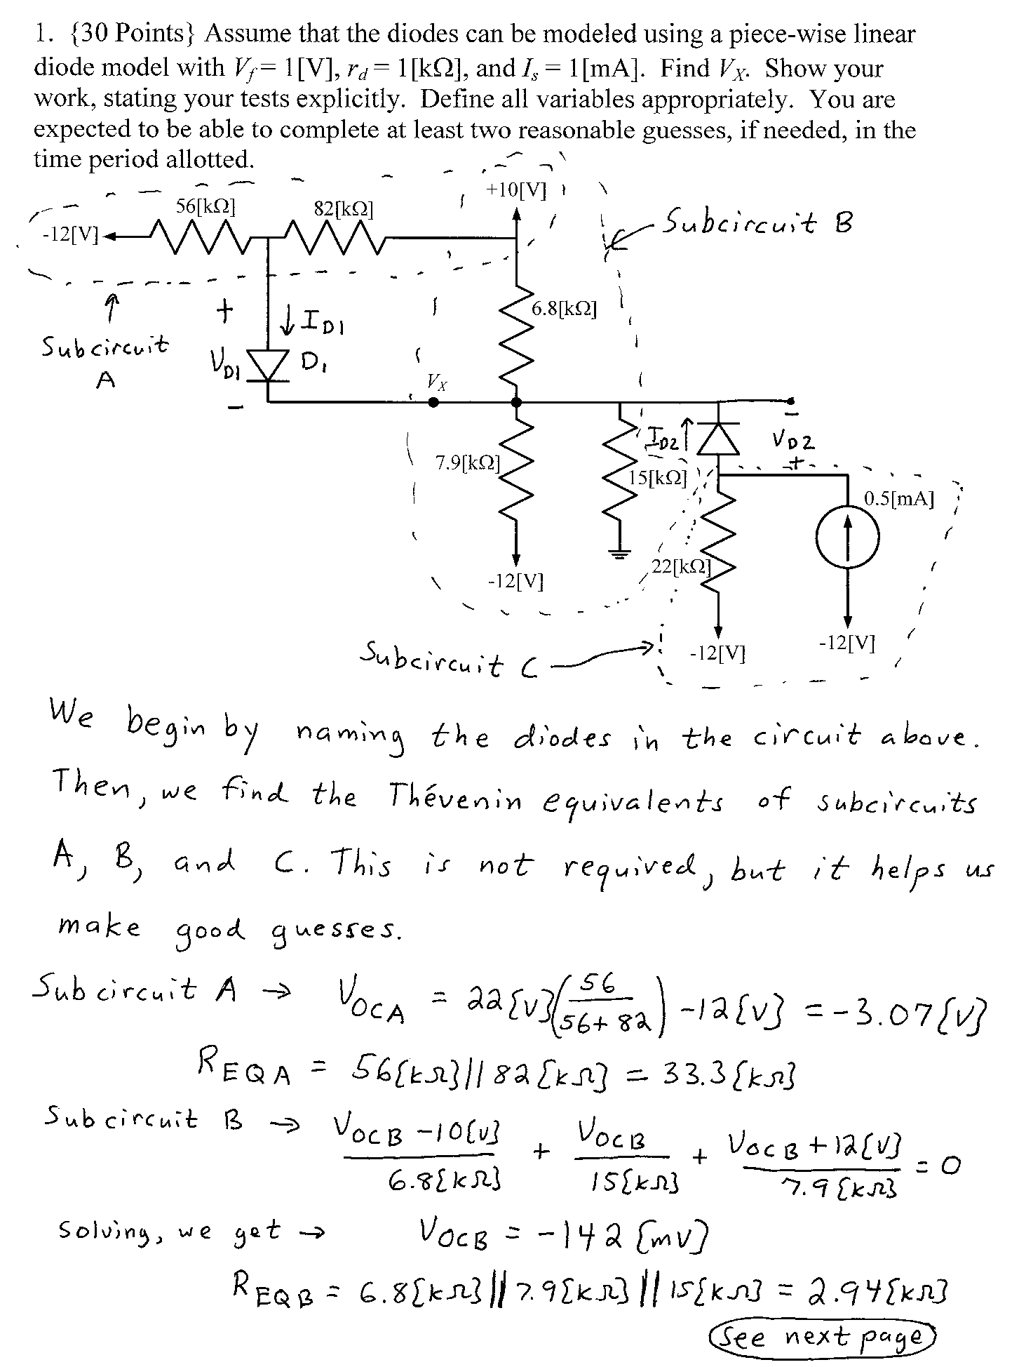
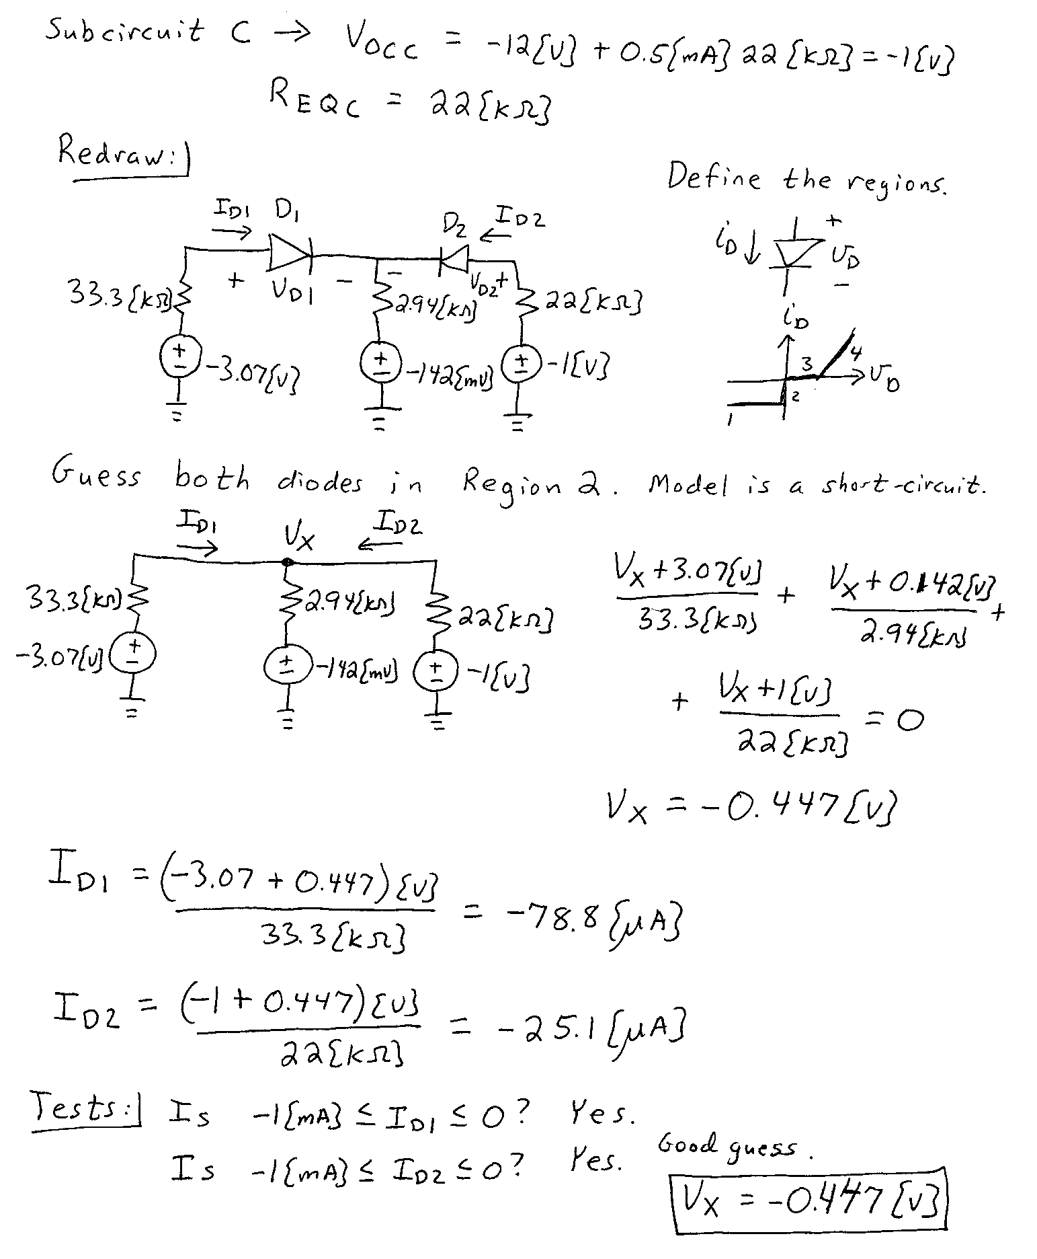

2. {40 Points} Assume ideal op amps.
a) Find i_{X}/v_{I} when v_{I} = 1[V].
b) Find i_{X}/v_{I} when v_{I} = 2[V].
c) Find the value of v_{I} that causes i_{X} to begin to change, as you increase v_{I} to values higher than 2[V].
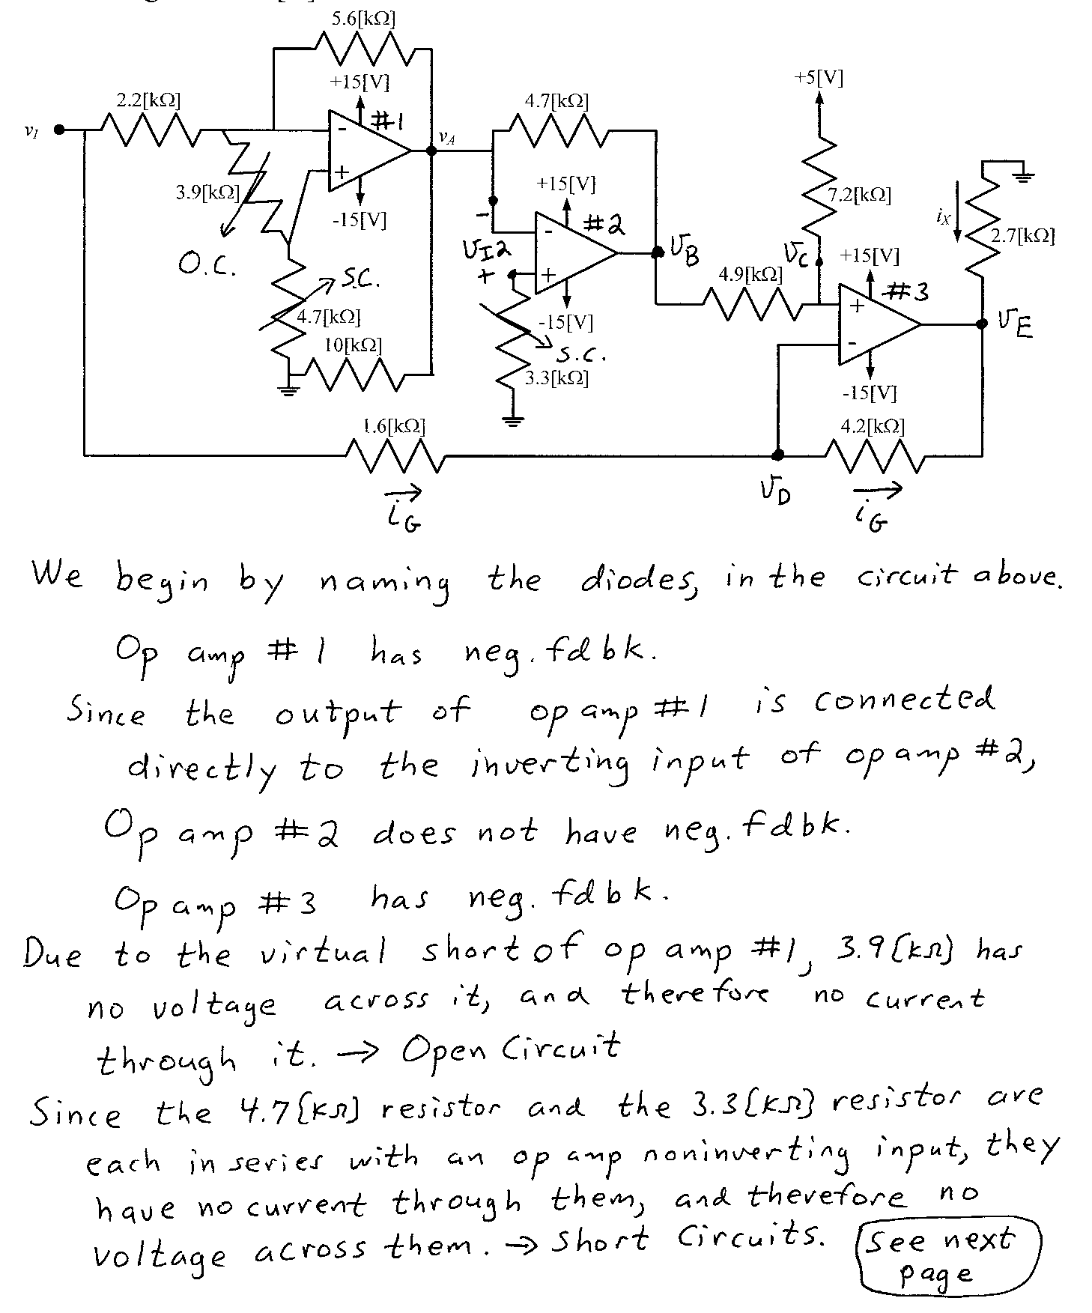
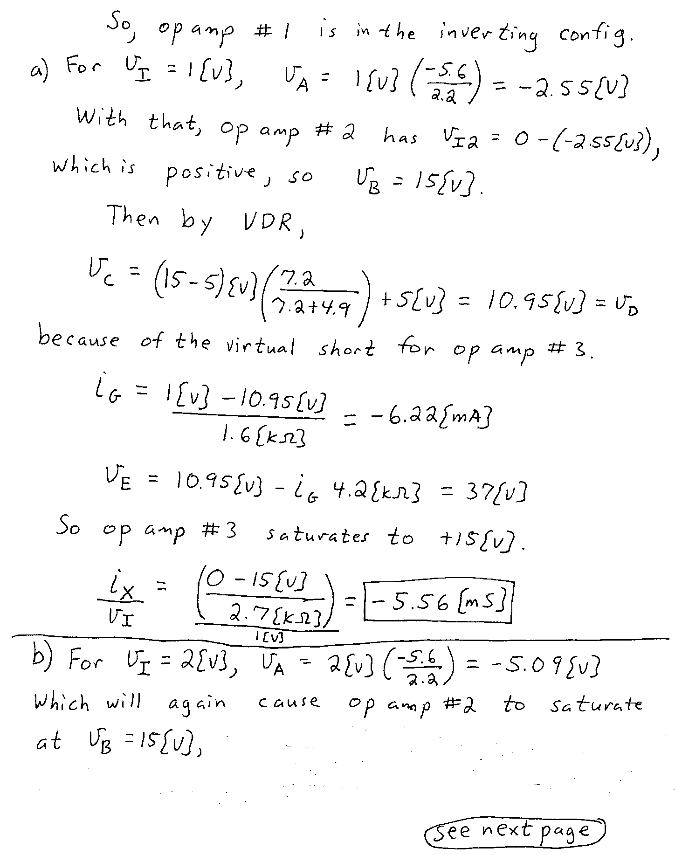
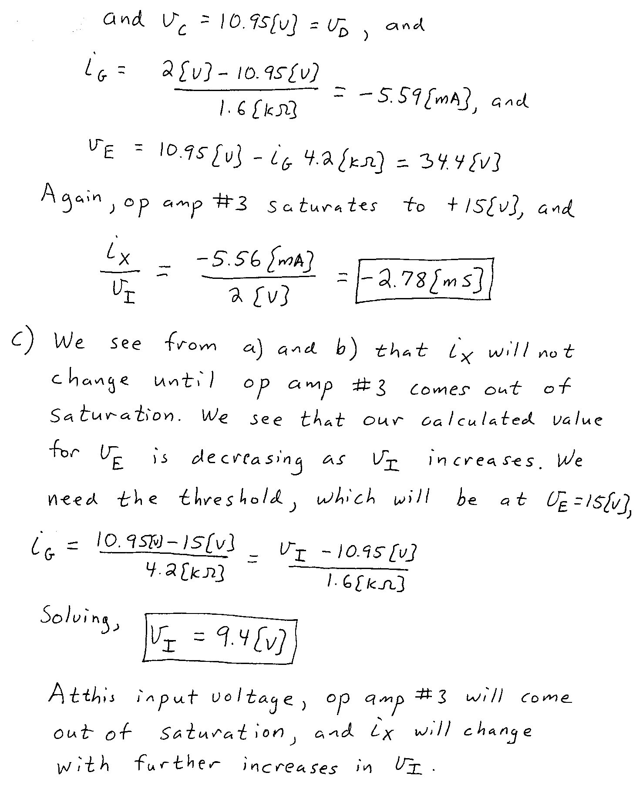

3. {30 Points} The switch was open for a long time before t = 0. Then, at t = 0, the switch closed. Assume an ideal op amp. Sketch v_{A}(t) for the time period from 0 to 10[s]. Show your work, and explain briefly how you got your plot.
