Name: _____________________________ (please print)
Signature: __________________________

ECE 3355 – Final Exam
December 12, 2015

Keep this exam closed until you are told to begin.

1. This exam is closed book, closed notes. You may use one 8.5” x 11” crib sheet, or its equivalent.
2. Show all work on these pages. Show all work necessary to complete the problem. A solution without the appropriate work shown will receive no credit. A solution that is not given in a reasonable order will lose credit. Clearly indicate your answer (for example by enclosing it in a box). If your answer is a plot, no box is needed.
3. It is assumed that your work will begin on the same page as the problem statement. If you choose to begin your work on another page, you must indicate this on the page with the problem statement, with a clear indication of where the work can be found. If your work continues on to another page, indicate clearly where your work can be found. Failure to indicate this clearly will result in a loss of credit.
4. Show all units in solutions, intermediate results, and figures. Units in the exam will be included between square brackets.
5. Do not use red ink. Do not use red pencil.
6. You will have 170 minutes to work on this exam.

1. ________________/20
2. ________________/45
3. ________________/45
4. ________________/45
5. ________________/45
Total = 200
Room for extra work

1. {20 Points} Use the circuit below to solve this problem. Assume ideal op amps, assume that all resistors have resistance of 1[kΩ], and assume that v_{I} = 1[V]. Find v_{O}.

Room for extra work

2. {45 Points} Use the circuit below to solve this problem. Assume an ideal op amp.
a) Find the voltage gain V_{A} / V_{IN}.
b) Find the voltage gain V_{a} / V_{in} as a function of angular frequency.
c) Find the voltage gain v_{a} / v_{in} as a function of time, if
v_{IN}(t) = 6[V] + 3[V]cos(300[rad/s]t).

Room for extra work

3. {45 Points} Assume an ideal op amp in the schematic in Figure 1. Find the values of R₂, C_{X}, and L_{X} that will produce the magnitude Bode plot that has the straight-line approximation given in the plot in Figure 2.

Room for extra work

4. {45 Points} The characteristic curve for the device, called a karrleeloid, is shown in Figure 1. The device schematic symbol is shown in Figure 2. The device is placed in the circuit in Figure 3.
- Find a model for each of the four regions of this device.
- Find a test that could be used to determine whether the correct region had been chosen in a guess and test analysis process. There should be one test given for each region.
- Find the solution or solutions, if any, for i_{B} in the circuit in Figure 3.

Room for extra work

Room for extra work

5. {45 Points} Use the circuit shown to solve this problem. Assume that for the transistor, β = 50, and that it is operating at room temperature.
a) Assume for part a) that the transistor is biased into the linear region, with
r_{π} = 300[Ω]. Find the voltage gain v_{o} /v_{i} in the passband, if R_{C} = 3.3[kΩ].
b) Assume for part b) that the transistor is biased into the linear region, with
r_{π} = 300[Ω]. Find the voltage gain v_{o} /v_{i} in the passband, as a function of R_{C}.
c) Find the range of values for R_{C} that will have the transistor biased into the linear region.

1. {20 Points} Use the circuit below to solve this problem. Assume ideal op amps, assume that all resistors have resistance of 1[kΩ], and assume that v_{I} = 1[V]. Find v_{O}.
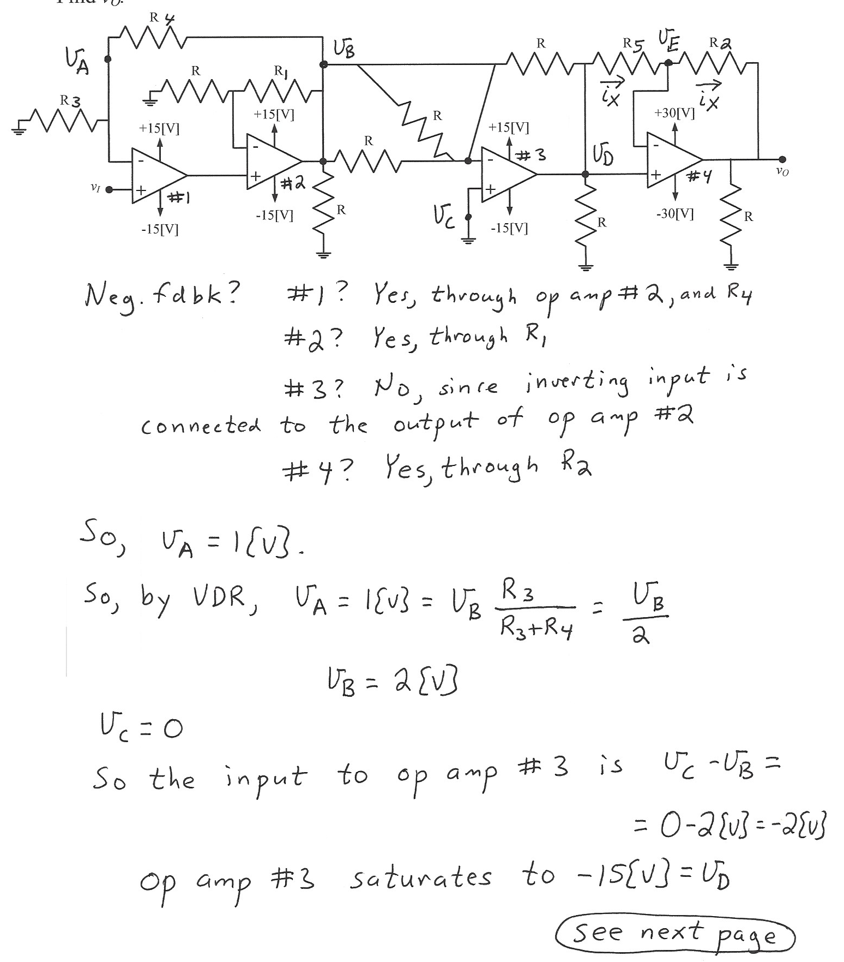
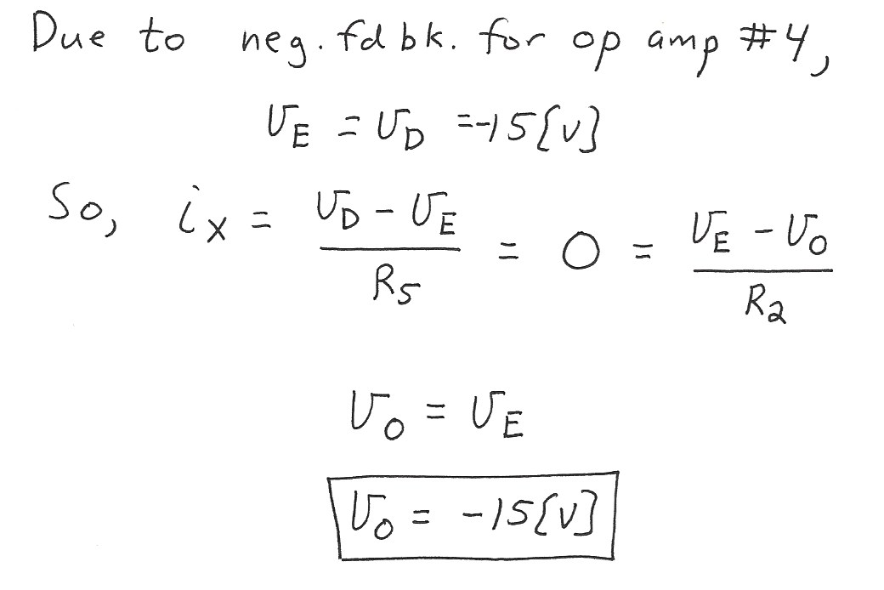

2. {45 Points} Use the circuit below to solve this problem. Assume an ideal op amp.
a) Find the voltage gain V_{A} / V_{IN}.
b) Find the voltage gain V_{a} / V_{in} as a function of angular frequency.
c) Find the voltage gain v_{a} / v_{in} as a function of time, if
v_{IN}(t) = 6[V] + 3[V]cos(300[rad/s]t).
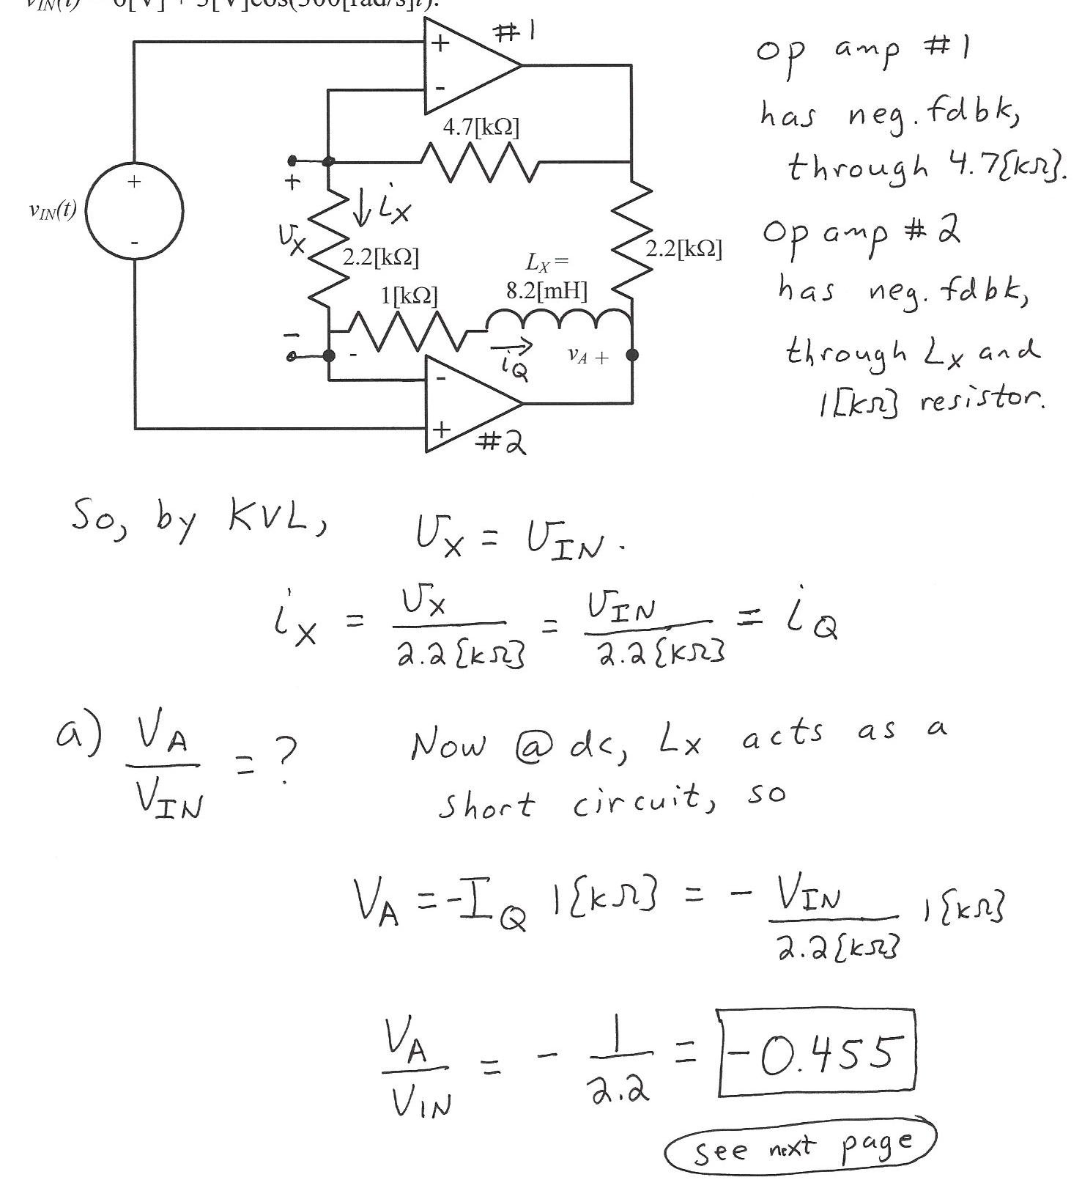
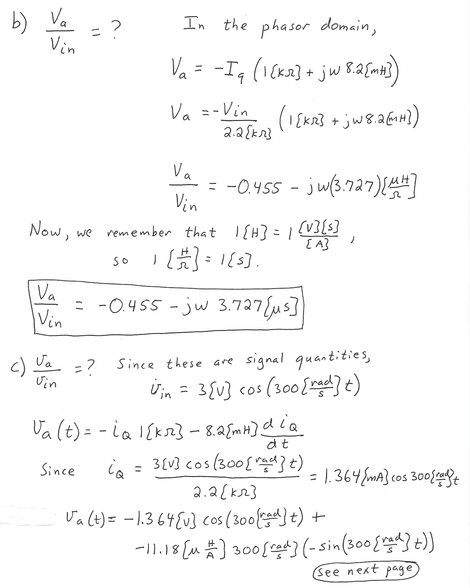
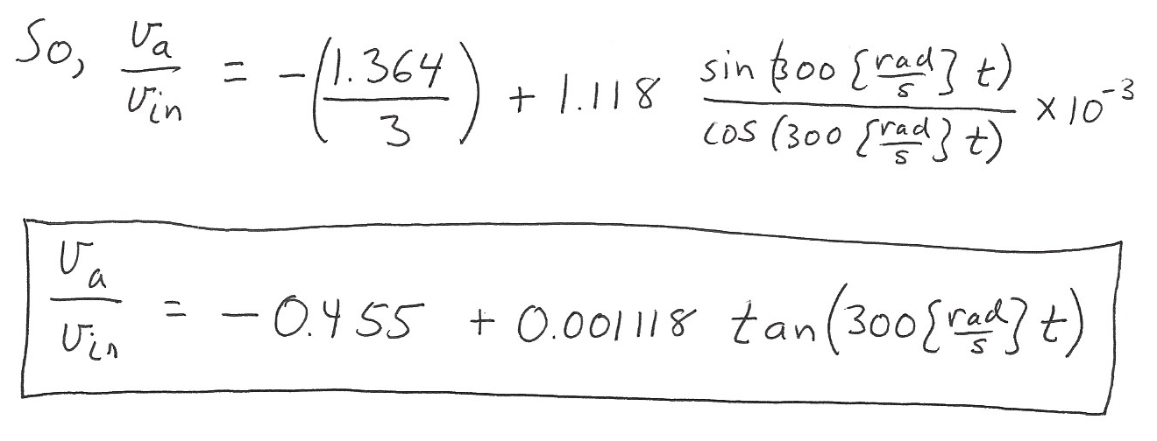

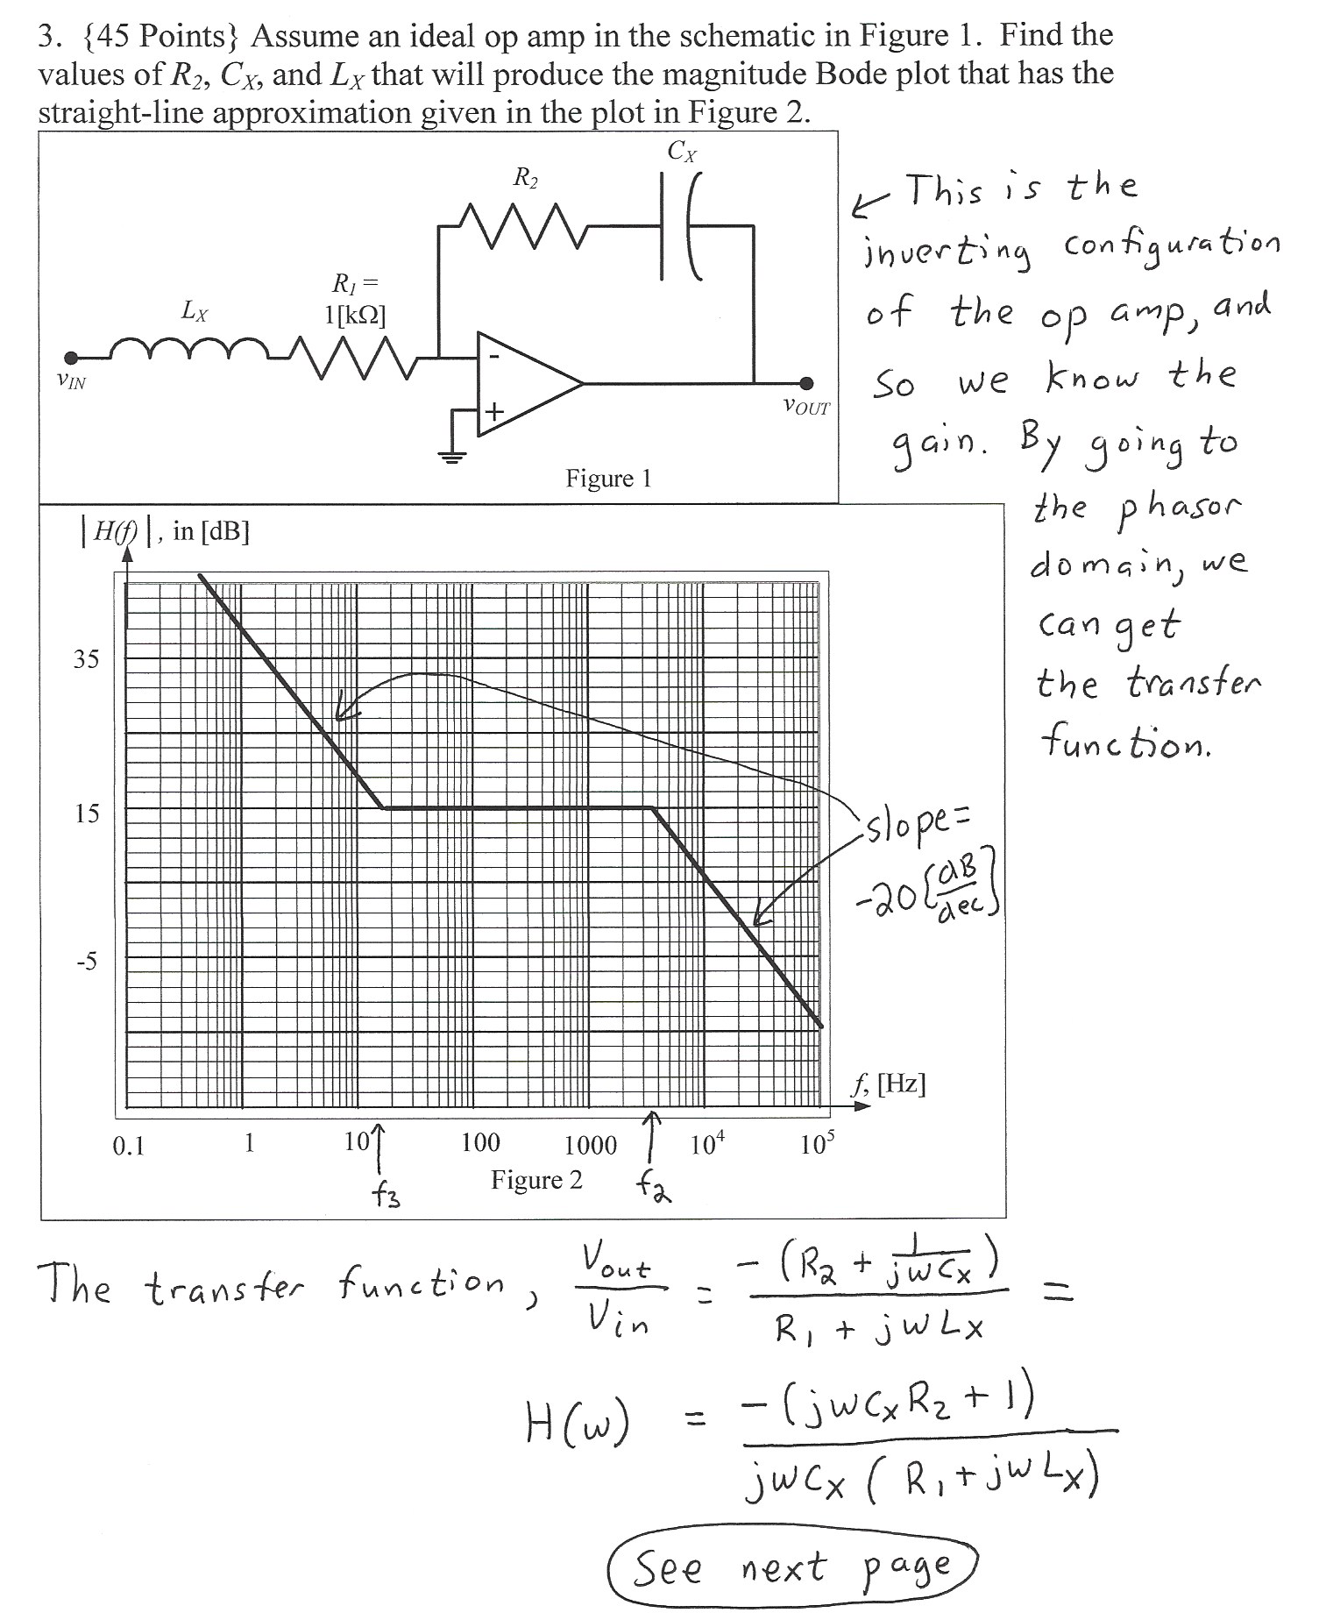
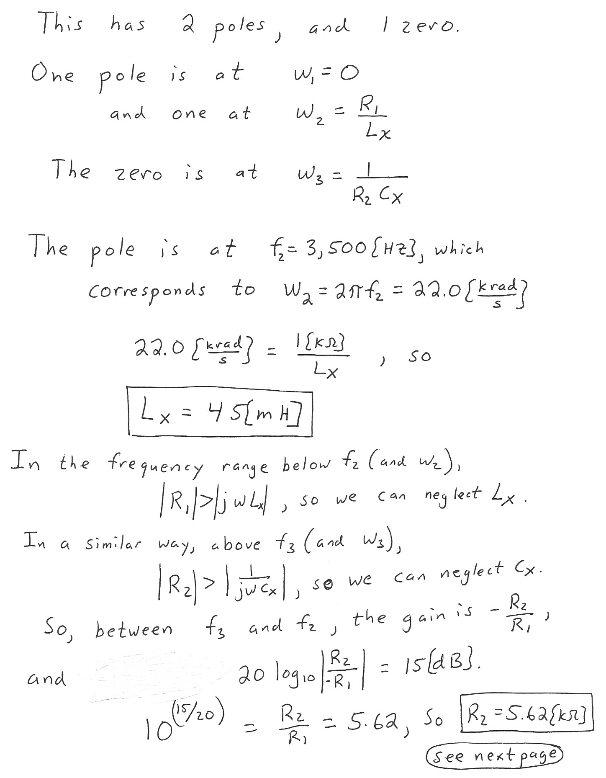
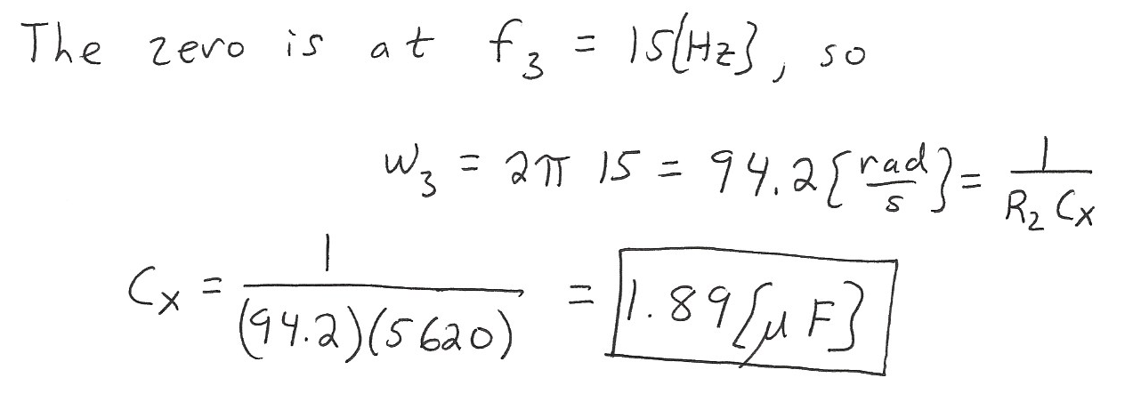

4. {45 Points} The characteristic curve for the device, called a karrleeloid, is shown in Figure 1. The device schematic symbol is shown in Figure 2. The device is placed in the circuit in Figure 3.
- Find a model for each of the four regions of this device.
- Find a test that could be used to determine whether the correct region had been chosen in a guess and test analysis process. There should be one test given for each region.
- Find the solution or solutions, if any, for i_{B} in the circuit in Figure 3.
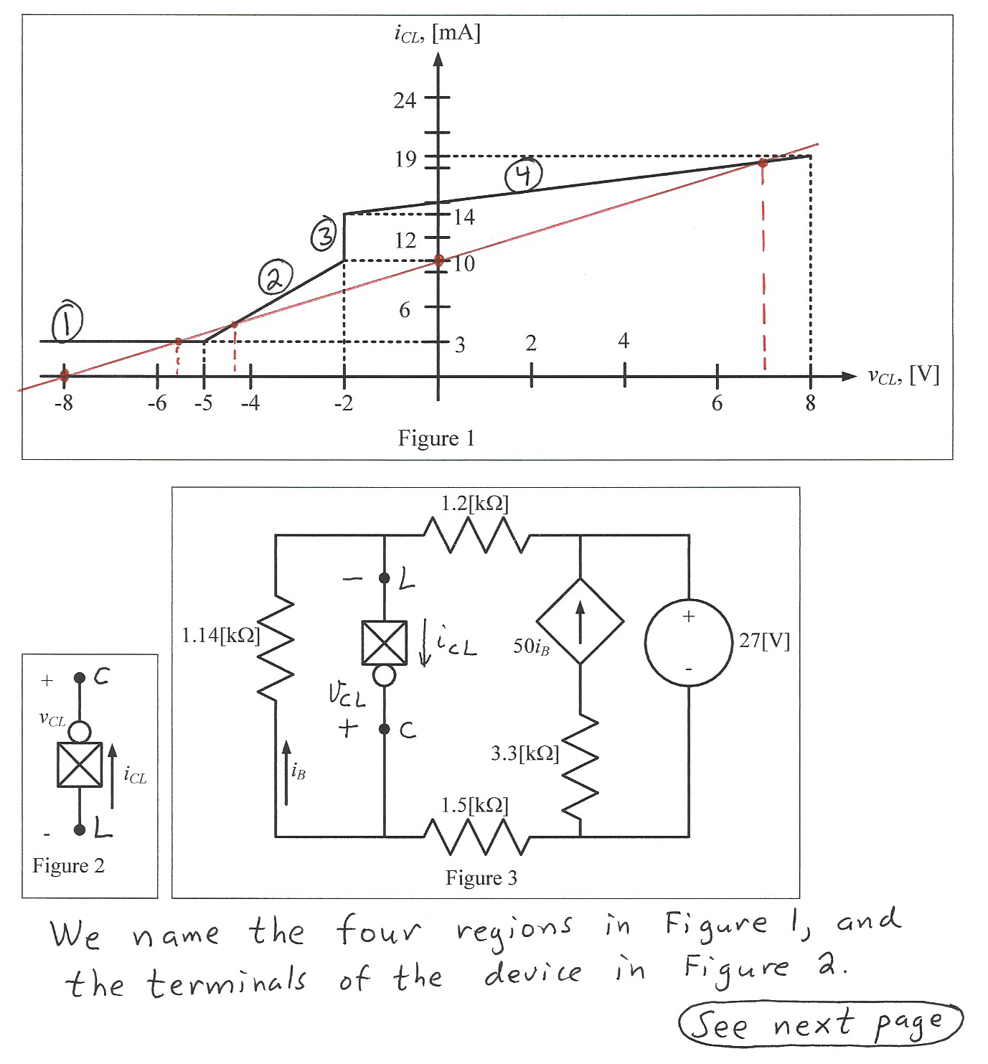
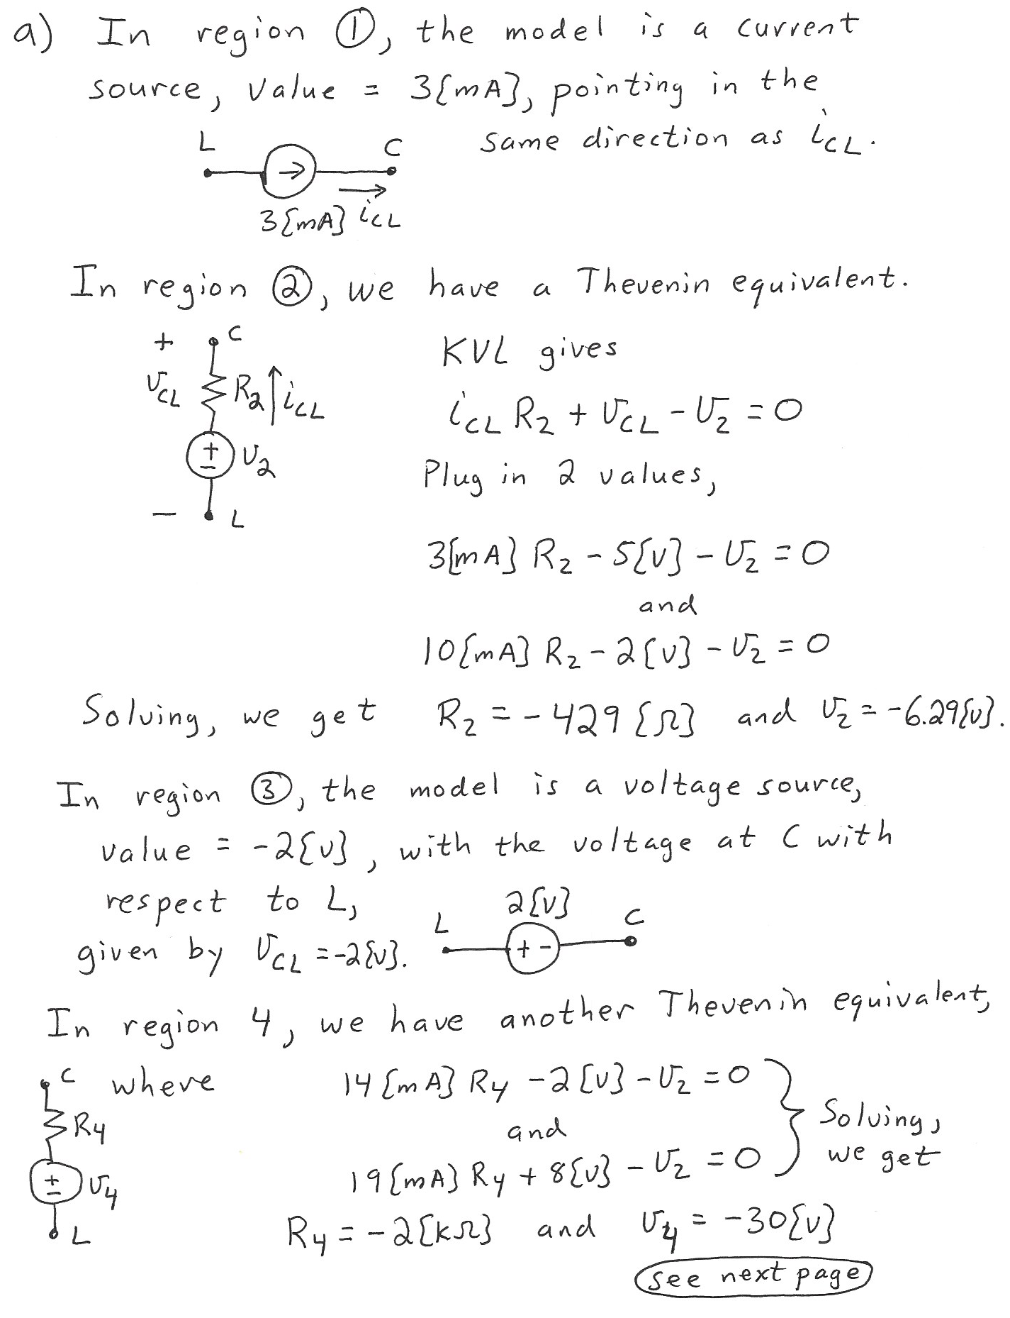
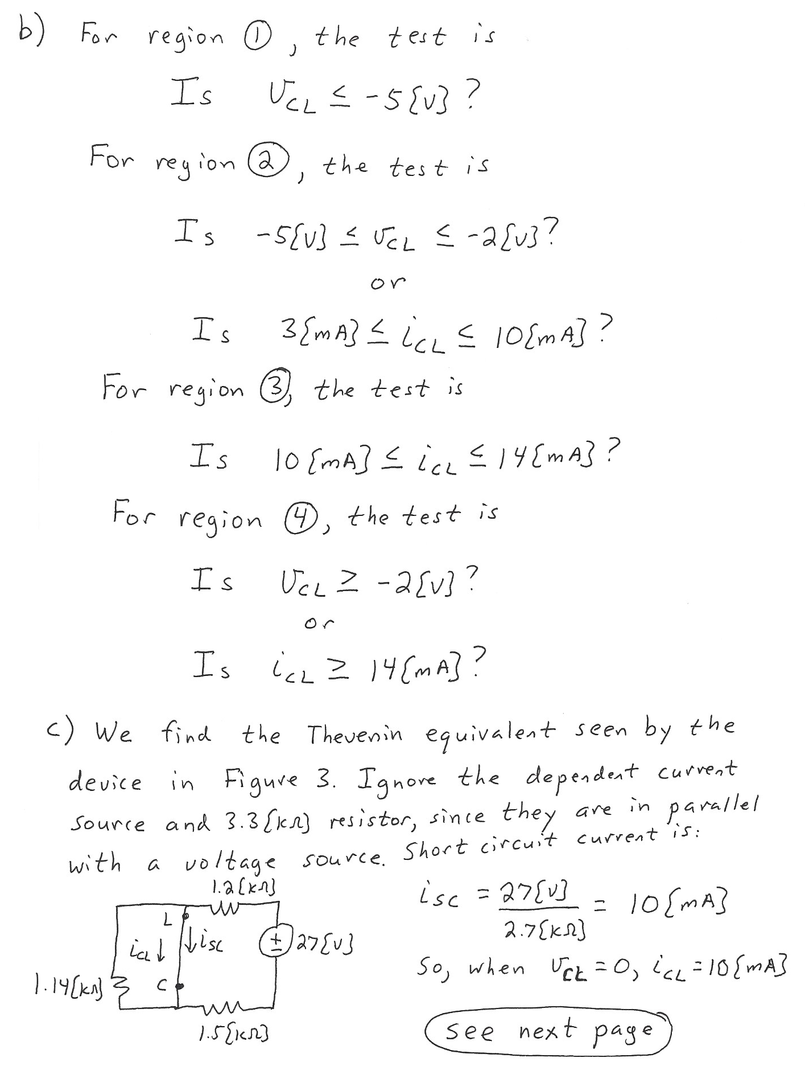
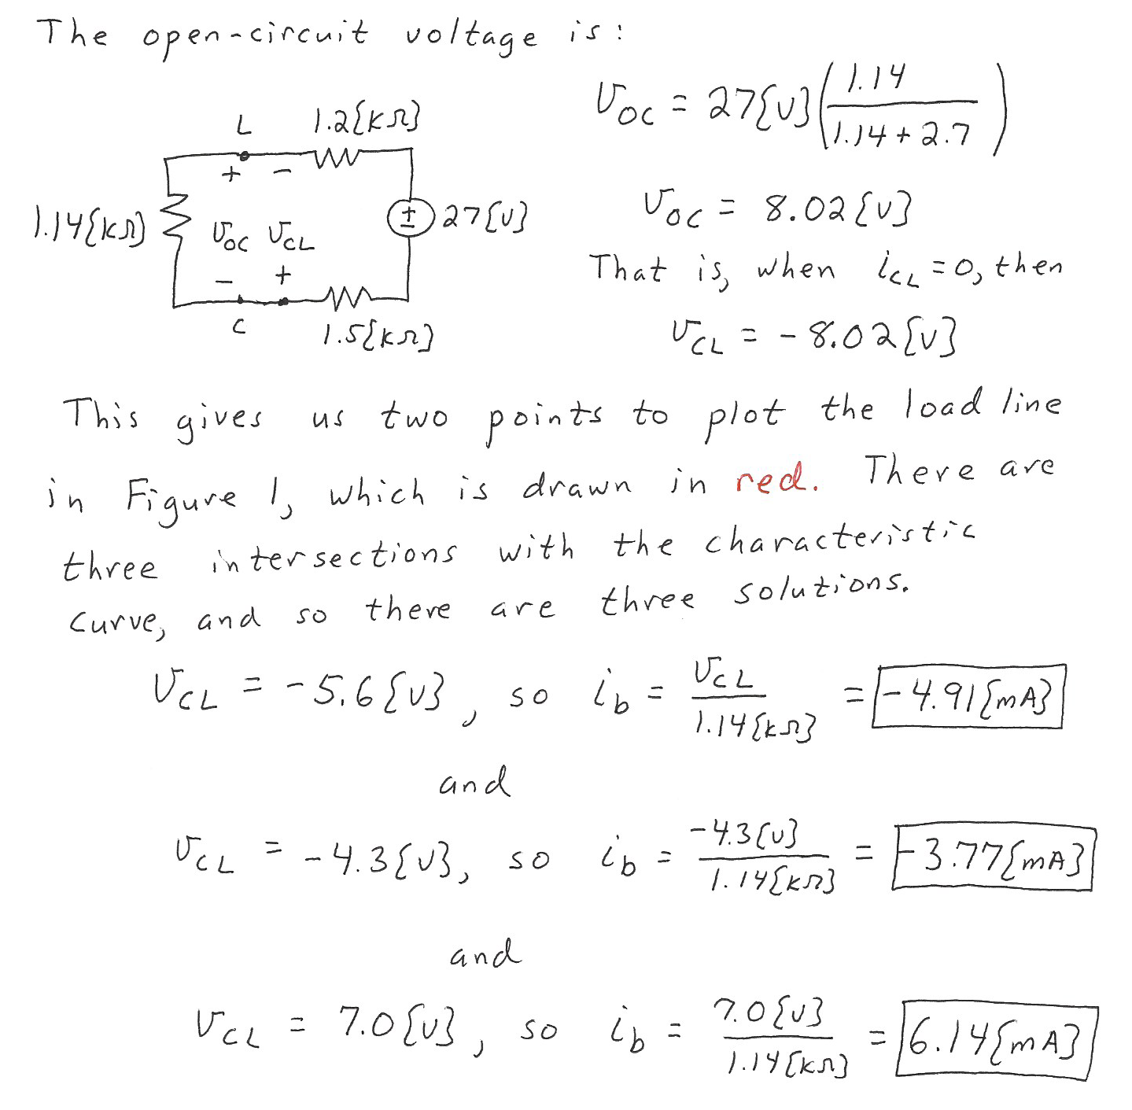

5. {45 Points} Use the circuit shown to solve this problem. Assume that for the transistor, β = 50, and that it is operating at room temperature.
a) Assume for part a) that the transistor is biased into the linear region, with
r_{π} = 300[Ω]. Find the voltage gain v_{o} /v_{i} in the passband, if R_{C} = 3.3[kΩ].
b) Assume for part b) that the transistor is biased into the linear region, with
r_{π} = 300[Ω]. Find the voltage gain v_{o} /v_{i} in the passband, as a function of R_{C}.
c) Find the range of values for R_{C} that will have the transistor biased into the linear region.
