Name: _____________________________ (please print)
Signature: __________________________

ECE 3355 – Exam 1
October 15, 2016

Keep this exam closed until you are told to begin.

1. This exam is closed book, closed notes. You may use one 8.5” x 11” crib sheet, or its equivalent.
2. Show all work on these pages. Show all work necessary to complete the problem. A solution without the appropriate work shown will receive no credit. A solution that is not given in a reasonable order will lose credit. Clearly indicate your answer (for example by enclosing it in a box). If your answer is a plot, no box is needed.
3. It is assumed that your work will begin on the same page as the problem statement. If you choose to begin your work on another page, you must indicate this on the page with the problem statement, with a clear indication of where the work can be found. If your work continues on to another page, indicate clearly where your work can be found. Failure to indicate this clearly will result in a loss of credit.
4. Show all units in solutions, intermediate results, and figures. Units in the exam will be included between square brackets.
5. Do not use red ink. Do not use red pencil.
6. You will have 90 minutes to work on this exam.

1. ________________/20
2. ________________/40
3. ________________/40
Total = 100
Room for extra work
1. {20 Points} By proper choice of the components R₁, C₁, R₂, and C₂, the transfer function of this circuit can be made independent of frequency. In that case the circuit is called a compensated attenuator, and the components R₁ and C₁ can be used as an oscilloscope probe. In this application, the signal from a circuit being viewed on an oscilloscope is attenuated, and the input impedance of the oscilloscope is “compensated” by the probe so that it does not distort the measurement. Assume that in Figure 2, R₁ and C₁ represent the probe, while R₂ and C₂ represent the oscilloscope input. For an oscilloscope with an input
R₂ = 2.2[MΩ] and a probe with R₁ = 8.3[MΩ] , it has been found that when the oscilloscope probe is connected to a square wave, that the image on the oscilloscope screen will be square when C₁ = 46[pF].
a) Find the capacitance of the oscilloscope, C₂.
b) In the lab, we use probes that are called “ten-times probes”. What would you call the probe in this case?

Room for extra work

2. {40 Points} Assume ideal op amps.
a) Find v_{A} as a function of v_{I}.
b) Find v_{B} as a function of v_{I}.
c) Find i_{A} as a function of v_{I}.

Room for extra work

3. {40 Points} The transfer function H(f) for an audio circuit has the straight-line approximation to the magnitude Bode plot shown in Figure 1. The frequency axis in this plot is not drawn to scale. The non-zero slope values are shown.
- Find f₁.
- Find f₂.
- Draw the straight-line approximation to the phase Bode plot on the semi-log graph paper given on the next pages. You are given two sheets, but you only need one of them. Use the values for f₁ and f₂ that you found in parts a) and b). If you did not find those values, use plausible values, and make the plot using those plausible values. Plot using the range
1[mHz] < f < 1[kHz]. Assume that

Solutions:
1. {20 Points} By proper choice of the components R₁, C₁, R₂, and C₂, the transfer function of this circuit can be made independent of frequency. In that case the circuit is called a compensated attenuator, and the components R₁ and C₁ can be used as an oscilloscope probe. In this application, the signal from a circuit being viewed on an oscilloscope is attenuated, and the input impedance of the oscilloscope is “compensated” by the probe so that it does not distort the measurement. Assume that in Figure 2, R₁ and C₁ represent the probe, while R₂ and C₂ represent the oscilloscope input. For an oscilloscope with an input
R₂ = 2.2[MΩ] and a probe with R₁ = 8.3[MΩ] , it has been found that when the oscilloscope probe is connected to a square wave, that the image on the oscilloscope screen will be square when C₁ = 46[pF].
a) Find the capacitance of the oscilloscope, C₂.
b) In the lab, we use probes that are called “ten-times probes”. What would you call the probe in this case?
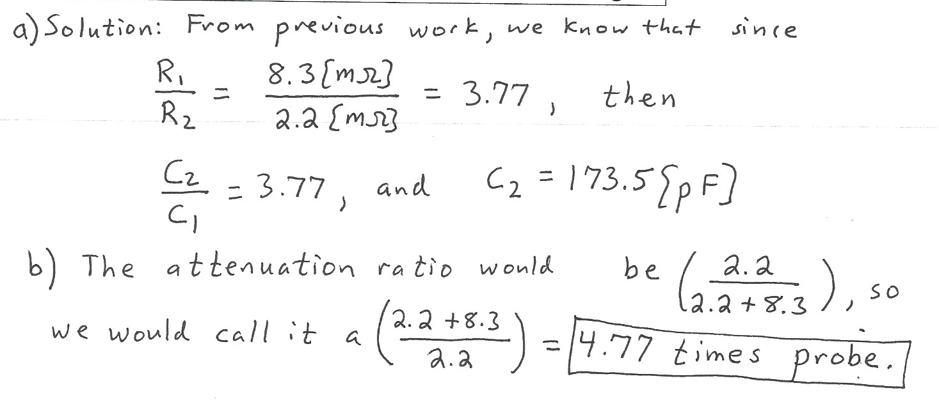

2. {40 Points} Assume ideal op amps.
a) Find v_{A} as a function of v_{I}.
b) Find v_{B} as a function of v_{I}.
c) Find i_{A} as a function of v_{I}.
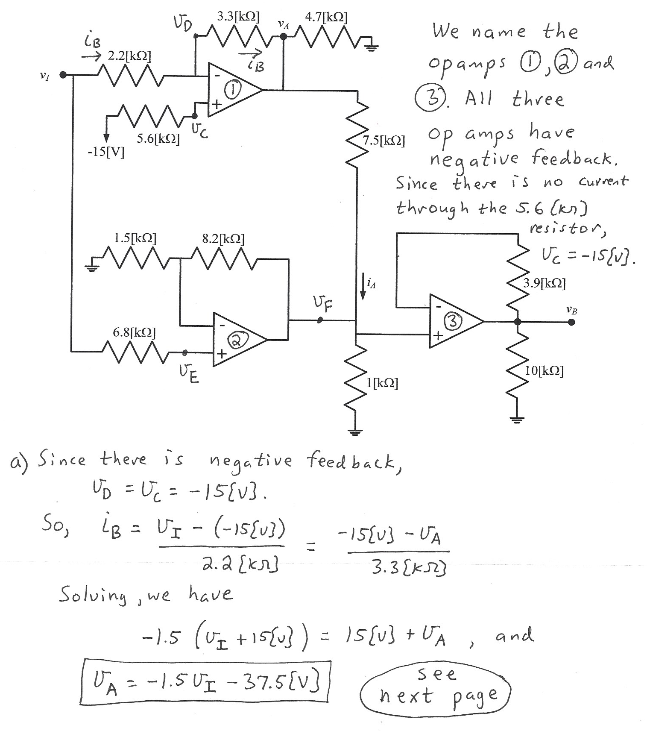
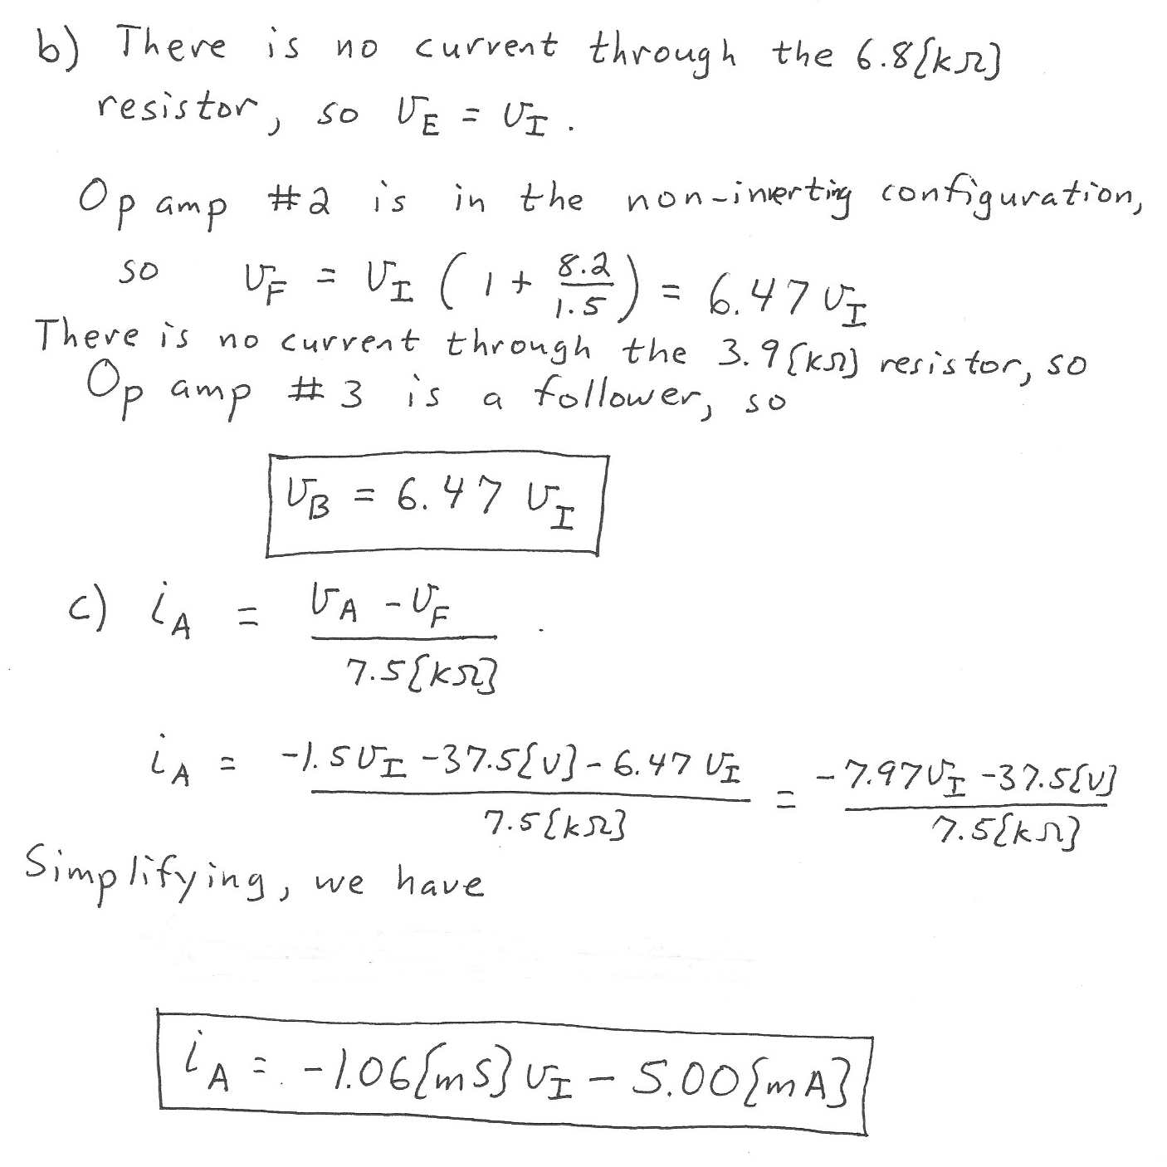

3. {40 Points} The transfer function H(f) for an audio circuit has the straight-line approximation to the magnitude Bode plot shown in Figure 1. The frequency axis in this plot is not drawn to scale. The non-zero slope values are shown.
- Find f₁.
- Find f₂.
- Draw the straight-line approximation to the phase Bode plot on the semi-log graph paper given on the next pages. You are given two sheets, but you only need one of them. Use the values for f₁ and f₂ that you found in parts a) and b). If you did not find those values, use plausible values, and make the plot using those plausible values. Plot using the range
1[mHz] < f < 1[kHz]. Assume that
