Name: _____________________________ (please print)

Signature: __________________________

ECE 3355 – Final Exam

December 7, 2016

Keep this exam closed until you are told to begin.

1. This exam is closed book, closed notes. You may use one 8.5” x 11” crib sheet, or its equivalent.

2. Show all work on these pages. Show all work necessary to complete the problem. A solution without the appropriate work shown will receive no credit. A solution that is not given in a reasonable order will lose credit. Clearly indicate your answer (for example by enclosing it in a box). If your answer is a plot, no box is needed.

3. It is assumed that your work will begin on the same page as the problem statement. If you choose to begin your work on another page, you must indicate this on the page with the problem statement, with a clear indication of where the work can be found. **If your work continues on to another page, indicate clearly where your work can be found. Failure to indicate this clearly will result in a loss of credit.**

4. Show all units in solutions, intermediate results, and figures. Units in the exam will be included between square brackets.

5. Do not use red ink. Do not use red pencil.

6. You will have 170 minutes to work on this exam.

1. ________________/25

2. ________________/40

3. ________________/40

4. ________________/50

5. ________________/45

Total = 200

Room for extra work

1. {25 Points} An oscilloscope probe has been designed, and is made up of a 9[M] resistor in parallel with a 37[mH] inductor. When used with a particular oscilloscope, this probe turns out to be a “ten-times probe”, which correctly displays square waves on the oscilloscope screen.

a) Find the input impedance of this particular oscilloscope, as a function of the angular frequency, **.

b) Find the input impedance of the probe and oscilloscope combination, at 40[MHz].

Room for extra work

2. {40 Points} An amplifier has a transfer characteristic that can be reasonably approximated by the following set of expressions:



a) Sketch this transfer characteristic.

b) Assume that *VS* = 9.4[V] and *vs* = -0.3[V]sin(60[rad/s]*t*) in Figure 1. For this signal level and dc bias value, what is the gain, *Av*, where



c) Again, assume that *VS* = 9.4[V] and *vs* = -0.3[V]sin(60[rad/s]*t*) in Figure 1. Find an expression for *io(t)*.

d) Again, assume that *VS* = 9.4[V] in Figure 1. What are the largest values for *vs* that will yield an undistorted output? Assume that *vs* is a zero-mean sinusoid.

Figure 1

Room for extra work

3. {40 Points} Assume ideal op amps.

a) Find the input resistance for signals, as seen by the signal source *va(t)*.

b) Find *vE(t)*, given that



c) Find *vB(t)*, given that





# Room for extra work

4. {50 Points} The characteristic curve for the device, called a Hermannoid, is shown in Figure 1. The device schematic symbol is shown in Figure 2. The device is placed in the circuit in Figure 3.

1. Find a test that could be used with the “guess and test method” to determine whether the device is actually biased into Region A.
2. Find a model that could be used with the “guess and test method” to replace the device when it is biased into Region B.
3. When the device is placed in Figure 3, find the value of *vX*.
4. Assume that the device is placed in the circuit in Figure 3, and then a small signal is applied by modulating the value of the voltage source around 12.8[V]. Find the small signal model for the device that would be appropriate in this case.



 

Room for extra work

Room for extra work

5. {45 Points} Use the circuit shown to solve this problem. Assume that for the transistor, * * = 200, and that it is operating at room temperature.

a) Find the value of *va(t)* in the passband, as a function of *vi(t)*.

b) Find the output resistance in the passband, as seen by the capacitor *C2*.

c) Assume for this part of the problem that *C1* is large enough so that its effects can be neglected. Assume that there are noise sources in *vi(t)* that are at frequencies above 200[kHz]. Find the value of *C2* that will reduce the gain by at least 20[dB] for frequencies above 200[kHz].



SOLUTIONS

1. {25 Points} An oscilloscope probe has been designed, and is made up of a 9[M] resistor in parallel with a 37[mH] inductor. When used with a particular oscilloscope, this probe turns out to be a “ten-times probe”, which correctly displays square waves on the oscilloscope screen.

a) Find the input impedance of this particular oscilloscope, as a function of the angular frequency, **.

b) Find the input impedance of the probe and oscilloscope combination, at 40[MHz].

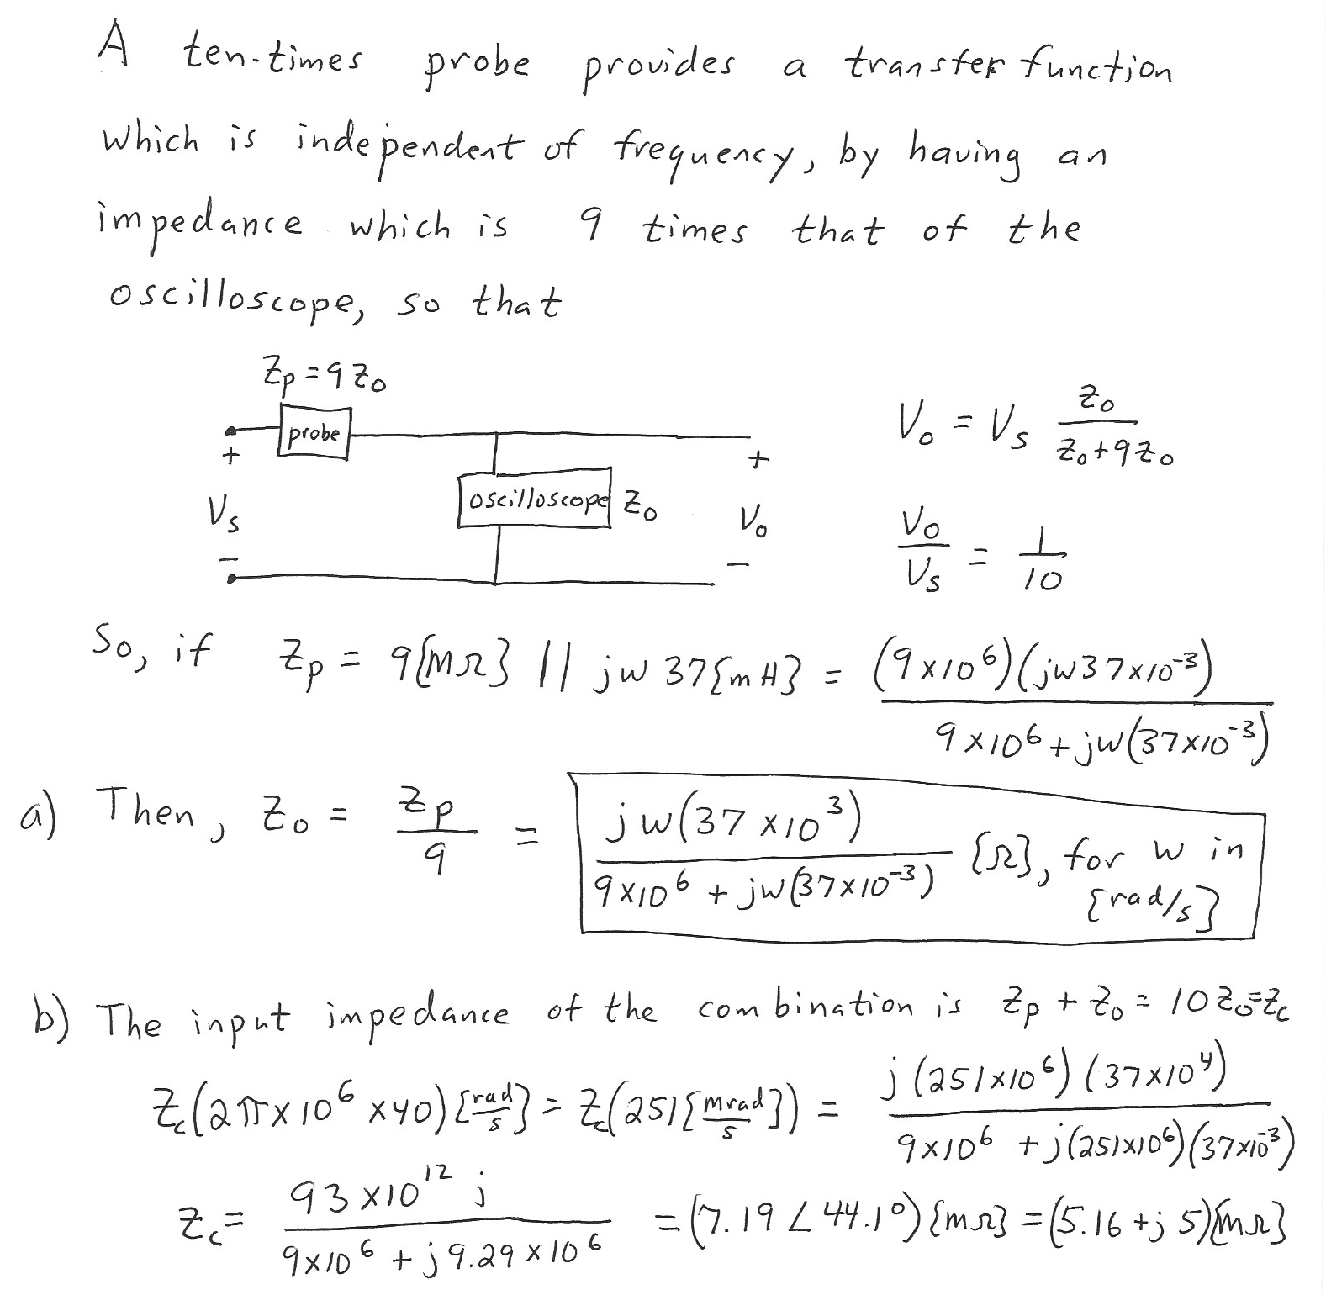

2. {40 Points} An amplifier has a transfer characteristic that can be reasonably approximated by the following set of expressions:



a) Sketch this transfer characteristic.

b) Assume that *VS* = 9.4[V] and *vs* = -0.3[V]sin(60[rad/s]*t*) in Figure 1. For this signal level and dc bias value, what is the gain, *Av*, where



c) Again, assume that *VS* = 9.4[V] and *vs* = -0.3[V]sin(60[rad/s]*t*) in Figure 1. Find an expression for *io(t)*.

d) Again, assume that *VS* = 9.4[V] in Figure 1. What are the largest values for *vs* that will yield an undistorted output? Assume that *vs* is a zero-mean sinusoid.



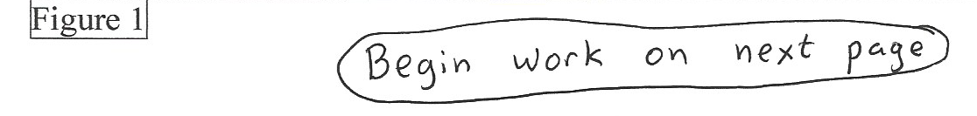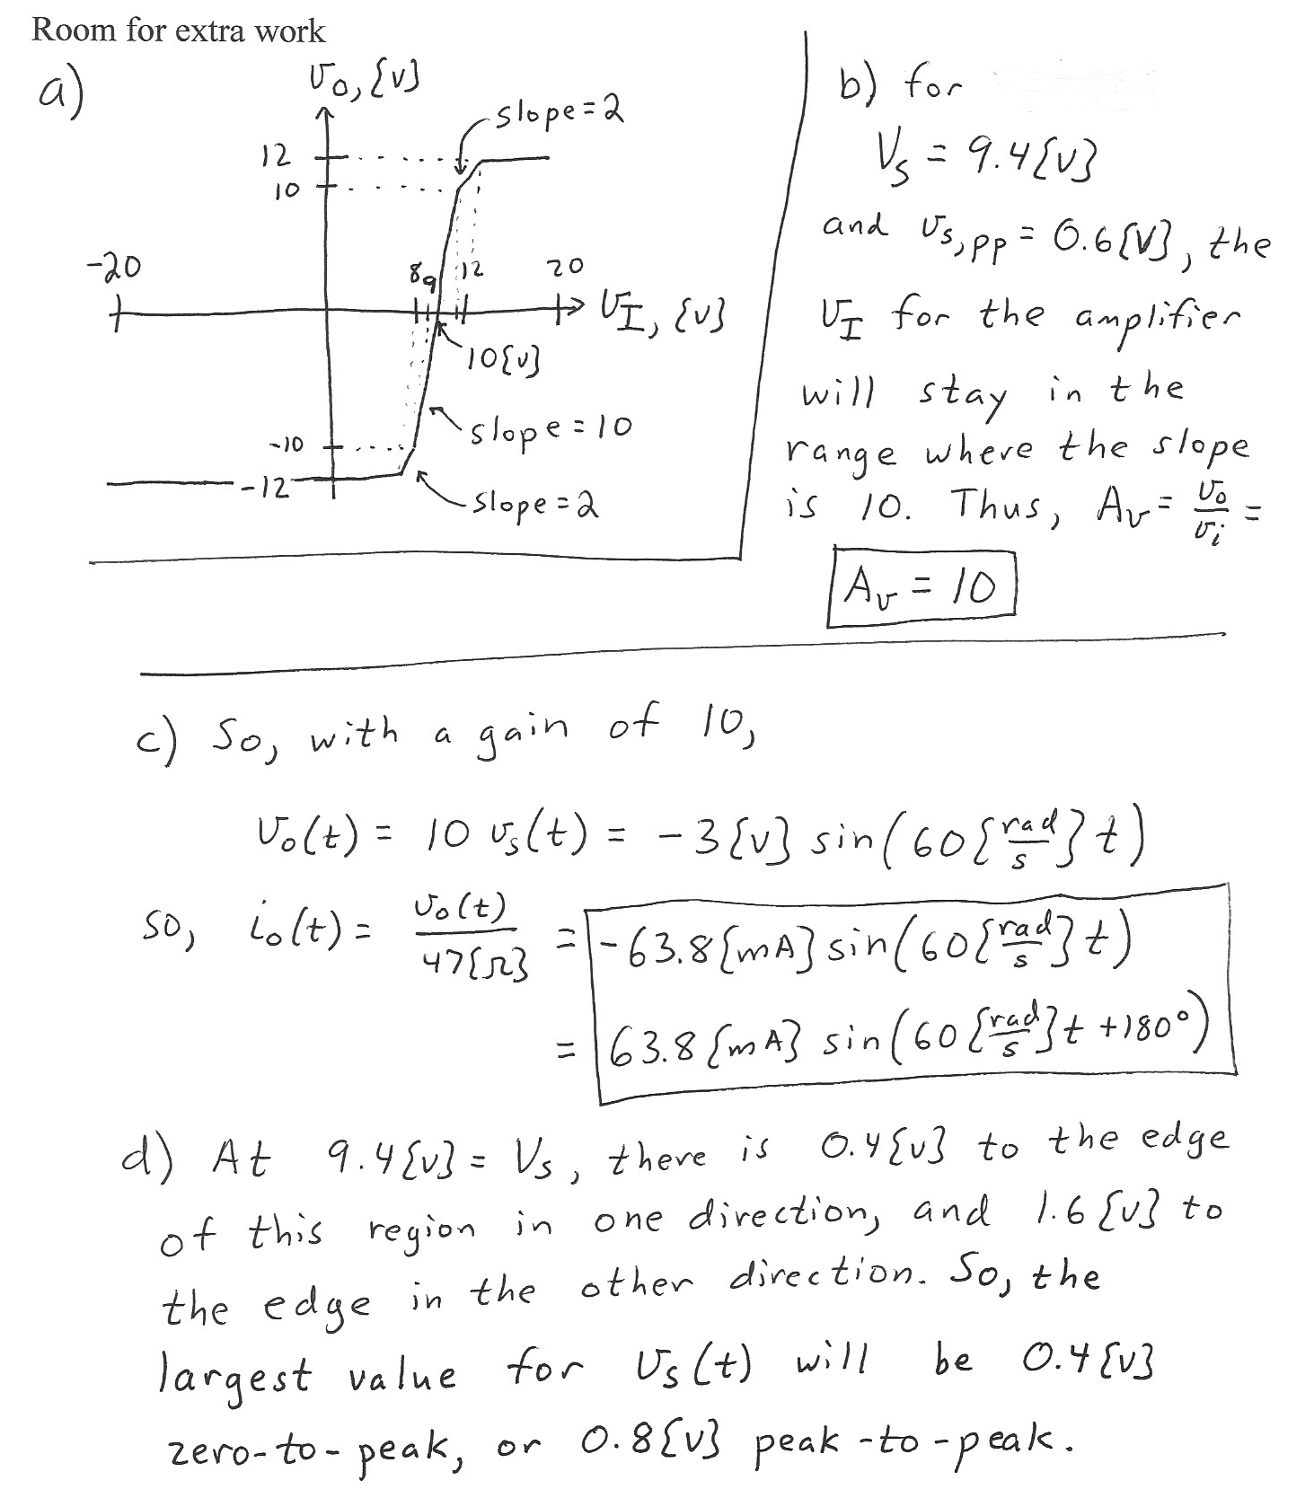

3. {40 Points} Assume ideal op amps.

a) Find the input resistance for signals, as seen by the signal source *va(t)*.

b) Find *vE(t)*, given that



c) Find *vB(t)*, given that



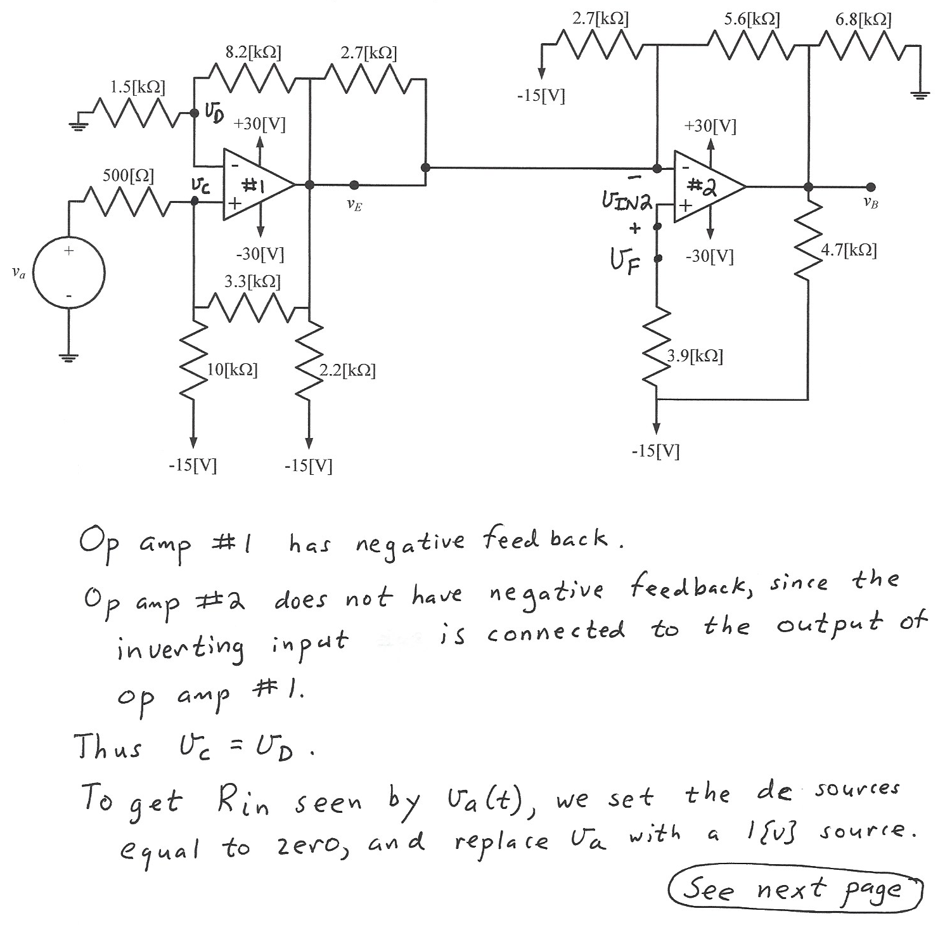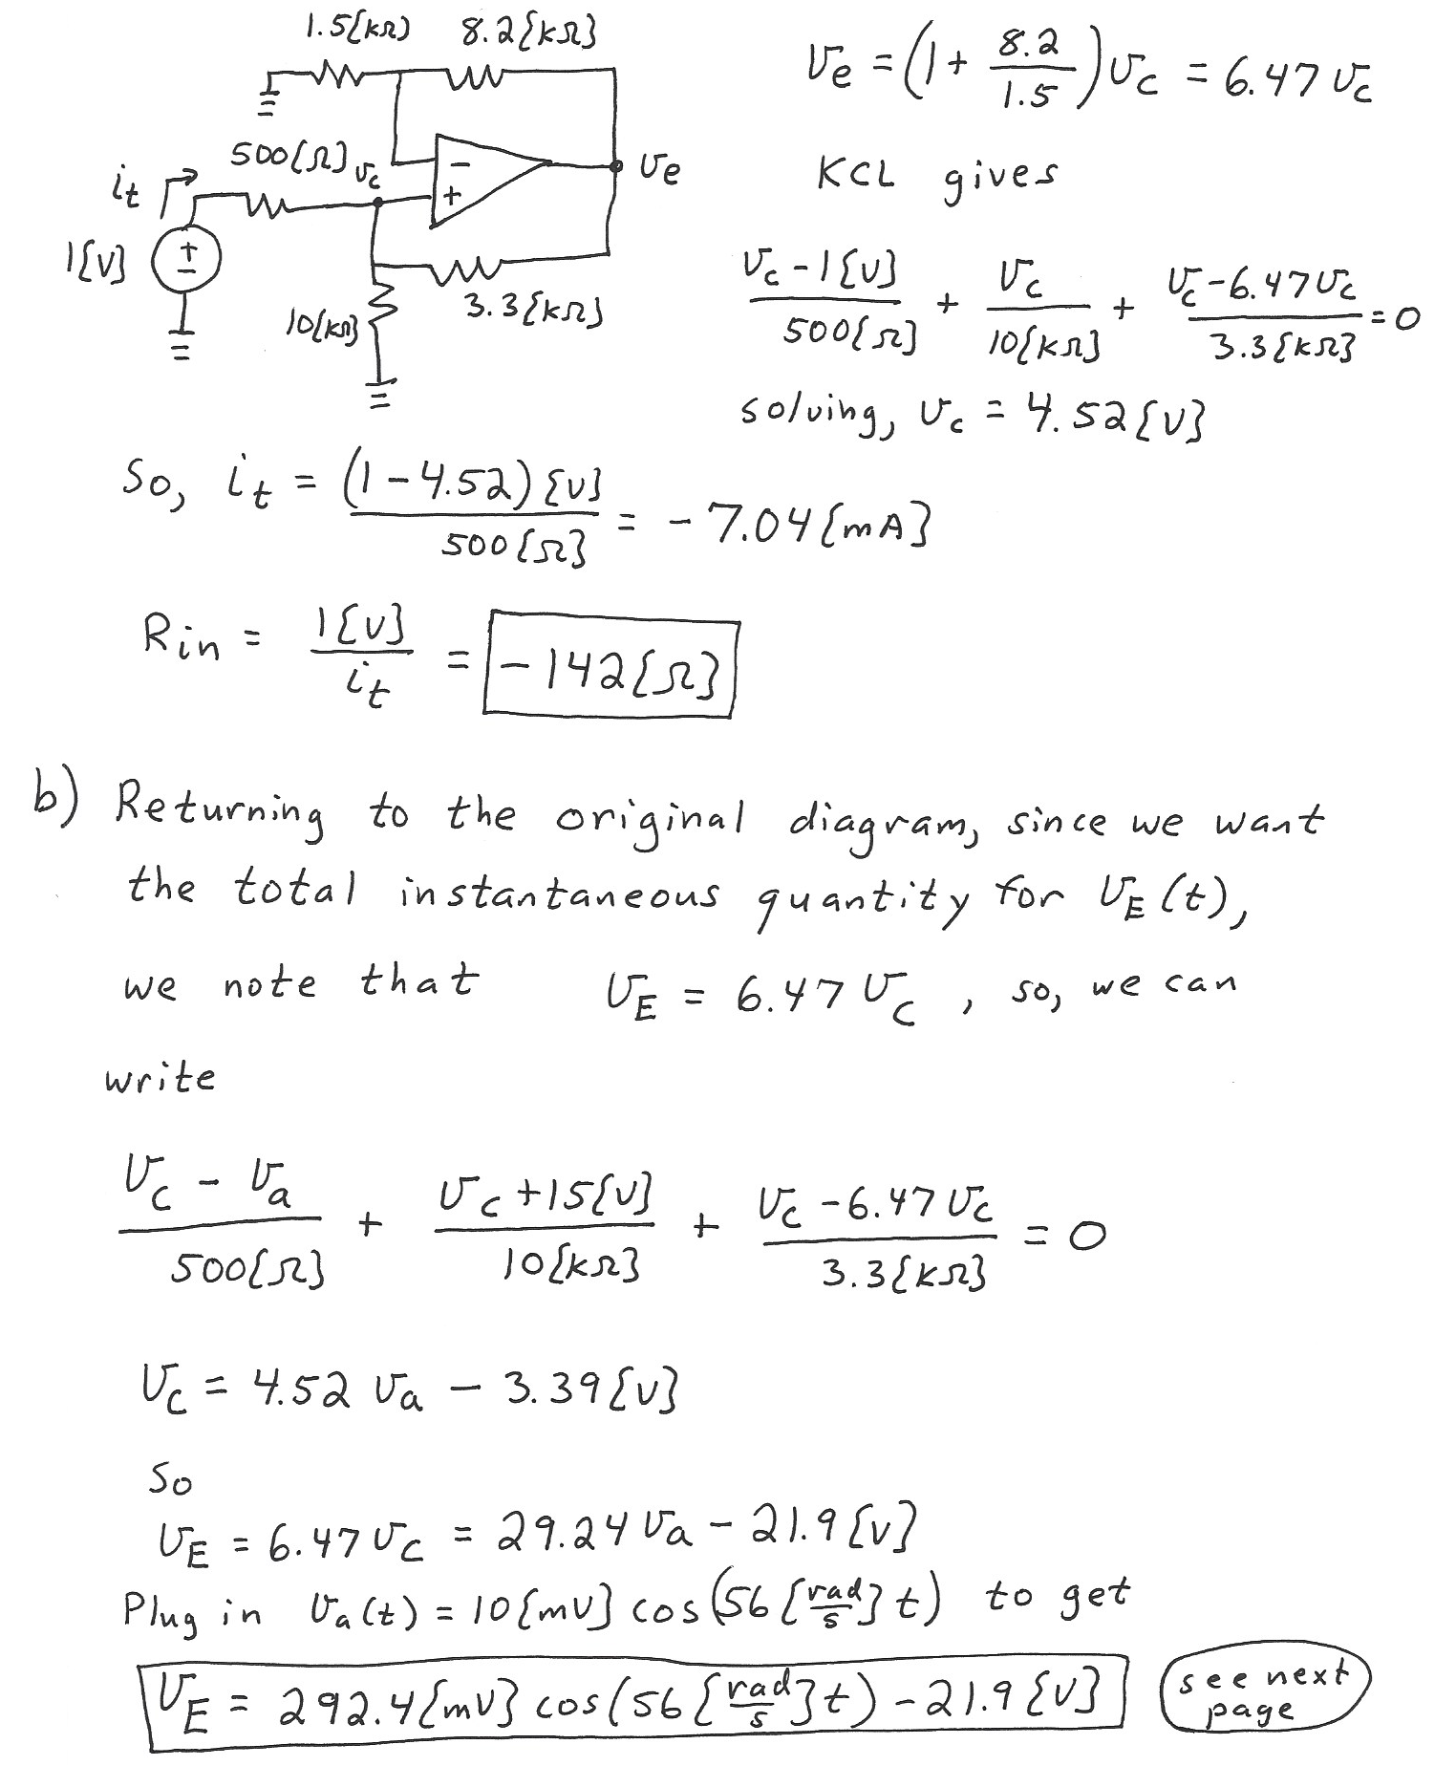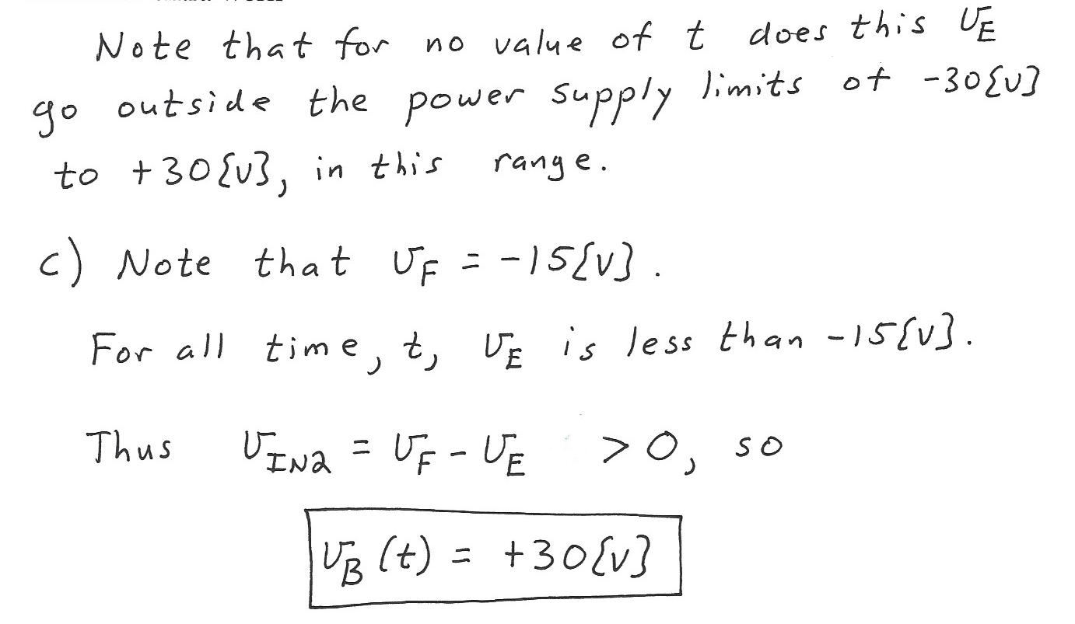

# 4. {50 Points} The characteristic curve for the device, called a Hermannoid, is shown in Figure 1. The device schematic symbol is shown in Figure 2. The device is placed in the circuit in Figure 3.

1. Find a test that could be used with the “guess and test method” to determine whether the device is actually biased into Region A.
2. Find a model that could be used with the “guess and test method” to replace the device when it is biased into Region B.
3. When the device is placed in Figure 3, find the value of *vX*.
4. Assume that the device is placed in the circuit in Figure 3, and then a small signal is applied by modulating the value of the voltage source around 12.8[V]. Find the small signal model for the device that would be appropriate in this case.

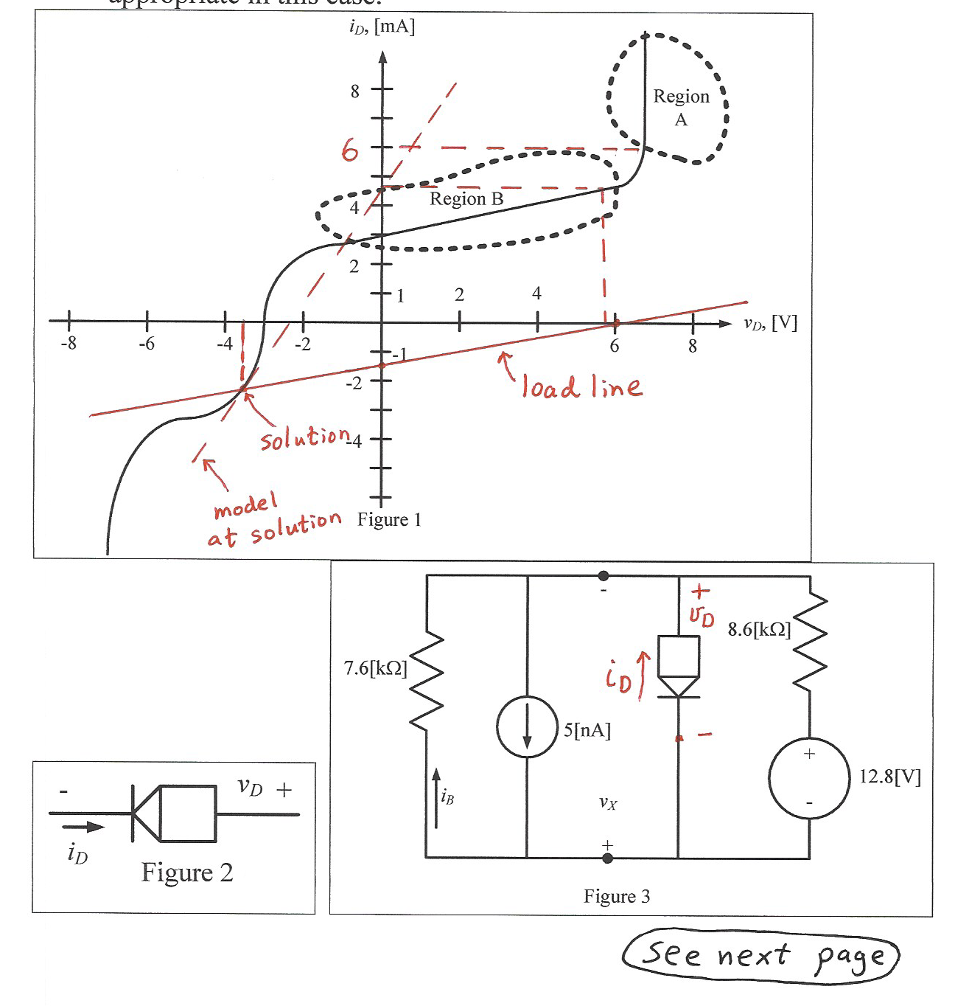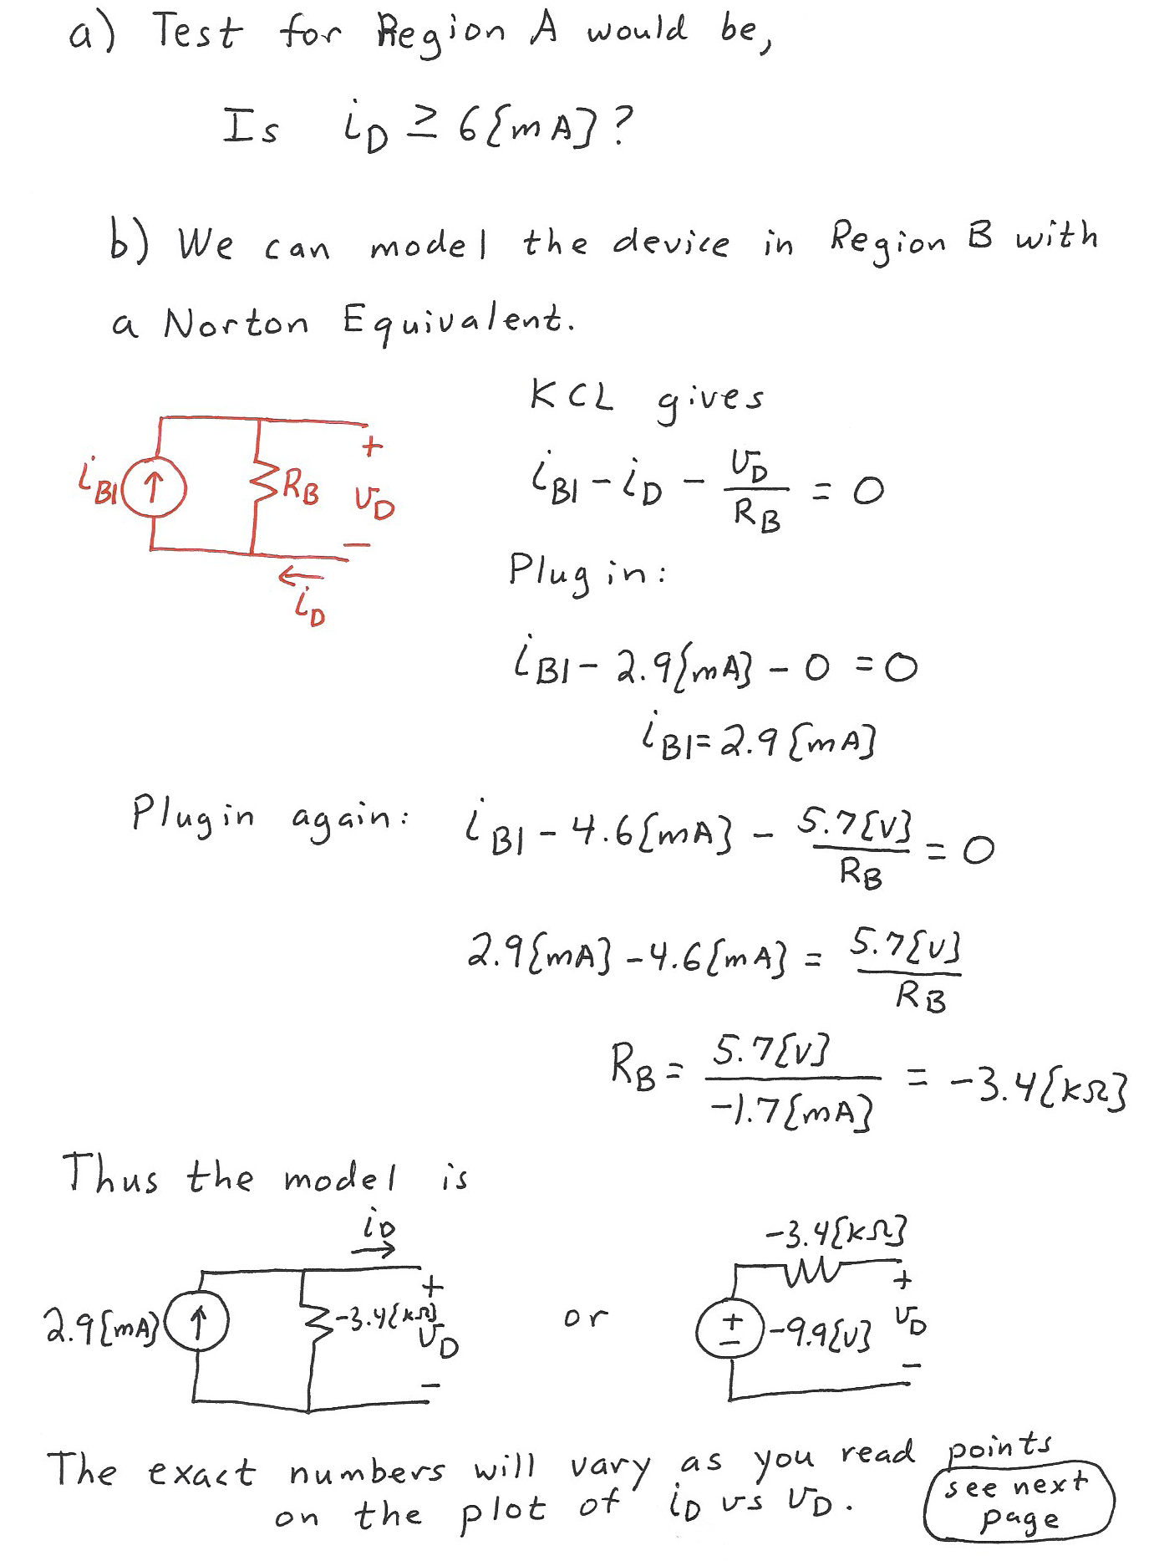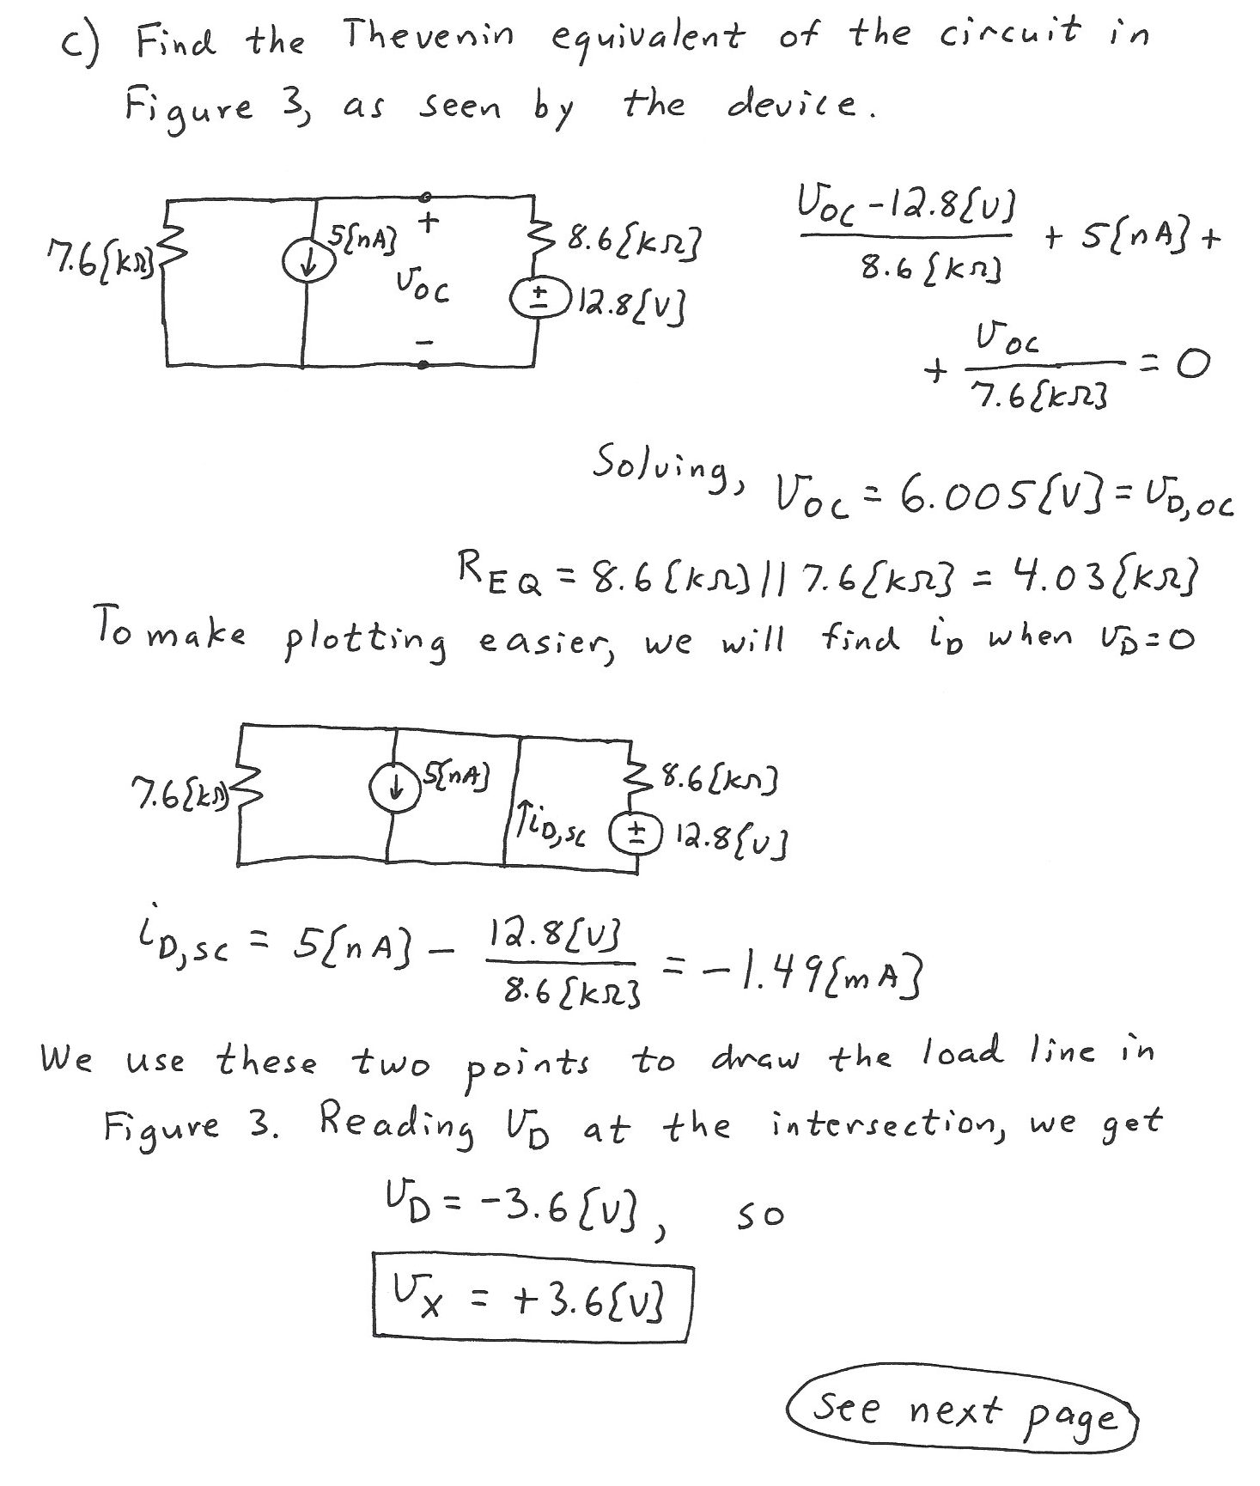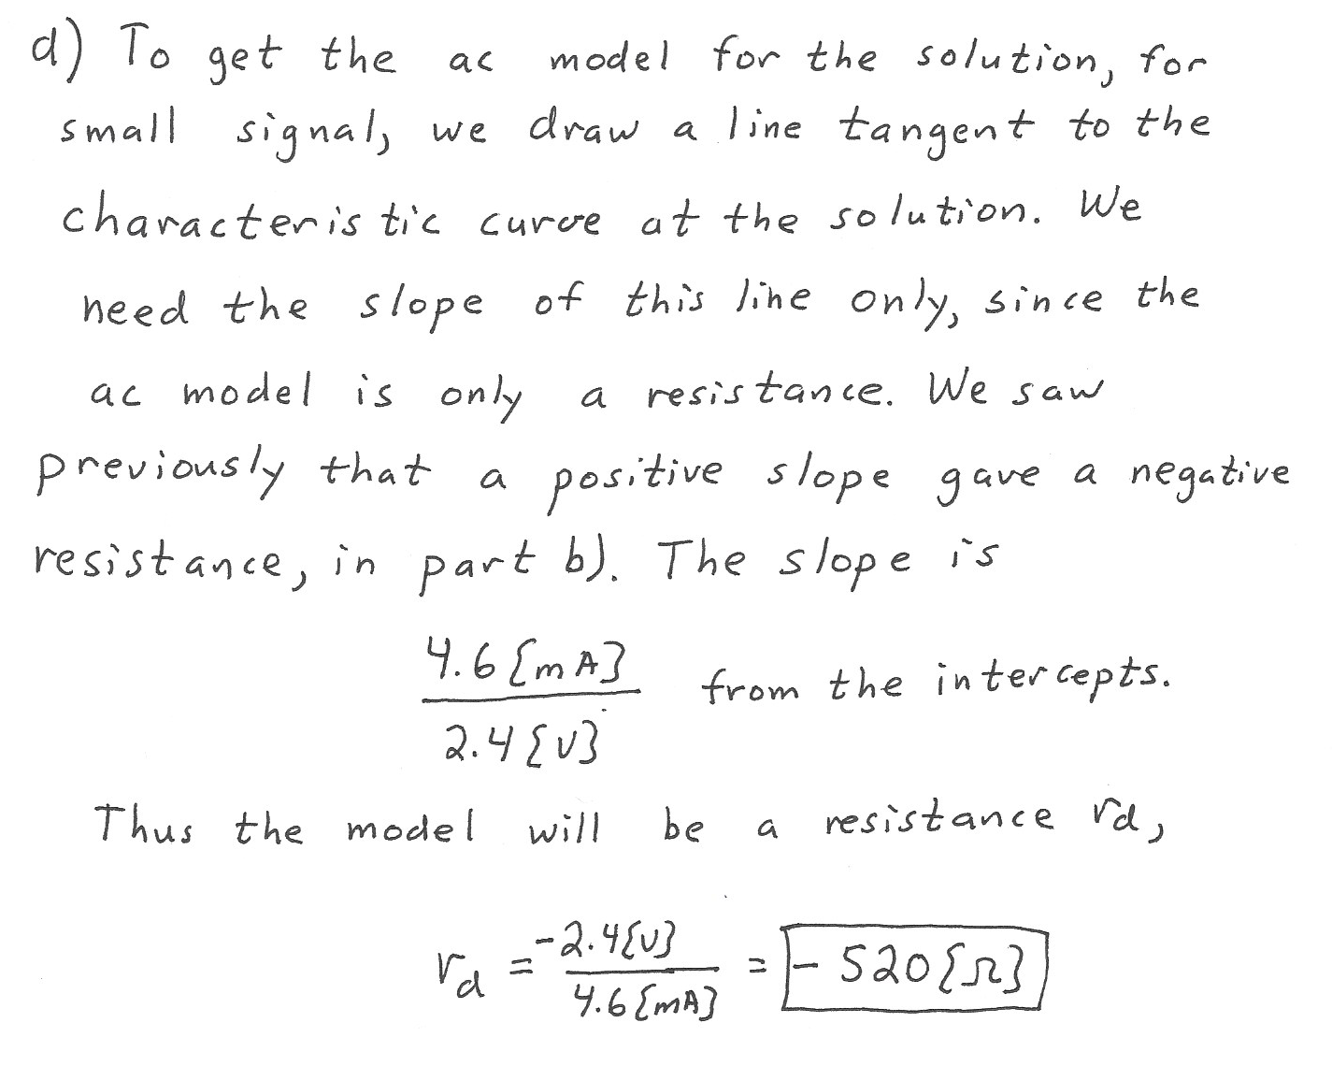

5. {45 Points} Use the circuit shown to solve this problem. Assume that for the transistor, * * = 200, and that it is operating at room temperature.

a) Find the value of *va(t)* in the passband, as a function of *vi(t)*.

b) Find the output resistance in the passband, as seen by the capacitor *C2*.

c) Assume for this part of the problem that *C1* is large enough so that its effects can be neglected. Assume that there are noise sources in *vi(t)* that are at frequencies above 200[kHz]. Find the value of *C2* that will reduce the gain by at least 20[dB] for frequencies above 200[kHz].



