Name: _____________________________ (please print)
Signature: __________________________

ECE 3455 Electronics
Final Exam – May 5, 1999

DO NOT OPEN THIS QUIZ BOOKLET UNTIL YOU ARE TOLD TO BEGIN

1. This quiz is open book and open notes. Any calculator may be used.
2. You will have 180 minutes to complete this exam.
3. Show all work on these pages. Show all work necessary to complete the problem, in order. If your work goes on to another page, indicate this with a note. A solution without the work shown will receive no credit.
4. Use appropriate notation.
5. Show units in all answers and in all major intermediate results. Units in the exam questions will be enclosed in square brackets.
6. Do not use red ink. Do not use red pencil.
7. There are 110 possible points on this exam. Earn as many points as possible.

1) ______________/25
2) ______________/20
3) ______________/20
4) ______________/20
5) ______________/25

1) (25 Points) Assume that the transistor in the amplifier shown below operates at room temperature with a β = 300. In each step of this problem, state your assumptions and test them, showing your tests where appropriate.
a) Find the input resistance seen by the source, in the passband.
b) Find the transfer function
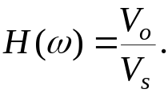
c) Sketch the straight-line approximation to the magnitude Bode plot for this transfer function. Use the axes on the next page.
d) What is the passband for this amplifier?
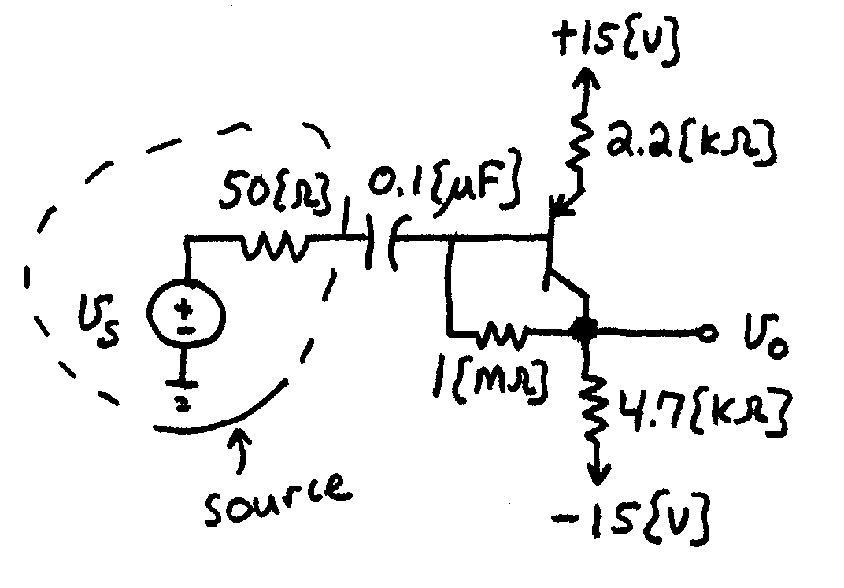

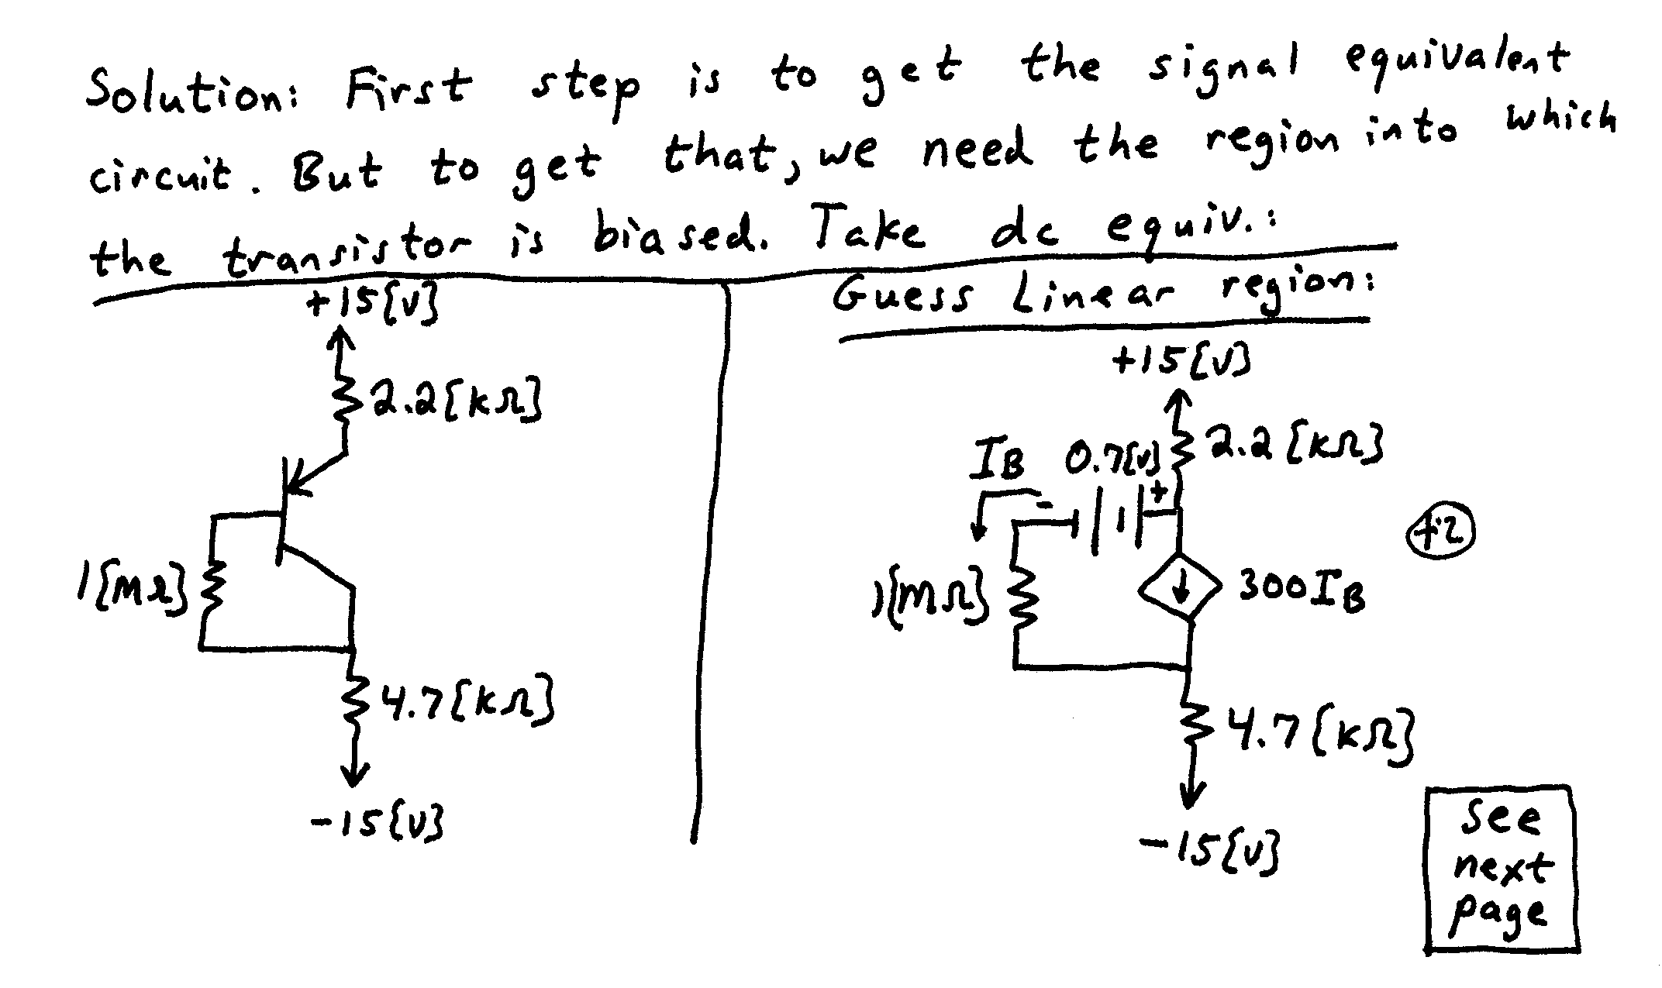
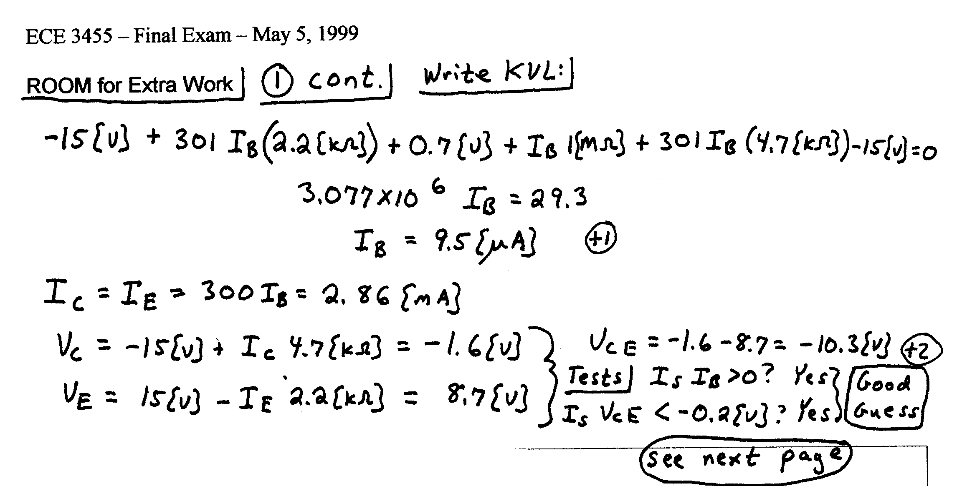


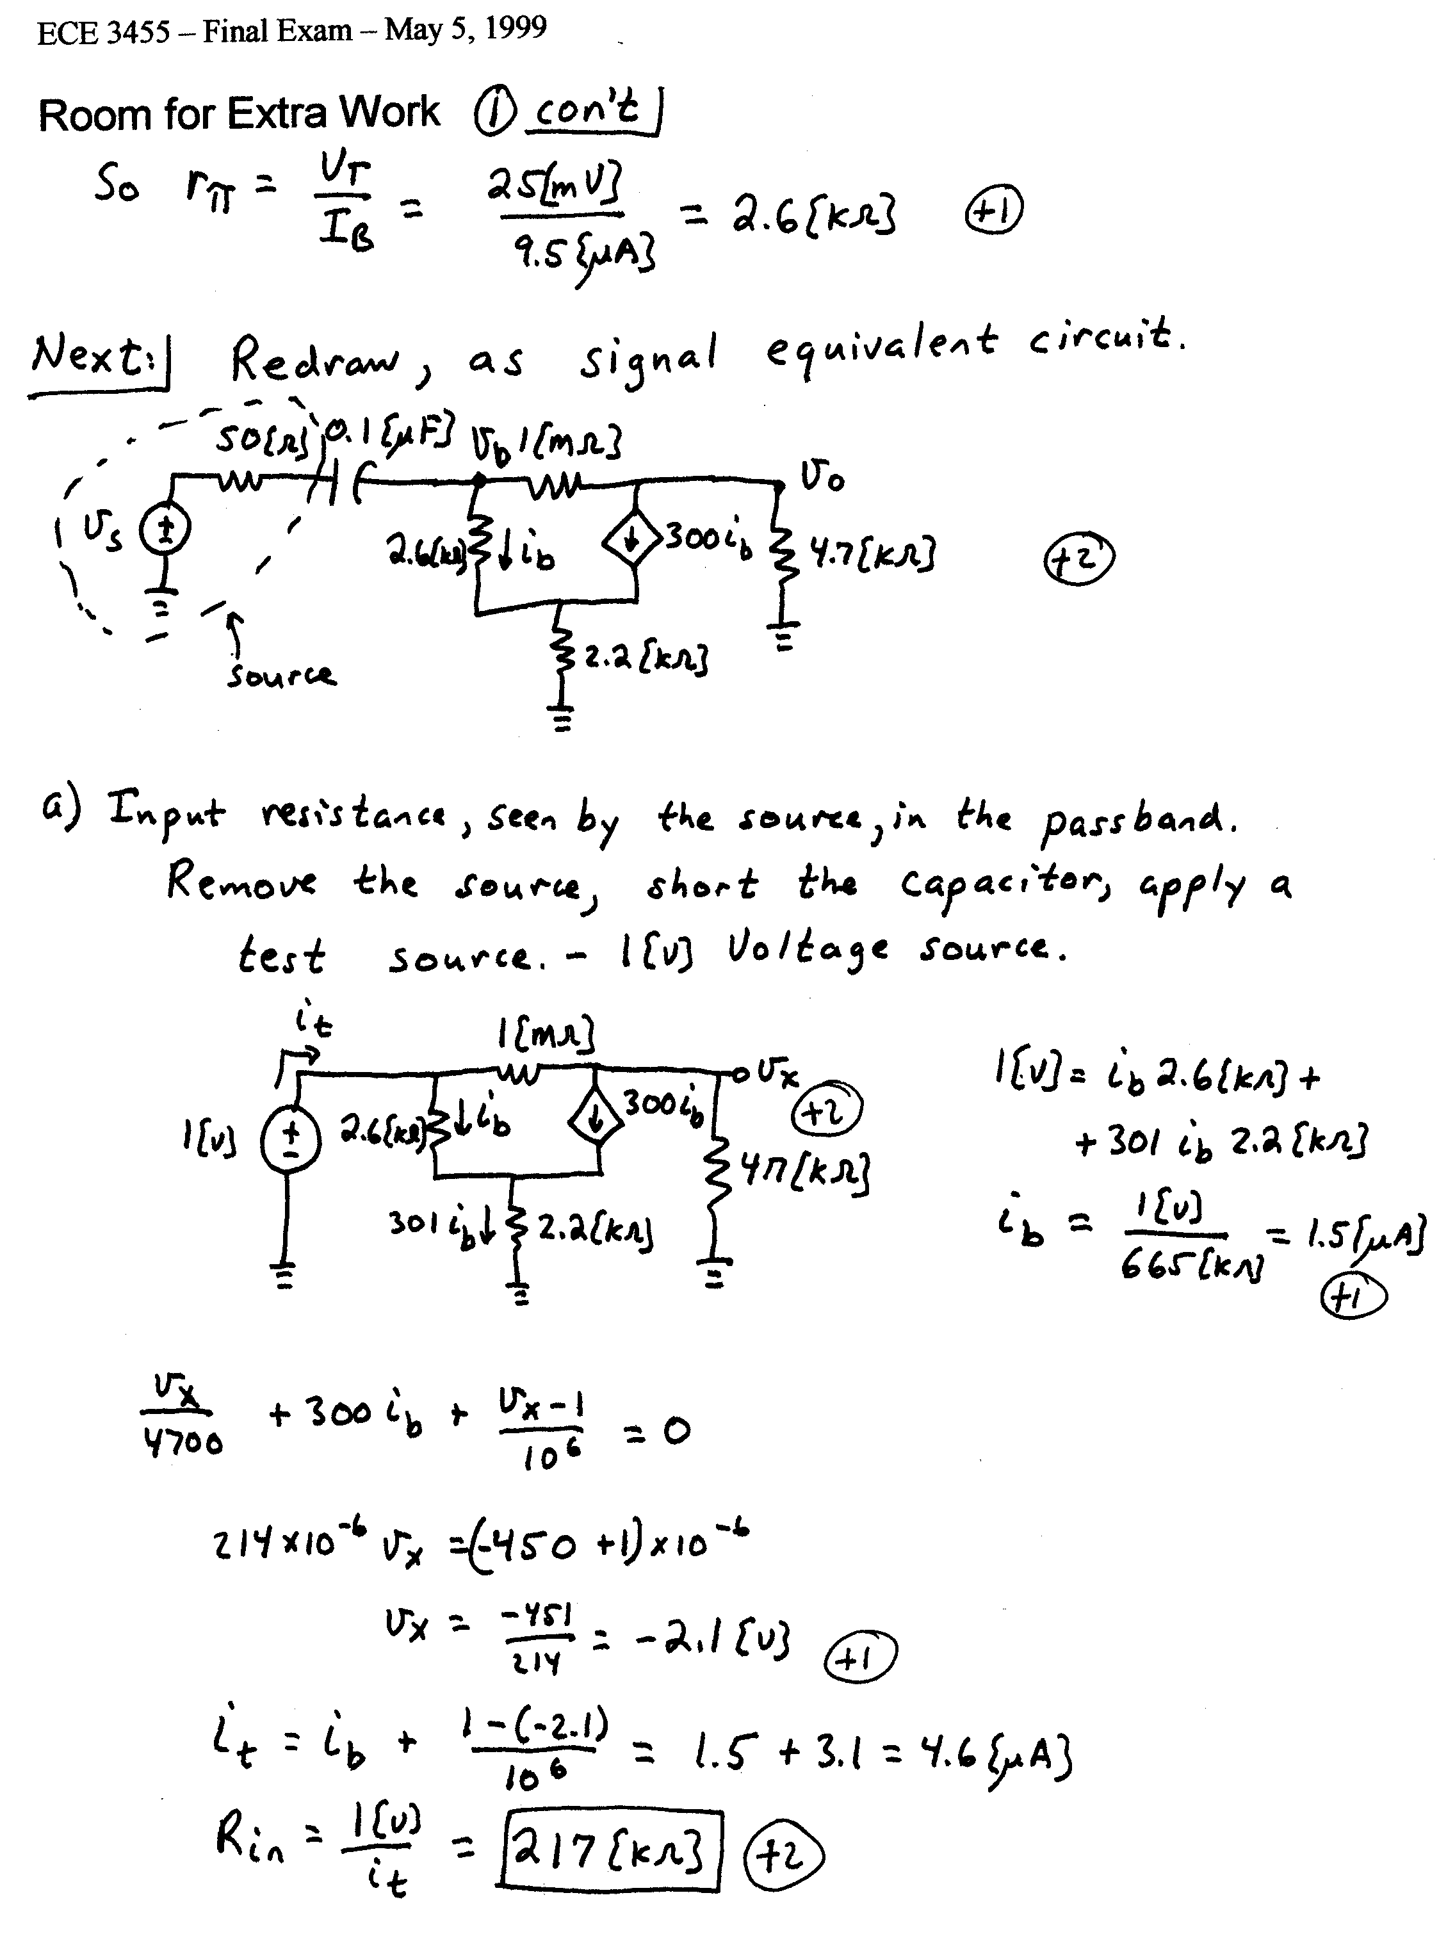
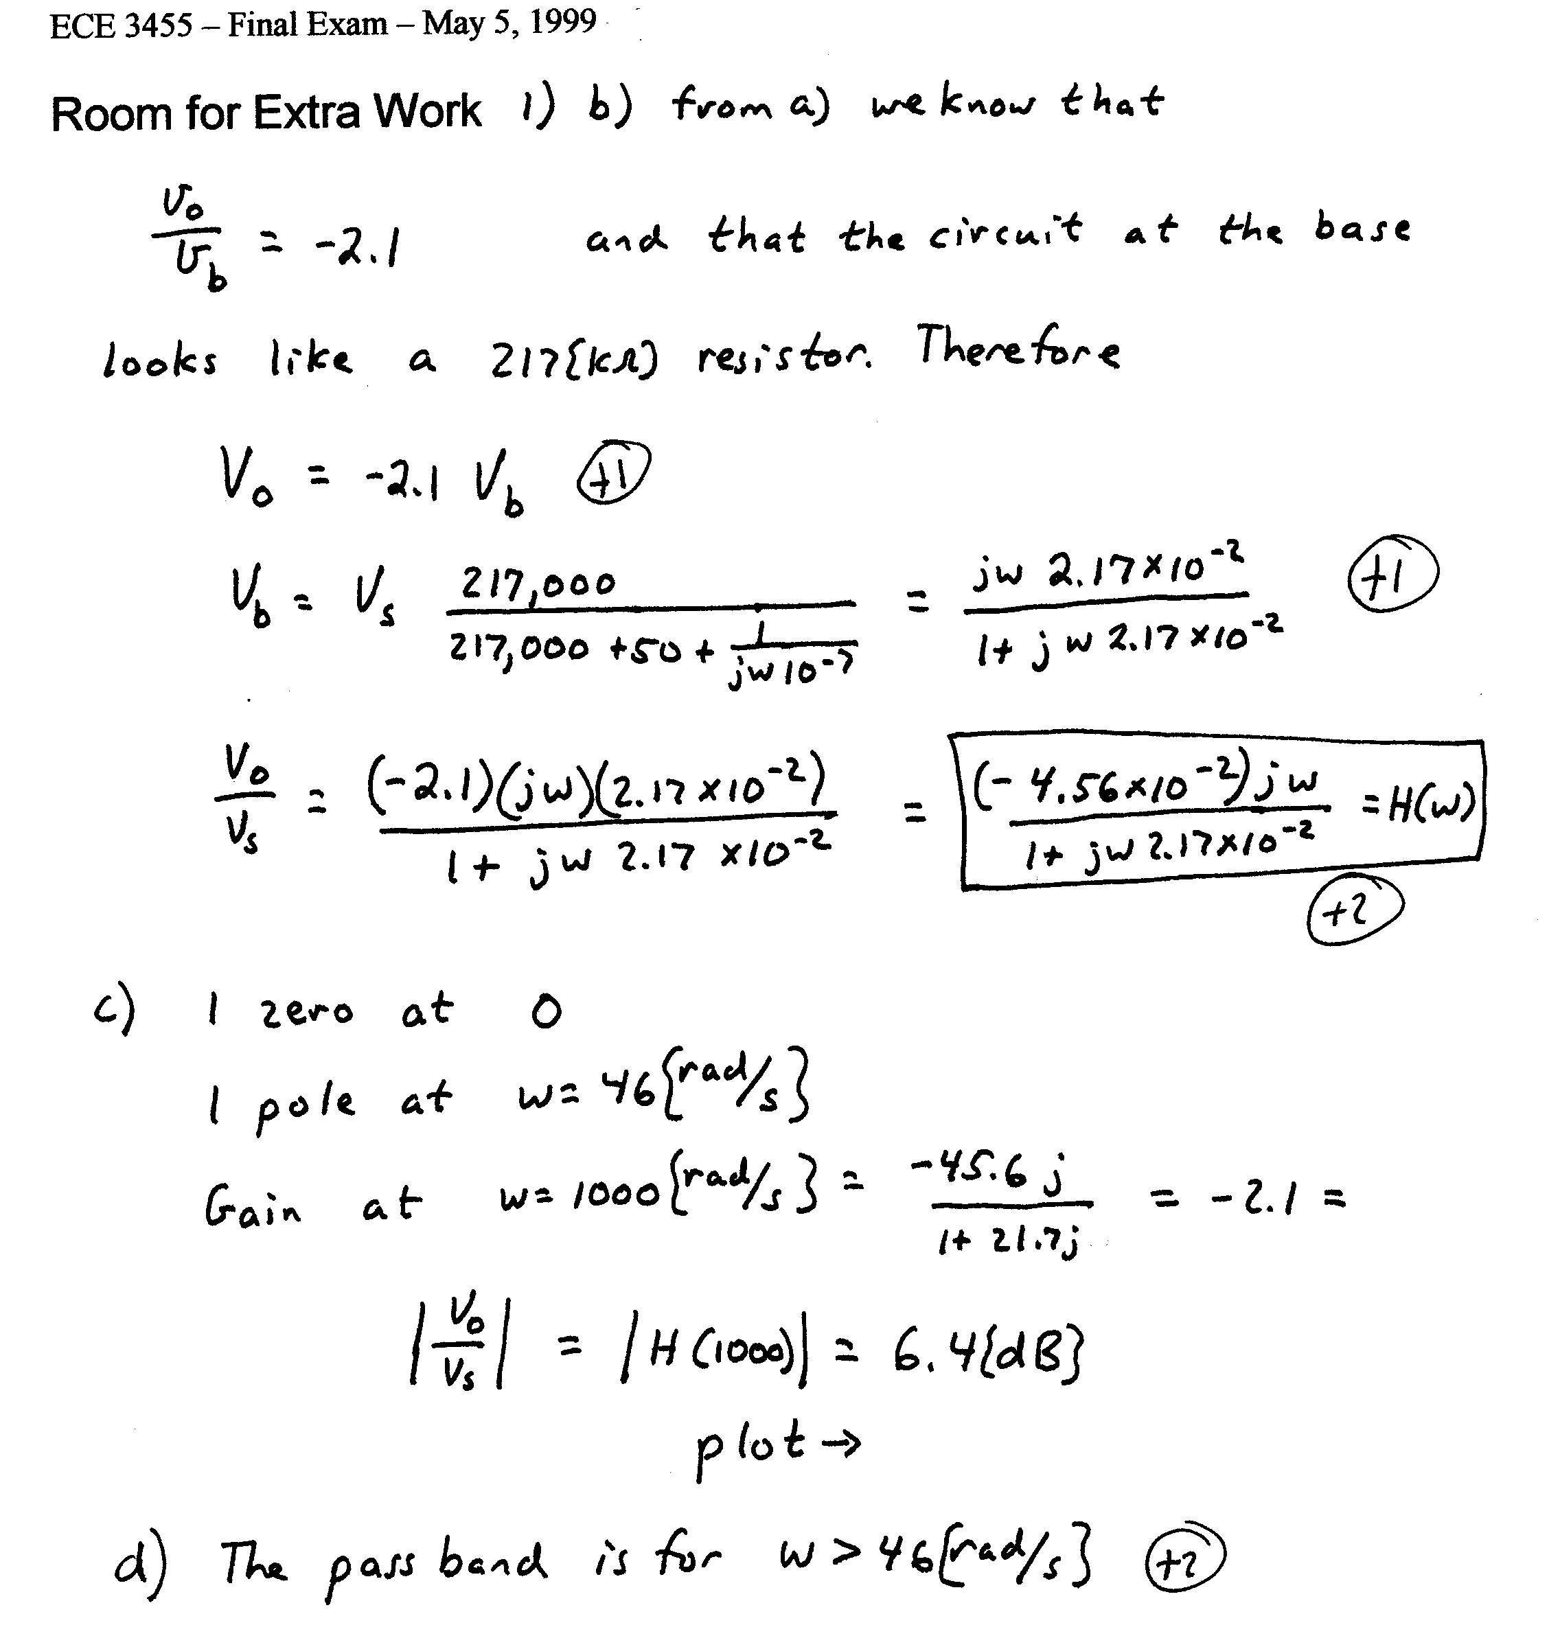
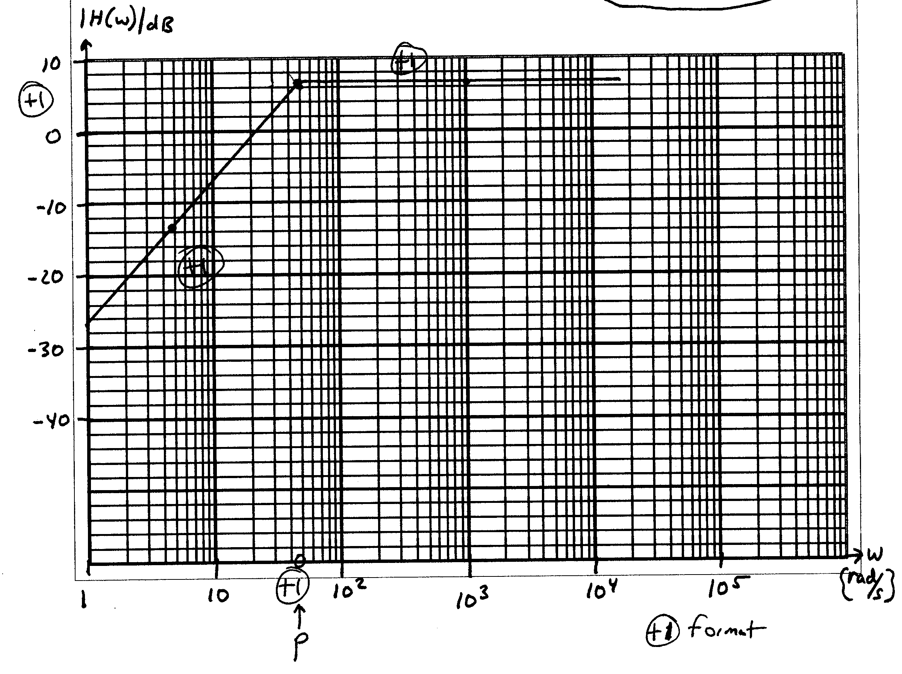

2. (20 Points) Design a circuit that will generate a 5[V] peak-to-peak square wave with a repetition frequency of 2[kHz]. The average value of the waveform should be 2.5[V]. In other words, the waveform should switch between zero and 5[V]. Use as many ideal op amps, resistors, capacitors and inductors as you wish. If you use diodes, model them with the piecewise linear model with V_{f} = 0.7[V], r_{d} = 0, and I_{s} = 0. Use only +15[V] and-15[V] dc power supplies as inputs. No other components may be used. Show your design equations.
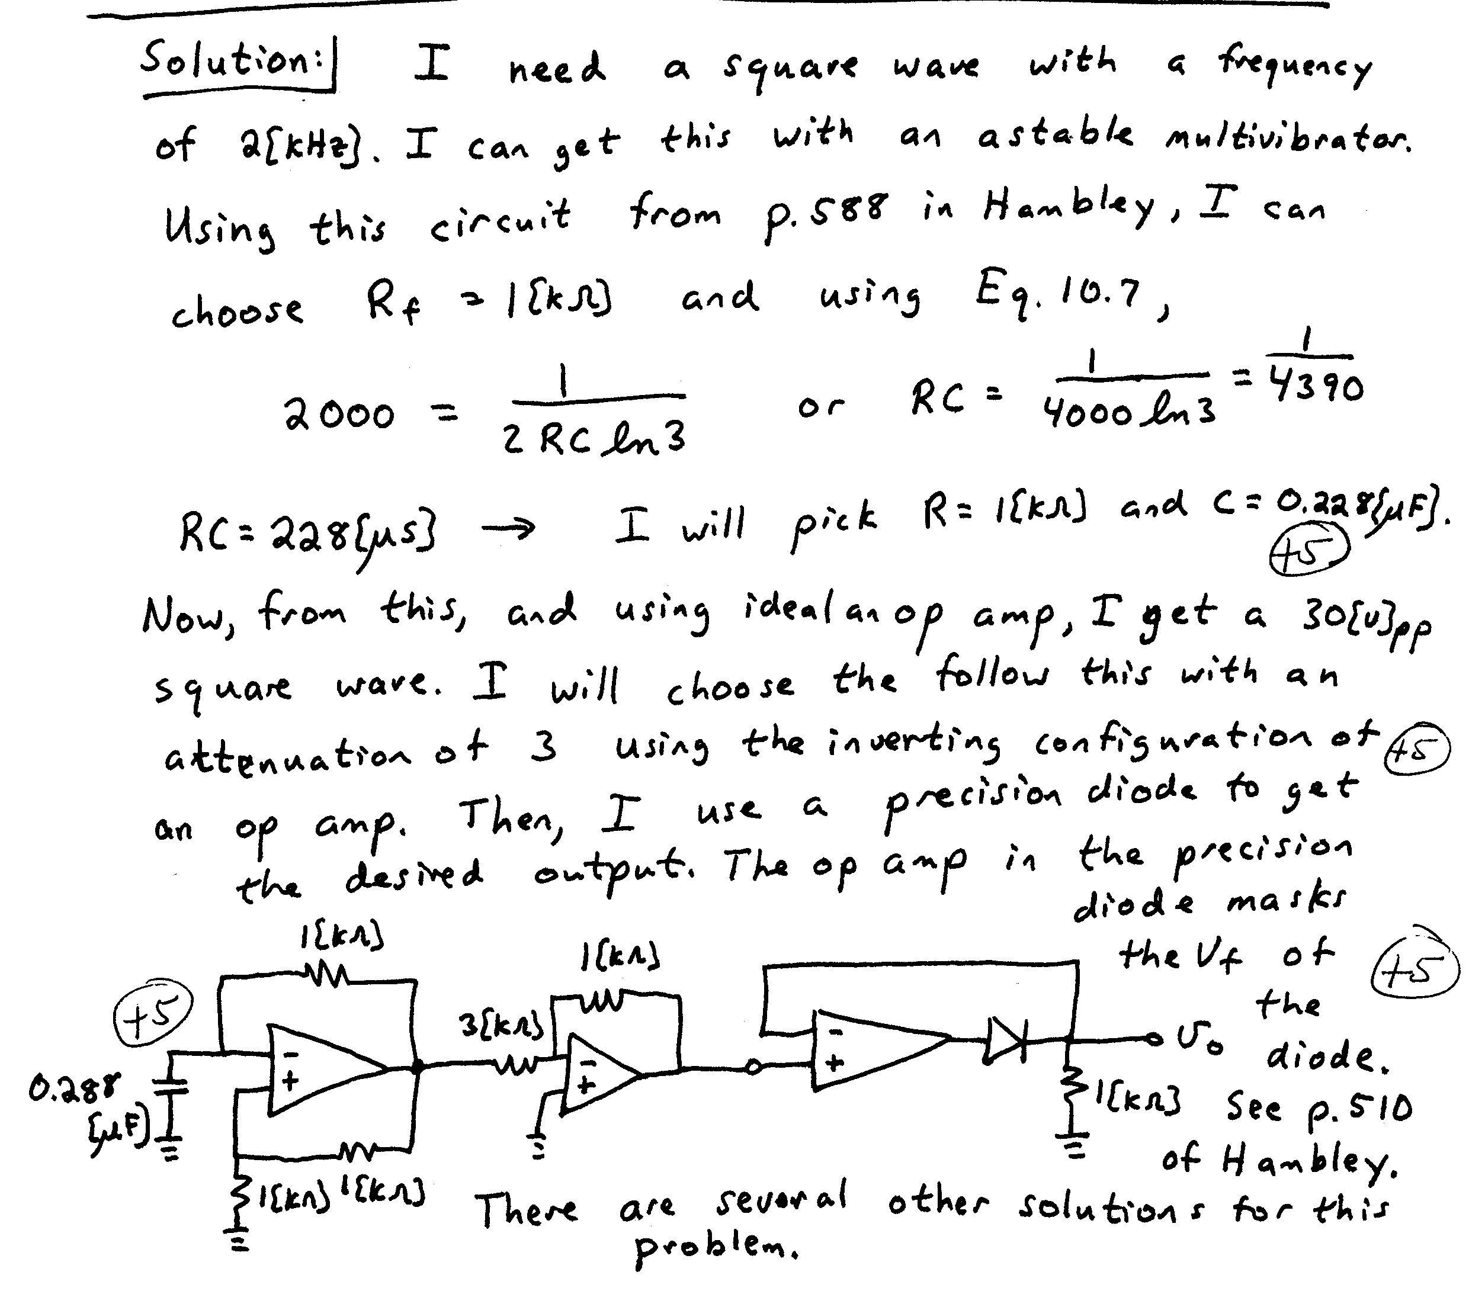

3. (20 Points) A nonlinear device called the davistor is found to have the transfer characteristics shown in Fig. 1 below. The schematic symbol for the davistor is given in Fig. 2. Two of the Davistor devices are used in the circuit shown in Fig. 3. Find VX. Use appropriate notation. State your assumptions, and test them, showing your tests. I expect you to complete at least two guesses, if necessary.
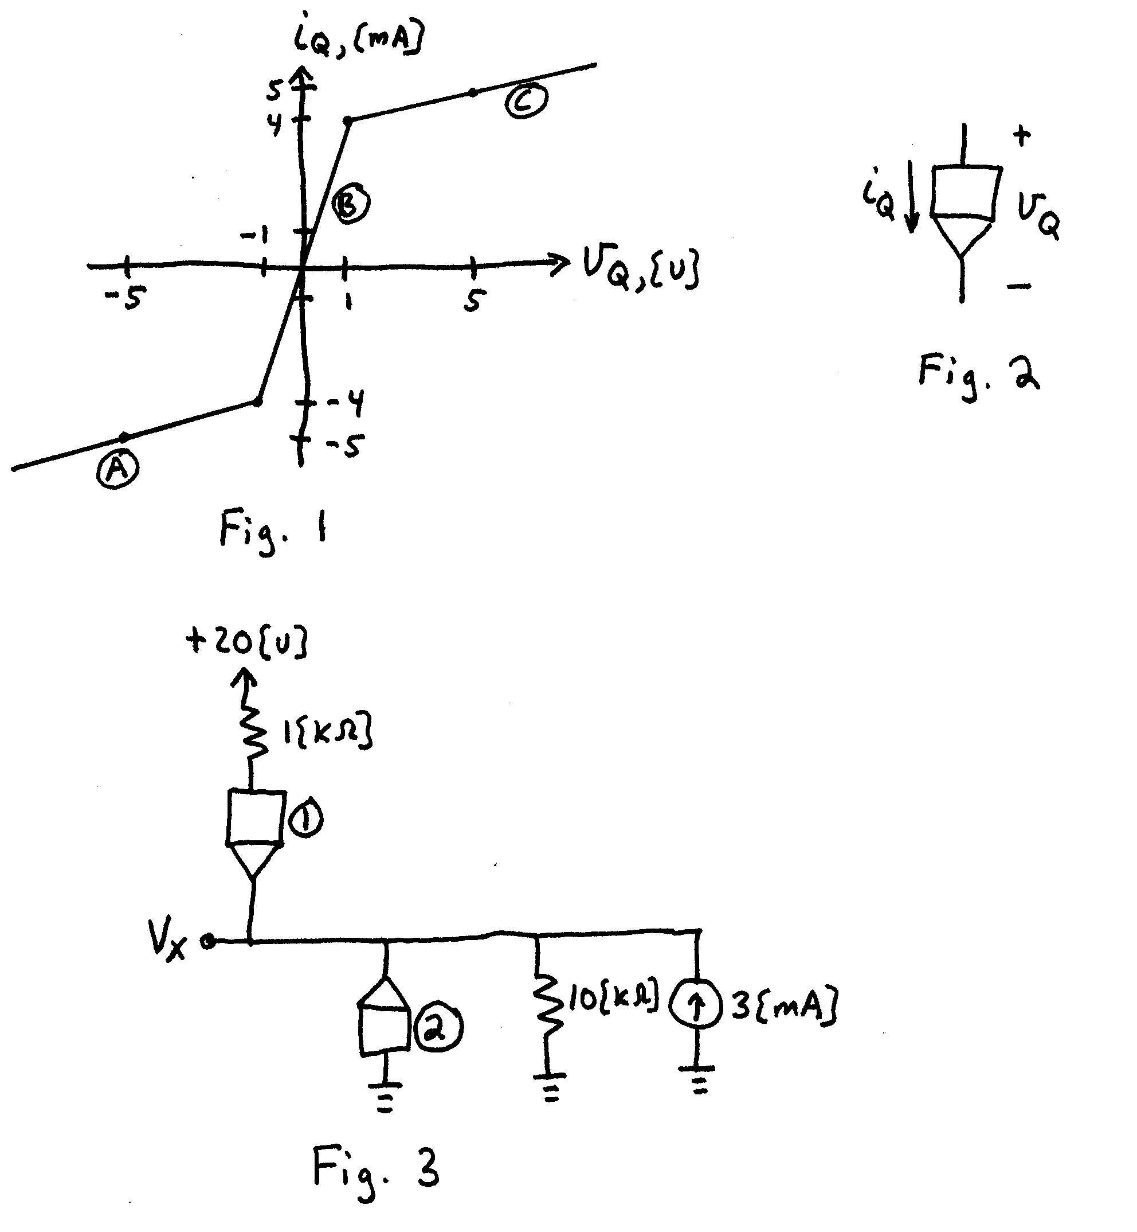
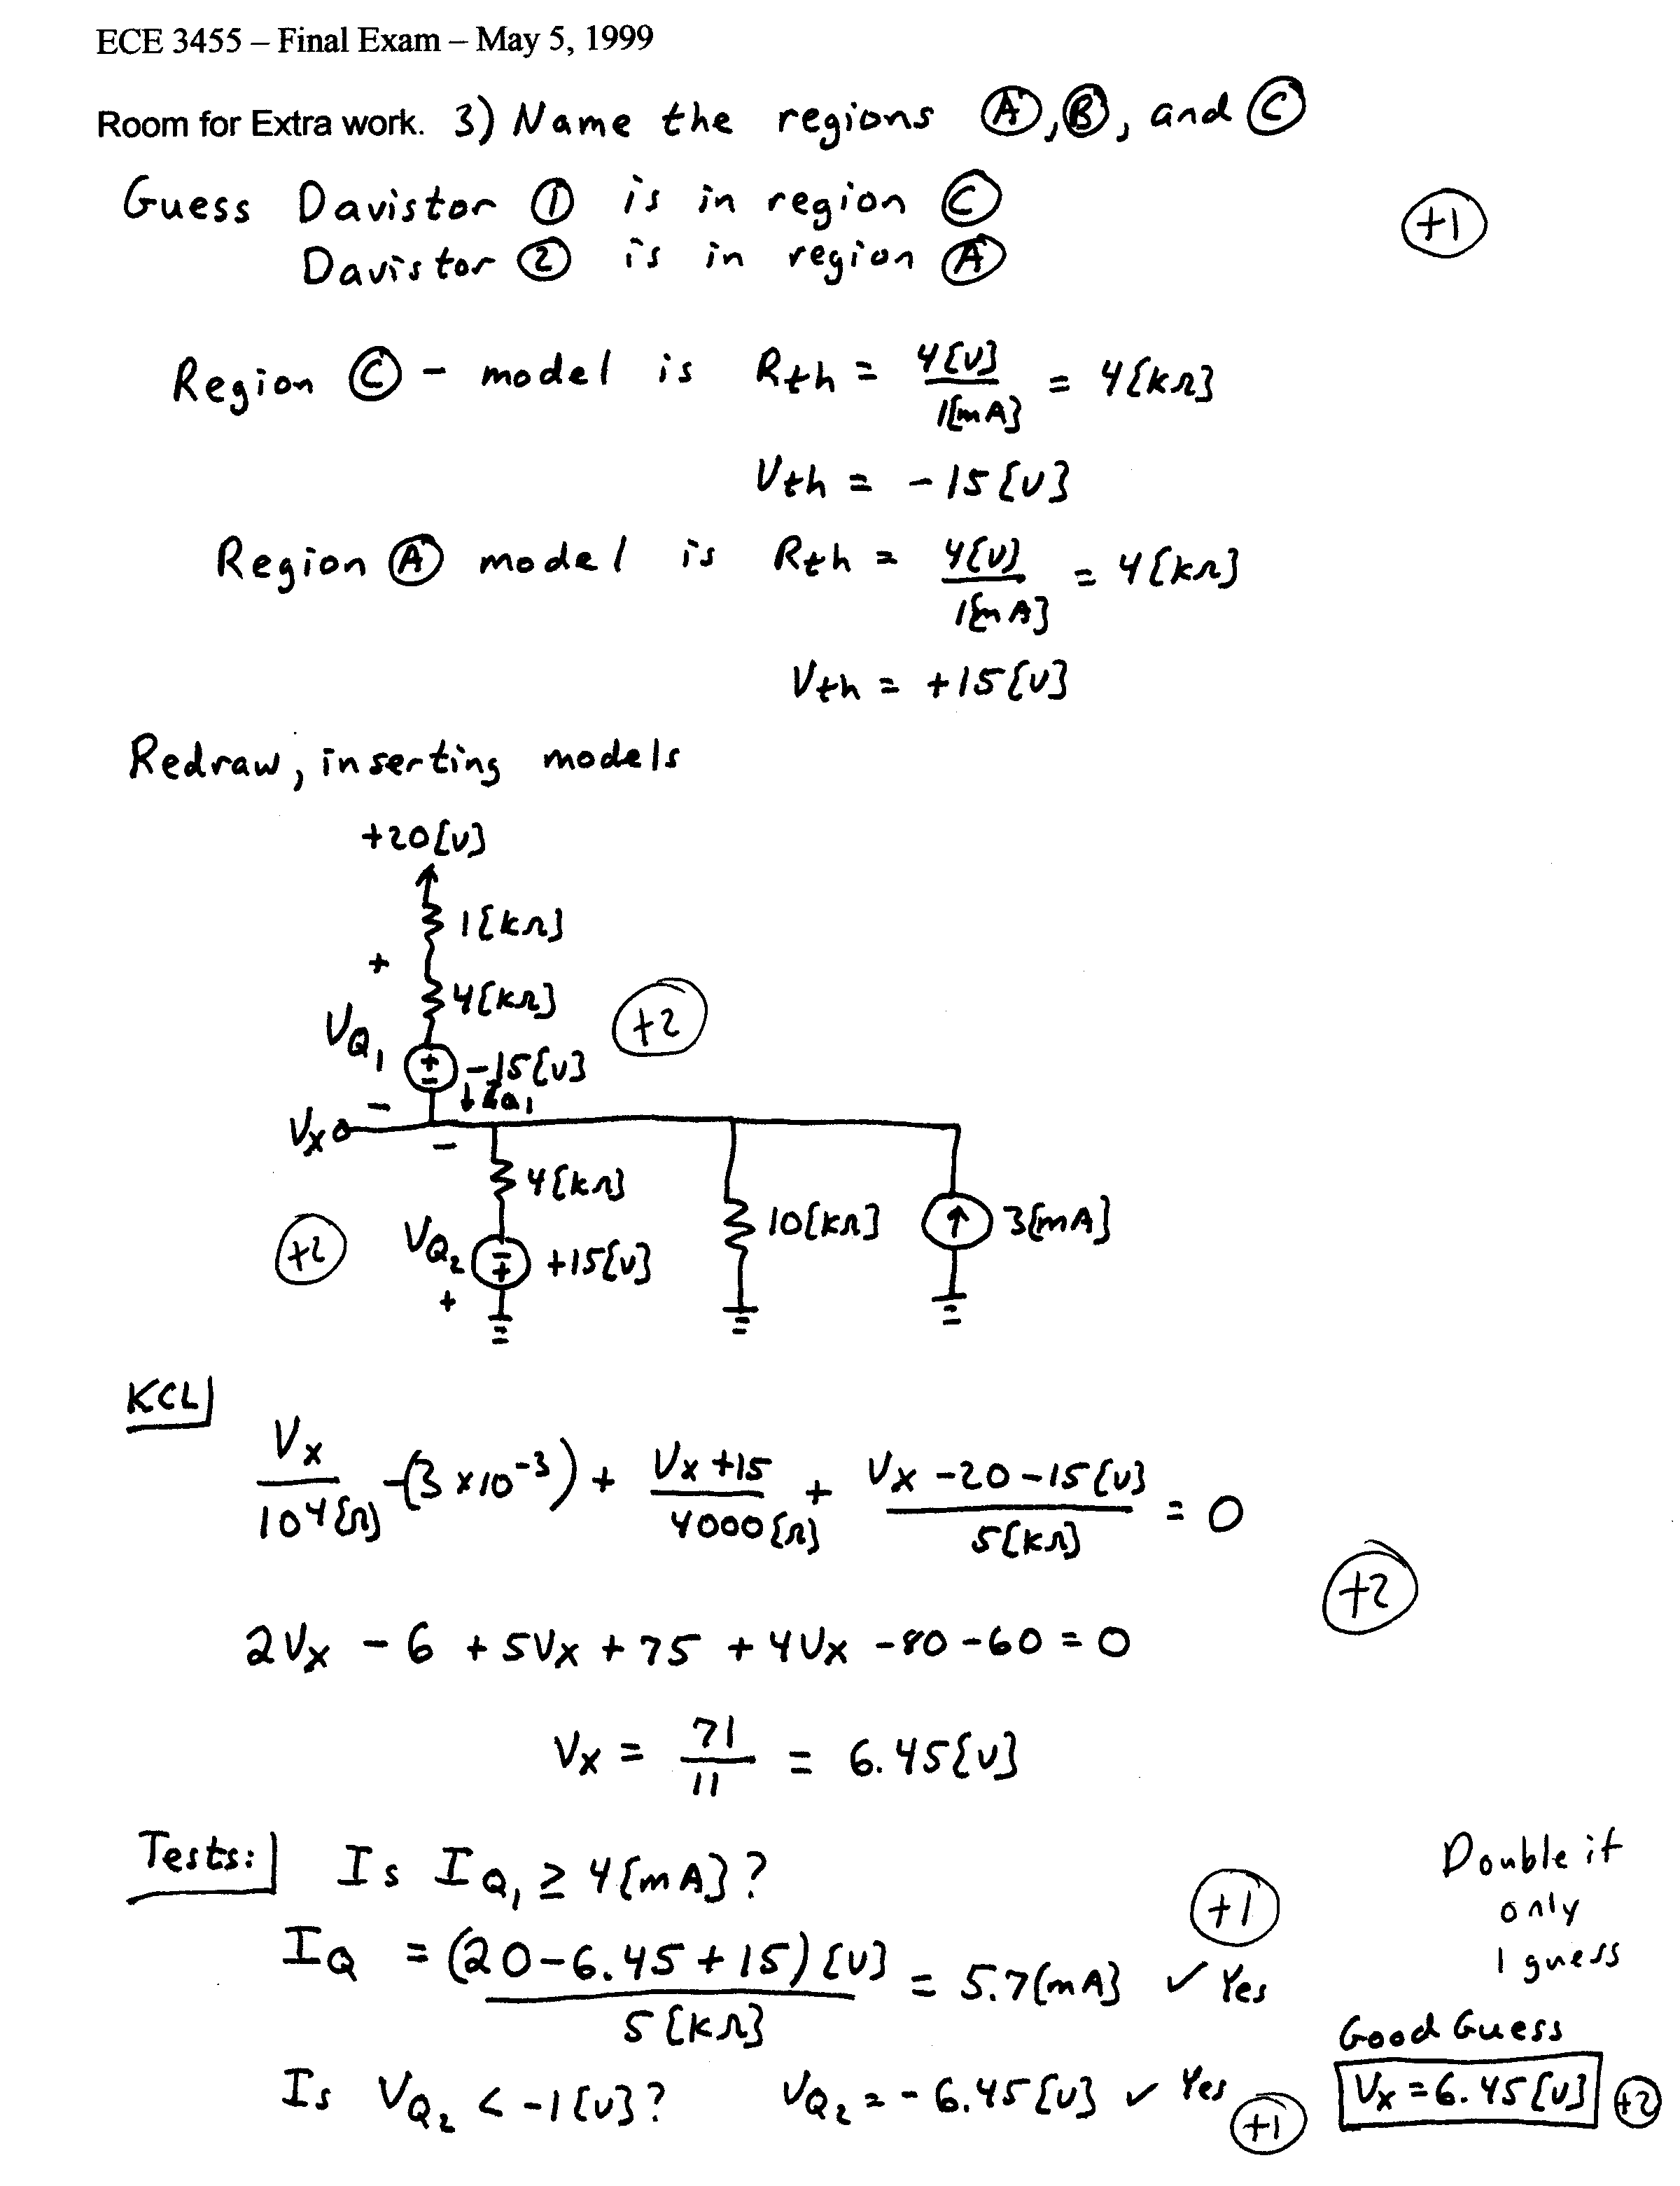

4. (20 Points) A NAND gate is intended to saturate the three transistors shown, when the output of the NAND gate is in the low state. Assume β = 40 for all three transistors.
The output of the NAND gate appears as a Thevenin equivalent with
V_{TH} = 10.0[V] and R_{TH} = 1[kΩ] in the high output state.
The output of the NAND gate appears as a Thevenin equivalent with
V_{TH} = 1[V] and R_{TH} = 500[Ω] in the low output state.
The input of the NAND gate appears as a Thevenin equivalent with
V_{TH} = -2.8[V] and R_{TH} = 200[kΩ] in the high input state.
The input of the NAND gate appears as a Thevenin equivalent with
V_{TH} = 3.0[V] and R_{TH} = 150[kΩ] in the low input state.
At the input of the NAND gate, 6[V] or higher behaves as a high state input and 2[V] or lower behaves as a low state input.
For a fanout of zero, V_{OH} = 10[V], and V_{OL} = 1[V].
Find the low state noise margin for the NAND gate driving the three transistors.
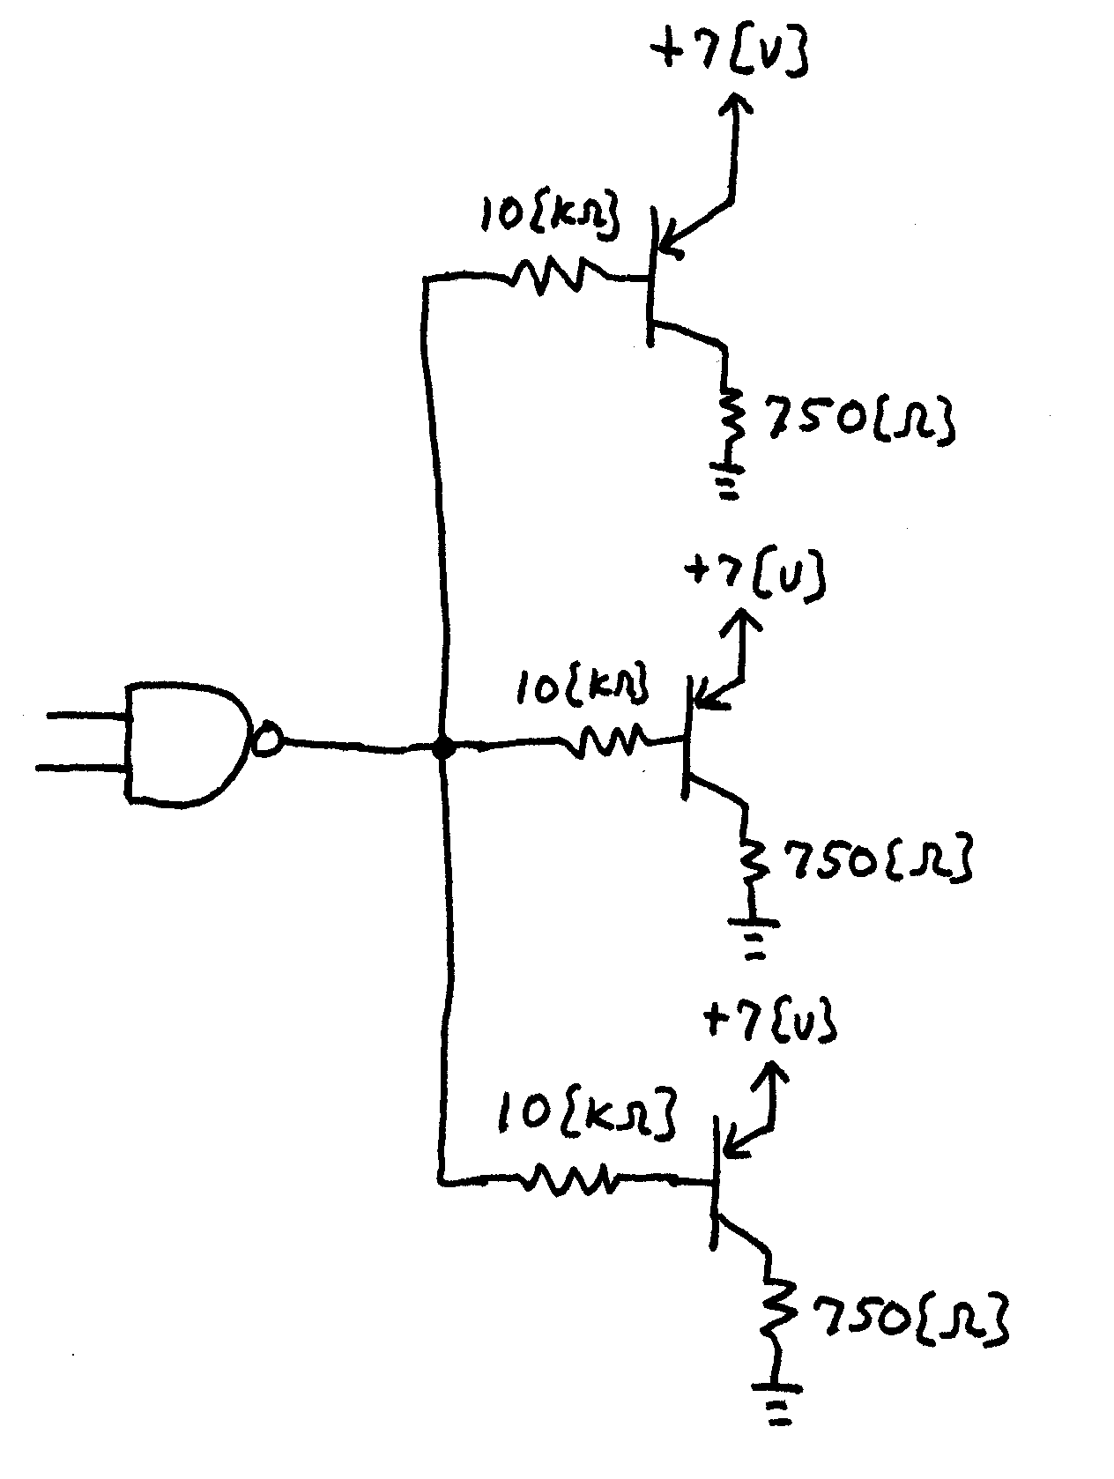
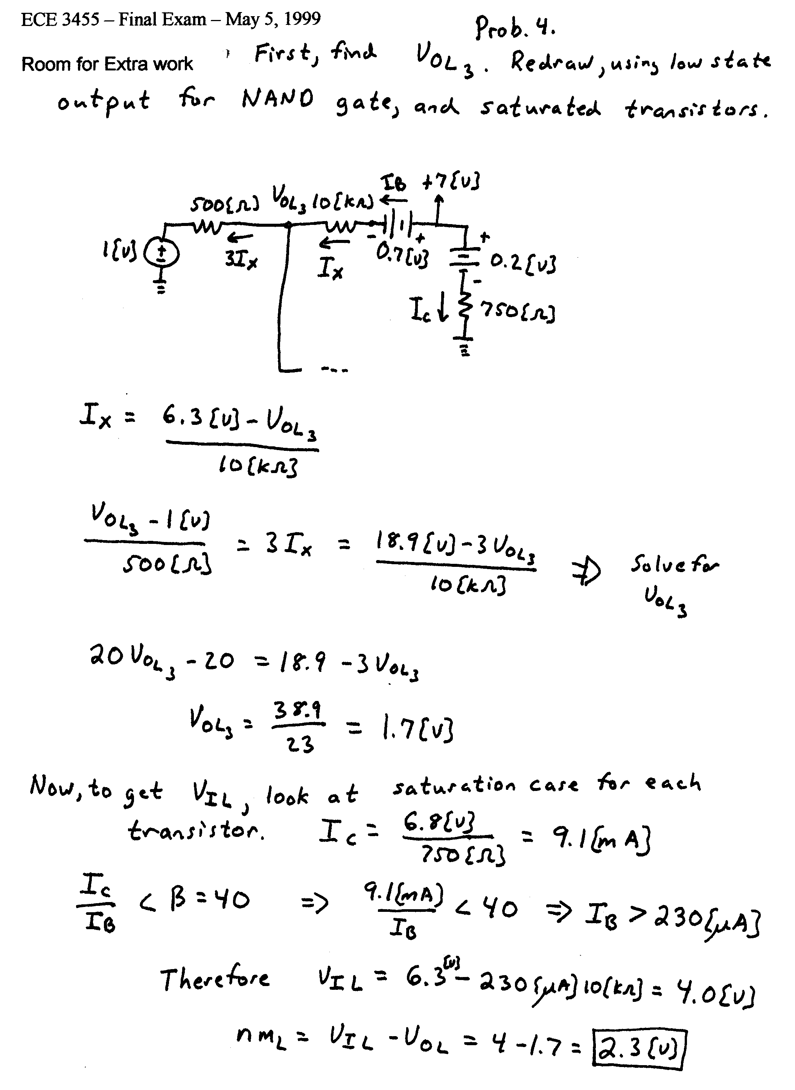
5. (25 Points) In the design project this semester, your team built and tested an electronic circuit. Your project used or illustrated at least one major electronics concept. Write three short paragraphs describing your team’s project, stating one of the concepts your project used or illustrated, describing how the project used that concept, and explaining how this concept might be used in a real world design. Use complete sentences in your description.

Solution:
There is no single given solution to this problem. My intention is to give points, if well written, according to the following outline:
Description of project – 5 Points
State one concept used – 5 Points
Describing how concept was used – 10 Points
How concept is used in real world design – 5 Points

